Loaded Fries
Menu price 350
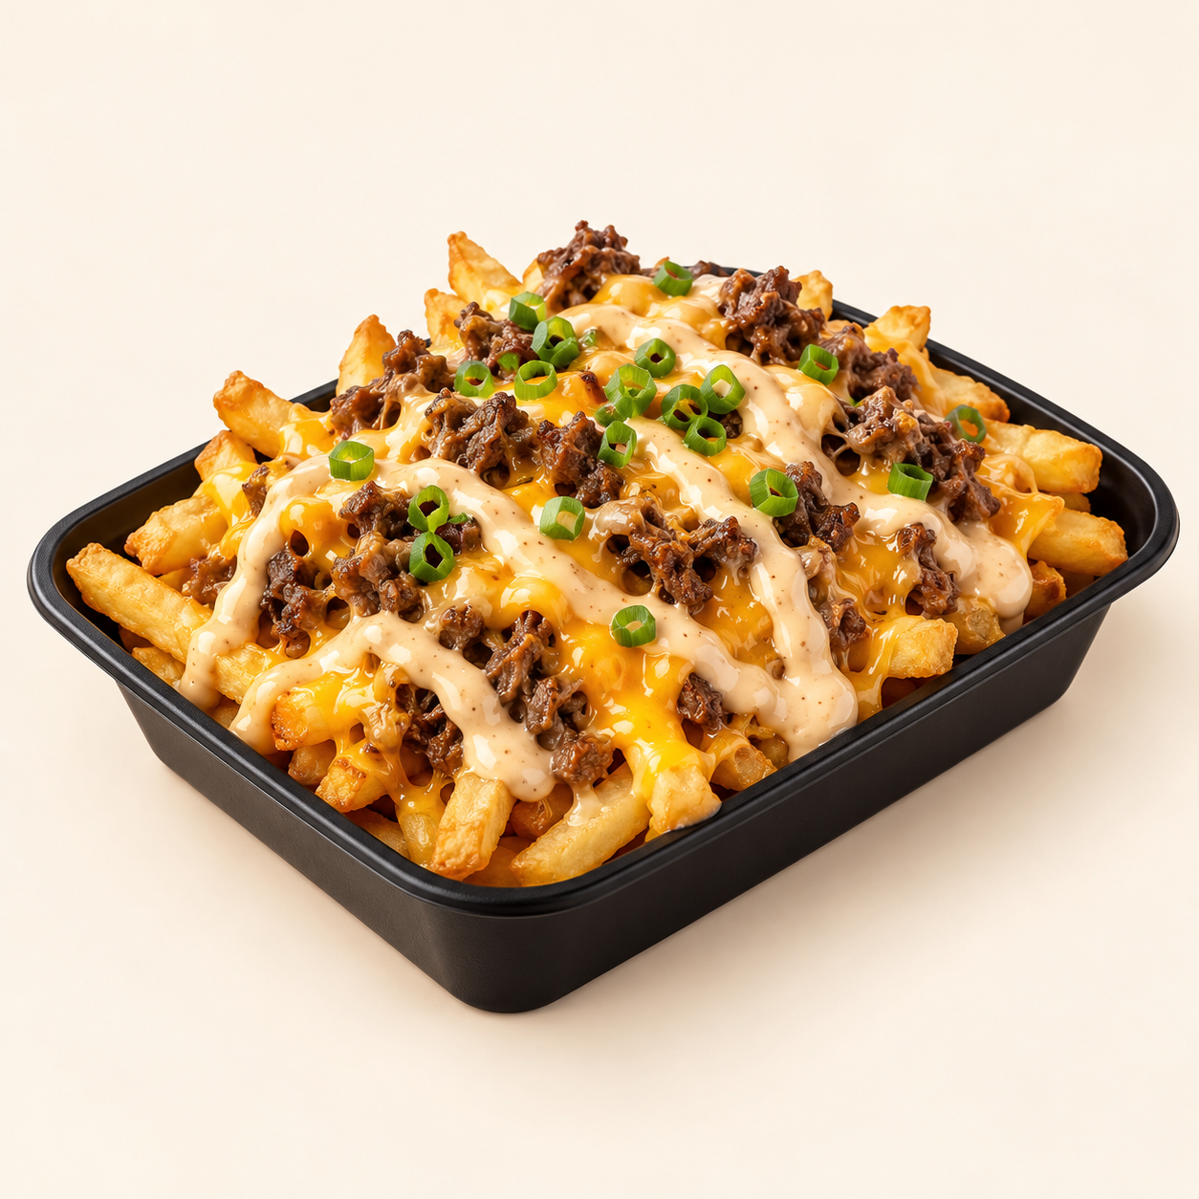
Crisp fries topped with seasoned beef, melted cheddar, creamy sauce and chopped spring onion.
Suggested recipe 1 loaded side portion
Time 25 minutes

Ingredients
- 200 g frozen fries, 75 g ground beef and 40 g grated cheddar
- 15 g mayonnaise, 10 g ketchup and 5 g mustard
- 10 g chopped spring onion, 1/4 tsp paprika, salt and pepper
- Neutral frying oil

Method
1. Brown beef in a skillet with paprika, salt and pepper, breaking it into small pieces. Cook until it reaches 71 C.
2. Mix mayonnaise, ketchup and mustard. Fry fries at 175 C according to package instructions and drain well.
3. Place fries in an ovenproof serving dish. Top with hot beef and cheddar. Broil briefly until the cheese melts, watching closely.
4. Drizzle with sauce, add spring onion and serve immediately.
Price source: supplied Nuvora menu; currency not stated. Suggested recipe, not an official restaurant formula. Image is AI generated.

