Nuvora Special Pizza
Menu price Medium 750 | Large 1,150
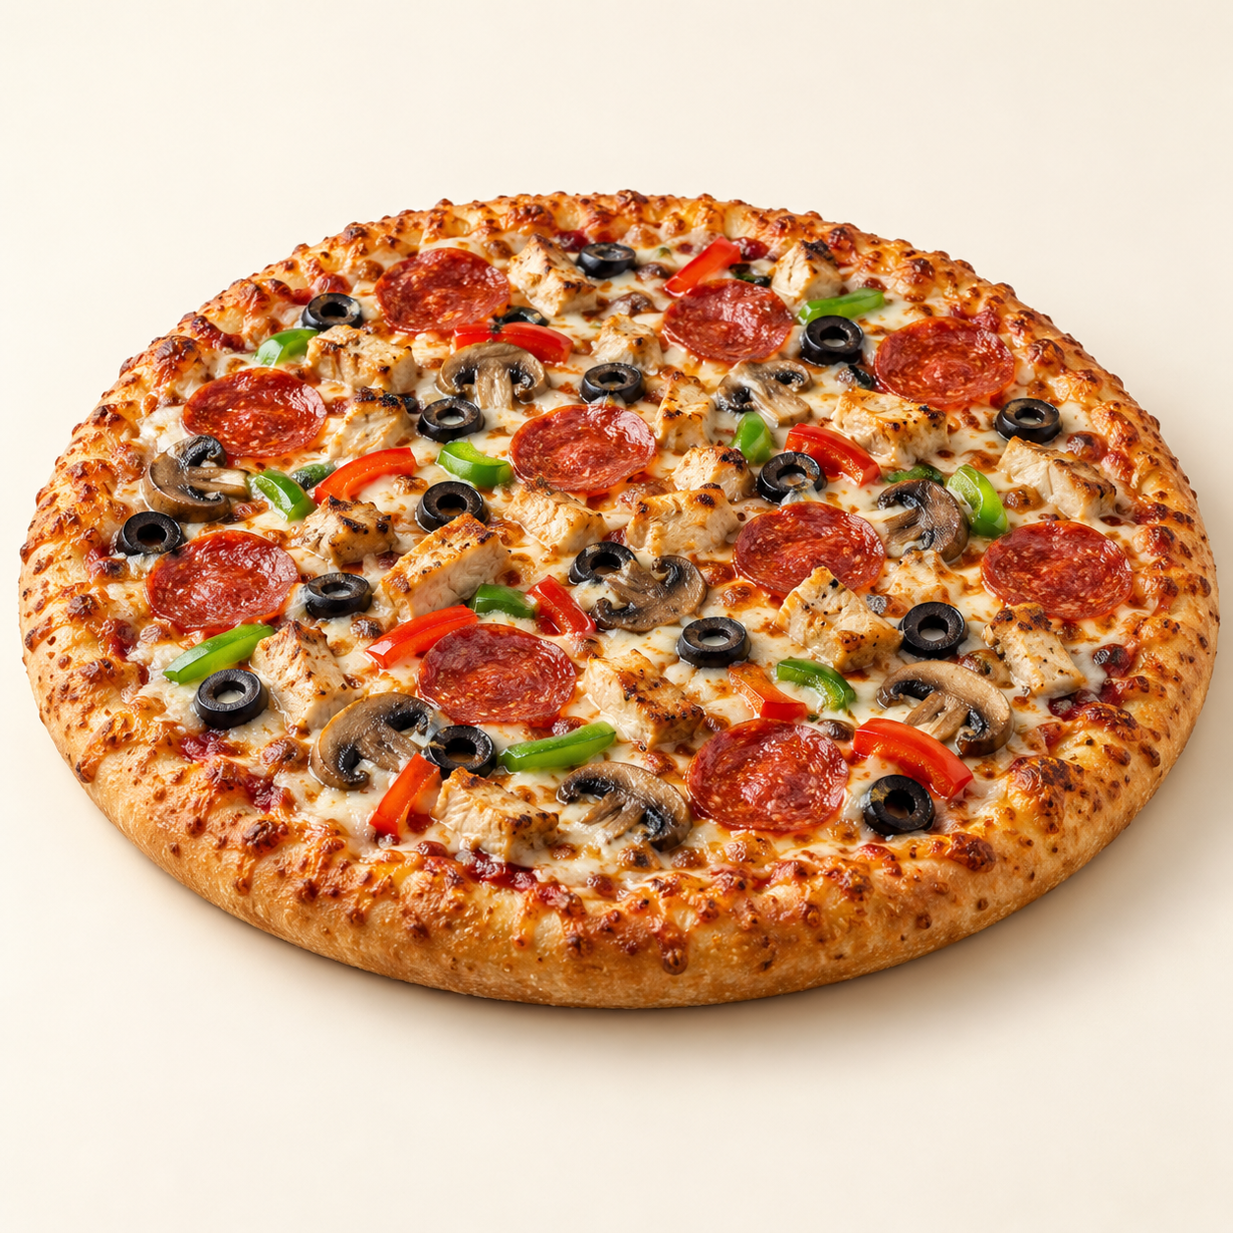
A generously topped signature pizza with chicken, beef pepperoni, mushrooms, bell pepper, olives and mozzarella.
Suggested recipe 1 proposed medium pizza, about 28 cm; see scaling note
Time 25 minutes active, plus 1 to 2 hours rising and 8 to 12 minutes baking

Ingredients
- Dough: 180 g strong bread flour, 115 ml lukewarm water, 2 g instant yeast, 3 g salt and 5 ml olive oil
- 80 g tomato pizza sauce, 110 g mozzarella
- 50 g cooked chicken and 35 g beef pepperoni
- 30 g sliced mushrooms, 25 g bell pepper and 15 g black olives

Method
1. Mix flour, water and yeast. Add salt and oil, then knead for 8 to 10 minutes until smooth. Cover and let rise for 1 to 2 hours until roughly doubled.
2. Heat the oven to 250 C, or its highest suitable setting, with a pizza stone or heavy baking tray inside for at least 30 minutes. Stretch dough into a 28 cm round on baking paper.
3. Spread tomato sauce, then add mozzarella, cooked chicken, pepperoni and vegetables evenly. Avoid overloading the centre and bake. Bake on the hot surface for about 8 to 12 minutes until the base is cooked and the crust is golden.
4. Rest for 1 minute, slice and serve. For a proposed 35 cm large pizza, multiply dough and toppings by about 1.56; baking time may vary. Menu diameters are not specified.
Price source: supplied Nuvora menu; currency not stated. Suggested recipe, not an official restaurant formula. Image is AI generated.

