Onion Rings
Menu price 250
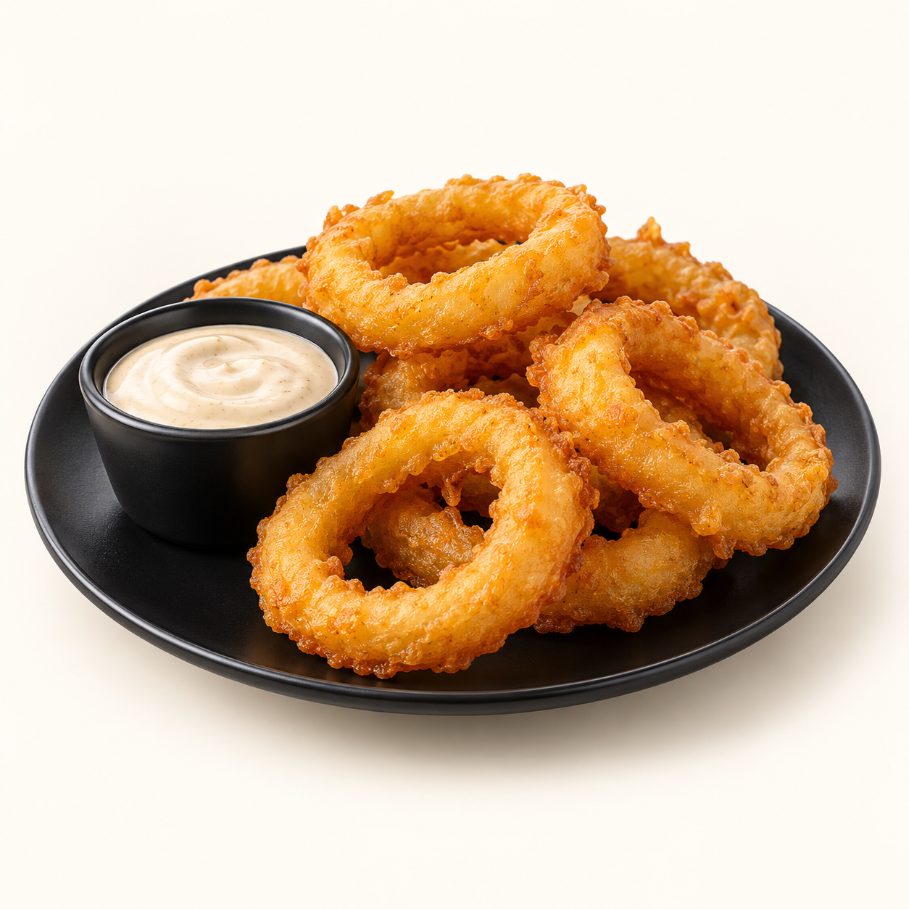
Thick onion rings in a light, crisp golden batter, served with dipping sauce.
Suggested recipe 1 side portion
Time 25 minutes

Ingredients
- 1 large onion, about 180 g, cut into thick rings
- 80 g flour, 20 g cornflour, 1/2 tsp baking powder
- 120 to 140 ml cold sparkling water, salt and pepper
- 20 g extra flour for dusting, neutral frying oil
- 30 g dipping sauce of choice

Method
1. Separate onion slices into rings and pat dry. Dust lightly with the extra flour.
2. Mix flour, cornflour, baking powder and seasoning. Whisk in sparkling water gradually until a thick but pourable batter forms.
3. Heat oil to 175 C. Dip rings in batter and fry in small batches for 2 to 3 minutes, turning until golden.
4. Drain on a rack, salt lightly and serve with dipping sauce.
Price source: supplied Nuvora menu; currency not stated. Suggested recipe, not an official restaurant formula. Image is AI generated.

