SynSystems - Regenerative Agriculture Platform

Project Overview
SynSystems is a web platform dedicated to regenerative agriculture education and farmland analysis. The application combines educational resources with interactive mapping tools to help farmers and agricultural enthusiasts understand and implement sustainable farming practices.
Key Features of SynSystems Platform
This application features a comprehensive Educational Center with four informational sections covering Syntropic Farming, Regenerative Agriculture, Agroforestry, and Climate Change Impact. Also featured is the Plot Analyzer Page, which uses Leaflet.js and open use maps to allow users to draw and measure farm plots on satellite, street, or terrain layers. Users can create multiple plots of various shapes and toggle between analysis in different GIS layers such as NDVI and soil moisture (with simulated data for preview). The interface includes a plot management panel that tracks drawn areas in acres, along with an analysis preview dashboard showing vegetation health and soil moisture statistics through visual progress bars.
This program uses Grid and Flexbox for responsive styling. Interactive elements like smooth transitions and the elevated effect are attributed to this CSS Hover Effects article. The educational content is organized in sections and is only visible if clicked, using the HTML data-attribute to store and switch between sections and images. The color combination uses a "Silver Sage" color palette with lots of variability in contrast. I used CSS-Tricks: CSS Variables Guide to easily adjust gradients from the top of the style sheet.
This idea for this web application is derived from a passion project I have been developing since April of 2025 called SynSystems. It allows farmers to create plots and gain access to GIS analysis tools for free. Version 1.0 included suggested planting strategies, climate data, online marketplaces, and an image gallery containing farms/regenerative systems already in place. My simplified version for this project focused on responsive and artistic styling, using Apple font and custom colorways to produce a more polished and professional result.
Key Updates
The primary updates for the final project assignment included the intake form which stores user’s names and email addresses in Local Storage and other small edits to styling and crop facts. While we are still far from launching a public access version the intake form lays a good foundation for other versions which would prioritize browser security and data privacy.
Style updates now include FAS-FA icons which are derived from the font awesome style sheet accessed via Cloudflare.

____________________________________________________________________________________
Version 1.0 SynSystems:
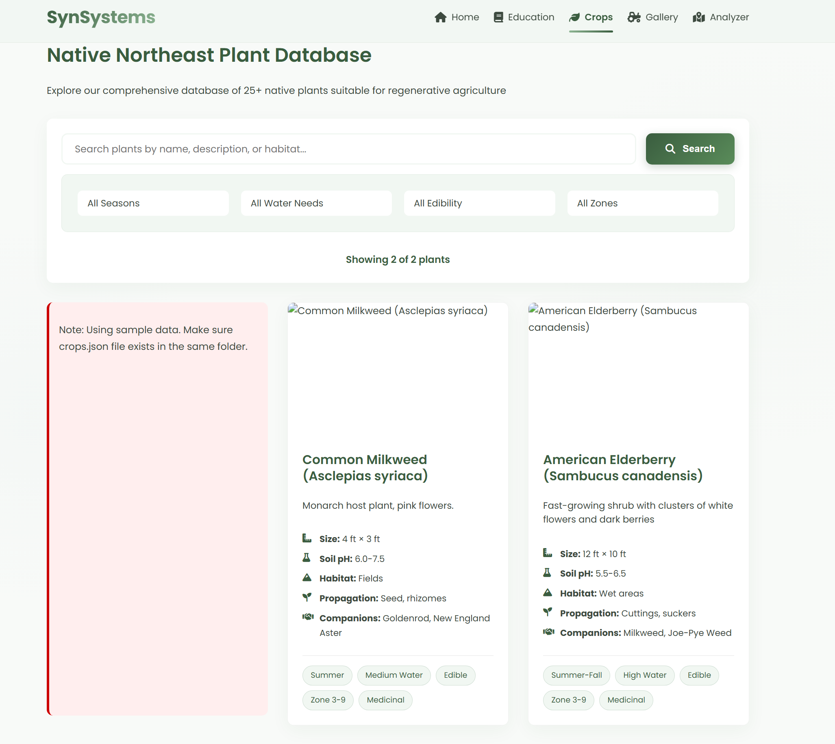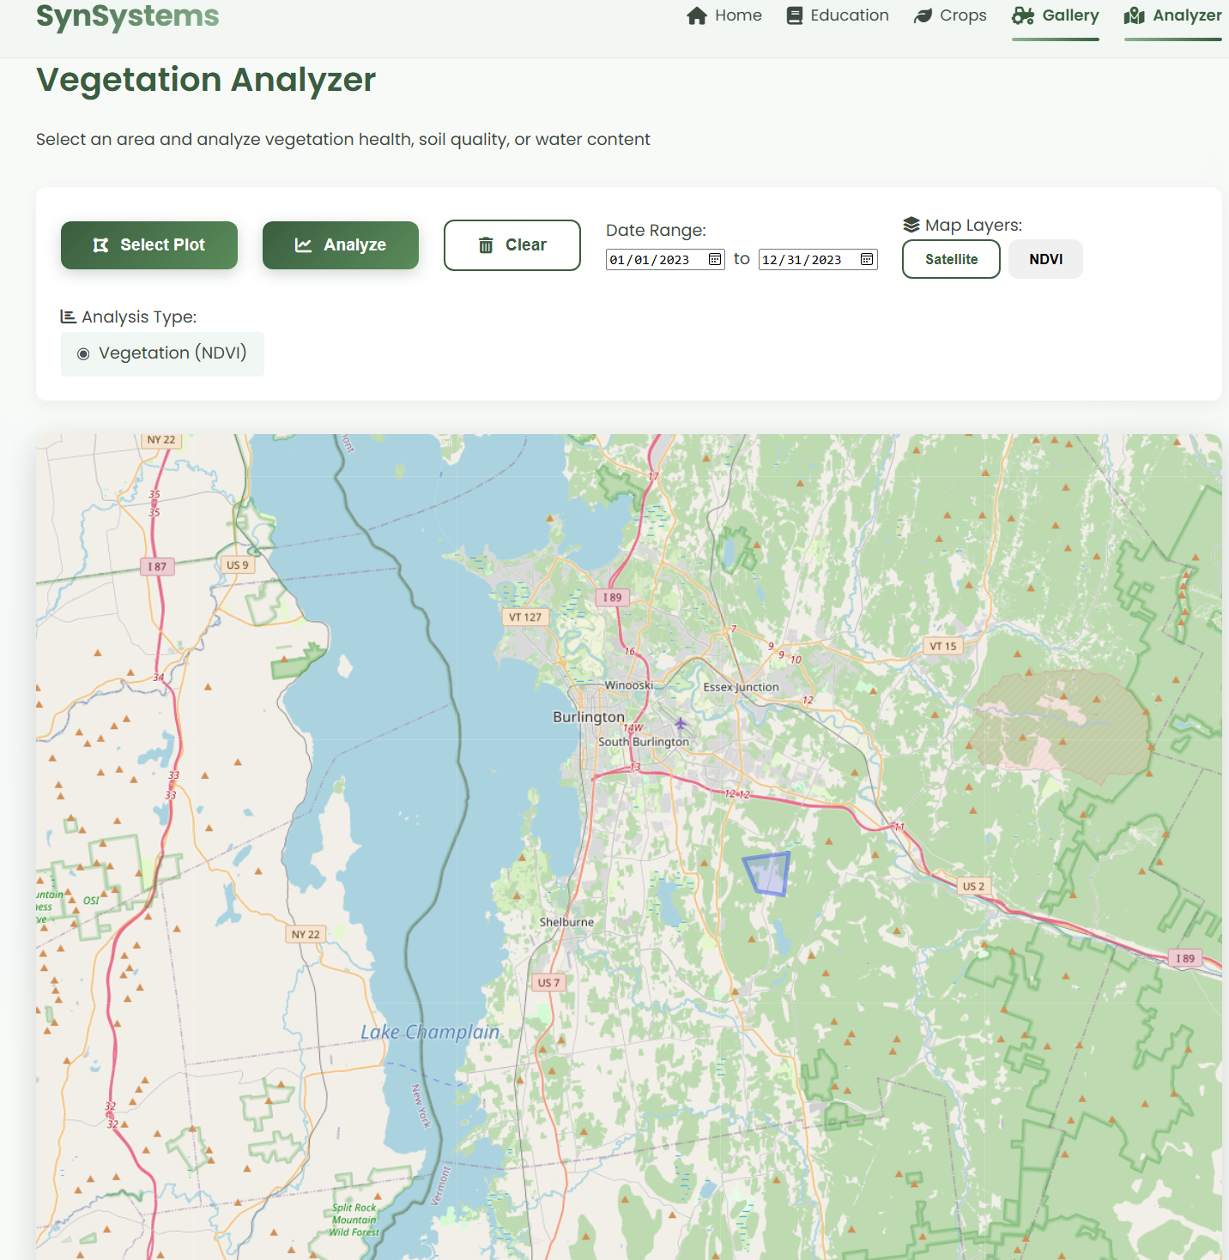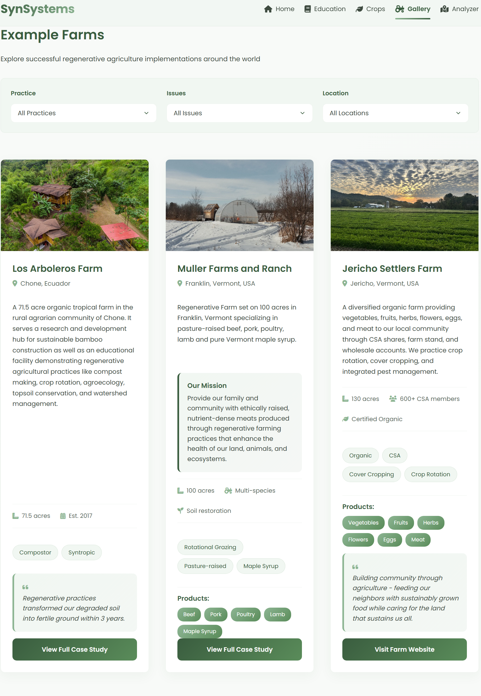
HTML Form and Local Storage Implementation:
Form:
<form id="intakeForm" class="intake-form">
<div class="form-group">
<label for="fullname">Full Name *</label>
<input type="text" id="fullname" name="fullname" placeholder="Enter your full name" required>
</div>
<div class="form-group">
<label for="email">Email Address *</label>
<input type="email" id="email" name="email" placeholder="you@example.com" required>
</div>
<button type="submit" class="submit-btn">Subscribe</button>
</form>
JSON:
const formData = {
id: Date.now(), unique ID
time: new Date().toLocaleString(), convert date to string form
fullname: fullname, Name Var
email: email Email Var
};

Console Logging:
console.log('To view all subscribers: Open DevTools (F12) → Application → Local Storage');
____________________________________________________________________________________
Data attribution examples:
<div class="education-nav"
<a href="#regenerative" class="nav-link-active" data-section="regenerative"> Regenerative Agriculture </a>
<a href="#syntropics" class="nav-link-active" data-section="syntropics"> Syntropic Practices </a>
</div>
<button id="layer-satellite" class="layer-btn active" data-layer="satellite">
<i class="fas fa-satellite"></i> Satellite
</button>
Source: W3schools - HTML data- attribute
____________________________________________________________________________________
CSS Leaflet/ Leaflet.js Implementation:
<link rel="stylesheet" href="https://unpkg.com/leaflet@1.9.4/dist/leaflet.css" />
<link rel="stylesheet" href="https://unpkg.com/leafletdraw@1.0.4/dist/leaflet.draw.css" />
<script src="https://unpkg.com/leaflet@1.9.4/dist/leaflet.js"></script>
Sources :
- Leaflet.js
- Leaflet Draw
- Leaflet.js Tutorials
- Leaflet Draw Plugin
____________________________________________________________________________________
CSS Custom Properties/ Variables example:
css
:root {
--primary-green: #84a98c;
--primary-dark: #2d6a4f;
--gray-900: #1e2b24;
--shadow: 0 6px 24px rgba(0, 0, 0, 0.12); // for the raised card/ elevated effect}
Sources & Documentation:
- CSS-Tricks: CSS Variables Guide
- W3C CSS Custom Properties Specification
___________________________________________________________________________________
CSS Grid Layout Implementation:
css
.benefits-grid {
display: grid;
grid-template-columns: repeat(auto-fit, minmax(400px, 1fr));
gap: 1.5rem;
}
.index-links-container {
display: grid;
grid-template-columns: repeat(2, 1fr);
gap: 2rem;
}
.control-panel {
display: grid;
grid-template-columns: repeat(auto-fit, minmax(300px, 1fr));
gap: 1.5rem;
}
Sources & Documentation:
- MDN: CSS Grid Layout
- CSS-Tricks: Complete Guide to Grid
____________________________________________________________________________________
CSS Animations and Transitions Implementation:
css
@keyframes fadeIn {
from {
opacity: 0;
transform: translateY(20px);
}
to {
opacity: 1;
transform: translateY(0);
}
}
.education-section.active {
animation: fadeIn 0.5s ease-out;
}
.step:hover {
transform: translateX(5px);
transition: var(--transition);
}
Sources & Documentation:
Card Hover Effect: CSS Hover Effects: 40+ Code Examples & Tutorials (2025)
____________________________________________________________________________________
Selectors and Pseudo-elements Implementation:
css
h2::after {
content: '';
position: absolute;
bottom: 0;
left: 0;
width: 60px;
height: 3px;
background: var(--primary-green);
}
.benefit-card:hover .benefit-image {
transform: scale(1.08);
}
Sources & Documentation:
- MDN: Pseudo-elements
- MDN: CSS Selectors
____________________________________________________________________________________
Gradient Backgrounds Examples:
css
.hero {
background: linear-gradient(rgba(30, 43, 36, 0.4), rgba(45, 106, 79, 0.4)),
url(Photos/indexBG.jpg);
background-size: cover;
background-position: center;
}
#syntropicsystem {
background: linear-gradient(135deg, var(--primary-light), var(--gray-200)),
url(Photos/RFI.png);
background-size: cover;
background-blend-mode: overlay;
}
Sources & Documentation:
- CSS Gradients Guide | CSS-Tricks
____________________________________________________________________________________

Box Shadows and Elevation
Implementation:
css
:root {
--shadow: 0 6px 24px rgba(0, 0, 0, 0.12);
--shadow-hover: 0 12px 30px rgba(45, 106, 79, 0.15);
}

.fact-card {
box-shadow: var(--shadow);
border-left: 4px solid var(--primary-dark);
}
Sources & Documentation:
- MDN: box-shadow
- CSS-Tricks: Box-shadow Guide
____________________________________________________________________________________

CSS Grid and Flexbox Hybrid Layouts
Implementation:
css
.analyzer-main {
display: grid;
grid-template-columns: 1fr;
gap: 1.5rem;
}

.stat-item {
display: flex;
gap: 1rem;
}

.stat-content {
flex: 1;
}
Sources & Documentation:
- CSS-Tricks: Grid vs Flexbox
- MDN: Relationship of Grid and Flexbox
____________________________________________________________________________________
Sticky Header Implementation:
css
header {
position: sticky;
top: 0;
z-index: 1000;
}
Sources & Documentation:
- MDN: position: sticky
____________________________________________________________________________________
Overflow Handling for Tables Implementation:
css
.comparison-table {
display: block;
overflow-x: auto;
}
Sources & Documentation:
- MDN: overflow
- CSS-Tricks: Responsive Tables
____________________________________________________________________________________
CSS Blend Modes Implementation:
css
#syntropicsystem {
background-blend-mode: overlay;
}
Sources & Documentation:
- MDN: background-blend-mode
- CSS-Tricks: Blend Modes
- Adobe: Understanding Blend Modes
____________________________________________________________________________________
Leaflet.js Sources:
- Leaflet.js Tutorials
- Leaflet Draw Plugin
____________________________________________________________________________________

HTML/CSS Standards
- W3C CSS Specification
- MDN Web Docs
Design Inspiration
- Material Design Guidelines
- SynSystems V1.0

