For testing, pls scroll to the bottom of the Available projects and select UQ

Here are the locations for the project

QR codes:

UQ Lakes Bus Station

Brisbane City Botanic Gardens

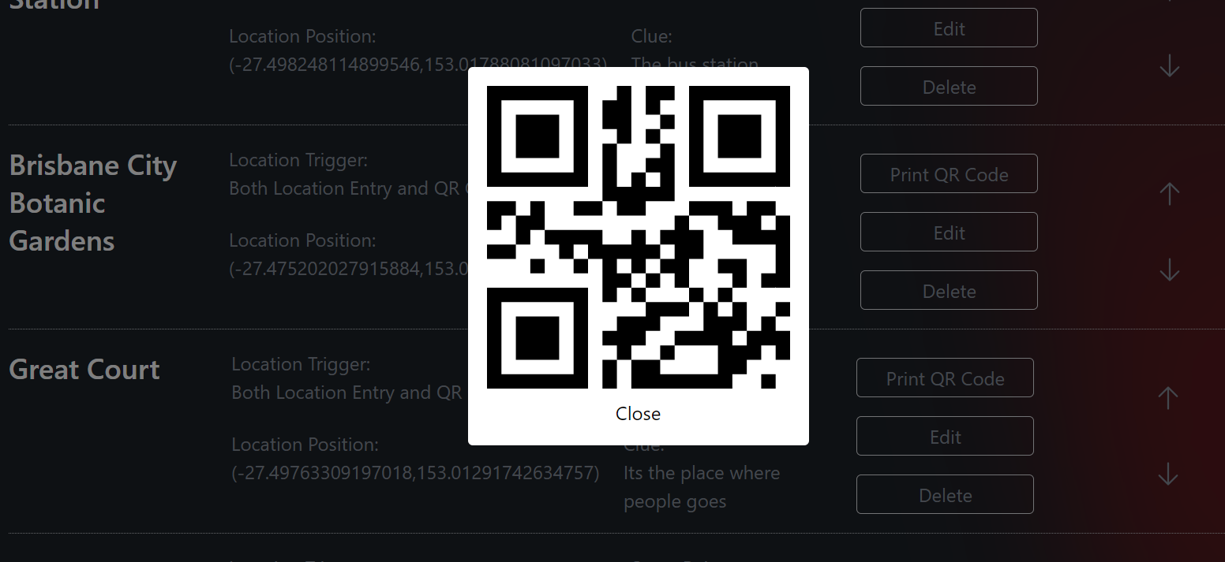

Great court

Queen St Mall

QUT Gardens Point Campus

Testing methods:

* Both location and QR codes are implemented.
* Can scan QR codes to visit locations, or by being within radius of location to visit location.
* For the locations, when you’re inside the app/projects/[id] folder, the location tracking will automatically run and show a location pop up if you’re within the location and it hasn’t been visited yet. The pop up will show whether you’re in the Project, Map or QR code tabs.

Scoring:

* Scoring uses the location_trigger type of the locations, ignoring the scoring option set for the project itself.

Emulator used:

Properties

avd.ini.displayname Story path 2

avd.ini.encoding UTF-8

AvdId Story_path_2

disk.dataPartition.size 6442450944

fastboot.chosenSnapshotFile

fastboot.forceChosenSnapshotBoot no

fastboot.forceColdBoot no

fastboot.forceFastBoot yes

hw.accelerometer yes

hw.arc false

hw.audioInput yes

hw.battery yes

hw.camera.back virtualscene

hw.camera.front emulated

hw.cpu.ncore 2

hw.device.hash2 MD5:3db3250dab5d0d93b29353040181c7e9

hw.device.manufacturer Generic

hw.device.name medium_phone

hw.dPad no

hw.gps yes

hw.gpu.enabled yes

hw.gpu.mode auto

hw.initialOrientation portrait

hw.keyboard yes

hw.lcd.density 420

hw.lcd.height 2400

hw.lcd.width 1080

hw.mainKeys no

hw.ramSize 2048

hw.sdCard yes

hw.sensors.orientation yes

hw.sensors.proximity yes

hw.trackBall no

image.androidVersion.api 35

image.sysdir.1 system-images\android-35\google_apis_playstore\x86_64\

PlayStore.enabled true

runtime.network.latency none

runtime.network.speed full

showDeviceFrame no

skin.dynamic yes

skin.path.backup _no_skin

tag.display Google Play

tag.displaynames Google Play

tag.id google_apis_playstore

tag.ids google_apis_playstore

vm.heapSize 228