ERD Diagram of Models

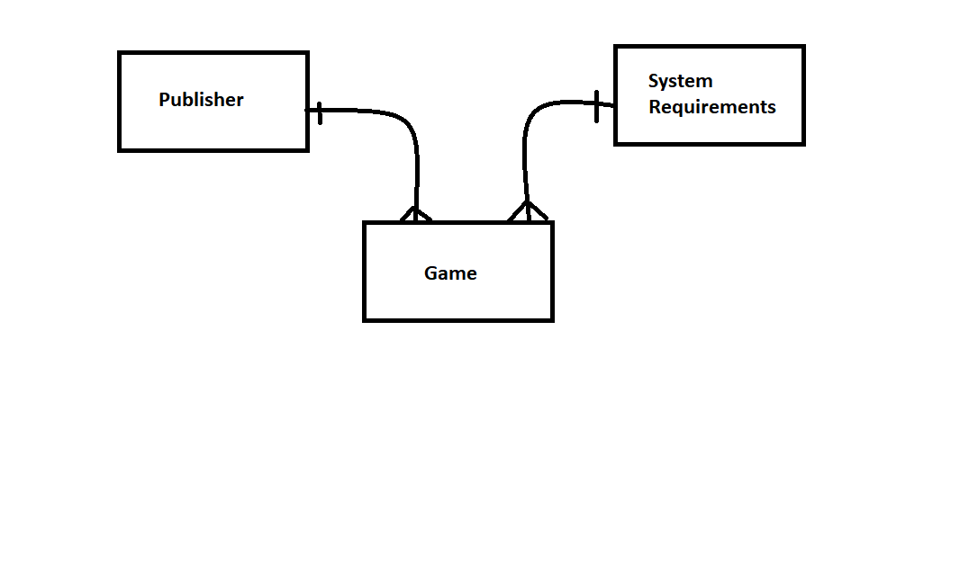

Publisher Model

|  |  |  |  |  |  |
| --- | --- | --- | --- | --- | --- |
| Name | Type | Size | Constraints | Description | Example |
| PublisherName | CharField | 100 | Not null | Name of publisher | Valve |
| Location | CharField | 100 | Not null | Physical Location of the publisher | Seattle |
| dateFounded | DateField |  | Not null, format is  YYYY-MM--DD | Date the publisher was founded | 1996-08-24 |

System Requirements Model

|  |  |  |  |  |  |
| --- | --- | --- | --- | --- | --- |
| Name | Type | Size | Constraints | Description | Example |
| memoryNeeded | CharField | 100 | Not null | Minimum RAM required to run the game | 16GB |
| minimumDiskSpace | CharField | 100 | Not null | Minimum Disk space required to install the game | 10GB |
| gpuRequired | CharField | 50 | Not null | Recommended minimum GPU for the game. | GTX1080 |

Game Model

|  |  |  |  |  |  |
| --- | --- | --- | --- | --- | --- |
| Name | Type | Size | Constraints | Description | Example |
| gameName | CharField | 100 | Not null | Title of the game | Counter Strike Global Offensive |
| Description | CharField | 1000 | Not null | Description of the games features. | Team Based First person shooter |
| price | DecimalField | 5 | Not null | Price the game sells for | 15.00 |
| releaseDate | DateField |  | Not null | Date it was or will be released | 2012-08-22 |
| publisher | Foreign Key | 100 | Not null | Whom the game was published by. | Valve |
| systemRequirements | Foreign Key | 100 | Not null | The Memory required to run the game | 2GB |

User Guide on Adding, deleting and updating a game entry

Adding an entry

To add entries to the database follow the steps below:

1. When adding an entry to the games table, first select ‘Create’ from the navigation menu.
2. Then click the button that has ‘Game’ written inside of it.
3. Then enter the information of the game you are adding.

NOTE: If you don’t already have the publisher or system requirements entries added to their respective tables you will need to do that before you can enter the correct information. You can do this for each table by following the three steps outlined above(but using the other two buttons).

Deleting an Entry

To delete an entry follow the steps below:

1. Make sure you know the name of the game you want to delete
2. Navigate to the delete selection page by clicking ‘Delete’ in the navigation menu
3. Select the button with ‘Game’ written inside of it.
4. Then enter the name of the game in the input box and click ‘Delete Entry’

The game should now be deleted.

Updating an Entry

To update an entry in the database follow the steps below:

1. Make sure you know the name of the game you want to update
2. Navigate to the update selection page by clicking ‘Update in the navigation menu
3. In the ‘Game to update’ input box type the name of the game you wish to update.
4. Then in the four input fields below, enter the new information for the game.