## Billy Davies

S230525

Assignment1

## Things I refactored in my code:

* Added constants for the upper & lower limit in the randomizer function. If I change it in the future I only need to change it in one place now([Shotgun Surgery](https://refactoring.guru/smells/shotgun-surgery)).

Below is before refactoring, where I had to define the ranges

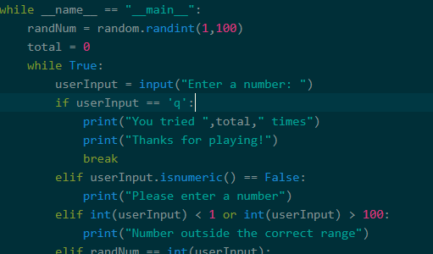

Below is now where I have constants in use and can changes all of the ranges in one place

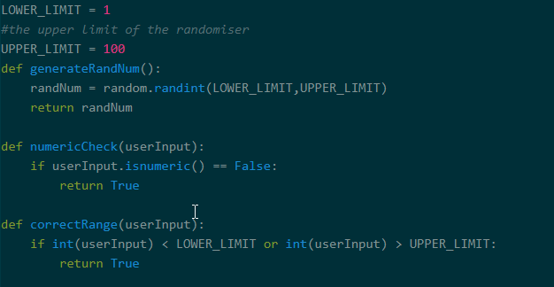

* Moved the quit check code out to its own function. I can easily add more keywords to check for and reuse the code in any new work now.

Before I moved it below

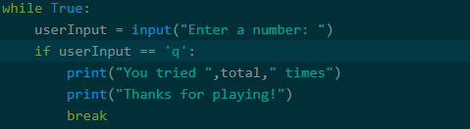

And moved into its own function

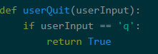

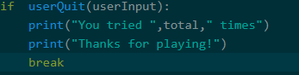

* Each if statement was moved to its own function and given a name that makes the operation the function performs very self explanatory and not require comments([Comments](https://refactoring.guru/smells/comments)).

Below is my while statement with all the if statements

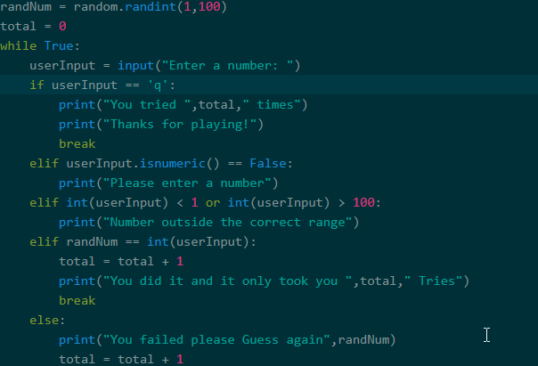

And here they have all been moved into their own functions

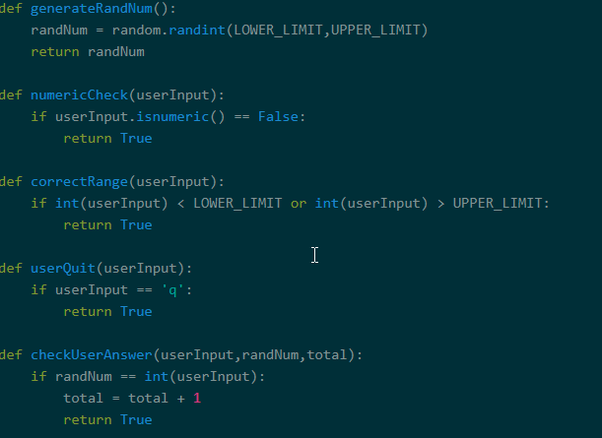

## Steps taken to create this program

To create the program I used the python language.

Before I started writing code I thought about all the tests I would need to check for and created test cases for them. As there was only going to be one input these are the things I identified that I would need to test for.

1. Numeric input
2. Between 1-100
3. No symbols
4. Not empty
5. Correctly displays incorrect & Keeps asking for input if wrong
6. Correctly display correct answer

After I had wrote the test cases and they had all failed (as they should) I began working on the program itself. I used the python library random to generate a random number from 1 to 100.

I then created a while loop and inside that loop placed a series of If statements to check user input validity.

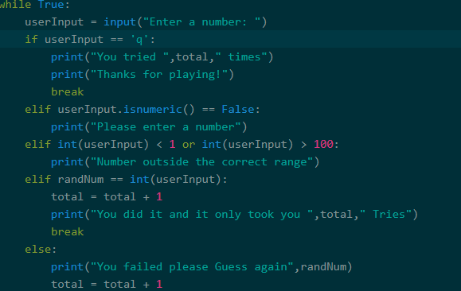

Once I had the main program working and valid I ran my tests and made sure they ran and then got to refactor my code. I was using a series of if statements to control my program which would have been annoying to modify and difficult to understand so I decided to create functions for each of the if statements that handled the logic and give them meaningful names.

This way my code would be easier to understand and much easier to modify if I returned to it in the future

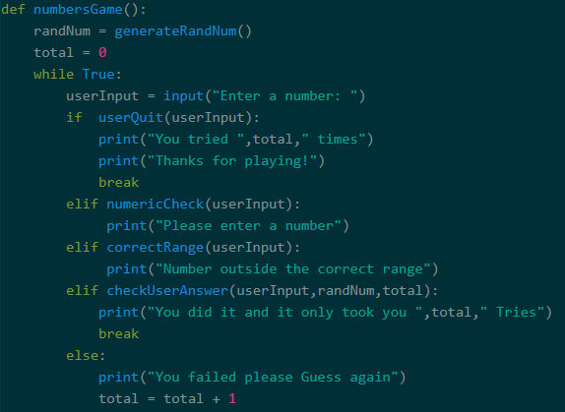

I could also modify my tests slightly and simply run my previous tests on the new functions I had created.