Pertemuan 2 : CSS
Tugas 2 : Website Penyewaan Alat Pertanian dan Perkebunan
Nama / Nim | : Billy Elvonda Aron Umpel (2418055)
Kelas | : B
Pengajar | : BAGASKARA ADHI PRADANA (2318090)
  - Tujuan
- Praktikan dapat memahami dasar CSS.
- Praktikan dapat fugnsi tag-tag dasar CSS.
- Praktikan dapat mengimplementasikan prototype ke HTML dan CSS.
  - Alat dan Bahan
- Laptop/pc
- Modul Praktikum Web 2024
- TextEditor (Visual Studio Code / Sublime Text)
  - Langkah-langkah
- Index.html
<!DOCTYPE html>
<html lang="en">
<head>
<meta charset="UTF-8">
<meta name="viewport" content="width=device-width, initial-scale=1.0">
<title>AlatAgri - Home</title>
<link rel="stylesheet" href="styles.css">
</head>
<body>
<header class="top-header">
<strong class="title">AlatAgri</strong>
<nav>
<ul>
<li><a href="#">Home</a></li>
<li><a href="#">Tentang Kami</a></li>
<li><a href="#">Produk</a></li>
<li><a href="#">Pelayanan Kami</a></li>
<li><a href="#">Kontak</a></li>
<li><a href="login.html" class="btn_signin">Sign In</a></li>
</ul>
</nav>
</header>
<main>
<section class="hero-container">
<div class="hero-image">
<img src="Foto.png" alt="Traktor di ladang pertanian">
</div>
<div class="hero-content">
<h1>Solusi Agribisnis Terlengkap untuk Hasil Optimal</h1>
<p>Sewa alat pertanian dan peternakan modern, beli pupuk, bibit, pakan, hingga rennet berkualitas.</p>
<div class="hero-buttons">
<button class="btn-primary">Belanja Produk Sekarang</button>
<button class="btn-secondary">Jelajahi Alat Sewa</button>
</div>
</div>
</section>
</main>
<footer class="footer">
<div class="footer-grid">
<div class="footer-column">
<h3>AlatAgri</h3>
<p>Platform terpercaya untuk penyewaan alat dan penjualan produk agribisnis berkualitas di Indonesia.</p>
<div class="social-links">
</div>
</div>
<div class="footer-column">
<h3>Jelajahi</h3>
<ul>
<li><a href="#">Sewa Alat Pertanian</a></li>
<li><a href="#">Sewa Alat Peternakan</a></li>
<li><a href="#">Beli Produk</a></li>
</ul>
</div>
<div class="footer-column">
<h3>Bantuan</h3>
<ul>
<li><a href="#">Cara Memesan</a></li>
<li><a href="#">Pertanyaan Umum (FAQ)</a></li>
<li><a href="#">Hubungi Kami</a></li>
</ul>
</div>
</div>
<div class="footer-bottom">
<p>&copy; 2025 AlatAgri</p>
</div>
</footer>
</body>
</html>
Hasil Tampilan :
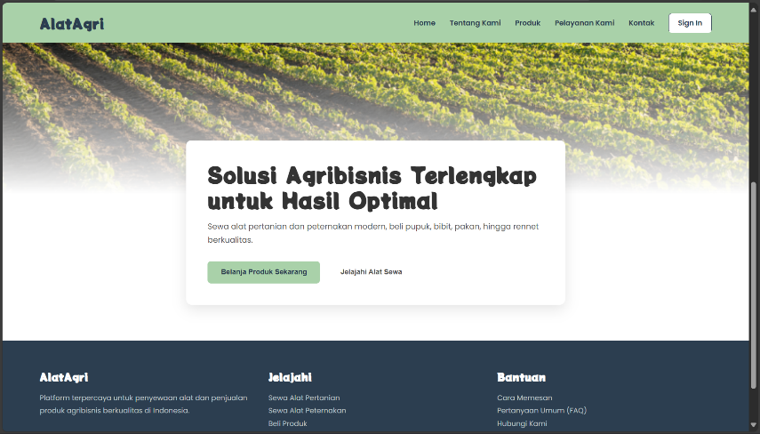
Gambar 1.1 Index.HTML
Analisa :
Pada pengimplementasi ini, saya sedikit mengubah bentuk bentuk agar visual lebih enak untuk dilihat dengan mengubah isi text biasa menjadi kedalam kotak serta tombol-tombolnya juga.
- Login.html
<!DOCTYPE html>
<html lang="en">
<head>
<meta charset="UTF-8">
<meta name="viewport" content="width=device-width, initial-scale=1.0">
<title>Login - AlatAgri</title>
<link rel="stylesheet" href="masuk-styles.css">
<link rel="stylesheet" href="https://cdnjs.cloudflare.com/ajax/libs/font-awesome/5.15.3/css/all.min.css">
</head>
<body>
<div class="auth-container">
<div class="auth-box">
<h1 class="title">AlatAgri</h1>
<form class="auth-form login-form">
<div class="input-group">
<i class="fas fa-at icon"></i>
<input type="text" placeholder="Masukan Username" required>
</div>
<div class="input-group">
<i class="fas fa-lock icon"></i>
<input type="password" placeholder="Masukan Password" required>
</div>
<a href="dashboard.html" class="btn-auth">Login</a>
</form>
<div class="extra-links">
<a href="register.html">Belum punya akun?</a>
<a href="index.html">Kembali</a>
</div>
</div>
</div>
</body>
</html>
Hasil Tampilan :
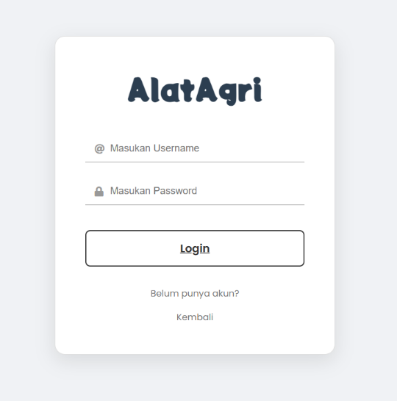
Gambar 1.2 Login.HTML
Analisa :
Setelah user menekan/meng-klik tombol Sign in, user akan diarahkan ke halaman login sama seperti alur pada prototype, jadi disini user akan memasukkan Username dengan Passwordnya agar bisa masuk di halaman dashboard. Jika belum memiliki akun, user bisa membuat akun dengan meng-klik “Belum punya akun?”, user juga bisa kembali ke halaman awal dengan meng-klik “Kembali”.
- Register.html
<!DOCTYPE html>
<html lang="en">
<head>
<meta charset="UTF-8">
<meta name="viewport" content="width=device-width, initial-scale=1.0">
<title>Register - AlatAgri</title>
<link rel="stylesheet" href="masuk-styles.css">
</head>
<body>
<div class="auth-container">
<div class="auth-box">
<h1 class="title">AlatAgri</h1>
<form class="auth-form register-form">
<div class="input-group">
<label for="username">Username</label>
<input id="username" type="text" placeholder="Masukan Username" required>
</div>
<div class="input-group">
<label for="password">Password</label>
<input id="password" type="password" placeholder="Masukan Password" required>
</div>
<div class="input-group">
<label for="email">E-mail</label>
<input id="email" type="email" placeholder="Masukan E-mail" required>
</div>
<button type="submit" class="btn-auth">Register</button>
</form>
<div class="extra-links">
<a href="login.html">Sudah punya akun? Login</a>
</div>
</div>
</div>
</body>
</html>
Hasil Tampilan :
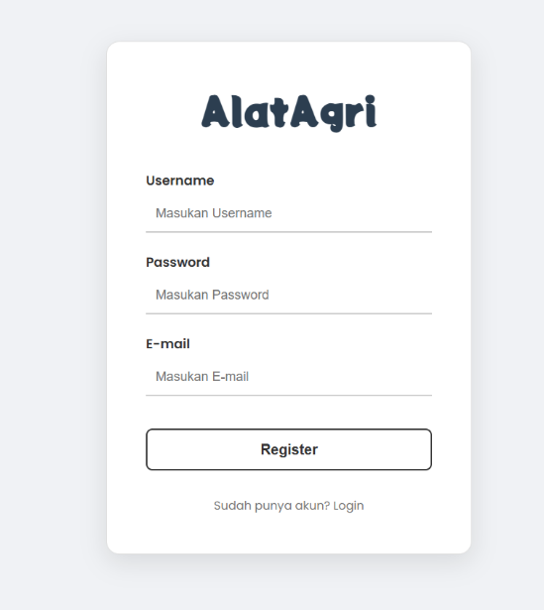
Gambar 1.3 Register.HTML
Analisa :
Jika User meng-klik “Belum punya akun?” pada halaman login, user akan diarahkan ke halaman ini. Yang dimana user bisa membuat akun baru dengan memasukkan Username, Password, dan E-mailnya
- Dasboard.html
<!DOCTYPE html>
<html lang="en">
<head>
<meta charset="UTF-8">
<meta name="viewport" content="width=device-width, initial-scale=1.0">
<title>Register - AlatAgri</title>
<link rel="stylesheet" href="masuk-styles.css">
</head>
<body>
<div class="auth-container">
<div class="auth-box">
<h1 class="title">AlatAgri</h1>
<form class="auth-form register-form">
<div class="input-group">
<label for="username">Username</label>
<input id="username" type="text" placeholder="Masukan Username" required>
</div>
<div class="input-group">
<label for="password">Password</label>
<input id="password" type="password" placeholder="Masukan Password" required>
</div>
<div class="input-group">
<label for="email">E-mail</label>
<input id="email" type="email" placeholder="Masukan E-mail" required>
</div>
<button type="submit" class="btn-auth">Register</button>
</form>
<div class="extra-links">
<a href="login.html">Sudah punya akun? Login</a>
</div>
</div>
</div>
</body>
</html>
Hasil Tampilan :
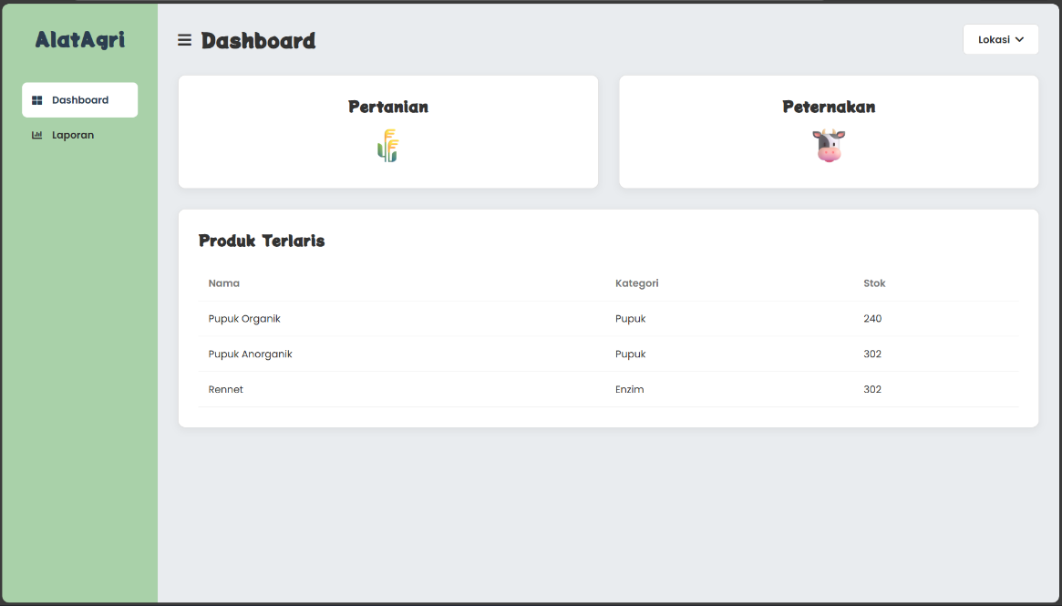
Gambar 1.4 dashboard.HTML
Analisa :
Setelah Login, admin akan langsung diarahkan ke halaman dashboard milik admin, desainnya mirip dengan prototype tapi hanya berbeda warna dan headernya. Disini user bisa mendapatkan mendapatkan Kesimpulan dari barang barang apa saja yang best seller, dan admin bisa menekan/meng-klik tombol peternakkan dan pertanian untuk bisa mengakses pelayanan serta produk dari masing-masing tombol.
- laporan.html
<!DOCTYPE html>
<html lang="en">
<head>
<meta charset="UTF-8">
<meta name="viewport" content="width=device-width, initial-scale=1.0">
<title>Register - AlatAgri</title>
<link rel="stylesheet" href="masuk-styles.css">
</head>
<body>
<div class="auth-container">
<div class="auth-box">
<h1 class="title">AlatAgri</h1>
<form class="auth-form register-form">
<div class="input-group">
<label for="username">Username</label>
<input id="username" type="text" placeholder="Masukan Username" required>
</div>
<div class="input-group">
<label for="password">Password</label>
<input id="password" type="password" placeholder="Masukan Password" required>
</div>
<div class="input-group">
<label for="email">E-mail</label>
<input id="email" type="email" placeholder="Masukan E-mail" required>
</div>
<button type="submit" class="btn-auth">Register</button>
</form>
<div class="extra-links">
<a href="login.html">Sudah punya akun? Login</a>
</div>
</div>
</div>
</body>
</html>
Hasil Tampilan :
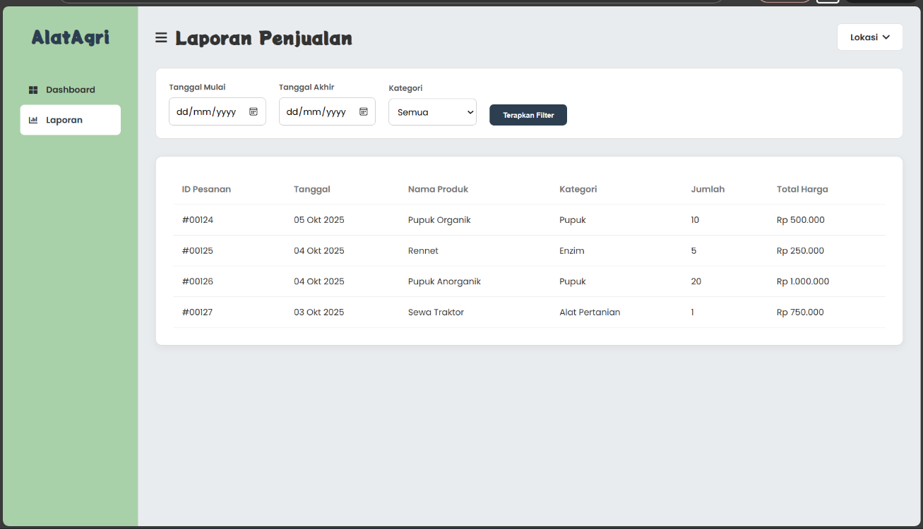
Gambar 1.5 laporan.HTML
Analisa :
Pada menu di samping kiri halaman dashboard, jika admin menekkan/klik menu laporan, admin akan di arahkan ke halaman laporan.html, disini admin bisa melihat kesimpulan dari produk-produk yang terjual.
- styles.css
@import url('https://fonts.googleapis.com/css2?family=Potta+One&family=Poppins:wght@400;600&display=swap');
* {
margin: 0;
padding: 0;
box-sizing: border-box;
}
body {
font-family: 'Poppins', sans-serif;
background-color: #ffffff;
padding-top: 90px;
}
.top-header {
display: flex;
align-items: center;
justify-content: space-between;
padding: 0.75rem 5%;
background-color: #A9D1A9;
min-height: 90px;
position: fixed;
top: 0;
left: 0;
width: 100%;
z-index: 1000;
}
.title {
font-family: 'Potta One', cursive;
font-size: 32px;
color: #2c3e50;
}
.top-header nav ul {
list-style: none;
display: flex;
align-items: center;
gap: 2rem;
}
.top-header nav ul li a {
color: #2c3e50;
text-decoration: none;
font-weight: 600;
padding: 8px 0;
border-bottom: 2px solid transparent;
transition: all 0.3s ease;
}
.top-header nav ul li a:hover {
color: #ffffff;
border-bottom-color: #ffffff;
}
.btn_signin {
background-color: white;
color: #2c3e50 !important;
padding: 10px 20px !important;
border-radius: 8px;
border: 1px solid #2c3e50;
}
.btn_signin:hover {
background-color: #f0f0f0;
border-bottom-color: transparent !important;
}
.hero-image img {
background-image: url('Foto.png');
background-size: cover;
background-position: center center;
background-repeat: no-repeat;
width: 100%;
min-height: 700px;
position: relative;
color: white;
display: flex;
justify-content: center;
align-items: center;
text-align: center;
flex-direction: column;
}
.hero-image img::after{
content: '';
position: absolute;
bottom: 0;
left: 0;
width: 100%;
height: 20%;
background: linear-gradient(to top, white, transparent);
z-index: 1;
}
.hero-content {
background-color: white;
color: #333;
padding: 3rem;
border-radius: 12px;
box-shadow: 0 10px 30px rgba(0, 0, 0, 0.1);
max-width: 850px;
text-align: left;
position: relative;
z-index: 5;
margin: -120px auto 80px auto;
}
.hero-content h1 {
font-family: 'Potta One', cursive;
font-size: 3rem;
line-height: 1.2;
margin-bottom: 1rem;
}
.hero-content p {
font-size: 1.1rem;
line-height: 1.7;
margin-bottom: 2rem;
color: #555;
}
.hero-buttons {
display: flex;
gap: 1rem;
}
.hero-buttons button {
padding: 14px 28px;
border-radius: 8px;
font-weight: 600;
cursor: pointer;
font-size: 1rem;
border: 2px solid transparent;
transition: all 0.3s ease;
}
.btn-primary {
background-color: #A9D1A9;
color: #2c3e50;
}
.btn-primary:hover {
background-color: #98bf99;
}
.btn-secondary {
background-color: white;
color: #555;
border-color: #ddd;
}
.btn-secondary:hover {
background-color: #f5f5f5;
border-color: #ccc;
}
.footer {
background-color: #2c3e50;
color: #f0f0f0;
padding: 4rem 5% 2rem 5%;
}
.footer-grid {
display: grid;
grid-template-columns: repeat(auto-fit, minmax(250px, 1fr));
gap: 2rem;
margin-bottom: 3rem;
}
.footer-column h3 {
font-family: 'Potta One', cursive;
font-size: 1.5rem;
margin-bottom: 1rem;
color: white;
}
.footer-column p, .footer-column a {
color: #bdc3c7;
text-decoration: none;
line-height: 1.8;
}
.footer-column ul {
list-style: none;
}
.footer-column a:hover {
color: white;
}
.footer-bottom {
text-align: center;
padding-top: 2rem;
border-top: 1px solid #34495e;
color: #7f8c8d;
}
.hero-image {
position: relative;
}
.hero-image::after {
content: '';
position: absolute;
bottom: 0;
left: 0;
width: 100%;
height: 30%;
background: linear-gradient(to top, white, transparent);
}
- masuk-styles.css
/* --- Global & Font Setup --- */
@import url('https://fonts.googleapis.com/css2?family=Potta+One&family=Poppins:wght@400;600&display=swap');
* {
margin: 0;
padding: 0;
box-sizing: border-box;
}
body {
font-family: 'Poppins', sans-serif;
background-color: #f0f2f5;
display: flex;
justify-content: center;
align-items: center;
height: 100vh;
}
/* --- KOTAK UTAMA (untuk Login & Register) --- */
.auth-container {
display: flex;
justify-content: center;
align-items: center;
width: 100%;
}
.auth-box {
background-color: white;
padding: 3rem;
border-radius: 16px;
box-shadow: 0 10px 30px rgba(0, 0, 0, 0.1);
width: 100%;
max-width: 450px;
text-align: center;
border: 1px solid #e0e0e0;
}
.auth-box .title {
font-family: 'Potta One', cursive;
font-size: 3rem;
margin-bottom: 2.5rem;
color: #2c3e50;
}
/* --- Form Styling (Umum) --- */
.auth-form {
display: flex;
flex-direction: column;
gap: 1.5rem;
}
.input-group {
position: relative;
display: flex;
align-items: center;
}
.auth-form input {
width: 100%;
padding: 12px;
border: none;
border-bottom: 2px solid #ccc;
font-size: 1rem;
transition: border-color 0.3s ease;
}
.auth-form input:focus {
outline: none;
border-bottom-color: #A9D1A9;
}
.btn-auth {
background-color: white;
color: #333;
padding: 14px;
border-radius: 8px;
border: 2px solid #333;
font-size: 1.1rem;
font-weight: 600;
cursor: pointer;
transition: all 0.3s ease;
margin-top: 1rem;
}
.btn-auth:hover {
background-color: #2c3e50;
color: white;
border-color: #2c3e50;
}
/* --- GAYA KHUSUS LOGIN --- */
.login-form .input-group .icon {
position: absolute;
left: 15px;
color: #999;
}
.login-form .input-group input {
padding-left: 40px;
}
.register-form {
text-align: left;
}
.register-form .input-group {
flex-direction: column;
align-items: flex-start;
gap: 0.5rem;
}
.register-form .input-group label {
font-weight: 600;
color: #333;
}
.extra-links {
margin-top: 2rem;
display: flex;
flex-direction: column;
gap: 1rem;
}
.extra-links a {
color: #777;
text-decoration: none;
font-size: 0.9rem;
}
.extra-links a:hover {
text-decoration: underline;
}
- dashboard-styles.css
@import url('https://fonts.googleapis.com/css2?family=Potta+One&family=Poppins:wght@400;600;700&display=swap');
* {
margin: 0;
padding: 0;
box-sizing: border-box;
}
body {
font-family: 'Poppins', sans-serif;
background-color: #f0f2f5;
color: #333;
}
.dashboard-container {
display: flex;
min-height: 100vh;
}
.sidebar {
width: 250px;
background-color: #A9D1A9;
padding: 2rem;
display: flex;
flex-direction: column;
}
.sidebar-header .title {
font-family: 'Potta One', cursive;
font-size: 2rem;
color: #2c3e50;
text-align: center;
margin-bottom: 3rem;
}
.sidebar-nav ul {
list-style: none;
}
.sidebar-nav ul li a {
display: flex;
align-items: center;
gap: 1rem;
padding: 1rem;
color: #333;
text-decoration: none;
font-weight: 600;
border-radius: 8px;
transition: background-color 0.3s ease;
}
.sidebar-nav ul li.active a,
.sidebar-nav ul li a:hover {
background-color: white;
color: #2c3e50;
}
.main-content {
flex-grow: 1;
padding: 2rem;
background-color: #e9ecef;
}
.main-header {
display: flex;
justify-content: space-between;
align-items: center;
margin-bottom: 2rem;
}
.header-left {
display: flex;
align-items: center;
gap: 1rem;
}
.header-left .menu-toggle {
font-size: 1.5rem;
cursor: pointer;
}
.header-left h2 {
font-family: 'Potta One', cursive;
font-size: 2rem;
}
.location-dropdown {
background-color: white;
padding: 0.75rem 1.5rem;
border-radius: 8px;
border: 1px solid #ddd;
font-weight: 600;
cursor: pointer;
display: flex;
align-items: center;
gap: 0.5rem;
}
.cards-container {
display: grid;
grid-template-columns: repeat(auto-fit, minmax(250px, 1fr));
gap: 2rem;
margin-bottom: 2rem;
}
.card {
background-color: white;
padding: 2rem;
border-radius: 12px;
border: 1px solid #ddd;
box-shadow: 0 4px 12px rgba(0,0,0,0.05);
text-align: center;
}
.card h3 {
font-family: 'Potta One', cursive;
font-size: 1.5rem;
margin-bottom: 1rem;
}
.card img {
height: 60px;
object-fit: contain;
}
.products-table {
background-color: white;
padding: 2rem;
border-radius: 12px;
border: 1px solid #ddd;
box-shadow: 0 4px 12px rgba(0,0,0,0.05);
}
.products-table h3 {
font-family: 'Potta One', cursive;
font-size: 1.5rem;
margin-bottom: 1.5rem;
}
.products-table table {
width: 100%;
border-collapse: collapse;
text-align: left;
}
.products-table th, .products-table td {
padding: 1rem;
border-bottom: 1px solid #eee;
}
.products-table thead th {
font-weight: 600;
color: #777;
}
.filters {
display: flex;
flex-wrap: wrap;
align-items: flex-end;
gap: 1.5rem;
background-color: white;
padding: 1.5rem;
border-radius: 12px;
margin-bottom: 2rem;
border: 1px solid #ddd;
}
.filter-group {
display: flex;
flex-direction: column;
gap: 0.5rem;
}
.filter-group label {
font-size: 0.9rem;
font-weight: 600;
color: #555;
}
.filter-group input,
.filter-group select {
padding: 0.75rem;
border: 1px solid #ccc;
border-radius: 8px;
font-family: 'Poppins', sans-serif;
font-size: 1rem;
}
.btn-filter {
padding: 0.75rem 1.5rem;
border: none;
background-color: #2c3e50;
color: white;
font-weight: 600;
border-radius: 8px;
cursor: pointer;
transition: background-color 0.3s ease;
}
.btn-filter:hover {
background-color: #34495e;
}
.report-table {
background-color: white;
padding: 2rem;
border-radius: 12px;
border: 1px solid #ddd;
box-shadow: 0 4px 12px rgba(0,0,0,0.05);
overflow-x: auto;
}
.report-table table {
width: 100%;
border-collapse: collapse;
text-align: left;
}
.report-table th, .report-table td {
padding: 1rem;
border-bottom: 1px solid #eee;
vertical-align: middle;
}
.report-table thead th {
font-weight: 600;
color: #777;
white-space: nowrap;
}

