Professional Practice And Employability, Team Based Software Development Workshop

CS2S567

Kavell Long 30004171 – Team 1 Payroll system

Individual portfolio

Contents

Team 1 2

Week 1-2 (28/09/21 – 05/10/21) 2

Week 3-4 (12/10/21 – 19/10/21) 3

Week 5-6 (26/10/21 – 02/11/21) 4

Week 7-8 (09/11/21 – 16/11/12) 4

Week 9-10 (23/11/21 – 30/11/21) 5

Week 11 (07/12/21) 6

Appendix – Evidence 6

Week 1: 6

Week 2 6

Week 3 7

Week 4 11

Week 5 13

Week 6 14

Week 7 15

Week 8 16

Week 9 17

Week 10 17

Week 11 17

* .

# Team 1

|  |  |
| --- | --- |
| Team Number | 1 |
| Team Task | To plan and create a GUI payroll system |
| Own role(s) and team tasks | Role:   * Team member * Team leader   Tasks:   * Get information on needs/wants of business and aesthetic details * Research payroll systems * Pseudocode * Flow charts * GUI design * Create the code |

# Week 1-2 (28/09/21 – 05/10/21)

This week we formed the group, created a group name, and began initial planning for our project choice.

|  |  |
| --- | --- |
| Week 1 | Own |
| Activities undertaken | * Formed group and group name |
| Outcome of QA activities | Our group name was decided |
| Activities resulting from QA process | We are Group 1 – Team 1 |
| Personal QA development | NA |
| Evidence of own activities | NA |

|  |  |
| --- | --- |
| Week 2 | Own |
| Activities undertaken | * Creation of Trello board with Tom |
| Outcome of QA activities | During this week Tom and I created the main Trello board for the whole team to collaborate on |
| Activities resulting from QA process | This gave us a space to work a place to work and have to do lists so we will not miss any deadlines etc |
| Personal QA development | This week showed me different methods of collaboration and I learnt how to use Trello to the best of its ability in order to keep us all on track |
| Evidence of own activities | See appendix – week 2 |

# Week 3-4 (12/10/21 – 19/10/21)

|  |  |
| --- | --- |
| Week 3 | Own |
| Activities undertaken | * Colour scheme research * Find logo for business and make it a PNG |
| Outcome of QA activities | I researched on Google what possible colour schemes would go together for our system, I considered which colours would clash and how they would be for people who cannot see colours normally  I also got our team logo and made it into a PNG (transparent) so it would be seamless on the system |
| Activities resulting from QA process | This led to us using mostly blue colours as they are less harsh on the eyes |
| Personal QA development | The research that was conducted showed me how important colour stories are and how some people can see colours differently to myself |
| Evidence of own activities | See appendix – week 3 |

|  |  |
| --- | --- |
| Week 4 | Own |
| Activities undertaken | * Researched example payroll systems in Python * Begun to learn Python basics |
| Outcome of QA activities | I researched some examples of a Python GUI payroll system on Google to see if there were any available to inspiration and that would help better fit what we wanted for our system  I also watched a few videos on YouTube to try gain a little more knowledge on Python |
| Activities resulting from QA process | This resulted in me finding an example of how to work out a person’s payslip and found an example on Blackboard which could be amended to fit what we want |
| Personal QA development | I learnt how to do the basics of Python and used previous coding knowledge to fill in the gaps to be able to start the code |
| Evidence of own activities | See appendix – week 4 |

# Week 5-6 (26/10/21 – 02/11/21)

|  |  |
| --- | --- |
| Week 5 | Own |
| Activities undertaken | * Continue to edit code to fit GUI design * Needed help with code from 3rd year PASS leaders |
| Outcome of QA activities | Following the weeks prior research, coding was continued and when I got stuck, I asked for help from someone from the 3rd year who has both completed this module and is proficient with Python |
| Activities resulting from QA process | This resulted in me getting the help I needed and was able to resolve my issue – which was a picture would not appear in some of the tables in some places but would in others |
| Personal QA development | This week expanded my knowledge and challenged me to produce something in a short period of time |
| Evidence of own activities | See appendix – week 5 |

|  |  |
| --- | --- |
| Week 6 | Own |
| Activities undertaken | * Continue to edit code to fit GUI design * Took part in seminar * Watched G2T1 |
| Outcome of QA activities | I continued to expand my knowledge and add elements to our system that we could showcase in our Seminar  The group met up mid-week to finalise the PowerPoint for our seminar then we presented as part of the first lot of groups to present |
| Activities resulting from QA process | This resulted in us having a good amount to be able to showcase what we have achieved thus far |
| Personal QA development | This helped develop my skills to present in front of a group |
| Evidence of own activities | See appendix – week 6 |

# Week 7-8 (09/11/21 – 16/11/12)

|  |  |
| --- | --- |
| Week 7 | Own |
| Activities undertaken | * Peter joined me to collaborate with coding * Watched G2T2 and G1T2 * Caught up with feedback forms |
| Outcome of QA activities | I helped with the feedback form for G2T1 |
| Activities resulting from QA process | This helped me improve on our code as they were good at Python |
| Personal QA development | I learnt a lot from G2T1 regarding Python because they fully explained what libraries they used and why – this was useful to me because it showed me different kinds of libraries that can be used |
| Evidence of own activities | See appendix – week 7 |

|  |  |
| --- | --- |
| Week 8 | Own |
| Activities undertaken | * All caught up with feedback forms * Watched G1T3, G1T4, G3T1 |
| Outcome of QA activities | Evaluating other seminars showed me techniques that I could include in my own and showed me things I know I shouldn’t include |
| Activities resulting from QA process | I learnt that I should not face the board while presenting as my voice may not be heard |
| Personal QA development | I learnt how to and how not to present from this week |
| Evidence of own activities | See appendix – week 8 |

# Week 9-10 (23/11/21 – 30/11/21)

|  |  |
| --- | --- |
| Week 9 | Own |
| Activities undertaken | * All caught up with feedback forms * Seminar cancelled |
| Outcome of QA activities | Same as previous week. |
| Activities resulting from QA process | Same as previous week. |
| Personal QA development | Same as previous week. |
| Evidence of own activities | See appendix – week 9 |

|  |  |
| --- | --- |
| Week 10 | Own |
| Activities undertaken | * Finishing our portfolios. * Quality insurance on work. * We also had other assignments coming up so used some of this time to complete them   We had a call about the start of phase 2 |
| Outcome of QA activities | I learnt about the different types of hackers and how they impact different projects |
| Activities resulting from QA process | This has inspired to what I could include into our next seminar |
| Personal QA development | It gave me insight onto what the different uses are for people like ethical hackers |
| Evidence of own activities | See appendix – week 10 |

# Week 11 (07/12/21)

|  |  |
| --- | --- |
| Week 11 | Own |
| Activities undertaken | * Quality assurance and portfolio writing ensuring there is adequate evidence. |
| Outcome of QA activities | Portfolios were completed |
| Activities resulting from QA process | Portfolios were completed |
| Personal QA development | Completing the portfolio showed me what it would be like in the real world to work my way through a project |
| Evidence of own activities | See appendix – week 11 |

# Appendix – Evidence

## Week 1:

N/A

## Week 2

Kavell: Personal account on Trello

## Week 3

Group: team leader organisation

Kavell: Research colour scheme

Group: logo found and made into a PNG

## Week 4

Kavell: researched example payroll systems and learnt Python basics

Kavell: Gantt chart

## Week 5

Kavell: consulting year 3 for help with Python

## Week 6

All: met up to rehearse seminar

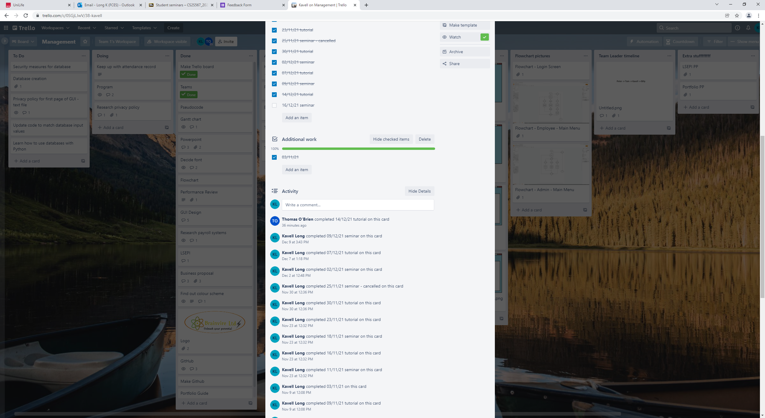

## Week 7

All: Completing feedback form

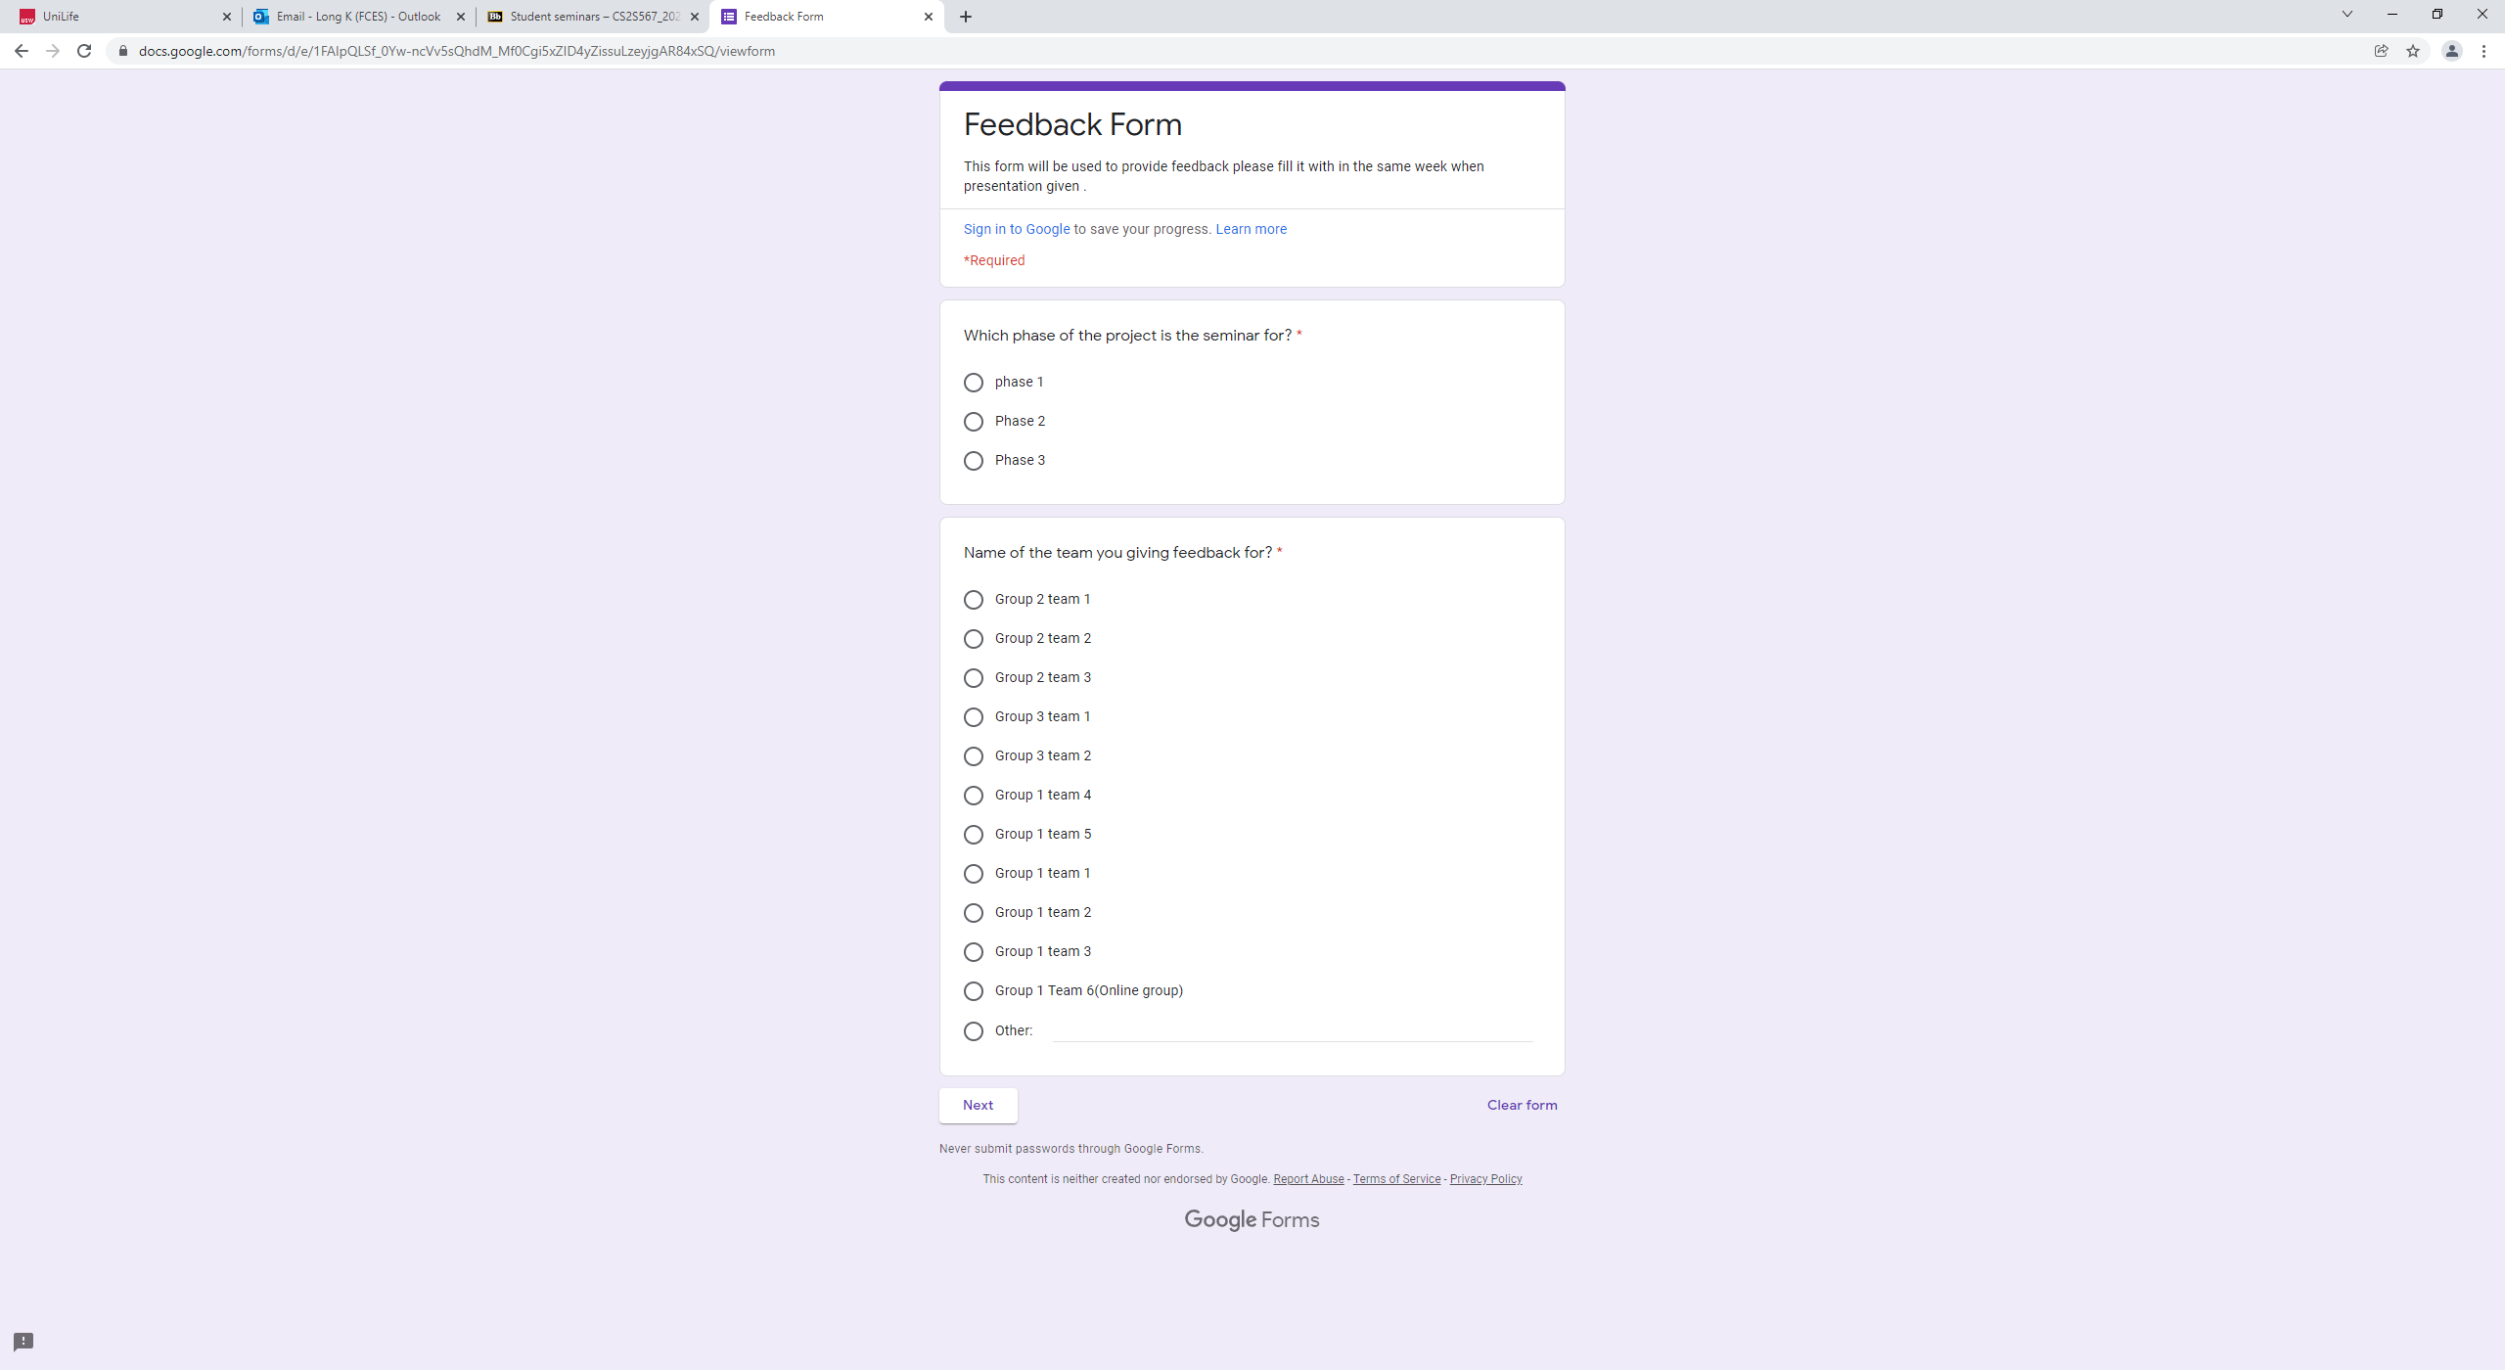

## Week 8

NA

## Week 9

NA

## Week 10

NA

## Week 11

Tom/ Kavell: Ensuring adequate evidence:

