**Having a look of the result of parser by our program.**

**Following are part of screen shot on program.**

**Run ”fact.n”:**

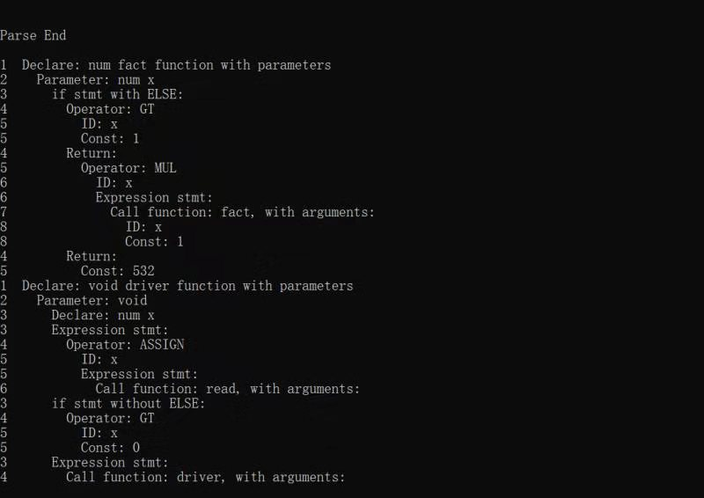

**Run ”arrayMaxMean.n”:**

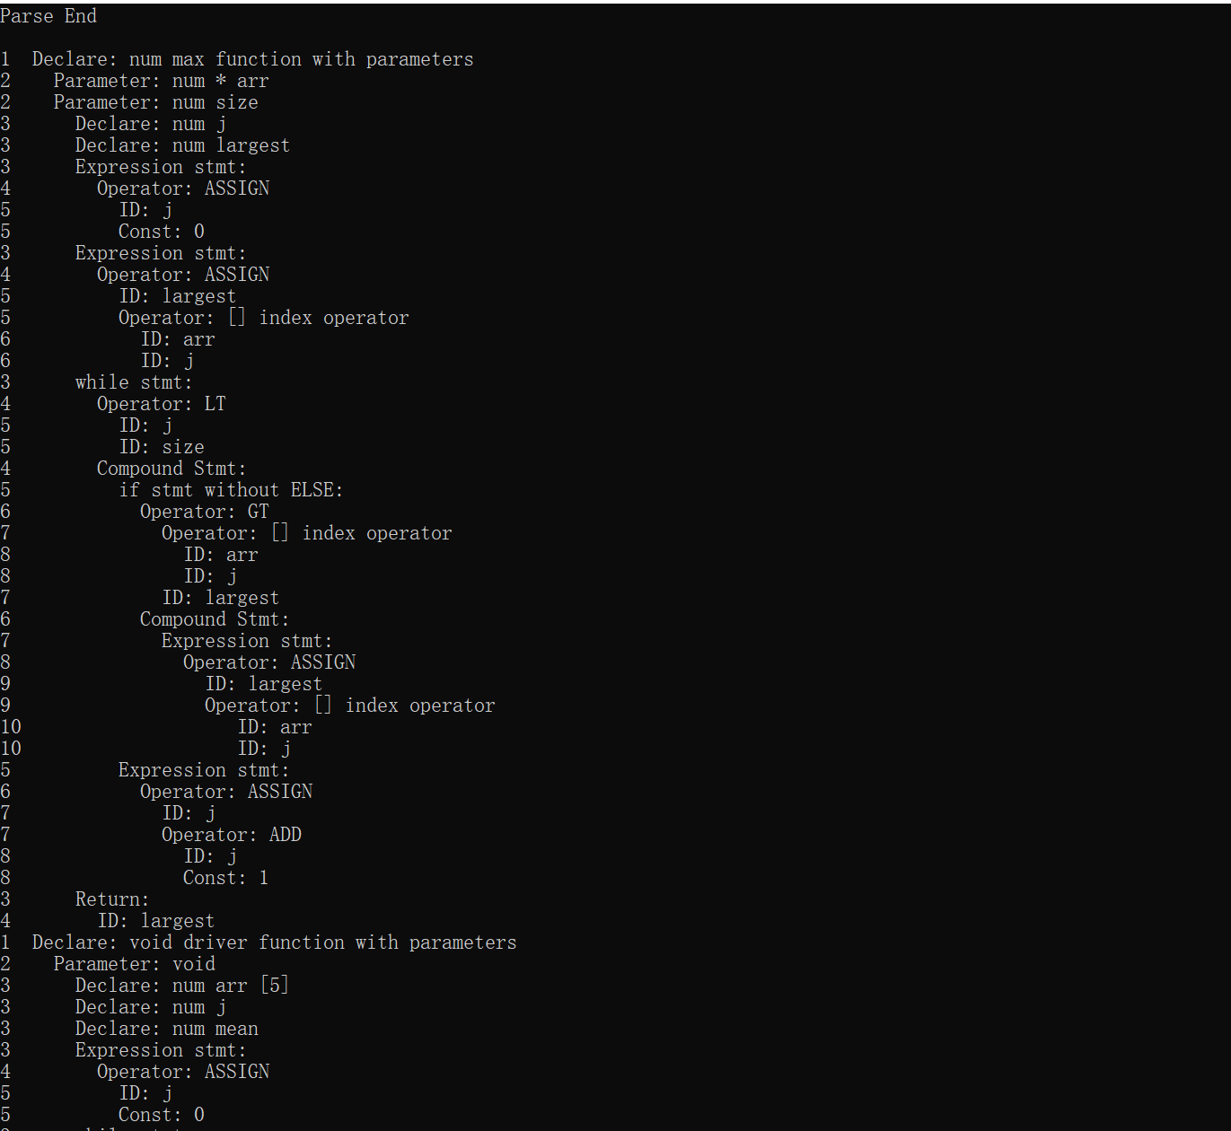

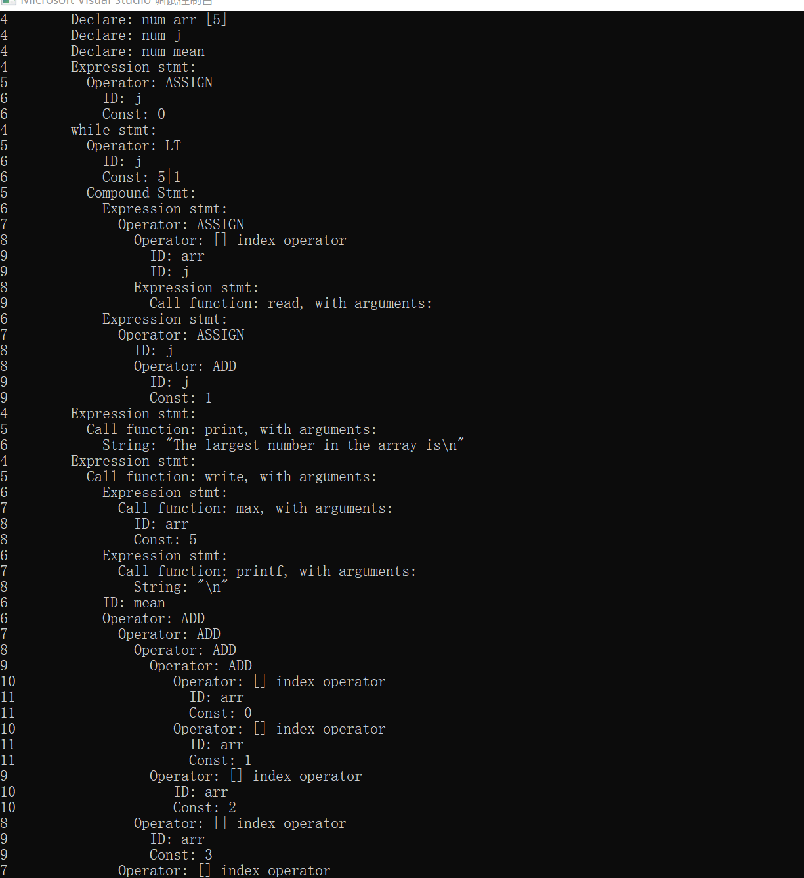

**Run “sum100.n”(on mac book)**

(sacnner part is above and the screen shot is the parser part):

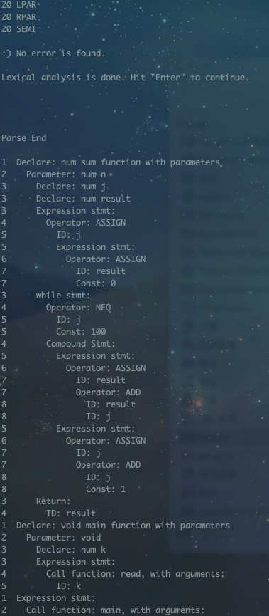

**Run ”selection_sort.n”:**

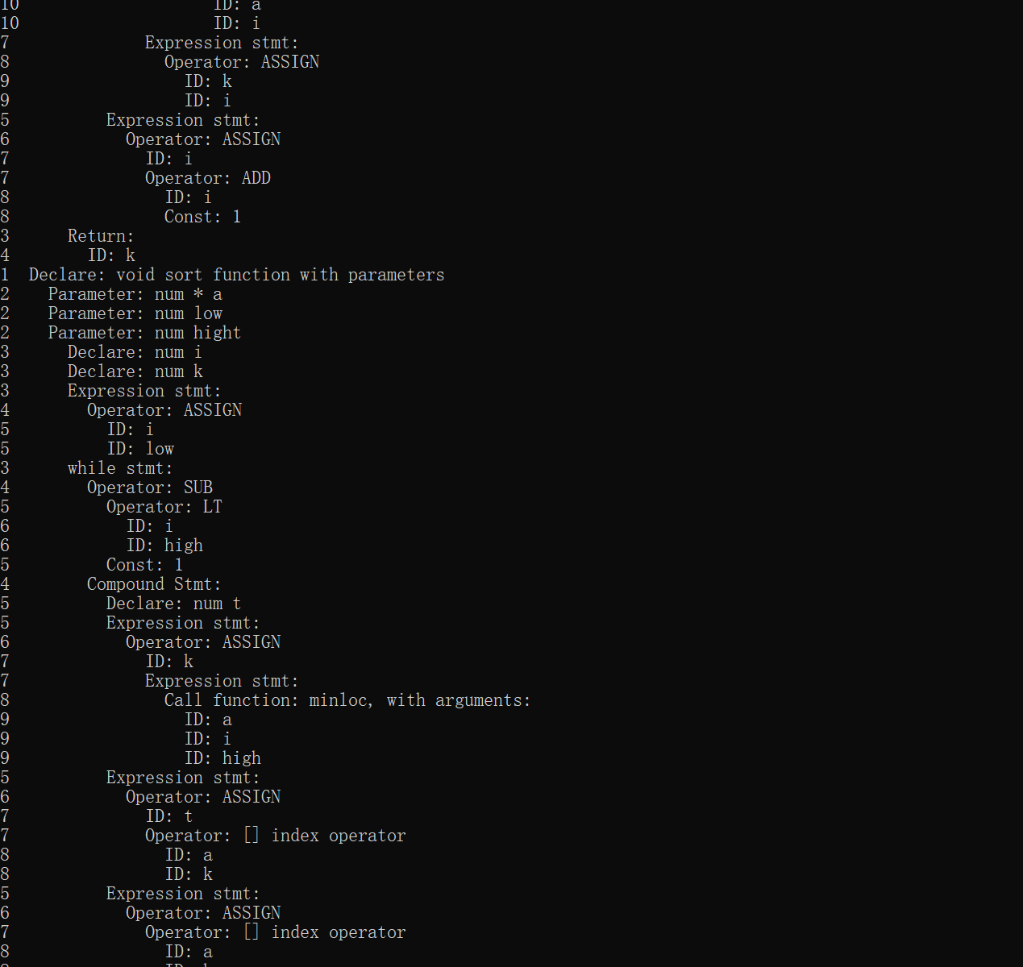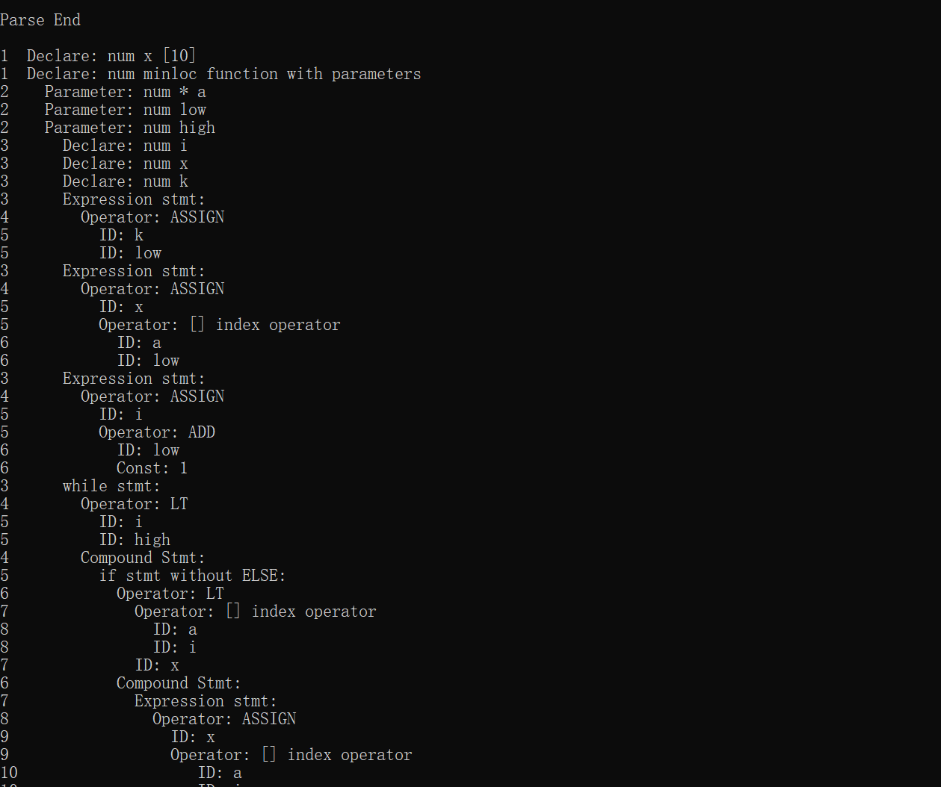

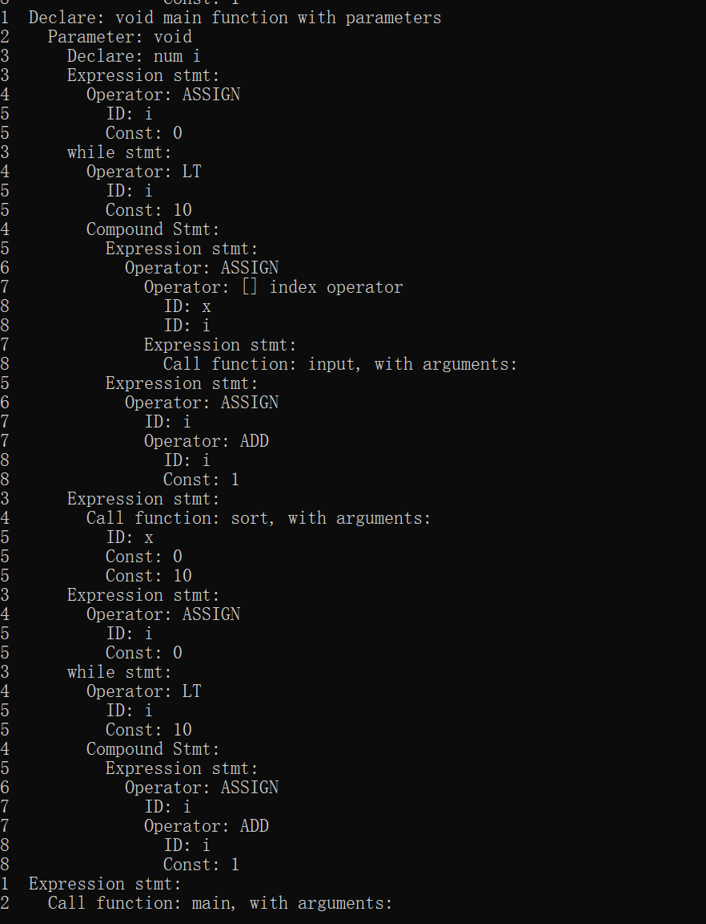

If you have any questions:

Please contact LEI RUIJIA

1. mail:1709853ui011001@student.must.edu.mo

Wechat: 雷枘佳（Number：lrj244737137）