Demo player configuration

Hardware configuration:

List:
TWR-DOCK2 (or TWR-DOCK + TWR-AUDIO-SGTL )
TWR-K22F120M
5V DC Adapter

TWR-K22F120M Board Jumpers:

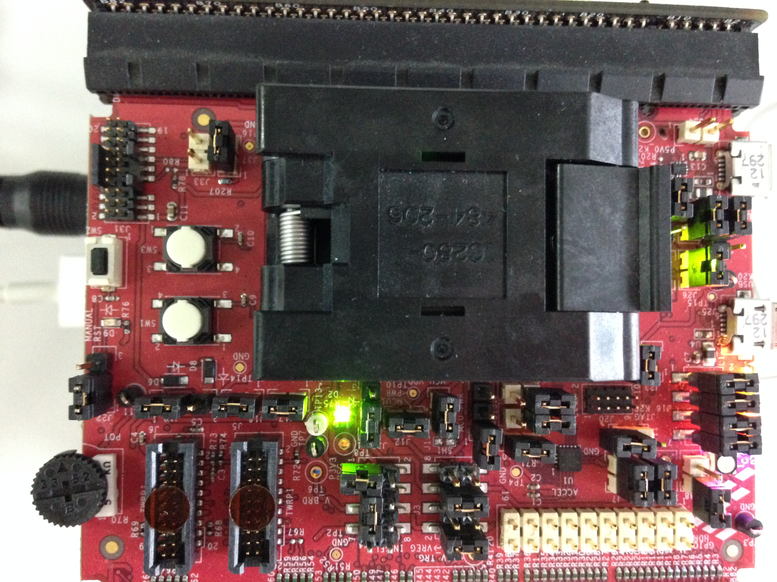
TWR-DOCK2 Board Jumpers:

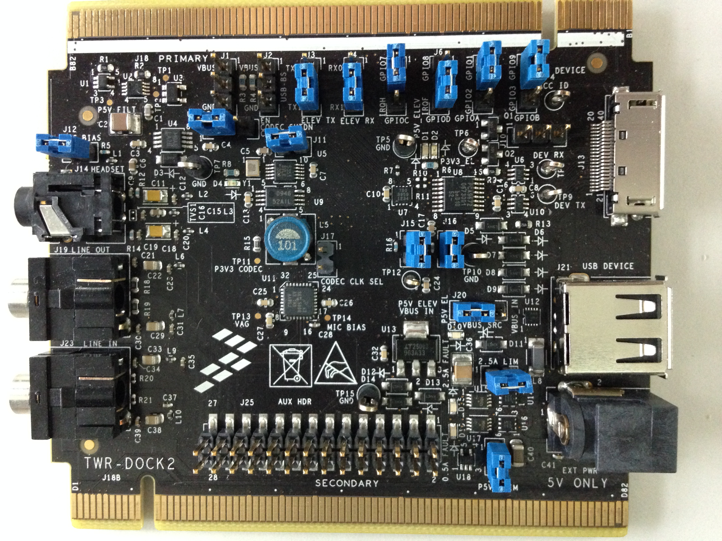

TWRER Assemble Picture:

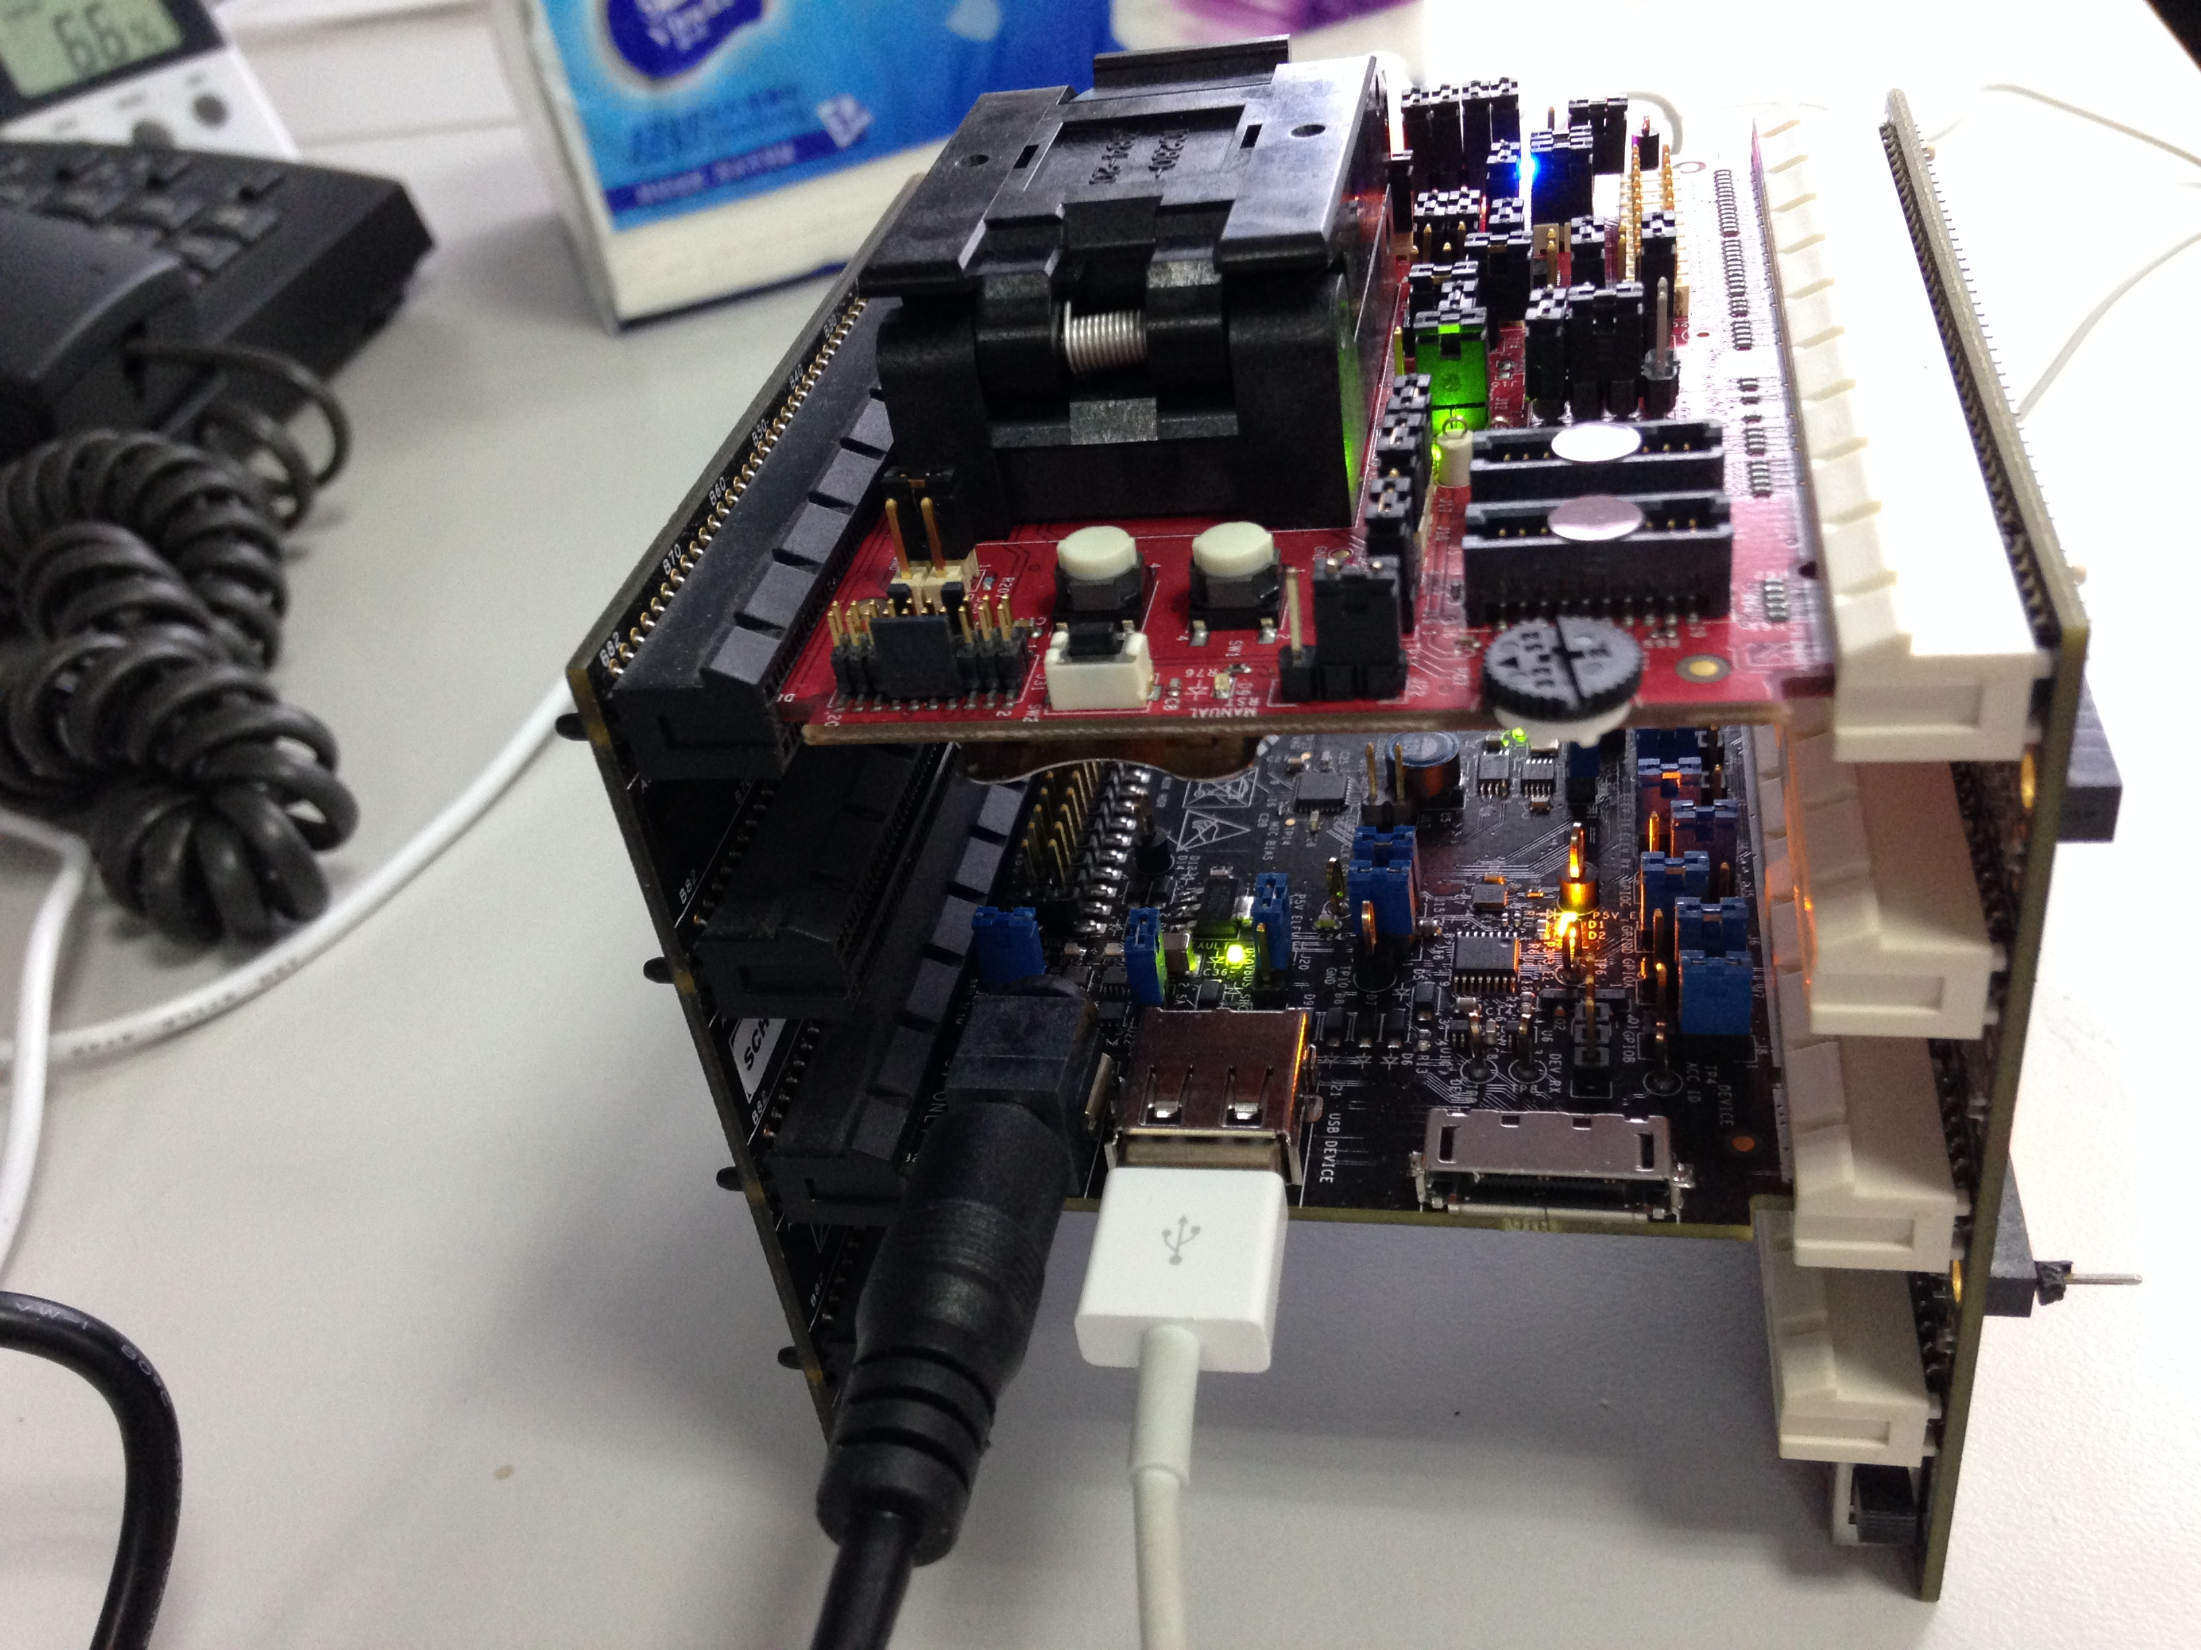

TWR-DOCK Power Adapter Picture:



