How to Reach Us:

Home Page:
www.freescale.com

Web Support:
http://www.freescale.com/support

Information in this document is provided solely to enable system and software implementers to use Freescale products. There are no express or implied copyright licenses granted hereunder to design or fabricate any integrated circuits based on the information in this document.

Freescale reserves the right to make changes without further notice to any products herein. Freescale makes no warranty, representation, or guarantee regarding the
suitability of its products for any particular purpose, nor does Freescale assume any liability arising out of the application or use of any product or circuit, and specifically disclaims any and all liability, including without limitation consequential or incidental
damages. “Typical” parameters that may be provided in Freescale data sheets and/or specifications can and do vary in different applications, and actual performance may vary over time. All operating parameters, including “typicals,” must be validated for each customer application by customer’s technical experts. Freescale does not convey any license under its patent rights nor the rights of others. Freescale sells products pursuant to standard terms and conditions of sale, which can be found at the following address: freescale.com/SalesTermsandConditions

Freescale and the Freescale logo are trademarks of Freescale Semiconductor, Inc., Reg. U.S. Pat. & Tm. Off.
All other product or service names are the property of their
respective owners.
© 2008-2014 Freescale Semiconductor, Inc. All rights reserved.

Introduction

SP140/141 is Qualocmm Atheros internet of everything(IOE) development platform. It uses the Qualcomm Atheros QCA4002 1x1 single band 802.11 a/b/g/n Wi-Fi SoC and operates on 2.4GHz band only. Qualocmm Atheros also provides development kit for this platform, while this guide tell you how to porting this development kit to Freescale TWR-K22F120M board. Before you doing the porting, please download SP140/141 development kit from https://developer.qualcomm.com/mobile-development/development-devices/ioe-wifi-development-platform/tools-and-resources, current development kit version is 3.0.2, this kit has include release notes and quick start guide, please read those Qualcomm Atheros documents firstly.
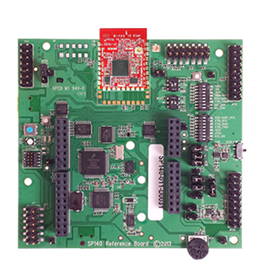
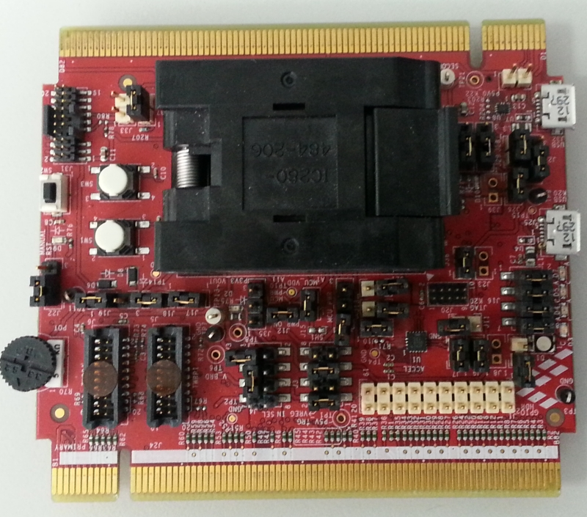

SP140/141
TWR-K22F120M

Preparing Hardware
This portting consists of the following hardware:
- TWR-SHIELD is on top .
- Qualcomm Atheros Wi-Fi GT202 carrier board seated in the TWR-SHIELD headers.
- TWR-K22F120M .
- TWR-ELEV.
- TWR-SER.

The jumper and hardware changes required are detailed below for each board.

2.1 TWR-SHIELD Setup.
The TWR-SHIELD board comes without the headers populated, and the default connects are shorted with traces on the board.

- Remove resistor R81, next to J3, removes conflict between TWRK22F120M ADC0_DM0 and GT202 module HM0/SDIO_D2/LED/i2S1_SDI
- Leave Default J82 on 1-2, for Wi-Fi Power Down signal D8 (PWR)
- Leave Default J74 on 1-2, Wi-Fi SPI Chip Select D10 ( CS: this map to TWRK22F120M SPI0 CS1 ,at TWR-SHILED board, this signal name is still named as CS0 D10/SPI_CS )
- Leave Default - Jumper J65 on 1-2, Wi-Fi SPI Clock D13
- Leave Default - Jumper J73 on 1-2, Wi-Fi SPI MOSI D11
- Leave Default - Jumper J81 on 1-2, Wi-Fi SPI MISO D12
- Leave Default - Jumper J83 on 1-2, Wi-Fi SPI Data Ready signal D7 (INT)

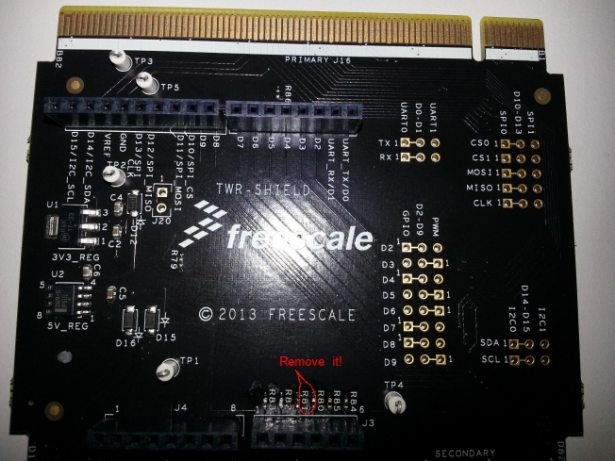

2.2 QCA GT202 Setup .

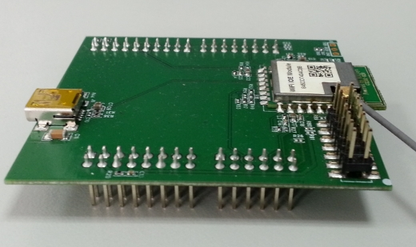

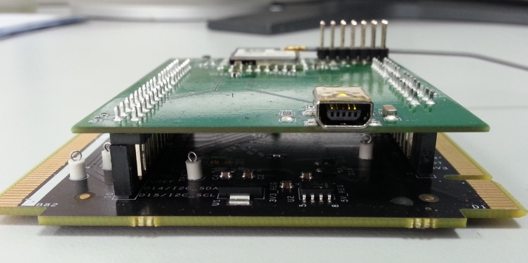

TWR-SHIELD with GT202 Board

2.3 TWR-K22F120M Setup.

- LED Connections J16 1-2 Need Jumper (Default)
3-4 Need Jumper (Default)
5-6 Need Jumper (Default)
7-8 Need Jumper (Default)
- Route Debug UART port from OpenSDA to TWR-SER.
UART RX Selection J29 1-2 Need Jumper(None Default)
UART TX Selection J30 1-2 Need Jumper(None Default)

Default debug UART output is not through OpenSDA port.

2.4 TWR-SER Setup
Default jumper settings will work.
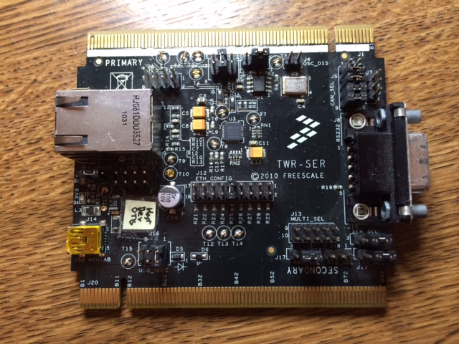

Default debug UART output is through TWR-SER RS232/485 Connector.

2.5 Assemble Tower.
The ordering of the cards in the Tower slots is not functionally important, but this is the recommended order for this.
- TWR-SHIELD is on top, with the Qualcomm GT202 carrier board seated in the TWR-SHIELD headers
- TWR-K22F120M
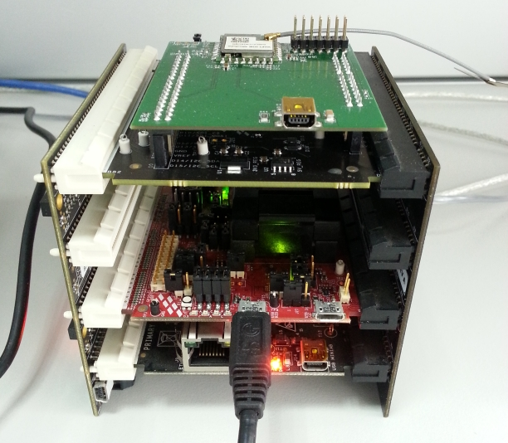
- TWR-SER on the bottom

Preparing development kit.
Original Qualcomm Atheros development kit is for SP140/SP141 , for SP140 it is based on MCU MK22FN1M0 and OS MQX4.0.2. While TWR-K22F120M equip with MCU PK22FN512 is a newer platform, MQX4.0.2 can't support it. PK22FN512 software development kit is based on MQX4.1, now it is in a per-release status. So Freescale MCU AE team will provide a patch which will enable Qualcomm Atheros development kit run on TWR-K22F120M.

3.1 Get development kit all parts.
The Original Qualcomm Atheros development kit every part.
- FSLMQXOS_4_0_2_GA.exe
- FSLMQXOS_4_0_2_TWRK21F120M.exe
- Install_MQX4.0.2_Patches_QCA3.0.2CS.exe
- Setup_MQX4.0.2_3.0.2CS.exe
Parts 1 ~ 3 download from Freescale website which provide MQX and SP140 board MQX BSP, Part 4 download from developer.qualcomm.com which provides SP140/SP141 driver and some demo codes.

TWR-K22F120M based Qualcomm Atheros development kit every part.
- MQX OS : FSLMQXOS_4_1_0_GA.exe which download from Freescale website. See below.
http://www.freescale.com/webapp/sps/site/prod_summary.jsp? code=MQX&fpsp=1&tab=Design_Tools_Tab
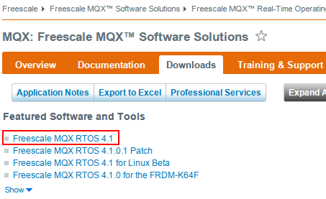

- Qualcomm Atheros drivers and demos: Setup_MQX4.0.2_3.0.2CS.exe it is include in pdk3.0.2-141.zip which can be download from developer.qualcomm.com. See below.
https://developer.qualcomm.com/mobile-development/development-devices/ioe-wifi-development-platform/tools-and-resources
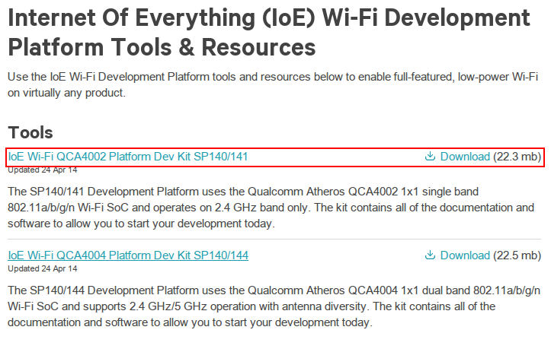

- qcapatch.tar.bz2 which include TWR-K22F120M MQX4.1 BSP & Qualcomm Atheros GT202 board support files.

3.2 Install development kit all parts.

Install FSLMQXOS_4_1_0_GA.exe, the default install directory is
C:\Freescale\Freescale_MQX_4_1
Install Setup_MQX4.0.2_3.0.2CS.exe, please install this to the same directory as
FSLMQXOS_4_1_0_GA.exe.
Install qcapatch.tar.bz2, please extract this file manually to the same directory as
FSLMQXOS_4_1_0_GA.exe.

3.3 Build Qualcomm Atheros Demos and Alljoyn Demos under Linux .

3.3.1 Copy development kit install directory to Linux file system .

3.3.2 Download and install cross compile tool chain from launchpad.net. See below
https://launchpad.net/gcc-arm-embedded, Please download 4.8-2014q1 as below picture.
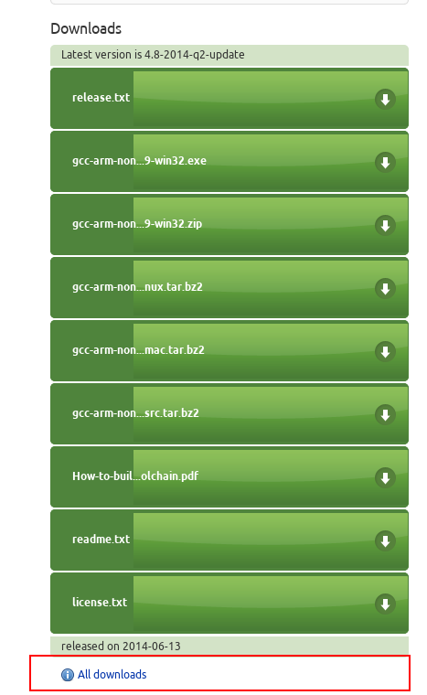
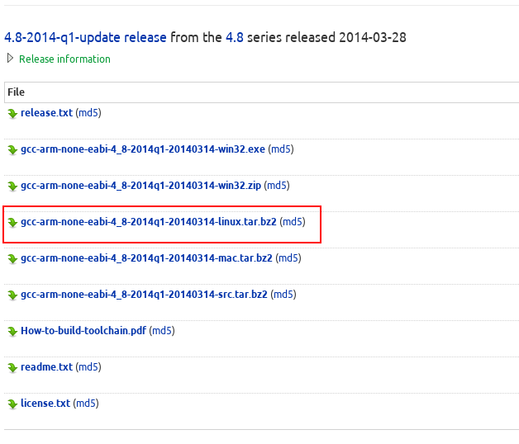

3.3.3 Update build environment.
Under development kit install directory, find the file “Makefile” change TOOLCHAIN_ROOTDIR to your cross compile tool chain install directory.

3.3.4 Development kit build process.
Under development kit install directory
$./build.sh twrk22_qca4002 debug base_build #which build MQX PSP BSP MFS SHELL RTCS components.
$./build.sh twrk22_qca4002 debug qca_build #which build Qualcomm Atheros throughput and firmware update demos.
$./build.sh twrk22_qca4002 debug aj_build #which build Alljoyn thin client ACServerSample and ServerSample.
The build completed Qualcomm Atheros and Alljoyn demos images(ELF and binary formats) have been copy to development kit install directory “output” directory.

3.3.5 Download image to TWR-K22F120M board through J-Link.
1: Download and install KDS Linux version from Freescale website, see below:
http://www.freescale.com/webapp/sps/site/prod_summary.jsp?code=KDS_IDE&fpsp=1&tab=Design_Tools_Tab
Ubuntu users please download DEB version.
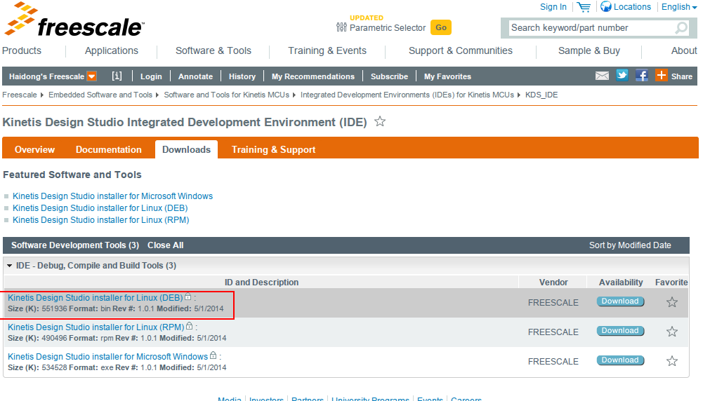

2: New a “ Kinetis Design Studio Project” which select “MK22FX512xx12” MCU and deselect “Use Processor Expert for configuration” for image download. See below:
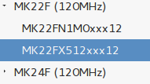
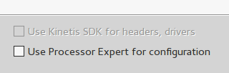

3: In this image download project debug configuration menu, double click “GDB SEGGER J-Link Debugging” item, a new debugging item will be generated, for this new item in the right “Debugging configuration menu” side “Main” TAB under “C/C++ Application:” pick up ELF image which will be download, in the “Debugger” TAB, change “Device name” to MK22FN512xxx12. Finally click “Debug” button to download image. See below.

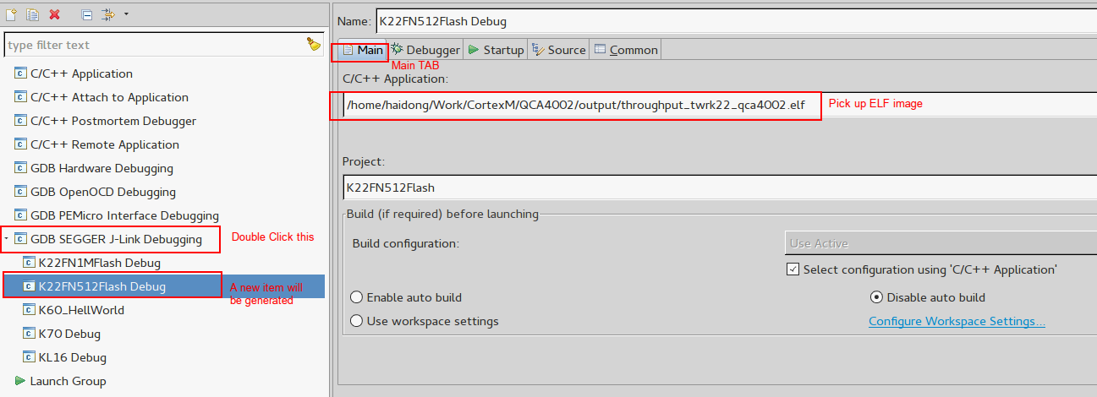

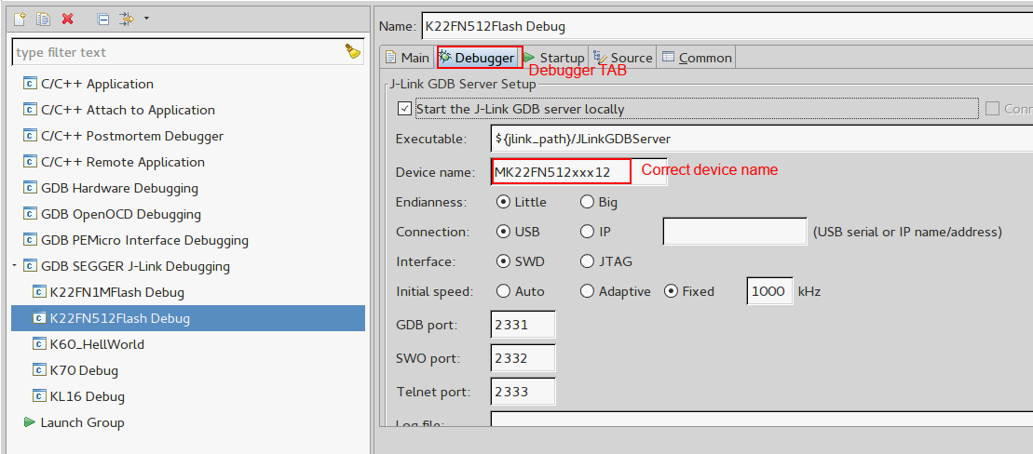

3.4 Build Qualcomm Atheros Demos and Alljoyn Demos under IAR .

3.4.1 Atheros Demos IAR workspace .
1: Open “twrk22_qca.eww” by IAR
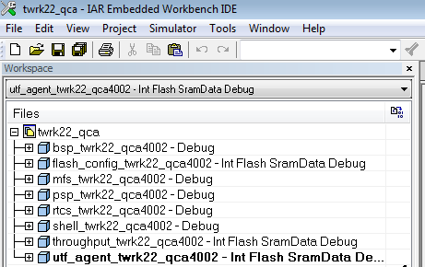

2: Build the project.
NOTE: Before build the project, Set path variable “MQX_ROOTDIR” value in Configure Custom Argument Variables item of Tools menu：Enter “Tools ->Configure Custom Argument Varialbes…” , see below.
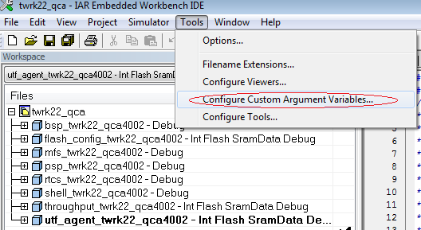
Click “New Group”, enter “MQXDIR” in name box and OK, See below.
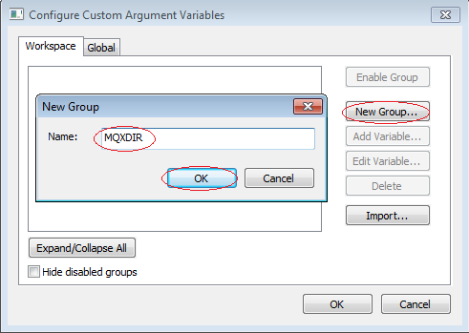
Then click “Add Variable”, enter “MQX_ROOTDIR” in name box, and set the path where your development kit root directory is installed under value box, see below.
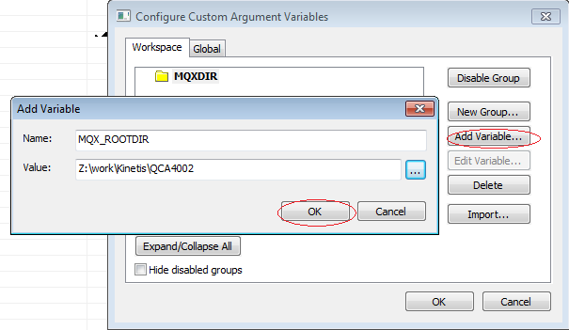
Then, firstly, build MQX lib bsp_twrk22_qca4002/ psp_twrk22_qca4002/ mfs_twrk22_qca4002/ shell_twrk22_qca4002/ rtcs_twrk22_qca4002 sequentially.
After build these MQX lib successfully, then you can build flash_config_twrk22_qca4002/ throughput_twrk22_qca4002/ ulf_gent_twrk22_qca4002 demo project.
3: Download the image
Download the image file by Open SDA Debugger(Connected TWR-K22F120M
main board with PC by microUSB-B cable through micro USB receptacle J25). Right click project enter “Options ->Debugger->Setup”, select “PE micro” as below.
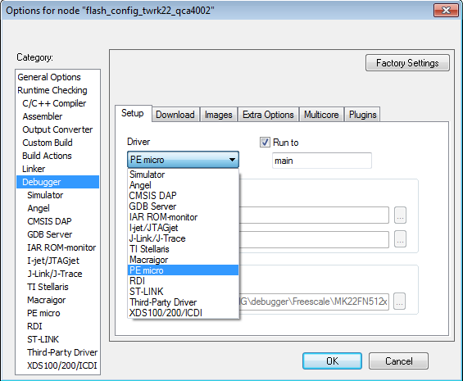
And in Download item, choose “Use flash loader(s)”
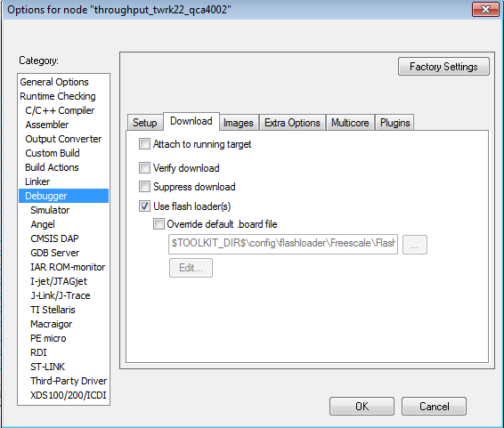
Then, enter “PE micro->Setup”，select “OpenSDA-USB”, interface “SWD”，as below.
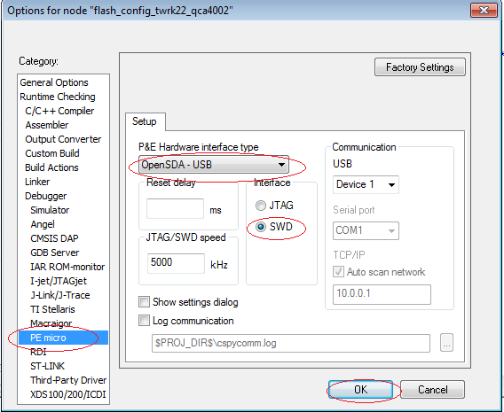
Click “OK”，then download and debug.

3.4.2 Alljoyn Demos IAR workspace .
1: Open twrk22_qca_aj.eww by IAR
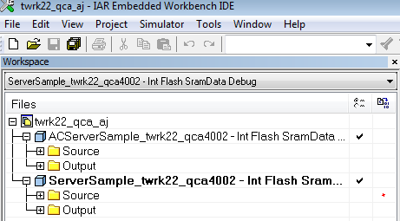
2: Build the project.
NOTE: Before build the project, Set path variable “MQX_ROOTDIR” value in Configure Custom Argument Variables item of Tools menu: Enter “Tools ->Configure Custom Argument Varialbes…” , see below.
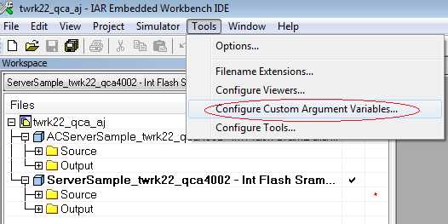
Click “New Group”, enter “MQXDIR” in name box and OK, See below.
Then click “Add Variable”, enter “MQX_ROOTDIR” in name box, and set the path where your development kit root directory is installed under value box, see below.
Then, firstly, make sure you have build MQX lib, build bsp_twrk22_qca4002/ psp_twrk22_qca4002/ mfs_twrk22_qca4002/ shell_twrk22_qca4002/ rtcs_twrk22_qca4002 project sequentially in twrk22_qca.eww.
Then build Serversample_twrk22_qca4002/ ACServerSample_twrk22_qca4002 project.
3: Download the image
Download the image file by Open SDA Debugger(Connected TWR-K22F120M
main board with PC by microUSB-B cable through micro USB receptacle J25). Right click project enter “Options ->Debugger->Setup”, select “PE micro” as below.
And in Download item, choose “Use flash loader(s)”
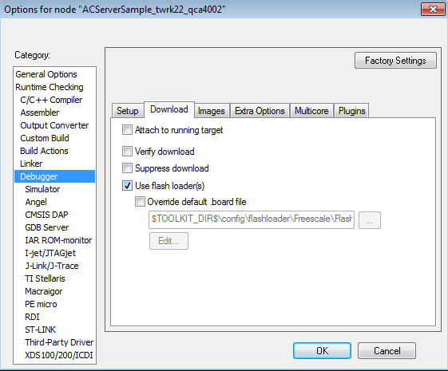
Then, enter “PE micro->Setup”，select “OpenSDA-USB”, interface “SWD”，as below.
Click “OK”，then download and debug.

