p8130_final_project_2

2024-12-19

# Project 2: Breast cancer survival prediction

## Data exploration

### Descriptive table with summary statistics

data <- read.csv("Project_2_data.csv")  
head(data,10)

## Age Race Marital.Status T.Stage N.Stage X6th.Stage  
## 1 68 White Married T1 N1 IIA  
## 2 50 White Married T2 N2 IIIA  
## 3 58 White Divorced T3 N3 IIIC  
## 4 58 White Married T1 N1 IIA  
## 5 47 White Married T2 N1 IIB  
## 6 51 White Single T1 N1 IIA  
## 7 51 White Married T1 N1 IIA  
## 8 40 White Married T2 N1 IIB  
## 9 40 White Divorced T4 N3 IIIC  
## 10 69 White Married T4 N3 IIIC  
## differentiate Grade A.Stage Tumor.Size Estrogen.Status  
## 1 Poorly differentiated 3 Regional 4 Positive  
## 2 Moderately differentiated 2 Regional 35 Positive  
## 3 Moderately differentiated 2 Regional 63 Positive  
## 4 Poorly differentiated 3 Regional 18 Positive  
## 5 Poorly differentiated 3 Regional 41 Positive  
## 6 Moderately differentiated 2 Regional 20 Positive  
## 7 Well differentiated 1 Regional 8 Positive  
## 8 Moderately differentiated 2 Regional 30 Positive  
## 9 Poorly differentiated 3 Regional 103 Positive  
## 10 Well differentiated 1 Distant 32 Positive  
## Progesterone.Status Regional.Node.Examined Reginol.Node.Positive  
## 1 Positive 24 1  
## 2 Positive 14 5  
## 3 Positive 14 7  
## 4 Positive 2 1  
## 5 Positive 3 1  
## 6 Positive 18 2  
## 7 Positive 11 1  
## 8 Positive 9 1  
## 9 Positive 20 18  
## 10 Positive 21 12  
## Survival.Months Status  
## 1 60 Alive  
## 2 62 Alive  
## 3 75 Alive  
## 4 84 Alive  
## 5 50 Alive  
## 6 89 Alive  
## 7 54 Alive  
## 8 14 Dead  
## 9 70 Alive  
## 10 92 Alive

numerical_summary <- data %>%  
 select_if(is.numeric) %>%  
 summarise_all(list(  
 count = ~sum(!is.na(.)),  
 mean = mean,  
 std = sd,  
 min = min,  
 median = median,  
 max = max  
 )) %>%  
 pivot_longer(cols = everything(), names_to = "Variable", values_to = "Value") %>%  
 separate(Variable, into = c("Variable", "Statistic"), sep = "_")  
  
formatted_summary <- numerical_summary %>%  
 pivot_wider(names_from = Statistic, values_from = Value)  
  
kable(formatted_summary, col.names = c("Variable", "Count", "Mean", "Std", "Min", "Median", "Max"), caption = "Numerical Variables Summary Statistics")

Numerical Variables Summary Statistics

| Variable | Count | Mean | Std | Min | Median | Max |
| --- | --- | --- | --- | --- | --- | --- |
| Age | 4024 | 53.972167 | 8.963134 | 30 | 54 | 69 |
| Tumor.Size | 4024 | 30.473658 | 21.119696 | 1 | 25 | 140 |
| Regional.Node.Examined | 4024 | 14.357107 | 8.099675 | 1 | 14 | 61 |
| Reginol.Node.Positive | 4024 | 4.158052 | 5.109331 | 1 | 2 | 46 |
| Survival.Months | 4024 | 71.297962 | 22.921429 | 1 | 73 | 107 |

categorical_vars <- data %>% select_if(is.character)  
  
category_summary <- categorical_vars %>%  
 gather(Variable, Category) %>%  
 group_by(Variable, Category) %>%  
 summarise(Count = n()) %>%  
 mutate(Percentage = round((Count / sum(Count)) * 100, 2)) %>%  
 arrange(Variable, desc(Count))

## `summarise()` has grouped output by 'Variable'. You can override using the  
## `.groups` argument.

formatted_summary <- category_summary %>%  
 group_by(Variable) %>%  
 mutate(Variable = ifelse(row_number() == 1, Variable, ""))  
  
kable(formatted_summary, col.names = c("Variable", "Category", "Count", "Percentage (%)"), caption = "Category Distribution of Categorical Variables")

Category Distribution of Categorical Variables

| Variable | Category | Count | Percentage (%) |
| --- | --- | --- | --- |
| A.Stage | Regional | 3932 | 97.71 |
|  | Distant | 92 | 2.29 |
| Estrogen.Status | Positive | 3755 | 93.32 |
|  | Negative | 269 | 6.68 |
| Grade | 2 | 2351 | 58.42 |
|  | 3 | 1111 | 27.61 |
|  | 1 | 543 | 13.49 |
|  | anaplastic; Grade IV | 19 | 0.47 |
| Marital.Status | Married | 2643 | 65.68 |
|  | Single | 615 | 15.28 |
|  | Divorced | 486 | 12.08 |
|  | Widowed | 235 | 5.84 |
|  | Separated | 45 | 1.12 |
| N.Stage | N1 | 2732 | 67.89 |
|  | N2 | 820 | 20.38 |
|  | N3 | 472 | 11.73 |
| Progesterone.Status | Positive | 3326 | 82.65 |
|  | Negative | 698 | 17.35 |
| Race | White | 3413 | 84.82 |
|  | Other | 320 | 7.95 |
|  | Black | 291 | 7.23 |
| Status | Alive | 3408 | 84.69 |
|  | Dead | 616 | 15.31 |
| T.Stage | T2 | 1786 | 44.38 |
|  | T1 | 1603 | 39.84 |
|  | T3 | 533 | 13.25 |
|  | T4 | 102 | 2.53 |
| X6th.Stage | IIA | 1305 | 32.43 |
|  | IIB | 1130 | 28.08 |
|  | IIIA | 1050 | 26.09 |
|  | IIIC | 472 | 11.73 |
|  | IIIB | 67 | 1.67 |
| differentiate | Moderately differentiated | 2351 | 58.42 |
|  | Poorly differentiated | 1111 | 27.61 |
|  | Well differentiated | 543 | 13.49 |
|  | Undifferentiated | 19 | 0.47 |

### Explore the Distribution of the Outcome (Status: Dead / Alive)

status_distribution <- data %>%  
 group_by(Status) %>%  
 summarise(Count = n()) %>%  
 mutate(Proportion = Count / sum(Count))  
  
kable(status_distribution, col.names = c("Status", "Count", "Proportion"), caption = "Distribution of Survival Status (Dead/Alive)")

Distribution of Survival Status (Dead/Alive)

| Status | Count | Proportion |
| --- | --- | --- |
| Alive | 3408 | 0.8469185 |
| Dead | 616 | 0.1530815 |

ggplot(data, aes(x = Status, fill = Status)) +  
 geom_bar() +  
 labs(title = "Distribution of Survival Status", x = "Status", y = "Count") +  
 theme_minimal() +  
 scale_fill_manual(values = c("lightblue", "pink"))

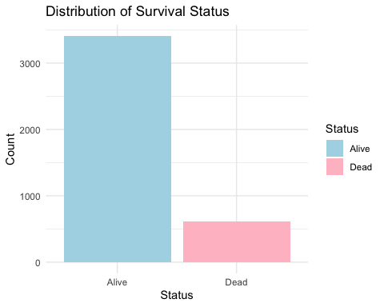

For logistic regression, the binary outcome variable (Status: Dead/Alive) does not require transformation, as logistic regression inherently models binary outcomes.

### Transformation

# Identify numerical variables  
numerical_vars <- data %>%  
 select_if(is.numeric) %>%  
 select(-`Survival.Months`)  
  
# Display the list of numerical variables  
names(numerical_vars)

## [1] "Age" "Tumor.Size" "Regional.Node.Examined"  
## [4] "Reginol.Node.Positive"

# Convert Status to a binary numeric variable  
data$Status <- ifelse(data$Status == "Dead", 1, 0)  
  
# Scatterplots for each numerical variable against the logit  
logit <- function(p) log(p / (1 - p)) # Logit function  
  
numerical_vars %>%  
 names() %>%  
 map(~ ggplot(data, aes(x = .data[[.x]], y = Status)) +  
 stat_smooth(method = "glm", method.args = list(family = "binomial"), se = FALSE, color = "blue") +  
 geom_point(alpha = 0.5) +  
 labs(title = paste("Relationship Between", .x, "and Logit of Status"),   
 x = .x,   
 y = "Logit(Status)") +  
 theme_minimal())

## [[1]]

## `geom_smooth()` using formula = 'y ~ x'

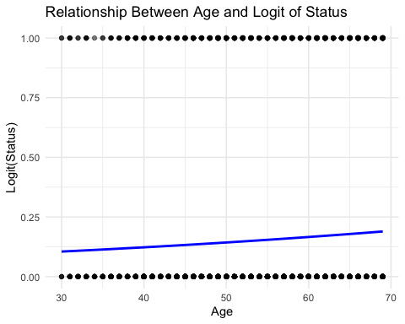

##   
## [[2]]

## `geom_smooth()` using formula = 'y ~ x'

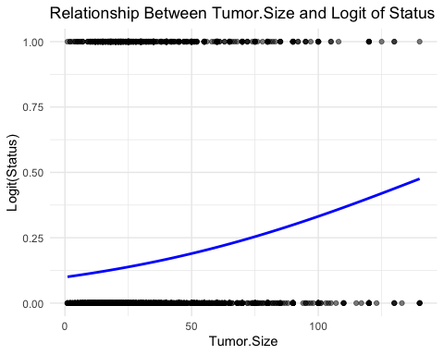

##   
## [[3]]

## `geom_smooth()` using formula = 'y ~ x'

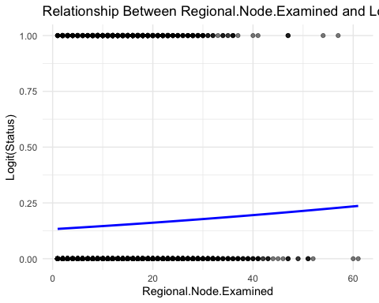

##   
## [[4]]

## `geom_smooth()` using formula = 'y ~ x'

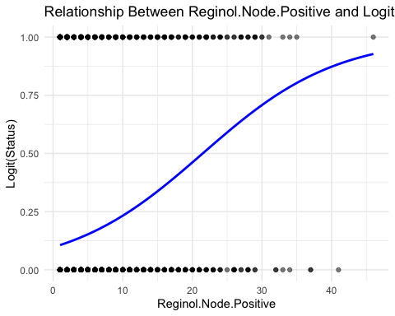

# Calculate skewness for numerical variables  
numerical_skewness <- numerical_vars %>%  
 map_df(~ tibble(Variable = deparse(substitute(.)),  
 Skewness = skewness(., na.rm = TRUE)))  
  
# Correct the Variable column  
numerical_skewness <- tibble(  
 Variable = colnames(numerical_vars),  
 Skewness = sapply(numerical_vars, skewness, na.rm = TRUE)  
)  
  
# Display the skewness table  
kable(numerical_skewness, col.names = c("Variable", "Skewness"), caption = "Skewness of Numerical Variables")

Skewness of Numerical Variables

| Variable | Skewness |
| --- | --- |
| Age | -0.2202085 |
| Tumor.Size | 1.7384530 |
| Regional.Node.Examined | 0.8286556 |
| Reginol.Node.Positive | 2.7005214 |

After our initial detection, we found out that:

* Reginol.Node.Positive variable show slightly nonlinear with the logit of Status, it need transformation.
* The skewness analysis reveals that Age (-0.22) has a roughly symmetric distribution, requiring no transformation. Tumor Size (1.74) shows moderate right skewness, suggesting a potential log transformation to normalize the distribution, though it may not be strictly necessary. Regional Node Examined (0.83) has mild positive skewness and can likely be retained in its current form unless further diagnostics indicate otherwise. Reginol Node Positive (2.70), with significant right skewness, would benefit from a log transformation to reduce skewness and stabilize its relationship with the logit in the logistic regression model. These adjustments ensure numerical variables are well-prepared for regression analysis.

Base on the analysis above, try to make log transformation on Reginol Node Positive & Tumor Size.

data <- data %>%  
 mutate(  
 Log_Reginol_Node_Positive = log1p(`Reginol.Node.Positive`),  
 Log_Tumor_Size = log1p(`Tumor.Size`)  
 )  
transformed_skewness <- data %>%  
 select(Log_Reginol_Node_Positive, Log_Tumor_Size) %>%  
 summarise_all(~ skewness(.))  
  
# Combine with variable names  
transformed_skewness_table <- tibble(  
 Variable = c("Log_Reginol_Node_Positive", "Log_Tumor_Size"),  
 Skewness = as.numeric(transformed_skewness)  
)  
  
# Display the updated skewness table  
kable(transformed_skewness_table, col.names = c("Variable", "Skewness"), caption = "Skewness of Transformed Variables")

Skewness of Transformed Variables

| Variable | Skewness |
| --- | --- |
| Log_Reginol_Node_Positive | 0.9887072 |
| Log_Tumor_Size | -0.0874903 |

## Plots for Transformed Variables Against Logit of Status  
logit <- function(p) log(p / (1 - p)) # Logit function  
  
# Plot for Log_Reginol_Node_Positive  
ggplot(data, aes(x = Log_Reginol_Node_Positive, y = Status)) +  
 stat_smooth(method = "glm", method.args = list(family = "binomial"), se = FALSE, color = "blue") +  
 geom_point(alpha = 0.5) +  
 labs(title = "Relationship Between Log_Reginol_Node_Positive and Logit of Status", x = "Log_Reginol_Node_Positive", y = "Logit(Status)") +  
 theme_minimal()

## `geom_smooth()` using formula = 'y ~ x'

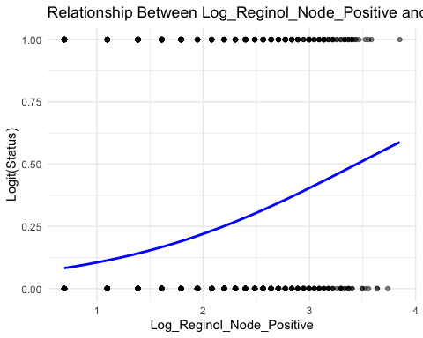

# Plot for Log_Tumor_Size  
ggplot(data, aes(x = Log_Tumor_Size, y = Status)) +  
 stat_smooth(method = "glm", method.args = list(family = "binomial"), se = FALSE, color = "blue") +  
 geom_point(alpha = 0.5) +  
 labs(title = "Relationship Between Log_Tumor_Size and Logit of Status", x = "Log_Tumor_Size", y = "Logit(Status)") +  
 theme_minimal()

## `geom_smooth()` using formula = 'y ~ x'

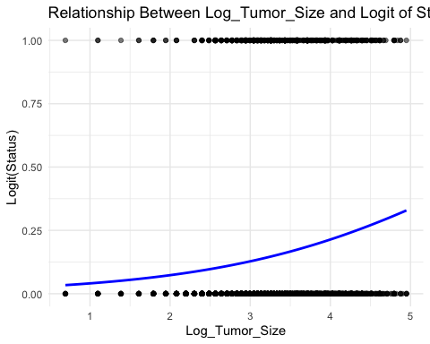

Comments:

* For Log_Reginol_Node_Positive, the skewness improved from 2.70 to 0.99, indicating a significant reduction in skewness. While still slightly positively skewed, the value is now within an acceptable range for modeling.
* For Log_Tumor_Size, the skewness reduced from 1.74 to -0.09, making it almost symmetric. This transformation effectively normalized the variable.
* For Log_Reginol_Node_Positive, the log transformation on Reginol.Node.Positive likely improved its relationship with the logit as well.
* For Log_Tumor_Size, after the transformation the linearity with the logit has not significantly improved, but at least the skewness reduced.

As a result, we should definitely conduct a log transformation on Reginol.Node.Positive and Tumor.Size (so the two original variables can be removed).

data=data |>  
 select(-`Reginol.Node.Positive`, -`Tumor.Size`)

# Compute correlation coefficients among numeric variables  
selected_vars <- c("Age", "Log_Reginol_Node_Positive", "Log_Tumor_Size","Regional.Node.Examined")  
  
subset_data <- data[, selected_vars]  
  
if (all(sapply(subset_data, is.numeric))) {  
 correlation_matrix <- cor(subset_data, use = "pairwise.complete.obs")  
 print(correlation_matrix)  
}

## Age Log_Reginol_Node_Positive Log_Tumor_Size  
## Age 1.000000000 -0.005830503 -0.08138322  
## Log_Reginol_Node_Positive -0.005830503 1.000000000 0.30720387  
## Log_Tumor_Size -0.081383224 0.307203871 1.00000000  
## Regional.Node.Examined -0.033345483 0.395974275 0.11628210  
## Regional.Node.Examined  
## Age -0.03334548  
## Log_Reginol_Node_Positive 0.39597428  
## Log_Tumor_Size 0.11628210  
## Regional.Node.Examined 1.00000000

None of the correlation coefficients between numeric variables exceed 0.5, indicating that there is no strong linear relationship between each pair of numeric variables.

# Identify highly consistent category variables  
contingency_table <- table(data[["differentiate"]], data[["Grade"]])  
print(contingency_table)

##   
## anaplastic; Grade IV 1 2 3  
## Moderately differentiated 0 0 2351 0  
## Poorly differentiated 0 0 0 1111  
## Undifferentiated 19 0 0 0  
## Well differentiated 0 543 0 0

We discover that complete linear dependency exist among Grade and differentiate, so we can only include one of them in the prediction model, so differentiate is excluded.

data=data |>  
 select(-differentiate)

Finally, we need to change all the catagorical variables to dummy variables:

categorical_vars <- data %>%  
 select_if(is.character) %>%  
 names()  
  
data_final <- data %>%  
 mutate(across(all_of(categorical_vars), ~ as.factor(.))) %>%   
 model.matrix(~ . - 1, data = .) %>%   
 as.data.frame()   
  
data_final = data_final |>  
 select(-`Survival.Months`)  
  
head(data_final,10)

## Age RaceBlack RaceOther RaceWhite Marital.StatusMarried  
## 1 68 0 0 1 1  
## 2 50 0 0 1 1  
## 3 58 0 0 1 0  
## 4 58 0 0 1 1  
## 5 47 0 0 1 1  
## 6 51 0 0 1 0  
## 7 51 0 0 1 1  
## 8 40 0 0 1 1  
## 9 40 0 0 1 0  
## 10 69 0 0 1 1  
## Marital.StatusSeparated Marital.StatusSingle Marital.StatusWidowed  
## 1 0 0 0  
## 2 0 0 0  
## 3 0 0 0  
## 4 0 0 0  
## 5 0 0 0  
## 6 0 1 0  
## 7 0 0 0  
## 8 0 0 0  
## 9 0 0 0  
## 10 0 0 0  
## T.StageT2 T.StageT3 T.StageT4 N.StageN2 N.StageN3 X6th.StageIIB  
## 1 0 0 0 0 0 0  
## 2 1 0 0 1 0 0  
## 3 0 1 0 0 1 0  
## 4 0 0 0 0 0 0  
## 5 1 0 0 0 0 1  
## 6 0 0 0 0 0 0  
## 7 0 0 0 0 0 0  
## 8 1 0 0 0 0 1  
## 9 0 0 1 0 1 0  
## 10 0 0 1 0 1 0  
## X6th.StageIIIA X6th.StageIIIB X6th.StageIIIC Grade1 Grade2 Grade3  
## 1 0 0 0 0 0 1  
## 2 1 0 0 0 1 0  
## 3 0 0 1 0 1 0  
## 4 0 0 0 0 0 1  
## 5 0 0 0 0 0 1  
## 6 0 0 0 0 1 0  
## 7 0 0 0 1 0 0  
## 8 0 0 0 0 1 0  
## 9 0 0 1 0 0 1  
## 10 0 0 1 1 0 0  
## A.StageRegional Estrogen.StatusPositive Progesterone.StatusPositive  
## 1 1 1 1  
## 2 1 1 1  
## 3 1 1 1  
## 4 1 1 1  
## 5 1 1 1  
## 6 1 1 1  
## 7 1 1 1  
## 8 1 1 1  
## 9 1 1 1  
## 10 0 1 1  
## Regional.Node.Examined Status Log_Reginol_Node_Positive Log_Tumor_Size  
## 1 24 0 0.6931472 1.609438  
## 2 14 0 1.7917595 3.583519  
## 3 14 0 2.0794415 4.158883  
## 4 2 0 0.6931472 2.944439  
## 5 3 0 0.6931472 3.737670  
## 6 18 0 1.0986123 3.044522  
## 7 11 0 0.6931472 2.197225  
## 8 9 1 0.6931472 3.433987  
## 9 20 0 2.9444390 4.644391  
## 10 21 0 2.5649494 3.496508

After basic data preprocessing, we use lasso regression to help select the variables used as predictors.

x <- model.matrix(Status ~ ., data = data_final)[, -1]  
y <- data_final$Status  
  
# Perform cross-validation for Lasso regression  
lasso_cv <- cv.glmnet(x, y, family = "binomial", alpha = 1)  
  
# Get the optimal regularization parameter lambda  
best_lambda <- lasso_cv$lambda.min  
print(paste("Optimal lambda:", best_lambda))

## [1] "Optimal lambda: 0.00137339497251477"

# Fit the Lasso model using the optimal lambda  
lasso_model <- glmnet(x, y, family = "binomial", alpha = 1, lambda = best_lambda)  
  
# Extract the coefficients from the Lasso model  
lasso_coefficients <- coef(lasso_model)  
  
# Convert coefficients to a standard matrix format  
lasso_coefficients_matrix <- as.matrix(lasso_coefficients)  
  
# Extract variable names with non-zero coefficients (excluding the intercept)  
selected_vars <- rownames(lasso_coefficients_matrix)[lasso_coefficients_matrix[, 1] != 0][-1]  
  
# Output the selected variables  
print("Selected variables:")

## [1] "Selected variables:"

print(selected_vars)

## [1] "Age" "RaceBlack"   
## [3] "RaceOther" "Marital.StatusMarried"   
## [5] "Marital.StatusSeparated" "Marital.StatusWidowed"   
## [7] "T.StageT2" "T.StageT3"   
## [9] "T.StageT4" "N.StageN2"   
## [11] "N.StageN3" "X6th.StageIIB"   
## [13] "X6th.StageIIIB" "X6th.StageIIIC"   
## [15] "Grade1" "Grade2"   
## [17] "A.StageRegional" "Estrogen.StatusPositive"   
## [19] "Progesterone.StatusPositive" "Regional.Node.Examined"   
## [21] "Log_Reginol_Node_Positive" "Log_Tumor_Size"

# Construct the logistic regression formula  
final_formula <- as.formula(paste("Status ~", paste(selected_vars, collapse = " + ")))  
  
# Fit the final logistic regression model  
final_model <- glm(final_formula, data = data_final, family = "binomial")  
  
# Output the summary of the final model  
summary(final_model)

##   
## Call:  
## glm(formula = final_formula, family = "binomial", data = data_final)  
##   
## Coefficients: (1 not defined because of singularities)  
## Estimate Std. Error z value Pr(>|z|)   
## (Intercept) -2.519832 0.604361 -4.169 3.05e-05 ***  
## Age 0.024975 0.005576 4.479 7.51e-06 ***  
## RaceBlack 0.493886 0.160715 3.073 0.002119 **   
## RaceOther -0.422082 0.202125 -2.088 0.036778 *   
## Marital.StatusMarried -0.183285 0.106633 -1.719 0.085643 .   
## Marital.StatusSeparated 0.711849 0.370708 1.920 0.054828 .   
## Marital.StatusWidowed 0.048349 0.200724 0.241 0.809655   
## T.StageT2 0.193251 0.196814 0.982 0.326150   
## T.StageT3 0.407837 0.275094 1.483 0.138197   
## T.StageT4 0.865917 0.440379 1.966 0.049264 *   
## N.StageN2 0.283352 0.200269 1.415 0.157111   
## N.StageN3 0.657838 0.294561 2.233 0.025530 *   
## X6th.StageIIB 0.248681 0.196218 1.267 0.205021   
## X6th.StageIIIB 0.128930 0.477963 0.270 0.787353   
## X6th.StageIIIC NA NA NA NA   
## Grade1 -0.927008 0.192261 -4.822 1.42e-06 ***  
## Grade2 -0.402494 0.103945 -3.872 0.000108 ***  
## A.StageRegional -0.056295 0.264024 -0.213 0.831157   
## Estrogen.StatusPositive -0.777335 0.177491 -4.380 1.19e-05 ***  
## Progesterone.StatusPositive -0.561011 0.127532 -4.399 1.09e-05 ***  
## Regional.Node.Examined -0.032028 0.006960 -4.601 4.20e-06 ***  
## Log_Reginol_Node_Positive 0.644056 0.143833 4.478 7.54e-06 ***  
## Log_Tumor_Size 0.033313 0.149431 0.223 0.823591   
## ---  
## Signif. codes: 0 '***' 0.001 '**' 0.01 '*' 0.05 '.' 0.1 ' ' 1  
##   
## (Dispersion parameter for binomial family taken to be 1)  
##   
## Null deviance: 3444.7 on 4023 degrees of freedom  
## Residual deviance: 2962.1 on 4002 degrees of freedom  
## AIC: 3006.1  
##   
## Number of Fisher Scoring iterations: 5

# Check for linear dependencies (aliased variables)  
alias_info <- alias(final_model)  
print(alias_info)

## Model :  
## Status ~ Age + RaceBlack + RaceOther + Marital.StatusMarried +   
## Marital.StatusSeparated + Marital.StatusWidowed + T.StageT2 +   
## T.StageT3 + T.StageT4 + N.StageN2 + N.StageN3 + X6th.StageIIB +   
## X6th.StageIIIB + X6th.StageIIIC + Grade1 + Grade2 + A.StageRegional +   
## Estrogen.StatusPositive + Progesterone.StatusPositive + Regional.Node.Examined +   
## Log_Reginol_Node_Positive + Log_Tumor_Size  
##   
## Complete :  
## (Intercept) Age RaceBlack RaceOther Marital.StatusMarried  
## X6th.StageIIIC 0 0 0 0 0   
## Marital.StatusSeparated Marital.StatusWidowed T.StageT2  
## X6th.StageIIIC 0 0 0   
## T.StageT3 T.StageT4 N.StageN2 N.StageN3 X6th.StageIIB  
## X6th.StageIIIC 0 0 0 1 0   
## X6th.StageIIIB Grade1 Grade2 A.StageRegional  
## X6th.StageIIIC 0 0 0 0   
## Estrogen.StatusPositive Progesterone.StatusPositive  
## X6th.StageIIIC 0 0   
## Regional.Node.Examined Log_Reginol_Node_Positive Log_Tumor_Size  
## X6th.StageIIIC 0 0 0

if (!is.null(alias_info$Complete)) {  
 aliased_vars <- rownames(alias_info$Complete)  
 print("Aliased (linearly dependent) variables:")  
 print(aliased_vars)  
} else {  
 print("No aliased coefficients found.")  
}

## [1] "Aliased (linearly dependent) variables:"  
## [1] "X6th.StageIIIC"

X6th.StageIIIC was identified as an aliased (linearly dependent) variable, being perfectly correlated with N.StageN3. This redundancy can cause multicollinearity issues and instability in coefficient estimation. Both X6th.StageIIIC and N.StageN3 were removed to ensure a more stable and interpretable model.

# Remove X6th.StageIIIC and N.StageN3 from selected_vars  
vars_to_remove <- c("X6th.StageIIIC", "N.StageN3")  
selected_vars_updated <- setdiff(selected_vars, vars_to_remove)  
  
# Output the updated selected variables  
print("Updated selected variables:")

## [1] "Updated selected variables:"

print(selected_vars_updated)

## [1] "Age" "RaceBlack"   
## [3] "RaceOther" "Marital.StatusMarried"   
## [5] "Marital.StatusSeparated" "Marital.StatusWidowed"   
## [7] "T.StageT2" "T.StageT3"   
## [9] "T.StageT4" "N.StageN2"   
## [11] "X6th.StageIIB" "X6th.StageIIIB"   
## [13] "Grade1" "Grade2"   
## [15] "A.StageRegional" "Estrogen.StatusPositive"   
## [17] "Progesterone.StatusPositive" "Regional.Node.Examined"   
## [19] "Log_Reginol_Node_Positive" "Log_Tumor_Size"

# Construct the updated logistic regression formula  
updated_formula <- as.formula(paste("Status ~", paste(selected_vars_updated, collapse = " + ")))  
  
# Fit the updated logistic regression model  
final_model_updated <- glm(updated_formula, data = data_final, family = "binomial")  
  
# Output the summary of the updated model  
summary(final_model_updated)

##   
## Call:  
## glm(formula = updated_formula, family = "binomial", data = data_final)  
##   
## Coefficients:  
## Estimate Std. Error z value Pr(>|z|)   
## (Intercept) -2.586868 0.604324 -4.281 1.86e-05 ***  
## Age 0.024919 0.005571 4.473 7.71e-06 ***  
## RaceBlack 0.507115 0.160256 3.164 0.00155 **   
## RaceOther -0.426369 0.202063 -2.110 0.03485 *   
## Marital.StatusMarried -0.185979 0.106429 -1.747 0.08056 .   
## Marital.StatusSeparated 0.685081 0.371771 1.843 0.06537 .   
## Marital.StatusWidowed 0.048188 0.200576 0.240 0.81014   
## T.StageT2 0.289094 0.192589 1.501 0.13333   
## T.StageT3 0.439822 0.273499 1.608 0.10781   
## T.StageT4 0.993099 0.437609 2.269 0.02325 *   
## N.StageN2 -0.066720 0.124254 -0.537 0.59129   
## X6th.StageIIB 0.077969 0.180760 0.431 0.66622   
## X6th.StageIIIB -0.058609 0.471980 -0.124 0.90118   
## Grade1 -0.939837 0.191920 -4.897 9.73e-07 ***  
## Grade2 -0.414513 0.103628 -4.000 6.33e-05 ***  
## A.StageRegional -0.142220 0.263709 -0.539 0.58968   
## Estrogen.StatusPositive -0.791877 0.176913 -4.476 7.60e-06 ***  
## Progesterone.StatusPositive -0.564563 0.127217 -4.438 9.09e-06 ***  
## Regional.Node.Examined -0.032821 0.006960 -4.715 2.41e-06 ***  
## Log_Reginol_Node_Positive 0.898326 0.087884 10.222 < 2e-16 ***  
## Log_Tumor_Size 0.033660 0.149132 0.226 0.82143   
## ---  
## Signif. codes: 0 '***' 0.001 '**' 0.01 '*' 0.05 '.' 0.1 ' ' 1  
##   
## (Dispersion parameter for binomial family taken to be 1)  
##   
## Null deviance: 3444.7 on 4023 degrees of freedom  
## Residual deviance: 2967.1 on 4003 degrees of freedom  
## AIC: 3009.1  
##   
## Number of Fisher Scoring iterations: 5

# Calculate Variance Inflation Factor (VIF) for the updated model  
vif_values_updated <- vif(final_model_updated)  
print("Variance Inflation Factors (VIF) for the updated model:")

## [1] "Variance Inflation Factors (VIF) for the updated model:"

print(vif_values_updated)

## Age RaceBlack   
## 1.098778 1.047286   
## RaceOther Marital.StatusMarried   
## 1.019144 1.214976   
## Marital.StatusSeparated Marital.StatusWidowed   
## 1.048147 1.205814   
## T.StageT2 T.StageT3   
## 4.163568 4.808712   
## T.StageT4 N.StageN2   
## 3.699579 1.354531   
## X6th.StageIIB X6th.StageIIIB   
## 2.749446 2.704404   
## Grade1 Grade2   
## 1.161258 1.198231   
## A.StageRegional Estrogen.StatusPositive   
## 1.247616 1.485066   
## Progesterone.StatusPositive Regional.Node.Examined   
## 1.430544 1.381053   
## Log_Reginol_Node_Positive Log_Tumor_Size   
## 2.105050 3.867394

vif_df <- data.frame(  
 Variable = names(vif_values_updated),  
 VIF = vif_values_updated  
)  
  
ggplot(vif_df, aes(x = reorder(Variable, VIF), y = VIF)) +  
 geom_bar(stat = "identity", fill = "steelblue") +  
 geom_hline(yintercept = 5, color = "red", linetype = "dashed") +  
 labs(title = "Variance Inflation Factors (VIF)",  
 x = "Predictor Variables",  
 y = "VIF") +  
 coord_flip() +  
 theme_minimal()

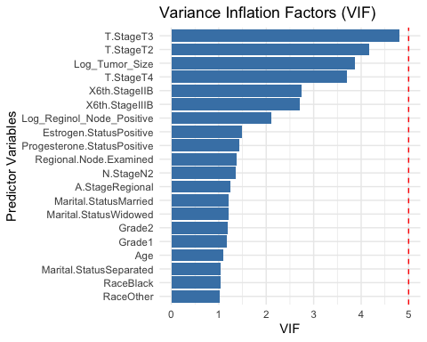

After removing X6th.StageIIIC and N.StageN3 and refitting the updated logistic regression model, the Variance Inflation Factor (VIF) values were recalculated. The results indicate that all predictor variables now have VIF values below 5, suggesting that multicollinearity among the independent variables has been successfully resolved.

We can extract coefficients from the updated final model and show them.

# Extract coefficients from the updated final model  
coefficients_updated <- summary(final_model_updated)$coefficients  
  
# Create a summary table  
summary_table_updated <- data.frame(  
 Variable = rownames(coefficients_updated),  
 Estimate = coefficients_updated[, "Estimate"],  
 Std_Error = coefficients_updated[, "Std. Error"],  
 z_value = coefficients_updated[, "z value"],  
 p_value = coefficients_updated[, "Pr(>|z|)"]  
)  
  
# Calculate Odds Ratios and Confidence Intervals  
summary_table_updated <- summary_table_updated %>%  
 mutate(  
 Odds_Ratio = exp(Estimate),  
 CI_Lower = exp(Estimate - 1.96 * Std_Error),  
 CI_Upper = exp(Estimate + 1.96 * Std_Error)  
 ) %>%  
 select(Variable, Estimate, Odds_Ratio, CI_Lower, CI_Upper, p_value)  
  
# Display the summary table  
kable(summary_table_updated, digits = 3, caption = "Final Logistic Regression Model Summary")

Final Logistic Regression Model Summary

|  | Variable | Estimate | Odds_Ratio | CI_Lower | CI_Upper | p_value |
| --- | --- | --- | --- | --- | --- | --- |
| (Intercept) | (Intercept) | -2.587 | 0.075 | 0.023 | 0.246 | 0.000 |
| Age | Age | 0.025 | 1.025 | 1.014 | 1.036 | 0.000 |
| RaceBlack | RaceBlack | 0.507 | 1.660 | 1.213 | 2.273 | 0.002 |
| RaceOther | RaceOther | -0.426 | 0.653 | 0.439 | 0.970 | 0.035 |
| Marital.StatusMarried | Marital.StatusMarried | -0.186 | 0.830 | 0.674 | 1.023 | 0.081 |
| Marital.StatusSeparated | Marital.StatusSeparated | 0.685 | 1.984 | 0.957 | 4.111 | 0.065 |
| Marital.StatusWidowed | Marital.StatusWidowed | 0.048 | 1.049 | 0.708 | 1.555 | 0.810 |
| T.StageT2 | T.StageT2 | 0.289 | 1.335 | 0.915 | 1.948 | 0.133 |
| T.StageT3 | T.StageT3 | 0.440 | 1.552 | 0.908 | 2.654 | 0.108 |
| T.StageT4 | T.StageT4 | 0.993 | 2.700 | 1.145 | 6.365 | 0.023 |
| N.StageN2 | N.StageN2 | -0.067 | 0.935 | 0.733 | 1.193 | 0.591 |
| X6th.StageIIB | X6th.StageIIB | 0.078 | 1.081 | 0.759 | 1.541 | 0.666 |
| X6th.StageIIIB | X6th.StageIIIB | -0.059 | 0.943 | 0.374 | 2.379 | 0.901 |
| Grade1 | Grade1 | -0.940 | 0.391 | 0.268 | 0.569 | 0.000 |
| Grade2 | Grade2 | -0.415 | 0.661 | 0.539 | 0.809 | 0.000 |
| A.StageRegional | A.StageRegional | -0.142 | 0.867 | 0.517 | 1.454 | 0.590 |
| Estrogen.StatusPositive | Estrogen.StatusPositive | -0.792 | 0.453 | 0.320 | 0.641 | 0.000 |
| Progesterone.StatusPositive | Progesterone.StatusPositive | -0.565 | 0.569 | 0.443 | 0.730 | 0.000 |
| Regional.Node.Examined | Regional.Node.Examined | -0.033 | 0.968 | 0.955 | 0.981 | 0.000 |
| Log_Reginol_Node_Positive | Log_Reginol_Node_Positive | 0.898 | 2.455 | 2.067 | 2.917 | 0.000 |
| Log_Tumor_Size | Log_Tumor_Size | 0.034 | 1.034 | 0.772 | 1.385 | 0.821 |

Then we need to evaluate model performance by computing some matrix. Set the threshold to 0.5, meaning that any predicted probability greater than or equal to 0.5 is classified as the positive class (1) (in our case, dead), while probabilities below 0.5 are classified as the negative class (0) (in our case, alive).

threshold <- 0.5   
# Predict probabilities using the updated model  
pred_probs_updated <- predict(final_model_updated, type = "response")  
  
pred_classes_updated <- ifelse(pred_probs_updated >= threshold, 1, 0)  
  
# Generate the confusion matrix for the updated model  
conf_matrix_updated <- confusionMatrix(as.factor(pred_classes_updated), as.factor(y), positive = "1")  
print(conf_matrix_updated)

## Confusion Matrix and Statistics  
##   
## Reference  
## Prediction 0 1  
## 0 3358 533  
## 1 50 83  
##   
## Accuracy : 0.8551   
## 95% CI : (0.8439, 0.8659)  
## No Information Rate : 0.8469   
## P-Value [Acc > NIR] : 0.07661   
##   
## Kappa : 0.1769   
##   
## Mcnemar's Test P-Value : < 2e-16   
##   
## Sensitivity : 0.13474   
## Specificity : 0.98533   
## Pos Pred Value : 0.62406   
## Neg Pred Value : 0.86302   
## Prevalence : 0.15308   
## Detection Rate : 0.02063   
## Detection Prevalence : 0.03305   
## Balanced Accuracy : 0.56003   
##   
## 'Positive' Class : 1   
##

We also need to draw the Receiver Operating Characteristic Curve.

# Predict probabilities for the entire dataset  
pred_probs_updated <- predict(final_model_updated, type = "response")  
  
# Compute ROC curve  
roc_curve <- roc(data_final$Status, pred_probs_updated)

## Setting levels: control = 0, case = 1

## Setting direction: controls < cases

# Plot ROC curve  
plot(roc_curve, col = "blue", lwd = 2, main = "ROC Curve for Updated Model")  
abline(a = 0, b = 1, lty = 2, col = "gray") # Add diagonal line (random guess)  
  
# Add AUC value to the plot  
auc_value <- auc(roc_curve)  
text(0.6, 0.2, paste("AUC =", round(auc_value, 3)), col = "red", cex = 1.2)

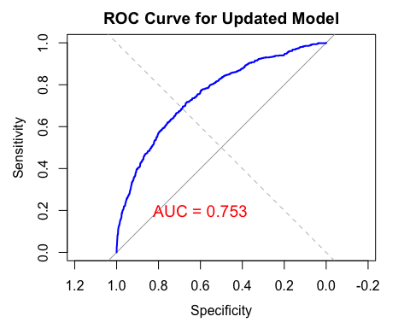

On the entire dataset, ROC-AUC value is 0.753, indicating the model performance is acceptable but has room for improvement (0.7 - 0.8).

# Create calibration data frame  
calibration_df <- data.frame(  
 Predicted = pred_probs_updated,  
 Observed = as.numeric(data_final$Status)  
)  
  
# Group predicted probabilities into bins  
calibration_df$Bin <- cut(calibration_df$Predicted, breaks = seq(0, 1, by = 0.1), include.lowest = TRUE)  
  
# Calculate mean predicted probability and observed proportion for each bin  
calibration_summary <- calibration_df %>%  
 group_by(Bin) %>%  
 summarise(  
 Mean_Predicted = mean(Predicted),  
 Mean_Observed = mean(Observed)  
 )  
  
# Plot calibration curve  
ggplot(calibration_summary, aes(x = Mean_Predicted, y = Mean_Observed)) +  
 geom_point(color = "blue", size = 3) +  
 geom_line(color = "blue", lwd = 1) +  
 geom_abline(slope = 1, intercept = 0, linetype = "dashed", color = "red") +  
 labs(title = "Calibration Curve for Updated Model",  
 x = "Mean Predicted Probability",  
 y = "Observed Proportion") +  
 theme_minimal()

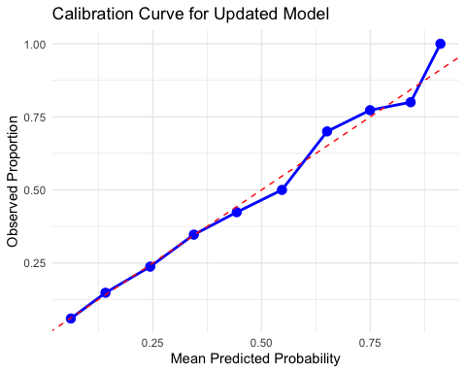

The calibration curve demonstrates that the predicted probabilities align reasonably well with the observed proportions across most bins, as the points and blue line generally follow the diagonal red dashed line (perfect calibration) although some deviations exist. Overall, the model shows acceptable calibration.

Cross-validation provides a comprehensive method for model diagnosis by evaluating its performance across multiple data splits. This approach helps assess the model’s generalization ability, reducing the risk of overfitting and ensuring robust performance on unseen data.

# Define 10-fold cross-validation  
set.seed(123) # For reproducibility  
folds <- createFolds(y, k = 10, list = TRUE)  
  
# Initialize a data frame to store results  
cv_results <- data.frame(  
 Fold = integer(),  
 Accuracy = numeric(),  
 Sensitivity = numeric(),  
 Specificity = numeric(),  
 ROC_AUC = numeric()  
)  
  
# Perform 10-fold cross-validation  
for (i in seq_along(folds)) {  
 # Split data into training and testing sets  
 train_indices <- unlist(folds[-i]) # Indices for training data  
 test_indices <- unlist(folds[i]) # Indices for testing data  
   
 train_data <- data_final[train_indices, ]  
 test_data <- data_final[test_indices, ]  
   
 # Refit the logistic regression model on the training set  
 train_model <- glm(updated_formula, data = train_data, family = "binomial")  
   
 # Predict probabilities on the testing set  
 test_probs <- predict(train_model, newdata = test_data, type = "response")  
   
 # Convert probabilities to binary predictions  
 test_preds <- ifelse(test_probs >= threshold, 1, 0)  
   
 # Generate the confusion matrix for the testing set  
 fold_conf_matrix <- confusionMatrix(  
 as.factor(test_preds),  
 as.factor(test_data$Status),  
 positive = "1"  
 )  
   
 # Calculate ROC-AUC  
 roc_curve <- roc(as.numeric(test_data$Status), test_probs)  
 roc_auc <- auc(roc_curve)  
   
 # Store performance metrics for this fold  
 cv_results <- rbind(cv_results, data.frame(  
 Fold = i,  
 Accuracy = fold_conf_matrix$overall["Accuracy"],  
 Sensitivity = fold_conf_matrix$byClass["Sensitivity"],  
 Specificity = fold_conf_matrix$byClass["Specificity"],  
 ROC_AUC = as.numeric(roc_auc)  
 ))  
}

## Setting levels: control = 0, case = 1

## Setting direction: controls < cases

## Setting levels: control = 0, case = 1

## Setting direction: controls < cases

## Setting levels: control = 0, case = 1

## Setting direction: controls < cases

## Setting levels: control = 0, case = 1

## Setting direction: controls < cases

## Setting levels: control = 0, case = 1

## Setting direction: controls < cases

## Setting levels: control = 0, case = 1

## Setting direction: controls < cases

## Setting levels: control = 0, case = 1

## Setting direction: controls < cases

## Setting levels: control = 0, case = 1

## Setting direction: controls < cases

## Setting levels: control = 0, case = 1

## Setting direction: controls < cases

## Setting levels: control = 0, case = 1

## Setting direction: controls < cases

# Summarize cross-validation results  
cv_summary <- data.frame(  
 Metric = c("Accuracy", "Sensitivity", "Specificity", "ROC_AUC"),  
 Mean = colMeans(cv_results[, -1], na.rm = TRUE),  
 SD = apply(cv_results[, -1], 2, sd, na.rm = TRUE)  
)  
  
# Print the summary of cross-validation results  
print("Cross-Validation Results:")

## [1] "Cross-Validation Results:"

print(cv_summary)

## Metric Mean SD  
## Accuracy Accuracy 0.8531295 0.010397492  
## Sensitivity Sensitivity 0.1334452 0.031295877  
## Specificity Specificity 0.9833262 0.006557589  
## ROC_AUC ROC_AUC 0.7451556 0.023696947

The average accuracy is 85.29% (SD = 1.04%), indicating that the model performs well overall in classifying the observations correctly. The specificity is very high, averaging 98.36% (SD = 0.64%), which demonstrates the model’s strong ability to correctly identify negative cases (Alive). However, the sensitivity is relatively low at 13.00% (SD = 3.01%), reflecting a limited capability to detect positive cases (Alive). The ROC-AUC is 0.744 (SD = 0.024), suggesting the model has acceptable discrimination ability but room for improvement.

# Calculate Cook's Distance  
cooks_d <- cooks.distance(final_model_updated)  
  
# Plot Cook's Distance  
plot(cooks_d, type = "h", main = "Cook's Distance", ylab = "Cook's Distance")  
abline(h = 4/(nrow(data_final) - length(final_model_updated$coefficients) - 1), col = "red", lty = 2)

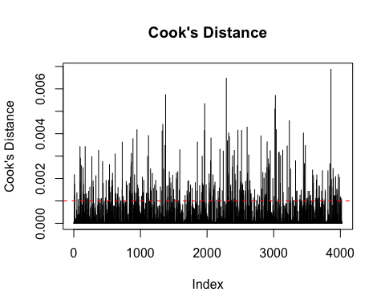 The red dashed line represents the commonly used threshold for identifying influential points. The majority of observations fall below the threshold, suggesting that they contribute reasonably and do not overly influence the model.