The ChocAn Simulator

Requirements Document
Table of Contents
1 Introduction 3
1.1 Purpose and Scope 3
1.2 Target Audience 3
1.3 Terms and Definitions 3
2 Product Overview 4
2.1 Users and Stakeholders 4
2.1.1 <Stakeholder 1> 4
2.1.2 <Stakeholder 2> 4
2.2 Use cases 4
2.2.1 <Use Case 1> 4
2.2.2 <Use Case 2> 4
2.2.3 <Use Case 3> 4
3 Functional Requirements 5
3.1 <Functional Requirement 1> 5
3.1.1 <Functional Requirement 1 Aspects 1> 5
3.1.2 <Functional Requirement 1 Aspect 2> 5
3.2 <Functional Requirement 2> 5
3.3 <Functional Requirement 3> 5
4 Nonfunctional Requirements 6
4.1 <Nonfunctional Requirement 1> 6
4.1.1 < Nonfunctional Requirement 1 Aspects 1> 6
4.1.2 < Nonfunctional Requirement 1 Aspect 2> 6
4.2 < Nonfunctional Requirement 2> 6
4.3 < Nonfunctional Requirement 3> 6
5 Milestones and Deliverables 7
5.1 <Milestone/Deliverable 1> 7
5.1.1 <Milestone/Deliverable 1 Stage 1> 7
5.1.2 < Milestone/Deliverable 1 Stage 1> 7
5.2 <Milestone/Deliverable 2> 7

Introduction
Introduce this document and the project it describes. You should also summarize the remaining content of the document here.

Purpose and Scope
You should describe this document by giving its purpose, scope.

Target Audience
Describe the target audience for this document.

Terms and Definitions
Define any terms or acronyms you will be using in the remainder of this document.

Product Overview
Give a high level description of the functionality of the project here. Describe the purpose of this section. It may be useful to give your definition of a user, a stake holder and a use case. If there are scope limitations to the project, i.e. things you will not be doing, or are not required to do, this is a good section to put those.

Users and Stakeholders
Describe the purpose of this section. Only a few sentences are expected here.

<Stakeholder 1>
List the first stakeholder or class of stakeholders if necessary. Describe, exactly, their role in the development, deployment, use, maintenance, etc. of the software.

<Stakeholder 2>
Don’t forget to remove the surrounding < and > symbols.

Use cases
Describe the purpose of this section. Only a few sentences are expected here.

<Use Case 1>
Describe the first use case here. Be sure to explicitly identify the participants, human or otherwise, and explain their roles. Diagrams may be effective here, particularly a sequence diagram.

<Use Case 2>
Don’t forget to remove the surrounding < and > symbols.

<Use Case 3>
Don’t forget to remove the surrounding < and > symbols.

Functional Requirements
Describe the purpose of this section and outline its contents. Only a few sentences are expected here. It may help to define a functional requirement.

<Functional Requirement 1>
Describe the first functional requirement. This is the meat of the document, so be sure to use precise language. Include diagrams when appropriate.

<Functional Requirement 1 Aspects 1>
It may be necessary to separate some of the larger functional requirements into several sub-requirements or requirement aspects.

<Functional Requirement 1 Aspect 2>
Don’t forget to remove the surrounding < and > symbols.

<Functional Requirement 2>
Don’t forget to remove the surrounding < and > symbols.

<Functional Requirement 3>
Don’t forget to remove the surrounding < and > symbols.

Nonfunctional Requirements
Describe the purpose of this section and outline its contents. Only a few sentences are expected here. It may help to define a nonfunctional requirement.

<Nonfunctional Requirement 1>
Describe the first nonfunctional requirement. This is the meat of the document, so be sure to use precise language. Include diagrams when appropriate.

< Nonfunctional Requirement 1 Aspects 1>
It may be necessary to separate some of the larger nonfunctional requirements into several sub-requirements or requirement aspects.

< Nonfunctional Requirement 1 Aspect 2>
Don’t forget to remove the surrounding < and > symbols.

< Nonfunctional Requirement 2>
Don’t forget to remove the surrounding < and > symbols.

< Nonfunctional Requirement 3>
Don’t forget to remove the surrounding < and > symbols.

Milestones and Deliverables
The purpose of this section is to provide the client with a summary of deliverables and the schedule of dates these are to be expected. Upon March 12th, the client will have received documents pertaining to product requirements, project design details, test planning, and an ultimate deliverable report. Along with the final deliverable report will include the code base for the project. The initial workflow plan can be seen in Figure 1, with corresponding details of each deliverable and a date of expectation found in the Major Milestones subsection below.

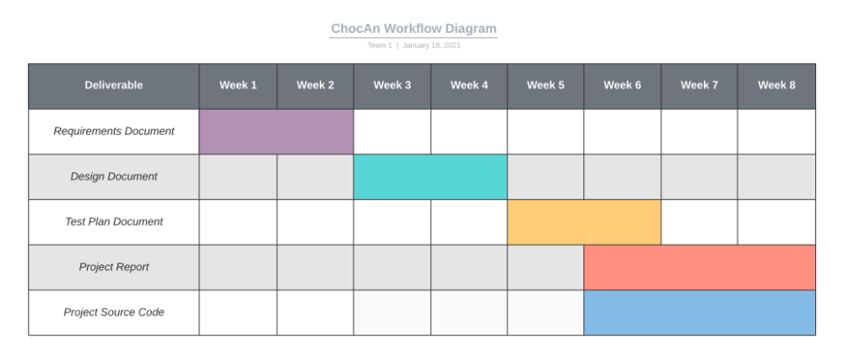
Figure 1: Team 1 Workflow Diagram

Major Milestones
While the due dates of each deliverable are listed with the title of each item, it is important to note that all of these due dates are soft deadlines with the exception of the final project report and final project source code (5.1.4 & 5.1.5).

    - Requirements Document – Due January 25th
Upon successful gathering of user and system requirements, this document summarizes the purpose and scope of the project, providing an overview of the desired end product, outlining major system requirements. Along with these details includes both functional and non-functional requirements, and expectations of dates of deliverables.

    - Design Document – Due February 8th
This document is intended to provide insight into the system architecture with detailed sub-system descriptions. At a high level, this gives the client an abstract understanding of the inner workings of their system, while simultaneously providing the software engineers an interface template. At this stage, the overall system architecture will be agreed upon by the engineering team, allowing for individuals to create sub-systems.

    - Test Plan Document – Due February 22nd
The test plan document is designed to assist in verification and validation of major systems and sub-systems. This report will include three main sections:
- Test Plan Description – providing overview of the scope of the testing, a schedule of testing, and a release criterion
- Unit Testing – code coverage, differences between unit and integration testing, excluded code
- Smoke Testing – a determination if the software product is stable for deployment

    - Final Project Report – Due March 12th
The project report will consist of two parts: the project retrospective and the presentation slides. The retrospective will include a discussion of how the project went over the course of the term, outlining one or two suggestions on things to improve for future projects, while the presentation slides will include information about system functionality, how the system was tested and any known defects or issues. The presentation slides will be used in a presentation to the project stakeholders.

    - Final Project Source Code – Due March 12th
Included with the final project report will be the source code of the project. The repository for the code will include the project binary, test suites, known issues, compilation instructions, as well as any other necessary data that will be outlined in the project report.

