Task 5.2

1) Analyze the structure of the /etc/passwd and /etc/group file, what fields are
present in it, what users exist on the system? Specify several pseudo-users, how
to define them?

man:x:6:12:man:/var/cache/man:/usr/sbin/nologin
etc/passwd consists of 7 fields :

testman:x:1001:1001:Testman,55,+380993737377,+37903,It is a test user:/home/testman:/bin/sh

login:password:UID:GID:GECOS:home:shell
- login = registration name
- password – x means that encrypted password hash is stored at /etc/shadow
- UID – user’s id, regular users have id bigger than 500
- GID – group id, user can join several groups
- GECOS – personal info about user (phone number, address, full name, description)
- home -path to user’s home catalog
- shell – command prompt interpreter, typically shell, but can be changed with chsh

/etc/group – list of users with their groups

adm:x:4:syslog,user

name:password:GID: members
Pseudo-users are created for the purpose of administering of the system and program services , for example, for instance "root" (for the superuser account) and "www-data" (for the account which owns and runs web servers). Any Linux system has these pseudo users by default Mail, news, games, Apache FTP, MySQL and sshd are related to the process of Linux system. Pseud- users usually do not need or cannot log in to the system.

2) What are the uid ranges? What is UID? How to define it?

UID ranges - set of reserved numbers that can be assigned to different kinds of users.

A UID (user identifier) is a number assigned by Linux to each user on the system.

UID 0 (zero) is reserved for the root.
UIDs 1–99 are reserved for other predefined accounts. UID
100–999 are reserved by system for administrative and system accounts/groups.
UID 1000–10000 are occupied by applications account. UID 10000+ are used for user accounts.

3) What is GID? How to define it?

GID 0 (zero) is reserved for the root group.
GID 1–99 are reserved for the system and application use.
GID 100+ allocated for the user’s group.

GID - Group identifier, it is an identifier that marks that particular represents a specific group of users.

4) How to determine belonging of user to the specific group?

groups username

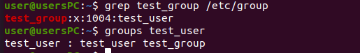

5) What are the commands for adding a user to the system? What are the basic
parameters required to create a user?

sudo useradd username
sudo passwd username
or
sudo adduser gena

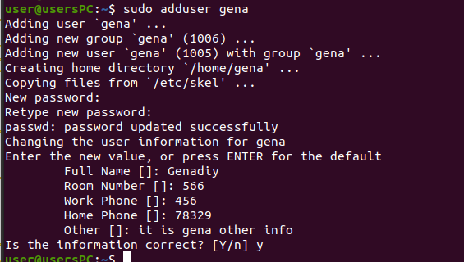
Basic parameters for useradd:
-d – set default home directory
-u – choose user id number for user
- g – choose group id for user
-G – add user to few groups
- m - set home directory if it does not exist
-M – set no home dir
-e – create user with his profile expiry date
-f – create user with password expiry date
-s – create user login shell

6) How do I change the name (account name) of an existing user?

sudo usermod -l newname oldname

7) What is skell_dir? What is its structure?

/etc/skel is used for initiation of user’s home directory when it was first created.

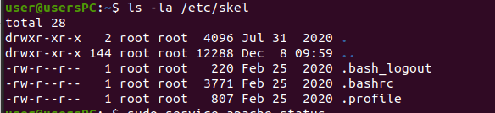
File /etc/default/useradd defines skel directory

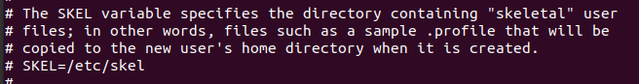

8) How to remove a user from the system (including his mailbox)?

sudo userdel -r username

9) What commands and keys should be used to lock and unlock a user account?
To lock:
sudo passwd -l username or sudo usermod -L username
Unlock:
sudo passwd -u username or sudo usermod -U username

To check user for blocking:
sudo passwd -S username

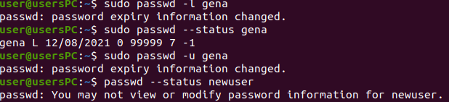
10) How to remove a user's password and provide him with a password-free
login for subsequent password change?

chage -l username
or
passwd -e username

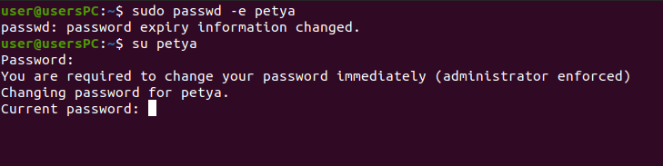
11) Display the extended format of information about the directory, tell about
the information columns displayed on the terminal.

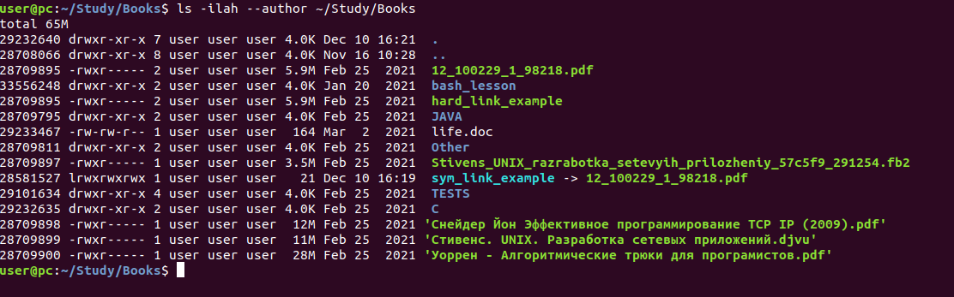
First line is total size of directory. Then by coluns:
- unique inode number, which hardlinks has the same as object they points
- file type (d, l, - )
- permissions for file
- number of links to file
- owner and group
- author (--author)
- size
- time of creation
- name

12) What access rights exist and for whom (i. e., describe the main roles)?
Briefly describe the acronym for access rights.

rwx rwx rwx
user group others

Each letter group can be trasformed to number by binary format:
r = 4
w = 2
x = 1

rwx = 111 = 2^2+2^1+2^0 = 4+2+1=7

So rw-r--r--will means 644

1st rwx – read write and execute permissions for the file owner
2nd rwx – for the group owner of the file
3rd rwx – for all other users

stat command will show octal representation of file permission
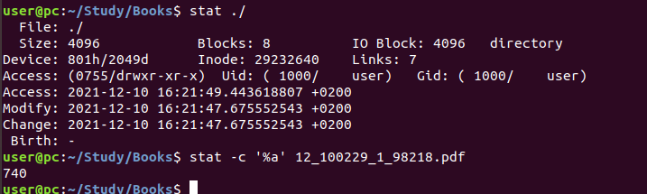

13) What is the sequence of defining the relationship between the file and the
user?

14) What commands are used to change the owner of a file (directory), as well
as the mode of access to the file? Give examples, demonstrate on the terminal.
15) What is an example of octal representation of access rights? Describe the
umask command.
16) Give definitions of sticky bits and mechanism of identifier substitution. Give
an example of files and directories with these attributes.
17) What file attributes should be present in the command script?

