Task1.Part1

1 – 2) passwd changes /etc/passwd (user account information), /etc/shadow (secure user account information, real data about passwords) and /etc/pam.d/password (PAM configuration for passwd – for dynamic authentification users in apps or services).
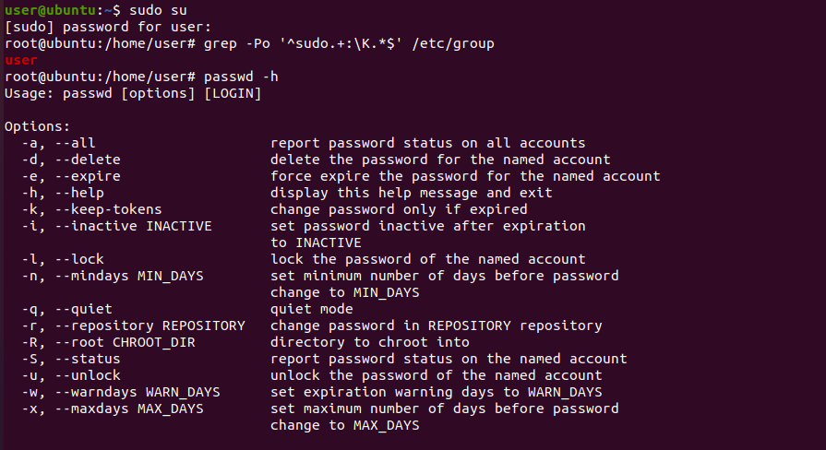
3) Command cat /etc/passwd shows all users registered in system.
“w” shows list of currently active users including time and what command they recently ran.
Information about login time, login name, the tty name, the remote host, idle time, JCPU, PCPU can be also gleaned.
The JCPU time is the time used by all processes attached to the tty. It does not include past background jobs, but does include currently running background jobs.
The PCPU time is the time used by the current process, named in the "what" field.

4) Change personal information about yourself.
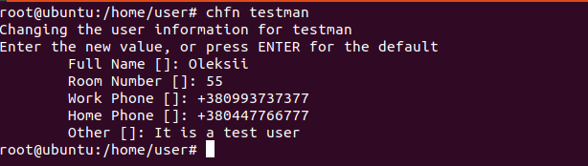

5) man and info
info pages usually give more detailed information about a command then its respective man page.
w -h, --no-header
Don't print the header.
w -o, --old-style
Old style output. Prints blank space for idle times less than one minute.
chfn -f, --full-name FULL_NAME
Change the user's full name.
chfn -h, --home-phone HOME_PHONE
Change the user's home phone number

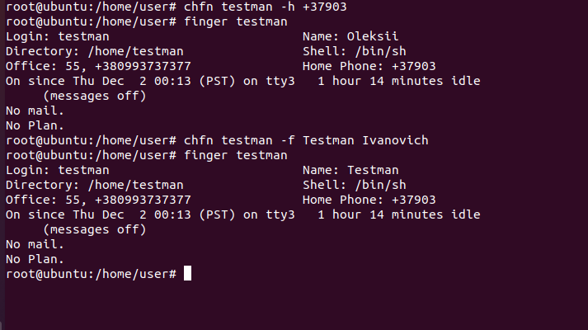
6) Main difference between more and less is that less command is faster because it does not load the entire file at once and allows navigation though file using page up/down keys.
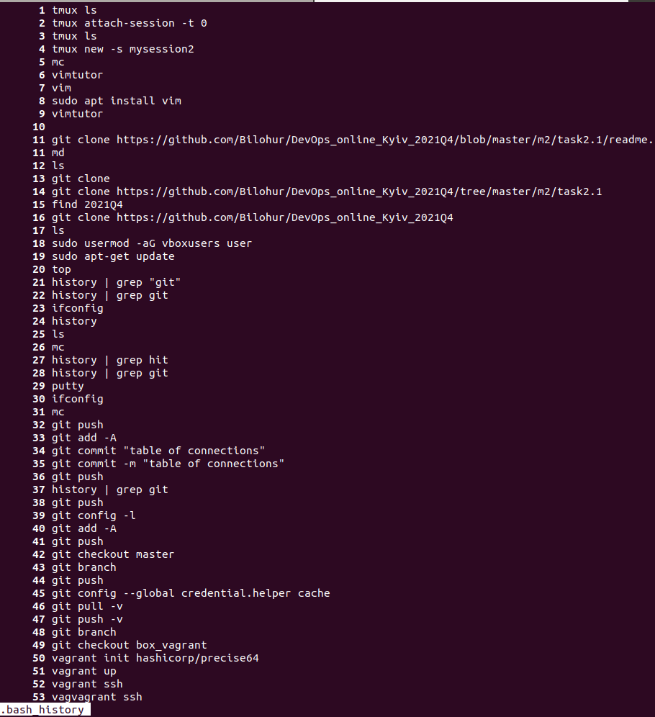
7)

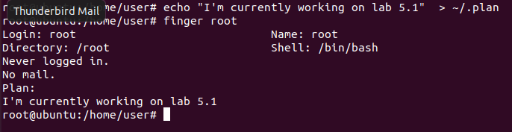

8)
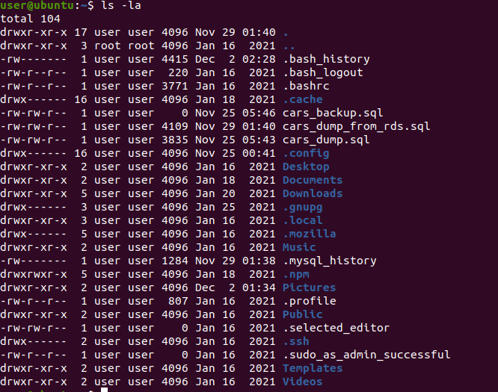
Task1.Part2

1)Display all files that contain a character c

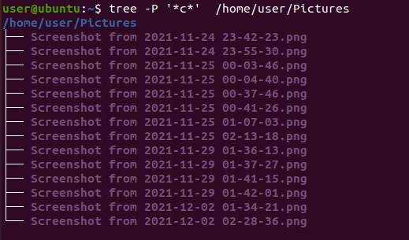
Display files that contain a specific sequence of characters

List subdirectories of the root directory up to and including the second nesting level
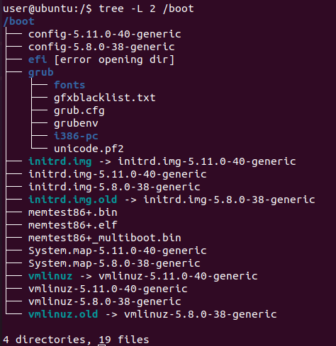

2) Determination of file type
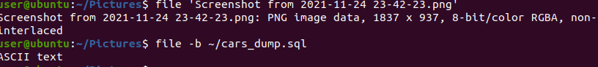
3) cd ~ - back to home directory
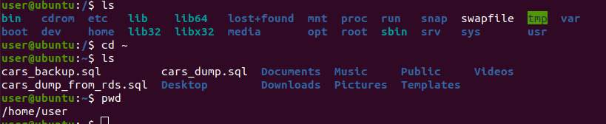

4) ls command examples using different keys:
ls -h – human readable format for file sizes
ls -R – list directories recursively
ls -t – newest files by modification type will be first
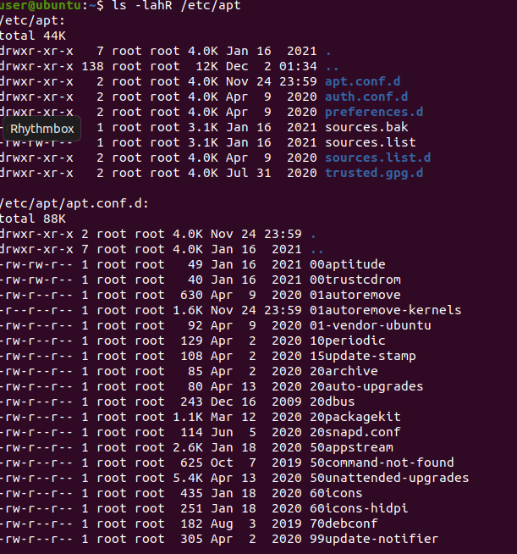
ls -la
-a, --all - do not ignore entries starting with .
-l - use a long listing format

5) mkdir subdirectory
tree -d ~ > subdirectory/dirs_in_root_dir.txt
ls -lh subdirectory/dirs_in_root_dir.txt
cp ~/subdirectory/dirs_in_root_dir.txt ~/dirs_in_dir_copy.txt
cp subdirectory/dirs_in_root_dir.txt dirs_in_dir_copy.txt
rm -Ri subdirectory
rm dirs_in_dir_copy.txt
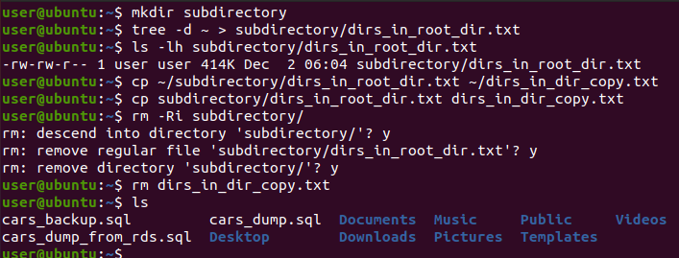
6) mkdir test
cp .bash_history /test/labwork2
ln test/labwork2 hardlink
ln -s test/labwork2 softlink

When softlink is defined, it acts as a pointer to the file name. On the other hand, hardlink acts as a mirrored copy of selected file and accesses the data available in it. Hardlink and file will have the same inode as they are in fact different names of the same file.
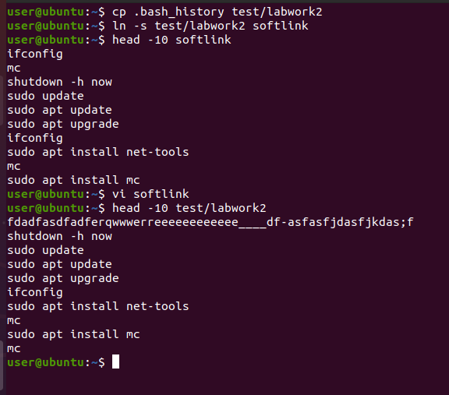

Changing data with softlink also changes file, because in fact original file was opened by this link. But if I had deleted or changed attributes of softlink, file labwork2 would stay constant unlike hardlink.
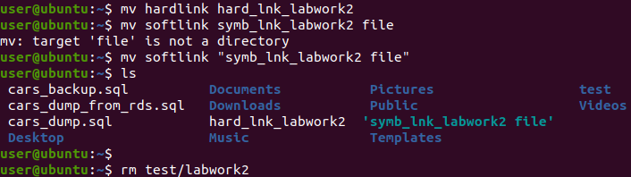

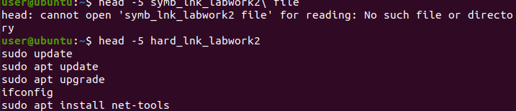
If hardlink is deleted, linked file will exists till there will be only one link to it. Only directory where it exists will change. Symbolic link after removing file starts to point on non-existed element.

7) Using the locate utility, find all files that contain the squid and traceroute
sequence.
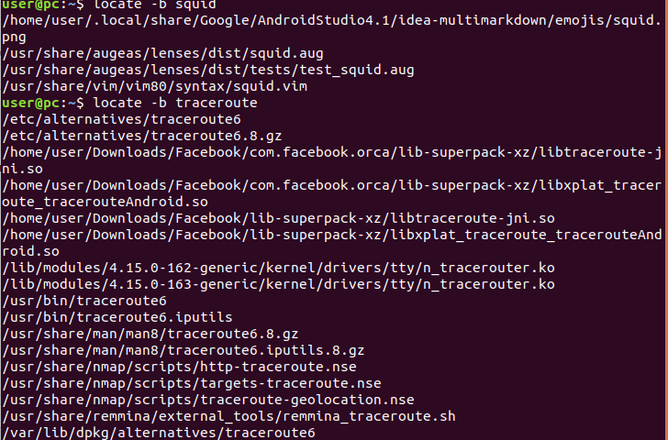

8) Partitions mounted in the system, as well as the types of
these partitions.

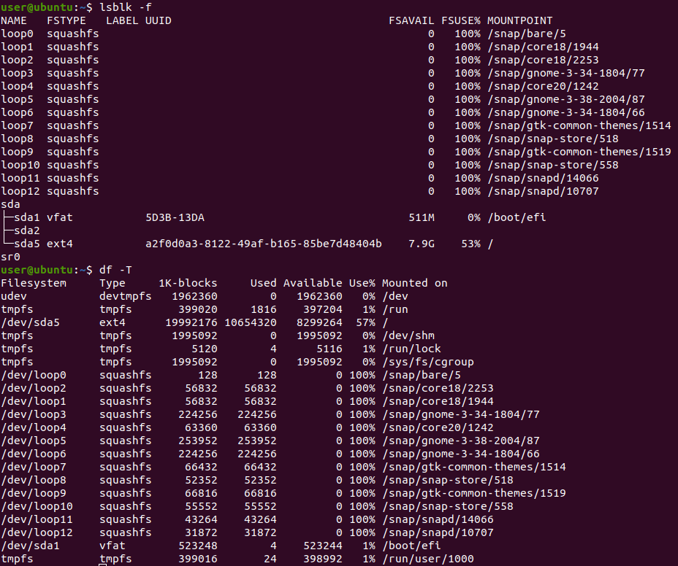
9) Count the number of lines containing a given sequence of characters in a given
file. 19 lines in file labwork2 contains string “labwork2”.

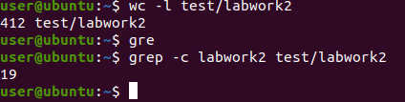

10) Using the find command, find all files in the /etc directory containing the
host character sequence.

find /etc -type f -exec grep -l "host" {} \; - finding file containing string
find /etc -name hosts – to find files containing string in its names
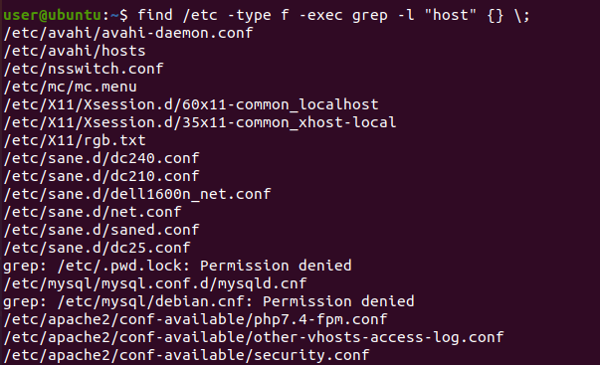
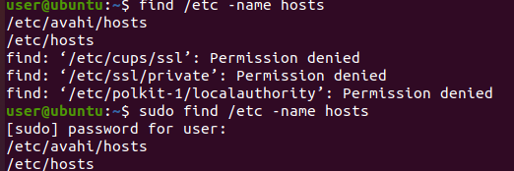

11) List all objects in /etc that contain the ss character sequence. How can I
duplicate a similar command using a bunch of grep?

ls -al | grep “”
locate etc/*ss*
grep -ril “ss” /etc
grep -r /etc -e “ss”

12) Screen-by-screen print of the contents of the /etc directory.
ls -la /etc | more
Also less command can be used. SPACE usage will show output by pages.
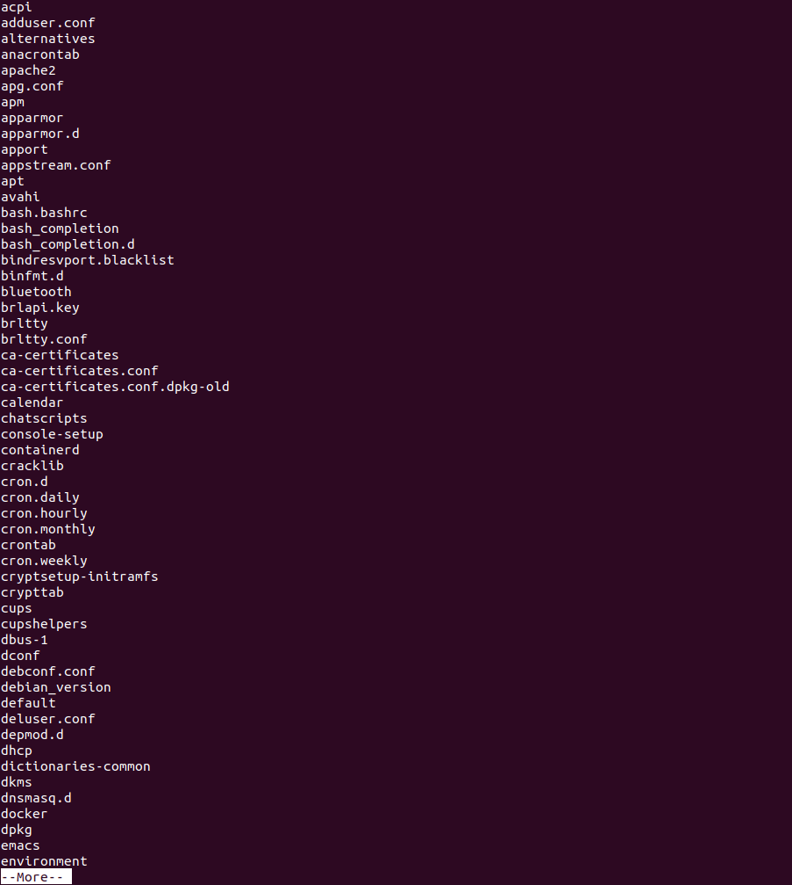
13) Types of devices, determination of device type with examples.

There are two main types of devices in Linux kernel: character(transfer data by one a character at a time) and block (transfer data, but in large fixed-sized blocks). Also network devices can be distinguished – any device that is able to exchange data with other hosts. It’s socket(facilitate communication between processes with many devices at once) pipe(allows two or more processes to communicate with each other) devices.
First
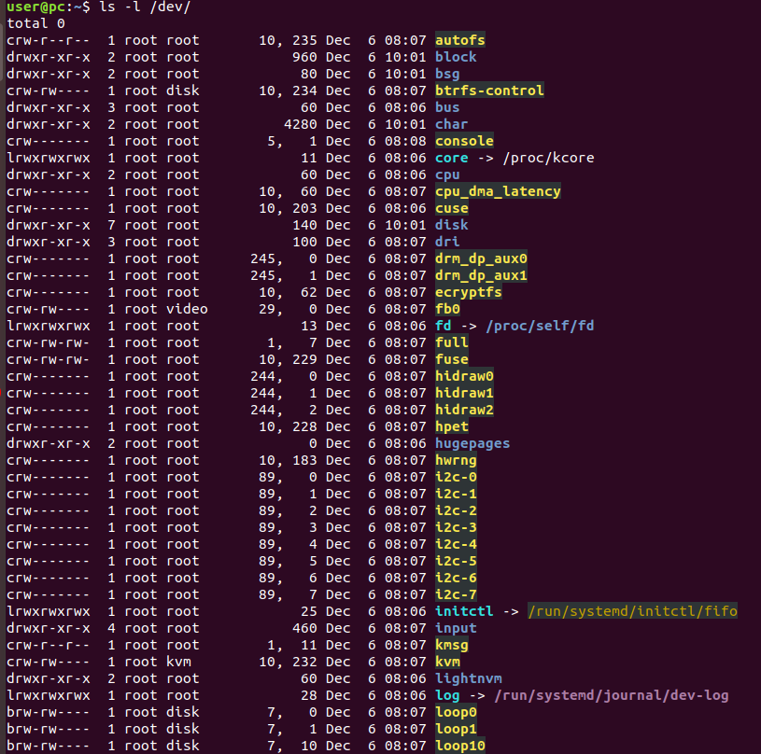
Devices types described in first byte of ls -l listing.

14) How to determine the type of file in the system, what types of files are there?

Linux supports 7 file types:
- “-” regular
- “d” - directory files
special :
- “p” - named pipe file
- “l” - link
- “b” - block
- “c” - character
- “s” - socket
File types are also can be shown in first byte of ls -l listing.

15) List the first 5 directory files that were recently accessed in the /etc
directory.

