POLICE RECORDED CRIME IN ENGLAND & WALES

A DATA ANALYSIS REPORT (2012/13 – 2023/24)

PREPARED BY
BILQIS OLUWATOYIN ABDULLAHI

DATA SOURCE: HOME OFFICE – POLICE RECORDED CRIME, ENGLAND & WALES

TOOLS USED: MICROSOFT EXCEL (POWER QUERY, PIVOTTABLES, CHARTS)

DATE: JUNE 2026

1. EXECUTIVE SUMMARY
This report presents a comprehensive analysis of police recorded crime data for England and Wales, covering the financial years 2012/13 through to 2023/24. The dataset, published by the Home Office, contains 258,906 records capturing offence counts across 44 territorial police forces, broken down by financial year, quarter, offence group, subgroup, and individual offence description.
Key findings from the analysis are summarised below:
Total recorded crime between 2012/13 and 2022/23 rose from approximately 4.1 million to 6.7 million offences.
The COVID-19 pandemic caused a significant dip in 2020/21, with total recorded crime falling to 5.4 million a decline of approximately 10.6% from the prior year before rebounding strongly.
Q1 (January–March) consistently records the highest crime volumes across all years, while Q4 (October–December) records the lowest.
The Metropolitan Police accounted for approximately 33.35% of all territorial police force crime across the period, more than any other single force.
Fraud offences showed the steepest sustained growth, rising from 510,403 in 2012/13 to 1,154,980 in 2022/23.

2. DATASET OVERVIEW
2.1 Source and Structure
The dataset was sourced from the UK Home Office Police Recorded Crime publication and covers 12 financial years from 2012/13 to 2023/24. The raw data was originally provided as an ODS file with one worksheet per financial year. Following conversion to Excel format (.xlsx), the 12 year-sheets were merged into a single unified table using Power Query, resulting in 258,905 rows of data with 9 columns (including an added Force Type classification column).

Column | Description | Data Type
Financial Year | Year of recorded crime (e.g. 2013/14) | Text
Financial Quarter | Quarter 1–4 within the financial year | Whole Number
Force Name | Name of the police force or reporting body | Text
Offence Group | Top-level crime category (10 groups) | Text
Offence Subgroup | Mid-level crime classification | Text
Offence Description | Specific individual offence type | Text
Offence Code | Alphanumeric offence identifier | Text
Number of Offences | Count of offences recorded | Decimal Number
Force Type | Territorial Force or National Body | Text

2.2 Data Quality Findings
The following data quality issues were identified and addressed prior to analysis:
Column names in the 2016/17 sheet were incorrectly labelled and were corrected before merging.
Columns in the 2022/23 sheet were in the wrong order and were rearranged to match the standard structure.
Data types for Financial Quarter and Offence Code were initially set to General/Text and were corrected during Power Query transformation.
426 rows contained negative offence counts, representing legitimate recording reversals and corrections by the Home Office. These were retained and flagged.
66,913 rows contained zero offence counts, representing quarters in which a force recorded no offences of a particular type. These were retained as they are meaningful absences, not missing data.
No duplicate records were identified after appending all year-sheets.
A Force Type helper column was added to distinguish 44 territorial police forces from 4 national reporting bodies (Action Fraud, CIFAS, Financial Fraud Action UK, UK Finance).

3. NATIONAL TREND ANALYSIS
3.1 Total Recorded Crime Over Time
Total recorded crime in England and Wales increased substantially over the 12-year period, rising from 4,063,571 offences in 2012/13 to a peak of 6,736,588 in 2022/23. This represents a 65.8% increase over ten years. The upward trend was briefly interrupted in 2020/21 due to the COVID-19 pandemic, before recovering strongly in 2021/22 and continuing to rise through 2022/23.
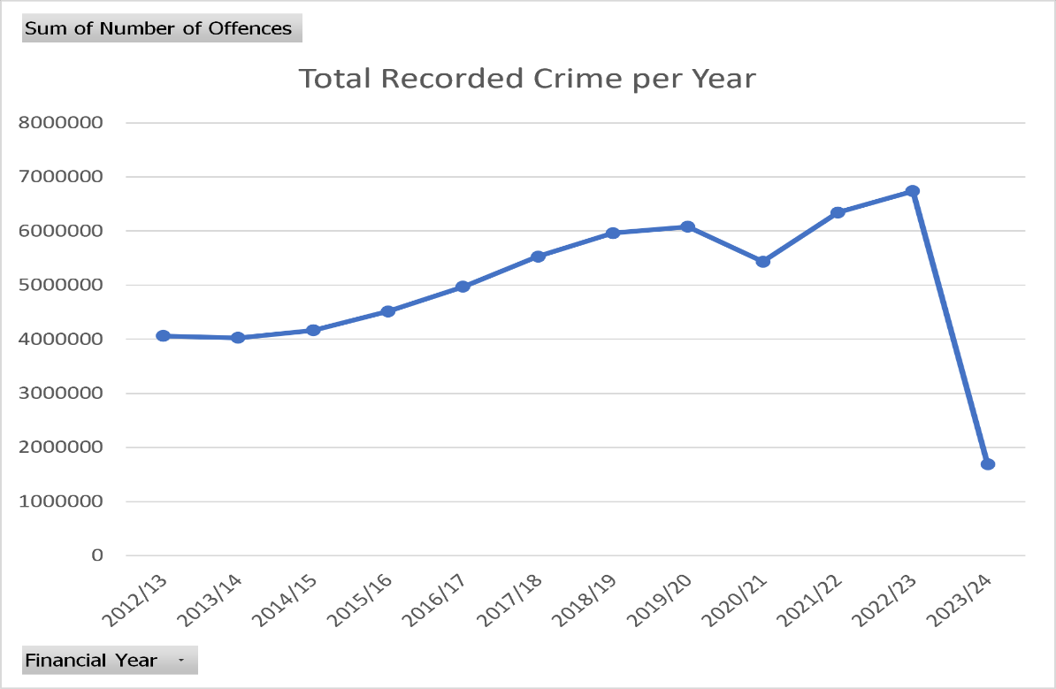
Figure 1: Total recorded crimes per year 2012/13–2022/23

3.2 Year-on-Year Percentage Change
The most significant annual increases occurred in 2015/16 (+21.7%) and 2020/21 — which showed a large spike in certain fraud and miscellaneous categories even as overall crime fell. The sharpest single-year decline was in 2020/21 (-10.6%), attributed to COVID-19 lockdown restrictions reducing social movement and therefore opportunity for many crime types.

Financial Year | Total Offences | YoY % Change | Note
2012/13 | 4,063,571 | —
2013/14 | 4,028,456 | -0.9%
2014/15 | 4,167,619 | +3.5%
2015/16 | 4,515,903 | +8.4% | Recording improvements
2016/17 | 4,970,709 | +10.1%
2017/18 | 5,528,510 | +11.2%
2018/19 | 5,964,467 | +7.9%
2019/20 | 6,078,988 | +1.9%
2020/21 | 5,434,426 | -10.6% | COVID-19 lockdown
2021/22 | 6,343,500 | +16.7% | Post-lockdown recovery
2022/23 | 6,736,588 | +6.2%

3.3 COVID-19 Impact Analysis
The COVID-19 pandemic and associated lockdown restrictions had a significant and measurable effect on recorded crime. Total offences fell from 6,078,988 in 2019/20 to 5,434,426 in 2020/21, a reduction of 644,562 offences (-10.6%). The most affected categories were theft offences particularly shoplifting and theft from the person which fell sharply as retail outlets closed and public spaces were restricted. By 2021/22, crime rebounded to 6,343,500 offences (+16.7%), exceeding pre-pandemic levels.
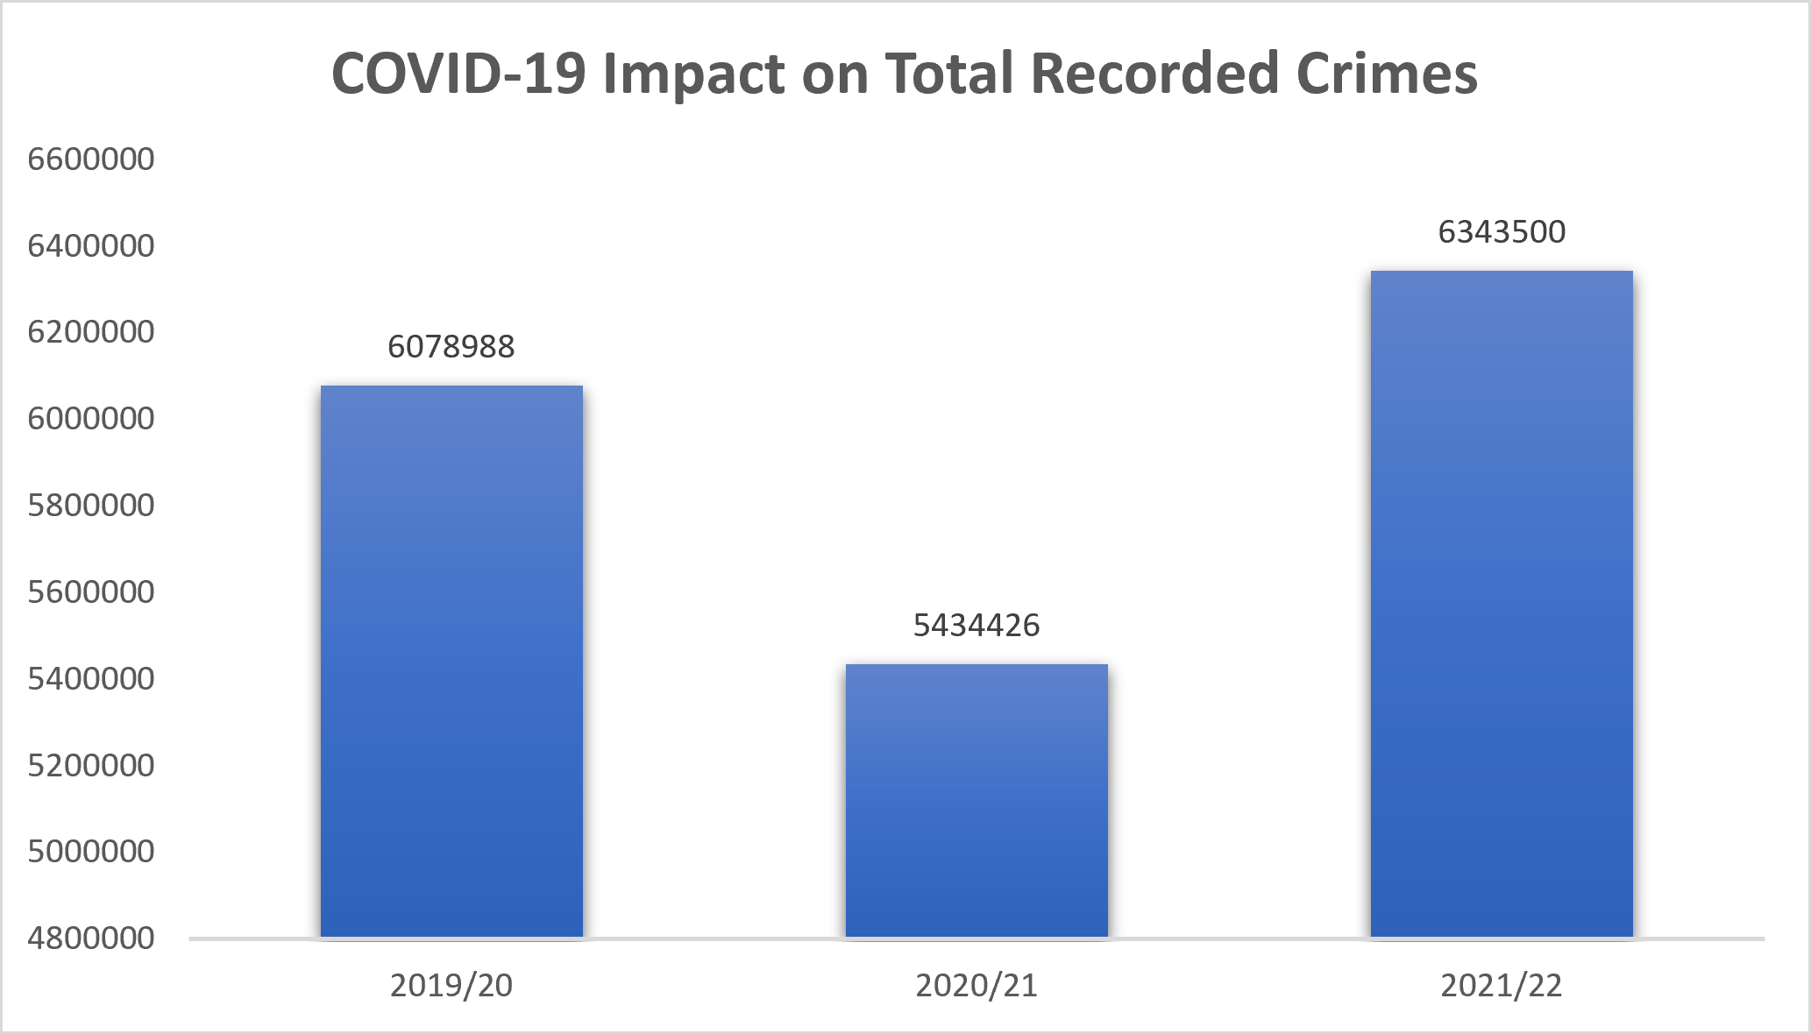
Figure 2: Covid-19 Impact on Recorded Crime 2019/20–2021/22

3.4 Trends by Offence Group
Violence against the person showed the steepest long-term rise, increasing from 601,141 in 2012/13 to 2,111,240 in 2022/23. It is important to note that a significant part of this increase particularly the sharp jump between 2014/15 and 2016/17 reflects improvements in police recording practices rather than a genuine surge in violent incidents. Fraud offences showed consistent growth throughout the period, driven by the rise of online fraud and digital crimes. Theft offences, by contrast, declined notably during the pandemic and had not fully recovered to pre-COVID levels by 2022/23.
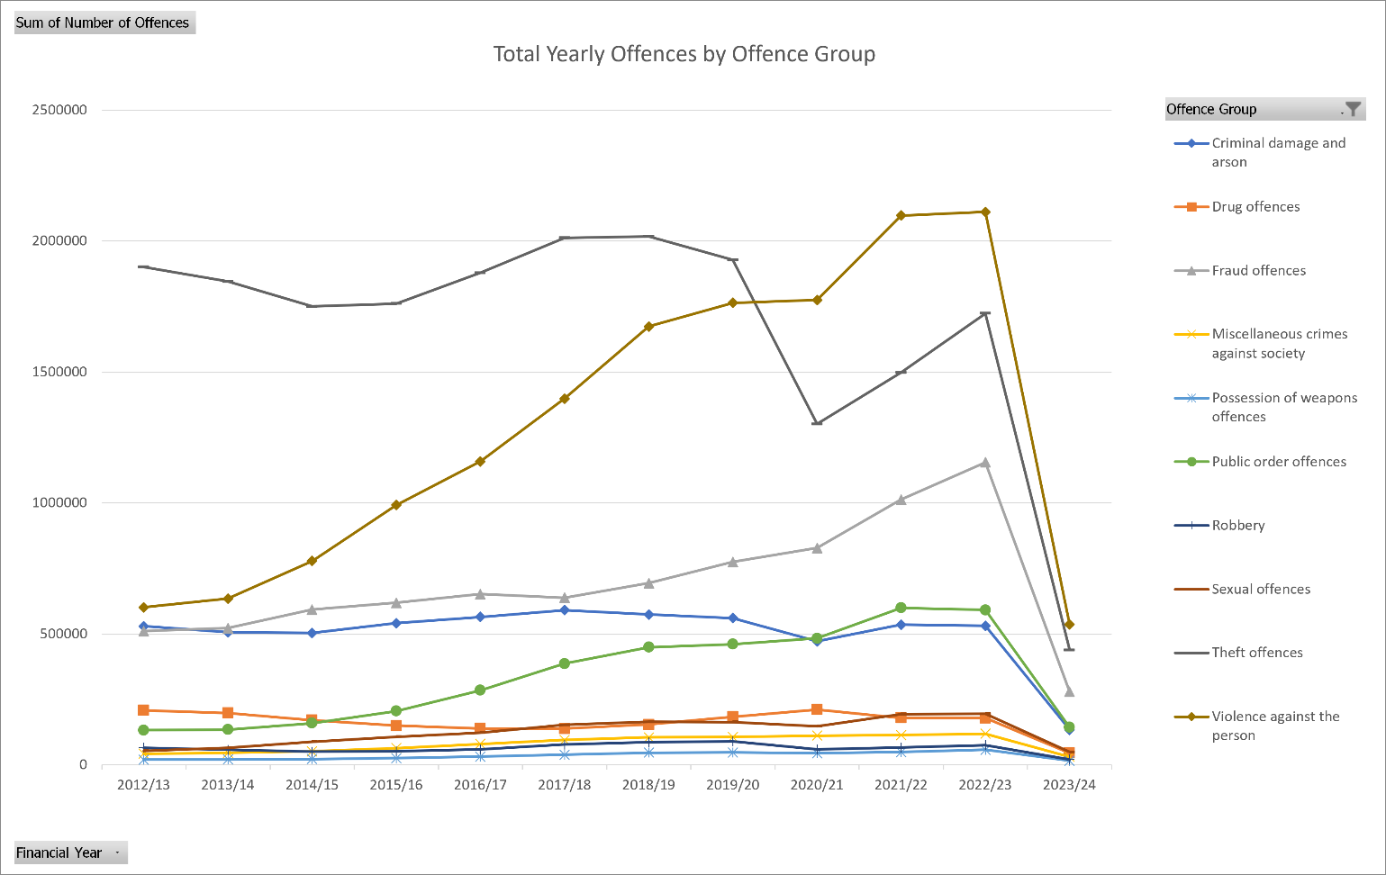
Figure 2: Trends by offence group, 2012/13–2022/23

5. SEASONAL ANALYSIS
Examining crime counts by financial quarter across all years reveals a consistent seasonal pattern. Q1 (January–March) is the highest-crime quarter across virtually all years, with a total of 16,003,855 offences recorded across the full dataset. Q4 (October–December) is consistently the lowest, with 14,231,724 total offences.
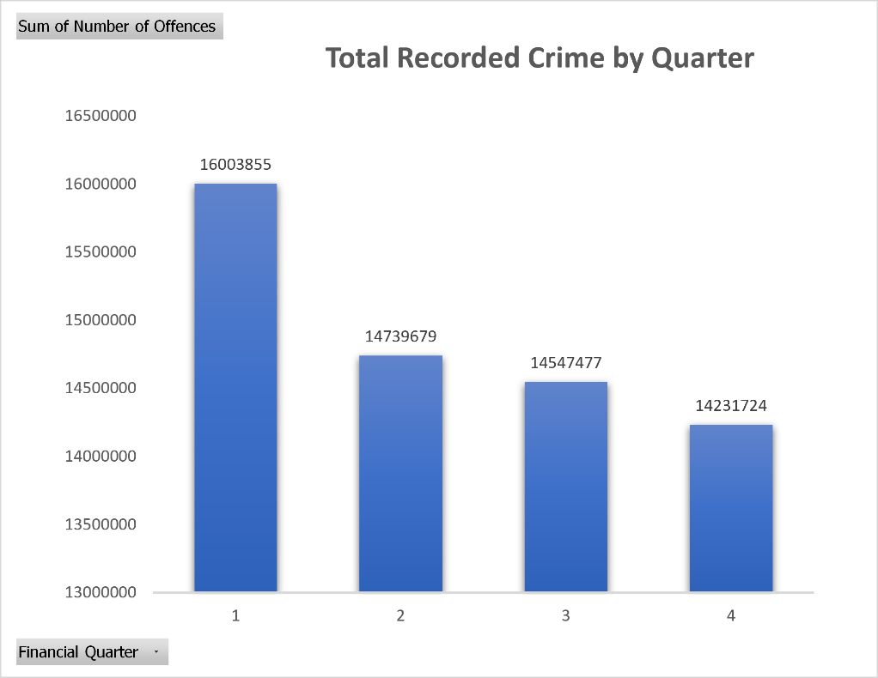
Figure 4: Total recorded crime by financial quarter (all years combined)
This seasonal pattern likely reflects the influence of warmer weather and longer daylight hours in Q1 on crime opportunity, particularly for outdoor offences such as theft from vehicles, robbery, and public order offences. The Q4 dip corresponds to the winter months of October through December, when reduced outdoor activity and shorter daylight hours limit certain crime opportunities.

Quarter | Period | Total Offences
Q1 | January – March | 16,003,855
Q2 | April – June | 14,739,679
Q3 | July – September | 14,547,477
Q4 | October – December | 14,231,724

Analysis of average quarterly crime by offence group reveals that Fraud offences record significantly higher average volumes per quarter than all other categories, peaking in Q4 (January–March) at approximately 21,000 offences on average. This is largely attributable to the concentration of fraud reporting in national bodies such as Action Fraud and CIFAS rather than territorial police forces. Across all remaining offence groups, average quarterly volumes are comparatively low and consistent, reflecting the distribution of offences across 44 forces. Notably, seasonal variation between quarters is minimal at the offence group level — the four financial quarters follow near-identical patterns across all categories — suggesting that the Q1 dominance observed in national totals is driven by aggregate volume rather than a strong within-group seasonal effect.
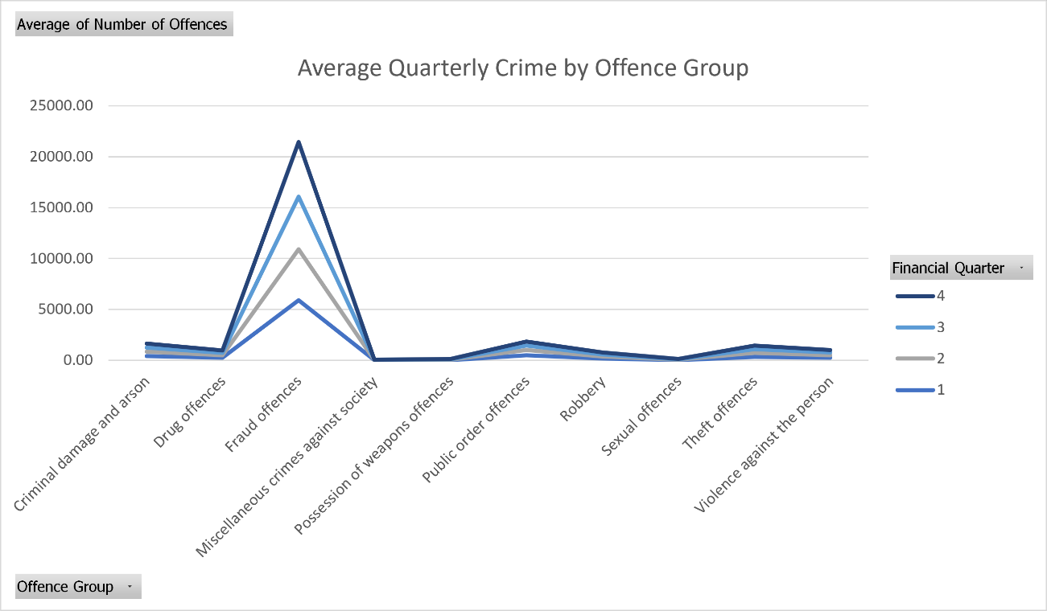
Figure 5: Analysis of average quarterly crime by offence group

6. GEOGRAPHIC ANALYSIS
6.1 Crime by Police Force
Significant variation exists in crime volumes across the 44 territorial police forces. The Metropolitan Police recorded by far the highest percentage across the period, with 33.35% of total recorded territorial crimes. Greater Manchester, West Midlands, and West Yorkshire formed the next tier of high-volume forces, each recording between 11.6% and 10.1% of total recorded territorial.
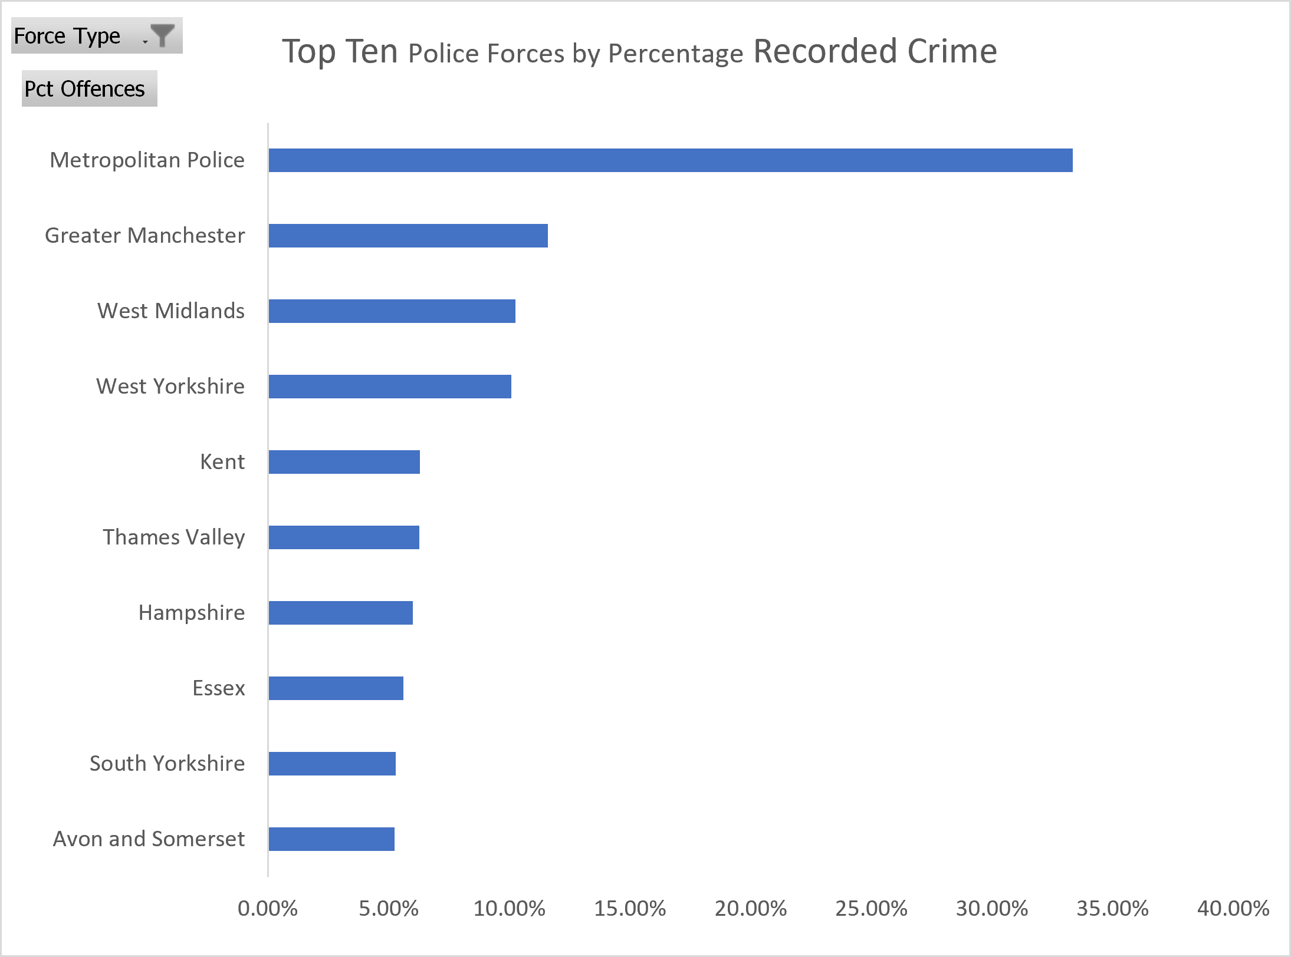
Figure 6: Top 10 territorial police forces by percentage recorded crime, 2012/13–2023/24
7. STATISTICAL SUMMARY
Descriptive statistics were computed for each offence group across all years and forces. Key observations from the statistical analysis are presented below.

Offence Group | Mean | Median | Standard Deviation | Max | Min
Criminal damage and arson | 414.77 | 179 | 639.41 | 6823.00 | -11.00
Drug offences | 247.03 | 121 | 699.60 | 14041.00 | -1.00
Fraud offences | 5364.82 | 1 | 19176.58 | 132693.00 | -118.00
Miscellaneous crimes against society | 19.64 | 2 | 60.72 | 1168.00 | -17.00
Possession of weapons offences | 35.31 | 10 | 79.21 | 1140.00 | 0.00
Public order offences | 467.21 | 122 | 1092.30 | 12140.00 | -268.00
Robbery | 191.59 | 42 | 741.64 | 10002.00 | -1.00
Sexual Offences | 33.35 | 8 | 86.50 | 2035.00 | -13.00
Theft offences | 366.09 | 40 | 1146.75 | 29480.00 | -58.00
Violence against the person | 252.45 | 3 | 994.24 | 21337.00 | -5.00

The large gap between mean and median values across all offence groups reflects significant right-skew in the data, driven by high-volume forces such as the Metropolitan Police. Fraud offences display the highest standard deviation (19,176.6), reflecting the concentration of fraud reporting in a small number of bodies (Action Fraud and CIFAS) alongside near-zero counts for most territorial forces.
8. KEY FINDINGS & LIMITATIONS
8.1 Key Findings
- Total recorded crime rose 65.8% between 2012/13 and 2022/23, with the sharpest growth in Violence against the person and Fraud offences.
- COVID-19 caused a 10.6% drop in total crime in 2020/21, with the strongest impact on theft and robbery; fraud and violence were largely unaffected.
- Q1 (April–June) is consistently the highest-crime quarter, likely driven by seasonal behavioural patterns.
- The Metropolitan Police accounts for 33.35% of all territorial crime, but its national share has declined over the period as regional forces record faster growth.
- Fraud is the fastest-growing major offence group by proportional change.
- Most offence groups showed a rising or stable long-term direction, with only public order offences classified as stable and no major group showing a sustained decline.

8.2 Limitations
- The 2023/24 data is incomplete, containing only Q1 figures. It was included in the dataset but excluded from year-on-year trend comparisons to avoid distortion.
- Increases in certain categories particularly Violence against the person and Sexual offences — partly reflect improvements in recording practices rather than genuine increases in incidents.
- National reporting bodies (Action Fraud, CIFAS, etc.) were excluded from geographic comparisons as they are not geographically bounded forces.
- Negative offence counts (426 rows) represent legitimate Home Office recording adjustments and were retained but excluded from certain statistical measures.

9. CONCLUSION
This analysis of Home Office police recorded crime data reveals a consistent long-term upward trend in crime across England and Wales between 2012/13 and 2022/23, punctuated by a COVID-19-related dip in 2020/21. The growth is most pronounced in Violence against the person and Fraud offences, though interpretive caution is required given known recording practice changes over the period.
Geographically, crime remains concentrated in the largest urban forces, with the Metropolitan Police accounting for nearly one in five recorded offences nationally. Seasonal analysis confirms that Q1 consistently produces the highest crime volumes. These findings provide a robust evidence base for further policy-focused research and regional comparisons.

REFERENCES
Home Office (2023). Police recorded crime, England and Wales. Available at: https://www.gov.uk/government/statistics/police-recorded-crime-open-data-tables
Office for National Statistics (2023). Crime in England and Wales. Available at: https://www.ons.gov.uk/peoplepopulationandcommunity/crimeandjustice

