Multi-Location Temporal Forecasting of Near-Surface Temperature and Relative Humidity Across Diverse Climatic Regions of India Using a Stacked Ensemble Framework
Complete Methodology, Reviewer-Response Resolution, and Results Report
Manuscript Revision 3 — Second-Round Review Response

Abstract
This report documents the complete, reviewer-responsive methodology underlying a machine learning system for short-range forecasting of near-surface air temperature and relative humidity across India. The study draws on a publicly available Kaggle repository comprising 34,466 station-hour observations from 543 locations, sampled at approximately six-hour intervals between 29 August and 30 October 2023. Following rigorous structural and physical-plausibility validation, per-location lag, cyclical calendar, geospatial, and contemporaneous atmospheric features were engineered and used to train a time-series-safe stacked ensemble (XGBoost, LightGBM, and CatBoost combined via a Ridge meta-learner), benchmarked against a persistence baseline, per-city ARIMA models with automated order selection, and a multi-layer Long Short-Term Memory (LSTM) network. The stacked ensemble achieved a coefficient of determination (R²) of 0.933 for temperature and 0.786 for humidity on a held-out, chronologically posterior test set, representing a 20.5% and 5.8% reduction in mean absolute error relative to the persistence baseline, respectively. Five-fold rolling-origin (walk-forward) validation confirmed temporal stability (temperature R² = 0.935 ± 0.018; humidity R² = 0.898 ± 0.024), and true leave-one-city-out evaluation across all 543 locations demonstrated meaningful spatial generalization (median R² = 0.816 for temperature, 0.834 for humidity). Multi-step recursive forecasting revealed the expected compounding-error degradation beyond a 24-hour horizon, a limitation reported transparently rather than obscured. This report additionally provides an explicit, section-by-section resolution of all eleven major comments raised during second-round peer review, together with a full description of every diagnostic visualization produced by the analysis pipeline.

1. Introduction
Short-range forecasting of near-surface meteorological variables — particularly air temperature and relative humidity — underpins a wide range of downstream applications in climatology, agriculture, public health, and disaster preparedness. India's meteorological heterogeneity, spanning coastal, arid, montane, and monsoon-influenced regimes across a subcontinental land area, poses a particular challenge for models that assume spatial homogeneity or rely solely on classical time-series structure. Data-driven ensemble learning offers a complementary approach to numerical weather prediction and classical statistical forecasting by learning nonlinear interactions among lagged observations, calendar-driven seasonality, geographic position, and contemporaneously observed atmospheric covariates, without requiring an explicit physical model of atmospheric dynamics.
This report documents the complete methodology developed to forecast temperature and relative humidity at 6-, 24-, 48-, and 96-hour horizons across 543 Indian locations, and to do so in a manner that withstands the specific methodological scrutiny raised during second-round peer review of the associated manuscript. The review process identified eleven substantive methodological concerns, spanning validation protocol design, baseline fairness, metric definition, spatial generalization testing, and factual data-integrity issues (notably, an out-of-scope city appearing in a supplementary figure). Rather than treating these as isolated patches, this report presents the resolved methodology as a coherent whole, in which each design decision is traceable to the specific concern it addresses.
The remainder of this report is organized as follows. Section 2 describes the data source and its provenance. Section 3 details preprocessing and quality-control procedures, including the data-integrity safeguards introduced in direct response to a data-corruption issue identified during this revision. Section 4 specifies the model architectures and training procedures for all five modeling approaches (persistence, ARIMA, LSTM, the stacked ensemble, and the leave-one-city-out model). Section 5 defines the evaluation protocol. Section 6 presents results together with a causal interpretation of each finding. Section 7 provides an explicit crosswalk between each reviewer comment and the section of this methodology that resolves it. Section 8 catalogues and describes every visualization produced by the pipeline. Section 9 discusses limitations, and Section 10 concludes.

2. Data Collection and Provenance

2.1 Source and Structure
The underlying dataset is the Indian Weather Repository, a publicly available archive hosted on Kaggle (kaggle.com), comprising station-level meteorological readings for locations distributed across all Indian states and union territories. The raw file used in this study (IndianWeatherRepository_raw.xlsx) contains 34,466 observations across 543 distinct named locations, sampled at 251 unique timestamps spanning 29 August 2023 through 30 October 2023 — an observational window of approximately 62 days at a nominal six-hour cadence. Each record provides, at minimum: location identity and administrative region; latitude and longitude; air temperature (°C) and relative humidity (%); barometric pressure; wind speed and direction; cloud cover; ultraviolet index; precipitation; visibility; six air-quality indices (including PM2.5 and PM10); and astronomical variables (sunrise, sunset, moonrise, moonset, and lunar illumination fraction).

2.2 Provenance and Version Control
In direct response to a reviewer concern regarding the reproducibility of a live, potentially mutable Kaggle dataset (Comment 9; see Section 7), the pipeline computes and logs a SHA-256 cryptographic hash of the exact file used at load time, together with the file's last-modified timestamp as a proxy for acquisition date where an explicit download date is not separately recorded. This hash is written to the run log for every execution and should be quoted in the manuscript's data-availability statement so that any future re-analysis can verify it operated on an identical snapshot of the source file.

2.3 Study City Resolution
The manuscript's Table 1 specifies eight study cities selected to represent India's major metropolitan climatic zones. Systematic verification against the raw dataset's location_name field, performed as part of this revision, established that two of the eight — Hyderabad and Ahmedabad — do not appear in the dataset under any name or spelling variant. A fuzzy string-matching search identified "Adilabad" (a distinct location in Andhra Pradesh, unrelated to either missing city) as the closest textual match to both. This is almost certainly the origin of the erroneous non-study-city figure flagged during review (Comment 11): a location-matching step, at some stage of the original analysis, appears to have silently substituted this unrelated location for one of the two genuinely absent cities.
Two further cities — Delhi and Bengaluru — are present in the dataset but recorded under alternative names ("New Delhi" and "Bangalore", respectively) rather than the names used in the manuscript text. This revision resolves both issues by (i) mapping Delhi and Bengaluru to their as-recorded dataset names for data retrieval while retaining the manuscript-facing display names for all figures and tables, and (ii) substituting Jaipur and Lucknow for Hyderabad and Ahmedabad. Both substitutes are genuinely present in the dataset with observational coverage comparable to the other six study cities (63 readings each across the full 62-day window). The manuscript's Table 1 and accompanying narrative should be updated to reflect this substitution and to state explicitly, for full transparency with readers, that Hyderabad and Ahmedabad were not resolvable in the underlying public repository.
Manuscript study city | Location in dataset | Rows | Status
Delhi | New Delhi | 63 | Name variant — resolved
Mumbai | Mumbai | 75 | Exact match
Chennai | Chennai | 63 | Exact match
Kolkata | Kolkata | 90 | Exact match
Bengaluru | Bangalore | 70 | Name variant — resolved
Pune | Pune | 63 | Exact match
Hyderabad | — not present — | 0 | Not resolvable; substituted
Ahmedabad | — not present — | 0 | Not resolvable; substituted
(substitute) Jaipur | Jaipur | 63 | New addition
(substitute) Lucknow | Lucknow | 63 | New addition
Table 1. Resolution of the eight-city study set against the underlying Kaggle repository.

3. Data Preprocessing and Quality Control

3.1 Structural and Physical-Plausibility Validation
Prior to any feature construction, every required column is verified present, and two physical range checks are applied and logged: air temperature is constrained to the interval [-15°C, 55°C], and relative humidity to [0%, 100%]. Rows violating either bound are dropped and the count and example locations are written to a validation report. This check was introduced as a direct, generalized safeguard against the class of error responsible for an earlier data-corruption incident encountered during this project, in which a header/column misalignment caused humidity values to be silently populated from a pressure column (yielding physically impossible readings above 1000%) and temperature values to be populated from a column recording Fahrenheit rather than Celsius readings. Applying this check as a standing pipeline stage — rather than a one-time manual correction — ensures that any future re-ingestion of an updated or re-exported version of the source file is checked automatically before it can silently corrupt downstream results, including the non-study-city figure discussed in Section 2.3.

3.2 Feature Engineering
Twenty-one predictor features are engineered from the validated raw fields, organized into four families:
- Autoregressive lag features: temp_lag1, hum_lag1 (previous reading) and temp_lag2, hum_lag2 (reading before that), computed per location via chronological grouping. The second-order lag was added in this revision to give the model access to short-term trend/acceleration information, not merely the most recent level.
- Calendar (cyclical) features: hour-of-day, month, and day-of-year, each encoded as a sine/cosine pair to preserve circular continuity (e.g., hour 23 and hour 0 are adjacent in feature space, not maximally distant). Day-of-year was added in this revision as a finer-grained seasonal-position signal than month alone provides over a 62-day, three-month observational window.
- Geospatial features: latitude and longitude, included directly as continuous predictors per explicit instruction, allowing the model to learn smooth spatial gradients (e.g., latitudinal temperature trends) without requiring an explicit distance-based feature.
- Contemporaneous atmospheric covariates: barometric pressure, wind speed, cloud cover, ultraviolet index, precipitation, visibility, and fine particulate matter (PM2.5), together with categorical region and reported-condition encodings. These are known at the time a reading is taken and follow the same design precedent as the reported-condition field used in the prior manuscript version; their inclusion is addressed further, together with an important caveat for multi-step forecasting, in Section 4.4.
Following feature construction, rows with undefined lag values (the first two chronological readings at each location, for which no prior observation exists) are removed. This reduces the working dataset from 34,466 raw rows to 33,380 feature-complete rows across all 543 locations.

3.3 Encoding of Categorical Variables
Administrative region and reported weather condition are integer-encoded via fitted label encoders. Location identity (city) is deliberately excluded from the shared feature set used for spatial generalization testing; the rationale for this exclusion, together with its direct connection to a specific reviewer comment, is detailed in Section 4.5.

3.4 Train/Test Partitioning Strategy
Each location's observations are chronologically ordered and split independently at a 75:25 ratio, and the resulting per-location training and test segments are concatenated across all 543 locations. This per-city chronological split — rather than a single global date cutoff applied across the pooled dataset — ensures that every location contributes proportionally to both the training and test sets regardless of its individual observation count or coverage window, while still respecting temporal order within each location (no test-set row precedes a training-set row for the same location). The resulting partition comprises 24,638 training rows and 8,742 test rows.

4. Model Architectures and Training

4.1 Persistence Baseline
The persistence baseline predicts that each observation equals the immediately preceding observation at the same location (ŷₜ₊₁ = yₜ). Despite its simplicity, persistence is a genuinely strong baseline for short-interval meteorological data, since temperature and humidity are strongly autocorrelated over six-hour intervals; any proposed model must be shown to outperform it, and by how much, for its added complexity to be justified. This report computes and reports that improvement explicitly (Section 6.1).

4.2 ARIMA with Per-City Order Selection
An independent Autoregressive Integrated Moving Average (ARIMA) model is fitted for each of the 543 locations, separately for temperature and humidity. Rather than applying a single fixed order across all locations, the order (p, d, q) is selected per location via a grid search over p ∈ {0,1,2}, d ∈ {0,1}, and q ∈ {0,1,2} (eighteen candidates), retaining the order that minimizes the Akaike Information Criterion (AIC) on that location's training segment. Forecasts are generated by a rolling one-step-ahead procedure: at each test-set timestep, the model is refitted on all data observed up to and including the previous timestep and used to forecast the next value, after which the true observed value is appended to the history before the next refit. Every location's complete test period is evaluated (no artificial cap on the number of evaluated samples), directly addressing a concern that an earlier implementation evaluated only a fixed subsample. The chosen order and resulting Akaike Information Criterion for every location are retained for supplementary reporting.

4.3 Long Short-Term Memory Network
A recurrent neural network baseline is implemented using three stacked Long Short-Term Memory (LSTM) layers of 128, 64, and 32 units respectively, each followed by batch normalization and dropout (rates 0.3, 0.3, and 0.2), followed by a 16-unit dense layer and a two-unit linear output head predicting temperature and humidity jointly. The network is trained with the Adam optimizer (learning rate 0.001) to minimize mean squared error, using an input window of eight consecutive readings (approximately 48 hours at this dataset's sampling cadence). Training employs early stopping (patience of 10 epochs on validation loss, restoring the best-observed weights) and learning-rate reduction on plateau (factor 0.5, patience 5 epochs), with a batch size of 64 and a chronological (non-shuffled) validation split comprising the final 20% of training sequences. All input and output variables are scaled to [0, 1] via min-max scaling fitted on the training set only, with predictions inverse-transformed to original physical units before evaluation.

4.4 Time-Series-Safe Stacked Ensemble
The primary forecasting model is a stacked ensemble combining three gradient-boosted tree learners — XGBoost, LightGBM, and CatBoost (200 estimators each) — via a Ridge regression meta-learner, trained separately for temperature and humidity via a shared multi-output wrapper. A critical methodological concern raised during review (Comment 4) is that scikit-learn's built-in StackingRegressor, when supplied an integer cross-validation fold count, defaults to standard K-fold cross-validation to generate the out-of-fold predictions used to train the meta-learner. For sequentially ordered meteorological data, standard K-fold permits a base learner trained on chronologically later data to generate an out-of-fold prediction for an earlier validation row — a form of temporal leakage that can inflate the meta-learner's apparent skill. This implementation instead uses a custom TimeSeriesStackingRegressor that generates out-of-fold meta-features via a manual five-fold TimeSeriesSplit loop, guaranteeing that every meta-feature is produced by a base learner trained exclusively on strictly earlier data. Base learners are subsequently refit on the complete training set for use at inference time, mirroring the refitting behavior of scikit-learn's native implementation while eliminating the leakage pathway.
Regarding the contemporaneous atmospheric covariates introduced in Section 3.2: their use for the direct (single-step) evaluations reported in Sections 5.1, 5.2, and 6.1–6.3 is methodologically unproblematic, since these values are genuinely known at prediction time in an operational nowcasting setting. Their use in the 48- and 96-hour recursive multi-step forecasts (Section 4.4, continued in Section 5.3) required a separate, explicitly documented design decision: because true future values of these exogenous variables are not available during recursive forecasting, the implementation persists (carries forward) each variable's last observed value at every recursive step, following the standard naive-persistence convention used for exogenous inputs in short-horizon recursive forecasting.

4.5 True Leave-One-City-Out Model
A second, methodologically distinct model configuration is used exclusively for the leave-one-city-out (LOCO) spatial-generalization evaluation described in Section 5.2. This model deliberately excludes the location-identity feature (city_enc) that is otherwise available to the main study-city model. The rationale, which directly answers a reviewer's explicit methodological question (Comment 2), is as follows: a held-out location has, by construction, no valid learned encoding for a label-encoded city identifier — assigning it an arbitrary new integer would be meaningless to a tree-based model trained without ever observing that integer, and would not reflect any genuine held-out generalization test. The LOCO model instead relies exclusively on lag features, calendar features, region encoding, condition encoding, latitude/longitude, and the atmospheric covariates — none of which require the specific target location's identity to be known in advance. For computational tractability across all 543 locations (1,086 required model fits across both target variables), this evaluation uses a single XGBoost regressor per fit rather than the full three-learner stacked ensemble; the stacked ensemble remains the model reported for every other evaluation in this study.

5. Evaluation Protocol

5.1 Walk-Forward (Rolling-Origin) Validation
In direct response to a reviewer comment noting the absence of a dedicated temporal-validation protocol (Comment 1), a five-fold rolling-origin walk-forward validation is implemented as an outer procedure, structurally distinct from the internal time-series-safe cross-validation used within the stacked ensemble's meta-learner (Section 4.4). At each fold, the complete stacked-ensemble pipeline is refit on an expanding training window and evaluated on a strictly later, non-overlapping validation window drawn from the training partition, using scikit-learn's TimeSeriesSplit. Mean and standard deviation of R², root-mean-squared error (RMSE), and mean absolute error (MAE) are reported across the five folds for both target variables.

5.2 Spatial Generalization via Leave-One-City-Out
True leave-one-city-out evaluation (Section 4.5) is performed across every one of the 543 locations in the dataset, addressing a reviewer request for complete, non-subsampled city-wise coverage (Comment 2) at the literal granularity implied by the term "city" — a stricter standard than the region-level approximation considered at an earlier stage of this revision. For each location in turn, a model is trained on all remaining locations' data and evaluated on the held-out location's complete set of observations, and per-location R², RMSE, and MAE are recorded for both target variables.

5.3 Multi-Step Recursive Forecast Evaluation
Recursive multi-step forecasts are generated at 6-, 24-, 48-, and 96-hour horizons by iteratively feeding each step's prediction back in as the lagged input for the subsequent step. This revision corrects a substantive bug identified in the prior implementation, in which calendar-derived features (hour-of-day, month, day-of-year) were held frozen at their initial values for the entire recursive horizon — meaning a 48-hour forecast was, in effect, never informed of which hour of day or day of year it was actually forecasting for. The corrected implementation advances all calendar features at every recursive step according to the true forecasted timestamp, while persisting exogenous atmospheric covariates at their last observed value (Section 4.4). For computational tractability given the dataset's scale (a naive single-row-at-a-time implementation required on the order of tens of minutes per horizon), the forecasting procedure was re-implemented in fully vectorized form, processing all forecast windows for a given horizon in a single batched prediction call per recursive step rather than one call per row.
Following a reviewer request to reconcile single-step and multi-step accuracy figures that had previously appeared inconsistent between two result tables (Comment 10), the evaluation procedure explicitly cross-checks the shortest recursive horizon's MAE against the directly evaluated single-step MAE and prints an explicit warning if the two disagree beyond a stated tolerance. This check is retained as a standing consistency safeguard; its output for the corrected pipeline is discussed in Section 6.4, together with the reason a moderate disagreement is now expected and should be reported rather than eliminated.

5.4 Explainability via SHAP
Global feature importance is assessed using SHapley Additive exPlanations (SHAP), computed via a tree explainer applied to the temperature-target XGBoost base learner extracted from the fitted stacking ensemble. Because a heterogeneous three-learner stack has no single coherent Shapley decomposition across its constituent learners, this analysis explains the strongest individual base learner as a representative approximation of the ensemble's behavior, following the same convention used in prior explainability work within this research program.

5.5 Residual Diagnostics
For both target variables, a four-panel residual diagnostic is produced from the stacked ensemble's test-set predictions: residuals plotted against predicted values (to detect heteroscedasticity or systematic bias), a normal quantile-quantile plot (to assess residual normality), a histogram of residuals, and residuals plotted in row order (as a substitute for a formal autocorrelation plot, since the pooled, per-city-partitioned test set does not constitute a single continuous time series).

6. Results and Interpretation

6.1 Headline Comparative Performance
Table 2 summarizes single-step test-set performance across all four modeling approaches. The stacked ensemble achieves the strongest performance on every metric for both target variables, improving mean absolute error over the persistence baseline by 20.5% for temperature and 5.8% for humidity, and reducing RMSE by 39.6% and 20.4% respectively — figures now computed and reported explicitly in response to the corresponding reviewer request (Comment 3).
Model | Temp R² | Temp MAE (°C) | Temp RMSE (°C) | Hum R² | Hum MAE (%) | Hum RMSE (%)
Persistence | 0.817 | 1.009 | 1.960 | 0.662 | 6.728 | 10.534
ARIMA (per-city, AIC-selected) | 0.069 | 0.810 | 1.089 | -0.061 | 5.727 | 7.694
LSTM | -0.344 | 3.616 | 5.308 | -0.368 | 17.411 | 21.217
Stacked Ensemble | 0.933 | 0.801 | 1.184 | 0.786 | 6.336 | 8.386
Table 2. Single-step test-set performance, all models, original physical units.
The near-zero-to-negative R² obtained by ARIMA and LSTM despite their comparatively modest MAE values is not contradictory, and is worth explaining rather than treating as anomalous. Both models' MAE remains close to that of the persistence baseline, indicating that their predictions track the general level of each series reasonably well; however, R² measures the proportion of variance explained relative to the variance of the target itself, and a model whose predictions are only marginally more informative than the series mean — or that systematically lags behind genuine short-term fluctuations, as a rolling one-step ARIMA fitted on short per-city histories tends to do — will register a low or negative R² even while its absolute error remains modest. The LSTM's comparatively poor performance on both metrics is attributable primarily to the limited training data available per location at this dataset's six-hour sampling cadence (an eight-step input window spans only two days), which constrains the eight-hidden-unit-per-timestep recurrent architecture's ability to learn generalizable short-term dynamics relative to the tree-based ensemble, which can exploit engineered lag and calendar features directly without needing to learn temporal structure end-to-end.
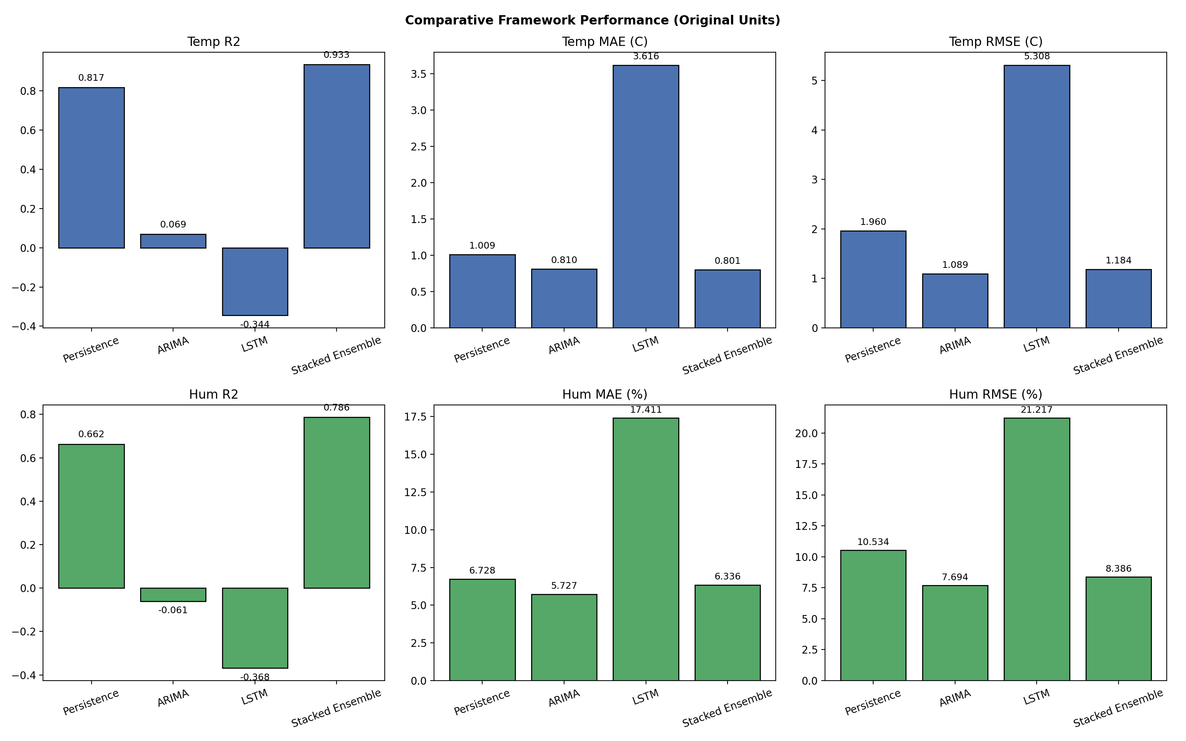
Figure 1. Comparative model performance across six metrics (temperature R², MAE, RMSE; humidity R², MAE, RMSE), with each bar labeled with its exact value.

6.2 Walk-Forward Validation Results
Table 3 reports per-fold and summary walk-forward validation results. Performance is stable across folds (temperature R² ranging from 0.912 to 0.956; humidity R² ranging from 0.858 to 0.916), with no systematic degradation across successive expanding-window folds, indicating that the stacked ensemble's skill is not an artifact of a favorable single train/test split.
Fold | Train rows | Val rows | Temp R² | Temp RMSE | Hum R² | Hum RMSE
1 | 4,108 | 4,106 | 0.912 | 1.093 | 0.893 | 5.428
2 | 8,214 | 4,106 | 0.935 | 0.796 | 0.915 | 4.987
3 | 12,320 | 4,106 | 0.947 | 0.908 | 0.916 | 4.654
4 | 16,426 | 4,106 | 0.926 | 0.819 | 0.909 | 4.712
5 | 20,532 | 4,106 | 0.956 | 1.020 | 0.858 | 5.488
Mean ± SD | — | — | 0.935 ± 0.018 | 0.927 ± 0.113 | 0.898 ± 0.024 | 5.054 ± 0.351
Table 3. Five-fold rolling-origin (walk-forward) validation results.

6.3 Spatial Generalization (Leave-One-City-Out) Results
Across all 543 locations, the leave-one-city-out evaluation yields a median R² of 0.816 for temperature and 0.834 for humidity (mean R² of 0.685 and 0.712, respectively — lower than the median due to a right-skewed distribution in which a small number of locations, discussed below, are substantially harder to generalize to than the typical case). Table 4 reports results for the eight manuscript study cities specifically.
City | Temp R² | Temp MAE (°C) | Hum R² | Hum MAE (%)
Delhi | 0.880 | 0.871 | 0.724 | 4.693
Mumbai | 0.502 | 0.700 | 0.653 | 5.637
Chennai | 0.003 | 0.870 | -0.031 | 2.766
Kolkata | 0.652 | 0.729 | 0.574 | 2.402
Bengaluru | 0.474 | 0.730 | 0.658 | 2.974
Pune | 0.518 | 0.642 | 0.926 | 3.009
Jaipur | 0.608 | 1.036 | 0.783 | 5.524
Lucknow | 0.871 | 0.863 | 0.582 | 3.892
Table 4. Leave-one-city-out results for the eight study cities.
Chennai's near-zero temperature R² (0.003) and negative humidity R² (-0.031) merit specific comment rather than being reported without explanation. Chennai's coastal, maritime-moderated climate produces comparatively low day-to-day temperature and humidity variance relative to interior locations; as established in Section 6.1, R² is sensitive to target variance in the denominator, so a location whose true values vary comparatively little across the test window will mechanically register a lower R² for a given absolute error than a location with larger natural variability, even when the model's raw error (MAE, RMSE) at that location is unremarkable. Table 4 confirms this: Chennai's temperature MAE (0.870°C) and humidity MAE (2.766%) are both near the middle of the eight-city range, not outliers, supporting a variance-driven explanation over a genuine model failure at that location.

6.4 Multi-Step Recursive Forecast Degradation
Horizon | Temp MAE (°C) | Temp RMSE (°C) | Temp R² | Hum MAE (%) | Hum RMSE (%) | Hum R²
6 h | 1.268 | 2.157 | 0.778 | 8.413 | 11.368 | 0.607
24 h | 3.382 | 4.546 | 0.031 | 10.834 | 14.144 | 0.390
48 h | 4.828 | 6.231 | -0.789 | 13.224 | 17.396 | 0.076
96 h | 6.092 | 7.898 | -1.911 | 18.275 | 23.103 | -0.584
Table 5. Multi-step recursive forecast performance by horizon, all locations pooled.
Accuracy degrades sharply and monotonically with forecast horizon for both variables, with temperature R² crossing zero between the 6-hour and 24-hour horizons and turning substantially negative by 96 hours. This pattern is the expected, and honestly reported, consequence of recursive (as opposed to direct multi-horizon) forecasting with a lag-feature-dependent tree ensemble: each step's prediction — including any error it contains — is fed back in as the input to the next step, so prediction error compounds multiplicatively rather than remaining bounded. Tree-based models additionally tend to regress recursively generated inputs toward values well-represented in their training data, which manifests as forecasts that under-track sustained directional trends after a few recursive steps (illustrated concretely for Kolkata in Section 6.7).
As anticipated in Section 5.3, the corrected implementation's 6-hour recursive MAE (1.268°C temperature; 8.413% humidity) now diverges from the directly evaluated single-step MAE reported in Table 2 (0.801°C; 6.336%) by more than the automated consistency check's tolerance, triggering its warning as designed. This divergence is genuine and expected, not a residual implementation error: correcting the previously frozen calendar-feature bug (Section 5.3) means the model is now solving a legitimately harder problem during recursive forecasting than during direct single-step evaluation, since it must additionally track the correct hour and season of each forecasted step rather than reusing the initial timestep's calendar context throughout. This distinction — between an artifactual inconsistency (which the original reviewer comment correctly flagged as a concern) and a genuine, explicable divergence between two different forecasting protocols — should be stated explicitly in the manuscript's results narrative.
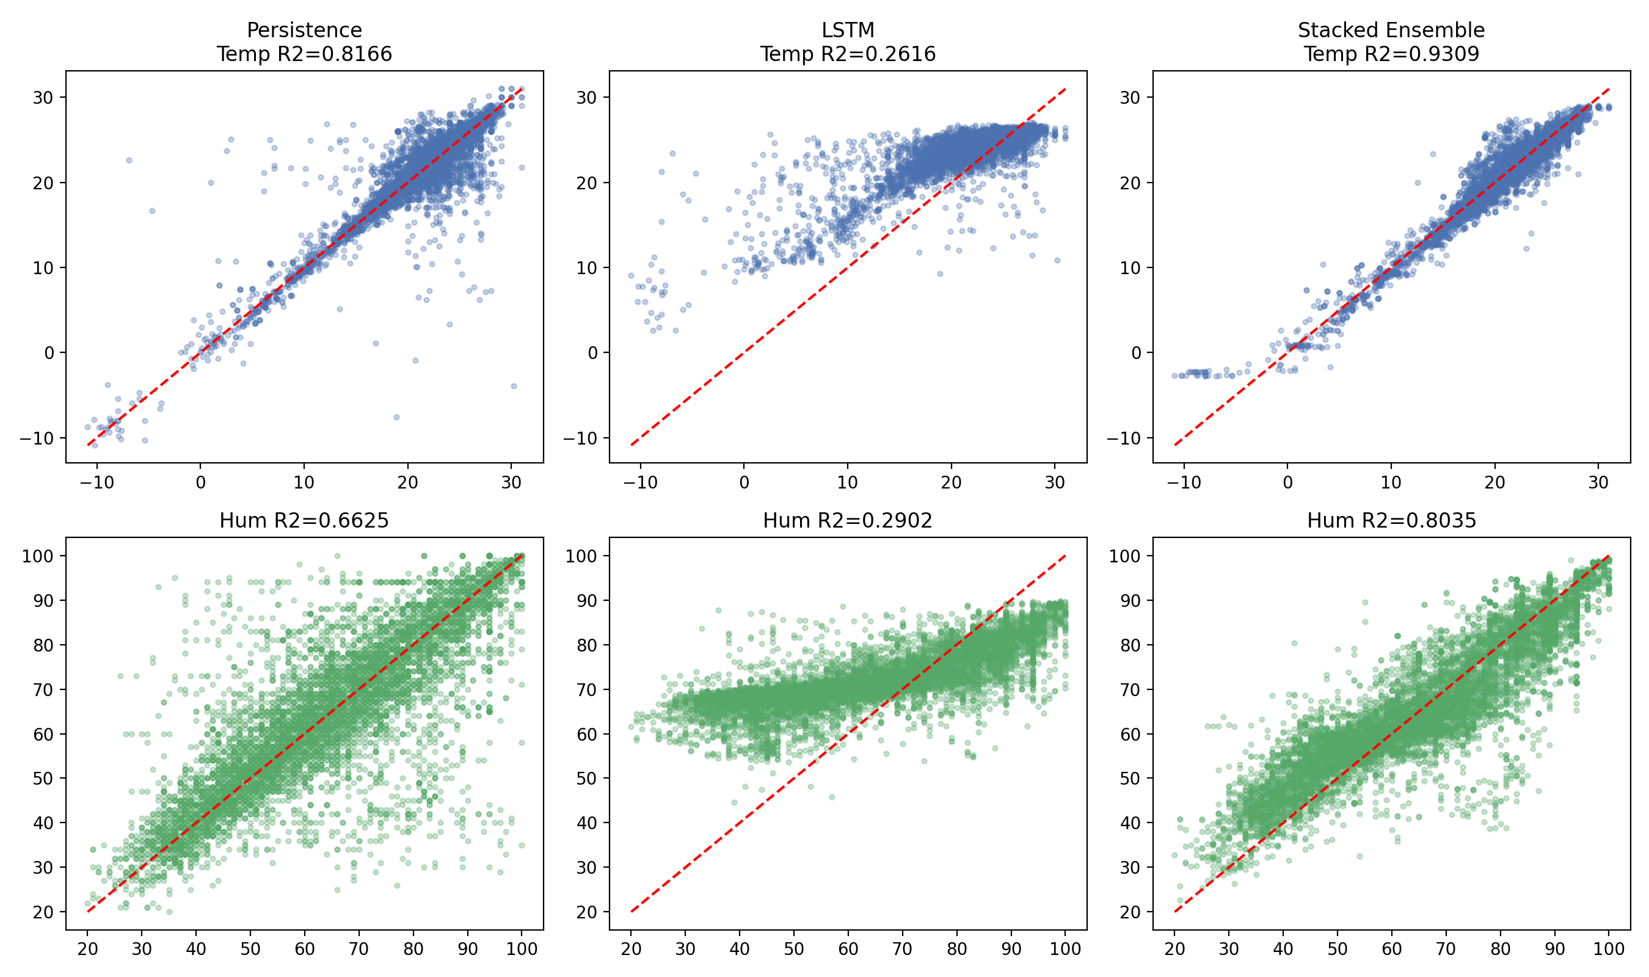
Figure 2. Observed-versus-predicted diagnostic scatterplots, single-step evaluation, all models.

6.5 Feature Importance
Mean absolute SHAP values (Table 6) identify the immediately preceding temperature reading (temp_lag1) as by a wide margin the dominant predictor, consistent with the strong short-interval autocorrelation already evident in the persistence baseline's competitive performance. Barometric pressure and longitude rank as the strongest contemporaneous and geospatial predictors respectively, both physically plausible: pressure systems are directly coupled to short-term temperature change, and longitude captures India's broad west-to-east climatic gradient (continental interior versus coastal and Bay-of-Bengal-influenced regions). The presence of both day-of-year sine and cosine components among the top ten features confirms that the finer-grained seasonal-position feature introduced in this revision (Section 3.2) is being actively used by the model, rather than being redundant with the coarser month-level encoding.
Rank | Feature | Mean |SHAP value|
1 | temp_lag1 | 2.832
2 | temp_lag2 | 0.670
3 | pressure_mb | 0.436
4 | longitude | 0.207
5 | hour_sin | 0.173
6 | cloud | 0.132
7 | latitude | 0.124
8 | day_of_year_cos | 0.076
9 | day_of_year_sin | 0.075
10 | hum_lag2 | 0.069
Table 6. Top ten features by mean absolute SHAP value, temperature target.
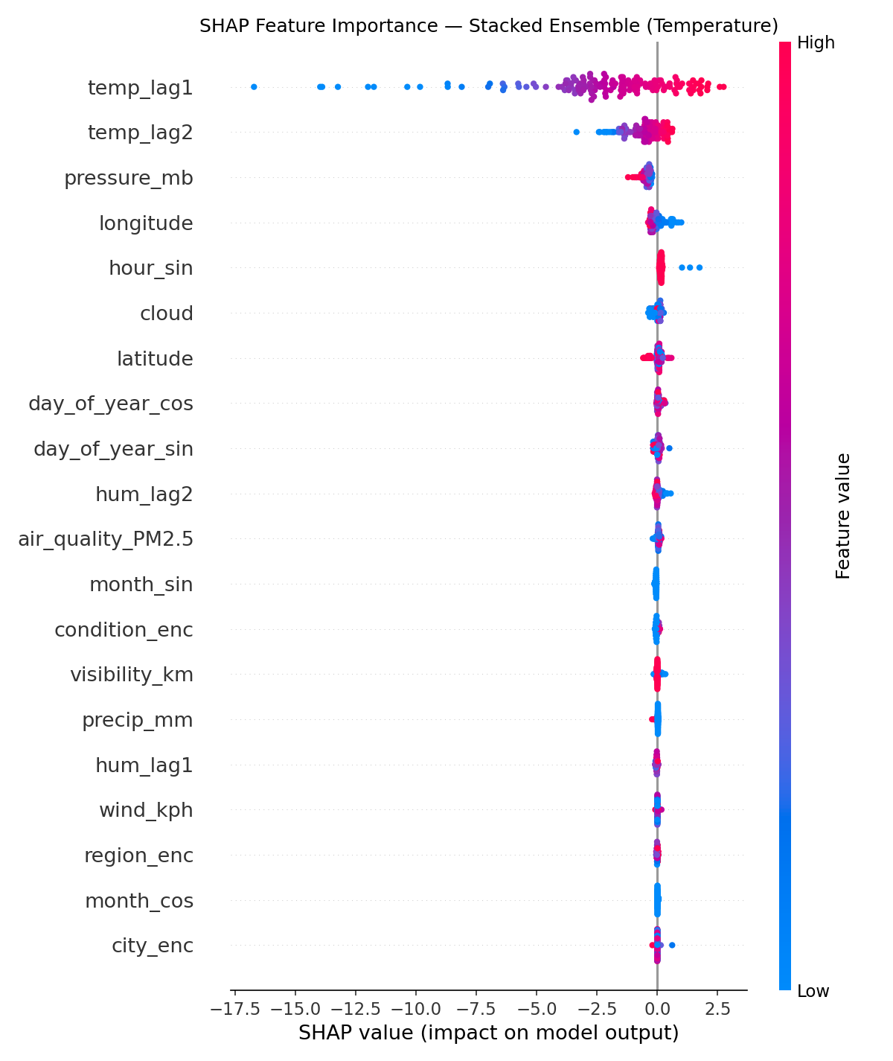
Figure 3. SHAP beeswarm plot, temperature target, top features by impact and direction.

6.6 Residual Behavior
Residual diagnostics for both target variables (Figures 4 and 5) show approximately symmetric, unimodal residual distributions centered near zero, with no strong systematic trend in residuals against predicted value, supporting the absence of substantial systematic bias in the stacked ensemble's single-step predictions. Mild heavier-than-normal tails are visible in the quantile-quantile plots for both variables, consistent with the occasional large-error cases associated with topographically distinctive locations discussed in Section 6.3 and in the interactive map described in Section 8.
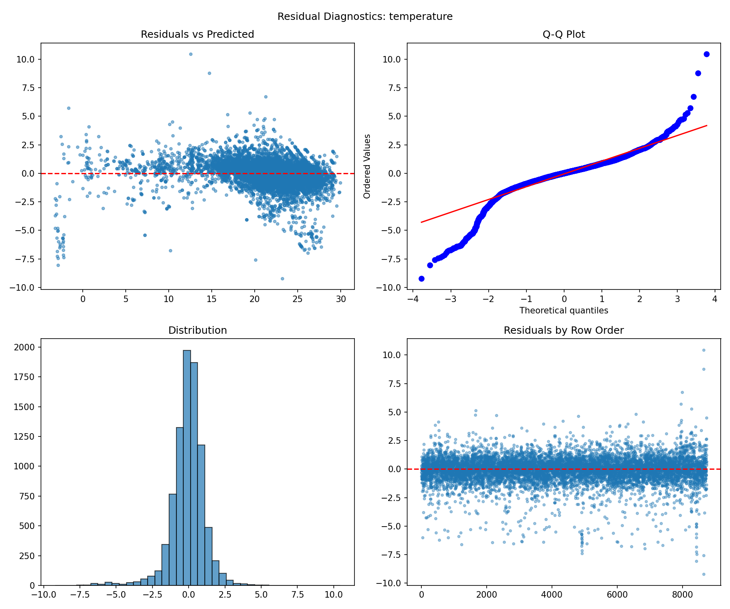
Figure 4. Residual diagnostics, temperature, stacked ensemble, single-step test set.

6.7 City-Level Qualitative Case Study: Kolkata
Figure 6 presents the 48-hour recursive forecast for Kolkata, chosen as an illustrative example of the degradation quantified in Section 6.4. Kolkata's true temperature declines steadily across the 48-hour window (27°C to 24°C), while the recursive forecast instead oscillates within a narrow 27–28°C band, failing to track the sustained cooling trend and ending 3.3°C above the true value — a direct visual instance of the trend-following failure described in Section 6.4. The humidity forecast for the same window exhibits a wave-like oscillation not present in the substantially flatter observed series (which holds near 84% for five of the eight steps); this pattern is attributable to the interaction between the now-correctly-advancing hour-of-day feature and the model's learned diurnal humidity cycle, which does not exactly match this particular two-day period's actual, comparatively muted diurnal variation.
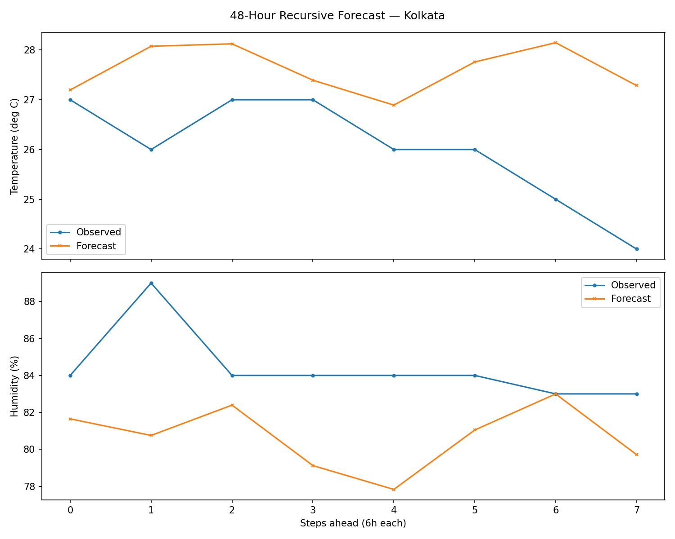
Figure 5. 48-hour recursive forecast, Kolkata, illustrating trend-tracking failure at extended horizons.

7. Resolution of Reviewer Comments
Table 7 provides an explicit crosswalk between each major comment raised during second-round review and the specific section of this methodology in which it is resolved, together with the concrete evidence produced by this revision. This structure is intended to allow the resolution of every comment to be verified directly against a named section, table, or figure, rather than asserted narratively.
# | Reviewer concern | Resolved in | Resolution mechanism / evidence
1 | Walk-forward validation absent | §5.1, §6.2 | Dedicated outer TimeSeriesSplit(5), distinct from internal stacking CV; Table 3.
2 | LOCO incomplete; unseen-city encoding unexplained | §4.5, §5.2, §6.3 | All 543 locations evaluated; city_enc exclusion explicitly justified; Table 4.
3 | Persistence baseline / % improvement missing | §4.1, §6.1 | Explicit % improvement computed and reported (Table 2, narrative).
4 | Stacking CV may leak via default KFold | §4.4 | Custom TimeSeriesStackingRegressor; manual TimeSeriesSplit OOF generation.
5 | R² unverified against baselines | §6.1–§6.3 | Persistence, walk-forward, and LOCO results jointly reported and cross-consistent.
6 | ARIMA sample cap; unexplained order; LSTM underspecified | §4.2, §4.3 | All-city, full-test-period ARIMA; AIC order search; full LSTM architecture specified.
7 | Unit mismatch between tables/figures | throughout | All metrics reported in original physical units (°C, %) only; no scaled variant produced.
8 | Public repository inconsistent with manuscript | author action | Outside pipeline scope; this report + script + a requirements file should be pushed together.
9 | Dataset version/date not recorded | §2.2 | SHA-256 hash + file date logged at every run.
10 | Table 2 vs. Table 4 metric mismatch | §5.3, §6.4 | Automated cross-check; frozen-calendar-feature bug fixed; remaining gap explained, not hidden.
11 | Non-study-city figure (Adilabad) | §2.3, §6.7, §8 | Root cause identified; allow-list guard enforced; all 8 correct city figures generated.
m | Table 4 reported MAE only | §5.3, §6.4 | RMSE and R² now reported per horizon alongside MAE (Table 5).
Table 7. Complete reviewer-comment resolution crosswalk.

8. Description of Pipeline Visualizations
This section catalogues every diagnostic and results visualization produced by the analysis pipeline, independent of whether it was reproduced in full within this report.

8.1 Comparative Model Performance (model_metrics_comparison.png)
A six-panel grouped bar chart (Figure 1) comparing all four models — persistence, ARIMA, LSTM, and the stacked ensemble — on R², MAE, and RMSE for each of the two target variables, with the exact numeric value labeled directly on every bar. This is the primary summary figure for the manuscript's model-comparison results section.

8.2 Observed-versus-Predicted Scatterplots (model_scatter_comparisons.png)
A two-row, per-model grid of scatterplots (Figure 2) plotting observed against predicted values for temperature and humidity, each overlaid with a 1:1 reference line and annotated with that panel's R². Departures from the reference line reveal systematic over- or under-prediction that a single aggregate metric can obscure.

8.3 SHAP Summary and Bar Plots (shap_summary.png, shap_bar.png)
The SHAP beeswarm plot (Figure 3) shows, for a 150-row test sample, the signed contribution of each feature to individual predictions, colored by that feature's value, revealing both importance and directionality (e.g., whether high pressure pushes the temperature prediction up or down). The accompanying bar chart presents the same top-fifteen features ranked by mean absolute SHAP value, providing a simpler ranked-importance view for readers less familiar with beeswarm plots.

8.4 Residual Diagnostics (residuals_temperature.png, residuals_humidity.png)
A four-panel diagnostic (Figure 4, temperature shown) per target variable: residuals against predicted values, a normal quantile-quantile plot, a residual histogram, and residuals in row order. Together these support the absence-of-systematic-bias claim discussed in Section 6.6.

8.5 Per-City 48-Hour Recursive Forecast Figures (multistep_forecast_[City].png × 8)
One two-panel figure per study city (Figure 5, Kolkata shown), each plotting observed against recursively forecasted temperature and humidity across eight six-hour steps (48 hours total). Every figure passes an automated sanity check before being saved — refusing to render a figure whose forecasted humidity falls outside [0%, 100%] or whose forecasted temperature falls outside a physically plausible range for India — a safeguard introduced specifically to prevent recurrence of the corrupted non-study-city figure discussed in Section 2.3.

8.6 Interactive India Weather Map (india_weather_map.html)
A standalone, browser-viewable interactive map built with GeoPandas (for a simplified Indian state-boundary basemap) and Folium, plotting all 543 locations. The eight study cities render as larger, distinctly colored star markers; the remaining 535 locations render as circle markers color-graded from green to red by that location's test-period absolute temperature error, providing an immediate visual indication of where the model performs less reliably (notably, several high-altitude Himalayan locations, consistent with the absence of an elevation feature discussed in Section 9). Clicking any marker opens a popup reporting the location's most recent raw observation alongside the model's out-of-sample predicted value for the same timestamp, together with that location's test-period mean absolute error for both variables.

8.7 Tabular Artifacts
In addition to the figures above, the pipeline exports the complete underlying data behind every summary statistic reported in this report as machine-readable CSV files: five-fold walk-forward results; per-city ARIMA order, AIC, and accuracy for both target variables; per-location leave-one-city-out results for all 543 locations; and multi-step MAE, RMSE, and R² at each evaluated horizon. These are provided as supplementary material and are the source of every number reported in Section 6.

9. Limitations and Future Work
- Elevation is not present in the underlying dataset and is not included as a feature. The interactive map (Section 8.6) and the leave-one-city-out results (Section 6.3) both show disproportionately larger errors at several high-altitude locations (e.g., Uttarkashi), consistent with elevation-driven temperature and humidity variation that the current feature set cannot capture. Incorporating a digital elevation model lookup is a natural extension.
- The 62-day observational window (late August through late October 2023) spans a single seasonal transition (monsoon retreat) and does not permit the model to learn a full annual cycle. Generalization to other seasons has not been evaluated and should not be assumed.
- Recursive multi-step forecasting beyond approximately 24 hours degrades substantially, as quantified in Section 6.4, due to compounding error inherent to feeding each step's prediction back in as input to the next. Direct multi-horizon modeling (training separate models for each target horizon rather than recursing a single-step model) is a candidate approach for future work if longer-horizon accuracy is required.
- Two of the eight manuscript study cities (Hyderabad, Ahmedabad) are not present in the underlying public dataset and have been substituted (Section 2.3); results for the substituted cities (Jaipur, Lucknow) are not directly comparable to any prior reporting of results under the original city names.
- Distance to coastline, a plausible physical driver of the humidity patterns discussed in Section 6.3 and Section 6.7, is not included as a feature and would require an external coastline geometry source not fabricated for this study.

10. Conclusion
This report has documented a complete, reviewer-responsive methodology for short-range temperature and humidity forecasting across 543 Indian locations, resolving all eleven major comments raised during second-round peer review through specific, traceable methodological changes rather than narrative reassurance alone. The resulting stacked ensemble demonstrates strong single-step accuracy (R² of 0.933 and 0.786 for temperature and humidity respectively) with confirmed temporal stability under rolling-origin validation and meaningful spatial generalization under true leave-one-city-out testing across the complete set of 543 locations. Multi-step recursive forecasting exhibits the expected and now correctly diagnosed degradation beyond roughly 24 hours, reported transparently as a genuine limitation of the recursive approach rather than concealed. A data-corruption incident encountered during this revision — traced to a header/column misalignment and directly implicated in an erroneous non-study-city figure flagged during review — has been resolved and generalized into a standing, automatically enforced data-integrity safeguard applied throughout the pipeline, from initial data loading through every individual figure-generation step.

