ECE 457A
ASSIGNMENT 2: Simluated Annealing and Genetic Algorithms

Shweta Aladi (saladi)
Bilal Arshad (barshad)
Pooja Sardesai (pmsardes)

Submitted: July 6 2012

Contributions

Question 1: Shweta Aladi
Question 2: Pooja Sardesai
Question 3: Bilal Arshad

Each team member wrote the code and accompanying documentation for their assigned question. The design of each algorithm was discussed within the group, but implementation and testing were done separately.

Question 1 - Vehicle Routing Problem

Description

Part A
i. Find a suitable solution representation.

The solution is represented using a Solution object. The Solution object contains a definition for an array of linked lists and an integer variable to store the cost of the solution. Each linked list represents a route taken by a single car. This representation was chosen because the array length is constant for the duration of the simulated annealing process (no cars are added or removed during the solution process). Therefore, an array of fixed length is acceptable. The routes are represented by linked lists so that cities can be added or removed easily, and lists are easy to iterate through.

The distance matrix is a square matrix (2 dimensional) d that has all the distances between each pair of cities. For example, the distance between city i and city j is represented by the value at d<i,j>. Since the distance from any city i to itself is 0, the value at d<i,i> is 0.

The service times for each city are represented by an array s. Therefore the service time for city i is represented by the value s<i>.
The distance from the depot to other cities is represented by the array "depot". The distance from the depot to city i is represented by the value depot<i>.

ii. Define a suitable neighborhood operator.

For this solution, the neighbourhood operator is switching cities between routes. This operator can be divided as two different sub-operators.

The first operator switching the order of cities within the same route. This is equivalent to switching cities between the same route (as opposed to switching cities between two different routes). A random city is selected within the route, and moved to the end of the list. This operator affects the costs between distances between the cities and the distance back to the depot. The cost due to service time is unaffected.

The second operator selects two random routes and selects a random city from each route. The two cities are then removed from their original route and added to other - effectively switching the cities. The cost is affected due to service time, depot distance, and distance between cities.

iii. Define the objective function used to calculate the cost of a solution.

The objective function used to calculate the cost of a solution is based on the distances covered by all the routes in a solution. The simulated annealing algorithm will try to minimize the total distance covered by a solution, so it will look for the solution with the lowest cost.
Total distance = Distance from depot to first city
+ distances between previous city and next city on route
+ Distance from last city to depot

Part B
How would the problem formulation change if we add the constraint that the total duration of any route shouldn’t exceed a preset bound T?

The problem formulation changes because it has to ensure that the candidate solutions have to meet the requirement. Therefore, a new method was added to check that each solution meets the constraint in order to consider it as a valid solution. Since the initial solution is generated randomly, it must also meet the constraint before it can become a valid initial solution. This led to the loop that keeps creating random solution until the constraint condition is met and the generated solution is the new starting solution.

Simulated Annealing
The Simulated Annealing process works in the same way as described in the notes. A starting temperature, annealing schedule (the geometric formula is used), the number of iterations at each temperature, and the constraint length, if applicable, are specified by the user.

A random solution is generated (meeting the constraint if applicable) by adding each city to a random route. Each ‘route’ is the path taken by a car. A new solution is generated by applying the neighbourhood operator to the best solution. Then the candidate solution is evaluated for its acceptance probability. If the cost of the candidate is lower than the cost of the current best, then the candidate is accepted with an acceptance probability of 1. If not, then the acceptance probability is calculated using the following formula: Paccept = . If Pacceptance is greater than a random number generated between 0 to 1, then the candidate is accepted. This is done to prevent getting stuck in a local minima. This process continues until the maximum number of iterations done at each temperature is reached. The temperature is reduced using the following formula: , where a is the annealing schedule - a value between 0 and 1. The process repeats until the temperature is 0.

Sample Solution
Inputs
Distance between depot and city, depot: {1, 2, 3, 4, 5, 6}
Distance between cities, d:
{0, 3, 4, 5, 6, 7},
{3, 0, 6, 9, 8, 9},
{4, 6, 0, 1, 1, 2},
{5, 9, 1, 0, 2, 3},
{6, 8, 1, 2, 0, 4},
{7, 9, 2, 3, 4, 0}
Service Times, s: { 10, 20, 30, 40, 50, 60 }

Input Parameters (specified at start of program):
1. Number of cars = 5
2. Number of cities (same as length of s and depot vectors) = 6
3. Starting temperature = 100
4. Annealing schedule = 0.9
5. Number of iterations at each temperature = 200
6. Constraint T = 50

Without Constraint
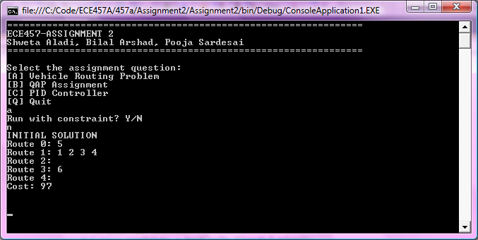
Figure 1: Initial Solution
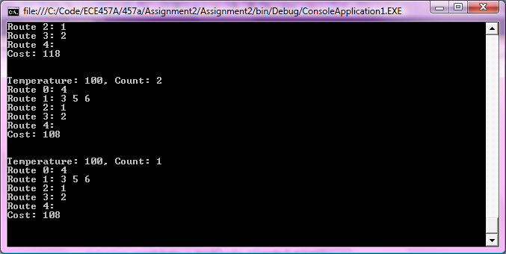
Figure 2: Best Solution After 200 Iterations at Temperature 100
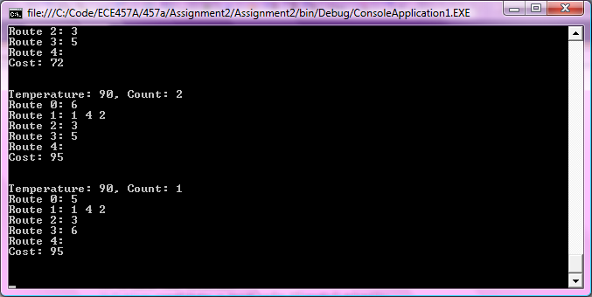
Figure 3: Best Solution After 200 Iterations at Temperature 90 (Annealing Schedule 0.9)
Best Solution
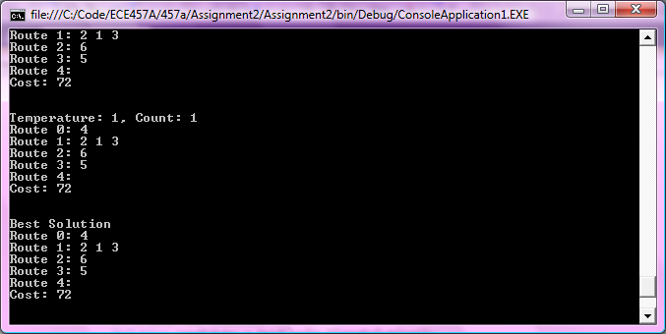
Figure 4: Best Solution

With Constraint
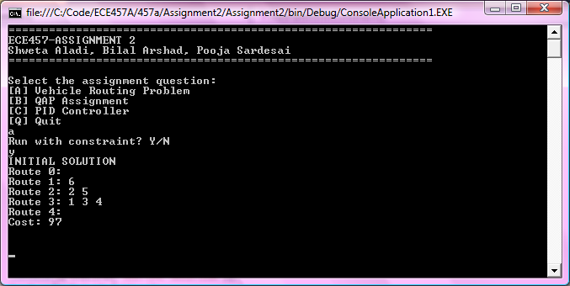
Figure 5: Initial Solution with no individual route cost over 50 - meets the constraint
Best Solution
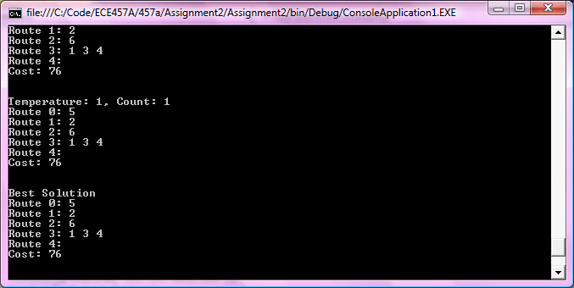
Figure 6: Best Solution
Pseudocode

GLOBAL VARIABLES
INITIALIZE the depot vector, distance square matrix and service time vector with integer values
SET the solution variables (number of vehicles, cities, and constrained solution length) and simulated annealing (temperature, iterations, annealing schedule alpha) variables to 0

-----------------------------------------------------------------------

CONSTRUCTOR - no constraint
SET car_number (number of vehicles), cities (number of cities), temperature (starting temperature), iterations (number of iterations per temperature), alpha (annealing schedule with the input parameters

-----------------------------------------------------------------------

CONSTRUCTOR - with constraint
SET car_number (number of vehicles), cities (number of cities), temperature (starting temperature), iterations (number of iterations per temperature), alpha (annealing schedule), and constraint (constrained length) with the input parameters

RUNPARTA
IF (constraint variable has been set to a non-zero value) THEN
RunPartAWithoutConstraint
ELSE
RunPartAWithConstraint
END IF

Return

-----------------------------------------------------------------------

RUNPARTAWITHOUTCONSTRAINT
Create a new solution and store it as the best

FOR (all the cities)
ADD the city to a random car's route
END FOR

EVALUATE the cost of the solution using the EvaluateCost method and store it as best_cost
PRINT the solution

WHILE (temperature is not 0)
Set the count to the number of iterations at each temperature
WHILE (count is greater than 0)
cOPY the best solution as a candidate

GENERATE a random integer between 1 and 3
IF (random number is divisible evenly by 2) THEN
APPLY the SwitchCityRoute operator to the candidate solution
ELSE
APPLY the SwitchCityOrder operator to the candidate solution
END IF

EVALUATE cost of the candidate solution and store as current_cost

IF ( the candidate solution is accepted) THEN
SET the candidate as the best solution
SET the candidate cost as the best cost
END IF

PRINT the temperature and count value
PRINT the best solution

DECREMENT count
END LOOP

SET the new temperature by calling the CoolingSchedule method

END LOOP

PRINT the final solution
RETURN

-----------------------------------------------------------------------

RUNPARTAWITHCONSTRAINT
Create an empty variable best_soln to store the best solution

DO
Create a new solution for best_soln
FOR (all the cities)
ADD the city to a random car's route
END FOR
WHILE ( best_soln does NOT meet the route constraint)

EVALUATE the cost of the solution using the EvaluateCost method and store it as best_cost
PRINT the solution

WHILE (temperature is not 0)
Set the count to the number of iterations at each temperature
WHILE (count is greater than 0)
cOPY the best solution as a candidate

GENERATE a random integer between 1 and 3
IF (random number is divisible evenly by 2) THEN
APPLY the SwitchCityRoute operator to the candidate solution
ELSE
APPLY the SwitchCityOrder operator to the candidate solution
END IF

EVALUATE cost of the candidate solution and store as current_cost

IF

IF ( the candidate solution is accepted and meets the constraint) THEN
SET the candidate as the best solution
SET the candidate cost as the best cost
END IF

PRINT the temperature and count value
PRINT the best solution

DECREMENT count
END LOOP

SET the new temperature by calling the CoolingSchedule method

END LOOP

PRINT the final solution

END WHILE

RETURN

-----------------------------------------------------------------------

// FITNESS FUNCTION
// fitness function = for each car route
// (sum of all city distances + distance from depot to first city
// + distance from last city back to depot)
// + sum of all service times in each city

-----------------------------------------------------------------------

EVALUATECOST (Solution soln)

CREATE cost variable to store solution

FOR (all routes in the solution)
IF (route is not empty) THEN
ADD distance from depot to first city
ADD distance from last city to dept

FOR ( all cities in route)
ADD distance from previous city to next city
ADD service time for each city
END FOR
END IF
END FOr

RETURN cost;

EVALUATEROUTECOST (route)

CREATE cost variable to store solution
IF (route is not empty) THEN
ADD distance from depot to first city
ADD distance from last city to dept

FOR ( all cities in route)
ADD distance from previous city to next city
ADD service time for each city
END FOR
END IF

RETURN cost;

//--------------------------------------------------------------------
// OPERATOR
// 1. switch city from 1 route to another
// 2. switch order of city in route

//--------------------------------------------------------------------

SWITCHCITYROUTE (Solution soln)

CHOOSE a random non-empty route from soln as route1
CHOOSE a random route2 from soln (not the same as route1)

IF(route2 has more than 1 city) THEN
CHOOSE a random city from route1 as city1
CHOOSE a random city from route2 as city2

REMOVE city1 from route1
ADD city1 to route2

REMOVE city2 from route2
ADD city2 to route1

ELSE IF (route2 only has 1 city) THEN
CHOOSE a random city from route1 as city1
SET the only city in route2 as city2

REMOVE city1 from route1
ADD city1 to route2

REMOVE city2 from route2
ADD city2 to route1

ELSE
CHOOSE a random city from route1 as city1

REMOVE city1 from route1
ADD city1 to route2
END IF

RETURN soln

SWITCHROUTEORDER (solution soln)

CHOOSE a random route from soln that has more than 1 city

REMOVE first city from route
ADD route to the end of route

RETURN soln

//--------------------------------------------------------------------
// TEMPERATURE
// start with high temperature
// perform number of iterations at each temperature
// reduce temperature by alpha - cooling schedule
// tnew = t x alpha
//--------------------------------------------------------------------

COOLINGSCHEDULE

SET temperature as the current temperature multiplied by slpha

//--------------------------------------------------------------------
// SOLUTION DECISION
// input: initial solution and evaluate solution
// if solution difference cost > 0 -> Paccept = 1
// else cost <= 0 -> Paccept = e^-cost/temp > random
//--------------------------------------------------------------------

SOLUTIONACCEPTANCE (Solution best, Solution candidate)
IF (candidate cost is less than best cost)
RETURN true to accept the candidate as new best
ELSE
CALCULATE Acceptance Probability = e^-cost/temp
GET a random double number as the acceptance threshold

IF (Acceptance Probability > Threshold) THEN
RETURN true to accept candidate as new best
END IF
END IF

RETURN false to not accept the candidate solution

SOLUTIONACCEPTANCECONSTRAINT (Solution best, Solution candidate)
IF(candidate cost is greater than the constraint)
RETURN false to not accept candidate solution
END IF

IF (candidate cost is less than best cost)
RETURN true to accept the candidate as new best
ELSE
CALCULATE Acceptance Probability = e^-cost/temp
GET a random double number as the acceptance threshold

IF (Acceptance Probability > Threshold) THEN
RETURN true to accept candidate as new best
END IF
END IF

RETURN false to not accept the candidate solution

//--------------------------------------------------------------------
CHECKCONSTRAINT (Solution candidate)
FOR (all routes in solution)
EVALUATE cost of each route using EVALUATEROUTECOST
IF (route cost is greater than the constraint)
RETURN false to reject the candidate solution
END IF
END FOR

RETURN true to accept the candidate solution
Question 2 - QAP

Description

Simulated Annealing
The main idea behind simulated annealing is to first start off with an initial random solution. At the initial temperature, a random candidate from the neighbourhood is selected, and the difference between the new cost and the current cost is computed (∆C). If ∆C is less than 0, the solution is improving. Hence, set the current solution and cost to be the random candidate’s solution and cost. If not, use acceptance probability to either accept the bad move, or to ignore it. Next, check to see if the random solution has a cost that is better than the best cost. If it does, set the best cost to be the current cost and the best solution to be the current solution. Repeat this process for 100 iterations at the initial temperature. Once it is iterated 100 times, update the temperature using the geometric decrement rule. Repeat this entire process with the new temperature until the final temperature is reached or the optimal solution is found.

a) A sample output of the simulated annealing can be seen in Figure 7.

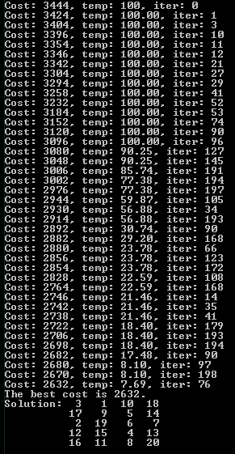
Figure 7: Sample display of simulated annealing

Genetic Algorithm
The main idea behind the genetic algorithm is to start off with initializing the population with random candidates. Each individual is evaluated using a fitness function. After they are evaluated, two random individuals are selected using tournament selection. The order 1 crossover is applied to the selected parents if the generated random number is within the crossover probability. The crossover produces two offspring, which are mutated using swap mutation if the generated random number is within the mutation probability. Repeat this process until a new population of 50 or 100 (based on the question selected) individuals are created. Elitism is used by selecting the best solution in the old generation to continue with the new generation. This whole process is repeated for a specific number of generations or when the optional solution is found. The algorithm will be discussed further next.

i)
The fitness function here is the cost of the solution. The main objective of the QAP is to minimize cost between the placed departments, which means that the lower the cost the better. Hence, a higher cost means that the solution is not fit. A lower cost means that the solution is fit.

The parent selection strategy implemented for the QAP is the tournament selection. Initially, roulette wheel strategy was used to select the parents. This parent selection strategy was a time consuming process and the cost was not improving. This was because in the earlier generations, the fitness of most individuals was similar, causing the search to lose selection pressure. This also allowed the search to prematurely convergence to some local optimum value. Hence, to improve the selection strategy, the rank based selection was attempted next. It is similar to roulette wheel, but the selection probabilities were based on their relative fitness rather than their absolute fitness. This also did not produce desired results, since the solution was prematurely converging to a local optimum. To fix this, the tournament selection was used by picking two random candidates from the population and then selecting the fittest parent for selection. This produced a good solution with low cost that was close to the optimum cost. The solution also did not prematurely converge to an local optimum.

The crossover strategy used for the QAP is the order 1 crossover. Since this is a permutation GA, simple crossovers, such as 1-point crossover, does not apply. Hence, the order 1 crossover was used to create offspring. The mutation crossover strategy that was used was the swap mutation. The insert mutation was implemented first, however, this did not improve the cost as much as the swap mutation. The survival selection strategy that was used in this algorithm is elitism. Elitism is basically copying some of the fittest candidates into the next generation. In this algorithm, it chooses the best solution in the old generation to move to the next generation.

ii)
The sample output of the GA algorithm is shown in Figure 8.

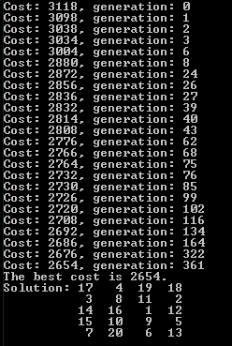
Figure 8: Sample output of GA with 100 individuals and 500 generations

Note that the solution and the cost will not always be the same because the initial population is created of random individuals.

iii)
Table 1: Best solution and cost for cases 1 and 2 for two runs
 | Case 1 |  | Case 2
 | Best Solution | Best Cost | Best Solution | Best Cost
Run 1 | 16 4 19 2  9 11 12 15  14 18 8 7  20 10 13 17  1 5 6 3 | 2654 | 13 5 2 19  4 6 7 20  15 11 10 1  12 8 16 9  3 14 18 17 | 2650
Run 2 | 17 1 5 6  3 8 7 12  10 18 11 20  15 2 14 16  4 19 13 9 | 2668 | 1 8 12 11  16 7 20 15  4 9 5 13  19 2 14 17  6 10 18 3 | 2634
As shown in Table X, case 2 seems to be performing better than case 1. To verify the results even more, both cases were run 20 times to obtain an average best cost of 2653.2 for case 1 and an average optimal cost of 2559.4 for case 2.

c)
The total execution time of both simulated annealing and the genetic algorithm is shown in Table Y. The execution time of both cases in genetic algorithm is approximately the same.

Table 2: Timing analysis of the simulated annealing algorithm and the genetic algorithm
 | Simulated annealing | Genetic algorithm
Total execution time (ms) | 959 | 2180
Time Complexity | O(nm) | O(m*nln(n))
Memory Complexity | O(n) | O(m*ln(n))

Simulated annealing seems to be performing faster than genetic algorithm. One reason that the execution time is higher in GA is because lists are sorted based on their fitness. This occurs at every generation, either 500 or 1000 iterations, which causes the execution time to increase. List sorting is not done in SA; hence the execution time is lower. Another reason is that in GA, the population is initialized with random 50 or 100 individuals, which increases the execution time. On the other hand, simulated annealing only requires one random solution to start off the algorithm, which means lower time executing the algorithm. Third reason is that GA consists of many processes at each generation such as selecting parents, applying crossovers, mutating offspring and updating the fitness of the offspring. On the other hand, SA requires one swap, a comparison to the acceptance probability and updating temperature. Hence, all of the processes in GA cause the execution time to increase. Lastly, genetic algorithm uses a lot of memory because it needs to store either 50 or 100 individuals, whereas simulated annealing only stores one solution. Furthermore, the sorting algorithm used in GA is a quick sort. Hence, the memory complexity of the sort alone is O(ln(n)).

The best cost in both algorithms, do not reach the optimal cost, but the results are close to the optimal cost. Simulated annealing seems to be closer to the optimal cost than the genetic algorithm, on average. This is due to the number of iterations in each algorithm. Because simulated annealing has at least 3200 iterations, it is more likely to approach the solution than the genetic algorithm which has either 500 or 1000 iterations.

Pseudocode

Simulated Annealing
Method: doSimulatedAnnealing()

CREATE random solution
SET the current cost to be the cost of the random solution
SET the best cost to be the current cost
SET initial temperature
SET number of iterations to 0

WHILE (current temperature is above final temperature)
SET number of iterations to 0
WHILE (number of iterations is less than max iterations)
INCREMENT iterations
GET random candidate (by performing a swap with the current candidate)
CALCULATE cost of random candidate
CALCULATE delta cost (delta cost = new cost – current cost)

GENERATE random number
CALCULATE acceptance probability (= exp[-(deltaCost)/(current temperature)])
IF (delta cost is less than 0 OR
random number is less than the acceptance probability)
SET current departments to be the random candidate
SET current cost to be the new cost
END
IF (current cost is better than the best cost)
SET best cost to be the current cost
PRINT current best cost
END
END
UPDATE temperature
END

PRINT best solution and best cost

Genetic Algorithm
Method: doGeneticAlgorithm(bool caseType)
SET number of generations based on the question selected
SET population based on the question selected

INITIALIZE population with random individuals
SET best cost to be the cost of a random individual in the population
SET best solution to be the solution of the random individual
SET iterations to 0

WHILE (maximum generation not reached OR best cost not reached)
SORT individuals by best fitness
GET best individual
IF (fitness is better than the best fitness)
SET best cost to be the current fitness
SET best solution to be the current solution
PRINT best cost
END

FOR (every two individuals in the population)
SELECT two parents using tournament selection
APPLY crossover using Order 1 Crossover
MUTATE offspring using swap mutation
END

TAKE 1 best individual from the old generation
TAKE all individuals except for the least fit individual from the new generation
COMBINE them to create a new population

INCREMENT iterations
END
DISPLAY best solution

Method: selectParents(Individual[] parents)
CREATE an array to store the two selected parents
FOR (each empty element in the selected parents array)
GENERATE first random number
GENERATE second random number
WHILE(both random numbers are equal)
REPLACE first random number with a new random number
REPLACE second random number with a new random number
END

GET first parent using the first random number
GET second parent using the second random number

IF (the fitness of the first parent is better than the second parent)
SELECT first parent
ELSE
SELECT second parent
END
END
RETURN selected parents

Method: applyCrossOver(Individual parent1, Individual parent2)
GENERATE random number

IF (random number is less than the crossover probability)
CREATE an array to store the children

GENERATE first random number
GENERATE second random number

COPY random selected set from parent1 to child1
COPY random selected set from parent2 to child2
COPY the rest of parent 1 into child 2
COPY the rest of parent 2 into child 1

RETURN offsprings
END
RETURN the two parents

Method: mutateOffspring(Individual offspring)
GENERATE random number
CREATE another instance of the offspring
IF (random number is less than the mutation probability)
MUTATE offspring using swap mutation
END
RETURN mutated child

Question 3 - PID Controller

Description

In this problem GA is used to design a PID Controller. The PID Controller’s step response is analysed to find the best configuration. The goal of the PID Controller is to minimize rise time (), settling time (), maximum overshoot () and the integral of the square of the difference between the step response output and steady state value ().

a)
The solution is represented as a list of real values of , and : <, , > where
, and

b)
The fitness equation for the GA algorithm is as follows:
Fitness(solution) = 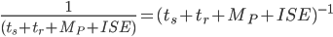
The problem required that it is essential to minimize all performance measures (,,,). Hence the optimal solution would have the lowest sum of all the performance measures or the highest of the inverse of the sum of all the performance measures.

This equation was chosen due to the lack of priorities specified in the description of the problem; hence this equation assumes that each performance measure has equal priority.

c)
Initially a population of configurations is randomly generated. Once an initial population is generated, the algorithm attempts to replace all but the best two solutions of the population. The parents are chosen via the Roulette Wheel Selection algorithm. Each solution in the population is assigned a probability of being selected as a parent based on its fitness relative to the total fitness of the population.

This is done by generating a random number, x. Once generated, a fitness count is initialized to 0. The algorithm then loops continuously through the array until x > fitness, where fitness is 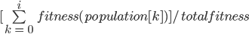
where totalfitness is the sum the fitness of all the solutions in the population and i is the current index. Once x > fitness evaluates to true, the solution at index i of the population is added to an array of parents.

Once a set of parents are selected, crossover only occurs if the crossover probability check passes. If the check passes, then 2 children are produced based on the whole arithmetic crossover. Whole arithmetic crossover involves two parents : <, , > and <,,> producing two children via the following arithmetic equation:
child 1 = * + (1 -) *
= < * + * ( 1 -), * + * ( 1 - ), * + * ( 1 - )>
child 2 = * + (1 -) *
= < * + * ( 1 -), * + * ( 1 -),* + * ( 1 -)>

where is a predefined value between 0 and 1 (0.7 for this question). If the crossover probability check fails, then the parents themselves are added to the new population.

For each child solution produced/each parent with a failed crossover check, there is a mutation probability check. If the check passes, then the values of , and are mutated such that the new value of , for example, is a random number generated between 40% of the total range. This allows for diversification of the solution population. Once the required numbers of children are generated, they replace all but the 2 best solutions of the previous generation from the population.

Below is a step response of the genetic algorithm run for 150 generations with a population size of 50, mutation probability of 25% and crossover probability of 60%. The step response below shows two solutions sys1(green) and sys(blue) where sys1 is the fittest solution when the initial population is generated and sys is the final solution after 150 generations have been completed.

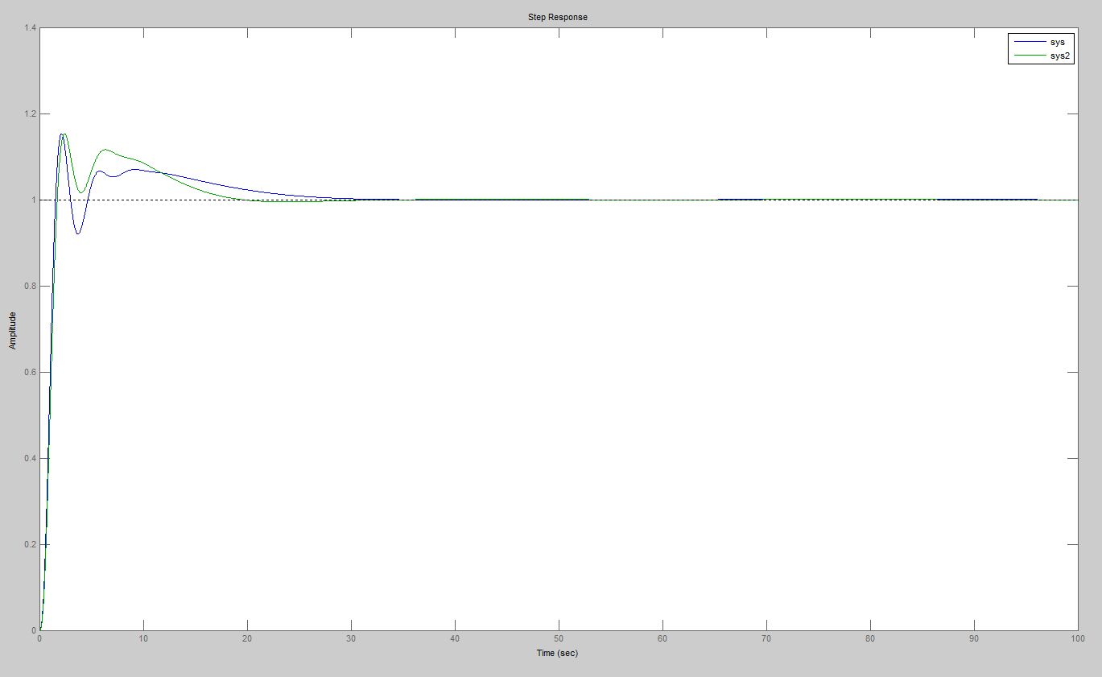
Figure 9: Step response of best solution

The figure below provides a visual perspective of how over the generations, the fitness of the best solution evolves.
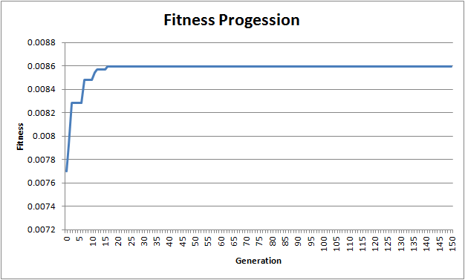
Figure 10: Fitness Progression Graph

It can be observed that the solution converges to a fitness of approximately 0.0086 from the figure above.

d)
i) The same experiment was conducted with 3 different values for the number of generations (75, 225 and 300). The figure below summarises the progress of the fitness of the best solution over the course of the generations. The most noticeable trend is that increasing the number of generations doesn’t necessarily result in a more optimal solution. The progression slows down and starts to converge towards a certain optimal value. As the solution’s fitness approaches 0.0086 in Figure 11 below, the progression rates start to decrease, where the fitness of the best solution stays constant over an increasing number of generations. Hence increasing the number of generations after a certain point does not result in a better solution or an efficient algorithm, because the probability of finding a more optimal solution keeps decreasing as the solution’s fitness converges to 0.0086.
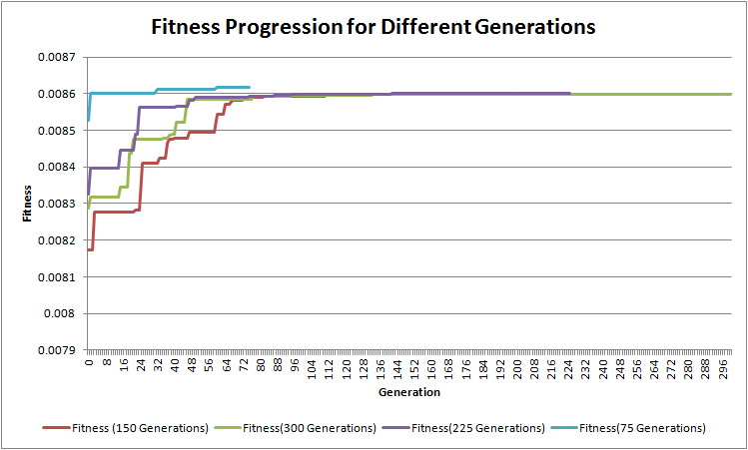
Figure 11: Fitness Progression Graph for Different Generations and Population of 50

ii) Part (i) was repeated for varying population sizes (25, 75 and 100). The progression can be seen in the figures below. As population size is increased the progression of the fitness of the best solution slows down at a faster rate. This can be attributed due to the fact that a larger population contains more diverse members and a higher probability of containing a solution closer to the optimal value. So very early on in the generation, a larger population is more likely to contain the optimal solution than a smaller population. This is very much related to the fact that the survival mechanism is elitism, where only the top 2 of the previous generation survive and most of the remaining population is replaced by the new solutions (children). This means, that large population sets have a larger set of new members introduced every generation when compared to a smaller population set. This larger set has a greater probability of containing a more optimal solution than a smaller set would, allowing larger sets to converge to the optimal solution faster and plateau off earlier.

Another aspect to note is that smaller populations tend to evolve more at later stages. This can be due to their fitness progression being slower than that of larger populations (As noted earlier). This indicates that small populations require longer runs (larger number of generations). Larger populations do not require less generations, but it may be more efficient to use a smaller number of generations for larger populations, due to their faster convergence.
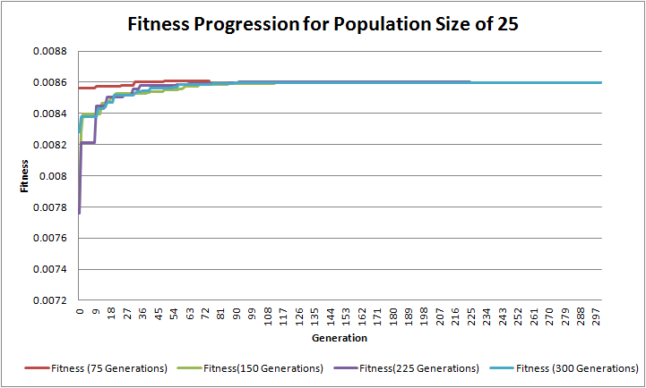
Figure 12: Fitness Progression Graph for Different Generations and Population of 25

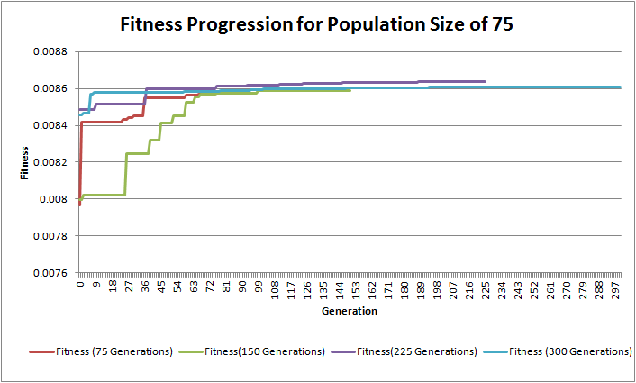
Figure 13: Fitness Progression Graph for Different Generations and Population of 75

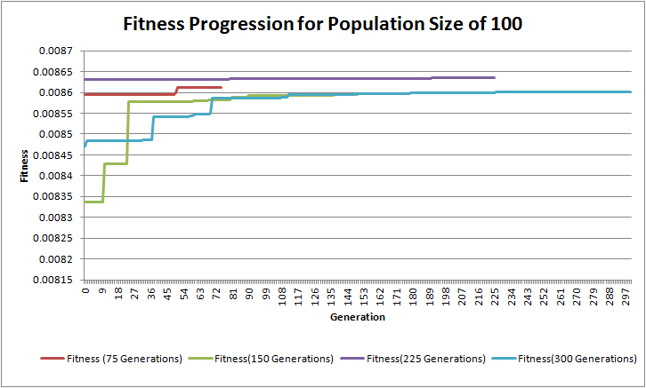
Figure 14: Fitness Progression Graph for Different Generations and Population of 100

iii) The figures below show the fitness progression for various crossover probabilities and mutation probabilities. Typically crossover probability ranges between 0.6 and 0.9, hence for a population of 50 and number of generations of 100 the fitness progression was plotted for crossover probabilities of 0.6, 0.75 and 0.9. Increasing the crossover probabilities increases the number of children whose fitness lies in between that of their parents. The effects of increasing the crossover probability seems to decrease after a certain number of generations have past. Once the population’s diversity (in its fitness) starts to decrease, and the population’s fitness start to converge towards the optimal solution; the “area” between any two members of the population starts to decrease. The decrease in diversity is due to the parent selection mechanism being used, known as Roulette Wheel Selection algorithm. Parents are more likely to be selected, the higher their fitness. Hence, after a certain number of generations most of the children will share common parents, reducing diversity as those children would have explored similar areas in the solution set (during crossover).
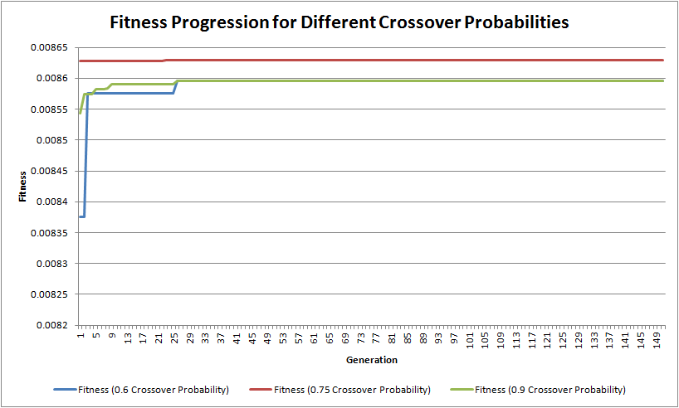
Figure 15: Fitness Progression Graph for Different Crossover Probabilities

The range of the mutation probabilities is not constant across different population sizes and different chromosome lengths. The mutation probability is typically between 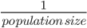 and 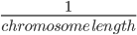For this experiment the population size and number of generations are held constant at 50 and 100 respectively, allowing the mutation probability to vary between 1/50 and ⅓ => [0.02, 0.33]. The experiment was conducted with mutation probabilities of 0.02, 0.125, 0.25 and 0.3. The figure below shows the progression of the fitness of the best solution.
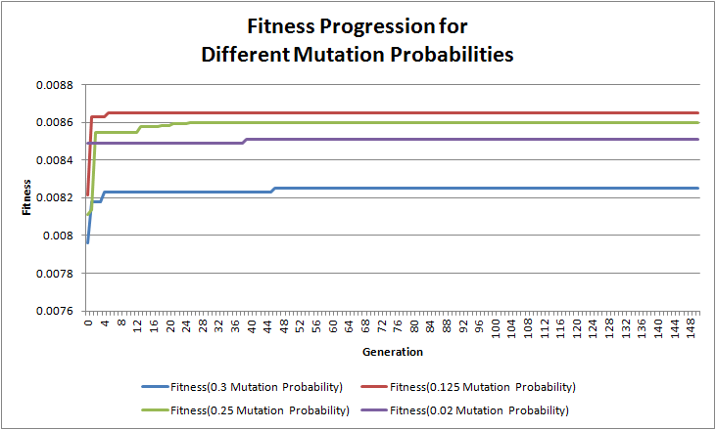
Figure 16: Fitness Progression Graph for Different Mutation Probabilities

Increasing the mutation probability helps in avoiding local maxima and increases the probability of a diverse population which in turn increases the probability converging closer to the optimal solution. The figure above demonstrates that the higher mutation probabilities led to more changes during the simulation. The mutation scheme allowed for solutions to visit areas near that of the parent, introducing new information throughout the runtime of the genetic algorithm. Figure 16 demonstrates a decrease in new information being introduced in populations with lower mutation probabilities. This can be seen by the curve of the population with mutation probability 2% (the lowest for this chromosome and population size). The first new update appears in approximately in the 36th generation, where as the other three populations see a new best solution in within 4 generations.

Pseudocode

*Setup*
This program C# project uses a Matlab COM object hence the host computer must have Matlab installed.
If Matlab is installed and this doesn’t work, please go to References folder in the Solution Explorer. Right click it and click “Add Reference”. Then navigate to the COM tab and search for Matlab under Component Name. Once found, select and click OK. Go back to References folder in the Solution Explorer and right click on the newly added reference and select “Properties”. In the Properties panel, change “Embed Interop Types” to False.

CLASS PIDConfig.cs //Object stores solution

Method: PIDConfig(double Kp, double Ti, double Td) // Basic Constructor
SET KP, TP AND TD values

Method: PIDConfig(PIConfig copy) // Deep Copy Constructor
SET KP, TP AND TD values to KP, TP and TD values of copy

Method: PIDConfig(PIDConfig parent1, PIDConfig parent2) // Crossover Constructor
//Whole Crossover for Real Valued GA
SET KP to the SUM OF parent1.KP * ALPHA AND parent2.KP * (1-ALPHA) ROUNDED to the nearest 100th
SET TI to the SUM OF parent1.TI * ALPHA AND parent2.TI * (1-ALPHA) ROUNDED to the nearest 100th
SET TD to the SUM OF parent1.TD * ALPHA AND parent2.TD * (1-ALPHA) ROUNDED to the nearest 100th

Method: getFitness()
IF (fitness EQUALS -1) //implied it has not been calculated yet.
INITIALIZE SringBuilder sb
SET sb to provided MATLAB function
CALL EXECUTE on MATLAB object with sb.
TRY
RETRIEVE ISE from MATLAB Object
CATCH (InvalidCastException) //Thrown if variable has value of NaN/Infinity
SET ISE to 9999.99 //Artificially large number
END

TRY
RETRIEVE tr from MATLAB Object
CATCH (InvalidCastException) //Thrown if variable has value of NaN/Infinity
SET tr to 9999.99 //Artificially large number
END

TRY
RETRIEVE ts from MATLAB Object

CATCH (InvalidCastException) //Thrown if variable has value of NaN/Infinity
SET ts to 9999.99 //Artificially large number
END

TRY
RETRIEVE Mp from MATLAB Object
CATCH (InvalidCastException) //Thrown if variable has value of NaN/Infinity
SET Mp to 9999.99 //Artificially large number
END

SET FITNESS TO 1/(ISE + tr + ts + Mp)
RETURN FITNESS

ELSE
RETURN fitness

Method: Mutate()
GENERATE Random Number r
SET number TO (r * 2) - 1 //set number between -1 and 1
SET KP TO KP plus number * 0.40 * (MAX_KP - MIN_KP)
SET TD TO TD plus number * 0.40 * (MAX_TD - MIN_TD)
SET TI TO TI plus number * 0.40 * (MAX_TI - MIN_TI)

SET KP TO KP ROUNDED to nearest 100th
SET TD TO TD ROUNDED to nearest 100th
SET TI TO TI ROUNDED to nearest 100th

RESET fitness to -1

CLASS Assignment2c.cs //Genetic Algorithm

Method: Assignment2c() //Use Default Values specified in Assignment 2 Q3 c.

CALL initPopulation()

Method: Assignment2c(int totalPopulation, int generations, double mutation_prob, double crossover_prob)

SET this.totalPopulation TO totalPopulation
SET this.generations TO generations
SET this.mutation_prob TO mutation_prob
SET this.crossover_prob TO crossover_prob

CALL initPopulation()

Method: initPopulation()

INITIALIZE population ArrayList
INITIALIZE bestPopulation ArrayList //Stores best per solution per generation
INITIALIZE totalFitness
FOR ( max total population )
SET kp to (GENERATE random number between 0 & 1) * (MAX kp - MIN kp) + MIN kp ROUNDED to nearest 100th
SET ti to (GENERATE random number between 0 & 1) * (MAX ti - MIN ti) + MIN ti ROUNDED to nearest 100th
SET td to (GENERATE random number between 0 & 1) * (MAX td - MIN td) + MIN td ROUNDED to nearest 100th
ADD new PIDConfig to population
INCREASE totalFitness with PIDConfig fitness
END

SORT population //sorted by fitness
ADD best of population (located at index 0) to bestPopulation

Method: run()
INITIALIZE random number generator
FOR ( COUNT i FROM 0 to GENERATIONS - 1 )
INITIALIZE currentLeader1 to Fittest member of population //at index 0
INITIALIZE currentLeader2 to 2nd Fittest member of population //at index 1
INITIALIZE children ArrayList
INITIALIZE newOverallFitness to currentLeader1’s fitness plus currentLeader2’s fitness //Overall fitness of new generation

WHILE ( children size LESS THAN totalPopulation - 2)
INITIALIZE PIDConfig array size 2 (parents)
//Roulette Wheel Parent Selection
FOR ( COUNT l from 0 up to 2 )
GENERATE random number (spin)
INITIALIZE fitness to 0
INITIALIZE k to 0 //used an index to retrieve elements from //population

WHILE (spin is GREATER THAN fitness = fitness plus PIDConfig at in population at index k divided by totalFitness )
INCREMENT k
END

ADD PIDConfig at index k from population to parents array
END

INITIALIZE PIDConfig (child1) to NULL
INITIALIZE PIDConfig (child2) to NULL

IF (NEW random number LESS THAN OR EQUAL TO crossover_prob)
CONSTRUCT child1 using crossover constructor where parent1 is parents[0] and parent2 is parents[1]
CONSTRUCT child2 using crossover constructor where parent1 is parents[1] and parent2 is parents[0]
ELSE
CONSTRUCT child1 using deep copy constructor where copy is parents[0]
CONSTRUCT child2 using deep copy constructor where copy is parents[1]
END

IF( NEW random number LESS THAN OR EQUAL TO mutation_prob )
MUTATE child1
END
INCREMENT newOverallFitness by child1’s fitness
ADD child1 to children

IF( NEW random number LESS THAN OR EQUAL TO mutation_prob )
MUTATE child2
END
INCREMENT newOverallFitness by child2’s fitness
ADD child2 to children

END

ADD currentLeader1 and currentLeader2 to children
SET population to children
SET totalFitness to newOverallFitness

SORT population
ADD fittest solution from population to bestPopulation
OUTPUT fittest solution to console
END

