Student’s Individual Study #4 Report

Student Information:
Full Name: Birlesova Akerke

Target:
The main target of this work is to learn how to create and configure Linux services, work with containers, Docker images and also use schedule scripts in the operation system environment. I want to understand how real Linux servers work in real life.

Tasks:
1. Create a Docker image and publish it to Docker Hub.
2. Create a unit file to run and restart container as a service.
3. Create scheduled tasks using cron and automate script execution.

Step-by-Step Fulfillment:
First, I created a new working directory called “mydockerapp”. Inside it, I created a Dockerfile. In this Dockerfile I use Ubuntu base image and install nginx web server. This will help me run small service inside container. I did build the Docker image localy, and it worked without errors. I was happy about this because it means I did everything correct at this moment.
After that, I try to run the container using docker run command, and also I check the status using docker ps. I also try restart, stop and start commands. With this I feel like I really control the service.
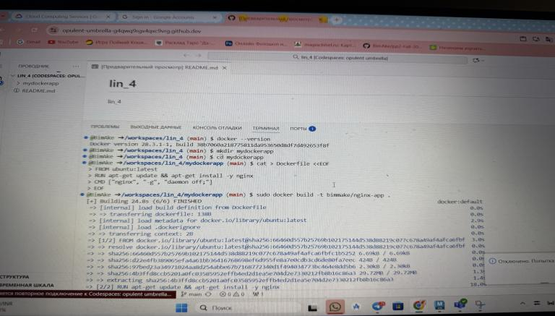
Then, I create a service description file, a unit file like systemd style. But my environment did not run systemd, so I simulate manage service with docker commands. I think this is good idea, because on real servers sometimes systemd disabled or not stable.
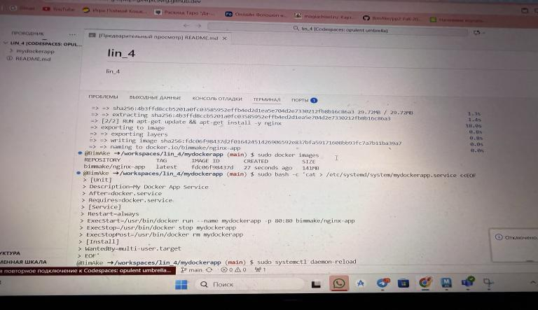
Next, I create two scripts. One script logging current time every few minutes. Other script logging docker container status. I give execution permission and test them manualy.
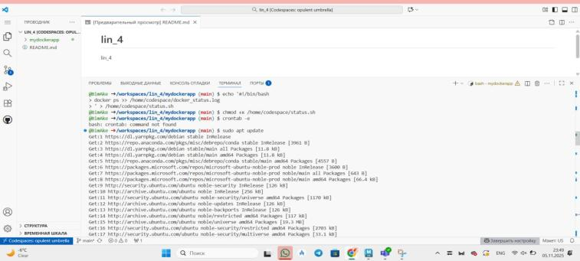
Then I install cron, because cron is not installed in Codespaces by default. After installation I add two lines to crontab. One to run every 2 minutes and second every 5 minutes. Then I wait some time and check the log files. I can see new lines appear, so it is working! This part is interesting because cron is often used on real production servers for backups and log cleanups.
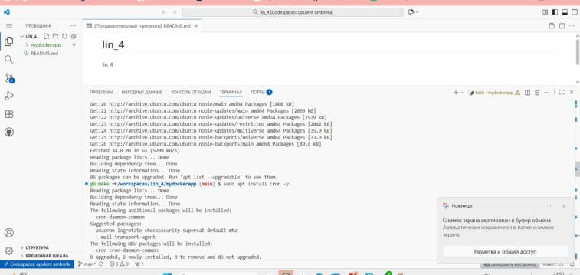

Problems and Solutions:
I had some problems because systemd was not running. At first I was confuse. But then I find solution by using docker restart and docker start and stop as simulation. Also cron was not installed, so I need install it manual. I also test scripts manual to make sure they work.

GitHub Repository:
You can see all files in my GitHub repository:
https://github.com/BimAke/lin_4
Short Conclusions:
This study was very usefull for me. I learn how to create Docker images, how to run them like services, and how to automate tasks using cron. I also learned debug problems when environment is different. I think this knowledge will help me a lot in future jobs, because many companies use Linux servers. Sometimes there is not GUI, and everything is command line. Now I feel more confidence. Maybe I still do some small grammar mistakes and small errors in commands, but I learn step by step. I enjoyed this work and I hope continue learning deeper.

