Below are the list of questions/queries :-
- What is the purpose of Parc-Roulant application?
The circulating parks have many applications in the field of parts & services.
Here are some examples of use for parts:
  - "CA / Parc" ratio: the CA / Parc analysis provides a real and objective view of the activity and allows us to make comparisons.
  - Analysis of parts activity by model
  - Budget, Strategy
- Explain below terms
  - Parks with example.
Parks represent the number of vehicles at a given time and in a given country.
Parks 10 years
Example fleet rolling 10 years on 01/01/2008 (known as "2008"): vehicles registered between 1998 and end 2007 minus those that are broken / exported, plus those imported. (The fleet 10 years is the park used by default)
Parks 7 years
Example fleet as of 01/01/2008: takes into account all vehicles registered between 2001 and end 2007 minus those that are broken / exported, plus those imported.
Total park
It takes into account all the vehicles in circulation (of the chosen park year).
  - Law of survival with example.
    - How it will calculated?
The calculated survival laws are the relationships between vehicles still in circulation and registered vehicles. These laws therefore take into account 4 phenomena without dissociating them:
      - - Scrapping,
      - - Exports of used vehicles,
      - - Imports of used vehicles
    - Explain complete calculation and partial calculation.
Laws of survival are calculated from parks and registrations. They are calculated for all the countries for which the parks are available (in POLK 42 countries in 2009).
Estimating breakage laws is to divide the number of vehicles in the Polk fleet according to their year of registration by the number of vehicles registered in those years.
Survival laws are calculated by / brand / country / gender (VU or VP or VU + VP) / Age
The parks are divided by the year's registrations for all of these criteria.
  - Calculations of average laws
The average survival laws (VP, VU, VP + VU) are used for the calculation of the parks of the countries not supplied by POLK and also for those for which we do not have the data registrations for all the years or for the countries for Which the laws of survival seem inconsistent.
The average survival law is calculated from the registrations and the parks of the countries having these data for all the years and confirmed by the user.
    - VP
    - VU
    - VU-VP
- What is the difference between POLK data and PSA data?
Polk data are the circulating park for all automotive brands in the world
PSA data are informations (Invoice / registration / forecast) for PSA
- Who are the users of this application?
  - 2 types of users:
    - Administrator (calculate Park / Survival law
    - Others : Onkys acces to reporting
- There are list of input data files integrated in the parc-roulant application.
  - POLK data file.
  - Registration data file.
  - Invoicing data file.
  - Forecasts medium term (AC and AP) data file.
  - Forecasts data file.
  - specific parks data file
- What is the frequency of each file? (daily, weekly, monthly or annually)
  - Annualy
- How much time will be taken by each file to integrate data?
  - Less than 5mn
- Explain transcodification process for each data file.
  - In order to calculate the AC and AP fleets from the different data sources it is imperative that the data format is homogeneous from one source to another
Polk File:
Only the FUEL_TYPE, VEH_TYPE, MANUF, COUNTRY and MODEL / BODY_TYPE fields are transformed during import.
File Registration:
Only the MARK, COUNTRY, ENERGY, GENDER, MODEL YEAR and BODY (MODEL / BODY) fields will be transformed during the import.
Billing File:
Only the MARK, COUNTRY, ENERGY, GENDER and FAMILY_LIB / BODY (GENDER and FAMILY_LIB / BODYWORK fields) fields will be transformed during the import.
Medium Term Forecast Files (AP and AC):
Only the fields MARK, COUNTRY, GENDER and MODEL (GENDER and MODEL will give MODELE_COMPLET) are transformed during the import.
Strategic Forecast File:
Only the MARK, COUNTRY, GENDER, and LIB_VEH fields (GENRE and LIB_VEH will give MODELE_COMPLET) are transformed during the import.
Parks Specific Files:
Only the MARK, COUNTRY and GENRE fields are transformed during the import
How data are imported in the Parc-Roulant application? (Explain importation process)
It’s the same principle that CAP-6391
Cf : http://docinfogroupe.inetpsa.com/ead/doc/ref.20656_10_05268/v.vc/pj

- What is the Difference between Parks, Standard parks and Specific parks?
We have 2 kinds of parcs:
  - Standard parcs : calculate from file Polk/Registration/forecast
  - Specifics parcs : calculate from users specifics data
- What is mean by management of countries?
Allows to fill PARQTPPY0 table
- Explain regrouping of countries and how it will manage in the application?
In reporting by select a regrouping of countries this permit to have by one selection all the countries neded
Reporting/Parcs 10 ans AP AC PSA / POids des pays dans le parc 10 ans
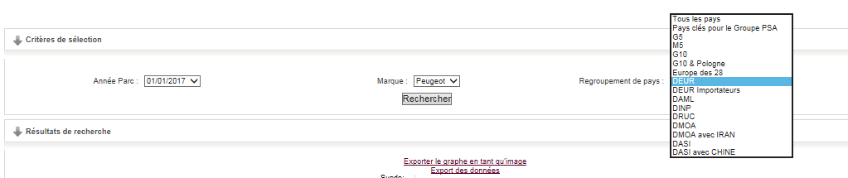
- Explain term
  - Segment with example.
The car market is often analyzed in the form of segments or categories of cars, which indicate the positioning of each model on the market. The latter are generally categorized according to the size or use of the vehicle
These segments are using :
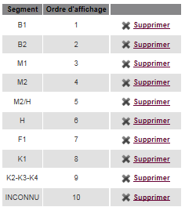
  - Management of segment with example.
  - Regrouping of segments with example.
Reporting/Parcs 10ans AP AC PSA/ Poids des segments dans le Parcs 10 ans
- Explain management of principle marks (Marques).
This allows administrator to manage and order brands displayed in Reporting / Parcs toutes marques (Polk)
- Explain management of Infobulles.
This allows administrator to manage labels displayed in application ex:
