JPA(JAVA PERSISTANT API)
What is JPA?
JPA (Java Persistence API) is a Java Specification (not a framework) that provides a standard way to store, retrieve, update, and delete Java objects from a relational database.
What does Persistence mean?
Persistence means
Storing Java Objects permanently in a database.
What is Hibernate?
Hibernate is an implementation of JPA.
JPA defines rules.
Hibernate implements those rules.
What is ORM?
ORM = Object Relational Mapping

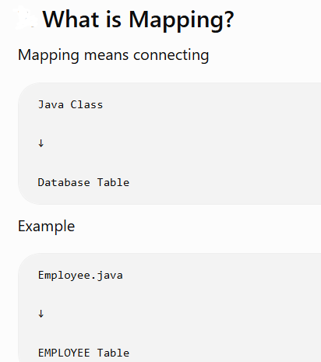

1. Entity
Entities in JPA are nothing but POJOs representing data that can be persisted in the database. An entity represents a table stored in a database. Every instance of an entity represents a row in the table.
Let’s say we have a POJO called Student, which represents the data of a student, and we would like to store it in the database:
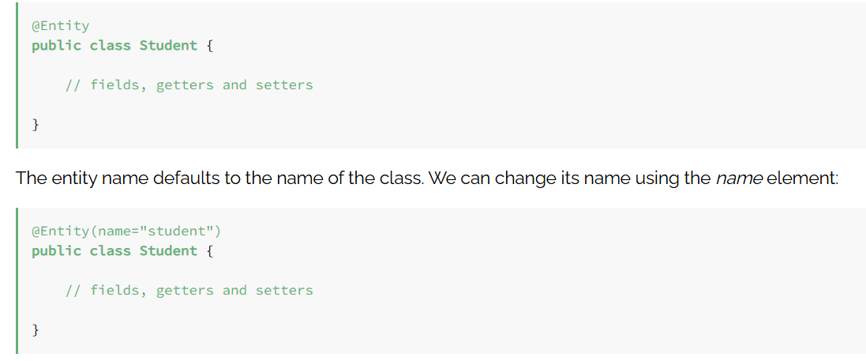
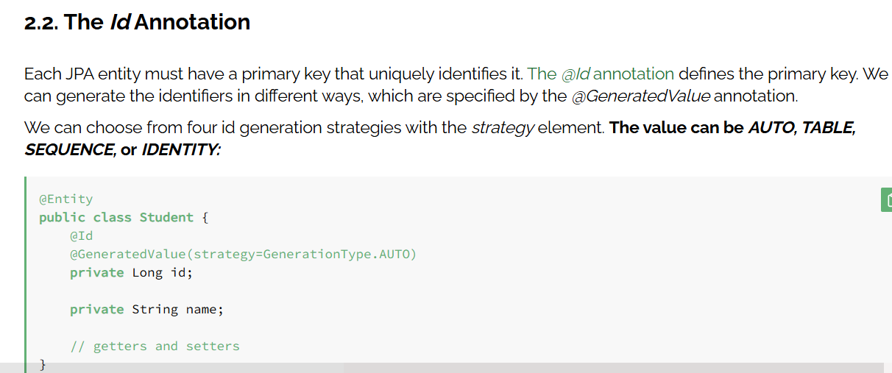

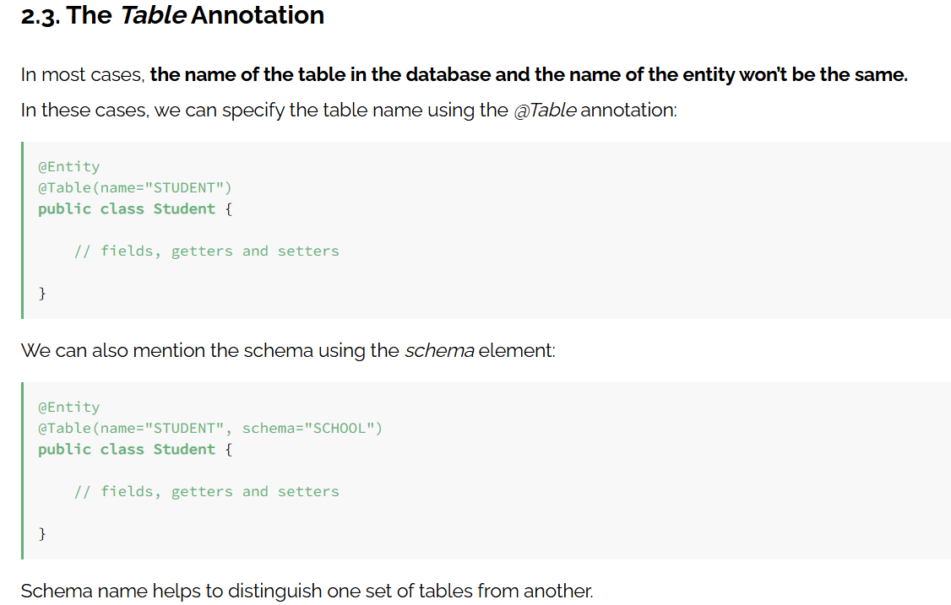
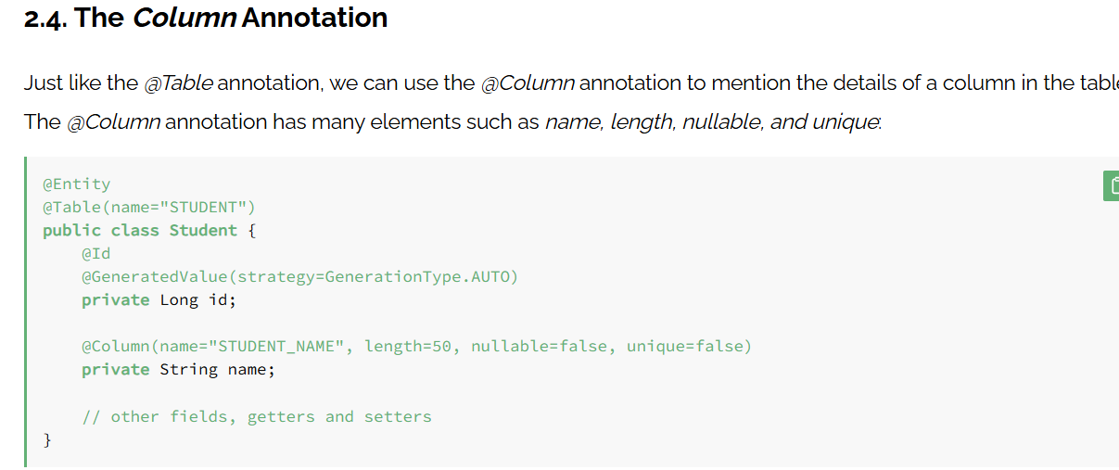
The name element specifies the name of the column in the table. The length element specifies its length. The nullable element specifies whether the column is nullable or not, and the unique element specifies whether the column is unique.
If we don’t specify this annotation, the name of the column in the table will be the name of the field.

Entity Lifecycle in JPA
The Entity Lifecycle in JPA describes the different states that an entity object goes through from the moment it is created until it is deleted from the database.
What is an Entity?
An entity is a Java class that represents a table in the database.

JPA entity lifecycle :-
The Entity Lifecycle represents the journey of an entity object between Java memory, the Persistence Context, and the database.

Stage 1 – Transient (New State)
A Transient entity is a normal Java object that has been created but has not yet been saved in the database.
Hibernate doesn't know this object exists.

Loan loan=new Loan()
loan.setName=”Shyani”;
loan.setAmount=10000000;
object is going to be stored in the heap memory
and in Database
Loan Table -- no records

Exists only in Java memory
Not stored in the database
Not managed by Hibernate
No SQL query is executed
Changes are not tracked

This is also called the transient state.

Stage 2 – Managed (Persistent State)
This is the most important state.
The entity becomes managed when we save it.
loanRepository.save(loan);

Hibernate now stores the entity inside the Persistence Context.

What is Persistence Context?
Persistence Context is a special memory area managed by Hibernate.
It stores all managed entities.

Characteristics
- Stored in the database
- Managed by Hibernate
- Changes tracked automatically
- Dirty Checking works

- Loan loan=new Loan()
- loan.setName=”Shyani”;
- loan.setAmount=10000000;
- entityManager.persist(loan);
Dirty Checking means Hibernate automatically detects modifications in managed entities.

Stage 3 – Detached State
entityManager.detach(loan);

Characteristics
Object exists
Database record exists
Hibernate does not manage it
Changes are ignored

entityManager.clear();

Stage 4 – Removed State
entityManager.remove(loan);

Repository Layer
The Repository Layer is responsible for communicating with the database.
Instead of writing SQL queries manually, we ask the repository to perform operations such as Save, Find, Update, and Delete.

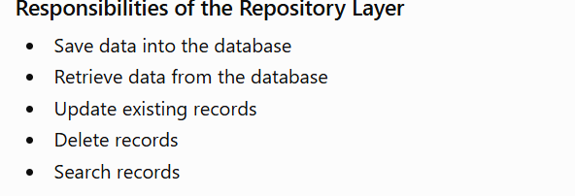

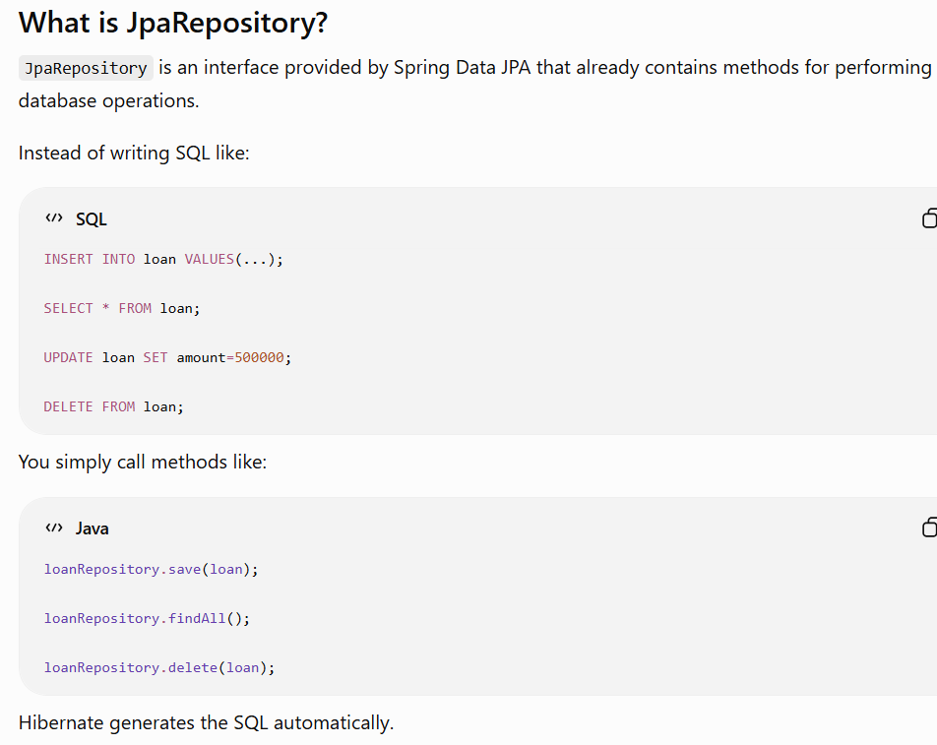

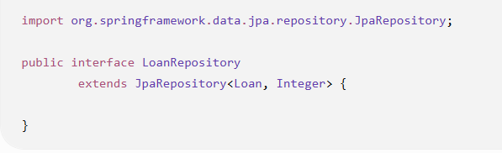
Loan → Entity class
Integer → Type of the primary key (loanId)
You call one method.
Hibernate writes the SQL.
