Kafka installation by kraft mode .

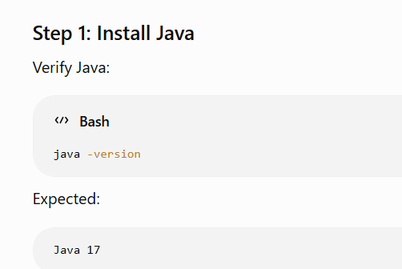

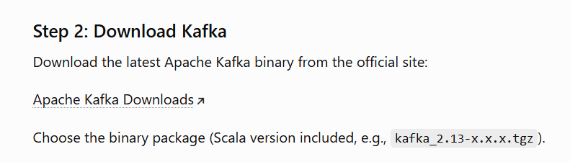
https://kafka.apache.org/community/downloads/
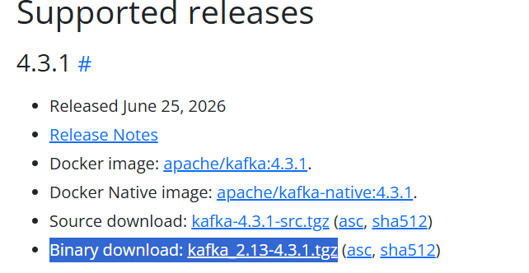



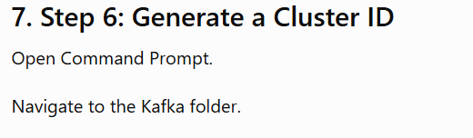

D:\Kafka\kafka_2.13-4.3.1> bin\windows\kafka-storage.bat random-uuid
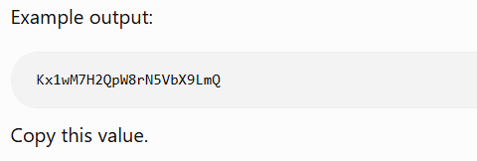
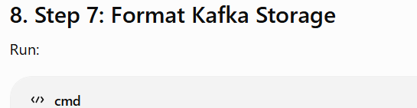
Type below:
D:\Kafka\kafka_2.13-4.3.1> bin\windows\kafka-storage.bat format --standalone -t ZO9JfQ4-S7GtZgPtDfHicQ -c config\server.properties
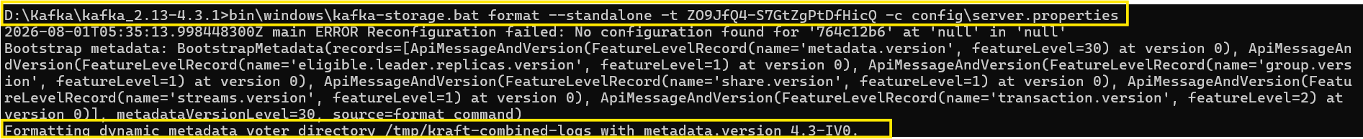
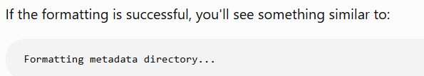
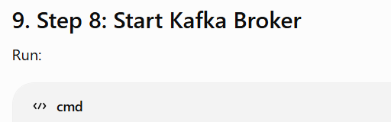
(1) D:\Kafka\kafka_2.13-4.3.1> bin\windows\kafka-server-start.bat config\server.properties
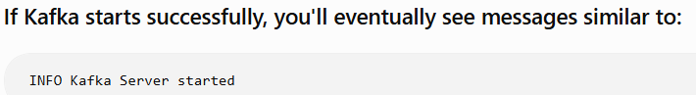
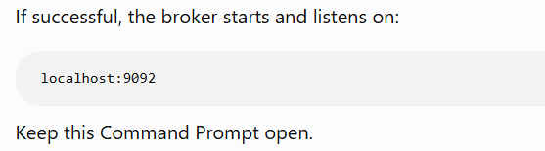
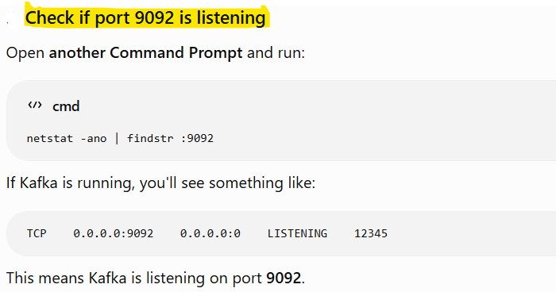
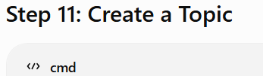
Open new cmd prompt below:
(1) D:\Kafka\kafka_2.13-4.3.1> cd D:\Kafka\kafka_2.13-4.3.1
(2) D:\Kafka\kafka_2.13-4.3.1> bin\windows\kafka-topics.bat --bootstrap-server localhost:9092 --create --topic test-topic --partitions 1 --replication-factor 1
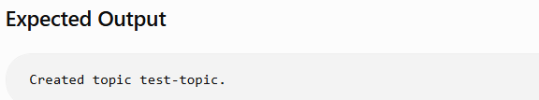
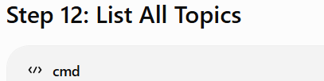
(1) D:\Kafka\kafka_2.13-4.3.1> bin\windows\kafka-topics.bat --bootstrap-server localhost:9092 --list
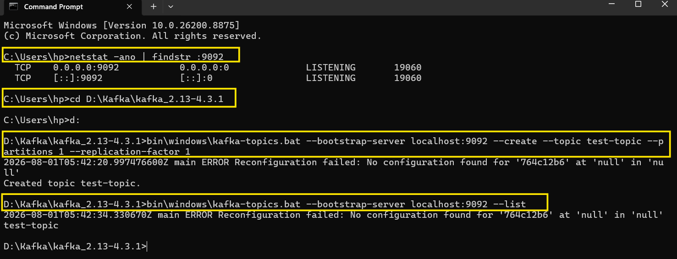
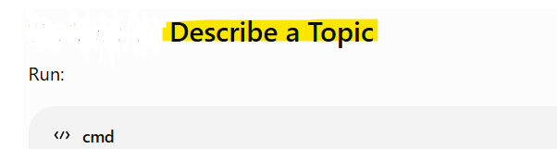
Type:
(1) D:\Kafka\kafka_2.13-4.3.1> bin\windows\kafka-topics.bat --describe --topic test-topic --bootstrap-server localhost:9092
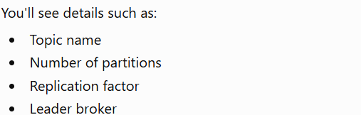
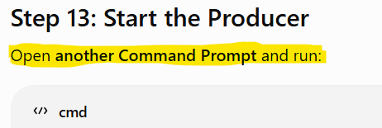
(1) D:\Kafka\kafka_2.13-4.3.1> cd D:\Kafka\kafka_2.13-4.3.1
(2) D:\Kafka\kafka_2.13-4.3.1> bin\windows\kafka-console-producer.bat --bootstrap-server localhost:9092 --topic test-topic
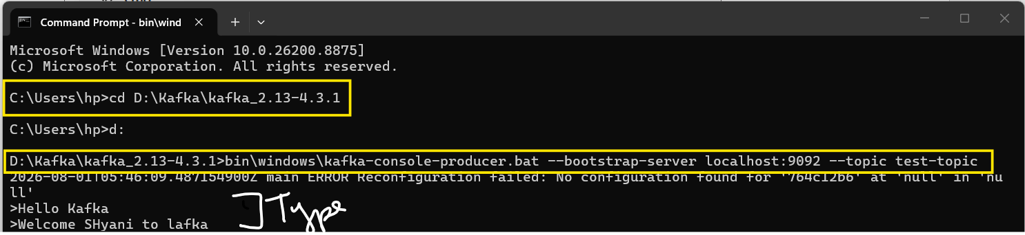
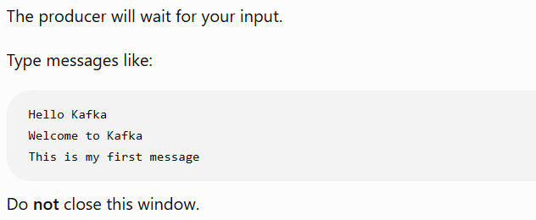
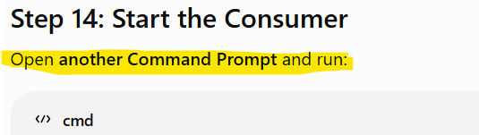
(1) D:\Kafka\kafka_2.13-4.3.1> cd D:\Kafka\kafka_2.13-4.3.1
(2) D:\Kafka\kafka_2.13-4.3.1> bin\windows\kafka-console-consumer.bat --bootstrap-server localhost:9092 --topic test-topic --from-beginning
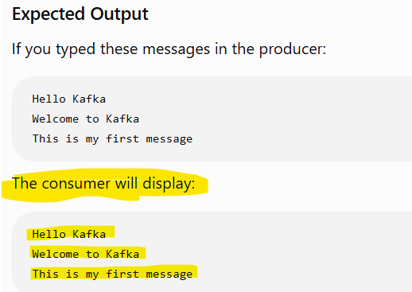
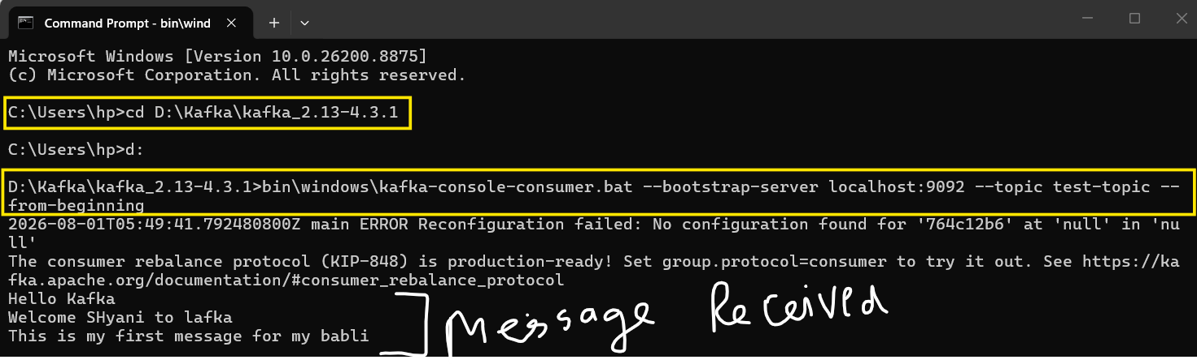
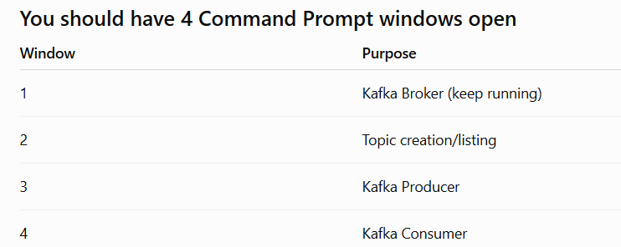

Integrating Kafka with Spring Boot

What does KRaft mean?
KRaft = Kafka Raft Metadata Mode
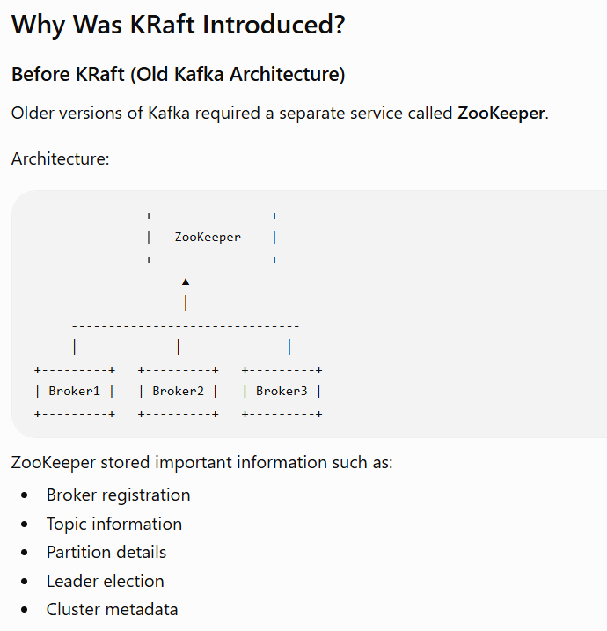
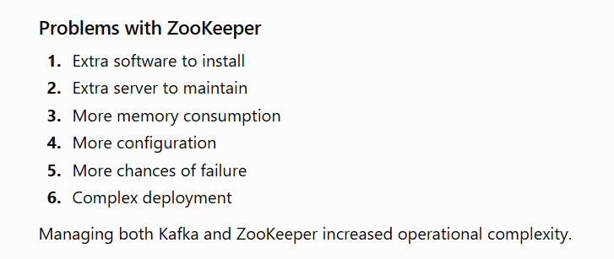
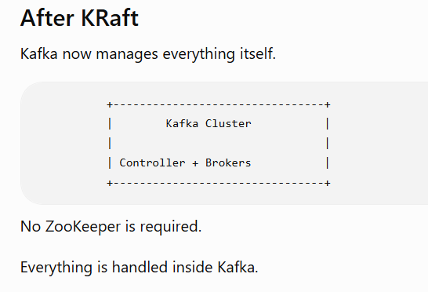
Now that Kafka is running, let's connect it to a Spring Boot application.
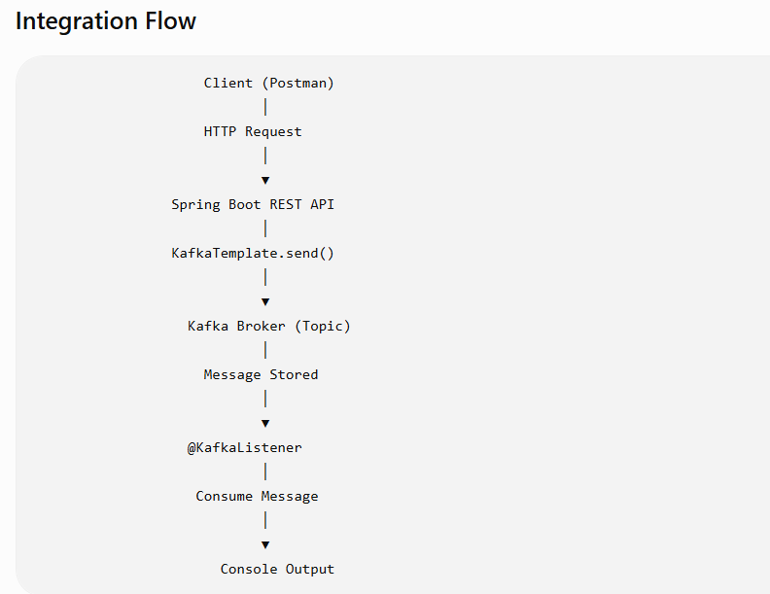

What is KafkaTemplate in Spring Boot?
KafkaTemplate is a helper class that allows a Spring Boot application to publish messages to Kafka topics.

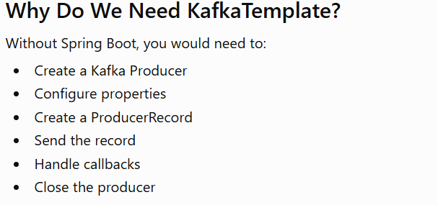

To use KafkaTemplate, include the Spring Kafka dependency

@KafkaListener is a Spring Boot annotation used to create a Kafka consumer. It tells Spring that a method should automatically listen for messages from a Kafka topic and execute whenever a new message arrives.
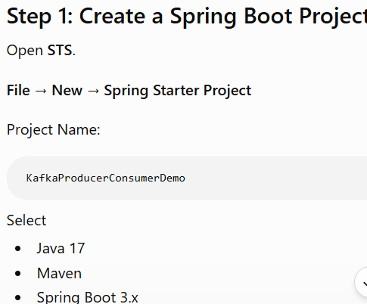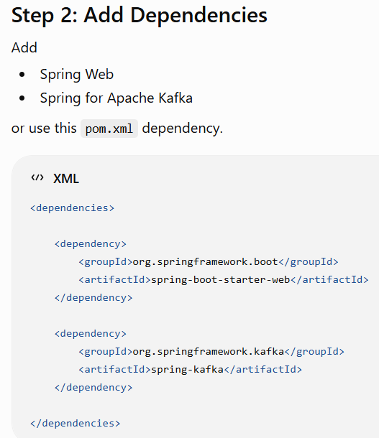

Step 3: Project Structure
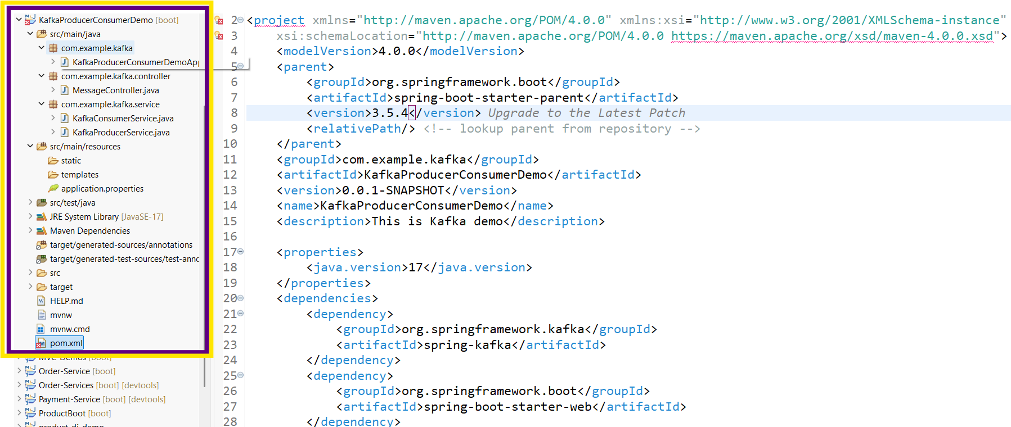
Step 4: Configure application.properties
spring.kafka.bootstrap-servers=localhost:9092
spring.kafka.consumer.group-id=my-group
spring.kafka.consumer.auto-offset-reset=earliest
spring.kafka.consumer.key-deserializer=org.apache.kafka.common.serialization.StringDeserializer
spring.kafka.consumer.value-deserializer=org.apache.kafka.common.serialization.StringDeserializer
spring.kafka.producer.key-serializer=org.apache.kafka.common.serialization.StringSerializer
spring.kafka.producer.value-serializer=org.apache.kafka.common.serialization.StringSerializer
Meaning:
(1) spring.kafka.bootstrap-servers=localhost:9092
This tells Spring Boot: "Connect to the Kafka server running on localhost at port 9092."
(2) spring.kafka.consumer.group-id=my-group
A Consumer Group is a collection of consumers that work together to read messages.
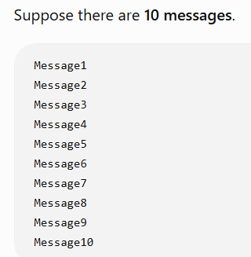 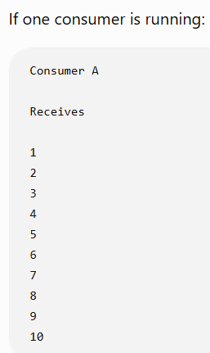 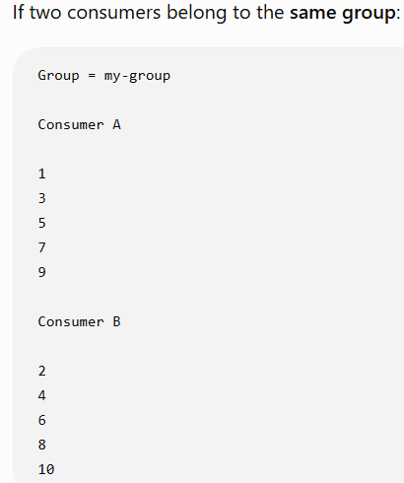
(3) spring.kafka.consumer.auto-offset-reset=earliest
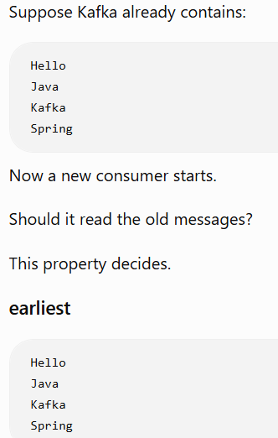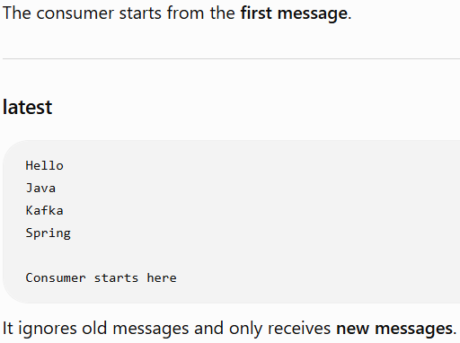

(4) spring.kafka.consumer.key-deserializer=org.apache.kafka.common.serialization.StringDeserializer
Kafka stores data as bytes. The deserializer converts those bytes back into a Java object.
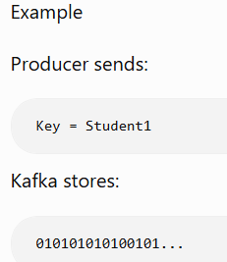 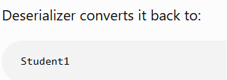
(5) spring.kafka.consumer.value-deserializer=org.apache.kafka.common.serialization.StringDeserializer
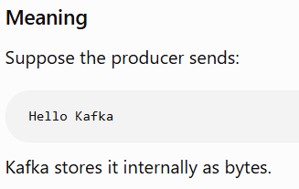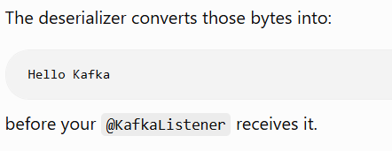
Step 5: Create Topic
Open CMD
D:\Kafka\kafka_2.13-4.3.1> bin\windows\kafka-topics.bat --bootstrap-server localhost:9092 --create --topic demo-topic --partitions 1 --replication-factor 1
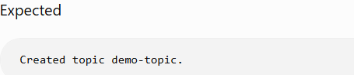
Step 6: Create Producer Service
package com.example.service;

import org.springframework.kafka.core.KafkaTemplate;
import org.springframework.stereotype.Service;

@Service
public class KafkaProducerService {

private KafkaTemplate<String,String> kafkaTemplate;

public KafkaProducerService(KafkaTemplate<String,String> kafkaTemplate){
this.kafkaTemplate=kafkaTemplate;
}

public void sendMessage(String message){

kafkaTemplate.send("demo-topic",message);

}
}

Step 7: Create Consumer Service
package com.example.service;

import org.springframework.kafka.annotation.KafkaListener;
import org.springframework.stereotype.Service;

@Service
public class KafkaConsumerService {

@KafkaListener(topics="demo-topic",groupId="my-group")

public void receiveMessage(String message){

System.out.println("Message Received : "+message);

}
}
Step 8: Create REST Controller
package com.example.controller;

import org.springframework.web.bind.annotation.*;
import com.example.service.KafkaProducerService;

@RestController
@RequestMapping("/kafka")
public class MessageController {

private KafkaProducerService producer;

public MessageController(KafkaProducerService producer){
this.producer=producer;
}

@PostMapping("/publish")
public String publish(@RequestParam String message){

producer.sendMessage(message);

return "Message Sent Successfully";

}
}

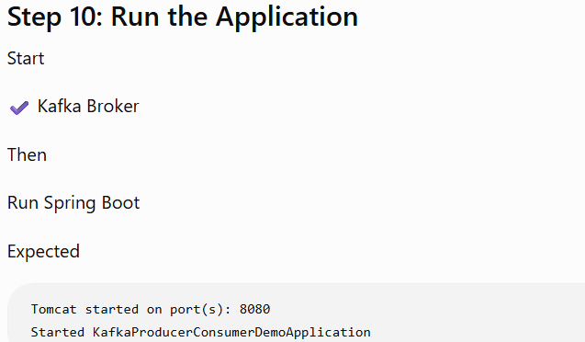

Step 11: Test Using Postman
Method POST
URL http://localhost:8080/kafka/publish?message=Hello Kafka
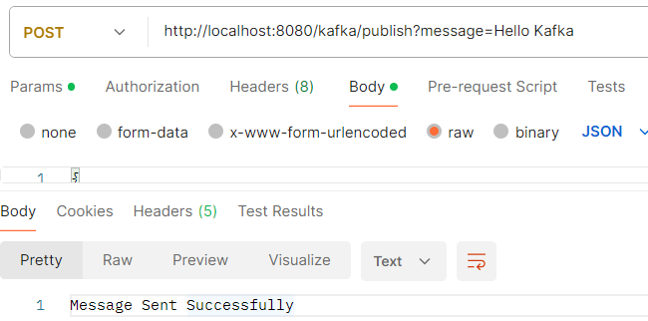
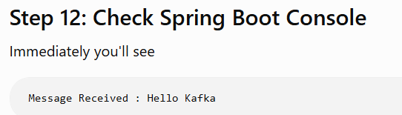
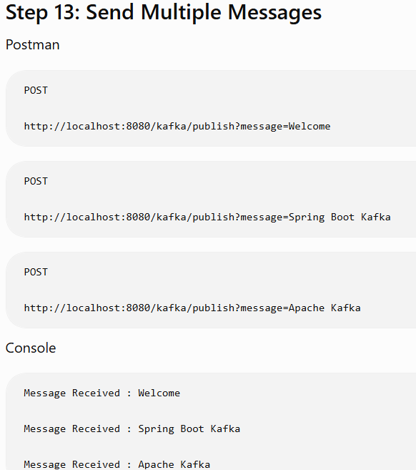

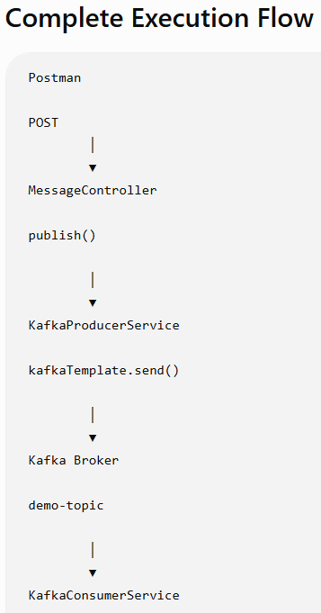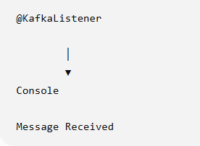

Theory

Apache Kafka is an open-source distributed event streaming platform developed by LinkedIn and later donated to the Apache Software Foundation. It is used to handle large-scale real-time data streams efficiently and reliably.
Kafka follows the publish-subscribe model, where producers send messages to topics and consumers read them. It provides high scalability, fault tolerance, and fast data processing, making it ideal for real-time data streaming and event-driven applications.
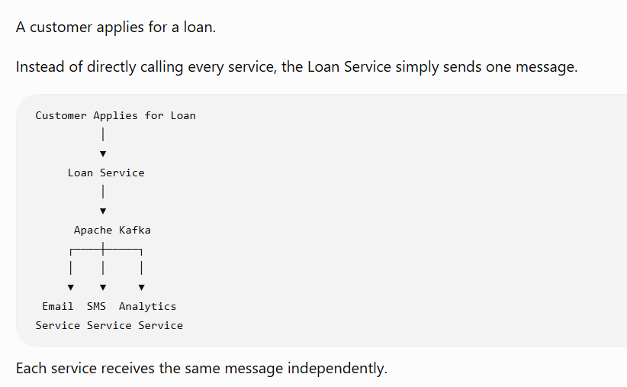

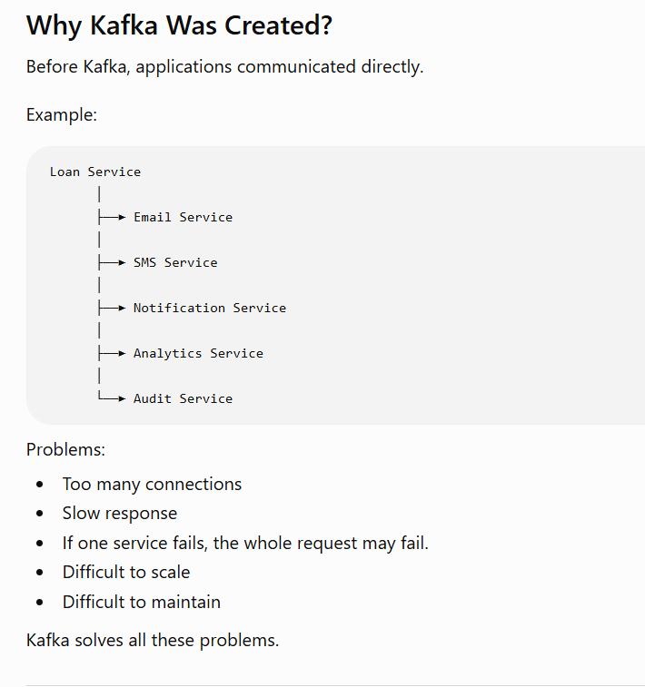
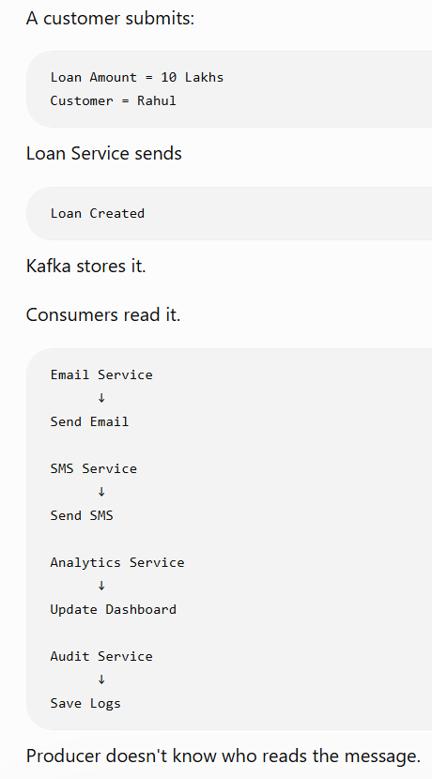

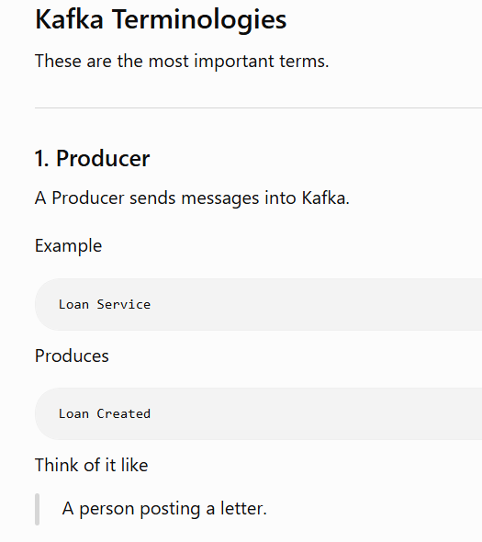
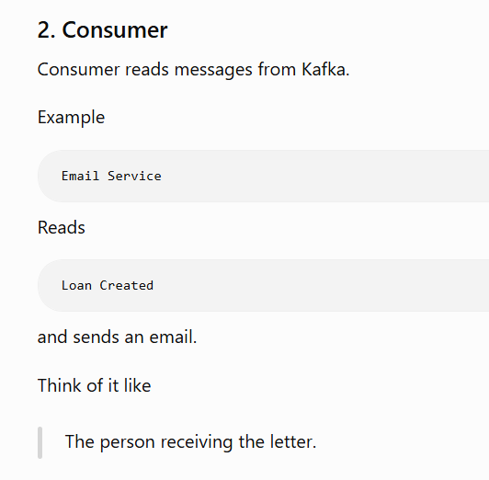
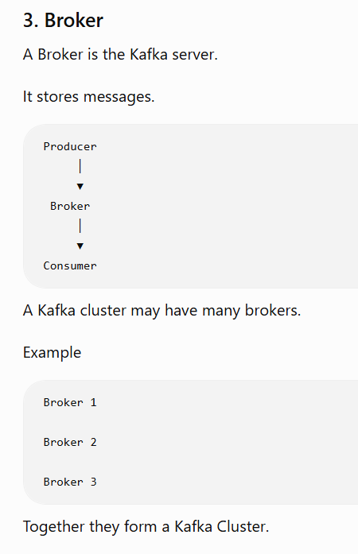
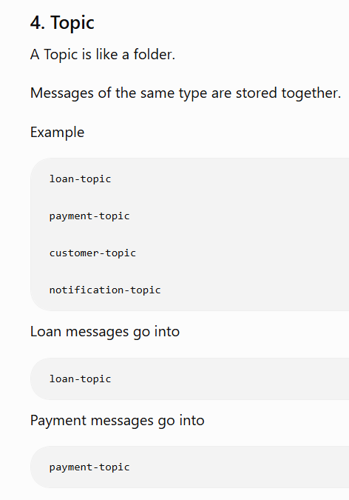

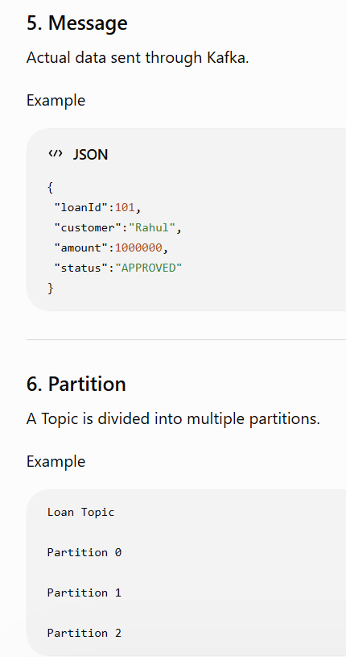

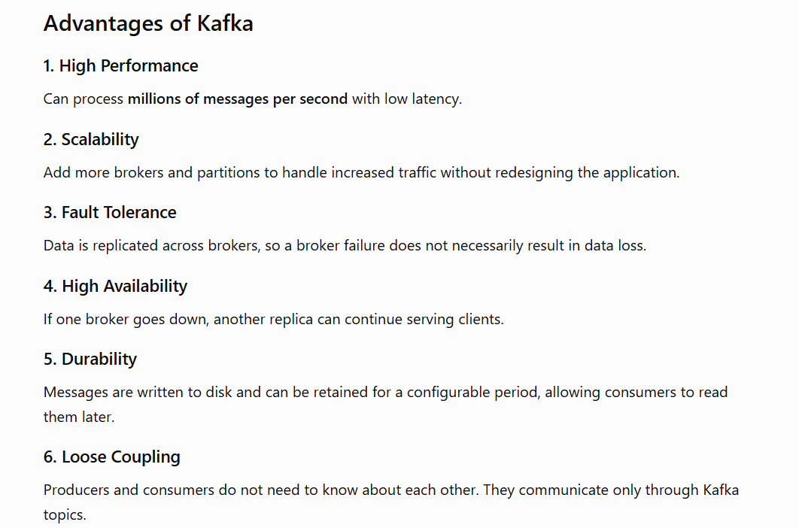
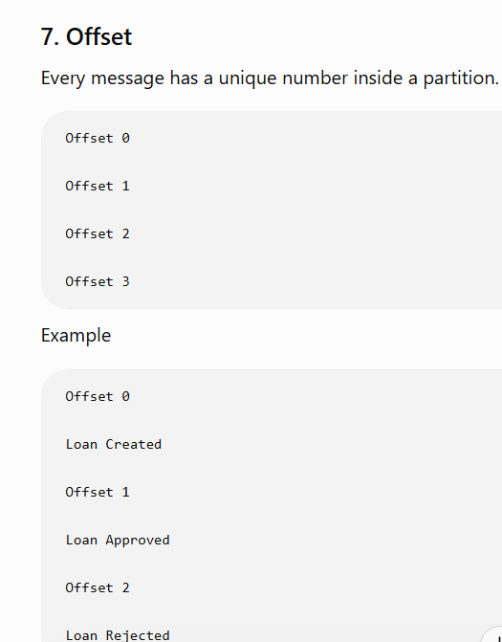

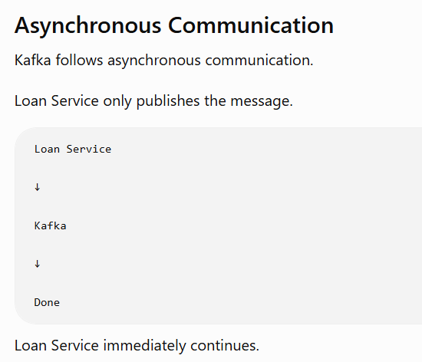
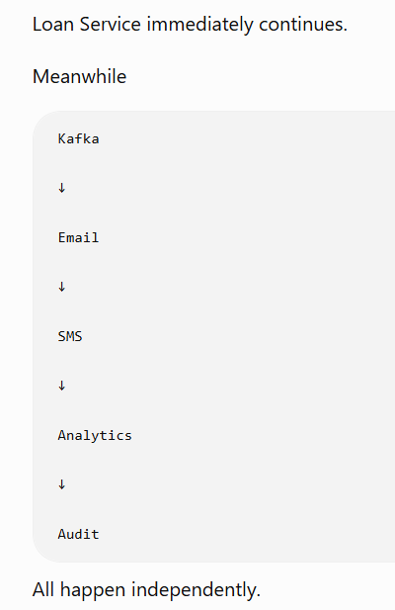

Consumer Group in Apache Kafka
