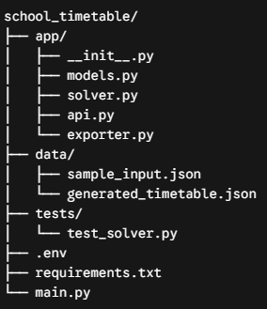
The Root Directory (Configuration & Entry)
- main.py The Engine Starter. This is the entry point for your application. If you are running this as a web service, this file boots up the server (e.g., using FastAPI or Flask) and listens for requests from the main school website.
- requirements.txt The Dependency List. Lists all the external Python libraries your project needs to run, such as ortools (for the solver), fastapi (for the web server), and pydantic (for data validation).
- .env The Secret Keeper. Stores environment variables, database connection strings, and API keys. This keeps sensitive data out of your main code.
The app/ Directory (Core Logic)
This folder contains the actual machinery of your timetable generator.
- app/models.py The Blueprint (Phase 1). This file defines your data structures using Python dataclasses or pydantic. It contains the classes for Teacher, Room, Subject, ClassGroup, and TimeSlot. It ensures that whenever data enters your program, it is formatted correctly.
- app/solver.py The Brain (Phases 2 & 3). This is where the heavy lifting happens. It takes the data from models.py, initializes the Google OR-Tools constraint solver, applies your hard and soft constraints, and searches for a clash-free schedule. It returns either a finished timetable or an error if the schedule is mathematically impossible.
- app/api.py The Bridge (Phase 4). This file contains the web routes (endpoints). For example, it defines the POST /generate route. When the school website's frontend needs a timetable, it sends the data to this file, which passes it to solver.py, and then sends the results back to the website.
- app/exporter.py The Formatter. Once the solver creates a timetable, it exists as raw computer logic. This file contains utility functions to convert that raw data into user-friendly formats like CSVs (for Excel), PDFs (for printing), or formatted JSON (for the website dashboard).
Supporting Directories
- data/ The Filing Cabinet. While developing, you won't always want to send data via a web request. This folder holds static JSON or CSV files (sample_input.json) so you can quickly test your solver locally before connecting it to a database.
- tests/ The Quality Control. Contains automated tests, like test_solver.py. You can write scripts here to ensure that your solver always respects hard constraints (e.g., writing a test that intentionally tries to double-book a teacher to ensure the program rejects it).

https://share.gemini.google/OZEdqQIzwi8l

