Lab 04 - Data Acquisition (DAQ)

Group 1b.b2
E/20/157 – S.M.B.G. Janakantha
E/20/158 – T.G.C. Jananga
E/20/168 – B.V.R.R. Jayasinghe
CO326 – Industrial Networks
2026-02-11

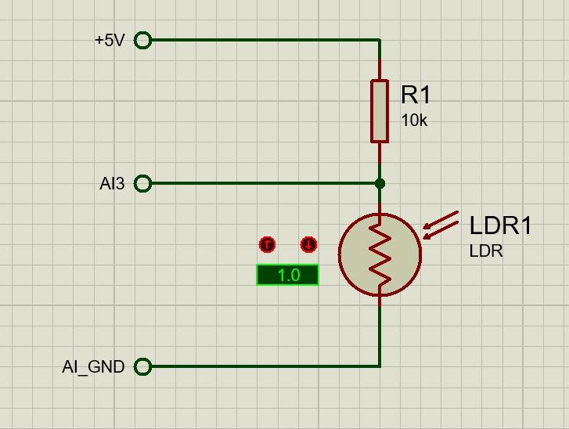
Figure 1: Circuit Diagram

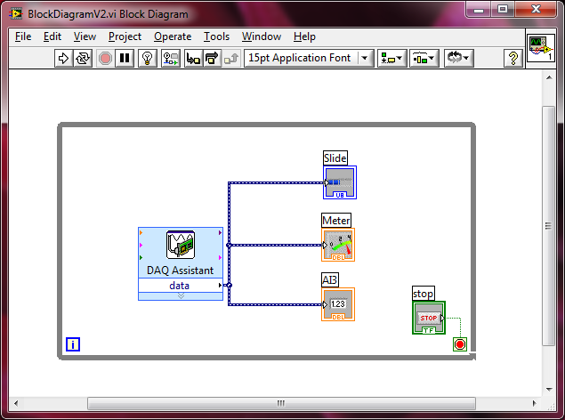
Figure 2: Block Diagram of LabVIEW

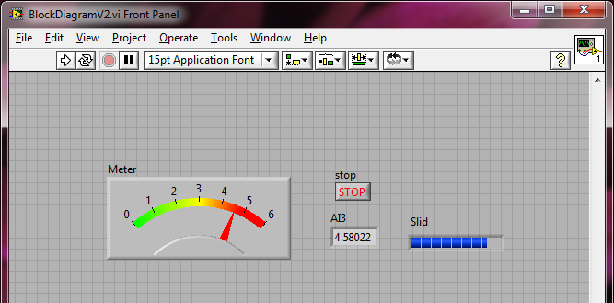
Figure 3: Front Panel of LabVIEW

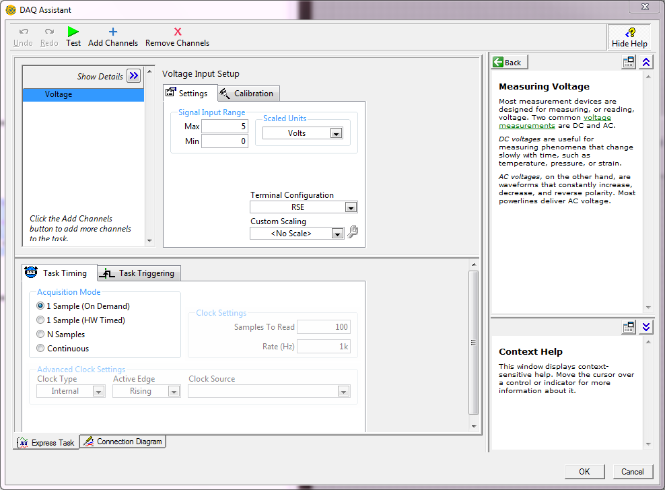
Figure 4: DAQ Assistant Properties

Pins used
- Pin 67 – AI GND
- Pin 30 – AI3
- Pin 8 – +5V

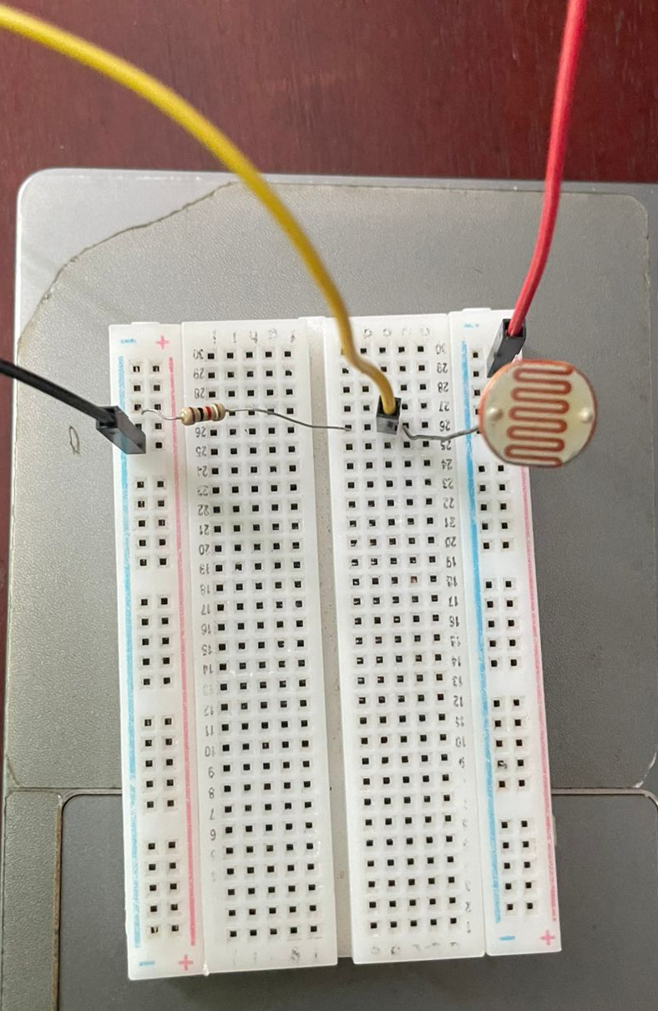
Figure 5: Physical Lab Setup

