Pre Lab: Parallel Port

Group 1b2
E/20/157 – Janakantha S.M.B.G.
E/20/158 – Jananga T.G.C.
E/20/168 – Jayasinghe B.V.R.R.

Part 01
- Draw the circuit diagram that includes a 7-segment display and the data port of the parallel port. Make sure that you have to connect separate resistors in series for each segment of SSD!
Calculate the resistance of the resistors that need to be connected.

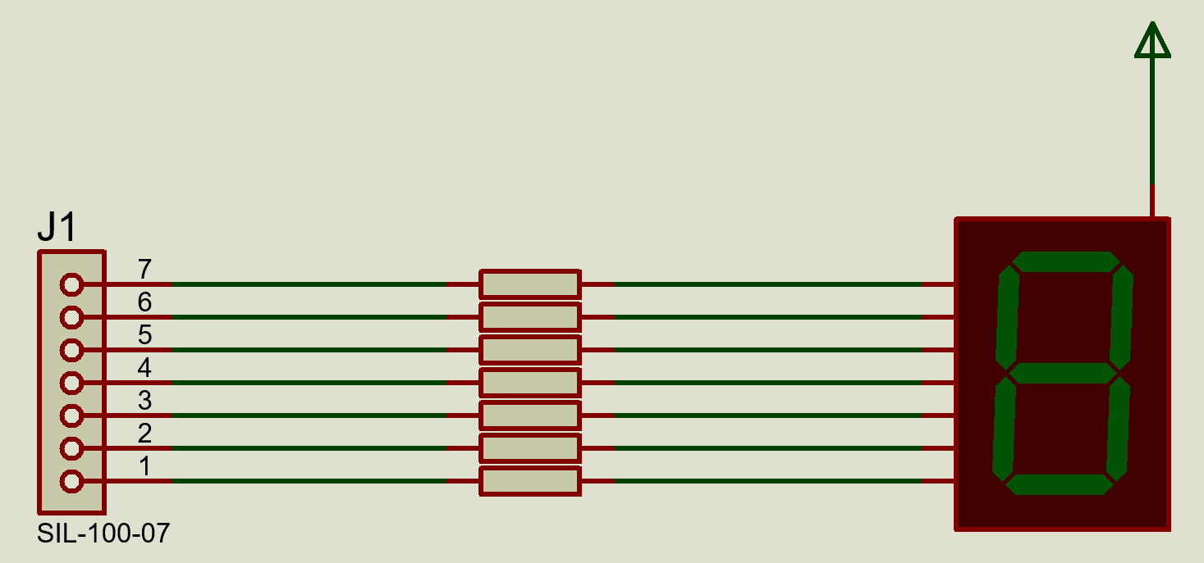

$$V_{HIGH}=5V, i_{max}=20 mA, R_{min}=250 Ω$$
$$∴R≥250 Ω$$

- Write a program to light up each segment of the SSD one by one.
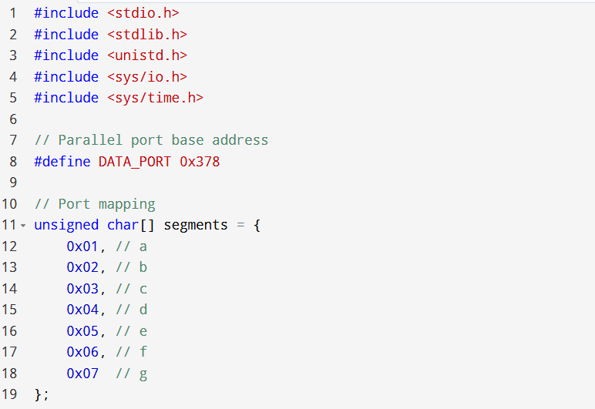
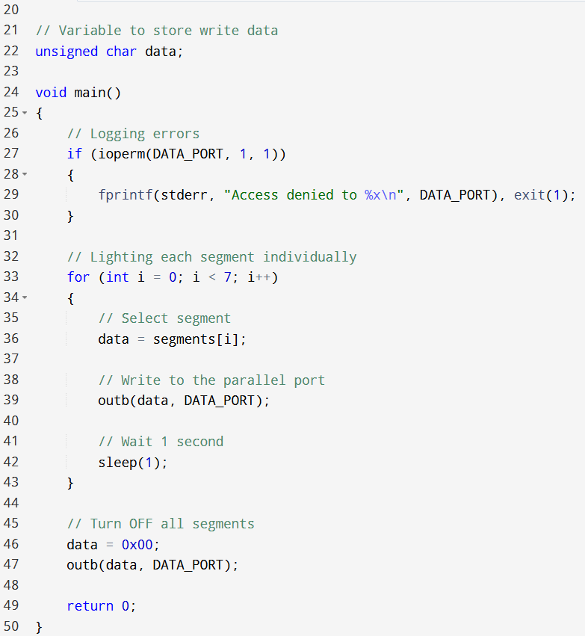

Part 2: Display 0-9 numbers on a single 7 segment display
- Differentiate between the common anode and common cathode 7-segment display.

- Common Anode (CA):
  - All anodes of the LEDs are connected to +V.
  - A segment glows when its cathode is connected to LOW (0V).
  - Logic LOW = ON, HIGH = OFF.

- Common Cathode (CC):
  - All cathodes of LEDs are connected to GND.
  - A segment glows when its anode is connected to HIGH (+V).
  - Logic HIGH = ON, LOW = OFF.

- Write a program to display characters from 0-9 in an infinite loop with a delay of 1 second between each character.
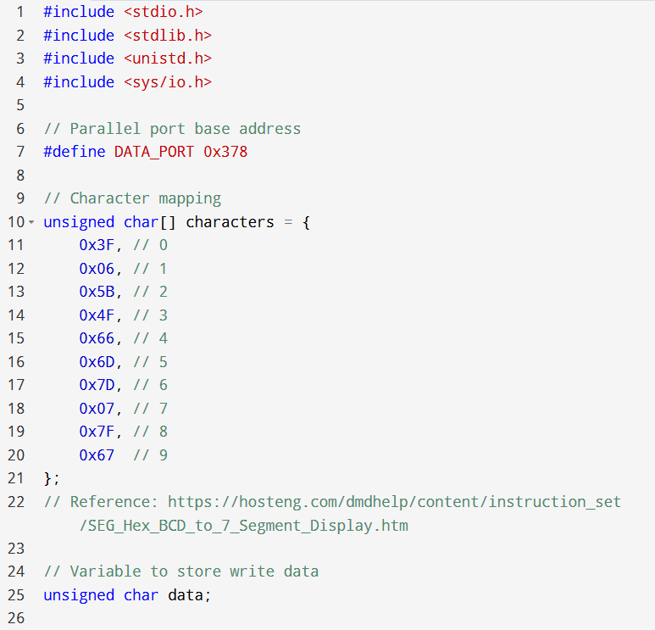
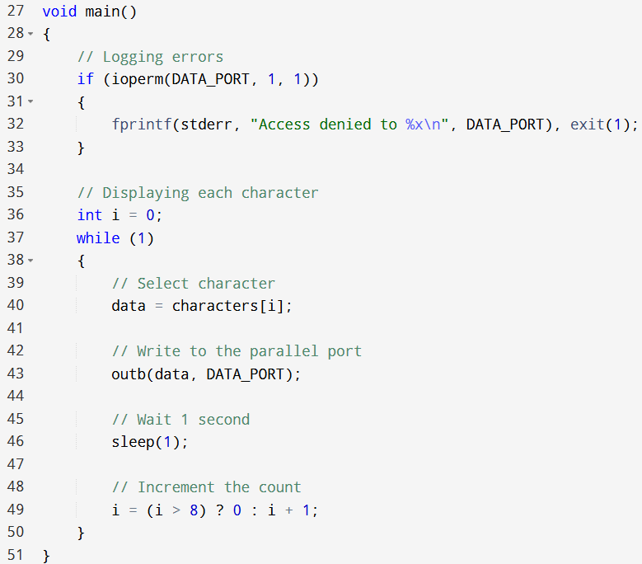

Part 3: Display 0-9 numbers on a single 7 segment display using 74LS47 IC
- Draw the circuit diagram that includes a 7-segment display, 74LS47 IC, and the parallel port. Refer to the datasheet of the 74LS47 IC to find the least significant bit of the output. (Use a common anode)

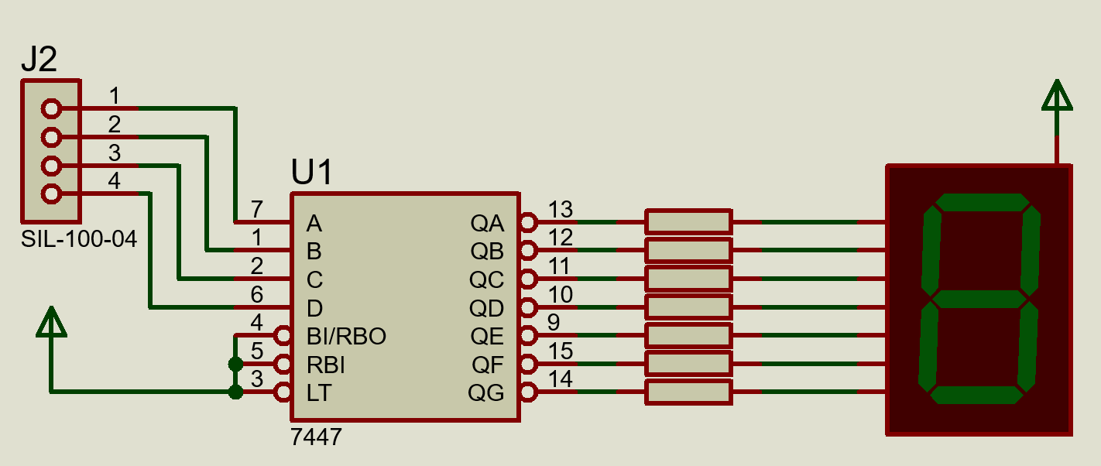

- Write the program to display characters from 0-9 in an infinite loop with a delay of 1 second between each character.
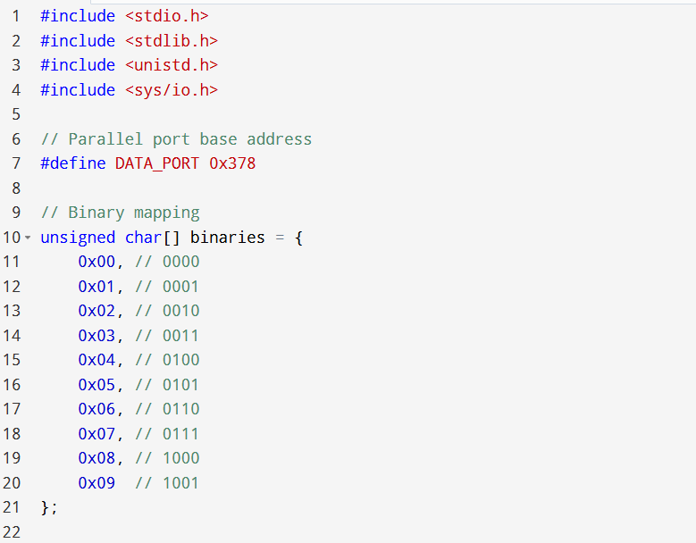
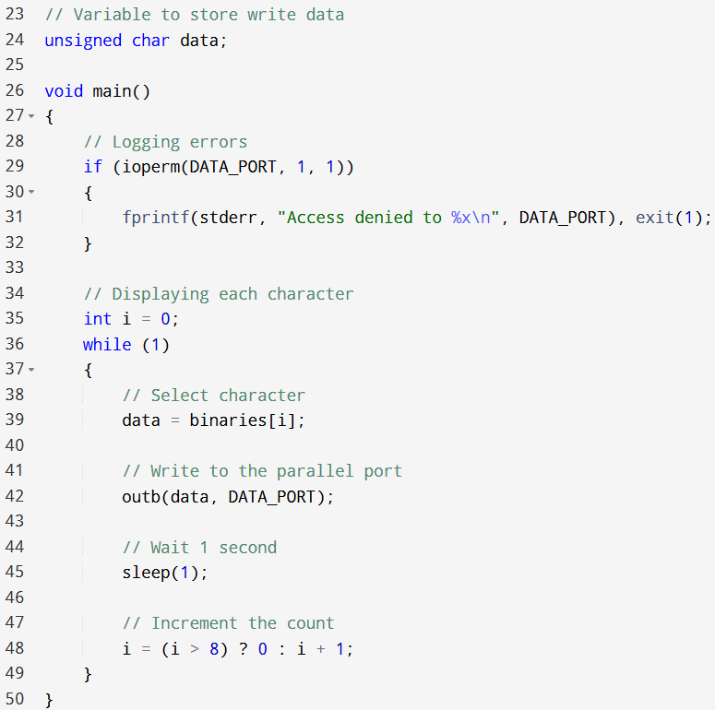

Part 4: Change the numbers displayed in the SSD with a push button
- Draw the circuit diagram that includes a push button to take inputs, a 7-segment display, a 74LS47 IC to show outputs and the parallel port. Make sure you use proper resistors (pull-up/pull-down) when taking inputs through the push button.

