Lab 05 - General Purpose Interface Bus (GPIB)

Group 1b.b2
E/20/157 – S.M.B.G. Janakantha
E/20/158 – T.G.C. Jananga
E/20/168 – B.V.R.R. Jayasinghe
CO326 – Industrial Networks
2026-03-04
- The following commands produce a sine wave with 1.5KHz frequency, 5V amplitude and a +90 degrees phase shift.
SOUR:FUNC SIN
SOUR:FREQ 1.5 KHz
SOUR:VOLT 5 V
SOUR:PHAS +90.0
OUTP ON

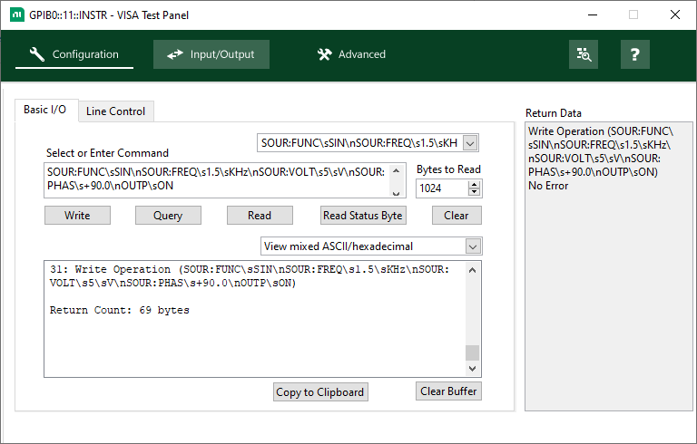
Figure 1: GPIB Software Configuration
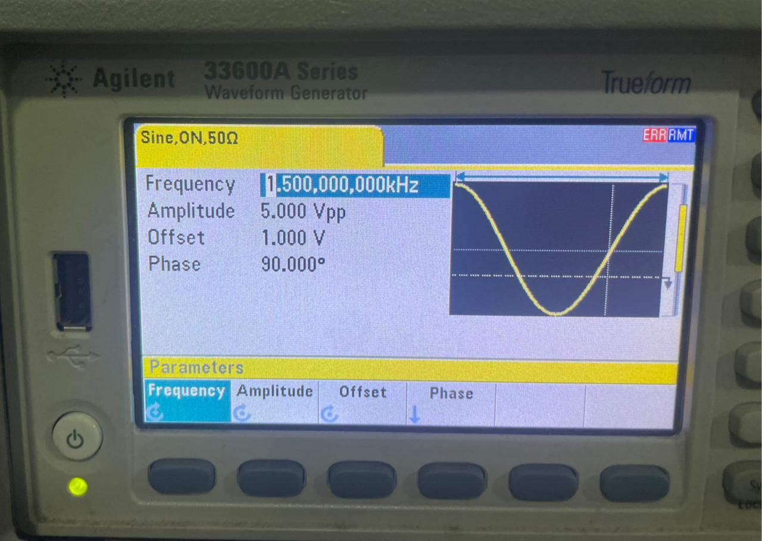
Figure 2: Signal Generator Output
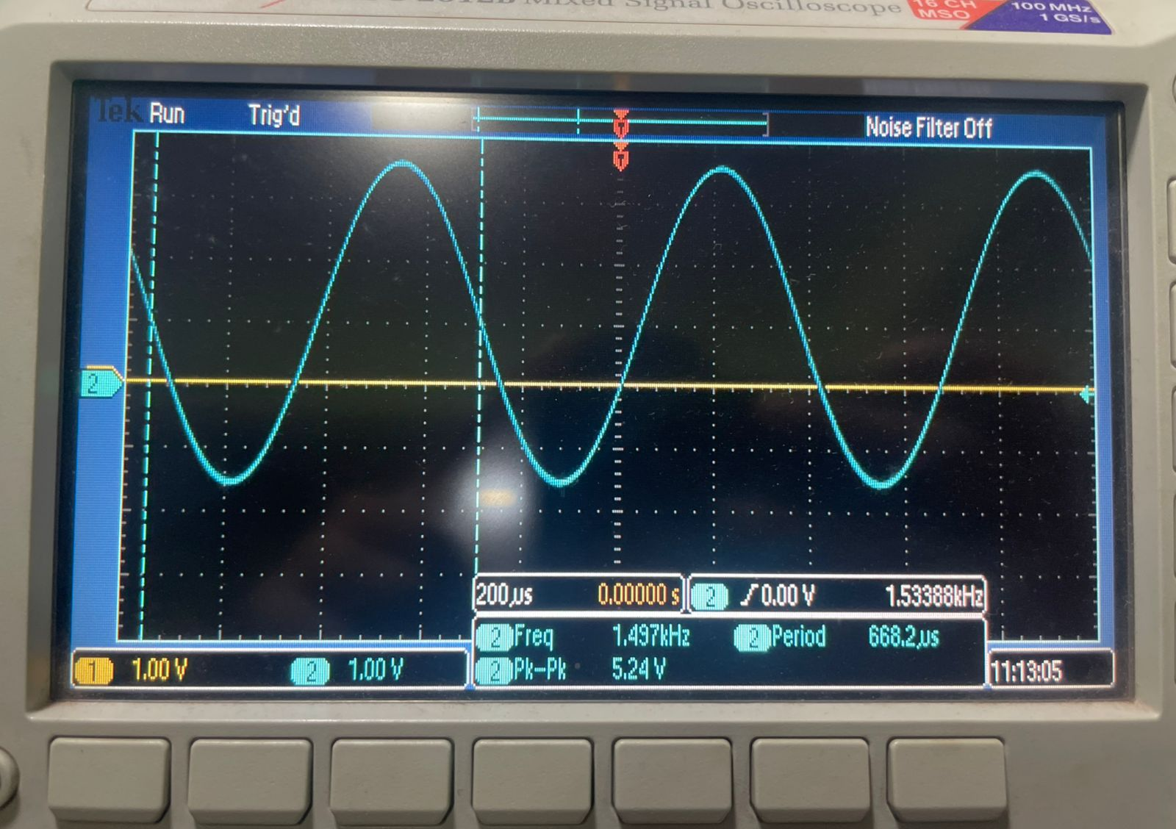
Figure 3: Oscilloscope Output

- Produce a ramp wave with a 2KHz frequency, 3V amplitude and a 1V DC offset

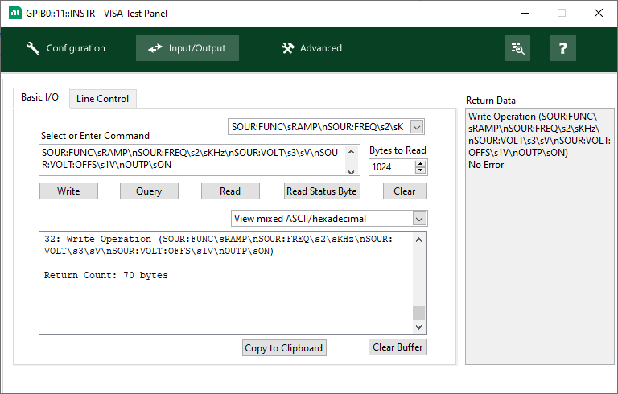
Figure 4: GPIB Software Configuration
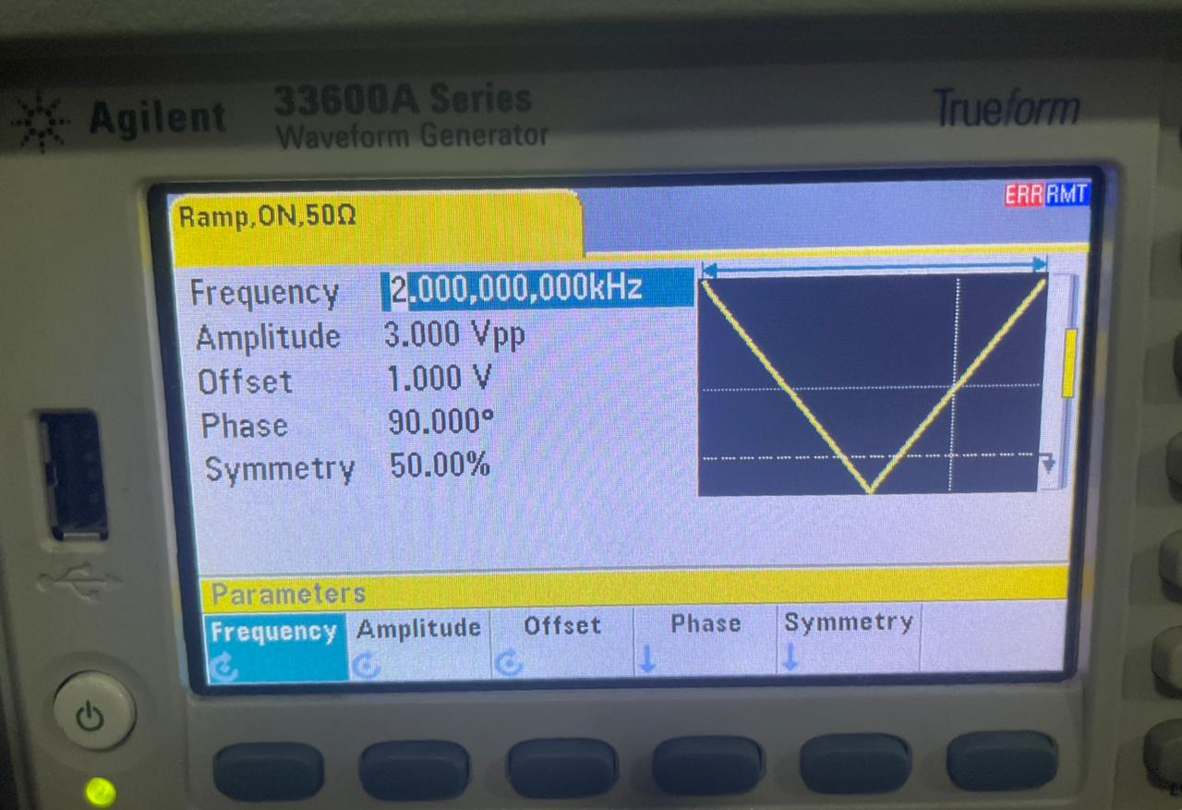
Figure 5: Signal Generator Output
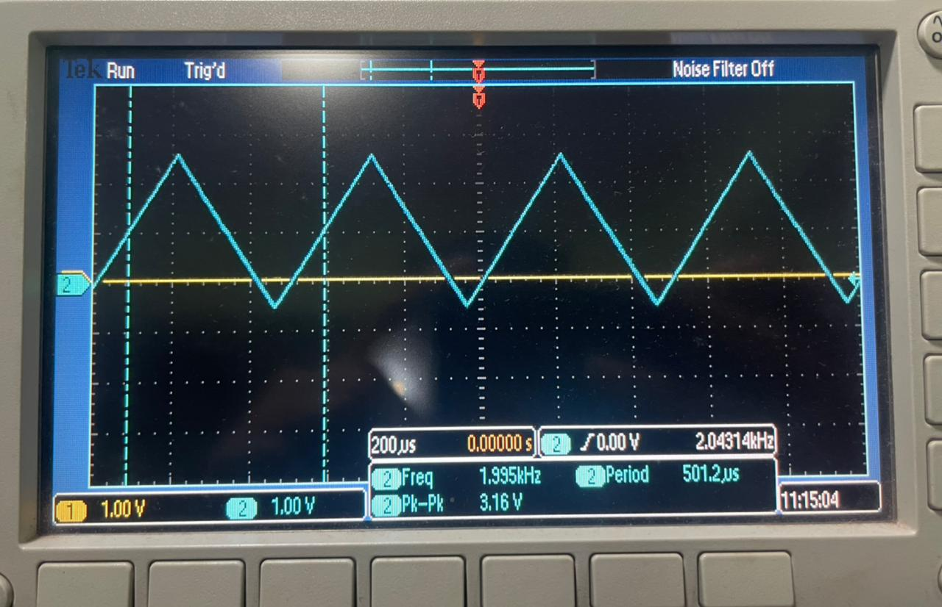
Figure 6: Oscilloscope Output

- Write and issue commands to the Signal Generator so that it produces the following signal
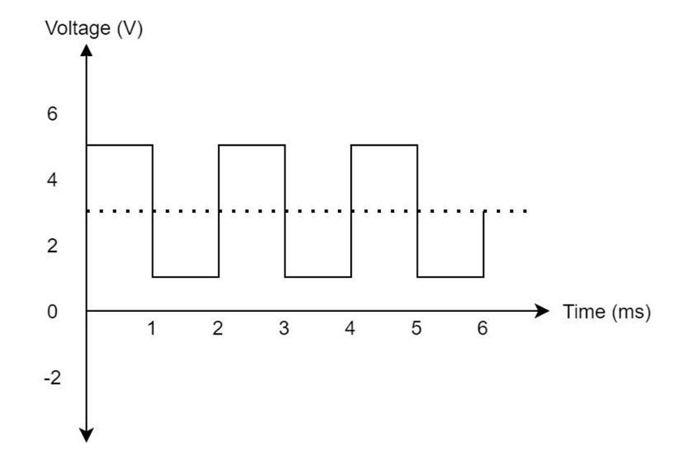

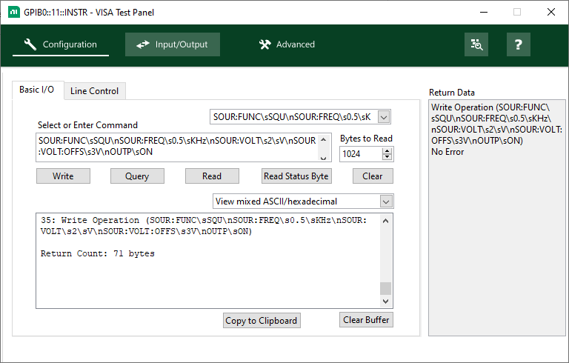
Figure 7: GPIB Software Configuration
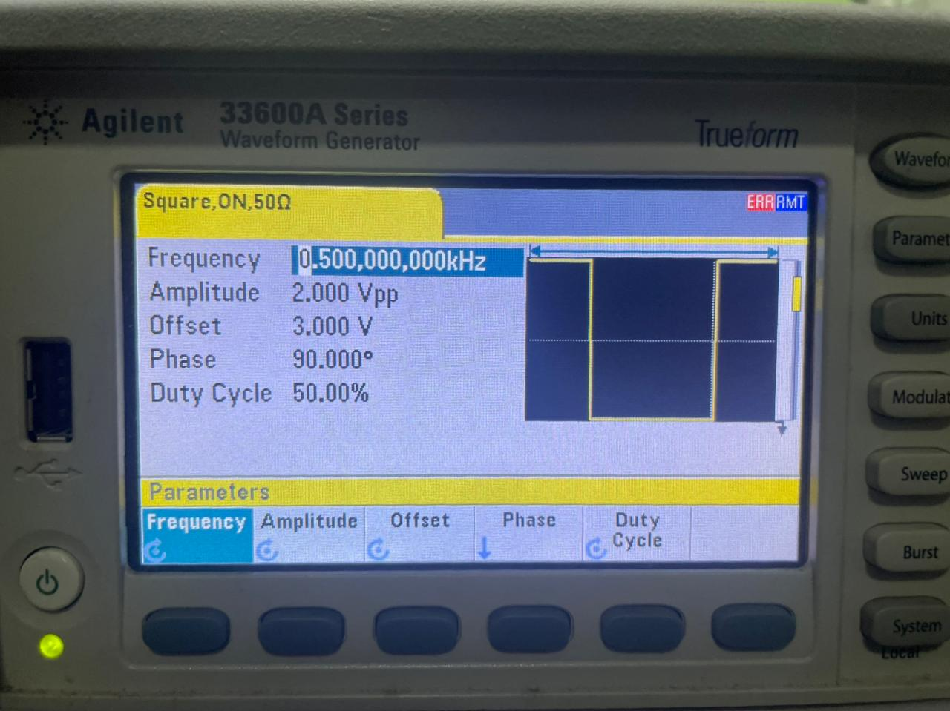
Figure 8: Signal Generator Output

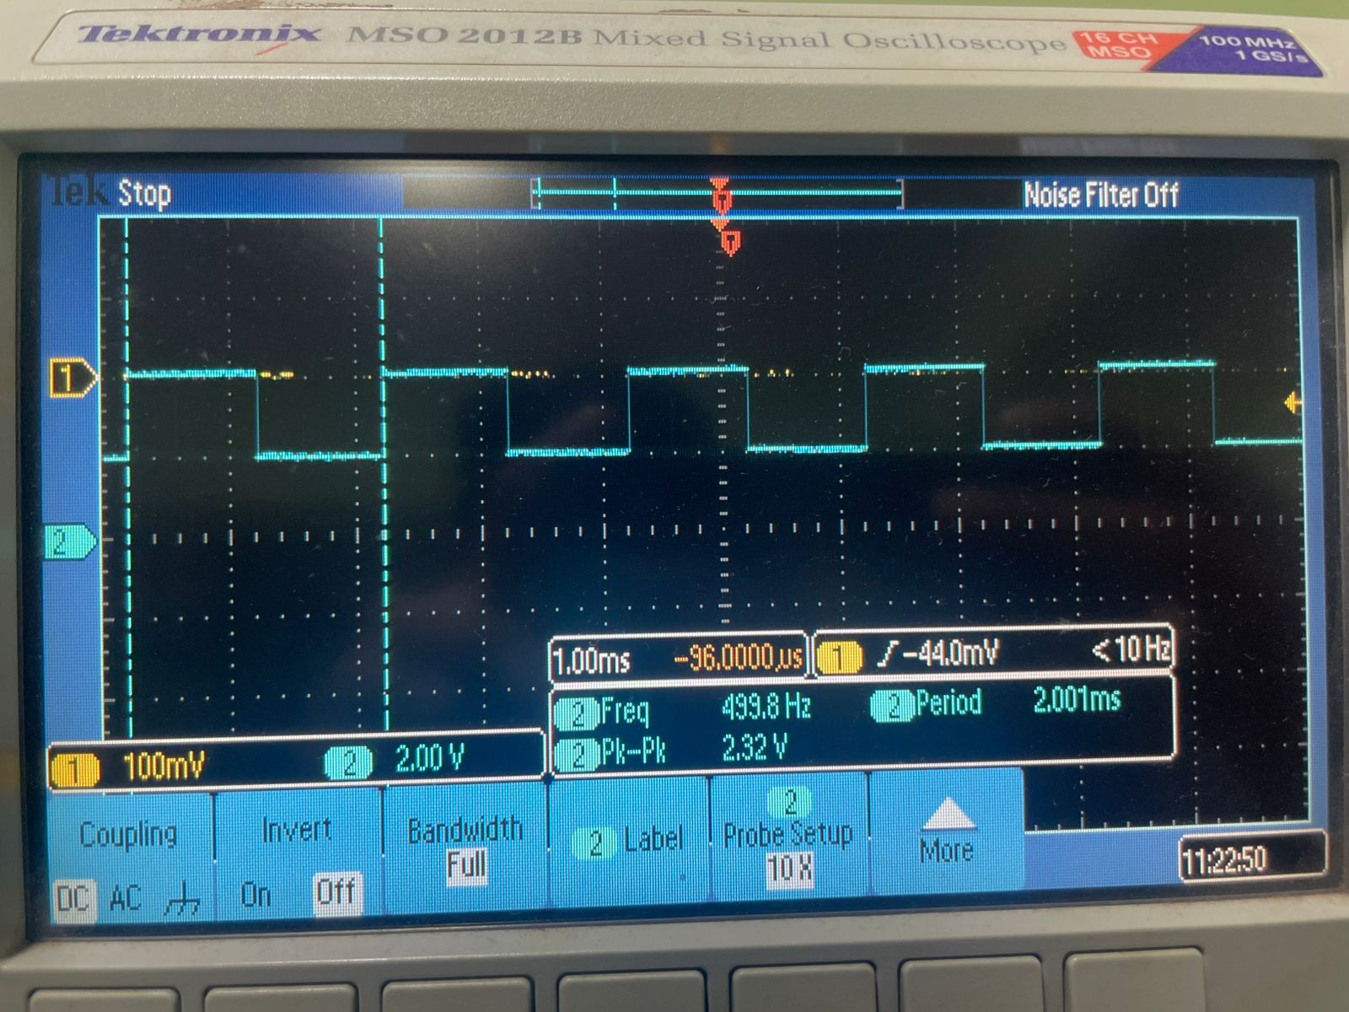
Figure 9: Oscilloscope Output

