Experiment No: 1
Date:

FAMILIARIZATION OF NS2

AIM

To learn the basics of network simulation with NS2.

INTRODUCTION OF NETWORK SIMULATION

A computer network is usually defined as a collection of computers interconnected for gathering, processing and distributing information. A computer network may include devices such as workstations, servers,routers, modems, base stations, wireless extension points etc and these devices are connected by communication links such as copper cables, fiber optic cables and microwave/satellite/radio links.

APPLICATIONS OF NETWORK SIMULATION

INTRODUCTION TO NS2

HOW NS2 WORKS

(give description for each type of statement in NS2 programming)

NETWORK ANIMATOR

TRACE FILE

ANLAYSIS OF TRACE FILE

RESULT

Experiment No: 2
Date:

THROUGHPUT CALCULATION USING AWK SCRIPT

AIM

To simulate a network of simple topology and to calculate throughput using AWK script.

TOPOLOGY DIAGRAM

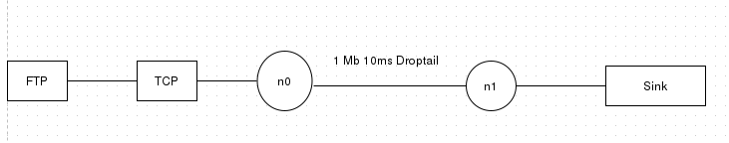
FEATURES OF THIS SCENARIO(eg: packet size, interval etc.)

FTP statrt at 0.5
FTP stop at 4.5

Simulation start at 0.0
Simulation stop at 5.0

PROCEDURE

- Start
- Create Simulatior object
- Create nodes n0,n1
- Create duplex link of 1Mb 10ms Droptail between n0 and n1
- Create protocol agent and attach to source and destination
- Create FTP application
- Set connection between source and sink.
- Start application at given time
  - $ftp0 at 0.5
- Stop application at given time
  - $ftp0 at 4.5
- Stop

PROGRAM
#create Simulator object

set ns [new Simulator]

#create Trace Object

set tr [open Sample.tr w]

$ns trace-all $tr

#Create NAM object

set nm [open first.nam w]

$ns namtrace-all $nm

#create node

set n0 [$ns node]

set n1 [$ns node]

#create link. Here we use duplex link

$ns duplex-link $n0 $n1 1Mb 10ms DropTail

#Create proto Agent to the source

set tcp0 [new Agent/TCP]

$ns attach-agent $n0 $tcp0

#Create sink/ Dest

set sink0 [new Agent/TCPSink]

$ns attach-agent $n1 $sink0

#Create application of FTP

set ftp0 [new Application/FTP]

$ftp0 attach-agent $tcp0

proc finish {} { puts "complete"; exit 0 }

#set connection for source and sink

$ns connect $tcp0 $sink0

#start the application of ftp at the time .5

$ns at 0.5 "$ftp0 start"

$ns at 4.5 "$ftp0 stop"

$ns at 5.0 "finish"

$ns run

DESCRIPTION ABOUT AWK PROGRAM

    - Start
    - Initialize variable data to 0
    - If event column value is read, destination column value is 1 and packet type is TCP
      - increment data variable with value of packet size
      - print time and throughput as data *8.0/time/1000000
    - Stop

AWK PROGRAM(for the experiment)

BEGIN {

data=0;

}

{

if($1=="r" && $4=="1" && $5=="tcp")

{

data += $6

print $2, data*8.0/$2/1000000

}

}

END{

}

OUTPUT

NAM image obtained
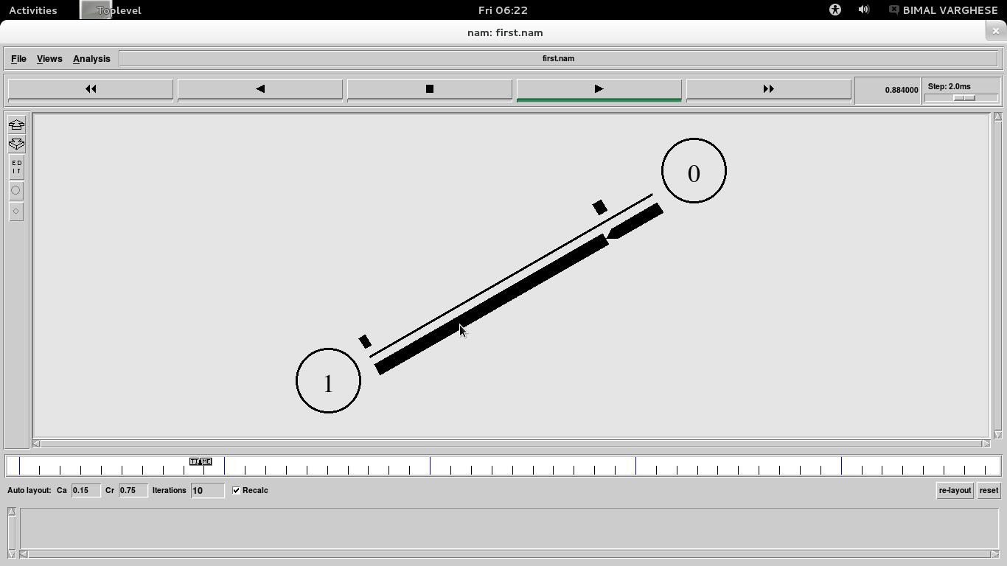

xgraph for throughput

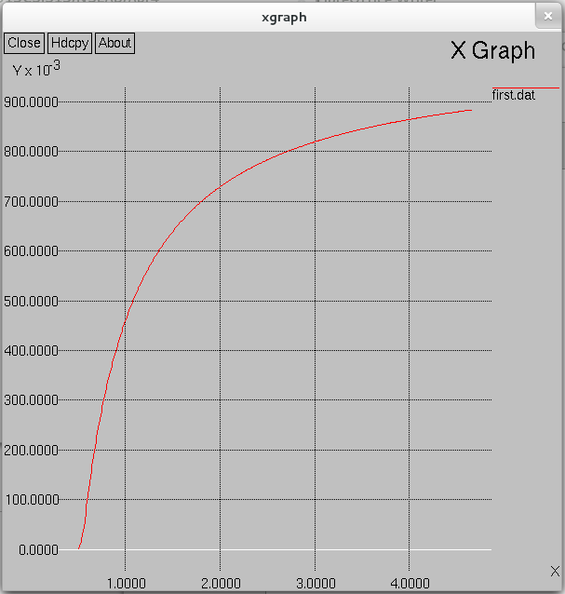

RESULT

Through put for the basic topology is obtained and output is plotted using xgraph.

Experiment No: 3
Date:

CALCULATING PACKET LOSS

AIM

To simulate the following scenario and to calculate the packet loss using AWK script.

TOPOLOGY DIAGRAM

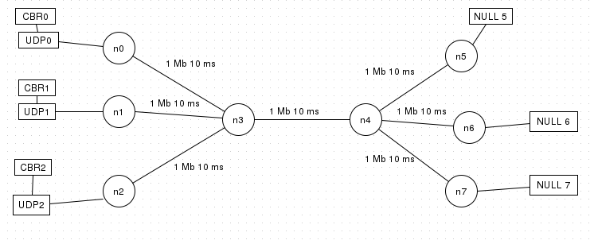
FEATURES OF THIS SCENARIO(eg: packet size, interval etc.)

CBR0 statrt at 0.5
CBR0 stop at 10.0

CBR0 statrt at 0.5
CBR0 stop at 10.0

CBR0 statrt at 2.0
CBR0 stop at 3.0

PROCEDURE

    - Start
    - Create simulator object
    - Creates nodes n0,n1,n2,n3,n4,n5,n6,n7
    - Create duplex link between nodes
      - n0 to n3
      - n1 to n3
      - n2 to n3
      - n3 to n4
      - n4 to n5
      - n4 to n6
      - n4 to n7
    - Create protocol agents and attach to corresponding nodes.
    - Connect Source node to destination node
      - n0 to n5
      - n1 to n6
      - n2 to n7
    - Set flowid values
    - Start cbr applications on given time
      - cbr0 at 0.5
      - cbr1 at 0.5
      - cbr2 at 2.0
    - Stop cbr applicationsat given time
      - cbr0 at 10.0
      - cbr1 at 10.0
      - cbr2 at 3.0
    - Stop

PROGRAM

set ns [new Simulator]

set f1 [open queuedrop.tr w]

$ns trace-all $f1

set f2 [open queuedrop.nam w]

$ns namtrace-all $f2

proc finish {} { puts "complete"; exit 0 }

set n0 [$ns node]

set n1 [$ns node]

set n2 [$ns node]

set n3 [$ns node]

set n4 [$ns node]

set n5 [$ns node]

set n6 [$ns node]

set n7 [$ns node]

#Set link b/n node0,1,2 & node3

$ns duplex-link $n0 $n3 1Mb 10ms DropTail

$ns duplex-link $n1 $n3 1Mb 10ms DropTail

$ns duplex-link $n2 $n3 1Mb 10ms DropTail

#Set link b/n node3 & node4

$ns duplex-link $n3 $n4 1Mb 10ms DropTail

#Set link b/n node4 & node5,6,7

$ns duplex-link $n4 $n5 1Mb 10ms DropTail

$ns duplex-link $n4 $n6 1Mb 10ms DropTail

$ns duplex-link $n4 $n7 1Mb 10ms DropTail

#Creating the protocol agents of source

#proto agents ovewr here are UDP

#Create proto Agent to the source

#Attach agent to source

set udp0 [new Agent/UDP]

$ns attach-agent $n0 $udp0

set udp1 [new Agent/UDP]

$ns attach-agent $n1 $udp1

set udp2 [new Agent/UDP]

$ns attach-agent $n2 $udp2

#all source agents created

#creating proto agents of Dest

#udp dest is set as Null. creating dest agents

#Dest agent is udp and it is null

set null5 [new Agent/Null]

$ns attach-agent $n5 $null5

set null6 [new Agent/Null]

$ns attach-agent $n6 $null6

set null7 [new Agent/Null]

$ns attach-agent $n7 $null7

#all Dest agents created

#Creating the user applications. Here the user app is CBR

set cbr0 [new Application/Traffic/CBR]

$cbr0 attach-agent $udp0

set cbr1 [new Application/Traffic/CBR]

$cbr1 attach-agent $udp1

set cbr2 [new Application/Traffic/CBR]

$cbr2 attach-agent $udp2

#Connecting different source and Destinations

#Connect n0 to n5

$ns connect $udp0 $null5

#Connect n1 to n6

$ns connect $udp1 $null6

#Connect n2 to n7

$ns connect $udp2 $null7

#Set flowid values since we are using UDP

$udp0 set fid_ 1

$udp1 set fid_ 2

$udp2 set fid_ 3

#start the applications

#App objects are $vars eg. $cbr0

$ns at 0.5 "$cbr0 start"

$ns at 0.5 "$cbr1 start"

$ns at 2.0 "$cbr2 start"

$ns at 3.0 "$cbr2 stop"

$ns at 10.0 "$cbr0 stop"

$ns at 10.0 "$cbr1 stop"

$ns at 10.1 "finish"

$ns run

AWK PROGRAM

#Awk file to calculate instantaneous throughput

BEGIN {

data=0;

}

{

if($1=="d" && $5=="cbr")

{

data += 1

}

}

END{

print data

}

OUTPUT

Nam image obtained is
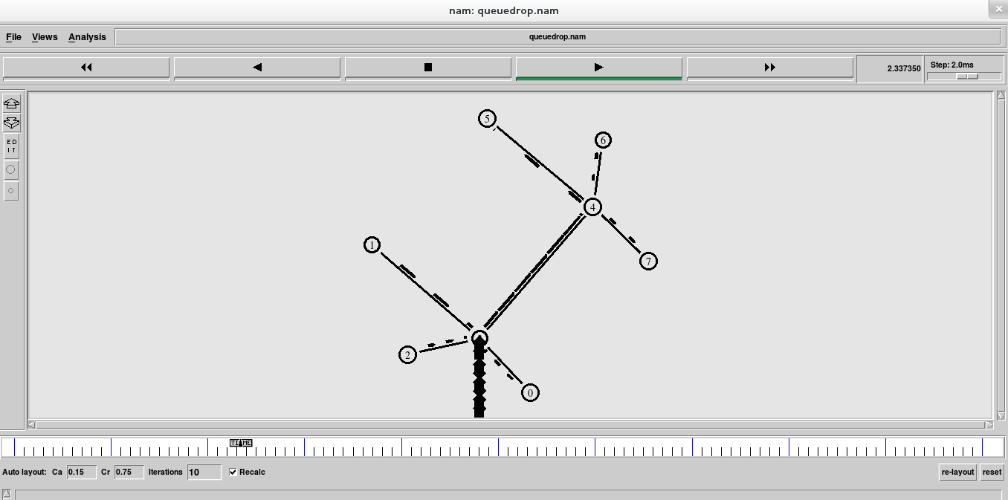

Dropcount is 158

RESULT

Given scenario is simulated using NS2 and the Dropcount of the given topology is obtained.

Experiment No:4
Date:

PERFORMANCE EVALUATION OF ROUTING PROTOCOLS

AIM

To evaluate performance of routing protocols like distance vector and link state routing in wired network.

INTRODUCTION TO ROUTING ALGORITHMS

STATIC AND DYNAMIC ROUTING

DISTANCE VECTOR ROUTING

LINK STATE ROUTING

TOPOLOGY DIAGRAM

FEATURES (eg: packet size, interval etc.)

PROCEDURE

PROGRAM

AWK PROGRAM

OUTPUT

(screen shot from nam, xgraph and result file)

RESULT

Experiment No:5
Date:

ANALYSIS OF CONGESTION CONTROL BEHAVIOUR OF TCP VARIANTS

AIM

To simulate a network consisting of TCP (Tahoe, Reno, Vegas) and to study congestion window behaviour

CONGESTION CONTROL IN TCP(for 3 variants)
Should include

- SLOW START
- ADDITIVE INCREASE
- MULTIPLICATIVE INCREASE
- FAST RETRANSMIT

TOPOLOGY DIAGRAM

FEATURES

PROCEDURE

PROGRAM

OUTPUT

(screen shot from nam, xgraph and dat file)

RESULT

Experiment No 6
Date:

THROUGHPUT CALCULATION OF TCP VARIANTS

AIM

To calculate the troughput of the following topology ,and to analyse the impact of TCP variants towards the contribution of throughput.

TOPOLOGY DIAGRAM

FEATURES

PROCEDURE

PROGRAM

AWK PROGRAM

OUTPUT

(screen shot from nam, xgraph and result file)

RESULT

Experiment No 7
Date:

PERFORMANCE EVALUATION OF DIFFERENT QUEUES

AIM

To evaluate performance of different queue models like DropTail and RED

INTRODUCTION TO QUEUES

- DROPTAIL QUEUE MODEL
- RED QUEUE MODEL

TOPOLOGY DIAGRAM

FEATURES

PROCEDURE

PROGRAM

AWK PROGRAM

OUTPUT

Include the drop statistics of each queue

RESULT

