COEN 554 — WEB PROGRAMMING
TECHNICAL REPORT
Personal Portfolio Website
Question 1 — Individual Multi-Page Web Application
Submitted by
Aliyu Idris
(Bin_Idrees)
Ahmadu Bello University, Zaria
Faculty of Engineering — Department of Computer Engineering, 500 Level
2025/2026 Session
Live site: https://bin0idrees.github.io/Aliyu-Idris-Portfolio-/

1. Introduction and Project Overview
This report documents the design and implementation of my personal portfolio website, built for the COEN 554 Web Programming examination (Question 1: the compulsory individual portfolio site). The site introduces me as a 500 Level Computer Engineering student at Ahmadu Bello University, Zaria, and presents my background, technical skills, projects, hobbies, CV and contact details across eight linked pages: Home, About Me, Educational Background, Technical Skills, Projects, Hobbies and Interests, CV, and Contact Me.
The entire site is hand-built using semantic HTML5, external CSS3 and structured JSON — no JavaScript, no Content Management System and no static site generator were used anywhere, in line with the examination's constraints. This report explains the visual design decisions behind the site, defines the structure of its JSON data files, explains how HTTP/HTTPS and MIME types govern how the static files are served to a browser, and closes with a comparative evaluation of this hand-built approach against a CMS.

2. Visual Design Rationale
The site deliberately uses two related but distinct visual themes: a light “blueprint” theme used consistently across seven of the eight pages, and a separate dark “terminal/console” theme used only on the Home page. Keeping one shared identity across the interior pages was important for usability and for satisfying the brief's requirement of consistent internal navigation, while giving the Home page its own distinct first impression.

2.1 The Blueprint Theme (interior pages)
About Me, Education, Technical Skills, Projects, Hobbies, CV and Contact all share one colour system, defined once as CSS custom properties in :root so the whole site's palette can be changed from a single place:
- --blueprint-deep (#0f3b4d) — a deep engineering-blueprint blue used for the header, footer and page headings, chosen to feel technical and professional rather than decorative.
- --circuit-green (#3f9463) — a muted circuit-board green used for links, hover states and section accents, echoing the Computer Engineering subject matter.
- --brown-accent (#8a6a45) — a warm secondary accent used in progress bars and small highlights, to avoid the palette feeling one-note.
- A light --blueprint (#dbe9ec) background and a near-white --card (#f4f9f7) surface colour for content cards, keeping body text (--ink, #16232a) at strong contrast for readability.
Typography pairs a serif display face (Georgia) for headings with a plain sans-serif (Arial/Helvetica) for body copy — a deliberately conservative, CV-appropriate pairing rather than a trend-driven one, since several of these pages (CV, About Me) are effectively formal self-presentation documents.
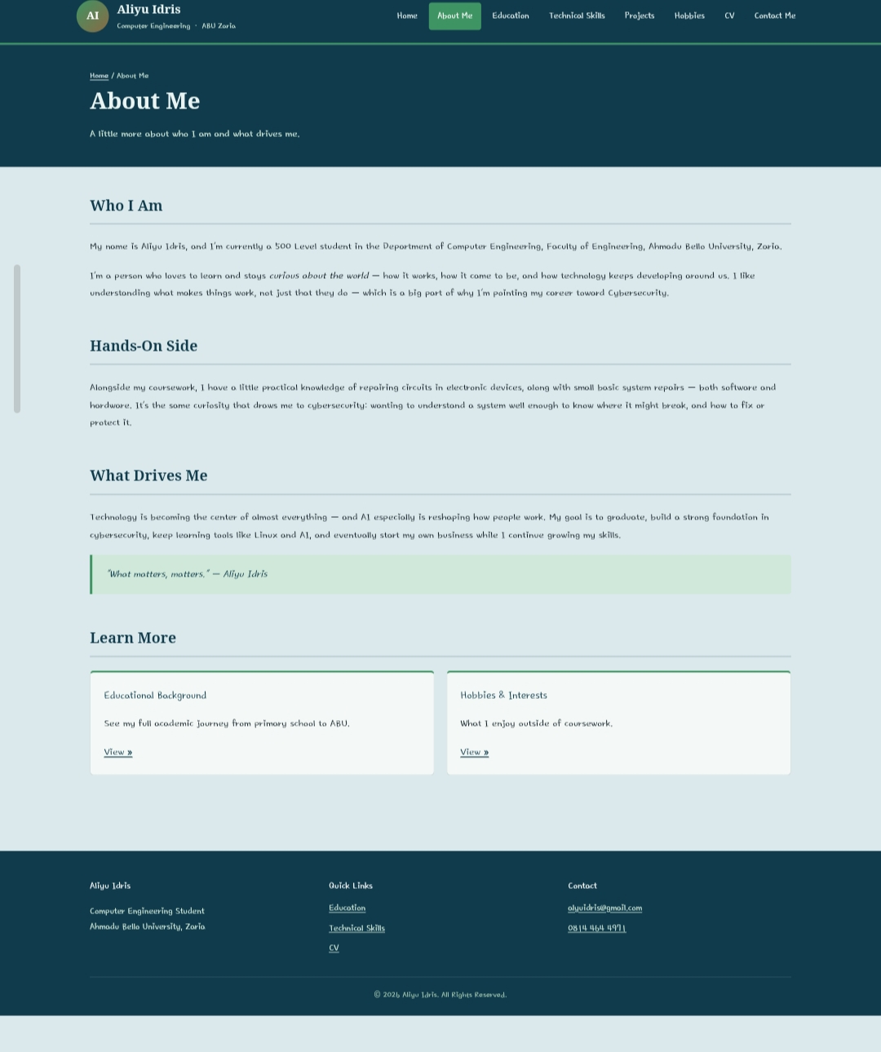
Figure 1 — About Me page, showing the light “blueprint” theme shared by all interior pages.

2.2 The Terminal Theme (Home page only)
The Home page uses a separate stylesheet (assets/css/home.css), scoped entirely under a body.home-page class so it never leaks into the other pages. It reimagines the introduction as a mock computer terminal: a near-black background, terminal-green monospace text, and a terminal “window” with a title bar (red/yellow/green dots) containing simulated commands — whoami, cat status.txt, echo $INTEREST — whose output introduces me, my course of study and my interest in cybersecurity. A small blinking cursor after the final line is produced with a pure CSS @keyframes animation (no JavaScript).
This theme was chosen specifically because my stated career direction is cybersecurity: a terminal aesthetic is an immediate, honest visual signal of that interest, rather than a generic hero banner. My profile photo receives a CSS grayscale/hue-rotate filter so it reads as part of the same green-tinted terminal world instead of clashing with it.

2.3 Layout System and Responsive Breakpoints
Both themes are built with Flexbox for the header/navigation/footer rows and CSS Grid for the multi-column card layouts (skills cards, project cards, quick-link cards). The site follows a mobile-first approach, with two progressive breakpoints widening the layout for larger screens:
Breakpoint | Layout behaviour
max-width: 780px | Navigation switches to the CSS-only checkbox-driven mobile menu; multi-column grids reduce to fewer columns.
max-width: 620px | Layout collapses to a single column throughout; hero/photo layouts stack vertically; type scale reduces for small screens.
A dedicated @media print block also removes navigation chrome for a clean, CV-appropriate printed version of the pages.

3. Site Architecture and CSS-Only Interactivity
All eight pages use standards-compliant HTML5 semantic elements — <header>, <nav>, <main>, <section> and <footer> — so the document outline carries meaning independent of its visual styling. Every page shares the same navigation bar, linking Home, About Me, Education, Technical Skills, Projects, Hobbies, CV and Contact Me, so any page is reachable from any other page in a single click.
Because the examination brief prohibits JavaScript entirely, all interactivity is implemented with CSS pseudo-classes:
- Mobile navigation menu — a hidden checkbox paired with a <label> toggle (the “checkbox hack”). Checking the box, by tapping the menu icon, changes a sibling selector's display state via :checked and slides the navigation panel into view, with no script involved.
- Hover and focus states — :hover and :focus are used throughout on navigation links, buttons and content cards to give clear, immediate feedback that an element is interactive, for both pointer and keyboard users.
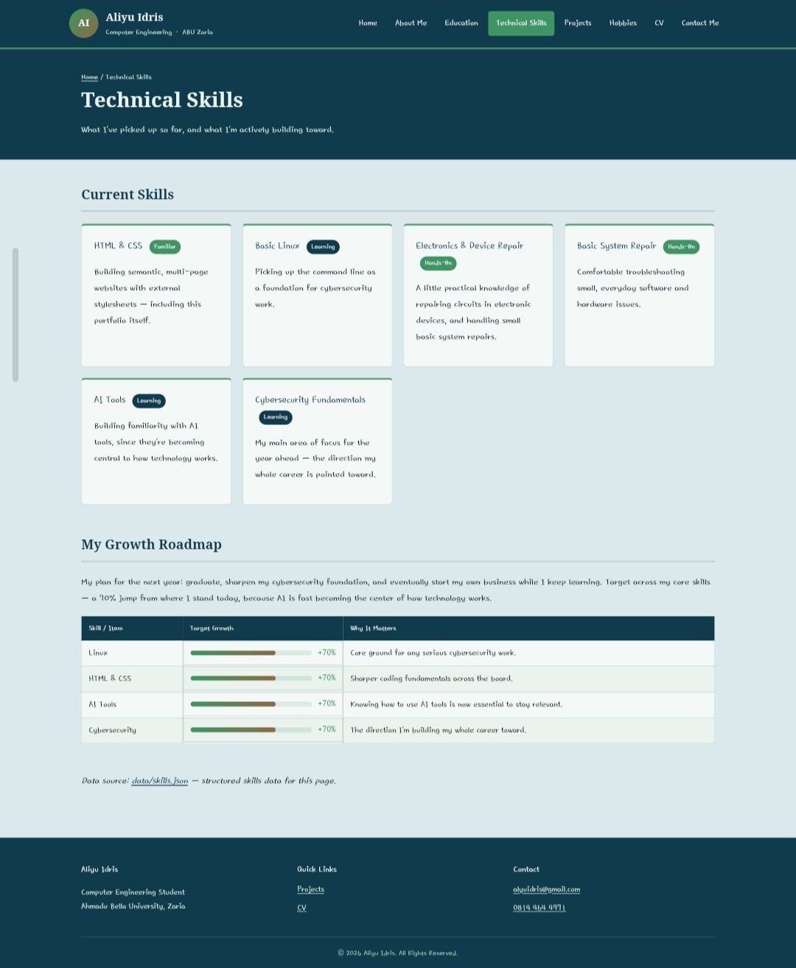
Figure 2 — Technical Skills page, showing skill cards and the growth-roadmap table rendered from data/skills.json.

4. JSON Data Structure Definitions
Structured data is modelled in two JSON files under /data/: skills.json and projects.json. Both follow a consistent, self-describing object shape — each entity carries an id, plus descriptive fields — comparable to the id / title / date / category / description pattern specified in the examination brief.

4.1 data/skills.json
Key | Type | Description
skills | Array<Object> | Six skill entities, each with id, name, level (Familiar / Learning / Hands-On), category and a short description.
growth_roadmap | Array<Object> | Four roadmap entities, each with skill, target_growth_percent (a numeric target) and reason, rendered as the progress-bar table on the Technical Skills page.
The Technical Skills page's card grid and growth-roadmap table are a direct, page-level presentation of this file's content — the caption on that page (“Data source: data/skills.json”) makes that relationship explicit to the reader.

4.2 data/projects.json
Key | Type | Description
projects | Array<Object> | Two project entities, each with id, title, date, category, description, and additional context fields (institution, project type, team_members, tools) specific to that project.
Project 1 models a diploma-level hardware project (“Construction and Testing of a PIC16F84A Microcontroller Programmer,” September 2021), including its full eight-member team. Project 2 models this portfolio website itself as a second, ongoing project entity. As with skills.json, no JavaScript is used to fetch or render this file at runtime; it is delivered as a standalone, validly-structured JSON artefact satisfying the brief's structured-data-modelling requirement, and its content is written directly into projects.html.

4.3 Semantic Linked Data (JSON-LD)
Machine-readable structured data is additionally embedded in the <head> of most pages using JSON-LD (application/ld+json) — a data format, not an executable script, and explicitly permitted under the examination's no-JavaScript constraint.
Page | Schema.org type | Purpose
index.html | Person | Identifies me as a Person entity with jobTitle, affiliation, email, phone and social profile links (sameAs).
about.html | AboutPage | Marks the page as an AboutPage describing a nested Person entity.
education.html | Person | Describes my education history as a Person entity with an alumniOf array of the institutions I have attended.
projects.html | ItemList | Lists both projects as CreativeWork items with name and dateCreated.
cv.html | Person | A compact Person entity carrying jobTitle, email and telephone for the CV page.
contact.html | ContactPage | A ContactPage describing a nested Person entity with email, telephone and social profile links.
Technical Skills and Hobbies and Interests do not currently carry JSON-LD blocks, as their content did not map cleanly onto a distinct schema.org type beyond what is already declared on the Home page.

5. HTTP/HTTPS Protocol Overview and MIME Types
This is a fully static site: every file a visitor's browser needs — HTML, CSS, JSON and images — exists as-is on disk and is served without any server-side processing.

5.1 Request/Response Cycle
When a visitor opens the site, the browser opens a connection to the host and issues an HTTP GET request for a resource, e.g. GET /index.html. The server locates the matching file and returns it in an HTTP response: a status line (e.g. 200 OK), response headers, and the file's raw bytes as the body. As the browser parses index.html, it discovers further references — the linked stylesheet, the profile photo's src attribute — and issues an additional GET request for each one, satisfied by the same request/response cycle.

5.2 HTTPS
HTTPS wraps the same exchange in TLS encryption, so the requested paths and response bodies are unreadable to a network eavesdropper, and the browser can verify it is talking to the genuine host. For a personal portfolio with a public contact form-free layout (contact is via direct email/phone/WhatsApp links, not a submission form), HTTPS's main benefit is integrity and avoiding the “Not secure” warning modern browsers show for plain HTTP sites — which matters for a page a prospective employer or lecturer might visit. Static hosts such as GitHub Pages issue HTTPS certificates automatically.

5.3 MIME Types
Every HTTP response includes a Content-Type header stating the MIME type of the body that follows. The browser uses this header — not the file extension — to decide how to interpret the bytes it receives.
File type | MIME type | Browser behaviour on receipt
.html | text/html | Parsed as a DOM document; triggers discovery and further requests for linked resources.
.css | text/css | Parsed as a stylesheet and applied to the DOM built from the linked HTML document.
.json | application/json | Treated as inert structured data — not executed, simply stored/served as a data resource (as with skills.json and projects.json).
.jpg | image/jpeg | Decoded and rasterised as a bitmap image, as with my profile photo on the Home page.
GitHub Pages — my hosting platform, with the site live at https://bin0idrees.github.io/Aliyu-Idris-Portfolio-/ — infers the correct MIME type automatically from each file's extension, so no manual server configuration is required for this project.

6. Content Architecture and Directory Structure
All project assets are organised into a clean, predictable directory hierarchy:
- / (root) — all eight HTML5 pages (index.html, about.html, education.html, skills.html, projects.html, hobbies.html, cv.html, contact.html)
- /assets/css/ — style.css (the shared blueprint theme, used by all pages) and home.css (the Home-page-only terminal theme override)
- /assets/images/ — my profile photograph
- /data/ — skills.json and projects.json
Every page links style.css; index.html additionally links home.css after it, so the terminal-theme rules override the shared theme only where they are scoped to body.home-page. There are no inline style attributes and no internal <style> blocks anywhere in the HTML.
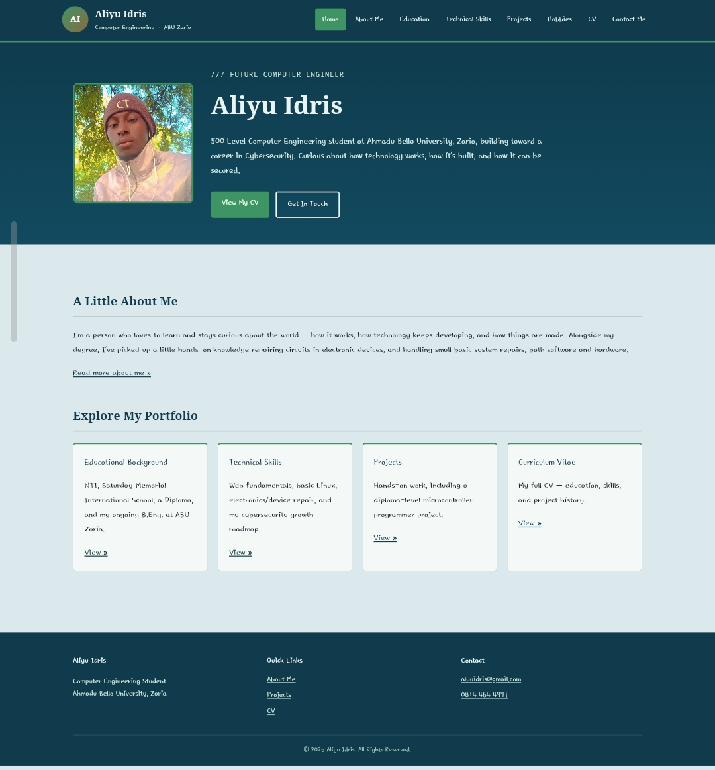
Figure 3 — Home page, showing the distinct terminal-themed introduction described in Section 2.2.

7. CMS Selection Justification
Although the examination brief excludes Content Management Systems from the implementation itself, it is worth evaluating this hand-authored HTML/CSS/JSON approach against a mainstream CMS such as WordPress, and identifying the conditions under which migrating this personal portfolio would become justified.
For a personal portfolio site like this one, the hand-built approach has clear advantages. Performance is excellent by default: every page is a small static file with no database queries, so load times are close to the practical minimum, and hosting on a platform such as GitHub Pages is free and requires no server maintenance, security patching or database backups. The attack surface is also minimal, since there is no admin login, plugin ecosystem or database that could be targeted — a meaningful benefit for a site that carries my personal contact details. Because I control every line of markup and styling myself, the site is also a direct, honest demonstration of my own HTML/CSS ability, which arguably matters more for a portfolio than for most other site types, since visitors evaluating my technical skills can view the source directly.
These same properties would become limiting under different conditions. A CMS's core value is separating content editing from code, letting a non-technical editor update a page through an admin panel and a form. That trade-off is irrelevant here: I am the site's only author, its only editor, and the person whose technical skills the site exists to demonstrate, so there is no benefit to hiding the HTML behind an editing abstraction. Migration to a CMS would only become justified if the site's purpose changed substantially — for example, if it grew into a small studio or freelance-agency site maintained by several people of varying technical ability, needed frequent blog-style publishing (multiple posts per week rather than the occasional CV or project update this site requires), or needed dynamic features such as a contact form with server-side validation, user accounts, or a searchable project archive that would require substantial custom server-side engineering to replicate by hand.
In short: for a single-author, low-update-frequency personal portfolio, hand-written static HTML/CSS/JSON is the more defensible choice on performance, security and cost grounds — and it is also the choice that best serves the portfolio's actual purpose, which is to demonstrate that I can build a site this way in the first place.

8. Deliverables Summary
- Source code package — eight validated HTML5 pages, two CSS3 stylesheets, and two structured JSON data files, organised in a clean /assets/css/, /assets/images/, /data/ directory hierarchy.
- Live deployment — the completed static site is hosted on GitHub Pages at https://bin0idrees.github.io/Aliyu-Idris-Portfolio-/, requiring no server-side runtime.
- Technical report (this document) — visual design rationale, JSON data structure definitions, HTTP/MIME protocol overview, and a CMS comparative evaluation.
Together, these deliverables satisfy the COEN 554 examination's constraints — no JavaScript and no CMS — while meeting every functional requirement: a professional homepage, full internal navigation, a fully responsive mobile-first layout, a professional footer with copyright and contact details, semantic HTML5 structure, pure-CSS no-script interactivity, and structured JSON/JSON-LD data modelling.

