TASK1

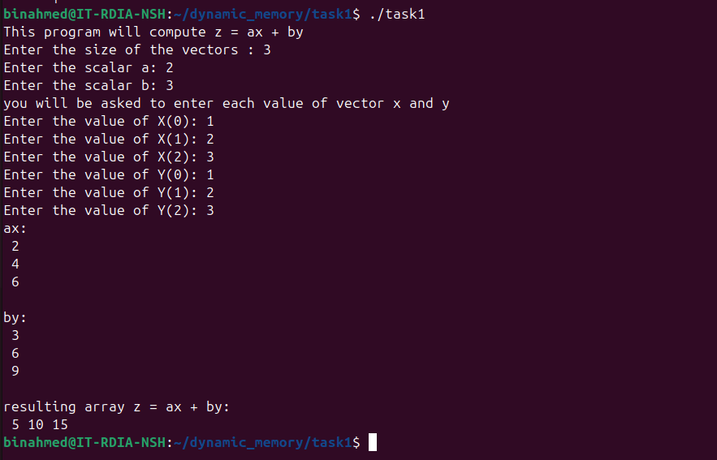

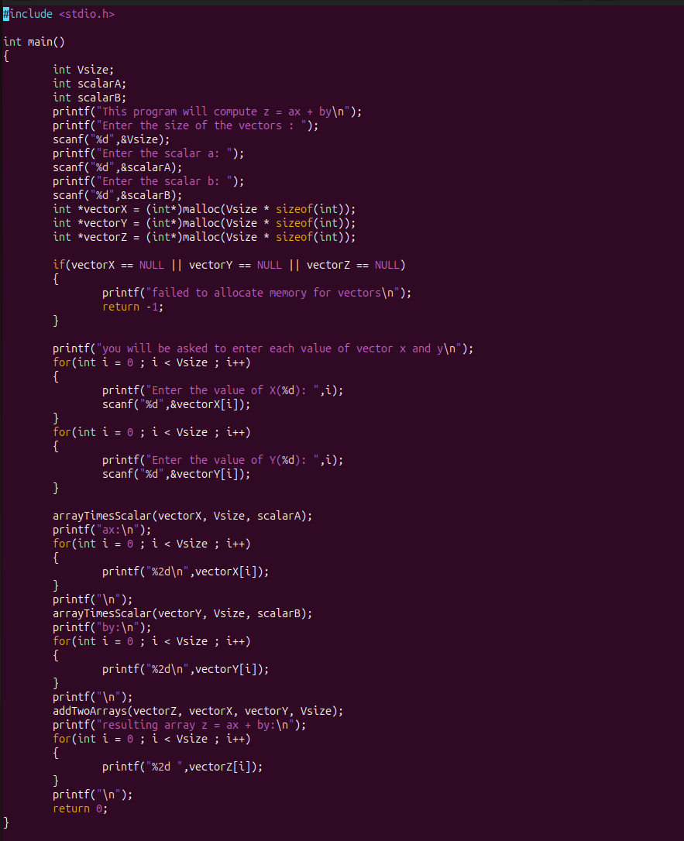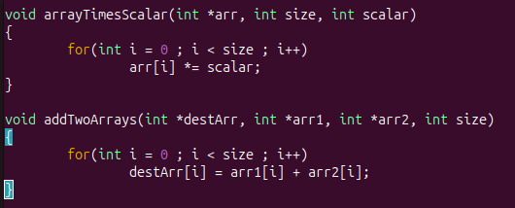

TASK2

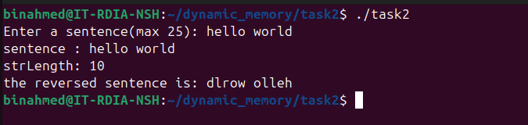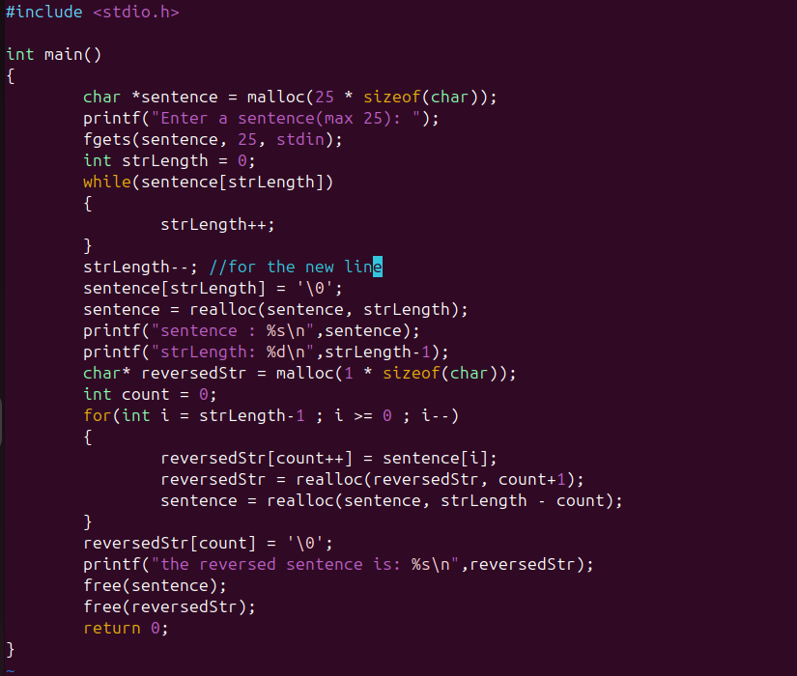

TASK3

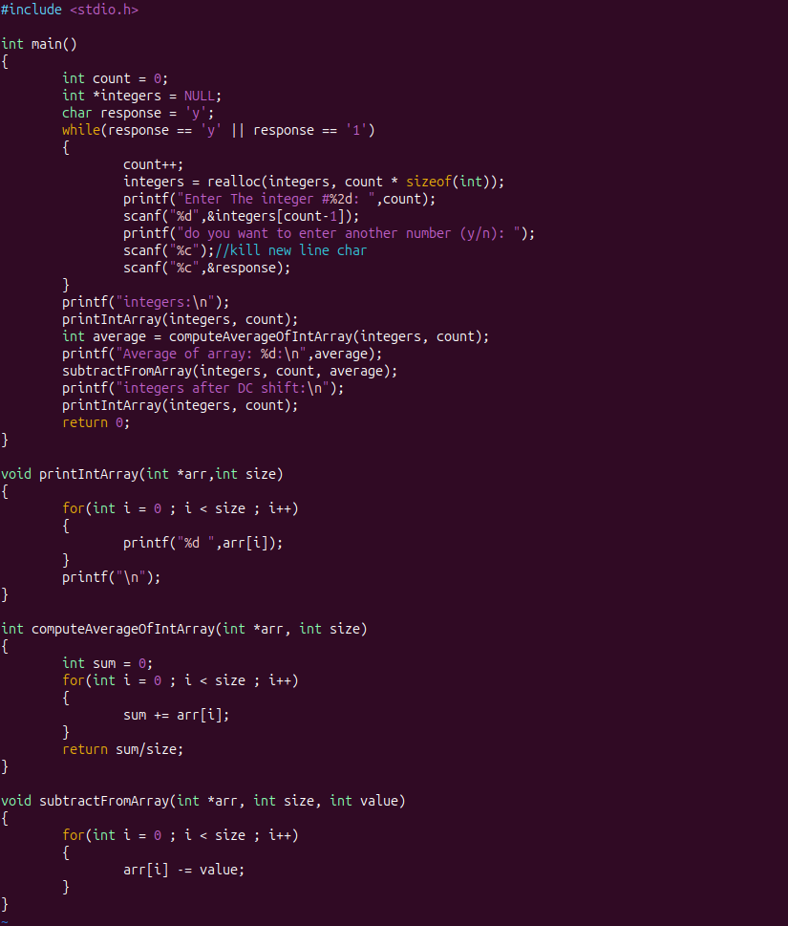

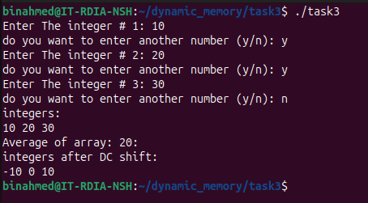

TASK4

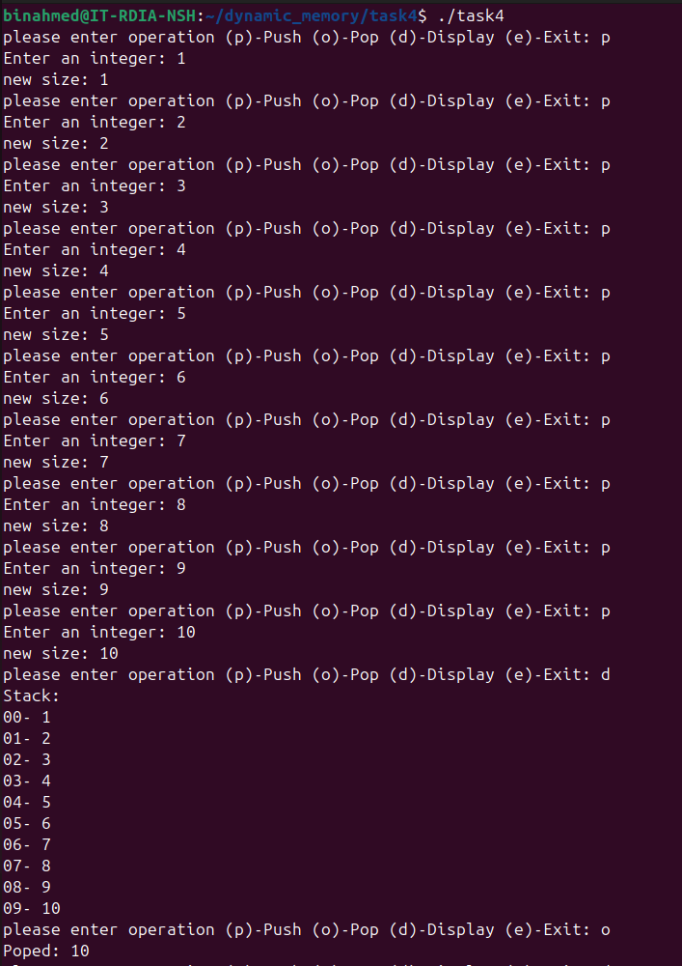

code :

#include <stdio.h>

int *stack = NULL;

int number_elements = 0;

int main()

{

char response;

while(1)

{

printf("please enter operation (p)-Push (o)-Pop (d)-Display (e)-Exit: ");

scanf(" %c",&response);

switch(response)

{

case 'p':

printf("Enter an integer: ");

int tmp;

scanf("%d",&tmp);

push(tmp);

break;

case 'o':

printf("Poped: %d\n",pop());

break;

case 'd':

display();

break;

case 'e':

return 0;

case '\n':

break;

default:

printf("not recognized please enter (p)-Push (o)-Pop (d)-Display (e)-Exit");

}

}

return 0;

}

void display()

{

printf("Stack:\n");

for(int i = 0 ; i < number_elements ; i++)

{

printf("%02d- %d\n",i,stack[i]);

}

}

void push(int value)

{

number_elements++;

grow();

printf("new size: %d\n",number_elements);

stack[number_elements-1] = value;

}

int pop()

{

if(number_elements == 0)

{

printf("stack is empty...");

return -1;

}

int value = stack[--number_elements];

shrink();

return value;

}

int grow()

{

stack = realloc(stack, number_elements * sizeof(int));

if(stack == NULL)

{

printf("failed to allocate more space\n");

return -1;

}

return 0;

}

void shrink()

{

stack = realloc(stack, number_elements * sizeof(int));

}