WEEK 20 FINAL PROJECT

Public Bus Operations Prediction
Student Project Report Template
Classification Target: delay_level
Regression Target: trip_duration_minutes

Student Information | Complete This Field
Student Name | Ahmed Emad Eldeen Mostafa Elsherif
Student ID | EYOUTH-31002101601472
Group / Cohort | ON-GH-L4DT-G1707
Submission Date | 29/8/2026

Use this report to record the required outputs produced by your executed notebook. Do not guess results and do not use Test Data during Model selection.

How to Complete This Report
- Complete every table and response field using outputs from your own executed notebook.
- Keep Classification and Regression results separate because they use different Metrics.
- Use Cross-Validation results to select each best Model; use Test Data only for final evaluation.
- Report the best Hyperparameters exactly as shown by your Grid Search results.
- Use New_Bus_Trips.csv for the final prediction task and do not add either Target column to that file.
- Paste the required visuals clearly in the spaces provided.
- Rename the completed file as student_id_bus_operations_report.docx.

1. Project Overview and Data Quality
Item | Student Response
Classification business question | Can we predict the expected delay level of a trip?
Regression business question | Can we predict the total trip duration in minutes?
Classification Target | delay_level (On Time, Moderate Delay, or Severe Delay.)
Regression Target | trip_duration_minutes (the trip length in minutes.)
Number of rows before cleaning | 10000
Number of columns before cleaning | 11
Number of exact Duplicates | 150
Rows after removing Duplicates | 9850

Data Quality Check | Finding
Missing Values in Nominal Features | weather_condition: 258 (2.58%),  bus_type: 202 (2.02%)
Missing Values in Numerical Features | route_distance_km: 151 (1.51%),  passenger_count: 182 (1.82%),  driver_experience_years: 223 (2.23%)
Identifier Feature | trip_id
Target leakage risk | trip_id, delay_level and trip_duration_minutes)
Class balance | Balanced (~33.3% for each class)

2. Classification Results
Target: delay level | Models: Logistic Regression and Support Vector Machine | Selection Metric: Mean CV F1-macro

2.1 Cross-Validation Comparison
Model | Best Mean CV F1-macro | CV Standard Deviation | Best Hyperparameters
Logistic Regression | 0.675272 | 0.016777 | {'model__C': 1, 'model__class_weight': 'balanced'}
Support Vector Machine | 0.699122 | 0.010868 | {'model__C': 1, 'model__class_weight': 'balanced', 'model__gamma': 0.1, 'model__kernel': 'rbf'}

2.2 Final Classification Test Evaluation
Metric | Test Result | Interpretation
Accuracy | 0.71 | About 71% of predictions of test trips were correct.
Macro Precision | 0.71 | About 71% of predictions across the three classes were correct.
Macro Recall | 0.71 | The model identified about 71% of trips in each class.
Macro F1-score | 0.71 | Balance between precision and recall across the three classes.
Confusion Matrix:
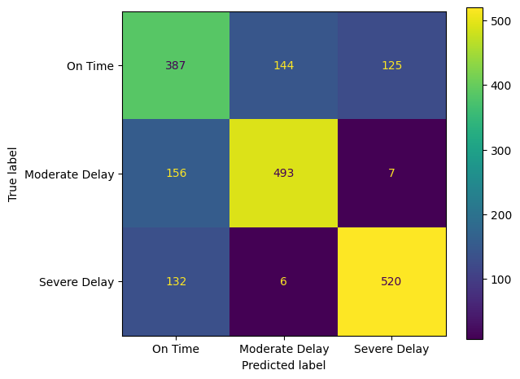

2.3 Classification Report and Risk Interpretation
Class | Precision | Recall | F1-score | Support
On Time | 0.57 | 0.59 | 0.58 | 656
Moderate Delay | 0.77 | 0.75 | 0.76 | 656
Severe Delay | 0.80 | 0.79 | 0.79 | 658
Most important Classification error for the transportation authority:
Missclassifying “Severe Delay” as “On Time” or “Moderate Delay”. This causes failing in dealing with these delay trips.

3. Regression Results
Target: trip_duration_minutes | Models: Linear Regression and KNN Regressor | Selection Metric: Mean CV R-squared

3.1 Cross-Validation Comparison
Model | Best Mean CV R-squared | CV Standard Deviation | Best Hyperparameters
Linear Regression | 0.924093 | 0.002990 | {'model__fit_intercept': True}
KNN Regressor | 0.926784 | 0.004159 | {'model__n_neighbors': 9, 'model__p': 1, 'model__weights': 'distance'}
Selected Regression Model and justification:
Best model: KNN Regressor | CV R2: 0.9268
Params: {'model__n_neighbors': 9, 'model__p': 1, 'model__weights': 'distance'}

3.2 Final Regression Test Evaluation
Metric | Test Result | Interpretation
MAE | 6.4882 minutes | On average, the predicted trip duration differs from the real duration by about 6.49 minutes.
RMSE | 8.6117 minutes | Larger errors affect more heavily. This indicates the effect of some larger prediction errors.
R-squared | 0.9364 | The model explains approximately 93.64% of the variation in trip duration in the test data.
Actual vs Predicted Plot:
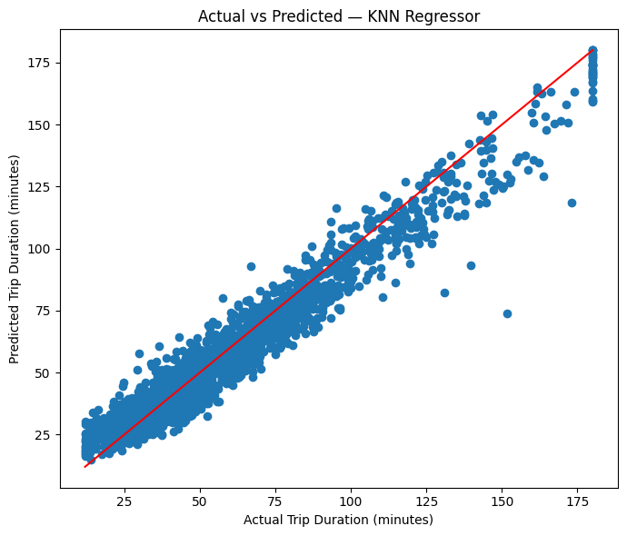

4. New Trip Input Data
Use the 10 records supplied in New_Bus_Trips.csv. The file contains input Features only and must not include delay_level or trip_duration_minutes.
Trip ID | Weather | Bus Type | Traffic | Distance (km) | Stops | Passengers | Driver Experience (years) | Start Hour
NEW001 | Clear | Express | Low | 5.8 | 6 | 18 | 12 | 10
NEW002 | Rainy | Standard | High | 14.5 | 16 | 40 | 4.5 | 18
NEW003 | Foggy | Mini Bus | Severe | 24 | 27 | 58 | 2.5 | 7
NEW004 | Windy | Standard | Moderate | 9.2 | 10 | 32 | 7 | 14
NEW005 | Clear | Mini Bus | High | 12.8 | 14 | 48 | 3.2 | 8
NEW006 | Rainy | Express | Severe | 21.5 | 23 | 52 | 6.5 | 17
NEW007 | Clear | Standard | Low | 3.5 | 4 | 12 | 15 | 6
NEW008 | Foggy | Express | Moderate | 17.2 | 18 | 35 | 9 | 20
NEW009 | Windy | Mini Bus | High | 8.7 | 9 | 44 | 1.5 | 22
NEW010 | Rainy | Standard | Moderate | 28 | 31 | 60 | 5 | 12

5. Final Predictions for New Trips
Generate both predictions for every supplied record and enter the results below.
Trip ID | Predicted Delay Level | Predicted Trip Duration (minutes)
NEW001 | On Time | 19.163966
NEW002 | Severe Delay | 100.750380
NEW003 | Severe Delay | 171.375926
NEW004 | On Time | 45.836484
NEW005 | Severe Delay | 67.998976
NEW006 | Severe Delay | 165.380225
NEW007 | On Time | 19.907289
NEW008 | Moderate Delay | 85.756454
NEW009 | Severe Delay | 62.508440
NEW010 | Severe Delay | 163.384532

6. Selected Models
Problem | Selected Model
Classification | EYOUTH-31002101601472_best_bus_delay_classifier.joblib
Regression | EYOUTH-31002101601472_best_bus_duration_regressor.joblib

7. Final Declaration
I confirm that the results in this report were produced from my own executed notebook and that the Test Data was not used during Model selection.
Student Signature | Date
Ahmed Emad Eldeen Mostafa Elsherif | 29/8/2026
End of Report Template

