**This file provides the instruction for the related source code of the Fig. 2 in our paper.**

1、Source code

1. Files:

This Demo contains the source files of both Canonic PSO, classical deterministic optimization method (sequential quadratic programming (SQP), *Multi-start* SQP, pattern search), the other heuristic methods (Generical Algorithm, Simulated Annealing method), as well as our EVOLER method in finding the global optimum of the challenging 2D non-convex benchmark function, i.e., Schewfel function.

The source file is named as ‘PSO_ schewfel.m’, for the classical PSO method. The source file is named as ‘EVOLER_schewfel.m’ for the proposed EVOLER method. The source file is named as ‘Comparison_methods_schewfel’, for the other classical comparative methods.

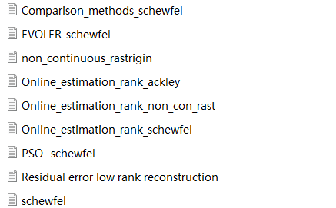

2、User Instruction to Fig. 2

1. **Open the Source File**

Our source code can be directly run on the specified software MATLAB R2019a.

1. **Running time**

For the source code of our EVOLER method in a standard test function (e.g., the ‘EVOLER_schewfel’), the running time is less than 1 sec for each independent realization.

1. **Impalement guidelines**

* **Reproducing Fig 1-a(iii): reconstruction of 2D Schewfel problem space**

Open the MATLAB platform, open the file folder ‘Demo_reproducing_Fig2’ and run the source file ‘Residual_error_low_rank_reconstruction’, which outputs the reconstructed problem space by our EVOLER method (Fig. 1a-iii). For convenience, one can also directly find the simulation result in the saved Figure file ‘fig1a_example’ in the file folder ‘Fig_2’.

* **Reproducing Fig. 2b: Residual error of reconstructed problem space**

First, open the file folder ‘Demo_reproducing_Fig2, and run the source code file ‘Residual_error_low_rank_reconstruction’, which outputs the histogram of residual error of reconstruction error (saved as ‘fig2b_example’ in the file folder ‘Fig_2’). Note that, in order to further obtain the probability density of the residual error as well as the theoretical result of this error, one can use the toolbox “dfittool” and load the histogram results, then fit the histogram data with the theoretically derived *Stable* distribution, which finally obtains the result of Fig. 2b.

* **Reproducing Fig. 2d/e and 2f: Convergence curves and required generations.**

Open the file folder ‘Demo_reproducing_Fig2’ and run the source file ‘PSO_schewfel.m’, which outputs the convergence curves of classical evolutionary PSO with 50 particles (500 independent trials); see Fig. 2d (the data was saved in Figure file ‘fig2d_example’ in the file folder ‘Fig_2’). On this basis, the histogram of required convergence generations for classical PSO method can be obtained; see Fig. 2f (top) (the data was saved in Figure file ‘fig2f1_example’ in the file folder ‘Fig_2’). Note that, the convergence condition is defined as the required generations whereby the achieved fitness is less that (1+0.0001) *optimal fitness.

For our method, one can directly run the source file ‘EVOLER_schewfel.m’, and the similar results can be obtained. In such a case, the source file ‘EVOLER_schewfel.m’ outputs the convergence curves (see Fig. 2e, data is saved in Figure file ‘fig2e_example’ in the file folder ‘Fig_2’), and the corresponding histogram of required convergence generations is also obtained (see Fig. 2f (bottom), data is saved in Figure file ‘fig2f2_example’ in the file folder ‘Fig_2’).

* **Fig2-g Simulation:**

Run the source file ‘Comparison_methods_schewfel’, which outputs the statistical probability of all comparative deterministic / heuristic methods in finding the global optimum of 2D non-convex Schewfel function; 500 independent trials with the random initializations. This result corresponds to Fig. 2g in the manuscript; and for convenience, the resulting data is saved to ‘fig2g_example’ in the file folder ‘Fig_2’.

3、Results Display

Note that, after running the source file we have also shown the reconstructed low-rank representation of our proposed EVOLER method, for the non-convex 2-dimension Schwefel problem.

1. reconstructing result

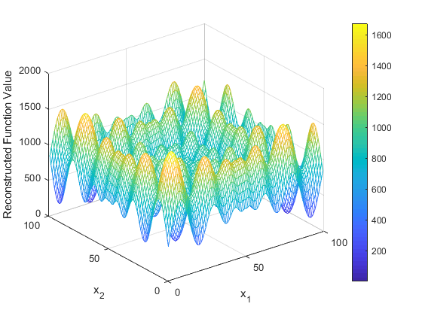

1. reconstructing error

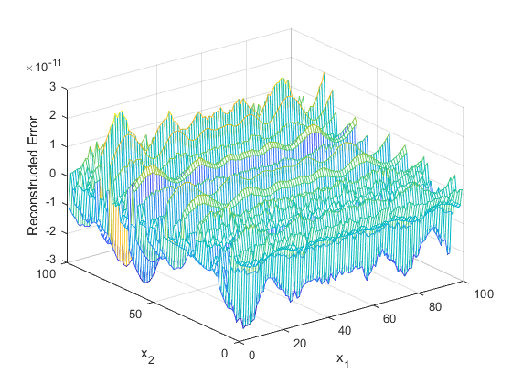

4、Other Considerations

In this folder, we also provide the source file for online rank estimation, to demonstrate how we can automatically estimate the rank value of one unknown problem space. As seen in these three demo source files ‘Online_estimation_rank_ackley.m’, ‘Online_estimation_rank_non_con_rast’, ‘Online_estimation_rank_schewfel’, which respectively give the rank estimation results of ackley、 non continuous rastrigin、schewfel function.

Specifically, our proposed rank estimation method set a singular value threshold ‘Tao’ (e.g., Tao = 1e-5) and the initial sampling length *s*1 = 3 in advance. Then, our EVOLER method reconstructs the problem space by leveraging the sampling length *s*, and calculates the singular values of this reconstructed problem space. If the accumulated energy ratio of the first *r* singular values exceeds this threshold ‘Tao’, *r* is exactly estimated as the rank value of this problem space (also see the details in SI Section I). If it is not, repeat the above steps with *s*1= *s*1+1.

Note that, the structured sampling length *s* of our EVOLER method is usually set as *s*~(*r*log(*r*)) according to our theoretical analysis in section MATERIAL & METHOD of our manuscript.