**This file provides the instruction for the related source code of the Fig. 5 in our manuscript.**

Note that, the parameter dataset of power dispatch system is available at https://alroomi.org/economic-dispatch.

User Instruction to Fig. 5

1. **Source code Running**

Our MATLAB code can be directly run on proper software, i.e., MATLAB R2019a

1. **Running time**

For the source code of our EVOLER method in the economic dispatch of power grid (3D and 6D), the running time is less than 30 sec (@ CPU 4GHz, RAM 32GB), for a single trial.

1. **Implementation guidelines**

In the following, we give the detailed implementation guidelines when reproducing Fig. 5.

* **Reproducing Fig. 5b:**

Firstly, open the MATLAB software, and open the file ‘Power_Grid_Distpacth_reproducing_Fig5’. Open the file folder ‘power_3D’, then directly run the main file ‘EVOLER_ 3D’, which outputs the optimization result of our EVOLER method for 3-dimensional power grid dispatch (saved in the data matrix ‘EVOLER_3D.mat’). At the meantime, the singular values distribution of 3-dimensional fitness is also plotted, i.e., the Fig. 5b.

* **Reproducing Fig. 5c and Fig. 5e:**

Open the MATLAB software, and also open the file folder ‘Power_Grid_Distpacth_reproducing_Fig5’ and the file folder ‘power_3D’. As seen, the source files of each evolutionary method for 3-dimensional power grid dispatch are structured into the corresponding files, i.e.,

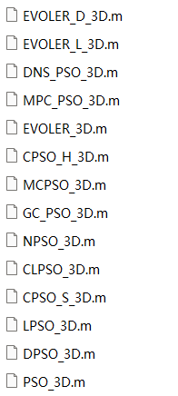

Note that, each method was running independently for 50 trials with the random initializations. Taking a classical CLPSO method for example, one can directly run the corresponding source file ‘CLPSO_3D’ on MATLAB software, which then outputs the optimization result (also saved in the data matrix ‘CLPSO_3D.mat’). And, for the other comparative methods, the similar operation can be applied.

Based on the obtained results and the produced data files, one can directly run the file ‘Plot_Fig5_ce’, which draws the average results of various evolutionary methods (i.e., the Fig. 5c), as well as the required generations for convergence (i.e., the Fig. 5e).

* **Reproducing Fig. 5d:**

Based on the obtained data files, one can run the source code file ‘Plot_Fig5_d’, which then plots the achievable minimal costs of different methods, as well as the probabilities of finding them (i.e., the Fig. 5d), in the case of 3-dimensional power grid dispatch.

For convenience, we have alternatively provided the derived data files for directly plotting the figures.

* **Reproducing Fig. 5f and Fig. 5h:**

As shown in the file folder ‘power_6D’, the source code of each evolutionary method for 6-dimensional power grid dispatch is structured into the corresponding files, i.e.,

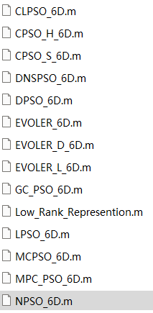

Firstly, run the source code file ‘Low_Rank_Represention’, which applies the structured random sampling to reconstruct the approximate problem space and outputs the estimated center of the attention subspace (also saved in ‘6D_result.mat’). Then, run the source code file ‘EVOLER_6D’ to obtain the result of our EVOLER method for 6-dimensional power grid dispatch (also saved in the data file ‘EVOLER_6D.mat’).

Furthermore, to obtain the result of other comparative PSO methods, one can run the remaining source code file in this folder. Also taking the classical CLPSO method for example, one may run the source code file ‘CLPSO_6D’ on MATLAB software, which outputs the corresponding 6-dimensional power grid dispatch result (saved in the data file ‘CLPSO_6D.mat’). For the other comparative methods, the similar operation can be applied.

Then, based on the above generated data files, one may directly run the file ‘Plot_Fig5_fh’, which draws the average results of various evolutionary methods (i.e., the Fig. 5f), and the required generations for convergence (i.e., the Fig. 5h), in the case of 6-dimensional power grid dispatch.

For convenience, we have alternatively provided the derived data files for directly plotting the figures.

* **Reproducing Fig. 5g:**

Also with the above data files, one can finally run the source code file ‘Plot_Fig5_g’, which draws the achievable minimal costs of different methods and the probabilities of finding them (i.e., the Fig. 5g), in the case of 6-dimensional power grid dispatch.