**This file provides a simple instruction for the related source files for the Fig. 3 in our manuscript.**

The MATLAB source code of different PSO variants and our EVOLER algorithm, as well as their running results, are structured into the corresponding folders.

User Instruction to Fig. 3

1. **Source Code Running:**

Our code can directly run on the proper software, i.e., MATLAB R2019a.

1. **Running time**

For the source code of our proposed EVOLER method on 20 benchmark functions (including: (a) Ackley function. (b) Rosenbrock function. (c) Griewank function. (d) Levy function. (e) Non-continuous Rastrigin function. (f) Rastrigin function. (g) Schwefel function. (h) Sphere function. (i) Weierstrass function. (j) Rotated Ackley function. (k) Rotated Griewank function. (l) Rotated Non-continuous Rastrigin function. (m) Rotated Rastrigin function. (n) Rotated Weierstrass function. (o) Shifted Levy function. (p) Shifted Rastrigin function. (q) Shifted Sphere function. (r) Shifted Weierstrass function. (s) Hybrid Composition Function 1. (t) Hybrid Composition Function 3.), the running time of each function is less than 2 sec (@ CPU 4GHz, RAM 32GB), for a single trial.

1. **Implementation guidelines**

In the following, we give the implementation guidelines when reproducing Fig. 3.

* **Reproducing Fig. 3a- Fig. 3t:**

One can directly run each method on each benchmark function for 500 independent trials to obtain the results in our manuscript. For convenience, we have alternatively provided the derived numerical results for directly plotting the figures. To do so, one may follow the subsequent guidelines.

Firstly, open the MATLAB platform, and then open the file folder ‘Test_Function_reproducing_Fig3’ and open the folder ‘Test_Function_2D’, the source code of these benchmark functions is structured into the corresponding folders, i.e.,

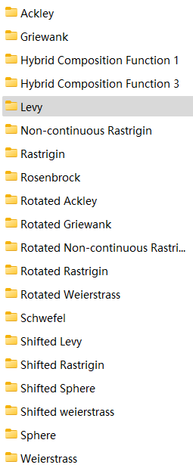

Note that, we can respectively evaluate the performance of these 20 benchmark functions, by using 11 comparative methods and our EVOLERmethods*,* EVOLER Local PSO*,* EVOLER Downhill method. Taking an Ackley function for example, one can firstly open the file folder ‘Ackley’, and then directly run the MATLAB file ‘ackley_PSO_EVOLER.m’, which outputs the fitness results of our EVOLER method for 500 independent trials and the result is also saved in the data matrix ‘Pro_data_ack.mat’’. After this, we can run the other three MATLAB file ‘ackley_compare_methods’ (11 PSO variant methods), ‘ackley_Local_PSO_EVOLER’, ‘ackley_downhill_EVOLER’, which output the average fitness curves (data is saved in Figure file ‘2D_Ackley_Fitness) as well as the probability in finding the global optimum of them (data is saved in Figure file ‘2D_Ackley_Probalility). And finally, the result of Fig. 3a can be obtained by plotting the fitness curves of different methods together.

The same operations can be applied to the case of other benchmark functions.

* **Reproducing Fig. 3u:**

By plotting together the probability in finding the global optimum of different methods in different benchmark functions, we can obtain the Radar-like figure in Fig. 3u.

* **Reproducing Fig. 3v:**

By running the MATLAB file ‘Probability_Theoretical.m’, we can obtain the theoretical low-bound probability of convergence to the global optimum and the empirical result, as seen in Fig. 3v.