**This file provides a simple instruction for the related source files for the SI Fig. E5 and Fig.4d of our manuscript.**

The MATLAB source code of different PSO variants and our EVOLER algorithm, as well as their running results, are structured into the corresponding folders.

User Instruction to SI Fig. E5 and Fig.4d

1. **Source Code Running:**

Our code can directly run on the proper software, i.e., MATLAB R2019a.

1. **Running time**

For the source code of our proposed EVOLER method on 15 30-dimensional benchmark functions (including: (a) Hybrid Composition Function 1. (b) Hybrid Composition Function 2. (c) Levy function. (d) Rastrigin function, (e) Rastrigin with noise function, (f) Rotated Griewank function, (g) Rotated Rastrigin function, (h) Schwefel function, (i) Shifted Hybrid Composition function, (j) Shifted Levy function, (k) Shifted Rastrigin function, (l) Shifted Sphere function, (m) Shifted Weierstrass function, (n) Sphere function, (o) Weierstrass function), the running time of each function is less than 10 sec (@ CPU 4GHz, RAM 32GB), for a single trial.

1. **Implementation guidelines**

In the following, we give the implementation guidelines when reproducing SI Fig. E5 and Fig.4d.

* **Reproducing SI Fig. E5 and Fig.4d:**

One can directly run each method on each benchmark function for 500 independent trials to obtain the results in our manuscript. To do so, one may follow the subsequent guidelines.

Firstly, open the MATLAB platform, and then open the file folder ‘Test_Function_reproducing_Fig3’ and open the folder ‘Test_Function_30D’, the source code of these benchmark functions is structured into the corresponding folders, i.e.,

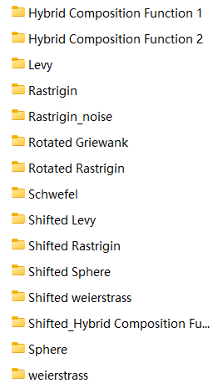

Note that, we can respectively evaluate the performance of these 15 benchmark functions, by using 11 comparative methods and our EVOLER methods, our EVOLER Local PSO method, our EVOLER Downhill method. Taking a Levy function for example, one can firstly open the file folder ‘Levy’, and then directly run the MATLAB file ‘Levy_EVOLER.m’, which outputs the fitness results of our EVOLER method for 500 independent trials and the results is also saved in the data matrix ‘Pro_data_levy.mat’’. After this, we can run the ‘levy_Local_PSO_EVOLER’, ‘levy_downhill_EVOLER’, which output the average fitness curves of our EVOLER Local PSO method and our EVOLER Downhill method. Then, we run the MATLAB file ‘levy_compare_methods’ , which output the average fitness curves 11 PSO variant methods (data is saved in Figure file ‘30D_Levy_Fitness’) as well as the probability in finding the global optimum of them (data is saved in Figure file ‘probability’). And finally, the result can be obtained by plotting the fitness curves of different methods together.

The same operations can be applied to the case of other benchmark functions.

By plotting together the probability in finding the global optimum of different methods in different benchmark functions, we can obtain the Radar-like figure in Fig. 4d.