C U R R I C U L U M V I T A E

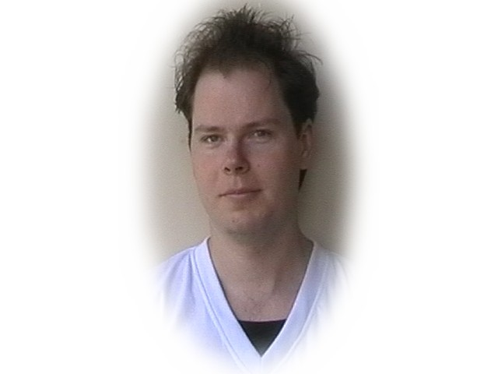
1. Name & Communication

Name: Petr
Surname: Josifek
Cell Phone: 0 (044) - 798 - 188 - 7118
BT Phone: 0 (044) - 141 - 959 - 0802
Web Page: http://www.xjosifek.travel.to
E-mail: xjosifek@yahoo.com
Address: Flat 13/4, 150 Kestrel Rd, Glasgow, G13 3PF
Marital Status: Married
D.O.B.: 31/07/1976
Place of Birth: Nove Mesto na Morave, Czech Republic
Languages: English, Czech and Russian
Full UK Work Permit: Yes
NI number: Yes
Driver’s Licence: Yes
Own car: Yes

2. Skill & Experience

Skills | Experience | Years
Programming | Visual Basic 6 | 1
Hardware | Build and repair computers, from 8086 till today | 11
Microsoft - OS | MS-DOS, WIN 3.x, WIN 95-98x, WIN Me, WIN 2000, WIN XP,Vista | 13
Others - OS | UNIX, OS/2, Mac Apple, etc. | 2
Application | Statistics, bookkeeping, database, etc. | 10
MS-Office | Word, Excel, Front Page, Power Point, etc. | 10
Multimedia | Converting, editing of movies, files, codecs, etc. | 9

3. Preferences

Preferred sector: IT Roll Out, Maintenance, Data Entry, Web Design, etc.
Type of work: Permanent, temporary, part time, contract, etc.

4. Previous Work

Position: Market Research Interviewer
Company: TNS Field Ltd, Westgate, London, W5 1UA
Duration: 29th April 2008 – 14th April 2009

Position: Staff/Supervisor
Company: Subway Restaurant, Great Western Road, G12 8HN
Duration: 29th August 2005 – 30th May 2008

5. Education

2008-2009
ESOL - English: Upper Intermediate, Anniesland College, Glasgow

2005-2006
A+ Training: Computer Technician, Anniesland College, Glasgow

2004-2005
HNC: Visual Basic, Architecture, Motherwell College

1996-1998 Informatics Degree: Faculty of Informatics (English, Unix, Algebra, Theory of Groups, Algorithums, Function Programming, Architecture, Formal Languages and Automats, O.S.s, Organization of Files,etc.), Masaryk University, Brno, Czech Rep.
Please Note - did not complete degree, left to travel around the world.

1991-1996
High School: Business (English, computers, bookkeeping, economy, management, marketing, philosophy, psychology), ISS Velke Mezirici – Czech Rep.

6. Travelling

A five year adventure in which I enjoyed many cultures and made many long-term friends. I am proud of Travelogue I made at: http://www.xjosifek.travel.to

Feb 1998 - Apr 2003 - Europe, Israel, Palestine, Egypt, United States, Turkey, Syria, Jordan, Sri Lanka, India, Pakistan, China, Japan, Thailand, Nepal, Cambodia, Laos,...
Since the 14 th of May, 2004 I am living in Scotland. I have been happily married (to a Japanese Lady). I would like to make clear that it is my intention live in U.K.

7. School experience

Position: Vice - president of Finance
Company: Busy Bee, Hgh School company - Economist
Duration: 9 months / Sep 1993 – May 1994

