PETE 4241 Project Report  2019

Coupled geomechanical reservoir simulation in Volve Field

PETE 4241 Student Group, Craft & Hawkins Department of Petroleum Engineering, Louisiana State University

Copyright 2018, Society of Petroleum Engineers

This paper was prepared for presentation at the PETE 4241 held in Baton Rouge, Louisiana, USA, 8 April 2019.

This paper was selected for presentation by an SPE program committee following review of information contained in an abstract submitted by the author(s). Contents of the paper have not been reviewed by the Society of Petroleum Engineers and are subject to correction by the author(s). The material does not necessarily reflect any position of the Society of Petroleum Engineers, its officers, or members. Electronic reproduction, distribution, or storage of any part of this paper without the written consent of the Society of Petroleum Engineers is prohibited. Permission to reproduce in print is restricted to an abstract of not more than 300 words; illustrations may not be copied. The abstract must contain conspicuous acknowledgment of SPE copyright.

Abstract

MEM provides the geomechanical information required by engineering software used for casing point selection, optimizing the number of casing strings, drilling stable wellbores, designing completions, performing fracture stimulation, and simulating reservoir production. In this project, the geomechanical properties is constructed for 9 wells from Volve field. Then these properties are populated through Kriging spatial interpolation and imported into CMG reservoir simulation model. Finally, the coupled geomechanics and flow reservoir simulation is performed. The effect of geomechanics and different numerical coupling algorithms on field production performance are investigated. Results show that geomechanics has negligible effect on field production performance on conventional reservoir production process. To incorporate even more detailed geomechanical analysis, the coupling of a reservoir simulator such as CMG with a geomechanical simulator such as ABAQUS would provide greater insights into the physics of the process.

Introduction

An MEM is a numerical representation of the geomechanical state of the reservoir, field, or basin. In addition to property distribution (e.g., density, porosity) and fracture system the model incorporates pore pressures, state of stress, and rock mechanical properties. The stresses on the reservoir are caused by the overburden weight, any superimposed tectonic forces, and by production and injection (**Fig. 1**).

MEM is fundamental to the success of geomechanics applications. It provides the geomechanical information required by engineering software used for casing point selection, optimizing the number of casing strings, drilling stable wellbores, designing completions, performing fracture stimulation, and simulating reservoir production (SLB, 2018).

One of import application of MEM is the coupled flow and rock mechanics reservoir simulation. The problem of coupled fluid flow and rock mechanics is encountered in many areas of geoscience. Changes in the pore pressure of a geological formation due to injection or removal of fluid can lead to rock deformation. Similar mechanisms are encountered in oil and gas recovery processes. (Garipov et al, 2016).

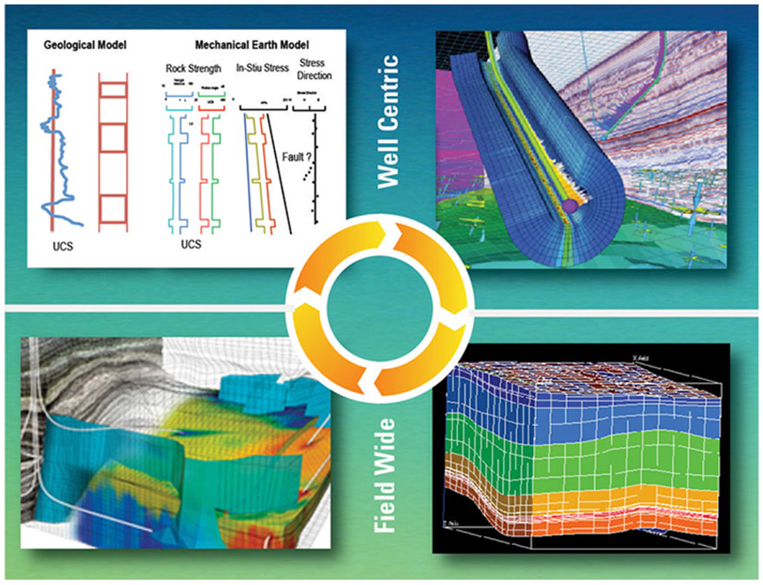

Figure 1 – Using MEMs throughout the life of a field (SLB, 2019)

In this project, the vertical stress, maximum/minimum horizontal stress, UCS, Young’s modulus and Poisson’ s ratio are constructed for 9 wells using the published log and drilling data from Volve field. Then these properties are populated through Kriging spatial interpolation and imported into CMG reservoir simulation model. Finally, the coupled geomechanics and flow reservoir simulation is performed. The effect of geomechanics and different numerical coupling algorithms on field production performance are investigated.

Description of Volve Field

The Volve field (**Fig. 2**) is a shallow water field located 200 kilometers to the West of Stavanger. It was discovered in the year 1993 and commenced production in the year 2008. Volve produced oil from sandstone of Jurassic age in the Hugin Formation (Byberg,

2016). At peak production, the Volve field produced 56,000 barrels per day and production a total of 63 million barrels in its 8 years lifetime from 2008 to 2016. The recovery percent of this field was 54%. Equinor (formerly Statoil) in 2018 together with its license partners released data to the general public for research and training purposes. Data released included high-resolution geophysical logs, subsurface measurements, various drilling and geological reports, and the reservoir model.

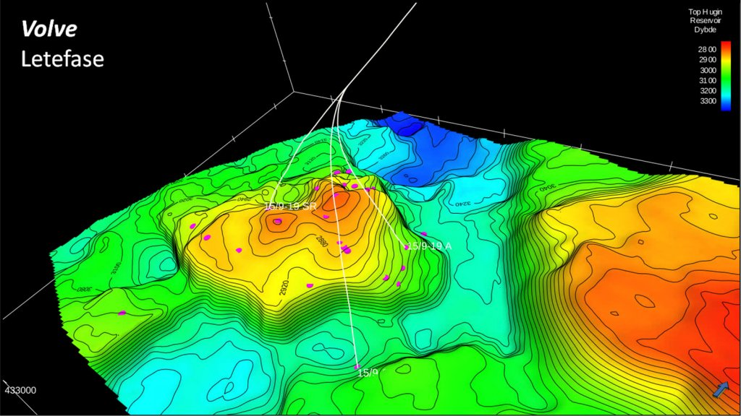 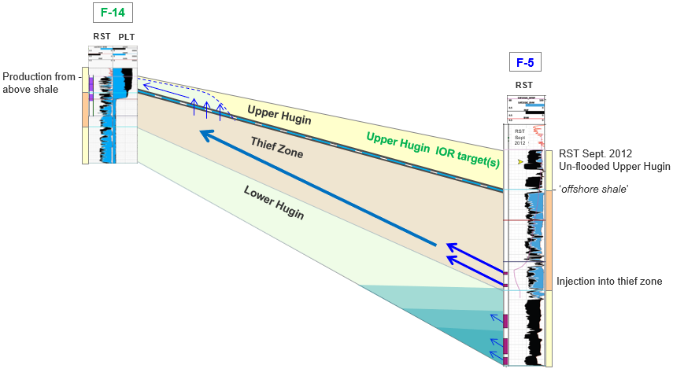

Figure 2 – 3D model and geology layer of Volve field (Equinor, 2019)

Constructing MEM for Volve field

The general MEM workflow (Fig. 3) can be summarized as follows:

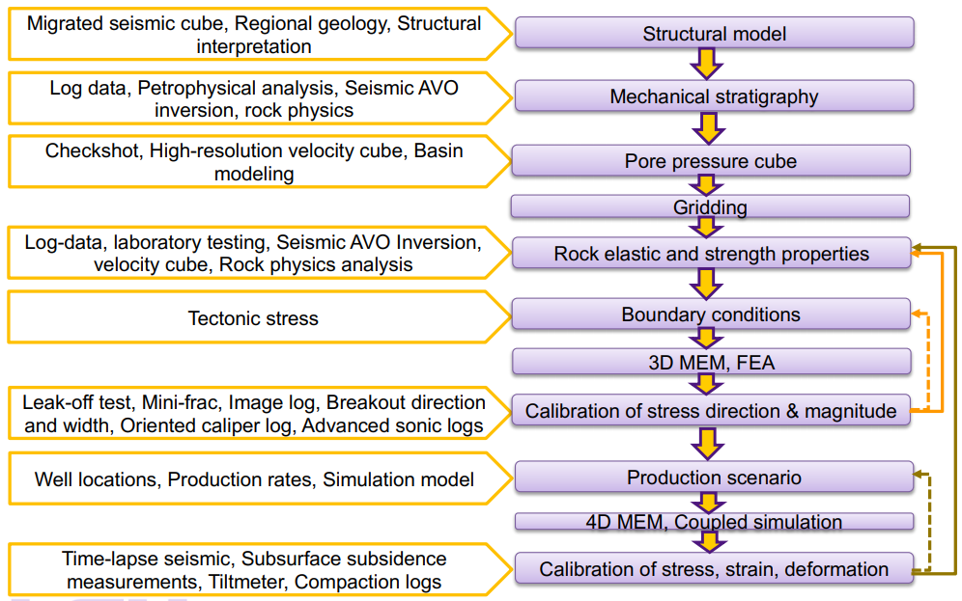

Figure 3 – MEM modeling workflow (Olorode, 2019)

One of key step in MEM is to extract the pore pressures, state of stress, and rock mechanical properties from the log data. In the Volve field, the log data of 9 wells (**Table 1**) with bulk density (RHOB), transmission wave velocity (DT, DTS), well trajectory (MD/TVD) are available to evaluate those quantities.

Table 1 – Log data of 9 wells in Volve Field (Equinor, 2019)

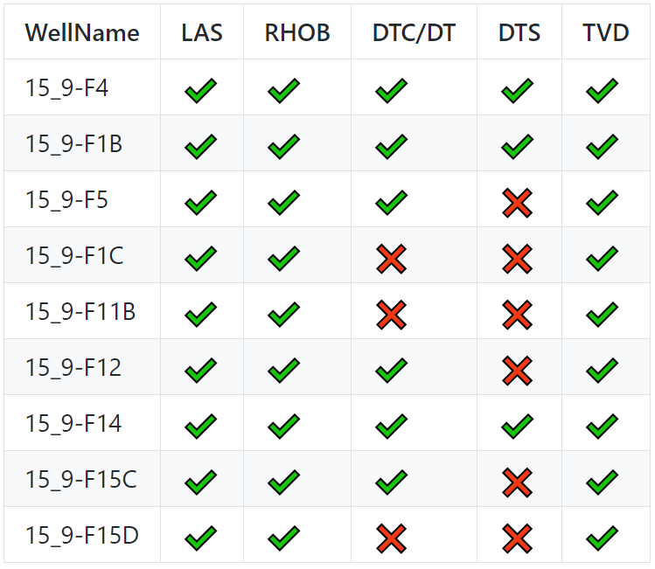

The sample plot of log data of Well 15_9-F-1 B are shown as follows (**Fig. 4**):

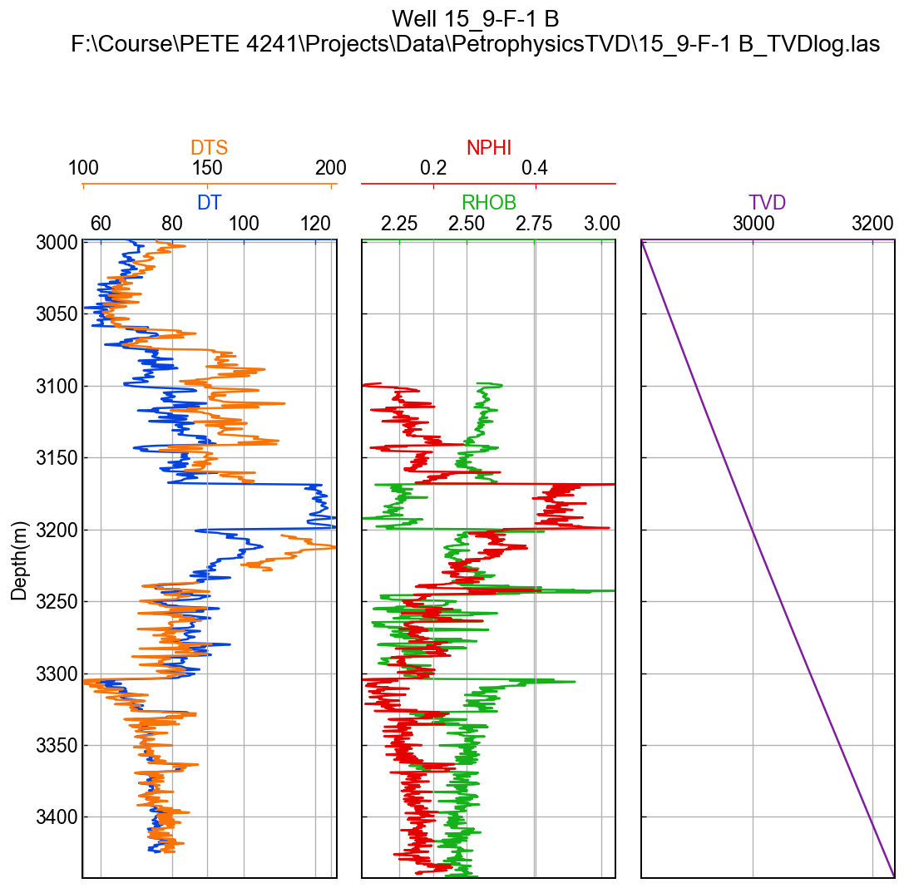

Figure 4 – Well log of Well 15_9-F-1 B

All other log figures can be found on our project repository, https://github.com /BinWang0213/PETE4241_19SP_ProjectCode

***Principal stresses:*** We have the well log data that can be used to calculate Sv using the relationship:



Lang et al. (2011) provides a relationship relating maximum horizontal stress (SHmax) and minimum horizontal stress (Shmin) with vertical stress (Sv):



where k is a constant defining the ratio of SHmax to Shmin. It ranges from 0 to 2 where k=0 represents isotropic horizontal stress system. Among limited stress regime studies available for Volve field, Sen and Ganguli (2019) use fracture gradient as the Shmin gradient and use the above relationship to calculate the SHmax gradient for four wells in the volve field. Their findings suggests that Sv>SHmax>Shmin, which means that the stress regime is normal faulting regime. Upon examination of their findings, we reach to the conclusion that the stress gradient for horizontal stresses can be roughly estimated by the relationships:



The three principle stresses are named S1, S2 and S3 for simplicity.

***Pore pressure:*** Pore pressure at different true vertical depths is calculated using the hydrostatic pressure gradient. Density of formation fluid is assumed to be 1g/cc.



***Rock porosity:*** The rock porosity (φ) is calculated from density log using the following relationship:



***Young’s modulus and Possion ration:*** Elastic properties of the rock can be calculated from Shear wave velocity (Vs) and Compressive wave velocity (Vp) logs.



***Unconfined Compressive Strength (UCS):*** The unconfined compressive strength (UCS) is calculated using the relationship for North Sea:



Based on **Eqs. 1-7**, the pore pressures, state of stress, and rock mechanical properties for each well can be calculated. A sample plot of MEM properties is shown in **Fig. 5**.

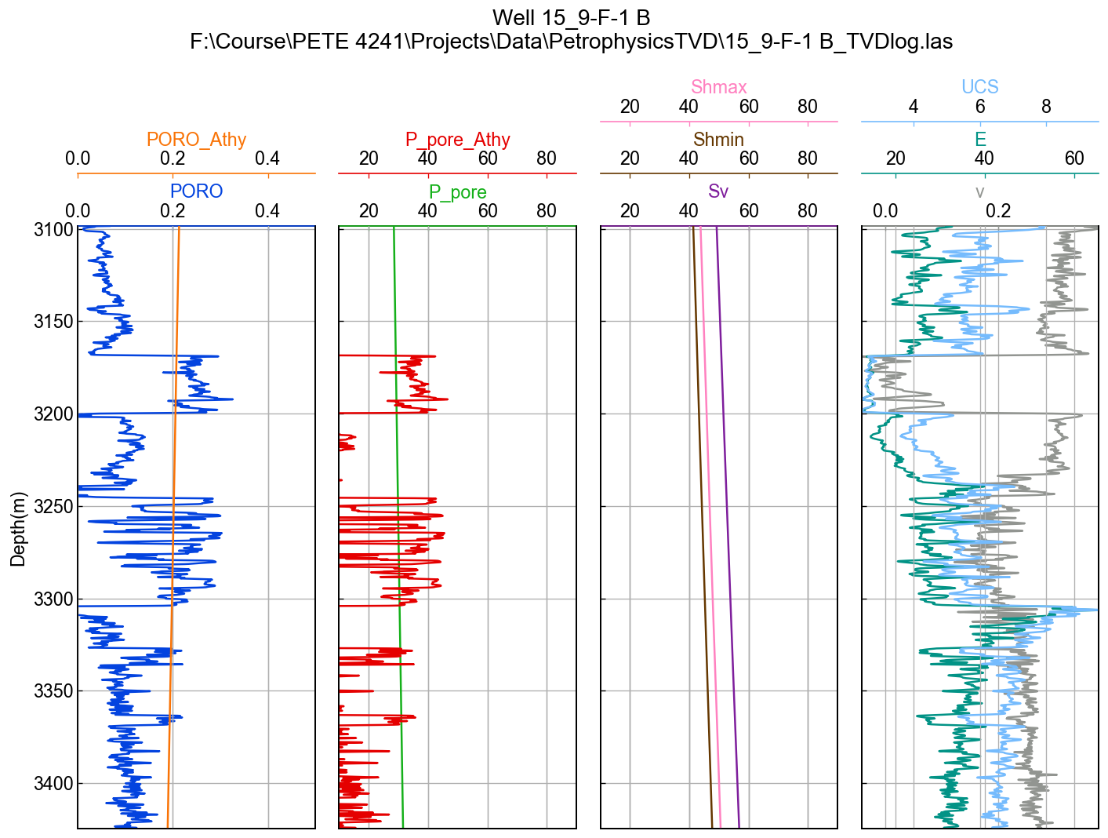

Figure 5 – Estimated MEM properties of Well 15_9-F-1 B

Once the MEM properties for each well is calculated. The MEM properties for each gridblock of 3D reservoir simulation model can be interpolated using Kriging spatial interpolation method. The sample results of vertical stress (Sv), Young’s modulus (E) and Poisson ratio for 3D model are shown as follows (**Fig. 6**):

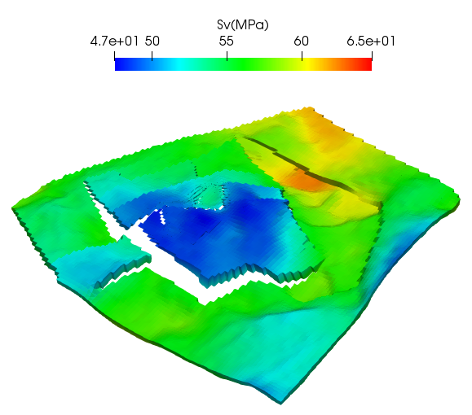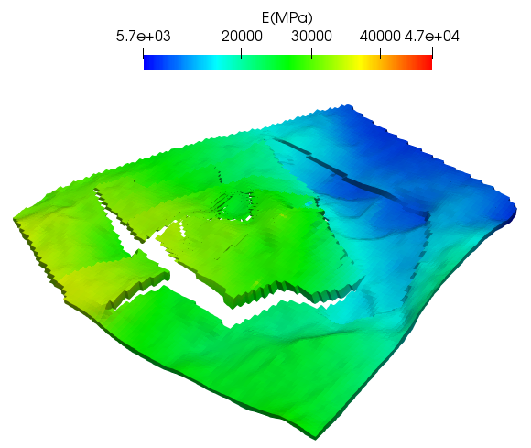

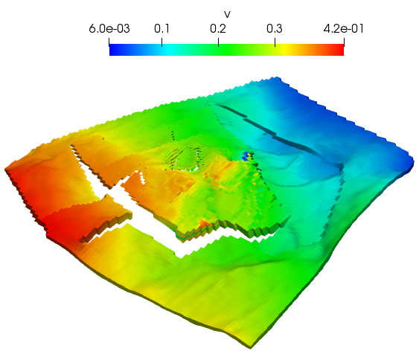

Figure 6 – Estimated MEM properties of 3D reservoir simulation model

Reservoir Simulation Model

The CMG MEM model was built using petrophysical properties derived from the well logs. To distribute these petrophysical properties through the entire model and generate a 3D MEM, the kriging algorithm was used. A cross section of the final porosity and log of permeability values is shown in Figure 7. PVT and relative permeability properties for the Volve field were same as that from the original model made public. In addition to the reservoir properties, mechanical properties were added to arrive at a fully coupled model. Mechanical properties added include Young Moduli, Poisson ratio, vertical stress distribution across the model and Biot coefficient. Though the workflow intended for this project was to populate with different mechanical properties for each grid block in line with what is expected in reality, limitations in software applications made achieving this task herculean. Therefore, single values were used in the model and are summarized

Table 2 – Mechanical Properties used in the model

|  |  |
| --- | --- |
| **Property** | **Value** |
| Young’s Modulus | 5.5e4 kPa |
| Poisson ratio | 0.3 |
| Sigma X | 52589.4 kPa |
| Sigma Y | 46804.6 kPa |
| Sigma Z | 44175.1 |
| Biot Coefficient | 0.3 |
| Yield Stress | 1e9 kPa |

A high yield stress was given in the simulation to ensure the material does not fail. All stress directions not represented in the table are taken to be zero. To ensure even faster numerical computations, the geomechanical grid used in simulations was more coarse than the flow simulation grid. While the flow simulation grid had a total of 680400 grid blocks, the geomechanical grid had a total grid of 43200 blocks. Boundary conditions at the edges and bottom of the domain were made to be fixed while the top boundary had a load boundary condition as specified by DLOADBC.

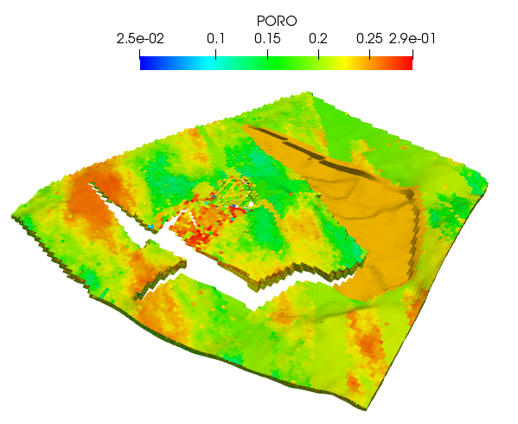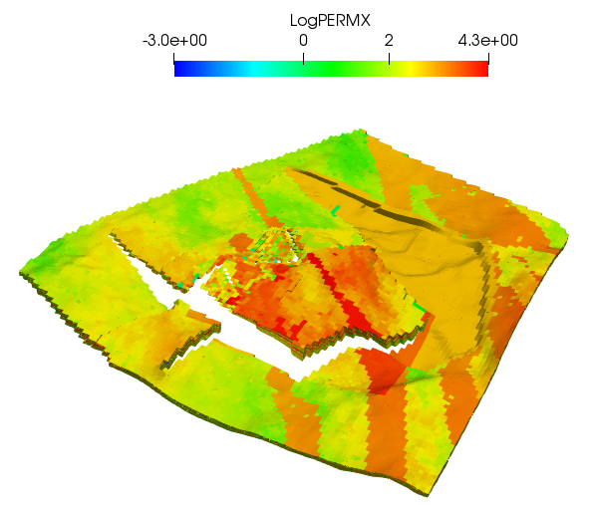

Figure 7 – Porosity and Permeability field of reservoir model for Volve field

Three different scenarios were tested in this project. In the first case, the geomechanics option was turned off and only flow simulation was run. In the second option, a one way coupling where fluid flow is simulated and the resulting parameters are transferred to the geomechanics simulation without a transfer back to the flow. A final case involved a two way coupling where fluid flow simulations are run and results serve as inputs to the geomechanics whose results are then transferred back to the fluid flow and so on.

Simulation results and discussions

***Model Verification:*** The first step in the analysis was to validate the flow only simulations carried out by the CMG software with the production profile of the Volve filed made public by Equinor. Acceptable trends for the oil production and water cut profiles can be seen in **Figs. 8-9** thus providing a solid base from which we could incorporate geomechanics.

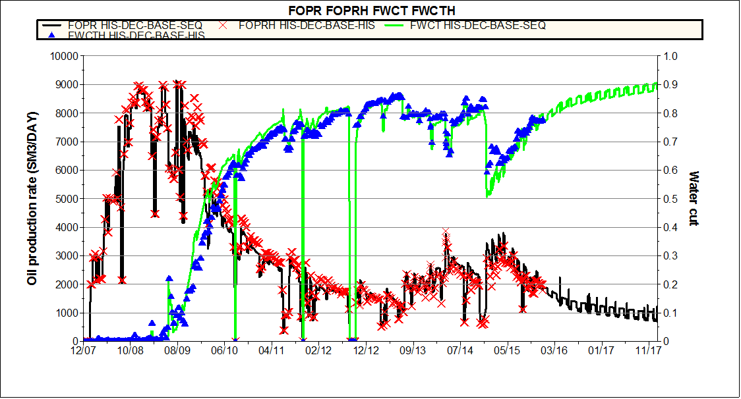

Figure 8 – Production and Water Cut profiles of the Volve field (Equinor, 2019)

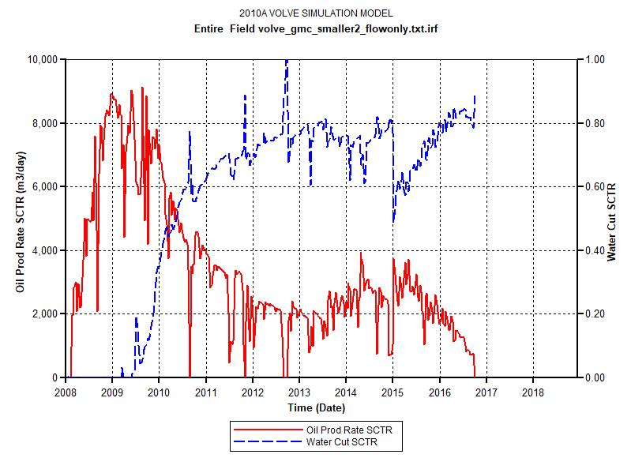

Figure 9 – Oil production and water cut profiles gotten from our CMG flow only simulations

***Effect of geomechanics:*** In this case, the effect of geomechanics and coupling algorithms (one-way and two-way coupling) on field and single well production performance is investigated. The geomechanics grid was made separate from the flow simulation. The dimensions of both grids were however made same with the only change being in the flow part. **Fig. 10-13** showsthe oil production rate, cumulative oil production and cumulative water production between flow only simulation, one-way geomechanics coupling and two-way geomechanics coupling. To visualize the differences better, the plots were zoomed in as shown in Fig. 11.

Result shows a slightly reduction in the production performance when geomechanics is fully coupled to the flow simulation. One-way couplings however do not show any changes as would be expected.

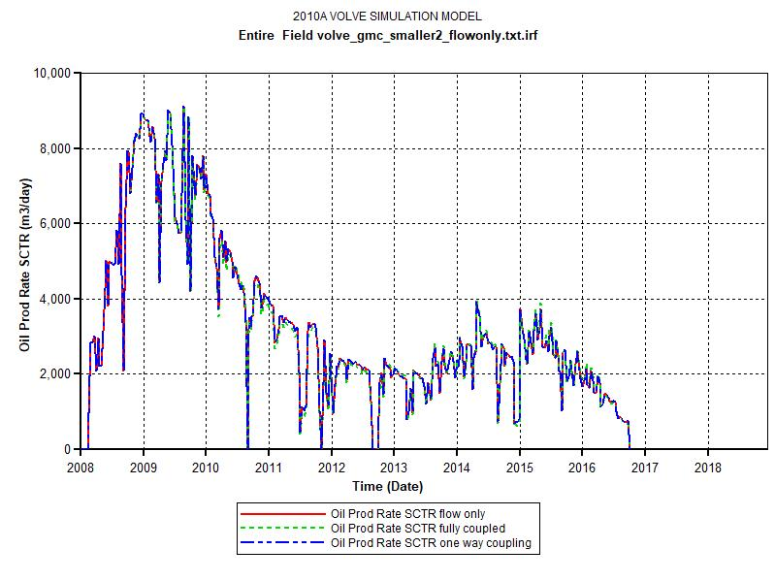

Figure 10 – Oil production profiles gotten from CMG for flow only, one-way coupling and two-way coupling algorithms

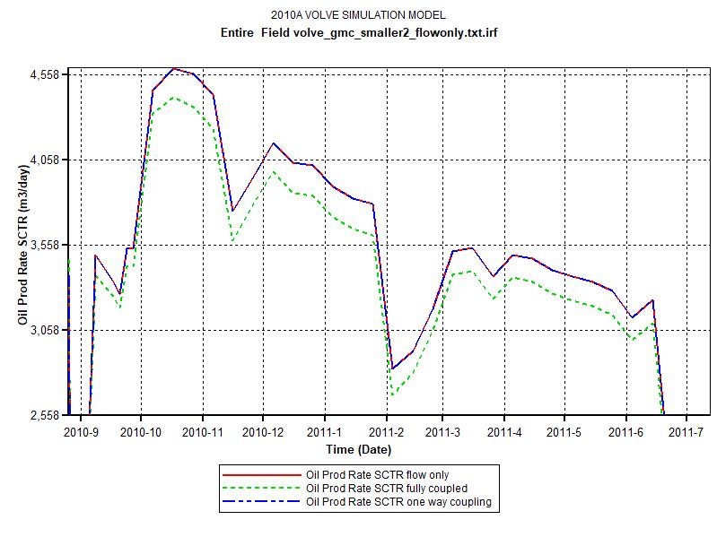

Figure 11 – Zoomed in oil production profiles gotten from CMG for the different scenarios

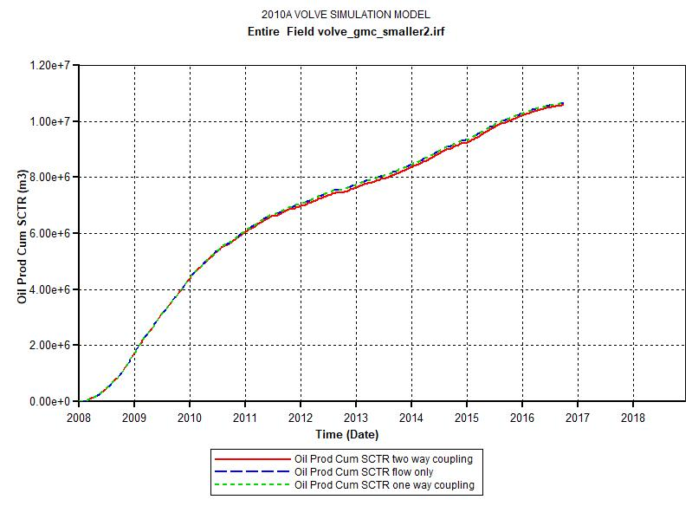

Figure 12 – Cumulative field oil production profiles gotten from CMG for flow only, one-way coupling and two-way coupling algorithms

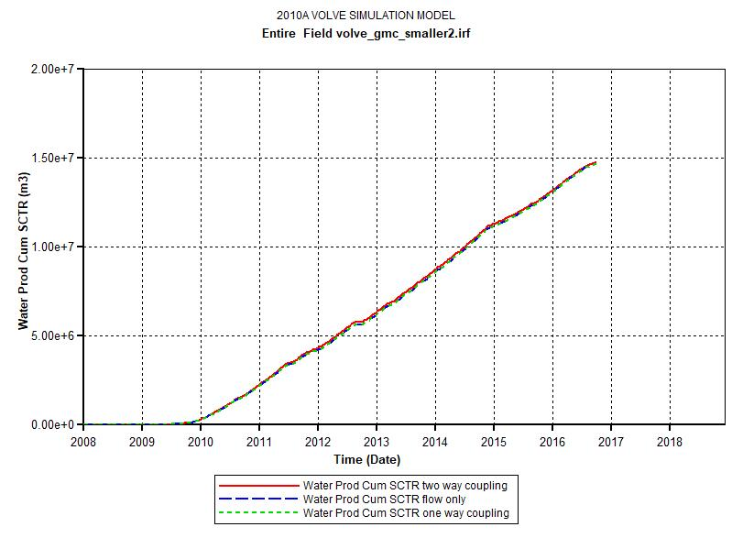

Figure 13 – Cumulative field oil production profiles gotten from CMG for flow only, one-way coupling and two-way coupling algorithms

**Fig 14-15** shows the effect of geomechanics on field performance for a single well of P-F-15C. Results show that the higher BHP observed due to compaction effect of reducing permeability and porosity. The negligible effect of oil production is also observed.

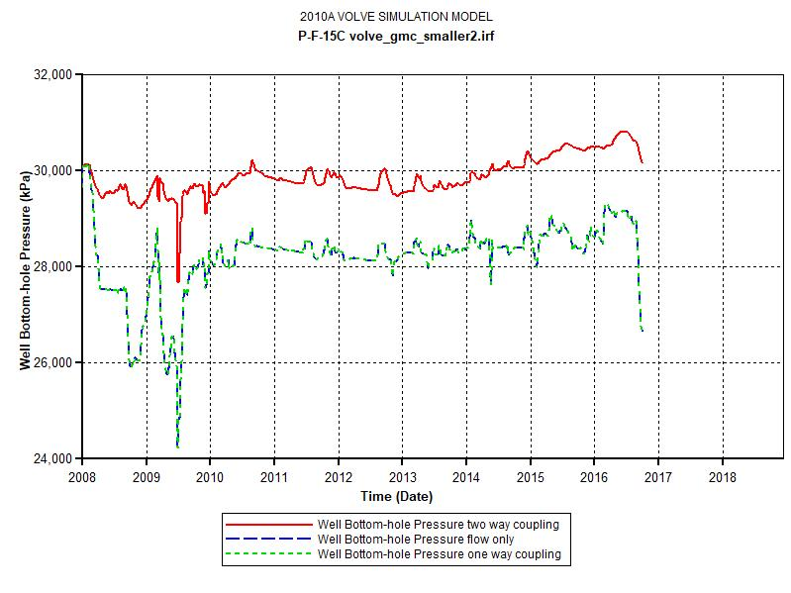

Figure 14 –Oil production profiles for P-F-15C using CMG for flow only, one-way coupling and two-way coupling algorithms

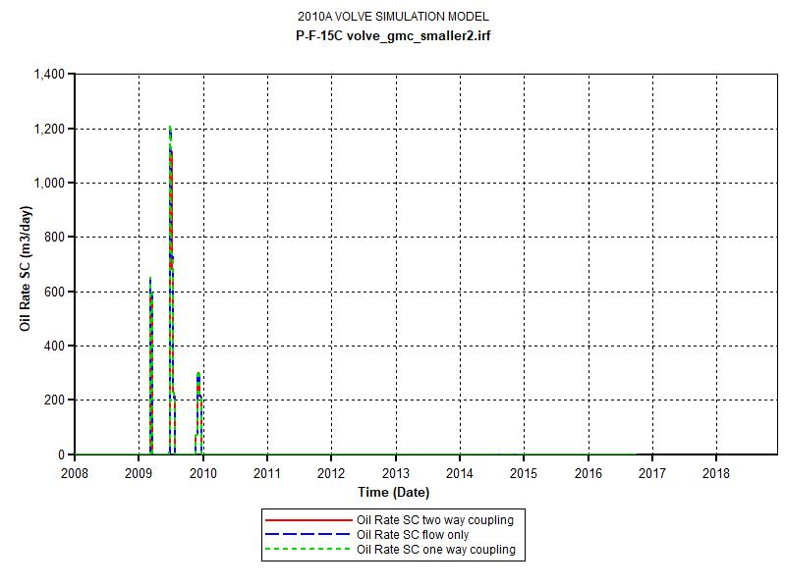

Figure 15 –Oil production profiles for P-F-15C using CMG for flow only, one-way coupling and two-way coupling algorithms

Due to separate grid being used for the geomechanical gird, the effect of geomechanics on the porosity and permeability was difficult to implement. However, the subsidence profile for the geomechanics was analyzed and is shown in **Figs 16-17**. The displacement along the Y direction is also shown in **Figs 18-19** at early and late times in the simulation.

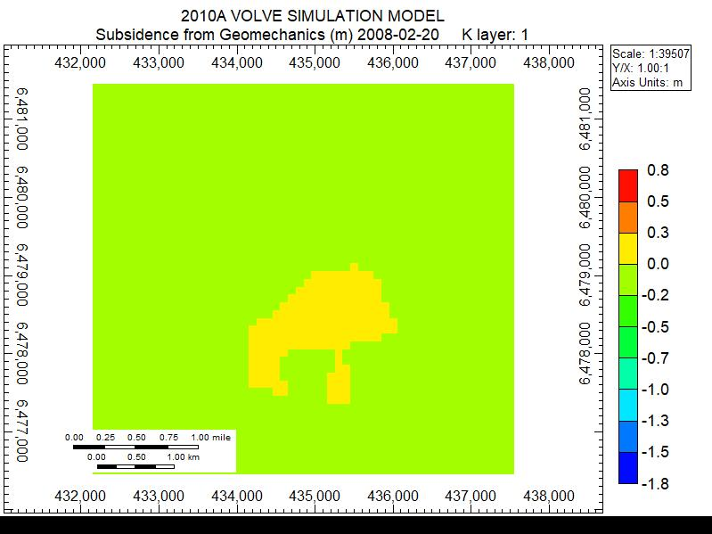

Figure 16 – Subsidence displacement profile from the geomechanical calculations at the beginning of the simulation

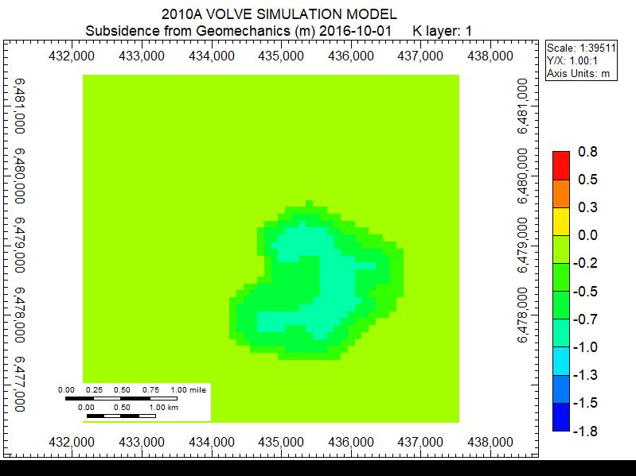

Figure 17 – Subsidence displacement profile from the geomechanical calculations at the end of the simulation

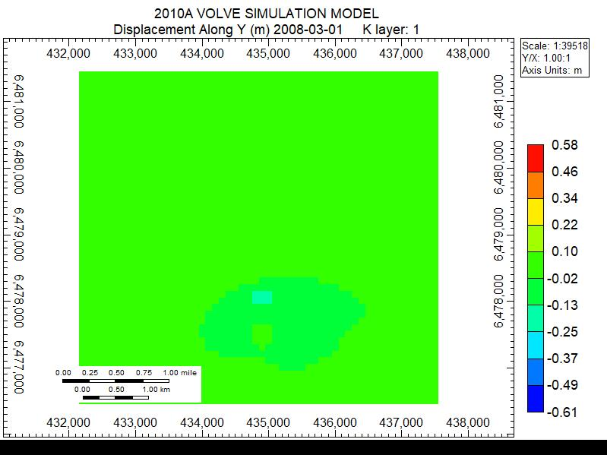

Figure 18 – Displacement along Y contour plot from the geomechanical calculations at the end of the simulation

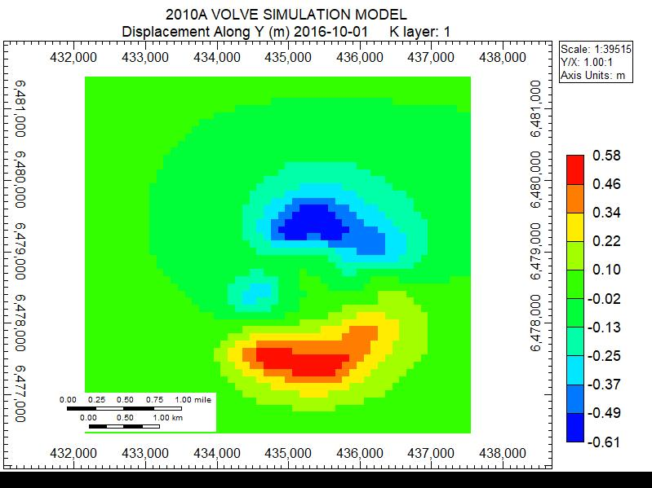

Figure 19 – Displacement along Y contour plot from the geomechanical calculations at the end of the simulation

Conclusion

Based on the numerical modelling procedures, the production profiles for the Volve field in Norway has been analyzed. To achieve this, geomechanical and petrophysical parameters were derived from the well logs and populated through the model using the Kriging algorithm. Three scenarios were tested involving the degree of coupling between the flow and the geomechanics; one with no coupling, another with one way coupling and a third with two way coupling. The following conclusions can be drawn accordingly:

* Development of a MEM model has an important role to play in analysis of flow from reservoirs.
* Moving forward, a more detailed analysis involving variations of mechanical properties in each grid block
* To incorporate even more detailed geomechanical analysis, the coupling of a reservoir simulator such as CMG with a geomechanical simulator such as ABAQUS would provide greater insights into the physics of the process

References

Garipov, T.T., Karimi-Fard, M. and Tchelepi, H.A., 2016. Discrete fracture model for coupled flow and geomechanics. Computational Geosciences, 20(1), pp.149-160.

SLB, 2019. https://www.slb.com/services/technical_challenges/geomechanics/mechanical_earth_mo del_defined.aspx

Equinor, 2019. https://www.equinor.com/en/news/14jun2018-disclosing-volve-data.html

Sleipner Øst and Volve Model Hugin and Skagerrak Formation Petrophysical Evaluation, 2006

Kalani, M., 2018. Multiscale seal characterization in the North Sea Implications from clay sedimentology, well logs interpretation and seismic analyses

Karstens, J., 2015. Focused fluid conduits in the Southern Viking Graben and their implications for the Sleipner CO2 storage project (Doctoral dissertation, Christian-Albrechts-Universität)

Appendix Intro of PyLasMech Library

In this project, we perform a geomechanical analysis of the Volve field. To begin with, as we had access to only the CMG software, the reservoir model of the Volve field was converted from Eclipse file format to CMG file format. The reservoir model was able to provide us with the geology of the Volve field, the grid block location of the wells and the grid block numbering convention used in the software used. To populate the grid block with reservoir properties, well log files from the Volve dataset were used. An efficient Python code was written to interpret the dataset. The interpretation process is summarized below

a) A GitHub repository was created to facilitate easy collaboration amongst members of the group.

b) To enable quick reproducible interpretation of the logs, a Python library was created. The Python library was named PyLasMech.

c) The PyLasMech library made use of existing python libraries such as Numpy for numerical computations, sys for system manipulations, os for operating system manipulations, lasio for .las file operations.

d) The Python library contained the script files IO.py, plot,py, and utils.py.

e) The IO.py contained a class Params with methods for getting index of a curve, getting common non-nan index from a list of curves among others

f) The IO.py script also contained methods for searching for files, reading, creating, saving and printing las files among other methods

g) The plot.py mainly contained methods for plotting log data .

h) The utils.py contained methods for performing other utilities which would assist in making calculations and plots. Amongst the methods in this script include stress polygon plotting, line intersection calculations, moving averages among others.

After completion of the PyLasMech library, the library was used in the calculation of geomechanical parameters (S1, S2, S3, E, v, UCS, PP) and quality checked by other members of the group to ensure accuracy and applied to all well logs.