PETE 4241 Project Report  2019

Coupled geomechanical reservoir simulation in Volve Field

PETE 4241 Student Group, Craft & Hawkins Department of Petroleum Engineering, Louisiana State University

Copyright 2018, Society of Petroleum Engineers

This paper was prepared for presentation at the PETE 4241 held in Baton Rouge, Louisiana, USA, 8 April 2019.

This paper was selected for presentation by an SPE program committee following review of information contained in an abstract submitted by the author(s). Contents of the paper have not been reviewed by the Society of Petroleum Engineers and are subject to correction by the author(s). The material does not necessarily reflect any position of the Society of Petroleum Engineers, its officers, or members. Electronic reproduction, distribution, or storage of any part of this paper without the written consent of the Society of Petroleum Engineers is prohibited. Permission to reproduce in print is restricted to an abstract of not more than 300 words; illustrations may not be copied. The abstract must contain conspicuous acknowledgment of SPE copyright.

Abstract

MEM provides the geomechanical information required by engineering software used for casing point selection, optimizing the number of casing strings, drilling stable wellbores, designing completions, performing fracture stimulation, and simulating reservoir production. In this project,

Introduction

An MEM is a numerical representation of the geomechanical state of the reservoir, field, or basin. In addition to property distribution (e.g., density, porosity) and fracture system the model incorporates pore pressures, state of stress, and rock mechanical properties. The stresses on the reservoir are caused by the overburden weight, any superimposed tectonic forces, and by production and injection (**Fig. 1**).

MEM is fundamental to the success of geomechanics applications. It provides the geomechanical information required by engineering software used for casing point selection, optimizing the number of casing strings, drilling stable wellbores, designing completions, performing fracture stimulation, and simulating reservoir production (SLB, 2018).

One of import application of MEM is the coupled flow and rock mechanics reservoir simulation. The problem of coupled fluid flow and rock mechanics is encountered in many areas of geoscience. Changes in the pore pressure of a geological formation due to injection or removal of fluid can lead to rock deformation. Similar mechanisms are encountered in oil and gas recovery processes. (Garipov et al, 2016).

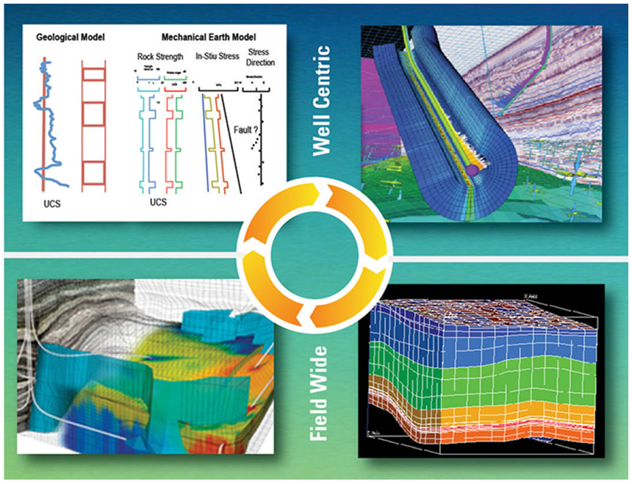

Figure 1 – Using MEMs throughout the life of a field (SLB, 2019)

In this paper, we present a generic …

Description of Volve Field

The Volve field (**Fig. 2**) is a shallow water field located 200 kilometers to the West of Stavanger. It was discovered in the year 1993 and commenced production in the year 2008. At peak production, the Volve field produced 56,000 barrels per day and production a total of 63 million barrels in its 8 year lifetime from 2008 to 2016. The recovery percent of this field was 54%. Equinor (formerly Statoil) in 2018 together with its license partners released data to the general public for research and training purposes. Data released included high-resolution geophysical logs, subsurface measurements, various drilling and geological reports, and the reservoir model.

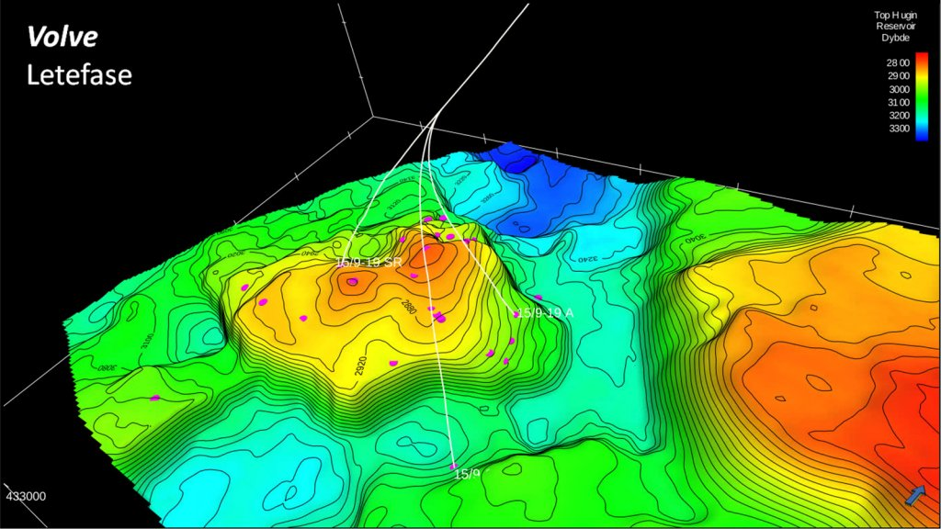

Figure 2 – 3D model of Volve field (Equinor, 2019)

Volve is a field in the central part of the North Sea, 5 km north of the Sleipner Øst field.

Volve produced oil from sandstone of Jurassic age in the Hugin Formation (Byberg,

2016)

[TODO] More geology and stratigraphy description

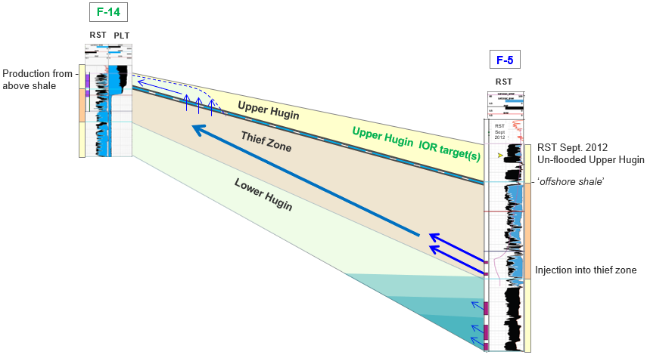

Constructing MEM for Volve field

The general MEM workflow (Fig. 3) can be summarized as follows:

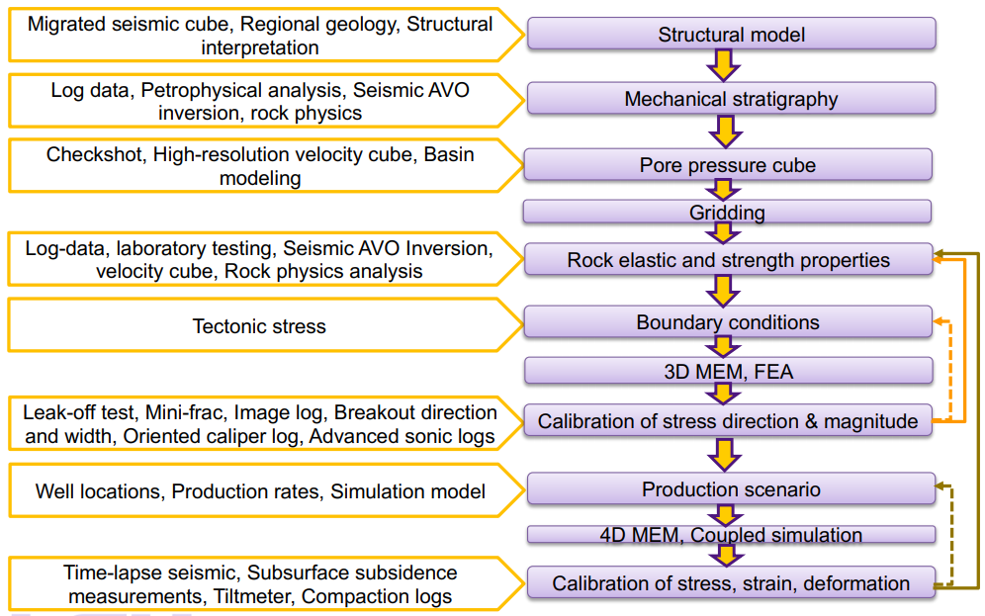

Figure 3 – MEM modeling workflow (Olorode, 2019)

One of key step in MEM is to extract the pore pressures, state of stress, and rock mechanical properties from the log data. In the Volve field, the log data of 9 wells (**Table 1**) with bulk density (RHOB), transmission wave velocity (DT, DTS), well trajectory (MD/TVD) are available to evaluate those quantities.

Table 1 – Log data of 9 wells in Volve Field (Equinor, 2019)

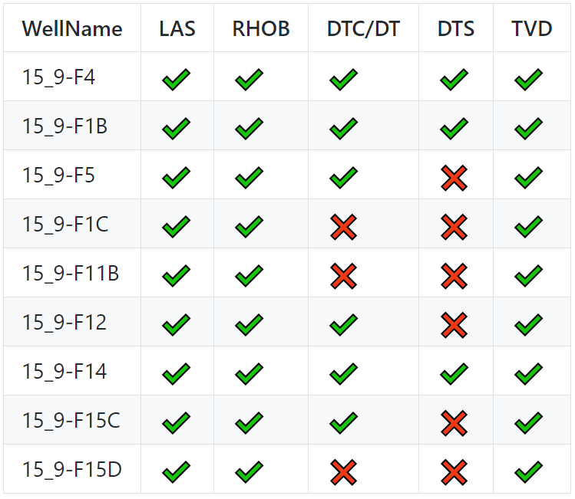

The sample plot of log data of Well 15_9-F-1 B are shown as follows (**Fig. 4**):

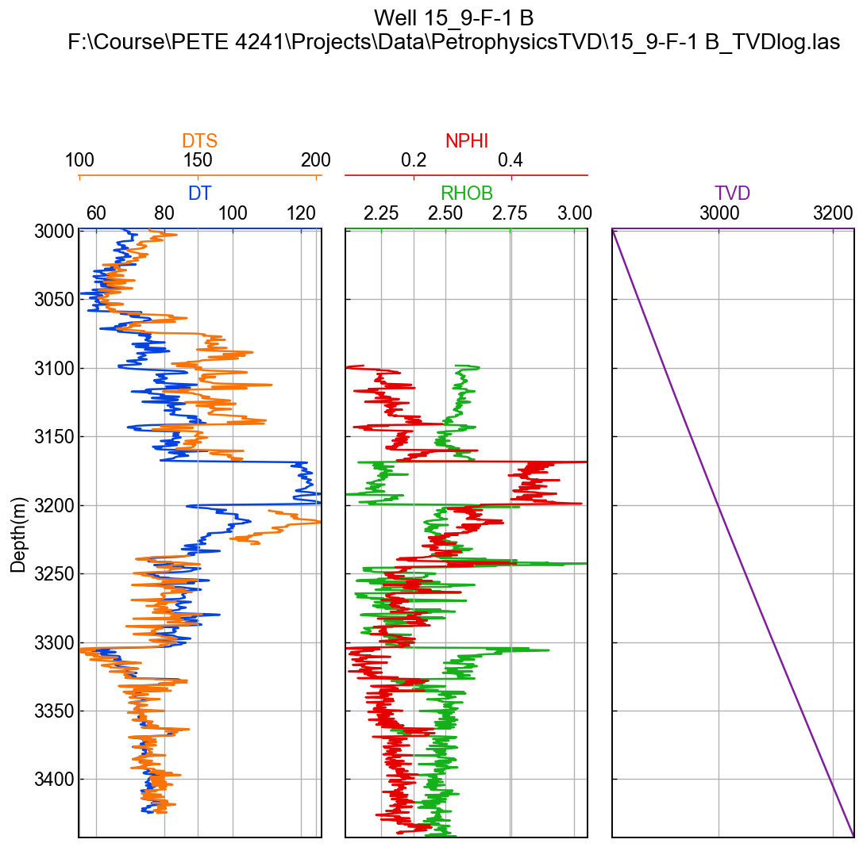

Figure 4 – Well log of Well 15_9-F-1 B

All other log figures can be found on our project repository, https://github.com /BinWang0213/PETE4241_19SP_ProjectCode

***Principal stresses:*** We have the well log data that can be used to calculate Sv using the relationship:



Lang et al. (2011) provides a relationship relating maximum horizontal stress (SHmax) and minimum horizontal stress (Shmin) with vertical stress (Sv):



where k is a constant defining the ratio of SHmax to Shmin. It ranges from 0 to 2 where k=0 represents isotropic horizontal stress system. Among limited stress regime studies available for Volve field, Sen and Ganguli (2019) use fracture gradient as the Shmin gradient and use the above relationship to calculate the SHmax gradient for four wells in the volve field. Their findings suggests that Sv>SHmax>Shmin, which means that the stress regime is normal faulting regime. Upon examination of their findings, we reach to the conclusion that the stress gradient for horizontal stresses can be roughly estimated by the relationships:



The three principle stresses are named S1, S2 and S3 for simplicity.

***Pore pressure:*** Pore pressure at different true vertical depths is calculated using the hydrostatic pressure gradient. Density of formation fluid is assumed to be 1g/cc.



***Rock porosity:*** The rock porosity (φ) is calculated from density log using the following relationship:



***Young’s modulus and Possion ration:*** Elastic properties of the rock can be calculated from Shear wave velocity (Vs) and Compressive wave velocity (Vp) logs.



***Unconfined Compressive Strength (UCS):*** The unconfined compressive strength (UCS) is calculated using the relationship for North Sea:



Based on **Eqs. 1-7**, the pore pressures, state of stress, and rock mechanical properties for each well can be calculated. A sample plot of MEM properties is shown in **Fig. 5**.

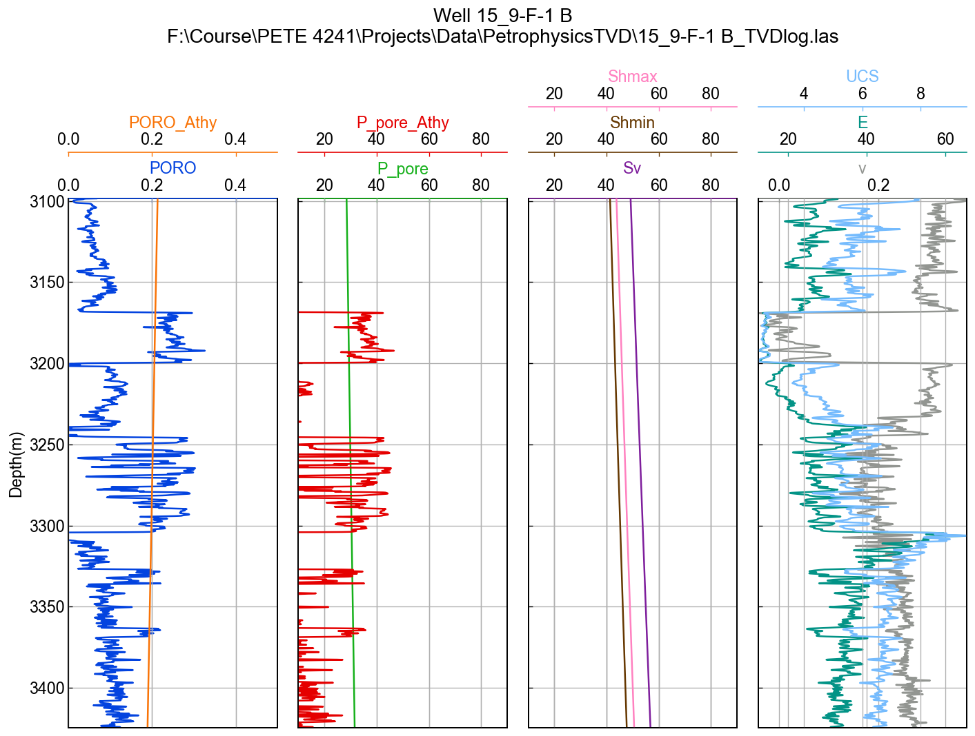

Figure 5 – Estimated MEM properties of Well 15_9-F-1 B

Once the MEM properties for each well is calculated. The MEM properties for each gridblock of 3D reservoir simulation model can be interpolated using Kriging spatial interpolation method. The sample results of vertical stress (Sv), Young’s modulus (E) and Poisson ratio for 3D model are shown as follows (**Fig. 6**):

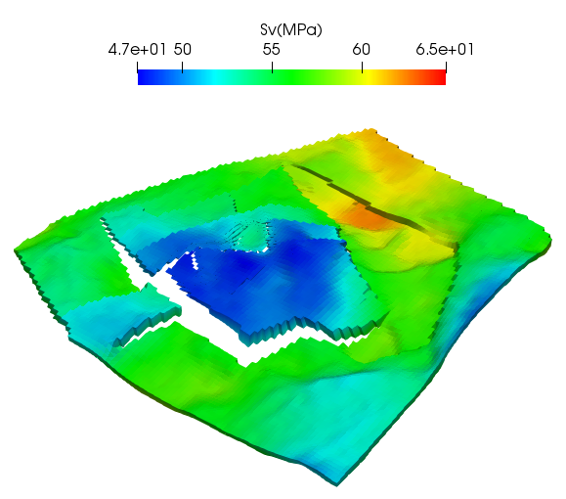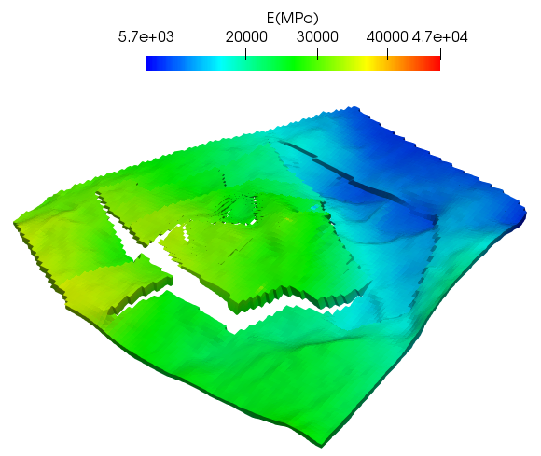

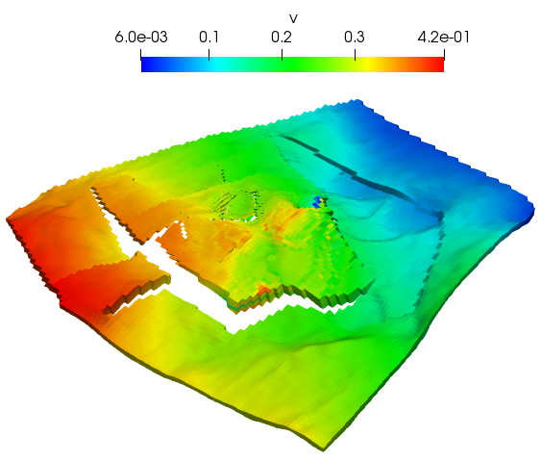

Figure 6 – Estimated MEM properties of 3D reservoir simulation model

Reservoir Simulation Model

The CMG MEM model was built using petrophysical properties derived from the well logs. To distribute these petrophysical properties through the entire model and generate a 3D MEM, the kriging algorithm was used. A cross section of the final porosity and log of permeability values is shown in Figure 7. PVT and relative permeability properties for the Volve field were same as that from the original model made public. In addition to the reservoir properties, mechanical properties were added to arrive at a fully coupled model. Mechanical properties added include Young Moduli, Poisson ratio, vertical stress distribution across the model and Biot coefficient. Though the workflow intended for this project was to populate with different mechanical properties for each grid block in line with what is expected in reality, limitations in software applications made achieving this task herculean. Therefore, single values were used in the model and are summarized

|  |  |
| --- | --- |
| **Property** | **Value** |
| Young’s Modulus | 5.5e4 kPa |
| Poisson ratio | 0.3 |
| Sigma X | 52589.4 kPa |
| Sigma Y | 46804.6 kPa |
| Sigma Z | 44175.1 |
| Biot Coefficient | 0.3 |
| Yield Stress | 1e9 kPa |

Table 1: Mechanical Properties used in the model

A high yield stress was given in the simulation to ensure the material does not fail. All stress directions not represented in the table are taken to be zero. To ensure even faster numerical computations, the geomechanical grid used in simulations was more coarse than the flow simulation grid. While the flow simulation grid had a total of 680400 grid blocks, the geomechanical grid had a total grid of 43200 blocks. Boundary conditions at the edges and bottom of the domain were made to be fixed while the top boundary had a load boundary condition as specified by DLOADBC.

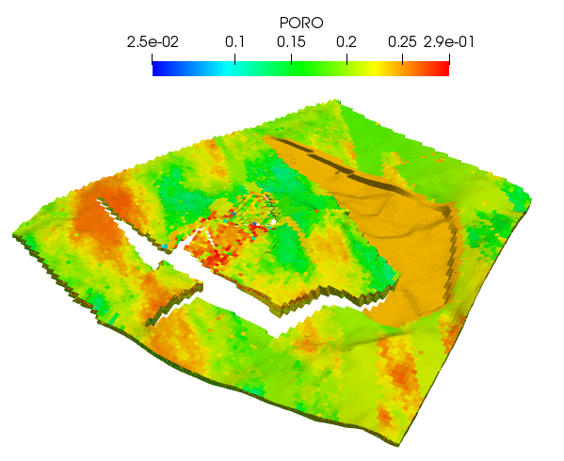 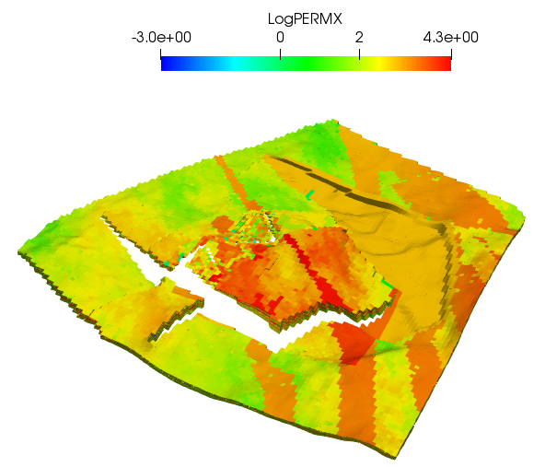

Figure 7 – Porosity and Permeability field of reservoir model for Volve field

Three different scenarios were tested in this project. In the first case, the geomechanics option was turned off and only flow simulation was run. In the second option, a one way coupling where fluid flow is simulated and the resulting parameters are transferred to the geomechanics simulation without a transfer back to the flow. A final case involved a two way coupling where fluid flow simulations are run and results serve as inputs to the geomechanics whose results are then transferred back to the fluid flow and so on.

Simulation results and discussions

The first step in the analysis was to validate the flow only simulations carried out by the CMG software with the production profile of the Volve filed made public by Equinor. Acceptable trends for the oil production and water cut profiles can be seen in Figures 8 and 9 thus providing a solid base from which we could incorporate geomechanics.

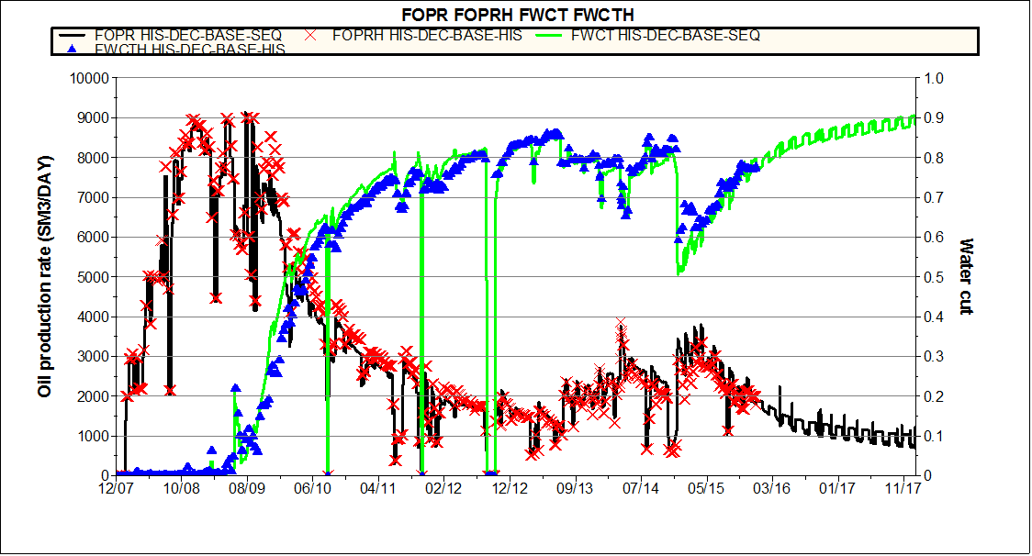

Figure 8 – Production and Water Cut profiles of the Volve field made public

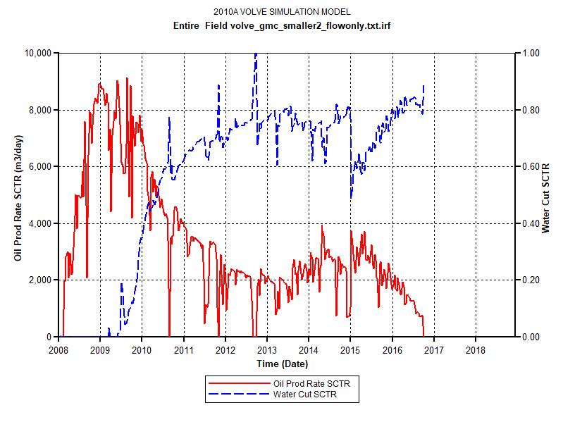

Figure 9 – Oil production and water cut profiles gotten from our CMG flow only simulations

As discussed earlier, the geomechanics grid was made separate from the flow simulation. The dimensions of both grid was however made same with the only change being in the flow part. Results for the different coupling procedures are shown in Figure 10. To visualize the differences better, the plots were zoomed in as shown in Figure 11

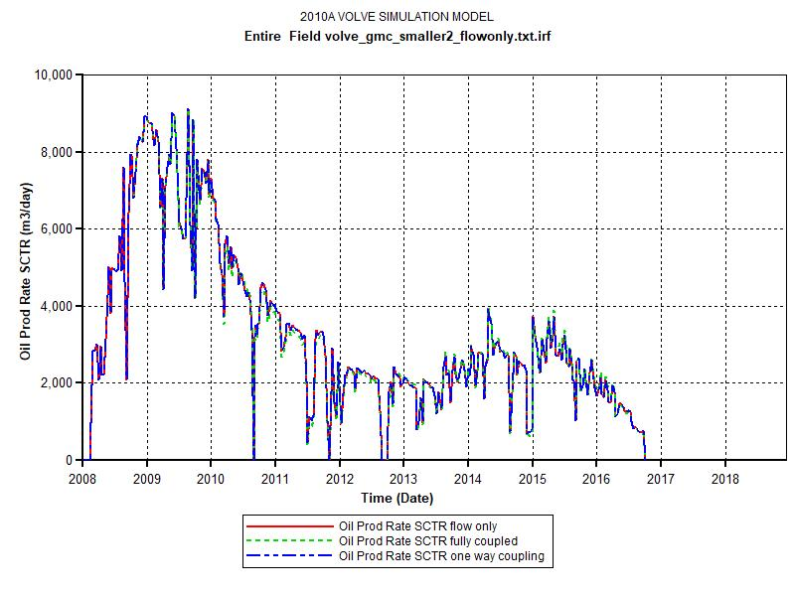

Figure 10 – Oil production profiles gotten from CMG for the different scenarios

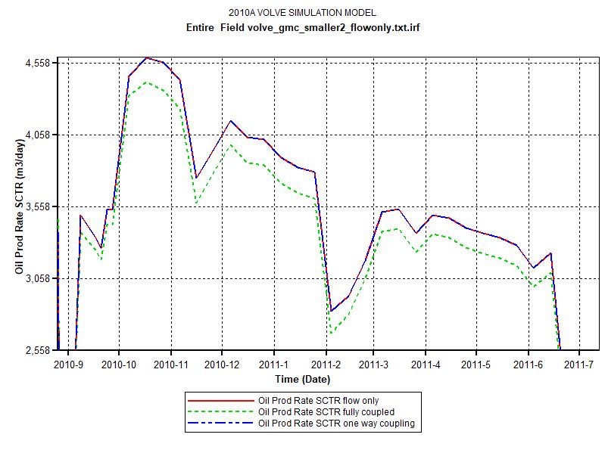

Figure 11 – Zoomed in oil production profiles gotten from CMG for the different scenarios

Results from figure 11 show a slight reduction in the production performance when geomechanics is fully coupled to the flow simulation. One way couplings however do not show any changes as would be expected.

Due to separate grid being used for the geomechanical gird, the effect of geomechanics on the porosity and permeability was difficult to implement. However the subsidence profile for the geomechanics was analyzed and is shown in Figure 11 and 12. The displacement along the Y direction is also shown in Figures 13 and 14 at early and late times in the simulation.

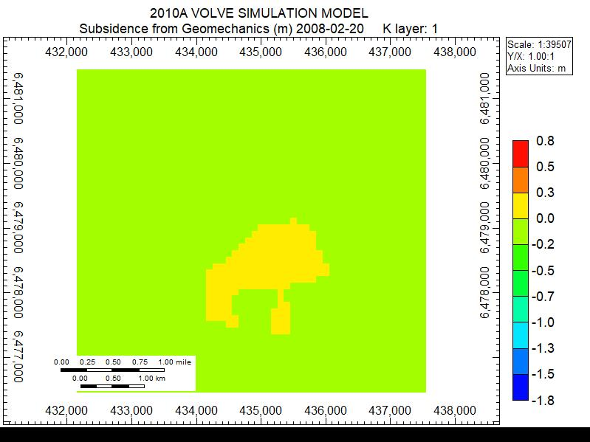

Figure 11 – Subsidence displacement profile from the geomechanical calculations at the beginning of the simulation

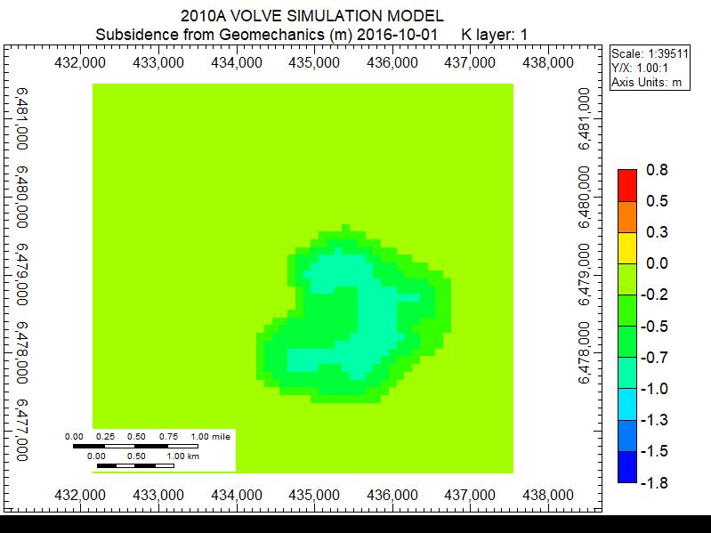

Figure 12 – Subsidence displacement profile from the geomechanical calculations at the end of the simulation

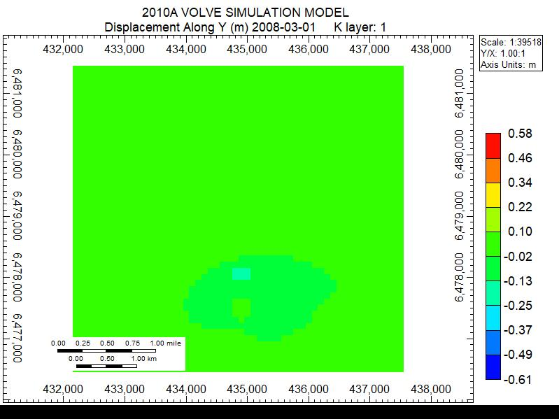

Figure 13 – Displacement along Y contour plot from the geomechanical calculations at the end of the simulation

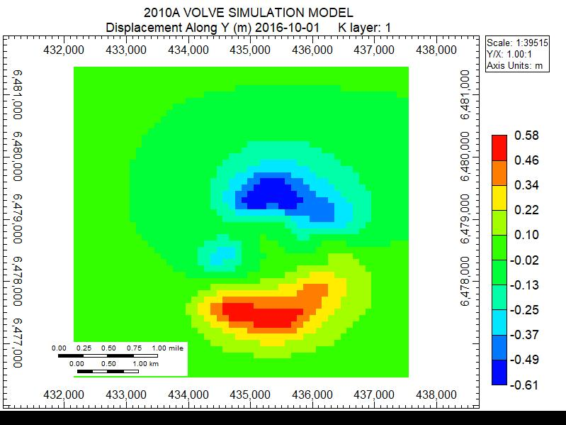

Figure 14 – Displacement along Y contour plot from the geomechanical calculations at the end of the simulation

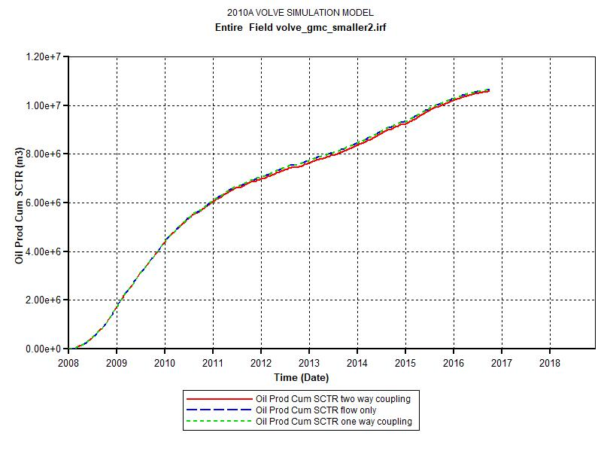

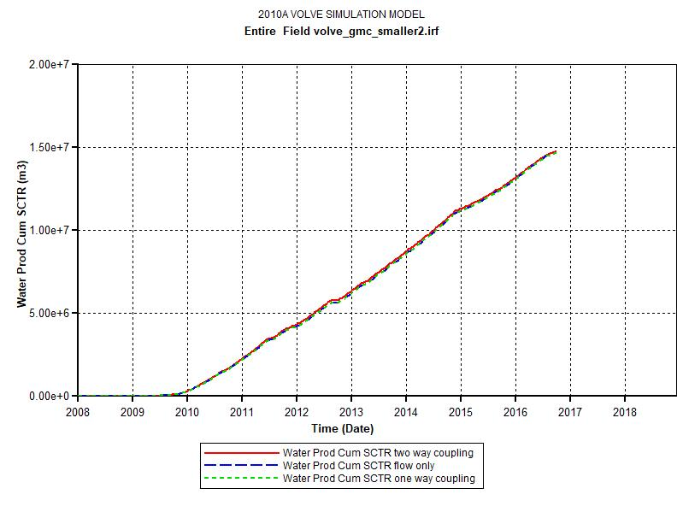

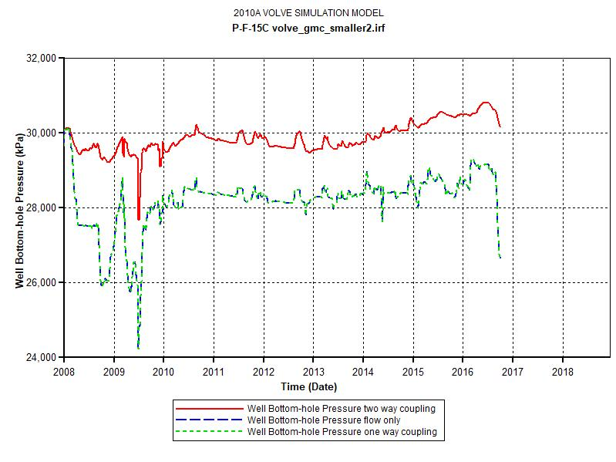

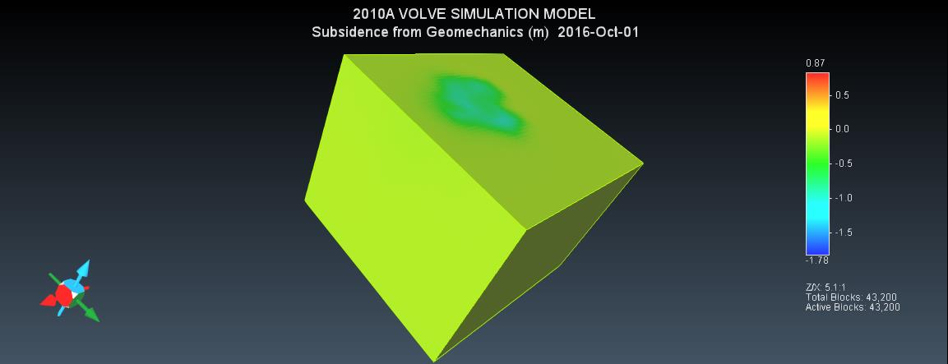

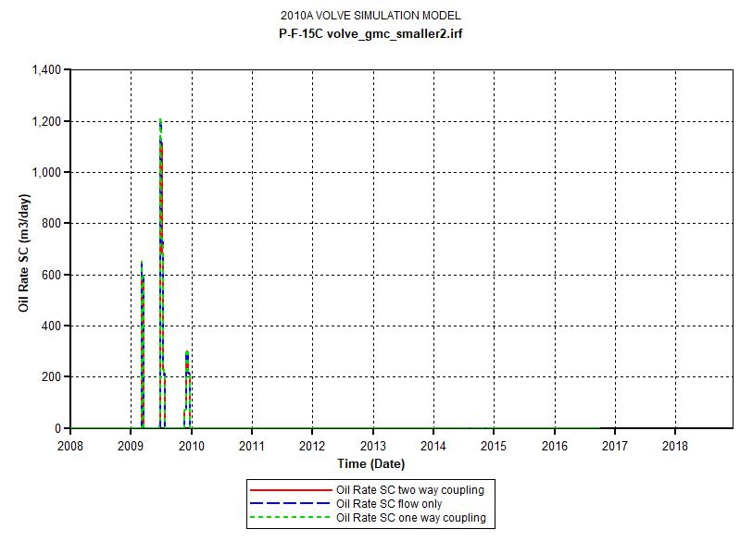

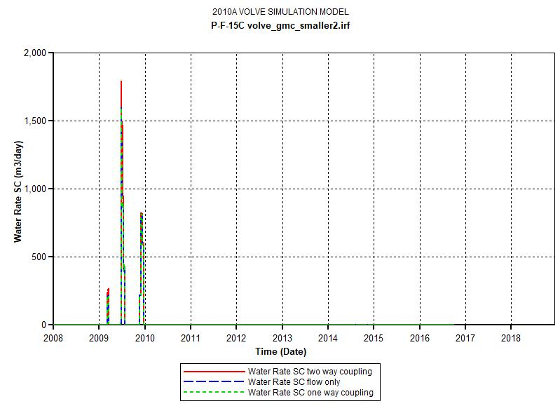

Conclusion

Based on the numerical modelling procedures, the production profiles for the Volve field in Norway has been analyzed. To achieve this, geomechanical and petrophysical parameters were derived from the well logs and populated through the model using the Kriging algorithm. Three scenarios were tested involving the degree of coupling between the flow and the geomechanics; one with no coupling, another with one way coupling and a third with two way coupling. The following conclusions can be drawn accordingly:

* Development of a MEM model has an important role to play in analysis of flow from reservoirs.
* Moving forward, a more detailed analysis involving variations of mechanical properties in each grid block
* To incorporate even more detailed geomechanical analysis, the coupling of a reservoir simulator such as CMG with a geomechanical simulator such as ABAQUS would provide greater insights into the physics of the process

References

Garipov, T.T., Karimi-Fard, M. and Tchelepi, H.A., 2016. Discrete fracture model for coupled flow and geomechanics. Computational Geosciences, 20(1), pp.149-160.

SLB, 2019. https://www.slb.com/services/technical_challenges/geomechanics/mechanical_earth_mo del_defined.aspx

Equinor, 2019. https://www.equinor.com/en/news/14jun2018-disclosing-volve-data.html

Sleipner Øst and Volve Model Hugin and Skagerrak Formation Petrophysical Evaluation, 2006

Kalani, M., 2018. Multiscale seal characterization in the North Sea Implications from clay sedimentology, well logs interpretation and seismic analyses

Karstens, J., 2015. Focused fluid conduits in the Southern Viking Graben and their implications for the Sleipner CO2 storage project (Doctoral dissertation, Christian-Albrechts-Universität)