Appendix A. Derivation of analytical BEM integration formulation
BEM formulation for the general potential problem
The PDE for general potential problem can be expressed as follows:
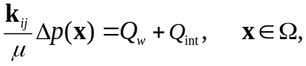
If homogeneous media is considered, Eqs. 4-5 can be simplified as follows:
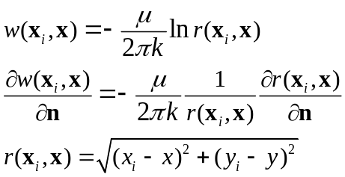
The general BEM formulation can be expressed as follows:
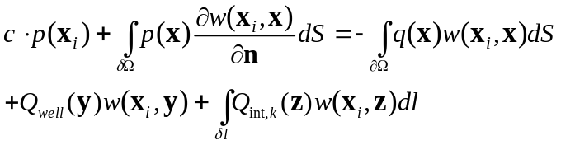
Geometry and Notation in BEM Elements
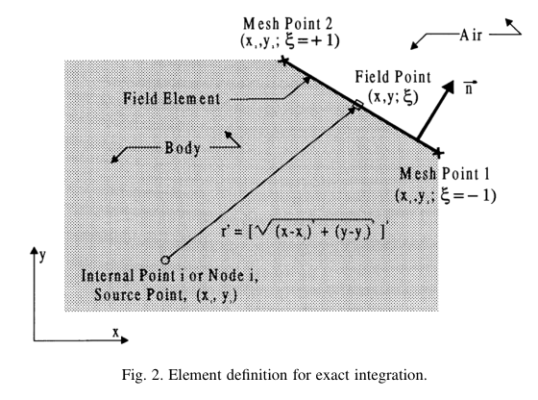
Fig. Off-element relation between on-element point (x, y) and off-element point (x_{i},y_{i})
Assuming a BEM element is a straight line, as shown in the Figure above, the point (x, y) on an element can be defined in terms of shape function in the local coordinates system (-1,1) as follows:
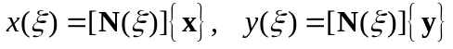
where N is the geometric linear shape functions as follows:
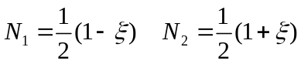
Thus, the points (x,y) on an element (two end points are (x₁,y₁) and (x₂,y₂)) can be expressed as follows:
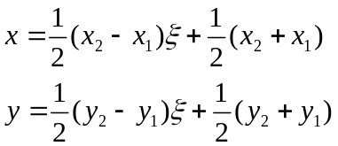
The Jacobian of straight element can be expressed as follows:
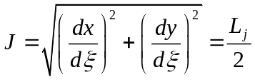
The boundary integration over a straight line can be expressed in terms of Jacobian as follows:
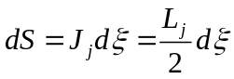
if a curve element is used, the Jacobian can be expressed as follows:
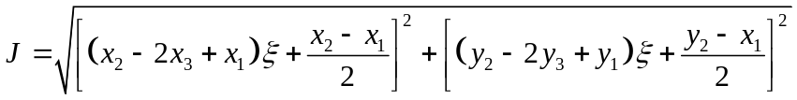
As shown in Eq. 13, the analytical solution for curve element is cumbersome. The straight line element is assumed here.
L_{j} is the length of the element j.
Off-element Case: Substituting Eq. 9 into Eq. 6, the distance function r between field point (x_{i},y_{i}) and element point (x,y) can be expressed as follows:
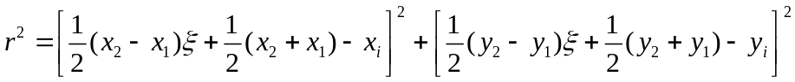
Follow the definition of Zhang (2017), the following constants is defined:
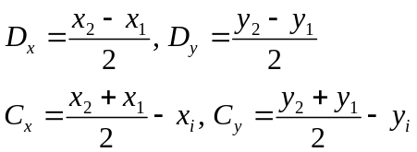
Substituting Eq. 15 into Eq. 14 gives:
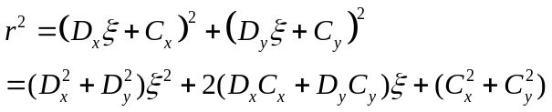
In order to derive the analytical formulation of Eq. 8 for CST, DL and DQ elements, following geometries variables are defined:
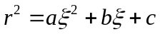
Comparing Eq. 16 with Eq. 15, the constant a, b, c can be expressed as follows:
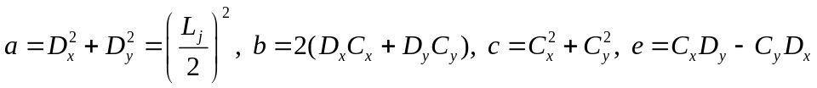
The radius derivative can be expressed as follows:
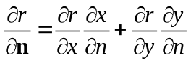
where,
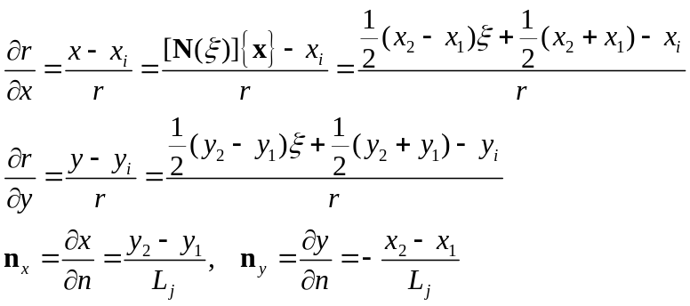
Similarly, the above equation can be simplified as follows:
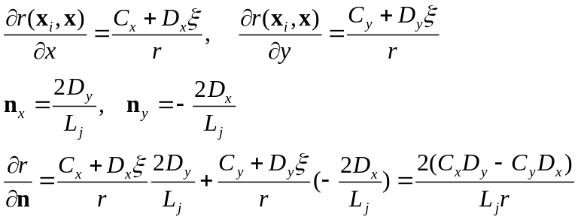
Specially, the directional derivative on the field point (x_{i},y_{i}) can be expressed as follows:
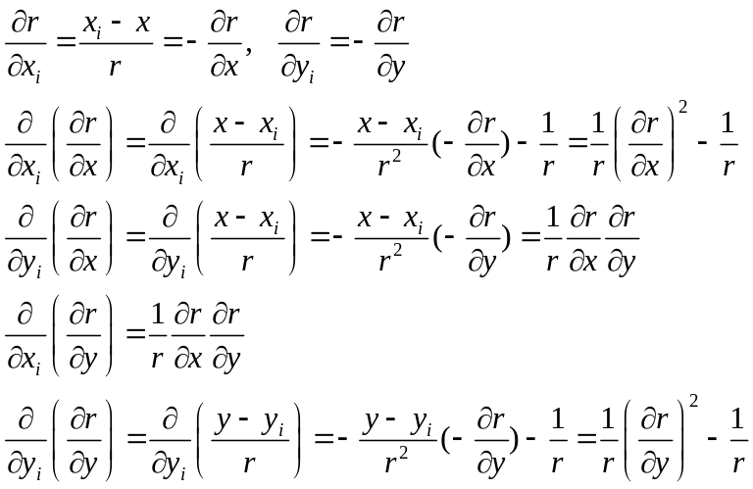
The partial derivative of radius derivate in terms of field point (x_{i,} y_{i}) can be written as follows:
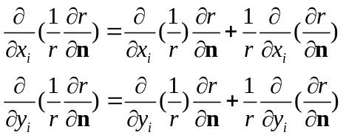
where, using field point derivate of Eq. 19, the above derivate can be evaluated as follows:
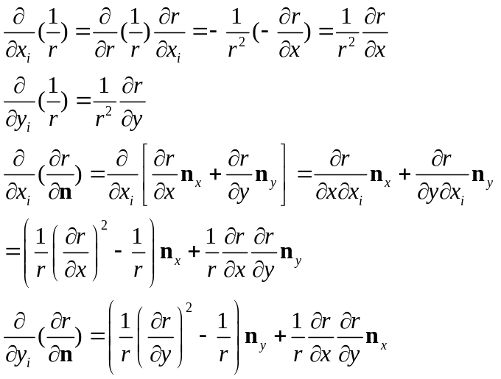
Substituting Eq. 24 into Eq. 23 gives:
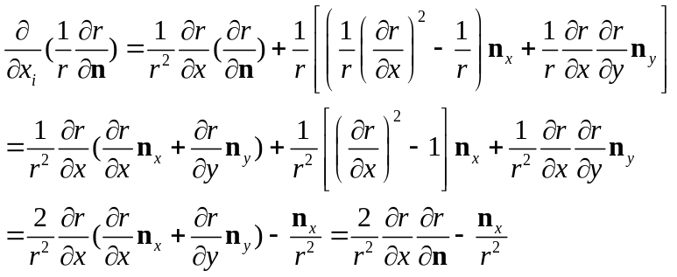
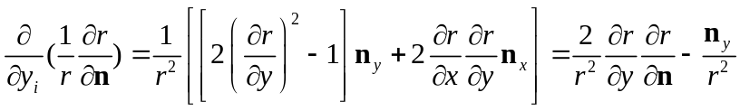
Again, the above equation can be simplified as follows:
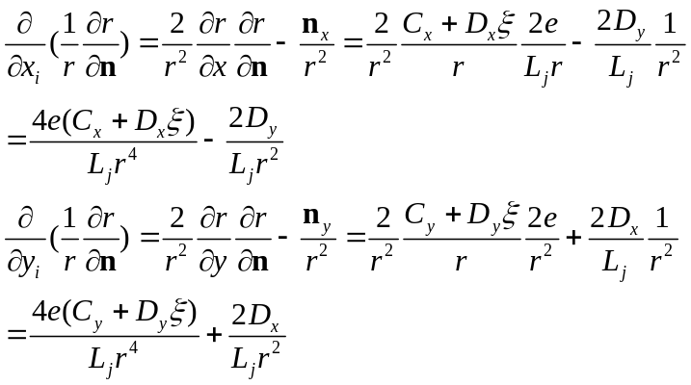
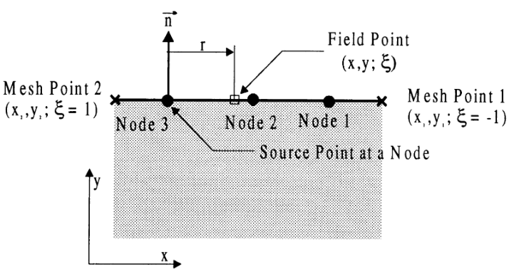
Fig. On-element relation between on-element point (x, y) and off-element point (x_{i},y_{i})

On Element Case: As shown in above, when the field point (x_{i},y_{i}) is located on the element, the field point and distance function r can be expressed as follows:
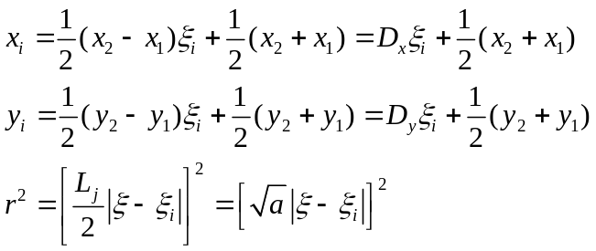
The derivative of distance function r can be expressed as follows:
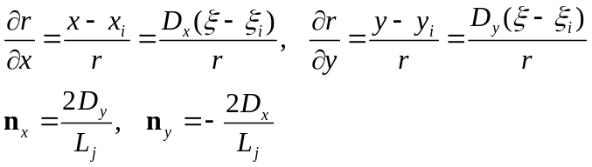
the normal vector n and distance vector r is perpendicular. Thus the following 4 terms are all equal to zero:
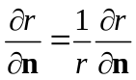

Boundary Element Integrals
In the BEM, the pressure and flux at any point in the domain can be expressed as follows:
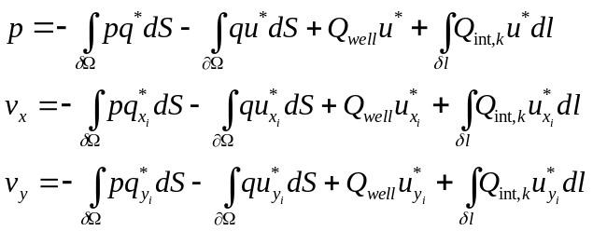
where,
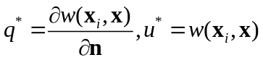
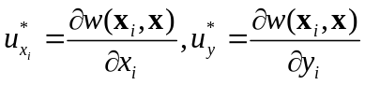
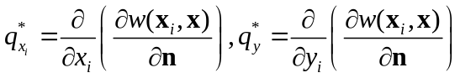
Thus, six integrals with singularity has to be evaluated in the BEM solution as follows
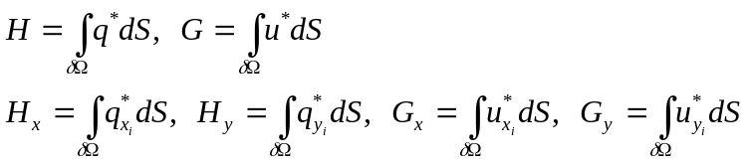
Off-element Case: Substituting fundamental solution of Eq. 6 and geometric notation of Eqs. 11, 15, 19 into Eqs 21-23 gives:
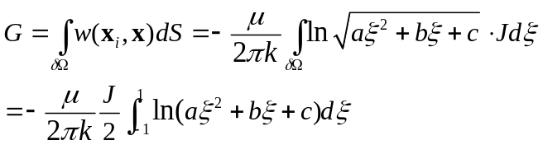
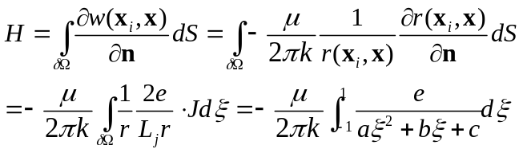
To derive the integral of G_{xi} G_{yi}, H_{xi} and H_{yi} on the field point (x_{i},y_{i}), following chains rules for fundamental solution has to be defined:
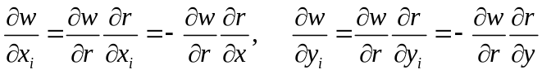
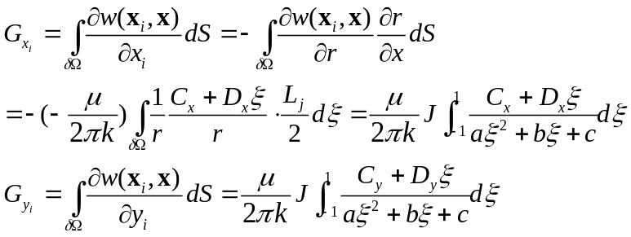
Similarly, the H_{xi} and H_{yi} can be derived as follows:
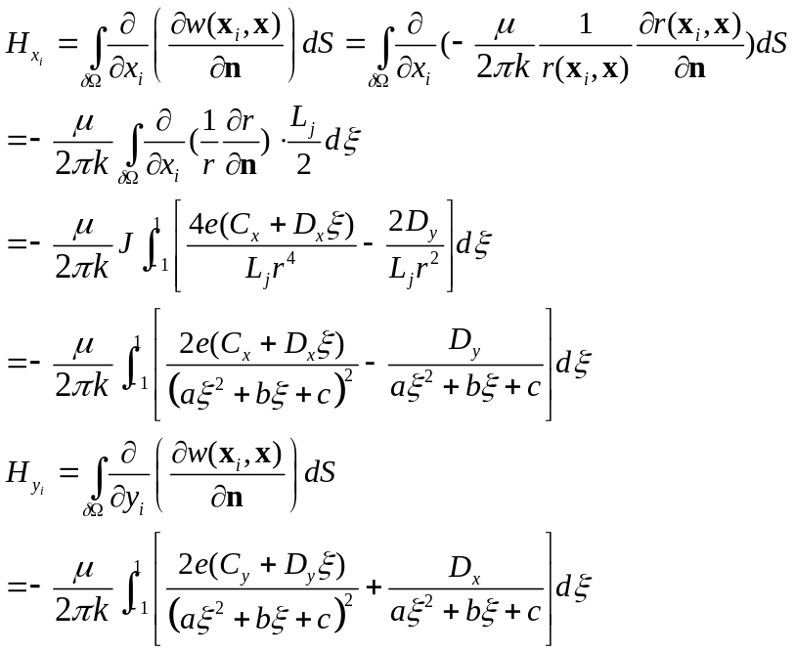
On-element Case:
When the field point is located on the element, the following simplified equation can be evaluated through the following identities:
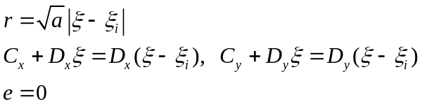
Thus, the corresponding integrals can be derived from the off-element case:
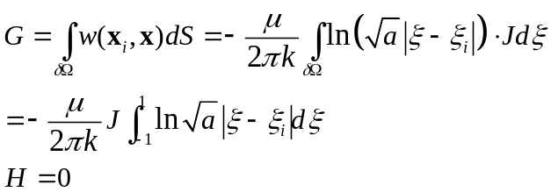
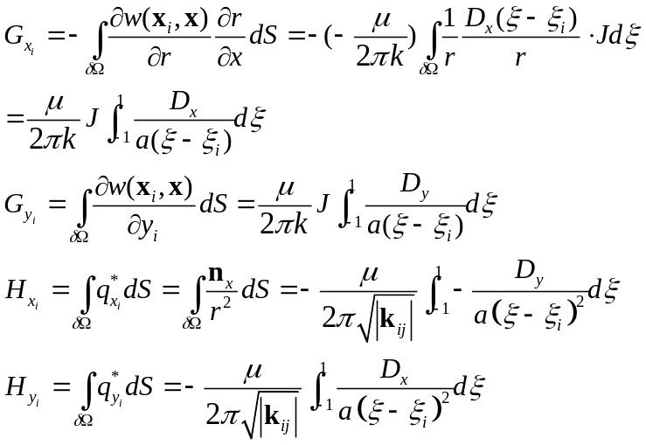
Boundary Integrals for Different Elements
As shown in Figure below, the pressure and flux can be assumed constant, linear and quadratic varies along a boundary element which can be expressed in terms of shape function as follows:
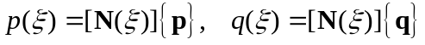
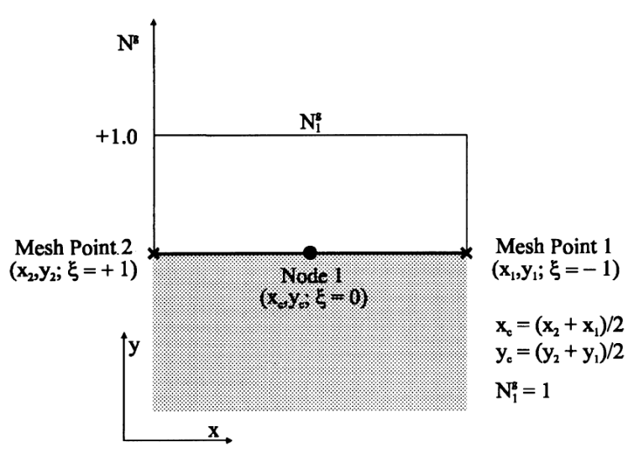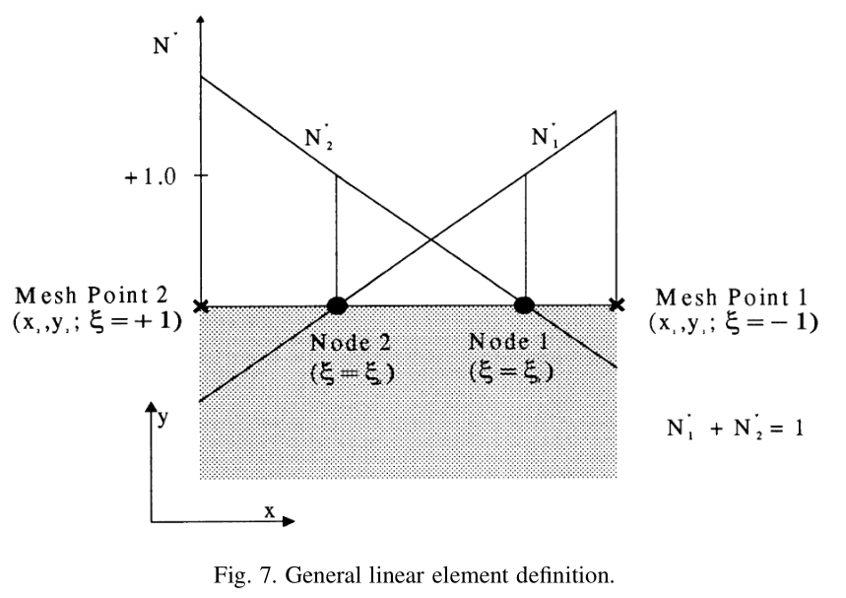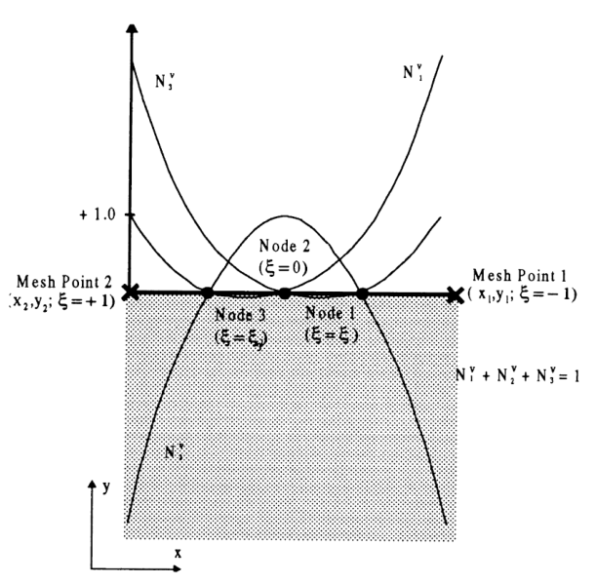
Fig. The definition of constant, discontinues linear and discontinues quadratic elements.
The shape function for constant (CST), discontinues linear (DL) and discontinues quadratic (DQ) elements in Eq. 8-9 can be expressed as follows:
CST Element 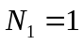
DL Element 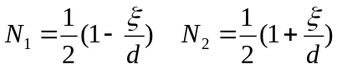
DQ Element 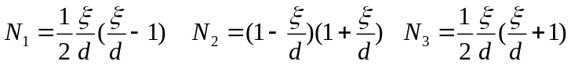
where d is the collocation factor (1/2,1) which is the local offset distance from the two ends of an element. For the different elements, the six integrals now can be adapted as follows:
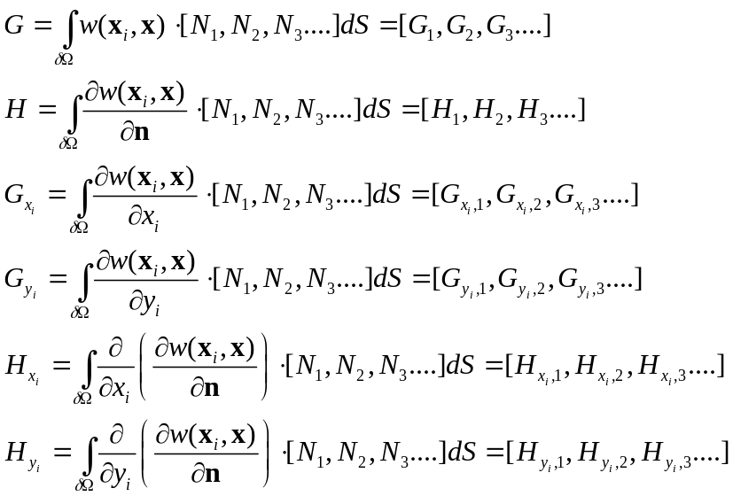
Constant Element:
When the field point is not located on the element:
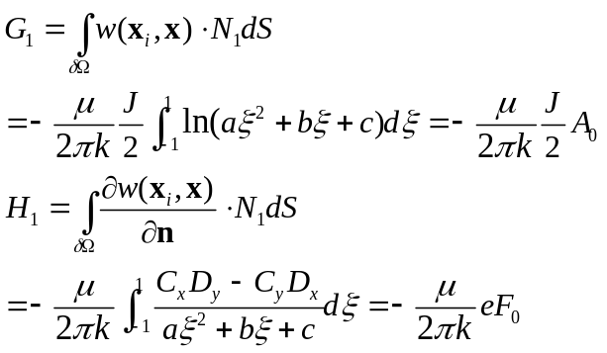
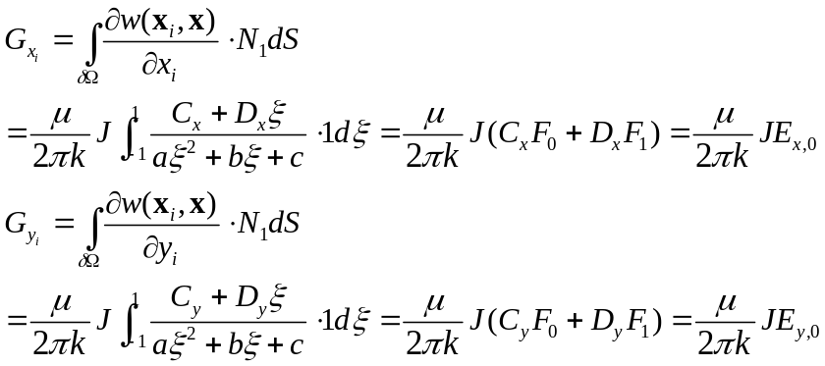

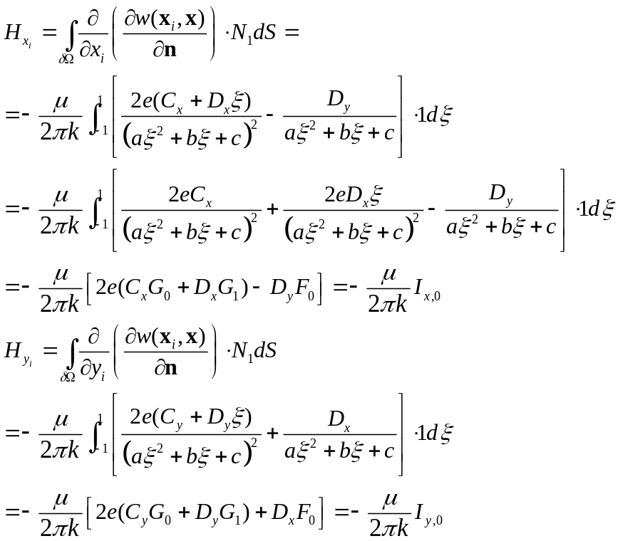
When the field point is located on the element, the singular integral can be evaluated as follows:
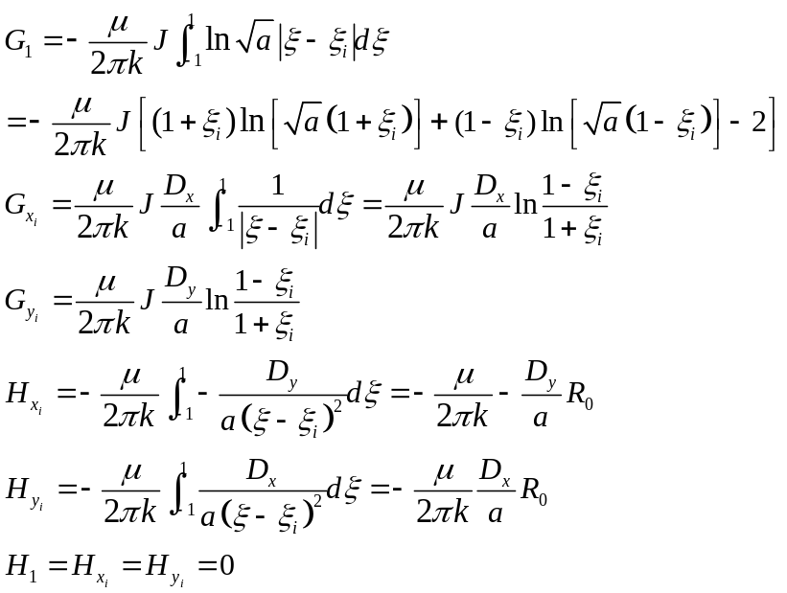
Linear Elements
When the field point is not located on the element:
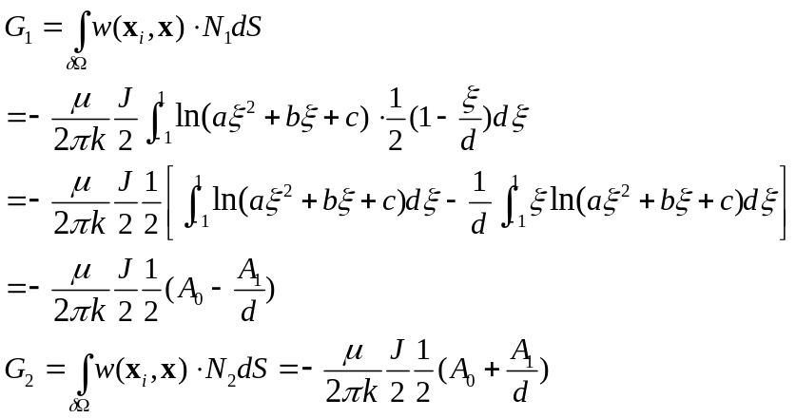
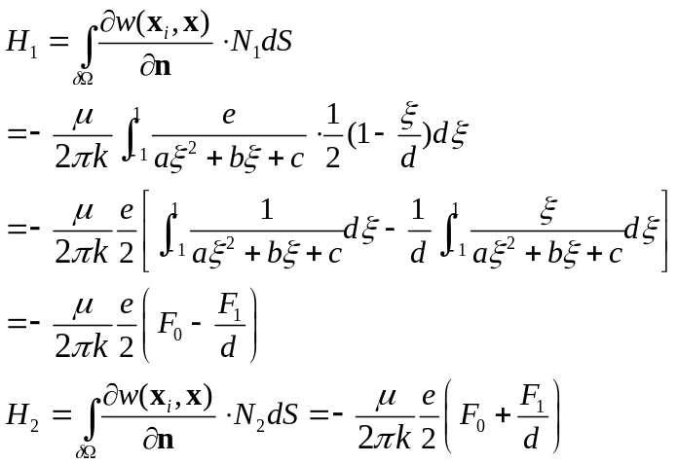
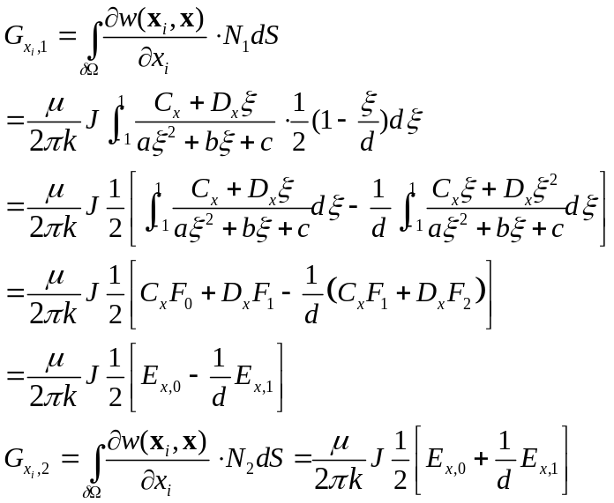
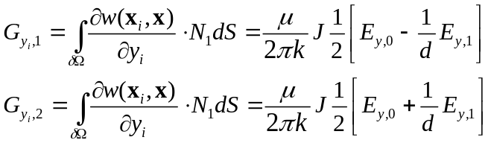
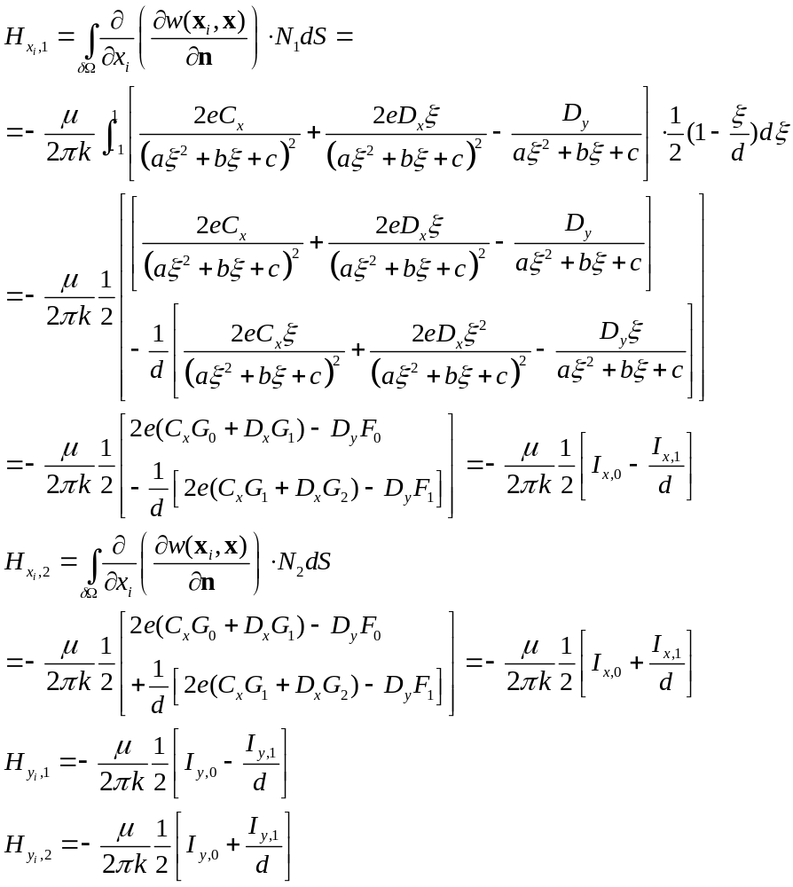
When the field point is located on the element, the singular integral can be evaluated as follows:
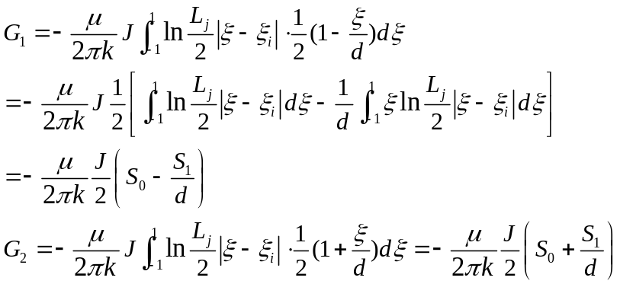
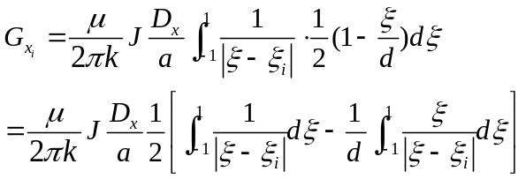
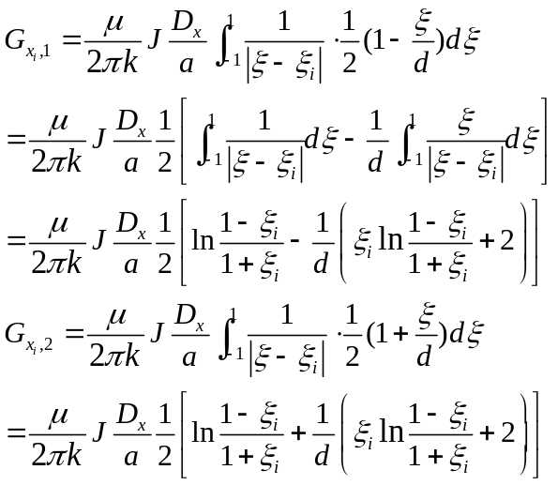
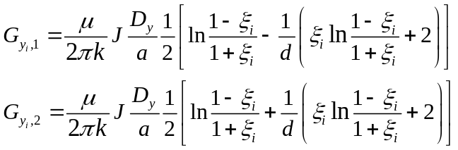
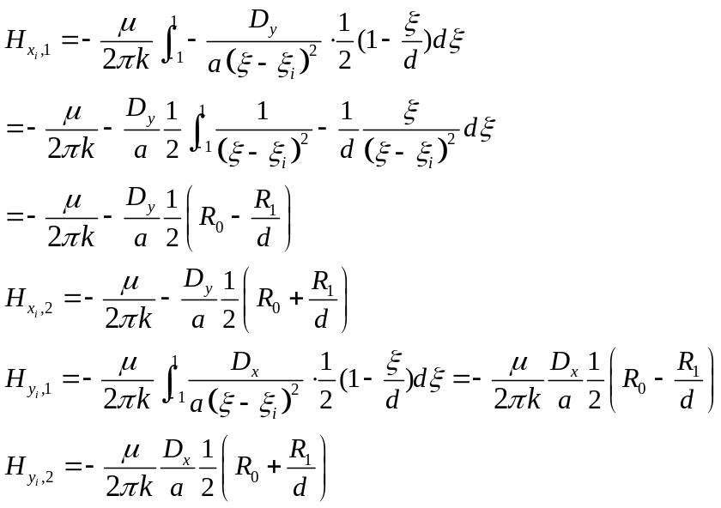
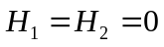
Quadratic Elements
When the field point is not located on the element:
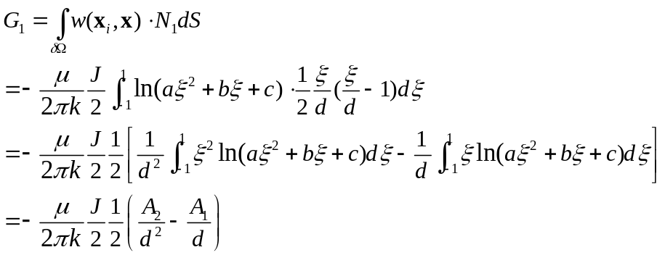
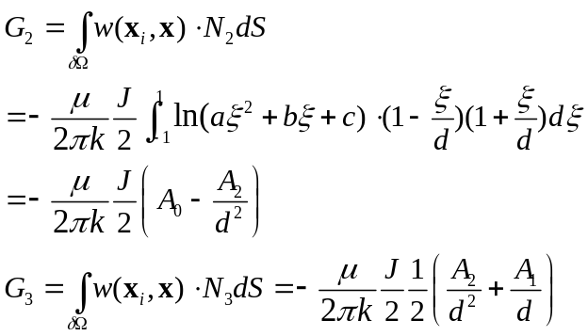
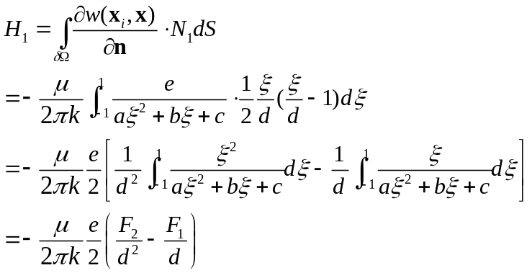
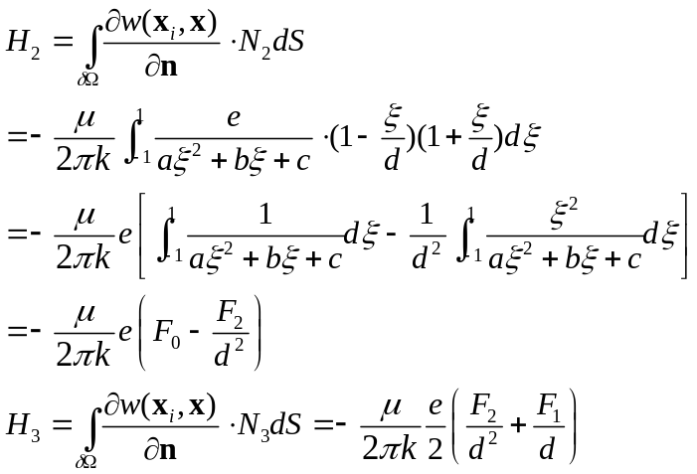
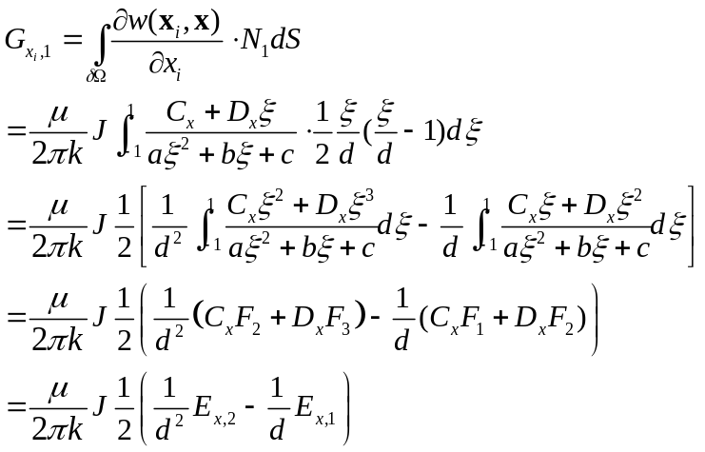
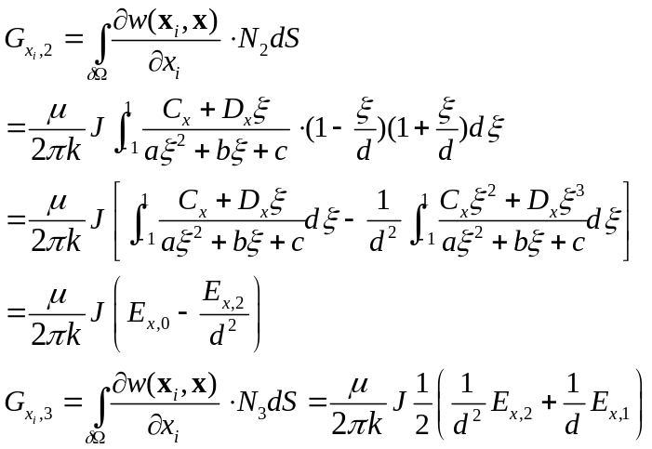
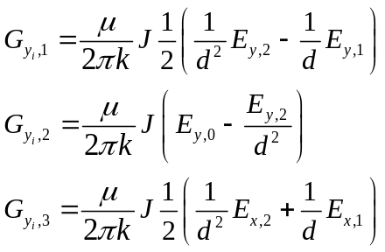
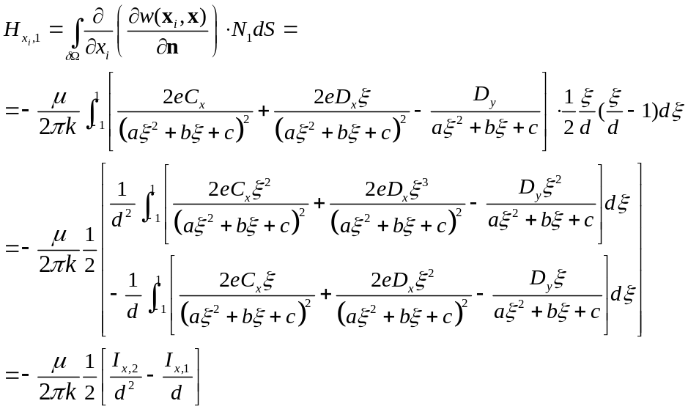
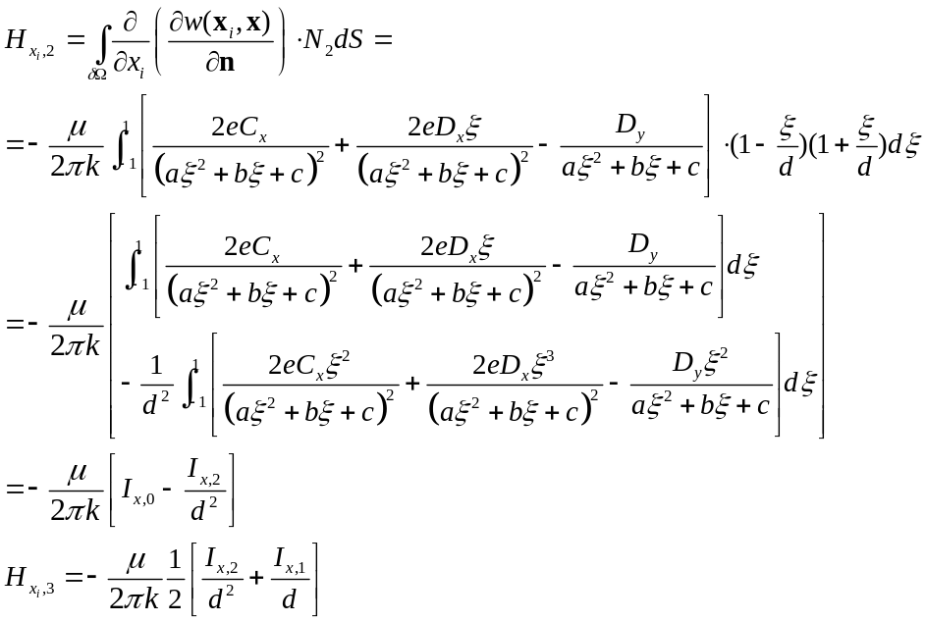
When the field point is located on the element, the singular integral can be evaluated as follows:
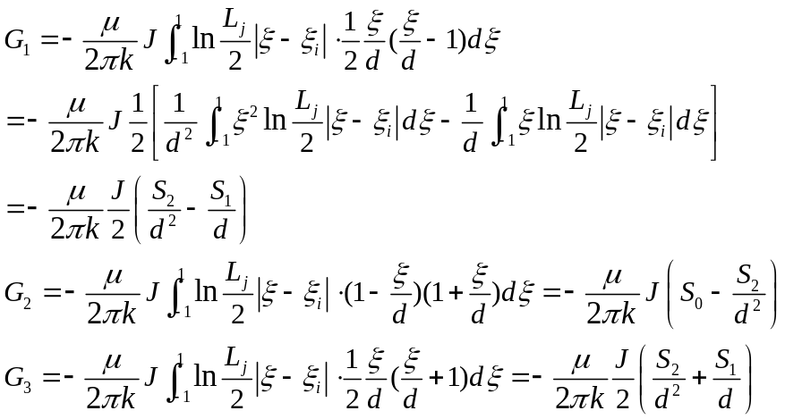
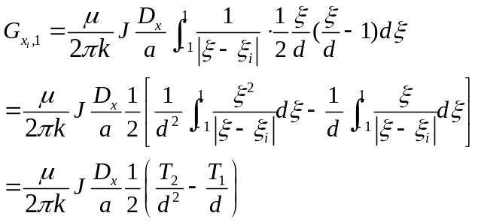
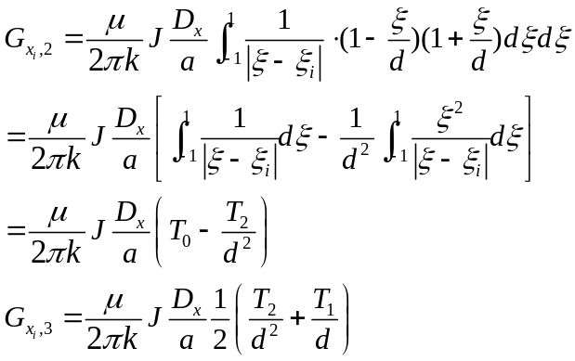
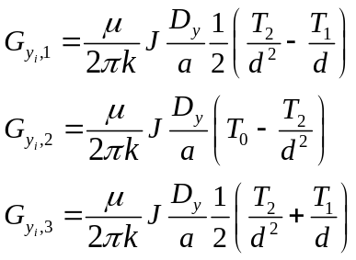
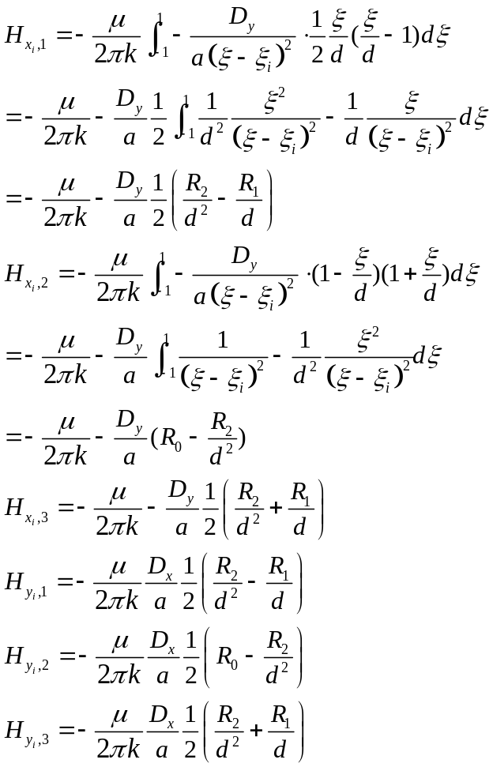

Appendix A. Analytical Integrals in BEM
Defining the discriminant ∆ as follows:
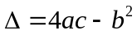
In BEM ∆ is always less or equal to 0, when ∆=0, the field point is collinear with the element line segment.
A.1 First kind of integral:
The first kind of Integral A can be calculated as follows:
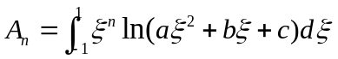
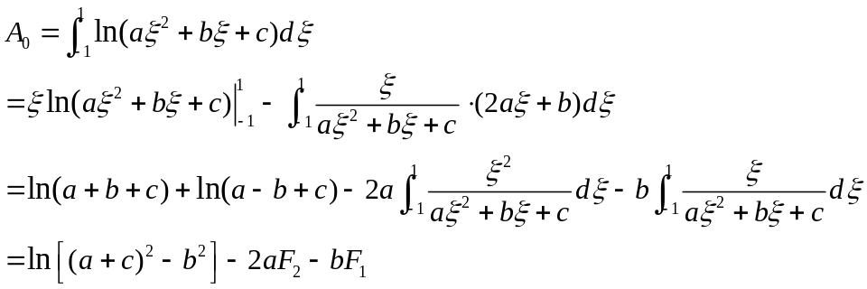
The second kind of integral A₁ can be calculated as follows:
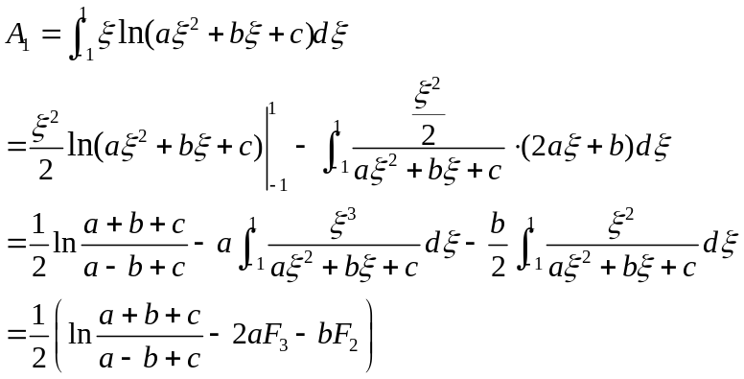
The third kind of integral A₂ can be calculated as follows:
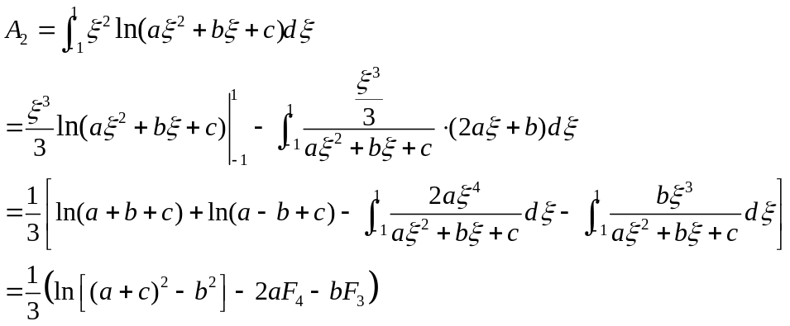
A.2 Second kind of integral:
The integral F and G can be defined as follows (Zhang et al. 2003):
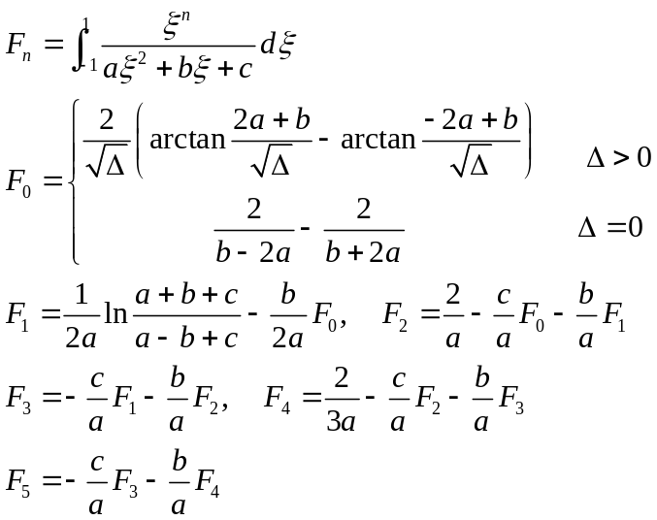
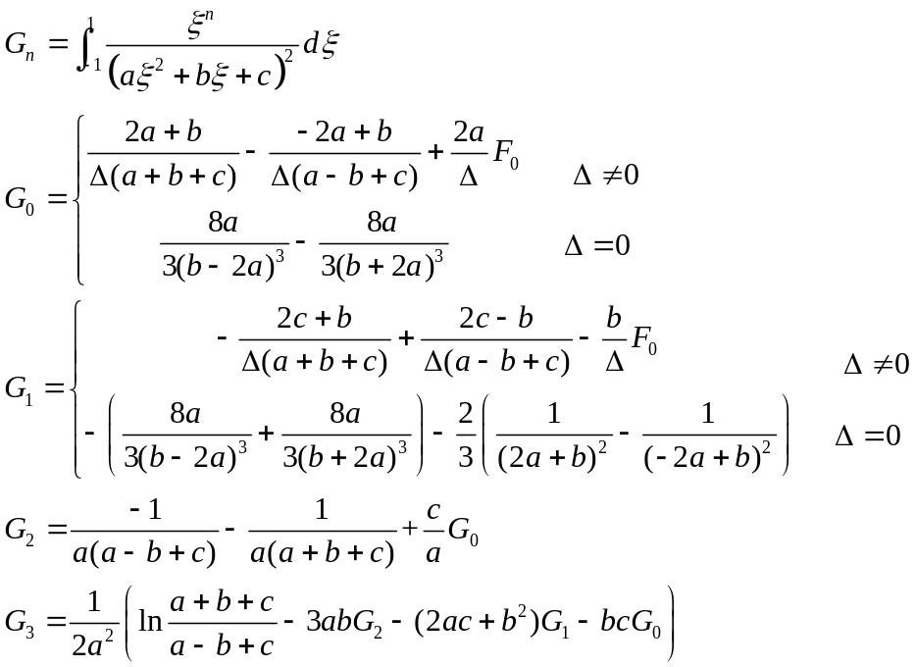
Some of common integrals can be simplified as follows:
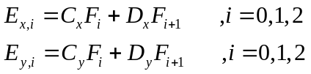
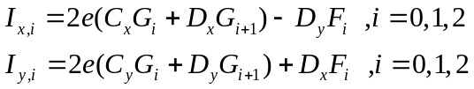
The special singular integration need to be evaluated using Cauchy Principle Value integral can be summarized as follows:
A.3 Singular Integral 1:
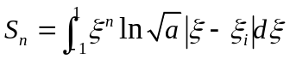
For the first integral of Eq. 54, defining 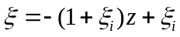 and 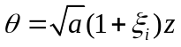, defining
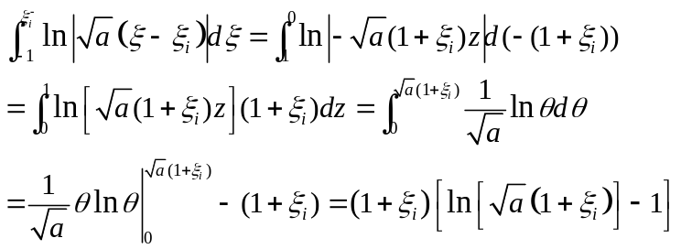
Similarly, for the second term, defining 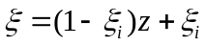 and 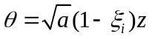:
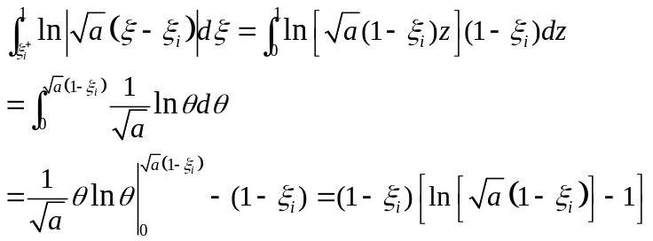
Substituting Eqs. 55-56 into 54 gives:
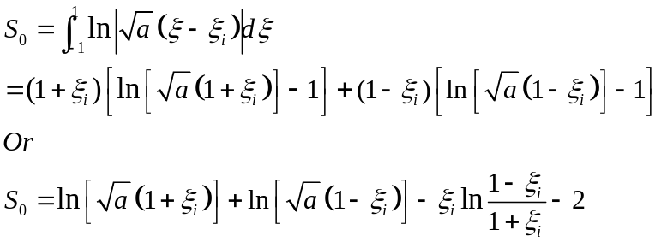
Noted that if 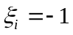, 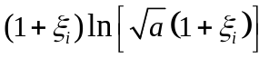 is equal to zero. This should be carefully handled when it is implemented.
For constant element, taking the middle point as an example, 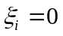,
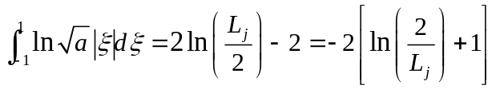
The above equation matched well with the analytical solution for constant element.

For the first integral of Eq. 54, defining and :
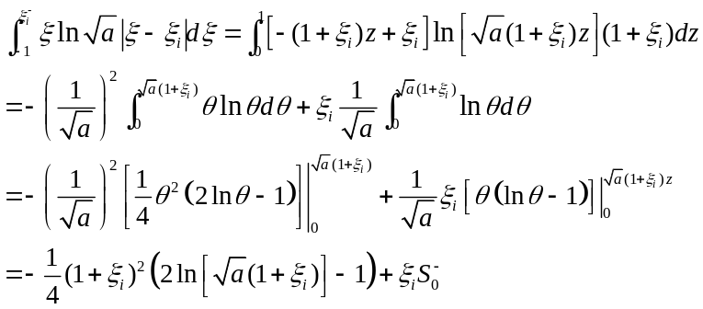
Similarly, for the second term, defining and :
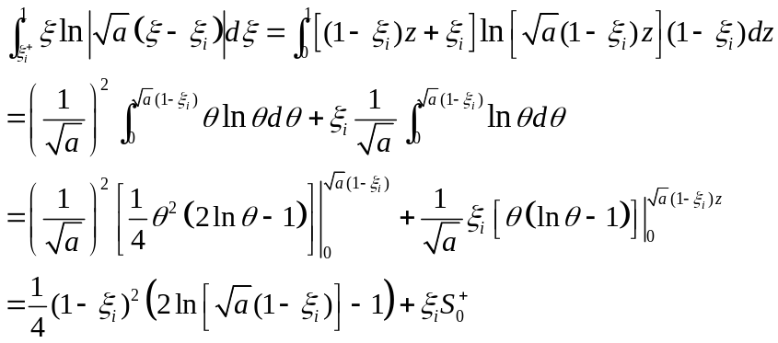
Thus, the integral of Eq. 70 can be expressed as follows:
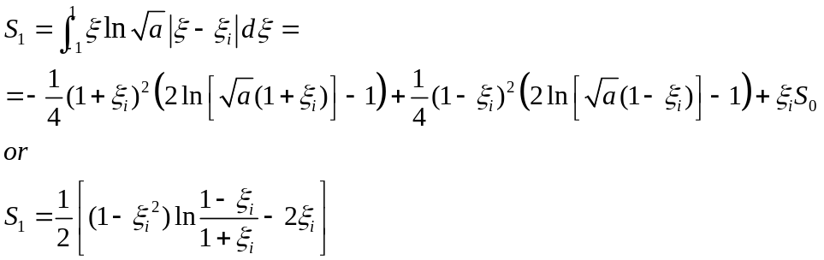

For the first integral, defining and :
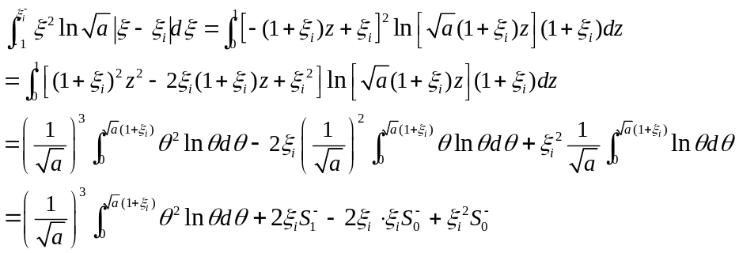
Similarly, for the second term, defining and :
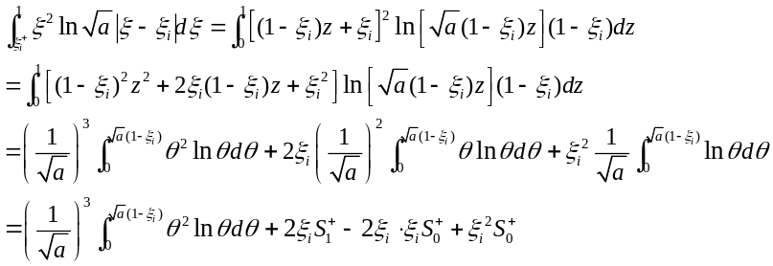
where
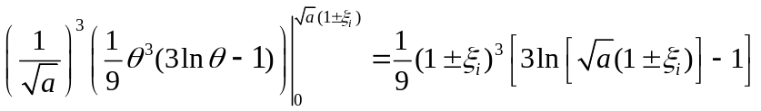
Thus, the integral of Eq. 87 can be expressed as follows:
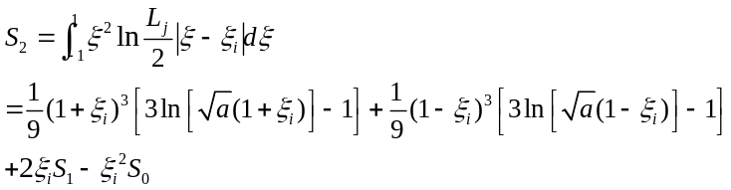
A.3 Singular Integral 2:
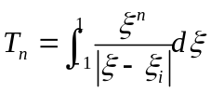
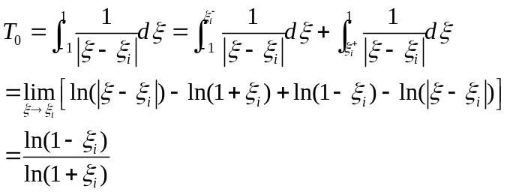
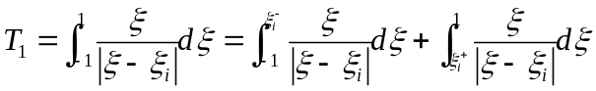
Based on the integration by part and solution of singular integral 1, the above integral can be computed as follows:
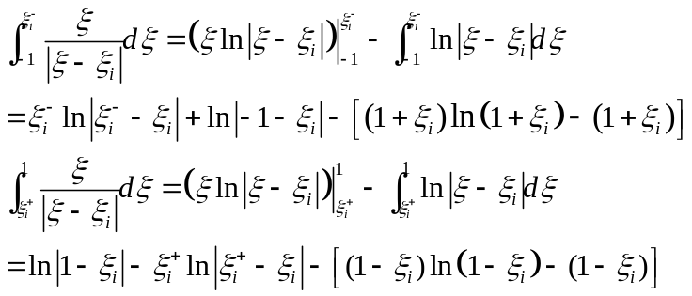
Substituting Eq. 75 into Eq. 74 gives:
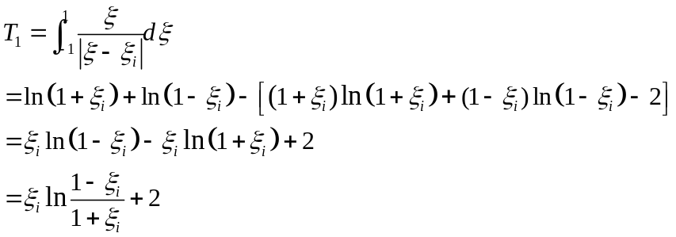
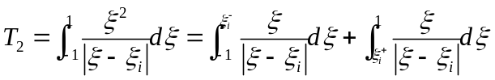
Based on the integration by part and solution of singular integral 1, the above integral can be computed as follows:
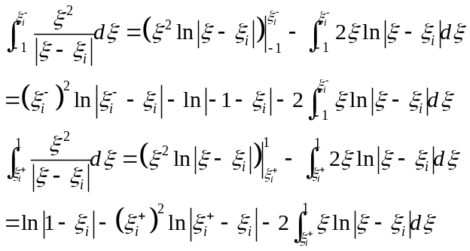
Substituting Eq. 107 into Eq. 106 gives:
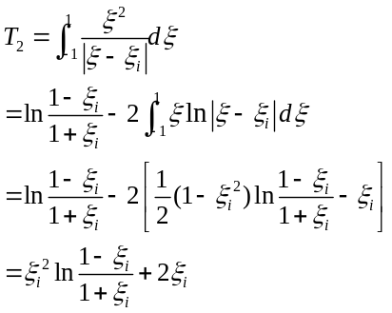
A.3 Singular Integral 3:
