Appendix A. Analytical BEM integration formulation
BEM formulation for the general potential problem
The PDE for general potential problem can be expressed as follows:
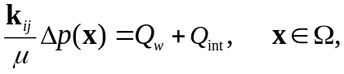
If an anisotropic media properties are considered, Eq. 1 can be expressed as follows:
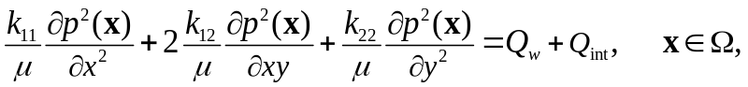
where,
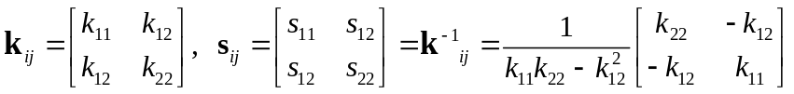
The fundamental solution of the above equation is:
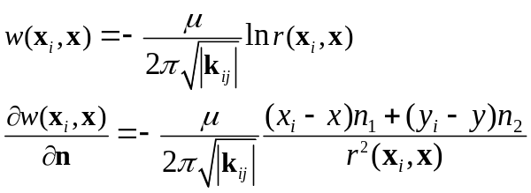
where, r is the distance function between source point x_{i} and field point x. r₁ and r₂
Specially, if homogeneous media is considered, Eqs. 4-5 can be simplified as follows:
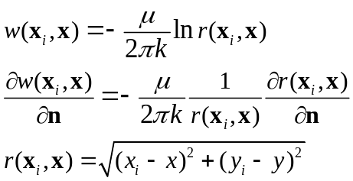
The general BEM formulation can be expressed as follows:
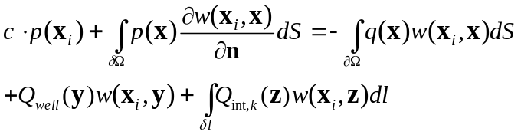
Geometry and Notation in BEM Elements
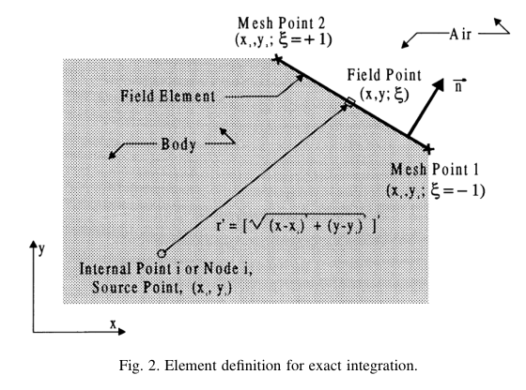
Fig. Off-element relation between on-element point (x, y) and off-element point (x_{i},y_{i})
Assuming a BEM element is a straight line, as shown in the Figure above, the point (x, y) on an element can be defined in terms of shape function in the local coordinates system (-1,1) as follows:
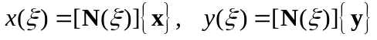
where N is the geometric linear shape functions as follows:
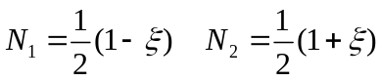
Thus, the points (x,y) on an element (two end points are (x₁,y₁) and (x₂,y₂)) can be expressed as follows:
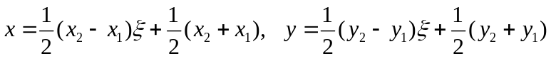
The Jacobian of straight element can be expressed as follows:
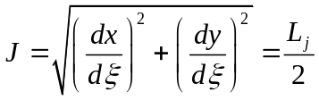
The boundary integration over a straight line can be expressed in terms of Jacobian as follows:
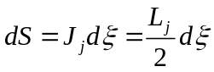
Off-element Case: Substituting Eq. 9 into Eq. 6, the distance function r between field point (x_{i},y_{i}) and element point (x,y) can be expressed as follows:
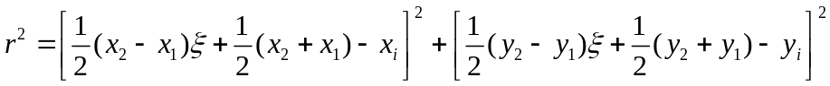
Follow the definition of Zhang (2017), the following constants is defined:
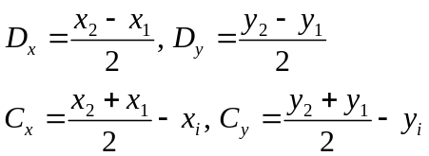
Substituting Eq. 15 into Eq. 14 gives:
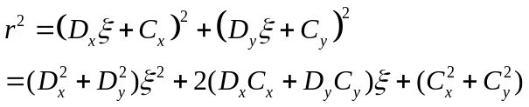
In order to derive the analytical formulation of Eq. 8 for CST, DL and DQ elements, following geometries variables are defined:
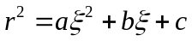
Comparing Eq. 16 with Eq. 15, the constant a, b, c can be expressed as follows:
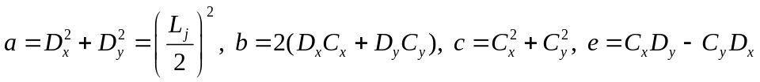
The radius derivative can be expressed as follows:
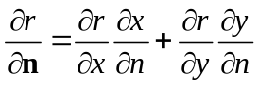
where,
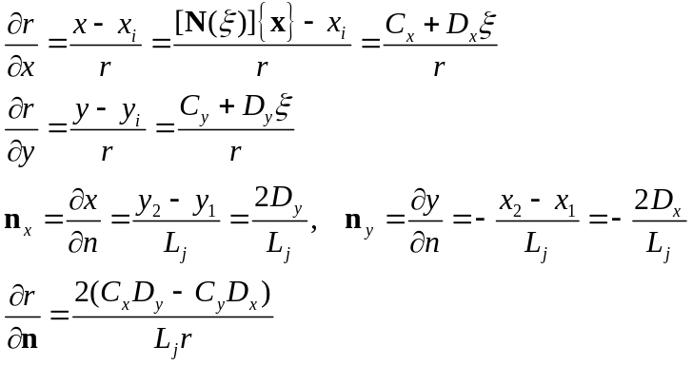
The partial derivative of radius derivate in terms of field point (x_{i,} y_{i}) can be written as follows:
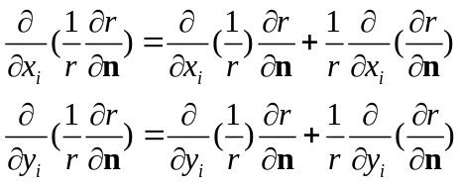
where, using field point derivative of Eq. 23, the above derivative can be derived as follows:
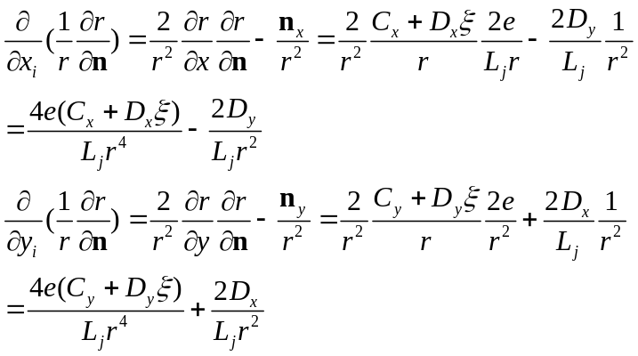
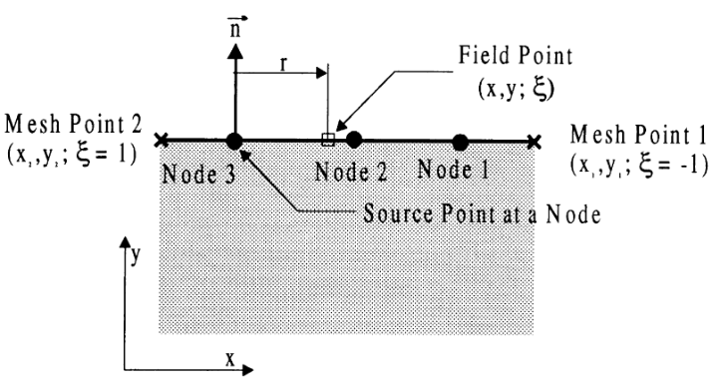
Fig. On-element relation between on-element point (x, y) and off-element point (x_{i},y_{i})

On Element Case: As shown in above, when the field point (x_{i},y_{i}) is located on the element, the field point and distance function r can be expressed as follows:
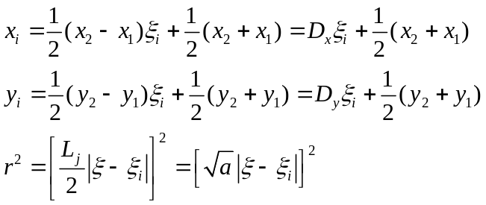
The derivative of distance function r can be expressed as follows:
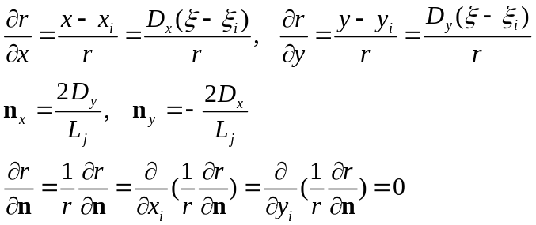
the normal vector n and distance vector r is perpendicular. Thus the normal vector is zero.

Boundary Element Integrals
For potential problem, the pressure and flux at any point in the domain can be expressed as follows:
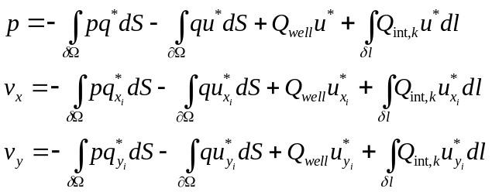
Six integrals with singularity has to be evaluated in the BEM solution as follows
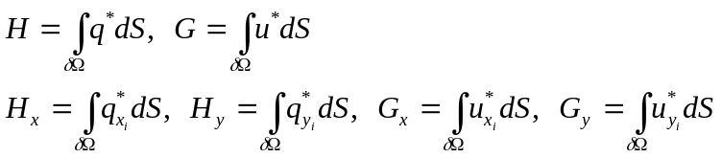
Off-element Case: Substituting fundamental solution of Eq. 6 and geometric notation of Eqs. 11, 15, 19 into Eqs 21-23 gives:
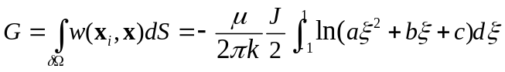
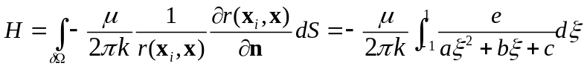
To derive the integral of G_{xi} G_{yi}, H_{xi} and H_{yi} on the field point (x_{i},y_{i}), following chains rules for fundamental solution has to be defined:
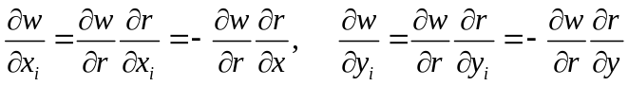
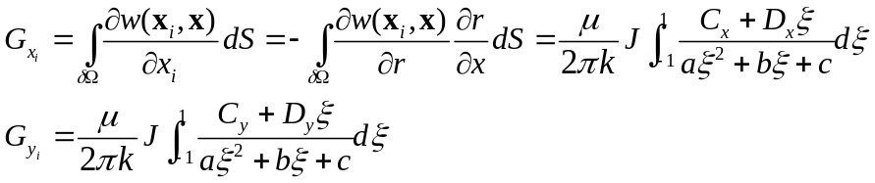
Similarly, the H_{xi} and H_{yi} can be derived as follows:
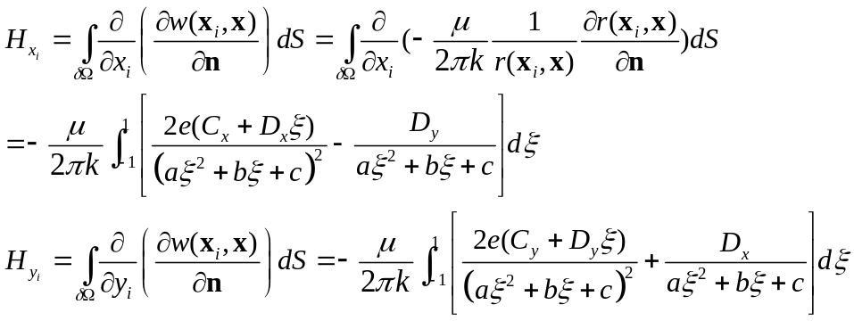
On-element Case:
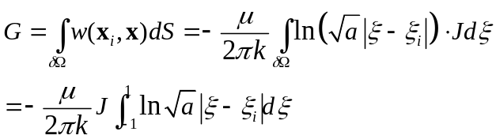
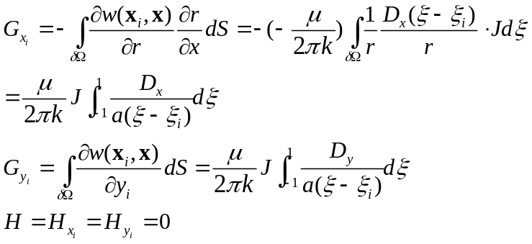
Boundary Integrals for Different Elements
As shown in Figure below, the pressure and flux can be assumed constant, linear and quadratic varies along a boundary element which can be expressed in terms of shape function as follows:
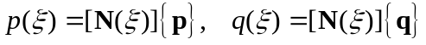
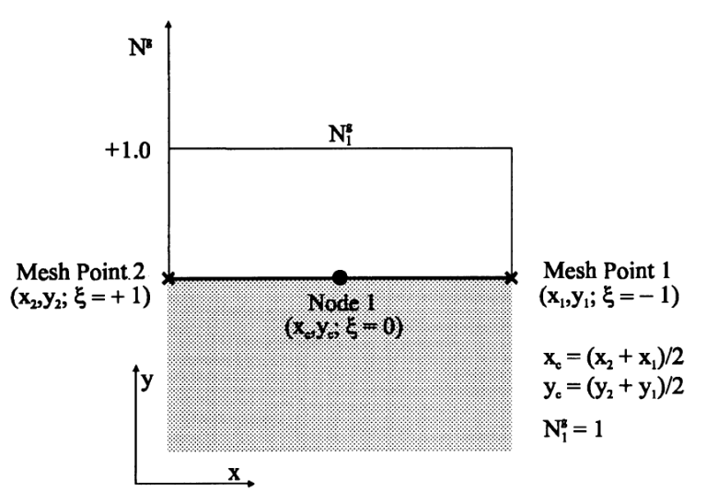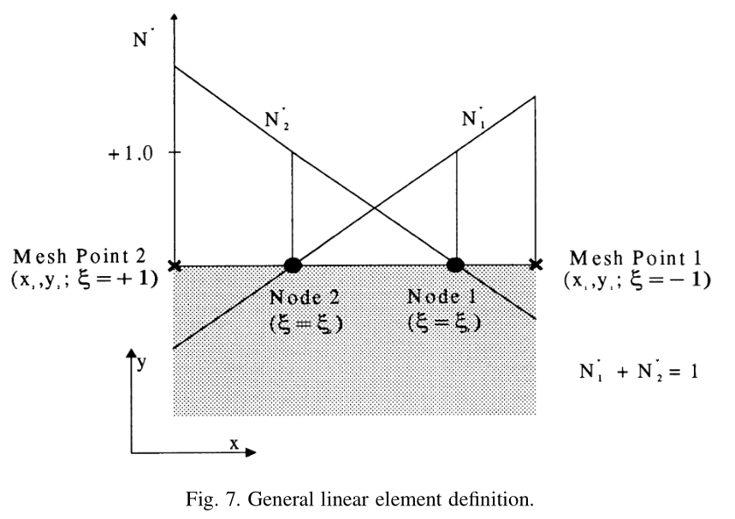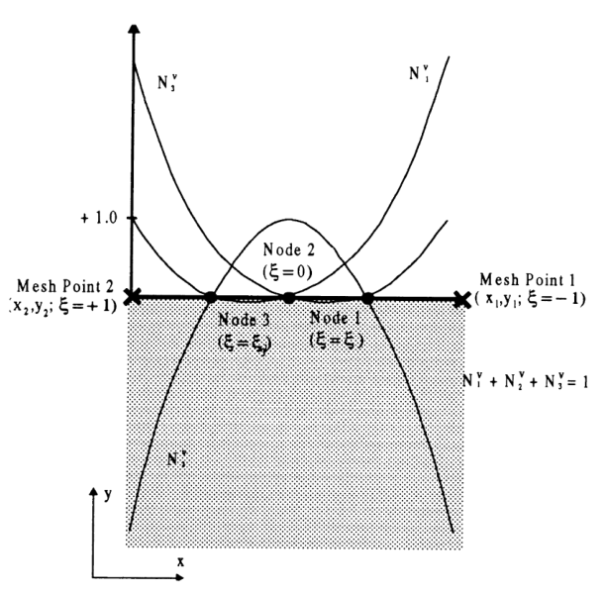
Fig. The definition of constant, discontinues linear and discontinues quadratic elements.
The shape function for constant (CST), discontinues linear (DL) and discontinues quadratic (DQ) elements in Eq. 8-9 can be expressed as follows:
CST Element 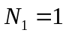
DL Element 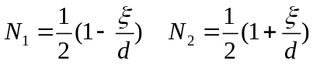
DQ Element 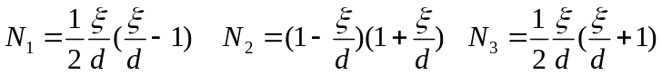
where d is the collocation factor (1/2,1) which is the local offset distance from the two ends of an element. For the different elements, the six integrals now can be adapted as follows:
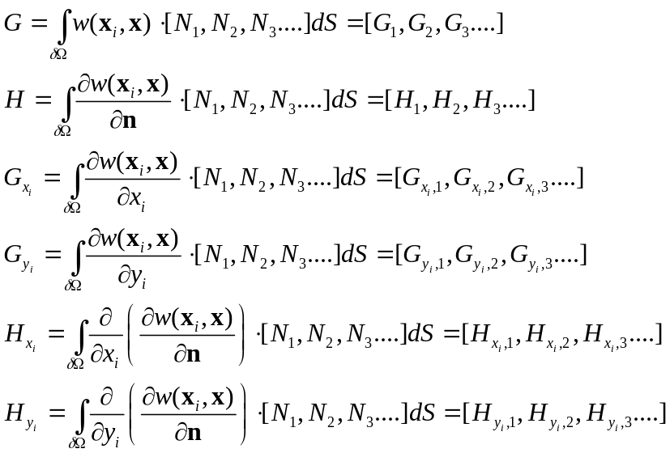
Constant Element:
When the field point is not located on the element:
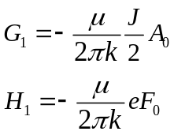
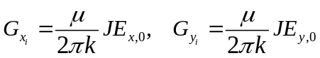
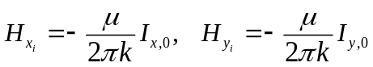
When the field point is located on the element, the singular integral can be evaluated as follows:
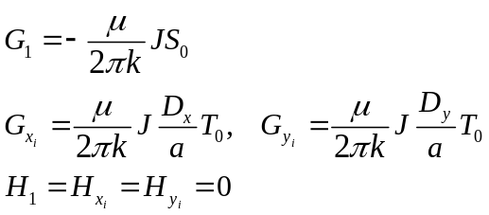
Linear Elements
When the field point is not located on the element:
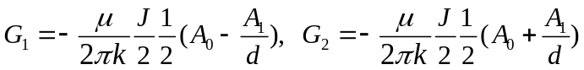
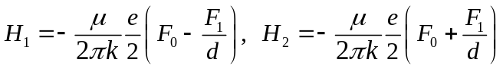
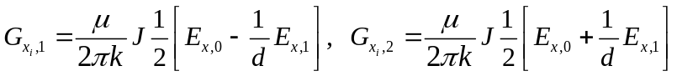
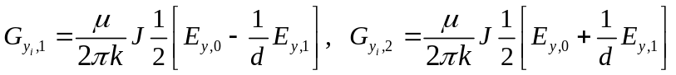
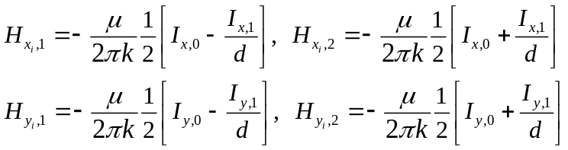
When the field point is located on the element, the singular integral can be evaluated as follows:
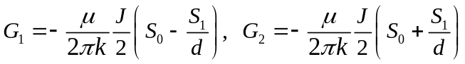
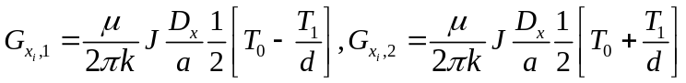
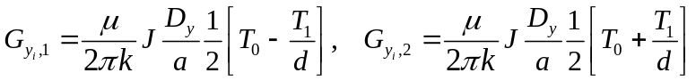
Quadratic Elements
When the field point is not located on the element:
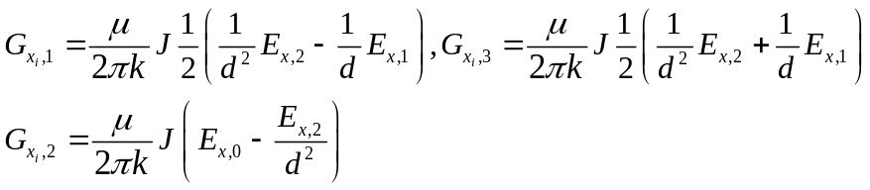
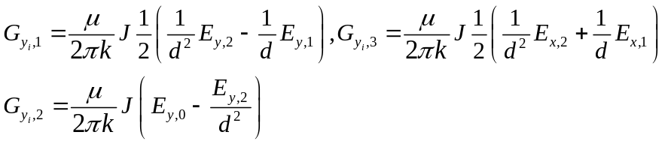
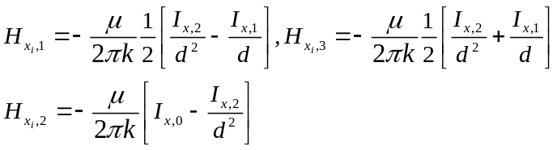
When the field point is located on the element, the singular integral can be evaluated as follows:
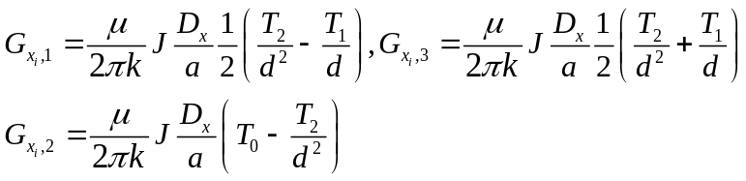
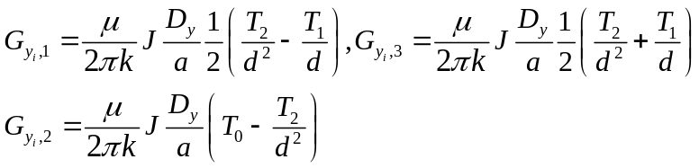

Appendix A. Analytical Integrals in BEM
Defining the discriminant ∆ as follows:
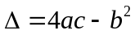
In BEM ∆ is always less or equal to 0, when ∆=0, the field point is collinear with the element line segment.
A.1 First kind of integral:
The first kind of Integral A can be calculated as follows:
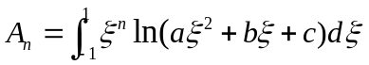
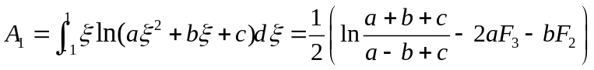
A.2 Second kind of integral:
The integral F and G can be defined as follows (Zhang et al. 2003):
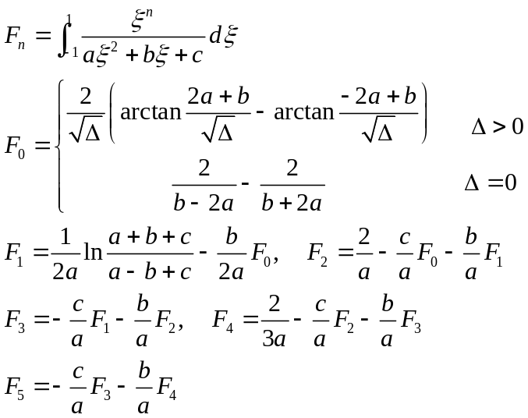
A.3 Third kind of integral:
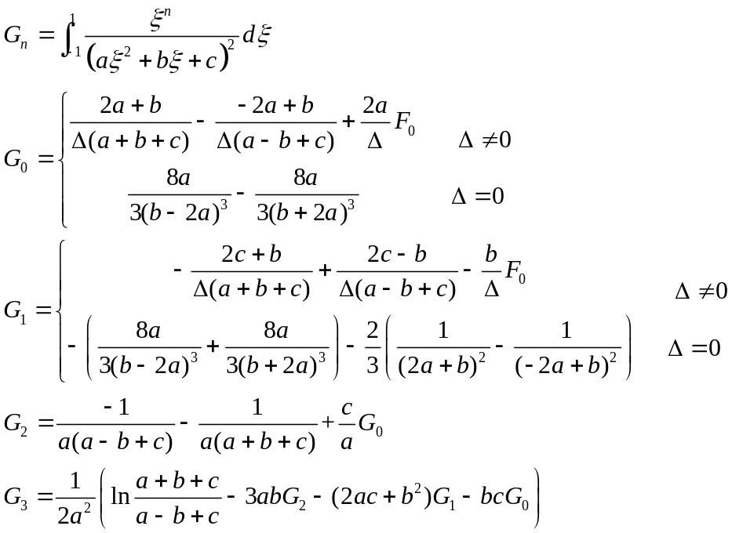
Some of common integrals can be simplified as follows:
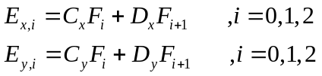
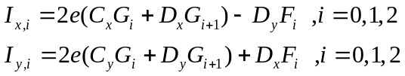
A.3 Singular Integral 1:
The special singular integration need to be evaluated using Cauchy Principle Value integral can be summarized as follows:
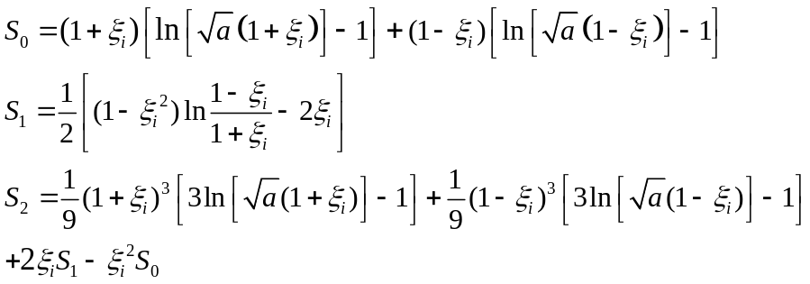
Noted that if x_{i}=-1, the ln(1+x_{i}) is equal to infinity, thus x_{i}=1-1E-15 can be used to treat this issue.
A.3 Singular Integral 2:
