# **Appendix A. Analytical BEM integration formulation**

**BEM formulation for the general potential problem**

The PDE for general potential problem can be expressed as follows:



where,



If an orthotropic media properties are considered, s12=k12=0, s11=1/k11, s22=1/k22, Eq. 1 can be expressed as follows:



The boundary condition can be expressed as follows:



The fundamental solution of the above equation is:



where, r is the distance function between **source point xi** and **field point x**. r1 and r2



The general BEM formulation can be expressed as follows:



**Geometry and Notation in BEM Elements**

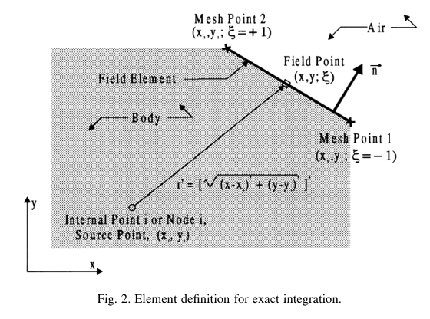

***Fig. Off-element relation between on-element point (x, y) and off-element point (xi,yi)***

Assuming a BEM element is a straight line, as shown in the Figure above, the point (x, y) on an element can be defined in terms of shape function in the local coordinates system  (-1,1) as follows:



where N is the geometric linear shape functions as follows:



Thus, the points (x,y) on an element (two end points are (x1,y1) and (x2,y2)) can be expressed as follows:



The Jacobian of straight element can be expressed as follows:



The boundary integration over a straight line can be expressed in terms of Jacobian as follows:



***Off-element Case***: Substituting Eq. 9 into Eq. 6, the distance function **r** between **field point** **(xi,yi)** and **element point** **(x,y)** can be expressed as follows:



Follow the definition of Zhang (2017), the following constants is defined:



Substituting Eq. 15 into Eq. 14 gives:



In order to derive the analytical formulation of Eq. 8 for CST, DL and DQ elements, following geometries variables are defined:



Comparing Eq. 16 with Eq. 15, the constant a, b, c can be expressed as follows:



The normal vector for the straight line element can be expressed as follows:



Geometrically,



The 1st order radius derivative for the element point (x,y) can be evaluated using symbolic math (e.g. sympy):



Specially, the directional derivative on the field point (*xi, yi*) can be expressed as follows:



The 2nd order derivative for the field point (xi,yi) can be expressed as follows:



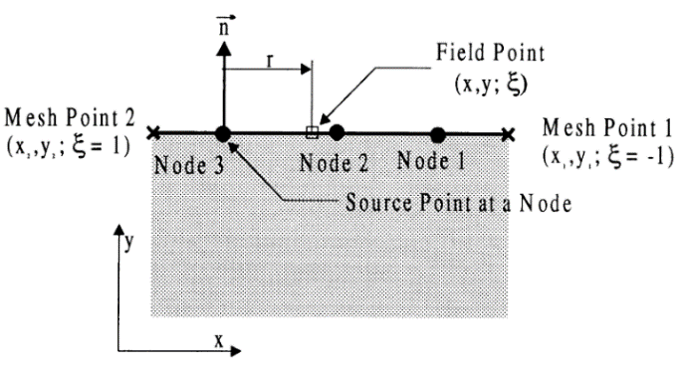

***Fig. On-element relation between on-element point (x, y) and off-element point (xi,yi)***

***On Element Case***: As shown in above, when the field point (xi,yi) is located on the element, the field point and distance function r can be expressed as follows:



The derivative of distance function r can be expressed as follows:



the normal vector **n** and distance vector **r** is perpendicular. Thus the normal vector is zero.

**Boundary Element Integrals**

For potential problem, the pressure and flux at any point in the domain can be expressed as follows:



Six integrals with singularity has to be evaluated in the BEM solution as follows



where (neglecting  for the following terms)













***Off-element Case***: Substituting fundamental solution of Eq. 9 and geometric notations into Eqs 21-23 gives:





k11*s11=1, k22*s22=1, substituting Eqs. 19-20 into Eq. 33 gives:



To derive the integral of Gxi Gyi, Hxi and Hyi on the field point (xi,yi), following chains rules for fundamental solution has to be defined:



Similarly, the Hxi and Hyi can be derived as follows:





***On-element Case***:





**Boundary Integrals for Different Elements**

As shown in Figure below, the pressure and flux can be assumed constant, linear and quadratic varies along a boundary element which can be expressed in terms of shape function as follows:



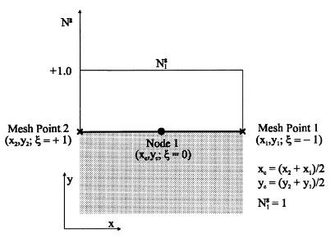 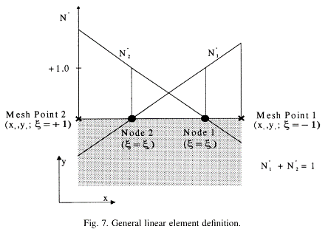 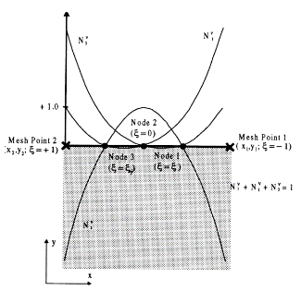

**Fig. The definition of constant, discontinues linear and discontinues quadratic elements.**

The shape function for constant (CST), discontinues linear (DL) and discontinues quadratic (DQ) elements in Eq. 8-9 can be expressed as follows:

CST Element 

DL Element 

DQ Element 

where *d* is the collocation factor (1/2,1) which is the local offset distance from the two ends of an element. For the different elements, the six integrals now can be adapted as follows:



***Constant Element:***

When the field point is not located on the element:







When the field point is located on the element, the singular integral can be evaluated as follows:



***Linear Elements***

When the field point is not located on the element:











When the field point is located on the element, the singular integral can be evaluated as follows:









***Quadratic Elements***

When the field point is not located on the element:











When the field point is located on the element, the singular integral can be evaluated as follows:









**Appendix A. Analytical Integrals in BEM**

Defining the discriminant ∆ as follows:



In BEM ∆ is always less or equal to 0, when ∆=0, the field point is collinear with the element line segment.

***A.1 First kind of integral:***

The first kind of Integral A can be calculated as follows:



 



***A.2 Second kind of integral:***

The integral F and G can be defined as follows (Zhang et al. 2003):



***A.3 Third kind of integral:***



Some of common integrals can be simplified as follows:





***A.3 Singular Integral 1:***

The special singular integration need to be evaluated using Cauchy Principle Value integral can be summarized as follows:





Noted that if xi=-1, the ln(1+xi) is equal to infinity, thus xi=1-1E-15 can be used to treat this issue.

***A.3 Singular Integral 2:***



