**DS-Algo Assignment#1 - ETL**

**Tasks**

Create Python script in AWS EC2 to fetch data from finnhub, and load it to AWS RDS:

You can choose any data;

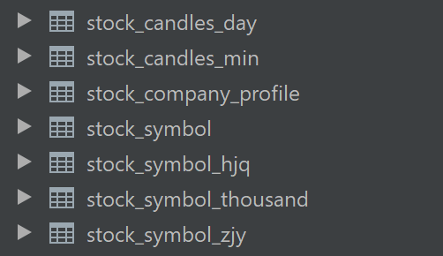

You can use any of these libs: request, finnhub-python, petl, pandas, etc.



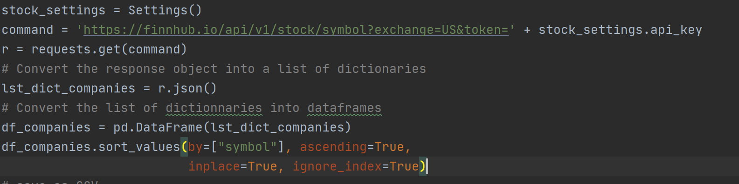

Create shell script to run above job automatically and recursively:

You can use any job scheduling tools, prefer use crontab



Implement simple alter/notification system:

Notify ETL job finished status, either via email or SMS

Sending Alert during etl job if anything need immediate attention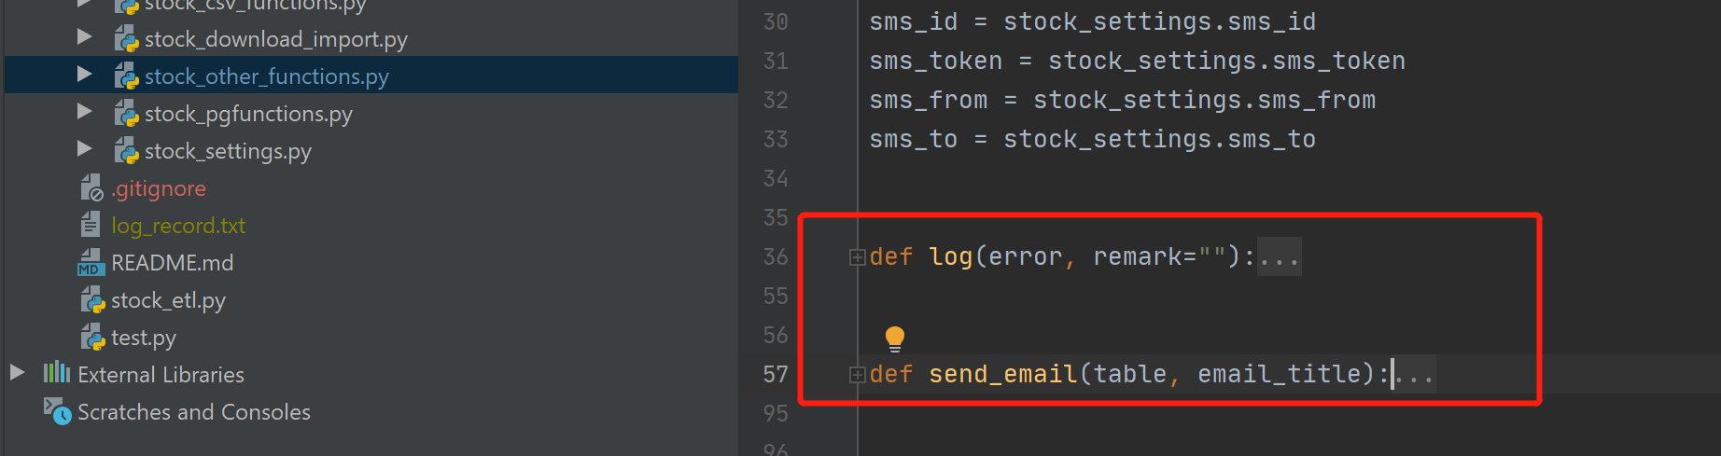

**Mark**

Satisfactory (60%)

15-Data was loaded from finnhub to AWS RDS;

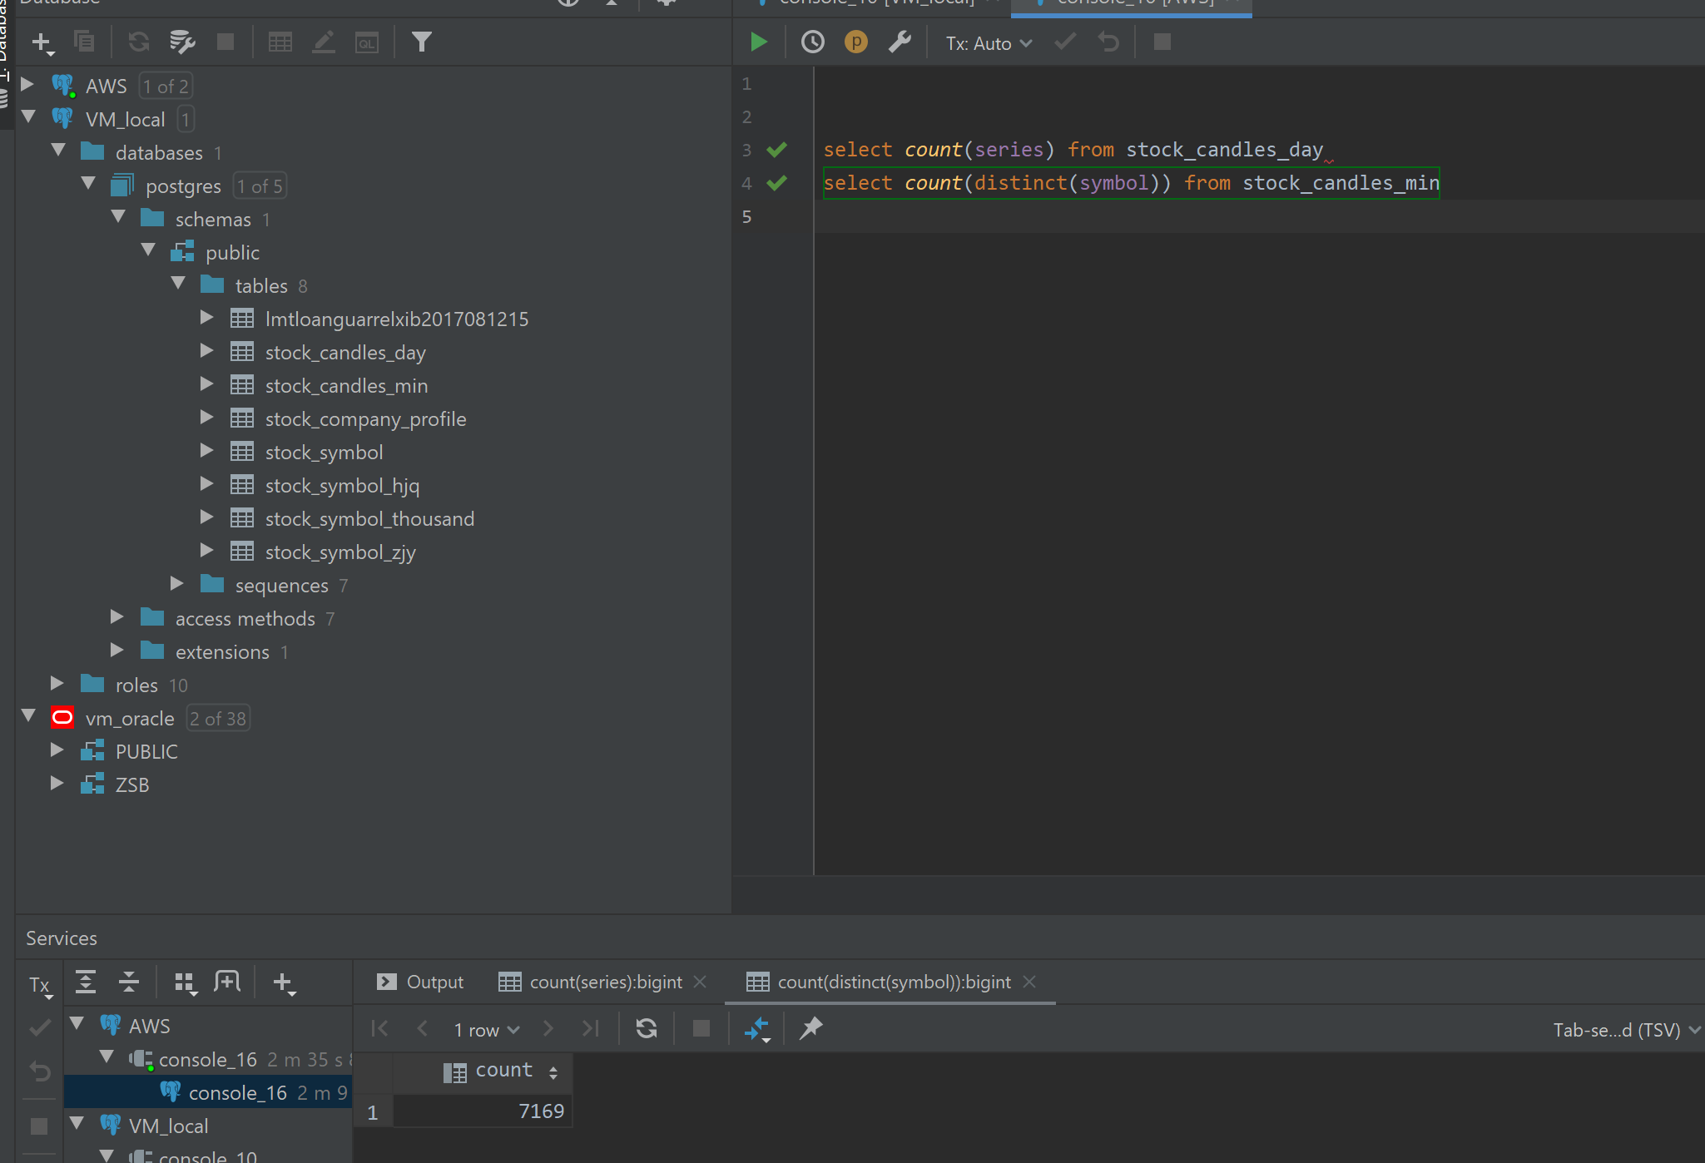

10-Job was scheduled and runs well;

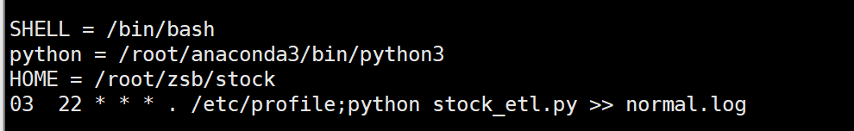

10-Notification / Alert works as expected;

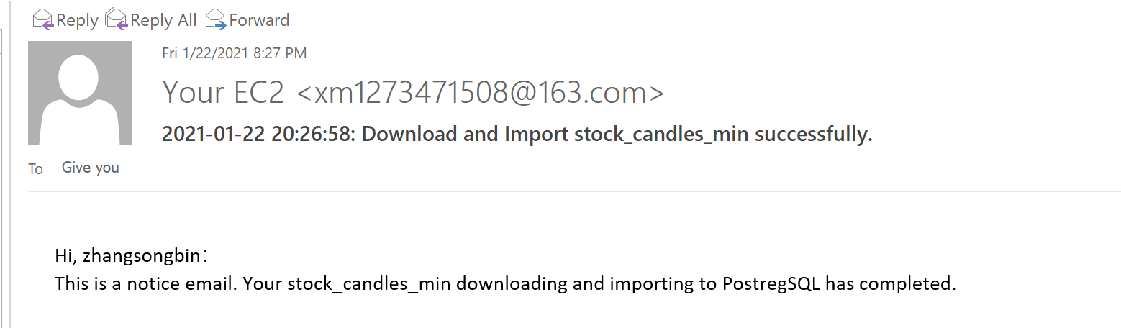

10-Applied basic best practice;

10-Clear project structure;

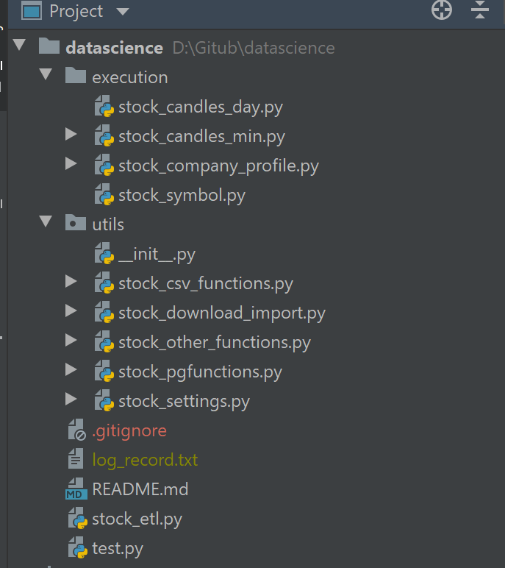

5-DB credential well managed;

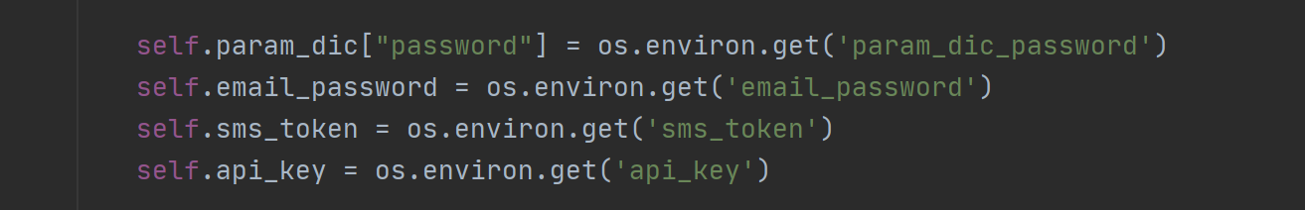

Above and beyond (40%)

10-Exceptions handled properly;

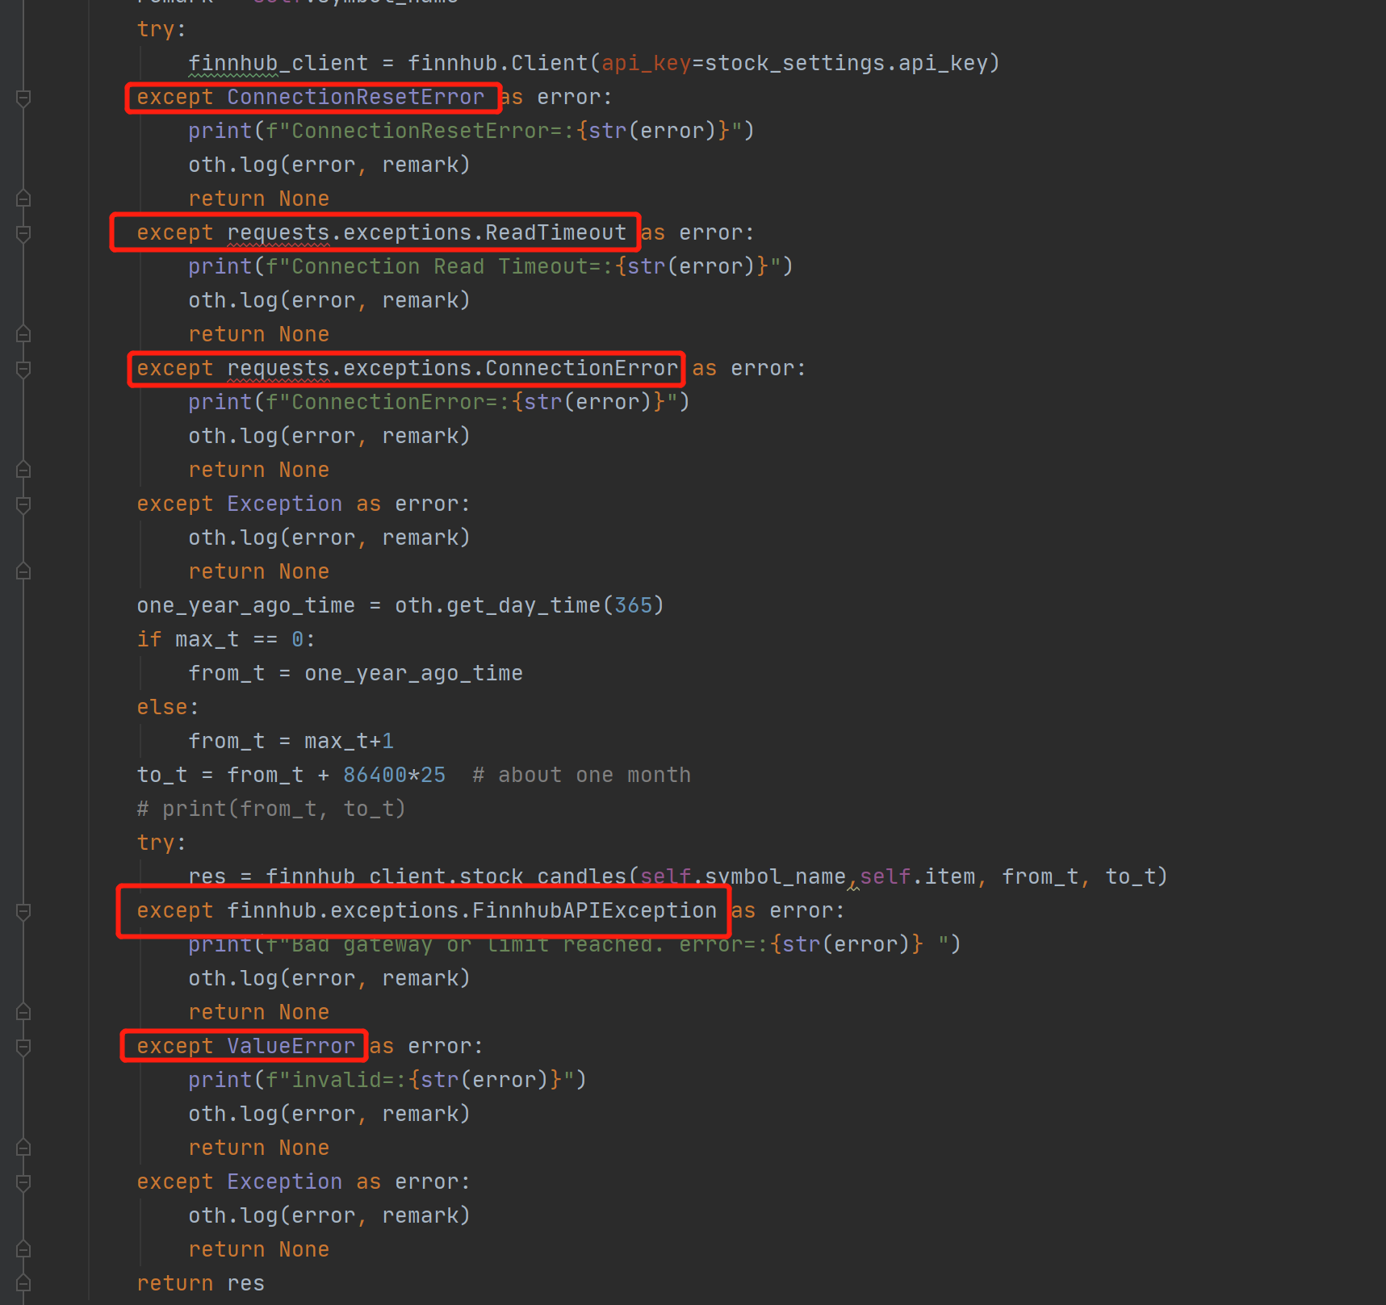

10-Small jobs running parallel/dependently;

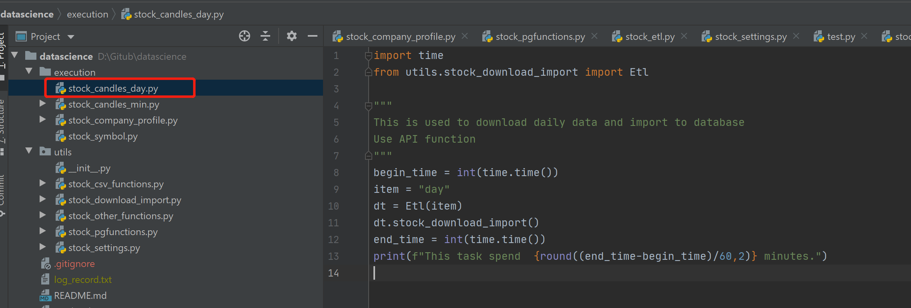

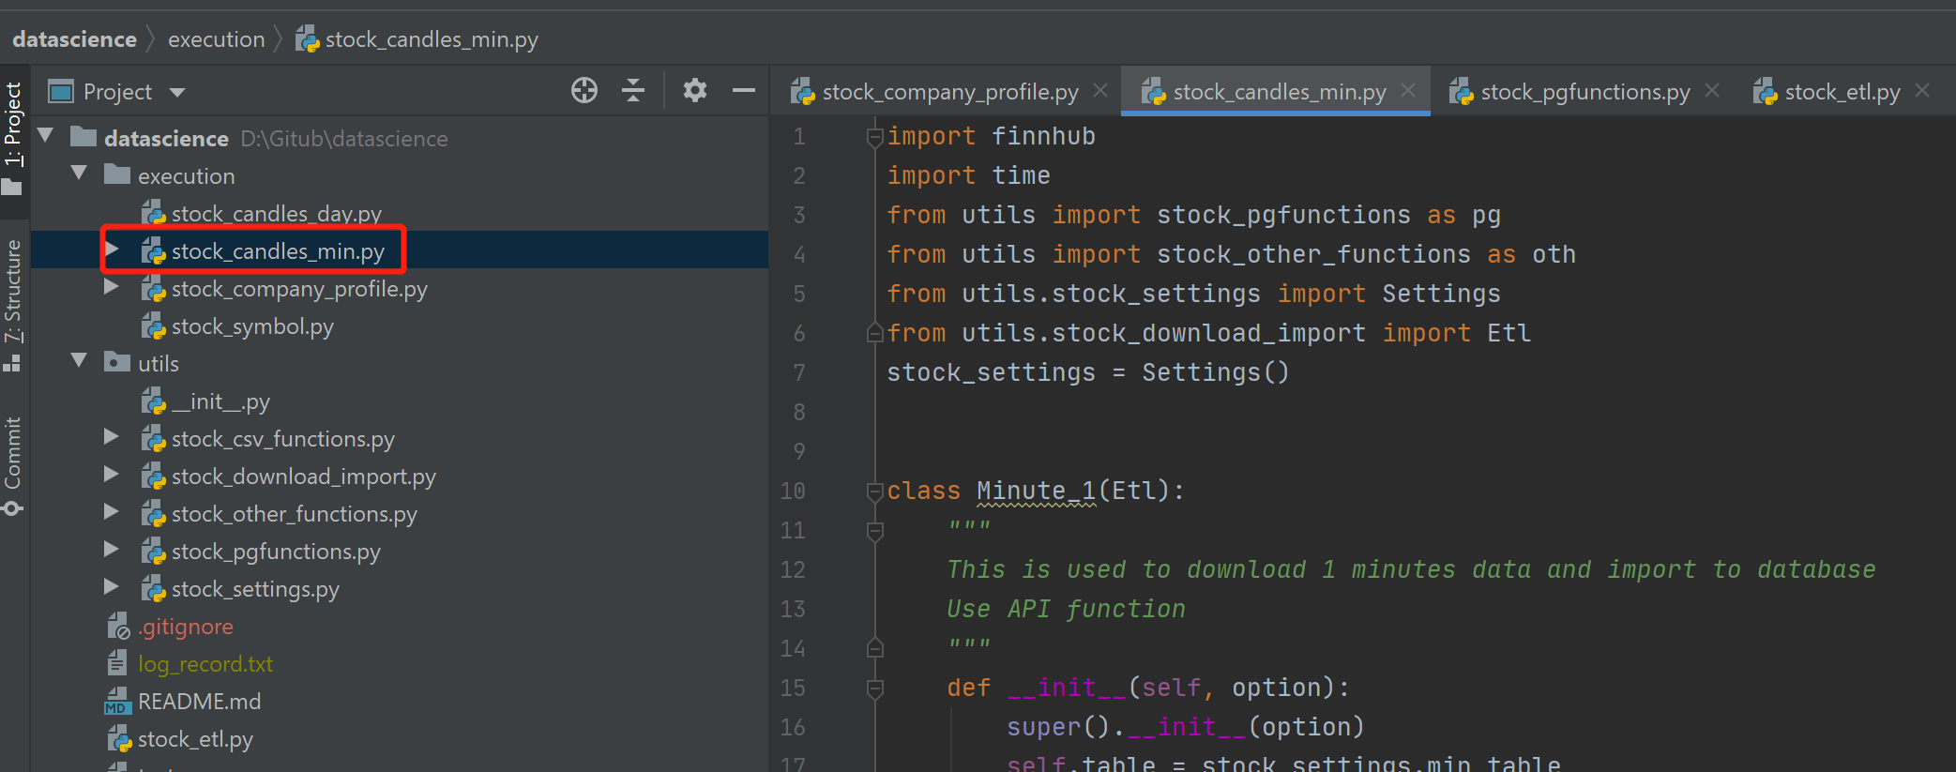

10-Applied most best practices;

5-Multiple solutions for loading, eg, use API and lib;





5-Dual channels(Email, SMS) for notification/alert;

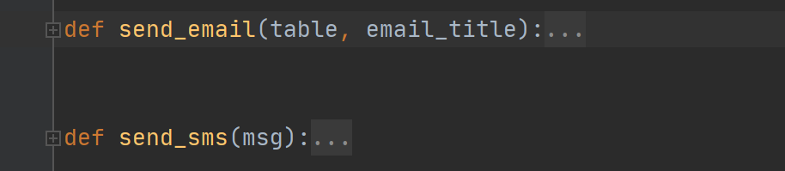

Nice to Have(20%)：

5-Configurable ETL behaviour;

5-Considered performance;



5-Unit test available;

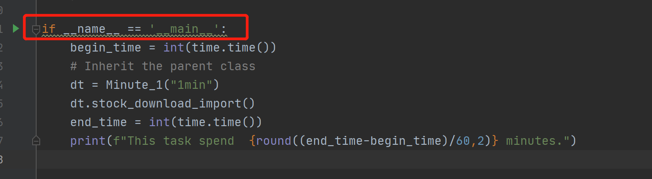

5-All ETL jobs are idempotent;

**Submit process**

**DB** : Create a user in your RDS with read access to all your tables

User name: algo

password: DS-Algo-ETL

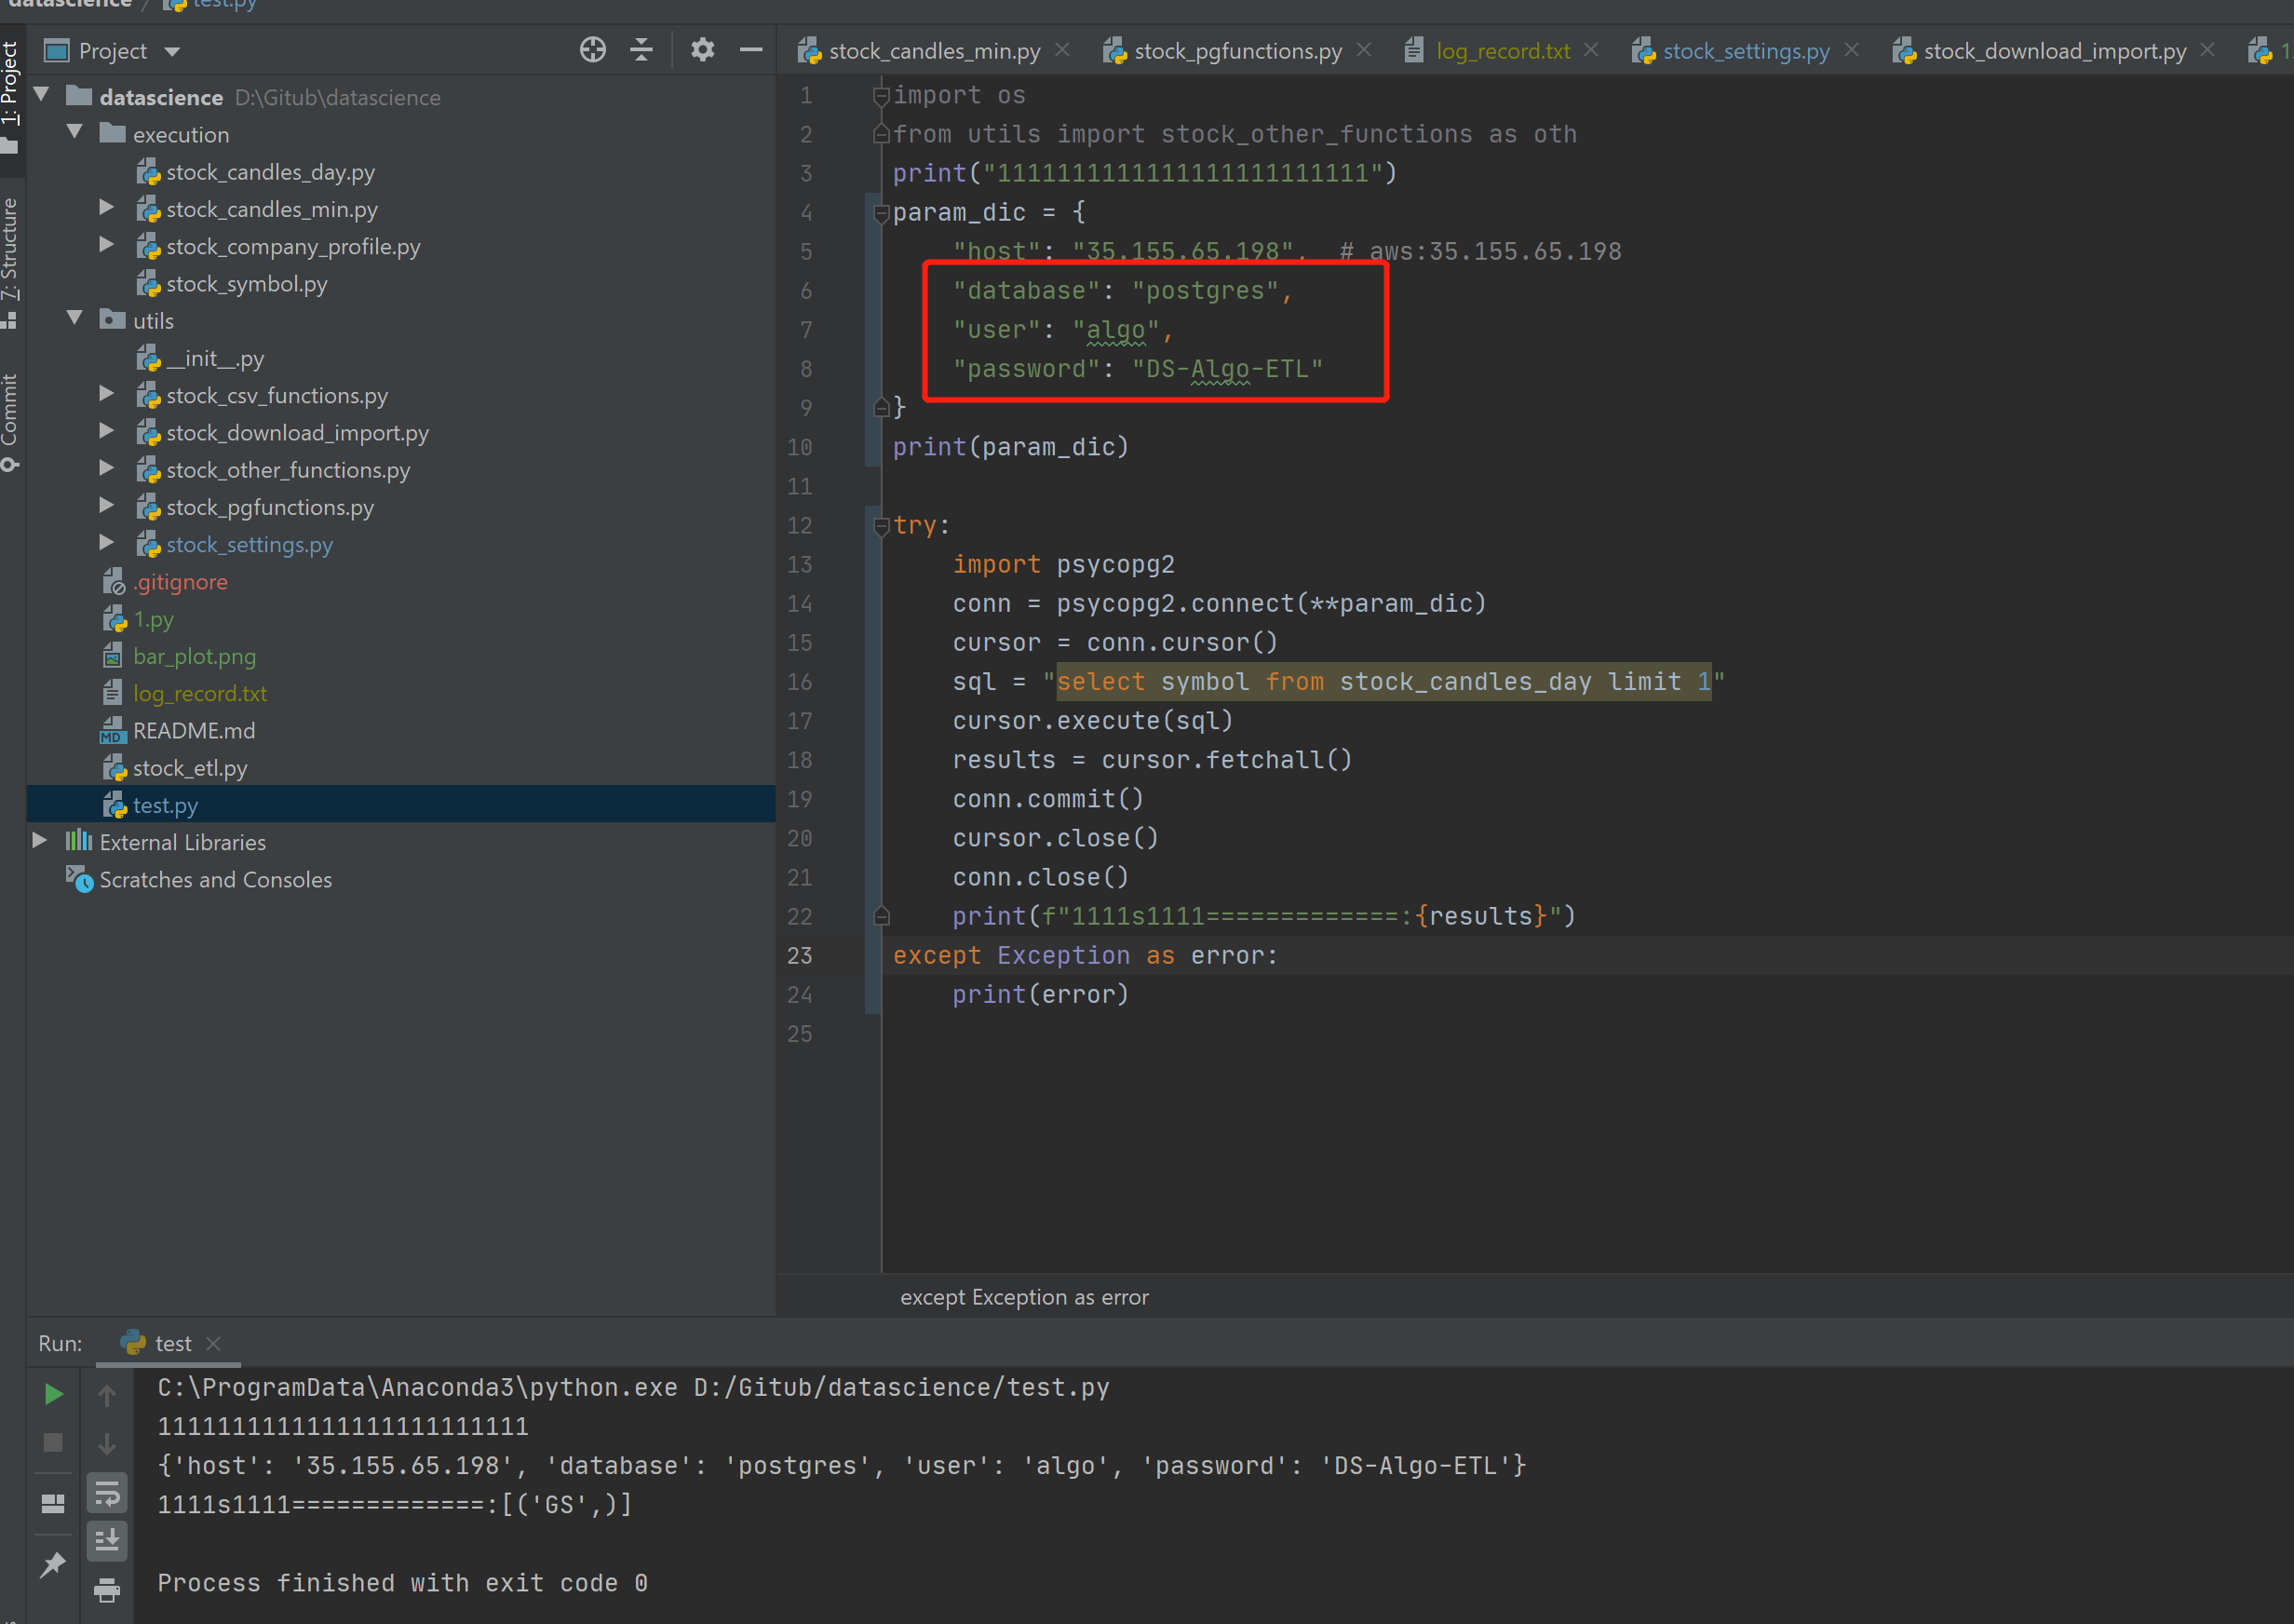

**Code** : Fork repo from github.com/BinYuOnCa/Algo-ETL and add your code

Create a new branch, name it as your name in WeChat group, use pinyin if needed

Add all you code into the branch, and follow best practice to submit/push

File a pull request when you are done

You can push code anytime, but only those filed before the due date will be accepted