1. Introduction

1.1. Background

Big data has made it a requisite for people in a variety of industries to be able to interpret and present data effectively. Data visualization is at the front line of this capability because it helps translate complex data sets into insights that are both understandable and applicable. Data visualization makes visible the relationships, patterns, and trends that might otherwise be obscured in raw data, something it does through graphical representations such as charts, graphs, and maps. This assignment looks forward to communicating insight using a number of effective strategies with the help of a given dataset. Data visualization indeed makes the tasks of data cleaning, data structure exploration, outlier and unusual group detection, trend and cluster identification, local pattern detection, number of results output, and further evaluative task of modeling output easy (Unwin, 2020).

1.2. Importance of Data Visualization

Technology of data visualization means creation of interactive visuals that can be used for the analysis of patterns, variations, and extraction of insightful information from the data. Actually, data cleaning and verification, data discovery and exploration, and results communication to the business partners are the three major purposes for visualizing data by any organization (Sharma, 2020, p-4). It is not any way the step of putting in graphical form; instead, it is the prime segment of data analysis and incidence of the decision-making process. Key reasons for the importance of data visualization:

- Enhanced Understanding: Any complex information can be easily and quickly understood with the use of visual representations.
- Patterns and Trends Recognition: Many of such trends and relationships, along with potential outliers, could be missed with pure text analytics, whereas visualizations can do that.
- More Effective and Far Reaching Communication: This means that results can more powerfully and thoroughly be communicated to non-technically oriented stakeholders through visual data, which is in turn more appealing.
- Decision Making: The visualizations work as a support system and help in making better decisions by bringing forward the salient data points and pattern.

Data visualization is an extremely powerful part of the data-driving project since it works just fine in filling up the gap between data analysis and data understanding.

1.3. Objective of the Assignment

To create a data visualization project that will show key findings and conclusions from the chosen dataset. The major key steps involved include selection of an appropriate and interesting dataset, cleaning and preparation of the data, and using multiple visualization techniques to present information from the dataset in a compelling and meaningful way. The main aim of the initiative is to:

- Picking the right dataset: Identifying and selecting a dataset from a variety of domain fields that incorporates social media, healthcare, finance, and sport, such that it has adequate data points for readily apparent cutting analysis.
- Data cleaning and preparing: clean up missing data in the dataset, treat it into the right formatting for data visualization, and do away with incomplete or irrelevant data.
- Utilize Various Visualization Techniques: The different techniques of visualization that could be used to represent data in an appropriate manner include a graph, chart, and map.
- Create a Story Flow: Develop a coherent story that will take the user through the visualizations while explaining the goal, revelations, and drawn conclusions from the data.
- Design and Aesthetics: Make sure that the visualizations are designed well with aesthetics; not just good-looking but also with meaning.

The students in this project apply their acquired knowledge in every aspect of the development process of a project on data visualization, starting from the process of selecting and preparing data, to the final design of data visualization.

2. Dataset Selection

2.1. Importance of Dataset Selection
An essential first step in any data visualization project is choosing the appropriate dataset. The dataset serves as the basis for all further analysis and visual aid creation. Relevance, accuracy, and value of the insights obtained are guaranteed by using a suitable dataset. It makes it possible to spot significant trends and patterns, which aids in the making of wise decisions. On the other hand, a badly selected dataset can undermine the project as a whole by producing false conclusions and ineffective visualizations.

2.2. Criteria for Choosing a Dataset

There are a few important factors to take into account when choosing a dataset for a data visualization project:
1. Relevance: The dataset ought to be relevant to the subject or inquiry under investigation. It should fit the objectives of the project and the preferences of the target audience.
2. Data Quality: There should be few missing or incorrect values in the dataset. Reliability and accuracy of the conclusions drawn are guaranteed by high-quality data.
3. Size and Scope: Enough data points should be included in the dataset to enable thorough analysis and visualization. To prevent needless complexity, it should also be a manageable size.
4. Accessibility: Ideally, the dataset can be accessed with ease from reliable sources. The best datasets are those that are openly accessible so that anyone can use and share them.
5. Diversity of Data: Richer visualizations and more thorough analysis are possible with a diverse dataset that has a range of attributes.

2.3. Available Dataset Options

The following dataset options are available for this assessment, and each presents special chances for analysis and visualization:

- Kaggle Data Set: Kaggle offers a sizable collection of datasets from a variety of industries, such as social media, healthcare, and finance. These datasets are appropriate for a variety of data analysis and visualization projects since they are frequently well-structured and include metadata.

- ONS Covid-19 Data: Information on Covid-19, including case counts, mortality rates, and vaccination statistics, is included in this dataset from the Office for National Statistics. It is useful for displaying pandemic-related trends and patterns.

- Data on Births, Deaths, and Marriages: This dataset offers a foundation for examining demographic trends over time and includes important statistics like birth, death, and marriage rates.
- Data on Business, Industry, and Trade: This dataset is perfect for visualizing economic trends and industry-specific insights because it includes trade statistics, business performance metrics, and economic indicators.
- Data on Employment and Labor Market: This dataset provides demographics of the workforce, employment rates, and labor market trends. It is helpful for analyzing the labor market and employment trends.
2.4. Reasons for Selecting the Dataset
The “Kaggle” dataset was chosen for this assessment. There are number of significant factors for choosing the dataset from “Kaggle” and they are:
- Relevance: There are many different types of datasets available on Kaggle, including ones related to social media, sports, healthcare, finance, and other topics. Due to its diversity, a dataset that closely matches the objectives of the project and the target audience can be chosen. Kaggle offers databases that are extremely pertinent and current, regardless of the topic being studied economic trends, health statistics, social media analytics, or any other area.
- The Quality of Data: The datasets that are made available on Kaggle are typically reliable and well-maintained.
- Scale and Range: The size of the datasets on Kaggle ranges from small datasets perfect for exploratory analysis to large datasets fit for more intricate, in-depth studies. This flexibility makes it possible to choose a dataset that is suitable in size for the project's scope. A sufficiently large dataset allows for both robust analysis and manageability for tasks involving data processing and visualization.
- Accessibility/Usability: Kaggle datasets are readily available and frequently come with in-depth documentation and community dialogues.
- Variety of Data: Numerous attributes and data types, such as numerical, categorical, time series, and geographic data, are among the diverse datasets available on Kaggle.
- Collaboration and Support from the Community: Data scientists and analysts have a thriving community on Kaggle where they actively share their work, ideas, and techniques.
- Possibility of Visualization: A multitude of visualization techniques are supported by the structure and richness of Kaggle datasets. Kaggle datasets offer the depth and detail required to create intricate time series plots, interactive dashboards, heat maps, and other complex visual representations.
3. Data Cleaning and Preparation

3.1. Dataset Overview

The dataset includes details on a range of Abu Dhabi rental properties, such as villas, apartments, and penthouses. Rent, the number of bedrooms and bathrooms, the type of property, the area, the rent per square foot, the rent category, and other details like the purpose, the furnishing status, the posted date, the location, and the geographic coordinates are all included. This dataset was obtained from Kaggle, which is reputable and offers a wealth of datasets for analysis (e.g., Kaggle, a government database, or the public data archive of a research institution). The platform makes sure the information is anonymized and conforms to all applicable data protection laws, which qualifies it for use in scholarly and research-focused projects. For further details about the dataset and its license directly get from the URL https://www.kaggle.com/datasets/azharsaleem/real-estate-goldmine-dubai-uae-rental-market.
- Summery of key Columns
1. Address: Provides the property's address.
2. Rent: The property's annual rental cost, expressed in AED.
3. Beds: The property's number of bedrooms.
4. Baths: The quantity of restrooms on the premises.
5. Type: Property type, such as an apartment, penthouse, or villa.
6. Area in sqft: This is the property's area measured in square feet.
7. Rent_per_sqft: The cost per square foot of rental space.
8. Rent_category: Designates Medium or High rent.
9. Frequency: The annual frequency of rent payments is indicated.
10. Furnishing: Specifies whether or not the property has furniture.
11. Purpose: The listing's (for rent) purpose.
12. Posted_date: The day on which the listing was made.
13. Age of listing in days: The duration in days that have elapsed since the property was listed.
14. Location: The precise location of the property within Abu Dhabi.
15. City: Abu Dhabi, the location of the property.
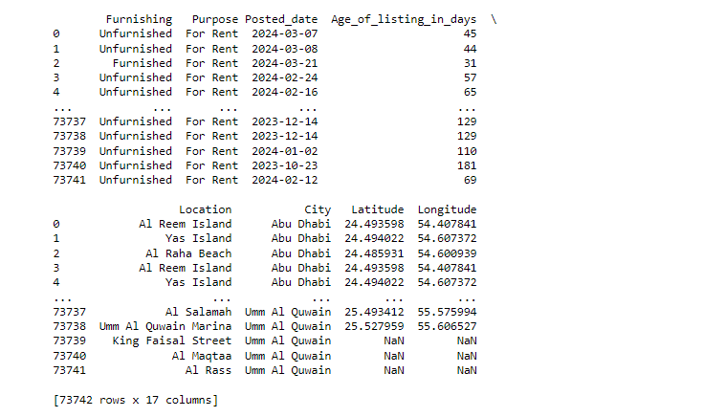
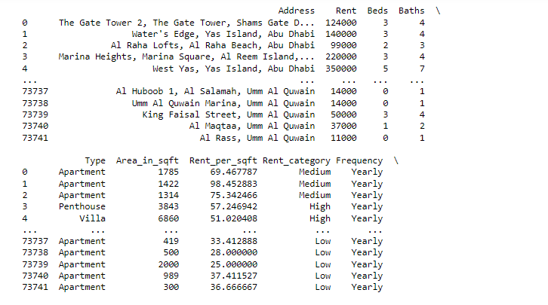
16. The property's geographic coordinates are Latitude and Longitud
[Figure 1: Dataset Overview]

3.2. Importance of Data Cleaning

In the process of analyzing and visualizing data, data cleaning is essential. Ensuring the integrity and reliability of data requires locating and fixing errors, inconsistencies, and inaccuracies within the dataset. Analyzing data properly helps to avoid drawing incorrect conclusions and improves the quality of the insights that are obtained. Improper interpretations and decisions may result from faulty visualizations if data is not thoroughly cleaned.

3.3. Steps in Data Cleaning and Preparation

1. Data Inspection : To begin, carefully examine the dataset to ascertain its types, organization, and any obvious problems. This entails going over the initial statistics (such as mean, median, and standard deviation) as well as the column names and data types.
2. Data Cleaning: Recognize and manage incomplete or irrelevant data, address any missing values, and fix any errors.
3. Data Transformation: Prepare the data in a way that makes sense for analysis and display. This could entail creating new calculated fields, normalizing values, and converting data types.
4. Data Validation: Verify that the data has been cleaned, prepared, and is accurate before analyzing it. This entails making sure that all transformations have been applied correctly and looking for any remaining inconsistencies.
5. Removing Irrelevant Data: Find the rows and columns that don't pertain to the analysis or visualization objectives. For instance, the dataset can have columns removed if they contain unique identifiers that have no analytical value or otherwise don't contribute to the analysis.
6. Filtering Missing or Incomplete Data: Find the rows that contain incomplete or missing data. Rows that have a small amount of random missing data may be eliminated in order to preserve the integrity of the dataset. Any row missing values may be excluded for essential columns.
7. Managing Particular Columns: Make sure that the dataset you are given includes all the columns you need for analysis, such as "Rent," "Beds," "Baths," "Area_in_sqft," and "Rent_per_sqft."
8. Identifying Missing Values: Utilize pandas to run Python functions such as `.isnull()` or `.isna()} to find missing values in the dataset.
9. Imputing Missing Values: Approximate missing values using methods such as mean, median, or mode substitution, depending on the type of data. If "Rent_per_sqft" is absent, for instance, the mean value of that column can be used to fill it.
10. Removing Rows/Columns: If there is a significant proportion of missing values in a column and imputing is not practical, you may want to remove that column. Rows that contain crucial missing values may also be eliminated.
11. Consistent Data Types: Verify that correct and consistent data types are present in every column. For example, the values for "Rent", "Beds", "Baths", and "Area_in_sqft" should all be numbers, but the value for "Posted_date" should be a date.
12. Categorical Data: Modify the format of the category columns. "Type," "Furnishing," and "Rent_category," for instance, are examples of categorical variables.
13.Date Formatting: Verify that date columns are formatted as datetime objects in the correct way. Time-series analysis and visualizations require this.
14. Geospatial Data: Check that the values for latitude and longitude are formatted correctly and consistently in order to use them in geospatial displays.
3.4. Data Cleaning and Preparation for the Abu Dhabi rental properties Dataset

1. Inspection: Examine the dataset to gain a basic understanding and note any pressing problems.
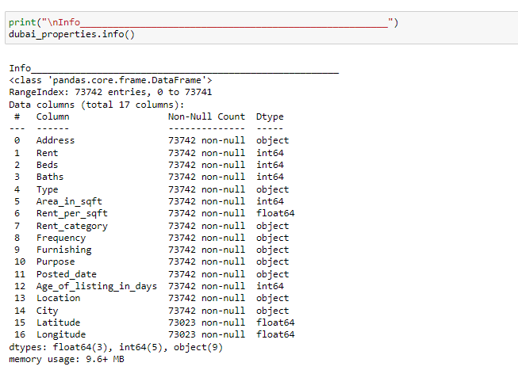

[Figure 2: Basic Information about dataset

2. Handling Missing Values:
- Find any values that are missing from important columns.
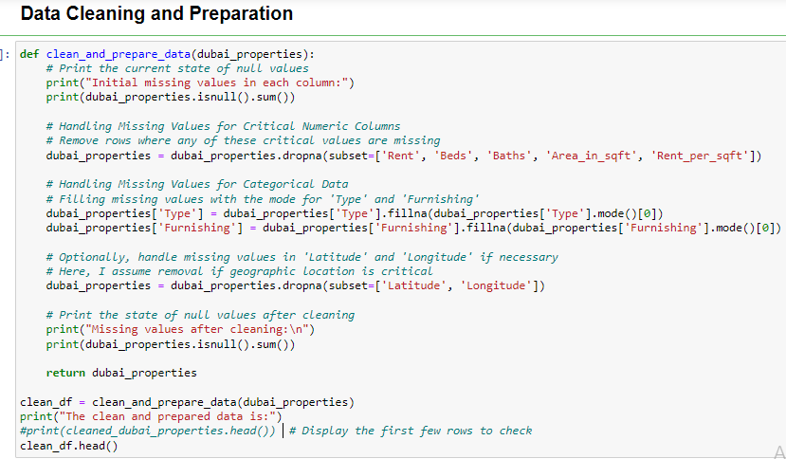

[Figure 3: Data Cleaning and Preparation steps for the Abu Dhabi rental properties Dataset]
3. Formatting:
- Verify that the numerical columns are formatted as floats or integers appropriately.
- Change "Posted_date" to a datetime format. Sort the following categories: "Type," "Furnishing," and "Rent_category."
- Check longitude and latitude values for geographic mapping.
4. Validation: Verify that all transformations are accurate and examine the cleaned data again for any lingering inconsistencies.
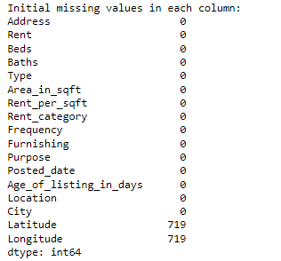

[Figure 4: Initial missing values]
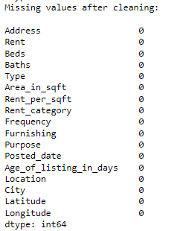

[Figure 5: Missing values after data cleaning]

4. Visualization Techniques, Storytelling & Interpretation

4.1. Introduction to Visualization Techniques
A key component of data analysis is visualization techniques, which provide a link between intricate datasets and useful insights. The ability to visualize data effectively is essential for making sense of large amounts of data in an era where data is everywhere. Through the use of visualization, analysts can spot trends, patterns, and anomalies that may not be obvious from just looking at raw data. Through the use of visual aids like charts, graphs, and maps, visualization techniques can help people comprehend data-driven findings more deeply and communicate them more effectively. Few (2006) asserts that when data is presented in text or tabular form, ineffective data visualization can "tell a story" that is not immediately apparent.
In order to properly present the provided dataset, this section aims to explain different visualization techniques and provide examples of how to apply them. We will illustrate the effectiveness of visual aids in identifying and communicating important insights by examining various visual representations, such as scatter plots, histograms, pie charts, bar charts, and geospatial maps. By giving a thorough overview of the techniques and tools available, this section hopes to improve the data analysis process by converting unprocessed data into understandable and informative visual representations. We want to make sure that the visualizations improve comprehension and facilitate data-driven decision-making, which is why we are conducting this investigation.

4.2. Importance of Visualization Techniques
The ability to convert complicated datasets into comprehensible and useful insights makes visualization techniques essential for data interpretation. When presented in text or numerical form, raw data can be intimidating and challenging to understand. By presenting data in a graphical format, visualization makes this complexity easier to understand and makes it simpler to spot patterns, trends, and relationships. For example, Anscombe's quartet highlights the significance of visualization in exposing underlying data structures by showing how datasets with the same statistical properties can display remarkably different characteristics when graphed (Anscombe, 1973).
Data visualization makes use of visual components like graphs, charts, and maps to help analysts identify trends and outliers that may go unnoticed in raw data formats. This is especially crucial for big datasets, for which manual analysis is not feasible. Understanding the distribution and frequency of data points, comparing various data categories, and identifying trends over time are all made easier with the help of visualization.
There are numerous advantages to proficient data visualization.
- Better Understanding: By placing complex data in a visual context, visualization improves understanding. This facilitates the quicker understanding of complex ideas by users and increases the accessibility of large data sets (Ware, 2019). By emphasizing important data points and trends, visualizations can streamline data analysis and facilitate the extraction of insightful knowledge.
- Better Communication of Insights: Regardless of an audience's level of technical proficiency, data visualizations offer a universal language. They make it possible to present data findings succinctly and clearly, which facilitates the sharing of insights with stakeholders and advances understanding among all parties (Kirk, 2019). For instance, a well-designed graph can convey financial health information about a company more effectively than a spreadsheet jam-packed with data.
- More Capable of Making Decisions: Better decision-making is supported by visualizations, which offer a clear view of the data. They enable decision-makers to quickly assess the implications of data and base their choices on verifiable facts. As a result, strategies and actions in the fields of business, healthcare, education, and other areas may become more informed (Few, 2012).
In conclusion, data interpretation requires the use of visualization techniques, which are essential. They facilitate well-informed decision-making processes and improve communication of findings in addition to helping to reveal hidden patterns and relationships.
4.3. Storytelling in Data Visualization
In data visualization, storytelling combines narrative components with data to effectively communicate insights. By using this method, unstructured data is transformed into insightful narratives that improve information comprehension and engagement. Giving context, concentrating on important insights, making sure the narrative flows logically, and boosting visual appeal are all important aspects of storytelling in data visualization.
Narrating a story puts data into context by leading the audience through the data journey and highlighting important discoveries. Storytelling enhances the memorability and impact of data presentations by arranging them logically and visually appealingly. It guarantees that viewers will be able to connect with the information and derive insights that will ultimately improve comprehension and decision making. Good data visualization storytelling puts data in context, leads the viewer through the data journey, and highlights key discoveries (Kirk, 2019).
4.4. Choosing Appropriate Visualization Techniques for Abu Dhabi rental properties Dataset

The many kinds of visualizations each have their own specific function in effectively presenting data. Maps, bar charts, line charts, pie charts, scatter plots, and other visual aids are examples of common visualizations. There are strengths specific to each type. Your goal and the type of data you want to visualize will determine which visualization type is best. Good visualization facilitates better decision-making and communication by making complex data more accessible and understandable (Kirk, 2019).
4.4.1. Bar Chart
A bar chart is a popular data visualization method wherein rectangular bars with lengths proportionate to the values they represent are used to display data. Bar charts are especially useful for comparing various data categories because they make it easy for viewers to identify the distinctions and similarities between the categories. It is possible to arrange bar charts vertically or horizontally. Although vertical bar charts, also called column charts, are often used to display data over time or to compare multiple items side by side, horizontal bar charts are typically used when the category names are lengthy, allowing more space for text. Bar charts have many benefits, chief among them being their accessibility and ease of understanding to a wide range of users. This simple design facilitates the quick identification of patterns, trends, and outliers in the data. Furthermore, bar charts are incredibly adaptable and can be used to effectively present and analyze categorical data in a variety of fields, including business, education, and research (Knaflic, 2015).

- Bar Chart for Abu Dhabi rental properties Dataset for Identifying the Most and Least Expensive Areas for Renting

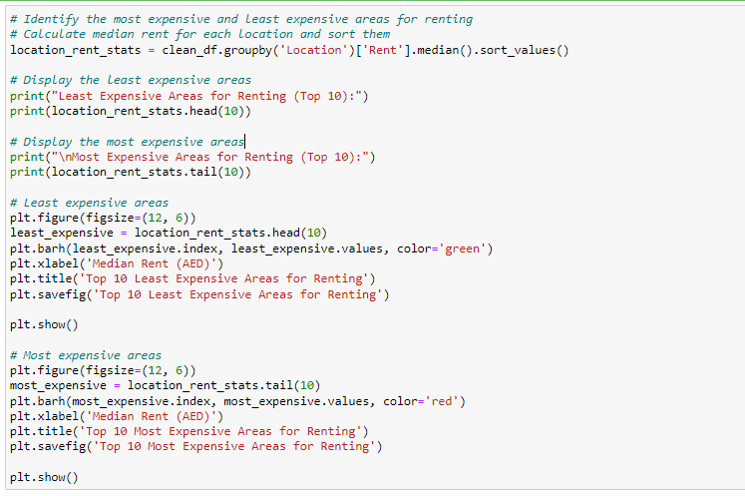
[Figure 6: Figure of python code to identify the most expensive and least expensive area for renting]

Code Explanation:
Identifying the Most and Least Expensive Areas for Renting
- location_rent_stats = clean_df.groupby('Location')['Rent'].median().sort_values()
- clean_df.groupby('Location')['Rent']: This groups the DataFrame `clean_df` by the 'Location' column and selects the 'Rent' column for further operations.
- .median():calculates the median rent for each location.
- .sort_values():sorts the median rent values in ascending order.
- print("Least Expensive Areas for Renting (Top 10):")
- print(location_rent_stats.head(10)): -This selects the first 10 entries.
- print("\nMost Expensive Areas for Renting (Top 10):")
- print(location_rent_stats.tail(10)): selects the last 10 entries (the most expensive areas).

Visualize the Least Expensive Areas:

- plt.figure(figsize=(12, 6)): This sets the size of the figure to 12 inches wide by 6 inches tall.
- least_expensive = location_rent_stats.head(10): This assigns the top 10 least expensive areas to the variable `least_expensive`.
- plt.barh(least_expensive.index, least_expensive.values, color='green'): This creates a horizontal bar chart with locations on the y-axis and median rent on the x-axis. The bars are colored green.
- plt.xlabel('Median Rent (AED)'): This labels the x-axis as 'Median Rent (AED)'.
- plt.title('Top 10 Least Expensive Areas for Renting'): This sets the title of the chart.
- plt.savefig('Top 10 Least Expensive Areas for Renting'): This saves the chart as an image file with the specified name.
- plt.show(): This displays the chart.

Visualize the Most Expensive Areas:
- plt.figure(figsize=(12, 6)): This sets the size of the figure to 12 inches wide by 6 inches tall.
- most_expensive = location_rent_stats.tail(10): This assigns the top 10 most expensive areas to the variable `most_expensive`.
- plt.barh(most_expensive.index, most_expensive.values, color='red'): This creates a horizontal bar chart with locations on the y-axis and median rent on the x-axis. The bars are colored red.
- plt.xlabel('Median Rent (AED)'): This labels the x-axis as 'Median Rent (AED)'.
- plt.title('Top 10 Most Expensive Areas for Renting'): This sets the title of the chart.
- plt.savefig('Top 10 Most Expensive Areas for Renting'): This saves the chart as an image file with the specified name.
- plt.show(): This displays the chart.

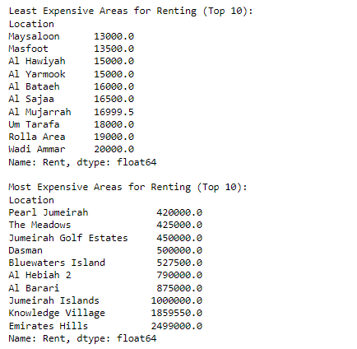

[Figure 7: Least and Most Expensive Areas for Renting(Top 10)]

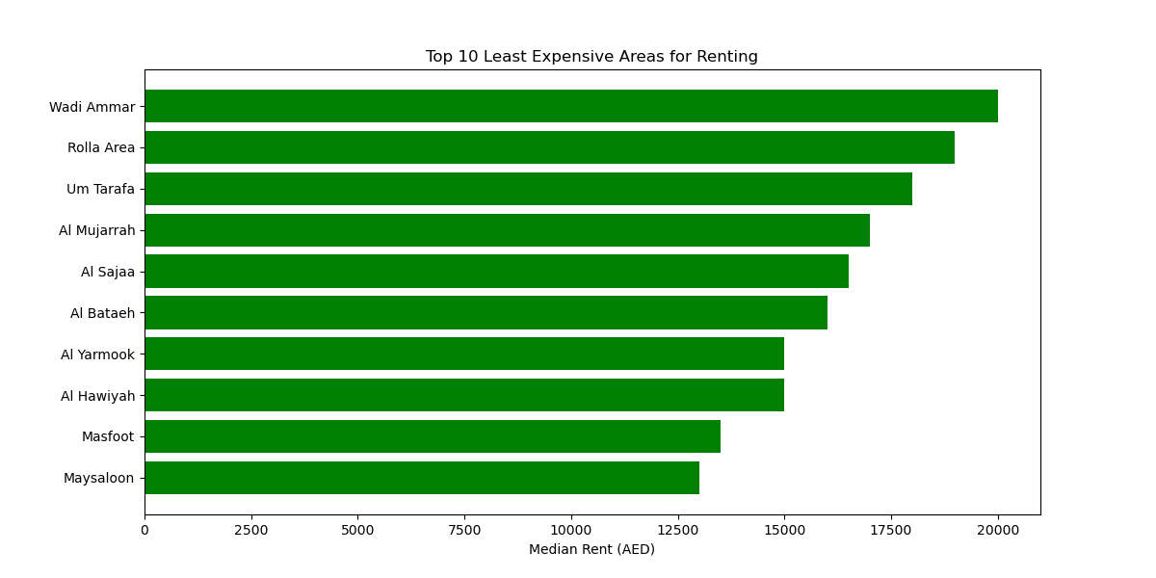
[Figure 8: Bar Graph showing Top 10 Least Expensive Areas for Renting]
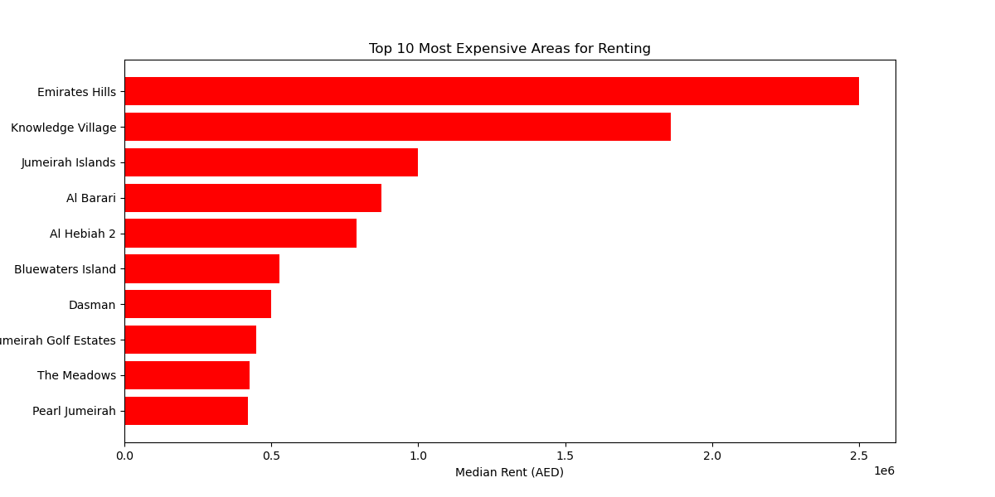
[Figure 9: Bar Graph showing Top 10 Most Expensive Areas for Renting]

Interpretation of the Charts:
- Least Expensive Areas for Renting Chart:
- Visualization: Ten horizontal bars, one for each location, will be displayed on the chart. The median rent for that location is reflected in the length of each bar.
- Color: The green bars indicate affordability visually.
- Insights: For people or companies searching for affordable rental options, this chart is helpful in rapidly determining which areas have the lowest median rents.

- Highest Renting Areas Chart:
- Visualization: This chart will display ten horizontal bars, each of which represents a location, much like the least expensive chart. The median rent for that location is reflected in the length of each bar.
-Color: Higher costs are visually indicated by the red bars.
- Insights: This graph is helpful for comprehending premium rental markets and areas where affluent people may congregate because it makes it easy to see which places have the highest median rents.

Both charts highlight the extremes in rental prices within the dataset and offer a clear visual comparison of costs across various locations.

4.4.2. Histogram
A histogram is a kind of bar chart that shows the frequency of data points within designated intervals, or bins, to depict the distribution of numerical data. The distribution and frequency of continuous data are displayed using histograms, as opposed to standard bar charts, which makes them perfect for identifying underlying patterns and trends in datasets.
When determining the normal distribution, skewness, and presence of outliers in the data distribution, histograms are especially helpful. They provide information about the general structure of the data by enabling analysts to see the central tendency, dispersion, and variability of the data. A histogram, for example, can show whether data is dispersed over a range of values, uniformly distributed, or concentrated around a specific value.
Selecting suitable bin widths is crucial for creating a histogram that accurately depicts the distribution of the data. Important details may be obscured by too few bins, and the histogram may become excessively complex and challenging to understand by having too many bins. Thus, choosing the appropriate bin width is essential to producing a useful histogram (Knaflic, 2015).
- Creating Histogram for Abu Dhabi rental properties Dataset for rent price distribution
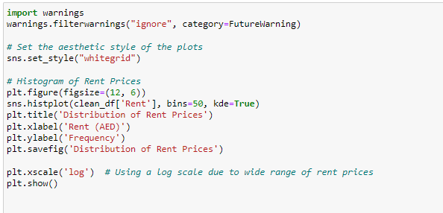
[Figure 10: Figure of code to generate Histogram]
Code Explanation:
-Histogram of Rent Prices
- plt.figure(figsize=(12, 6)): Sets the figure size.
- sns.histplot(clean_df['Rent'], bins=50, kde=True): This line use the Seaborn library to creates a histogram.
- plt.title('Distribution of Rent Prices'):- This line sets the title of the Histogram.
- plt.xlabel('Rent (AED)'):-This line labels x – axis as 'Rent (AED)’.
- plt.ylabel('Frequency'):- This line labels the y-axis as 'Frequency', indicating the number of occurrences of each rent price interval.
- plt.savefig('Distribution of Rent Prices'):- This line saves the histogram.
- plt.xscale('log') :- The x-axis's scale is changed to a logarithmic scale by this line.
- plt.show()
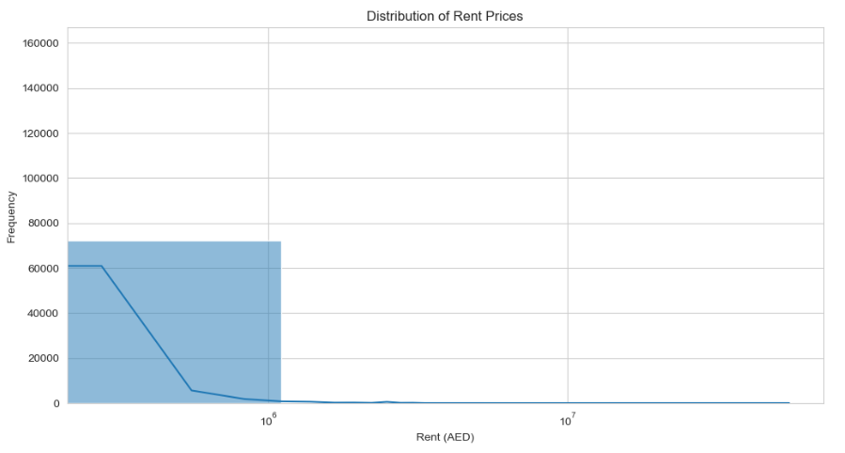
- Explanation of the Histogram
The dataset's rent price distribution is represented visually by the histogram:
[Figure 11: Histogram to show Distribution of Rent Prices]

-The range of rent prices is displayed on the X-Axis (Rent in AED). A clearer picture of the distribution over a large range is provided by the log scale, which causes higher rent prices to be compressed and lower rent prices to be more widely distributed.
- Y-Axis (Frequency): Displays the quantity of rent prices that occur in each bin.
- Bins By counting how many rent prices fall into each interval, the 50 bins divide the rent prices into intervals.
- KDE Curve: This smoothed line over the histogram indicates the approximate density of rent prices and aids in determining the distribution's general shape and peaks.
The distribution of rent prices, their skewness toward higher or lower values, and the existence of any peaks or patterns in the rent prices are all revealed by this histogram in conjunction with the KDE curve. The data is presented in a more comprehensible way and the large range of rent prices is managed with the use of a logarithmic scale.

4.4.3. Box Plot

A standardized method of displaying the distribution of data based on a five-number summary is a box plot, also called a box-and-whisker plot or minimum, first quartile (Q1), median, third quartile (Q3), and maximum. When determining the data's central tendency, dispersion, and skewness as well as locating outliers, box plots are especially helpful. When comparing distributions across several groups or datasets, box plots are useful. They are perfect for exploratory data analysis and differentiating between groups because they give a concise summary of the variability and symmetry of the data. Due to their ability to concisely convey a large amount of information, box plots are widely used in a variety of fields, including quality control, research, and finance (Evergreen, 2019).
- Creating Box Plot for Abu Dhabi rental properties Dataset to analyze the relationship between rent and the number of bathrooms

Creating Box Plot to analyze the relationship between rent and the number of bathrooms:
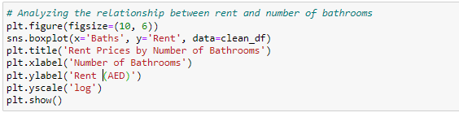

[Figure 12:Figure of code to generate Box Plot to analyze the relationship between rent and the number of bathrooms]
Code Explanation:
- plt.figure(figsize=(10, 6)):- The figure, which is 10 inches wide and 6 inches tall, is set up in this line.
Creating the Boxplot:
- sns.boxplot(x='Baths', y='Rent', data=clean_df):- This line creates a boxplot using Seaborn's `boxplot` function.
- plt.title('Rent Prices by Number of Bathrooms'):- This line sets 'Rent Prices by Number of Bathrooms' as the boxplot's title.
-plt.xlabel('Number of Bathrooms'):- This line labels the x-axis as 'Number of Bathrooms', indicating what the x-axis values represent.
- plt.ylabel('Rent (AED)'):- This line labels the y-axis as 'Rent (AED)', indicating the unit of measurement for the rent prices.
- plt.yscale('log'):- This line changes the y-axis to a logarithmic scale.
- plt.show():-The boxplot is displayed by this line and is available for instant examination in the output cell.
-Explanation of the Generated Boxplot
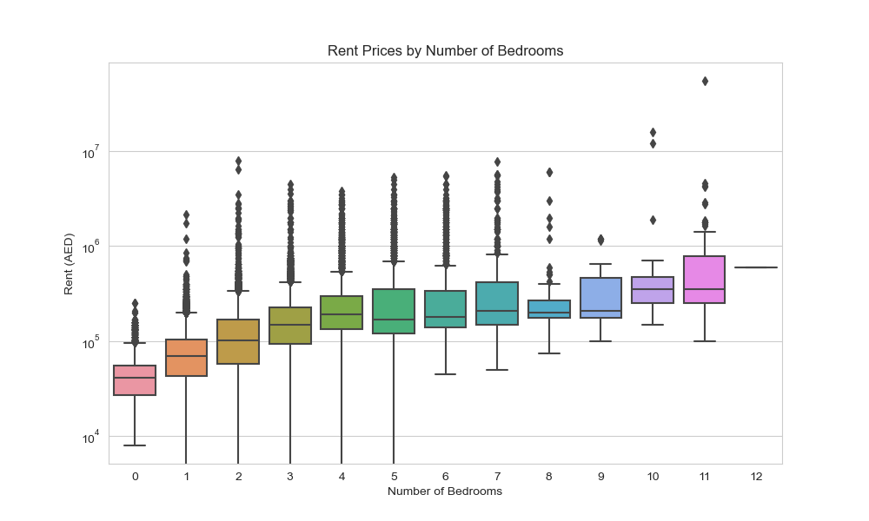
[Figure 13: Box Plot to analyze the relationship between rent and the number of bathrooms]
- Box Plot:

- Boxes: For a given number of bathrooms, each box shows the interquartile range (IQR) of the rental prices. Within the data, the IQR represents the range between the 25th percentile (Q1) and the 75th percentile (Q3).

- Medians: The rent price for a given number of bathrooms is indicated by the line inside each box.

- Whiskers: The top and bottom lines of each box show the range of the data within 1.5 times the interquartile range (IQR) for Q1 and Q3. Outliers are defined as data points that fall outside of this range.

- Outliers: Plotting points outside of the whiskers, which show rent prices that are abnormally high or low in relation to the rest of the data, is referred to as an outlier.
The X-Axis, or "Number of Bathrooms," shows how many bathrooms each property has. Every tick on the x-axis represents a distinct bathroom count. The rent prices are represented by the Y-Axis (rent in AED). The axis is changed to display the logarithm of rent prices when the log scale is applied, which makes it easier to manage the large range of values and better visualize the data.

- Box Plot Insights
Rent Price Distribution: The distribution of rent prices for homes with various bathroom counts is displayed in the Box Plot. For each category, the range of rent prices, the median value, and any outliers are displayed.
Rent prices for properties with a particular number of bathrooms tend to have a central tendency, which can be visually represented by the median line within each box.
Variation and Outliers: The variation in rent prices is displayed by the IQR (box). More variability is indicated by wider boxes, whereas less variability is indicated by narrower boxes. Plotted as single points, outliers can reveal anomalous rental rates.
Impact of Bathroom Count on Rental Prices: You can determine how the number of bathrooms influences rent costs by comparing the medians and the spread of the boxes. In general, you might anticipate that rental properties with more bathrooms will cost more to rent. In particular, when there are extreme values, the log scale makes it easier to see these trends.
In conclusion, the generated Box Plot shows central tendencies, variances, and outliers in the data and offers a thorough visual analysis of how rent prices change depending on how many bathrooms a property has. The graphic is more illuminating and simpler to understand thanks to the use of a log scale on the y-axis to control the large range of rent prices.
4.4.4. Scatter Plot

A type of data visualization that shows values for a set of data is a scatter plot, which usually shows values for two variables. Each point in the data visualization represents the values of two variables. When attempting to discern connections, correlations, and patterns between the two variables, scatter plots are especially helpful. The simplicity and efficiency of scatter plots in illustrating complicated data relationships make them popular in disciplines like economics, biology, and social sciences (Kirk, 2019).Different kinds of relationships between variables, including linear, non-linear, and no correlation, can be seen using scatter plots. They can assist in locating outliers and clusters within the data and are crucial to regression analysis. The general pattern of the points can also be used to evaluate the direction and strength of the relationship.
- Creating Scatter Plot for Abu Dhabi rental properties Dataset to visualize the spatial distribution of rental properties based on geographic locations:
Creating a scatter plot that visualizes the spatial distribution of rental properties based on their geographic locations (latitude and longitude) and includes extra information like the city
and rent amounts using the Matplotlib and Seaborn Python libraries.

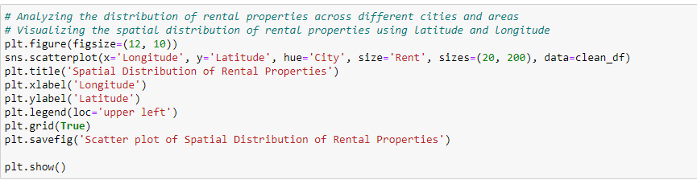
[Figure 14: Figure of code to generate Scatter Plot to analyze the distribution of rental properties across cities and areas]

Code Explanation:
-plt.figure(figsize=(12, 10)):- This line initializes a figure or plot with a specified size..

- sns.scatterplot(x='Longitude', y='Latitude', hue='City', size='Rent', sizes=(20, 200), data=clean_df):- This line of code creates a scatter plot using Seaborn library. It's a versatile function that supports coloring and sizing individual points based on variables in the data.

- plt.title('Spatial Distribution of Rental Properties'): - Sets the title of the scatter plot.

- plt.xlabel('Longitude') and plt.ylabel('Latitude'):- These lines label the x-axis and y-axis with "Longitude" and "Latitude" respectively, providing clarity on what each axis represents.

- plt.legend(loc='upper left'): - Adds a legend to the plo, positions the legend in the upper left corner of the plot.

- plt.grid(True):- This enables a grid on the plot, which helps in better visual perception of the points in relation to the axes.

-plt.savefig('Scatter plot of Spatial Distribution of Rental Properties')`: - Saves the figure as an image file

-plt.show(): Displays the plot.

-Explanation of Scatter Plot

The scatter plot below illustrates the distribution of rental properties geographically among different cities. A rental property is represented by each point on the scatter plot, which is located using its latitude and longitude. The size variation represents the range of rent prices, and the color differentiation aids in the identification of properties in various cities. The legend offers a convenient means of quickly determining which color corresponds to which city, and the grid and clearly labeled axes facilitate the interpretation of the plot.
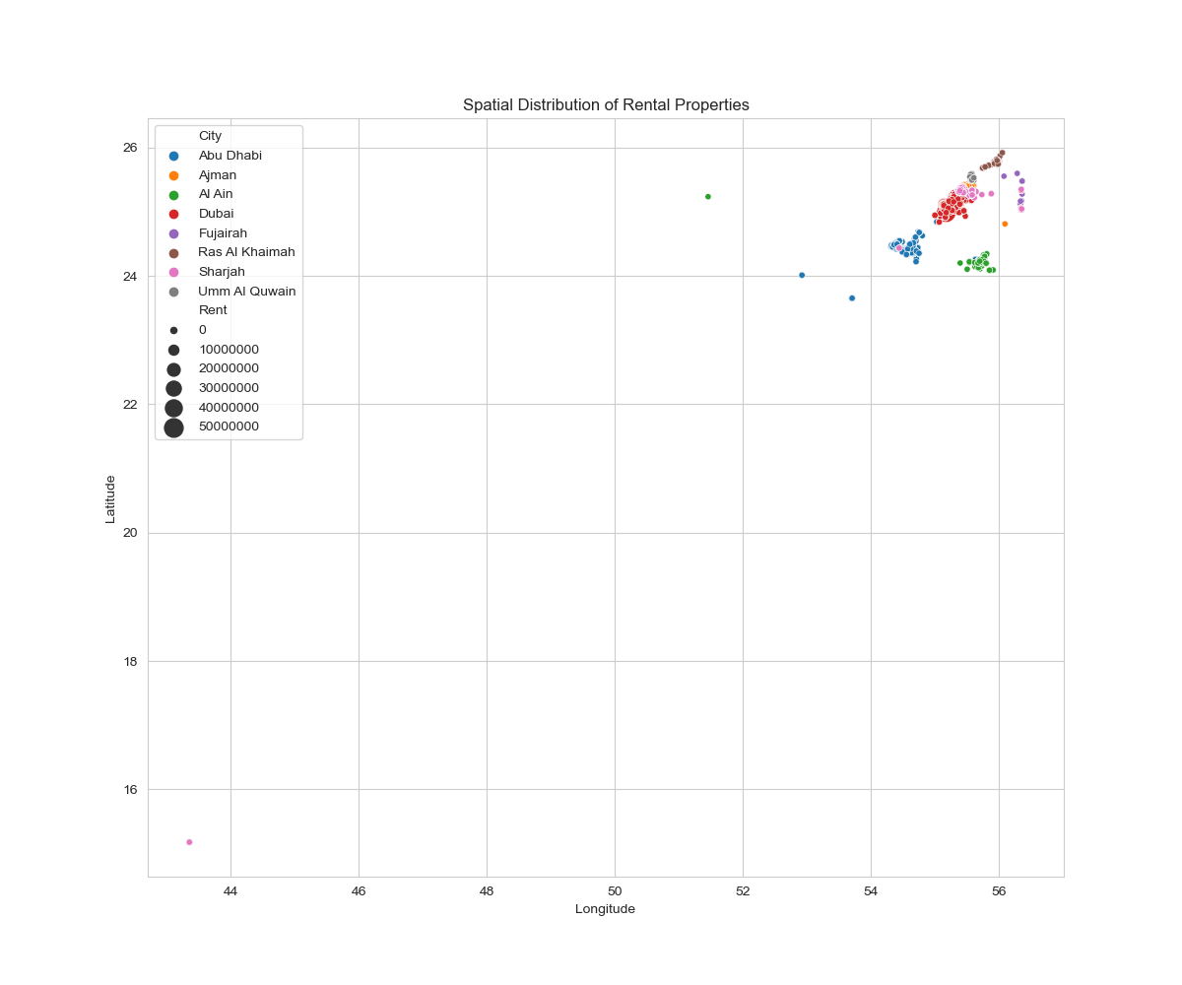
[Figure 15: Scatter Plot to analyze the distribution of rental properties across cities and areas]
In real estate analysis, this visualization can be especially helpful as it enables stakeholders to evaluate pricing and distribution of properties in various regions in a timely manner.
4.4.5. Heatmap
A heatmap is a type of data visualization where the values of the data points in a matrix are represented by color. Since each cell in the matrix is colored according to its value, it is possible to quickly spot correlations, patterns, and trends even in large datasets. The color's intensity usually corresponds to the value's magnitude, making it simple to identify areas with high and low concentration. Heatmaps are useful because they can present large amounts of information in a clear, aesthetically pleasing way (Tufte, 2001). When it comes to visualizing intricate data sets with several variables, like correlation matrices, frequency distributions, and geographic data, heatmaps are especially helpful. They offer a quick visual summary that makes it easier to spot outliers, groups, and correlations between different variables. For example, a heatmap in a correlation matrix can quickly indicate which variables are positively or negatively correlated, which can help with hypothesis testing and exploratory data analysis.

- Creating Heatmap for Abu Dhabi rental properties Dataset to analyze the count of each property type in location:

The code block below creates a Heatmap to analyze and visualize data in order to display the popularity and distribution of various property types in different locations.
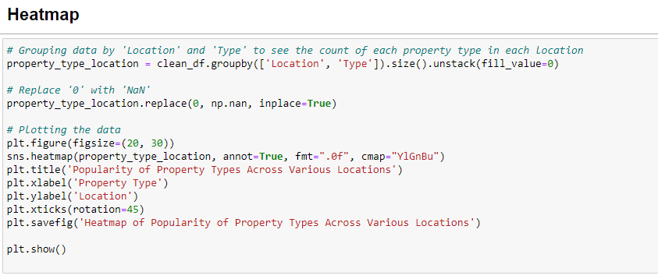
[Figure 16: Figure of code to generate Heatmap to analyze the count of each property type in location]
--Code Explanation:
- property_type_location = clean_df.groupby(['Location', 'Type']).size().unstack(fill_value=0): - This line first groups the data in `clean_df` by two columns: 'Location' and 'Type'. 'Location' could refer to different areas, regions, or cities, while 'Type' indicates the type of property, like apartments, houses, etc.
- property_type_location.replace(0, np.nan, inplace=True): - This line replaces all '0' values with 'NaN'.
- plt.figure(figsize=(20, 30)):- Initializes a new figure with a size of 20 inches wide by 30 inches tall, providing ample space for a large or detailed heatmap.
- sns.heatmap(property_type_location, annot=True, fmt=".0f", cmap="YlGnBu"): This line of code uses the Seaborn library creates a heatmap to visually represent the data matrix
- plt.title('Popularity of Property Types Across Various Locations'): - Sets the title of the heatmap.
- plt.xlabel('Property Type') and plt.ylabel('Location'): - Labels the x-axis and y-axis.
- plt.xticks(rotation=45):- Rotates the x-axis tick labels by 45 degrees.
- plt.savefig('Heatmap of Popularity of Property Types Across Various Locations')`:
- plt.show(): - Displays the Heatmap.

- Explanation of the Generated Heatmap

The generated Heatmap below from the above line of code will visually represent how popular different types of properties are across various locations. Each cell in the heatmap corresponds to a specific location and property type, with the color intensity and annotated number indicating the count of properties. Locations are listed on the y-axis, and property types are on the x-axis. This visualization is effective for quickly identifying trends, such as which types of properties are most common in which areas, and highlighting regions with high or low diversity in property types.

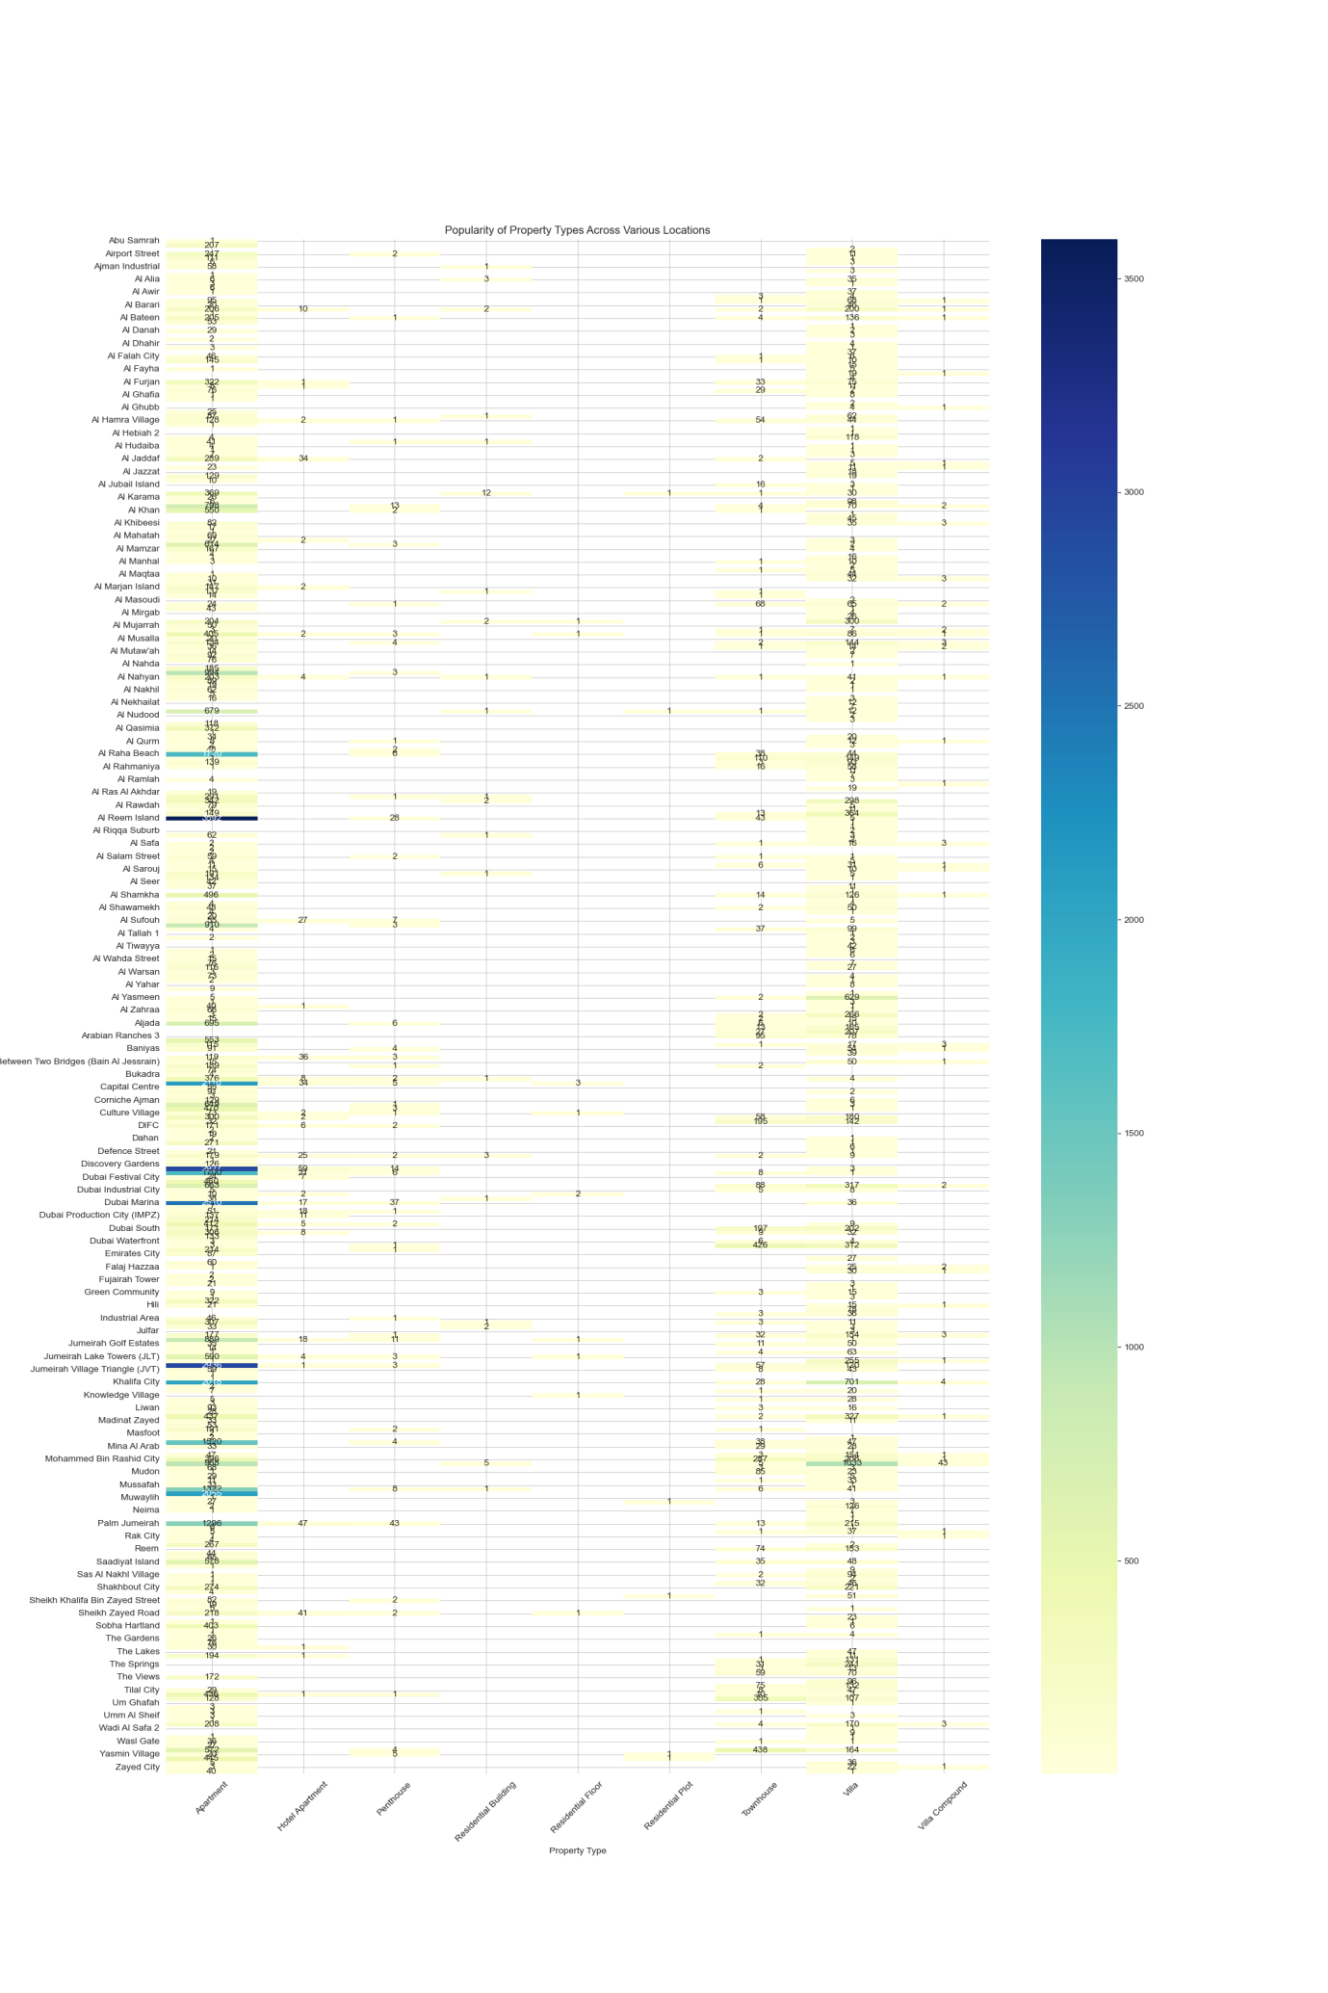
[Figure 17:Heatmap to analyze the count of each property type in location]
4.4.6. Sunburst Chart

A sunburst chart is a kind of multi-level pie chart where concentric circles are used to represent hierarchical data. The sunburst chart's rings or levels each indicate a level in the hierarchy, with the innermost circle denoting the top level. Each ring's segments are proportionally divided to represent their portion of the parent segment's value, which allows for the simultaneous display of the relative sizes and hierarchical structure. In a variety of disciplines, such as business analytics, bioinformatics, and website navigation analysis, sunburst charts are an effective tool for data exploration and presentation (Kirk, 2019).

- Creating Sunburst Chart for Abu Dhabi rental properties Dataset to show distribution of rental properties according to their rent category:

This code snippet below uses Plotly Express to generate a sunburst chart that shows the distribution of rental properties according to their rent category and furnishing state.

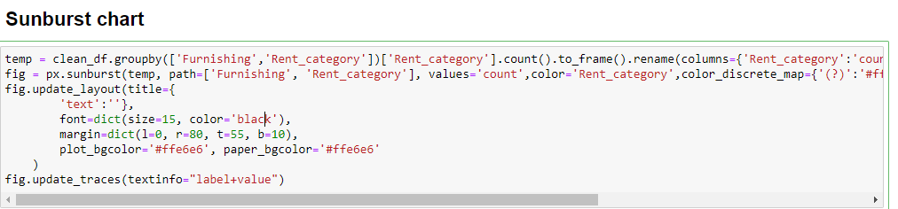
[Figure 18:Figure of code to generate Sunburst Chart to show distribution of rental properties according to their rent category]

- Code Explanation
temp=clean_df.groupby(['Furnishing','Rent_category'])['Rent_category'].count().to_frame().rename(columns={'Rent_category':'count'}).reset_index()
This line groups the data by two categorical variables: 'Furnishing' (how the property is furnished) and 'Rent_category' (categorical division of rent amounts like low, medium, or high). It then counts the number of occurrences for each group and converts the series to a DataFrame and renames the resultant column to 'count' to reflect that it contains counts of properties in each group.
Sunburst Chart Creation:
fig = px.sunburst(temp, path=['Furnishing', 'Rent_category'], values='count', color='Rent_category',color_discrete_map={'(?)':'#ff00ff','Low':'#aa55ff','Medium':'#55aaff','High':'#00ffff'})
- px.sunburst(temp, path=['Furnishing', 'Rent_category'], values='count'): Creates a sunburst chart using Plotly Express, where 'temp' is the DataFrame. The `path` argument defines the hierarchy levels in the sunburst: first by 'Furnishing', then by 'Rent_category'. The `values='count'` argument assigns the size of each segment in the sunburst based on the count of entries in that category.
- color='Rent_category': Colors the segments based on the rent category.
- color_discrete_map={...}: Assigns specific colors to each rent category for visual distinction.
Layout Update:
fig.update_layout(title={'text':''}, font=dict(size=15, color='black'), margin=dict(l=0, r=80, t=55, b=10), plot_bgcolor='#ffe6e6', paper_bgcolor='#ffe6e6')
- title={'text':''}: Sets the chart title. In this case, it's an empty string, meaning no title is displayed.
- font=dict(size=15, color='black'): Defines the font size and color for text within the chart.
- margin=dict(...): Adjusts the margins around the chart to ensure the visualization fits well within the plot area.
- plot_bgcolor` and `paper_bgcolor: Sets the background colors for the plot area and the paper respectively.
Trace Updates:
fig.update_traces(textinfo="label+value")
- textinfo="label+value": Configures the text displayed on each segment of the sunburst to show both the label and the value (count in this case).
- Explanation of Generated Sunburst Chart:

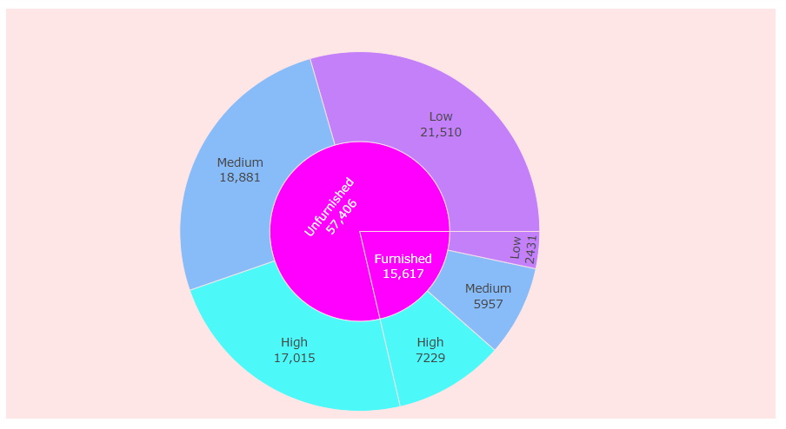
A sunburst chart based on the furnished status of the properties will be produced, which will show how many properties fall into each rent category. A furnishing status will be represented by the inner ring of the chart, and a rent category by each segment within a status. Rent categories can be distinguished by the colors used, and the size of each segment indicates the number of properties in that particular category. With its ability to display the most common combinations of furnishing types and rent levels, this visualization is a great way to understand the distribution of properties.
[Figure 19: Sunburst Chart to show distribution of rental properties according to their rent category]
4.4.7. Count Plot

A count plot is a kind of bar plot that uses bars to show how frequently observations occur in each category bin. It is especially helpful for comprehending the number of observations in each category and for visualizing the distribution of categorical data. It is simple to compare group sizes because the height of each bar indicates the number of data points in that category. The simplicity and interpretability of count plots is one of their main advantages. They are frequently used to present categorical data in a visually appealing format in domains like the social sciences, market research, and business analytics (Wickham, 2016).
- Creating Count Plot for Abu Dhabi rental properties Dataset to show the distribution of rental price by City:

In order to visualize the distribution of rental price categories across different cities, the below code will builds a count plot using the Seaborn library.
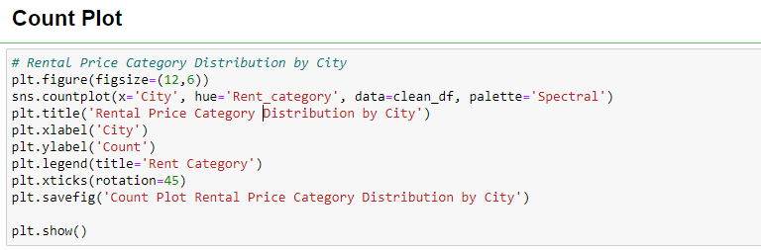

[Figure 20 : Code snippet to create Count plot to show distribution of rental price by City]

- Code Explanation:

1. plt.figure(figsize=(12,6)):- Initializes figure for plotting, with figure size as 12 inches wide and 6 inches tall.
2. sns.countplot(x='City', hue='Rent_category', data=clean_df, palette='Spectral'):- A function from Seaborn that simplifies creating bar charts that show the count of observations in each categorical bin.
3. plt.title('Rental Price Category Distribution by City'):- Sets the title of the plot.
4. plt.xlabel('City') and plt.ylabel('Count'):- These commands label the x-axis and y-axis. 5. plt.legend(title='Rent Category'): - Adds a legend to the plot to help identify which colors correspond to which rent categories.
6. plt.xticks(rotation=45): - Rotates the labels on the x-axis by 45 degrees.
7. plt.savefig('Count Plot Rental Price Category Distribution by City'):- Saves the figure to the local file system.
8. plt.show( )- Displays the plot.

- Explanation of the Generated Count Plot

A sequence of bars for each city will be displayed in the generated count plot, with each bar colored in accordance with the rental price category. The number of rental listings in each category within that city is indicated by the height of each bar. This graphic illustrates trends or abnormalities in the rental market, such as whether some cities are generally more expensive or less expensive than others, and offers insights into how rental prices are distributed across various cities.

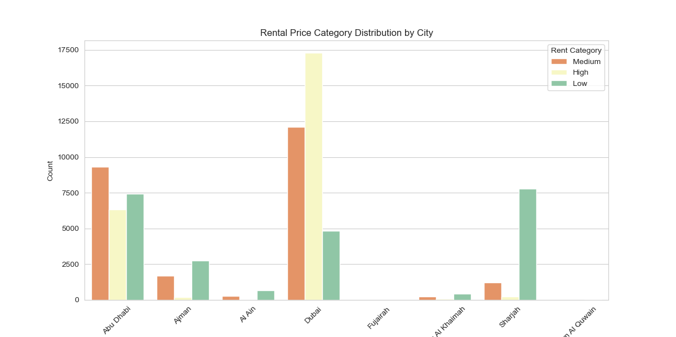

[Figure 21: Count plot to show distribution of rental price by City]

4.4.8. Parallel Plot

Plotting multivariate data can be accomplished with a parallel plot, sometimes referred to as a parallel coordinates plot. Every data point is represented by a line that crosses parallel axes, each of which stands for a distinct variable. Relationships and patterns across several dimensions can be simultaneously visualized with this technique. Parallel plots have an advantage over traditional 2D or 3D plots in that they can handle large and complex datasets. On the other hand, parallel plot interpretation can be difficult, particularly when there are a lot of variables or overlapping lines. Interactive features may be needed to improve clarity (Healy, 2018).
- Creating Parallel Plot for Abu Dhabi rental properties Dataset:

The given code snippet use Plotly Express in Python to prepare categorical data and visualize multidimensional data using a parallel coordinates plot.
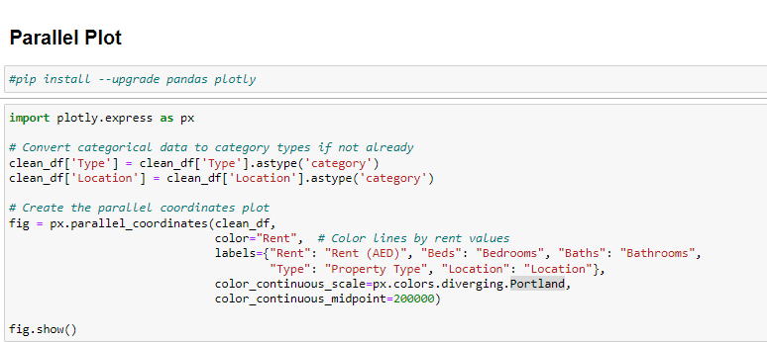
[Figure 22 : Code snippet to create Parallel Plot ]

- Code Explanation:
-Converting data to categorical types:
clean_df['Type'] = clean_df['Type'].astype('category')
clean_df['Location'] = clean_df['Location'].astype('category')
- This code ensures that the 'Type' and 'Location' columns in the DataFrame `clean_df` are treated as categorical data types.
Plot creation using Plotly Express:
fig = px.parallel_coordinates(clean_df,
color="Rent", # Color lines by rent values
labels={"Rent": "Rent (AED)", "Beds": "Bedrooms", "Baths": "Bathrooms",
"Type": "Property Type", "Location": "Location"},
color_continuous_scale=px.colors.diverging.Portland,
color_continuous_midpoint=200000)
- px.parallel_coordinates(): This function generates a parallel coordinates plot
- color="Rent": Provides a visual gradient that represents the rental price.
- labels: Provides a mapping of DataFrame column names.
- color_continuous_scale=px.colors.diverging.Portland: Defines the color scale using a pre-defined diverging color scale from Portland.
- color_continuous_midpoint=200000: This sets the midpoint of the color scale.

- fig.show(): - Displaying the plot.

- Explanation of the Generated Parallel Plot

The generated parallel coordinates plot has multiple axes, each of which represents a different dimension ('Rent, Beds, Baths, Type, Location', etc.). Individual records are represented by lines that cross these axes. A brief visual representation of the relationship between rent and other attributes can be obtained by grading the colors of the lines according to the 'Rent' values. For example, higher rents may be associated with specific locations or with more bedrooms and bathrooms.
When identifying trends and patterns in the dataset across various dimensions, such as determining the typical property attributes that command higher rents in particular locations, this kind of visualization is especially helpful. It is also a useful method for performing a visual inspection of multivariate data in a condensed format.

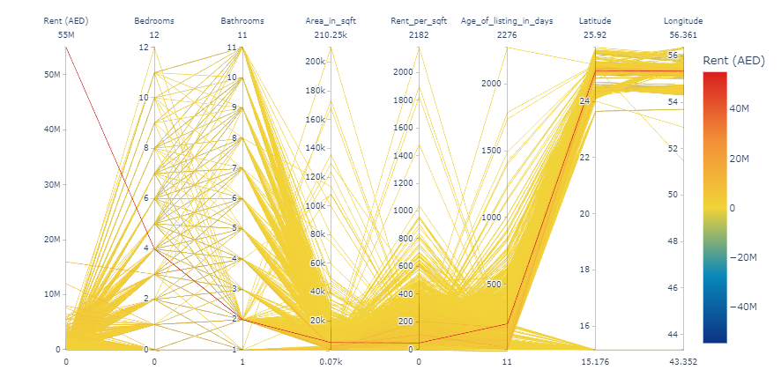
[Figure 23 : Parallel Plot ]

4.4.9. Pie Chart

A pie chart is a graphical depiction in the form of a circle that is divided into slices to show numerical proportions. The size of each slice corresponds to its percentage of the total, and each slice represents the contribution of a category to the whole. Pie charts are especially useful for displaying, in an easy-to-understand and visually appealing way, the relative sizes of the various parts of a whole. Pie charts give a clear visual depiction of each category's proportion in relation to the entire dataset, making them most useful for comparing a limited number of categories (Few, 2013). They are frequently used to display data like market shares, budgetary allotments, and survey results in business, the media, and education.
- Creating Pie Chart for Abu Dhabi rental properties Dataset to show distribution of distribution of various property types:

The code below create a pie chart by using Plotly Express to show the distribution of various property types in a dataset.
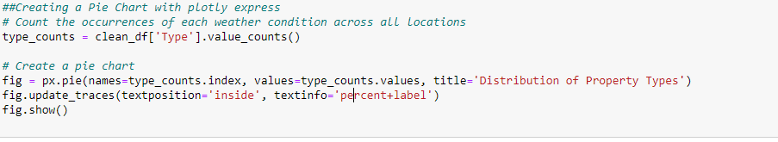
[Figure 24 : Code snippet to create Pie Chart to show distribution of various property types ]

- Code Explanation:
type_counts = clean_df['Type'].value_counts():- This function counts the occurrences of each unique value in the 'Type' column of `clean_df`. ‘type_counts’, the resultant object, is a Series in which the values denote the count of each type and the index contains the property types.
Pie Chart Creation:
fig = px.pie(names=type_counts.index, values=type_counts.values, title='Distribution of Property Types')
- px.pie(): Creates a pie chart using Plotly Express.
- names=type_counts.index: Sets the categories used in the pie chart.
- values=type_counts.values: Sets the values that determine the size of each pie slice,
- title='Distribution of Property Types': Sets the title of the pie chart.

Trace Updates:
fig.update_traces(textposition='inside', textinfo='percent+label'):- Configures the pie chart so that the text (labels and percentages) is displayed inside the pie slices. –
fig.show(): Display the Plot.

- Explanation of generated Pie Chart

The distribution of property types in dataset can be seen visually in the generated pie chart. A distinct property type is represented by each slice of the pie, and the size of the slice indicates the percentage of properties of that type relative to the total. Each slice has labels inside that assist with type identification and indicate what proportion of the total each type makes up. Pie charts such as these are perfect for presentations or reports where a visual summary of categorical data is required, as they allow the viewer to quickly understand how different categories compare in size and proportion.
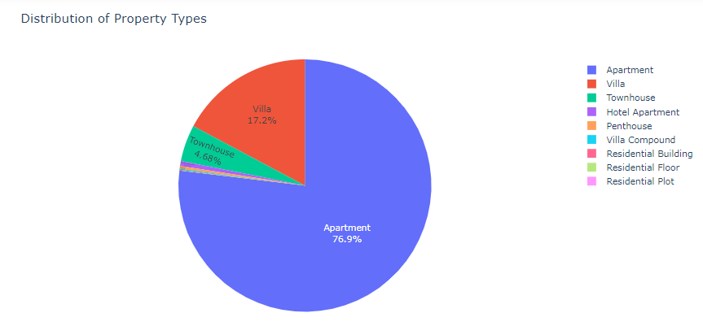
[Figure 25: Pie Chart to show distribution of various property types]

5.4.10. Donut Chart

A donut chart is a kind of pie chart where the data is shown as a ring with a hole in the middle. Like in a pie chart, the size of each segment reflects its percentage of the total.
When comparing categories within a dataset and visualizing proportions, doughnut charts are especially helpful (Kirk, 2019). To improve the functionality of the chart, additional information, such as total values or important metrics, can be displayed in the central hole. Donut charts are a popular way to display data, including budget allocations, market share, and sales distributions, in business dashboards and reports. Donut charts have a few advantages over pie charts, one of which is that the central area can lessen visual clutter and facilitate easier comparison between the segments.
- Creating Donut Chart for Abu Dhabi rental properties Dataset to Count the occurrence of each Location in the dataset:
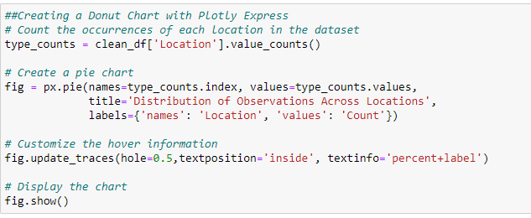
[Figure 26: Code snippet to generate Donut Chart to Count the occurrence of each Location in the dataset]

- Code Explanation:
location_counts = clean_df['Location'].value_counts: Counting the occurrence of Location in dataset.

fig = px.pie(names=location_counts.index, values=location_counts.values,
title='Distribution of Observations Across Locations',
labels={'names': 'Location', 'values': 'Count'})

- px.pie(): Creates a pie chart which will be adapted to a donut chart.

- names=location_counts.index: Uses the indices of `location_counts`, which are the unique locations, as the categories in the pie chart.

- values=location_counts.values: Uses the values from `location_counts`, which are the counts of each location, to determine the size of each pie slice.

- labels={'names': 'Location', 'values': 'Count'}: Customizes the labels for tooltips and legends to enhance readability and relevance
.
Customizing the Donut Chart
fig.update_traces(hole=0.5, textposition='inside', textinfo='percent+label')

- hole=0.5: Adds a hole with size 0.5, in the center of the pie chart, turning it into a donut chart.

- textposition='inside': Places the text inside the slices.

- textinfo='percent+label': Specifies that both the label and the percentage should be displayed inside each slice.

-fig.show():- Display the Chart

- Explanation of Generated Donut Chart

The generated donut chart shows how the observations were distributed among the various locations. Every donut segment represents a location, and the size of a segment reflects the quantity of observations at that particular location. For presentations where comprehending the relative distribution of data is crucial, the inner labels offer instant insight into the percentage share of each location. When highlighting the prevalence or rarity of data points across categories in a dataset, this kind of chart is especially helpful.

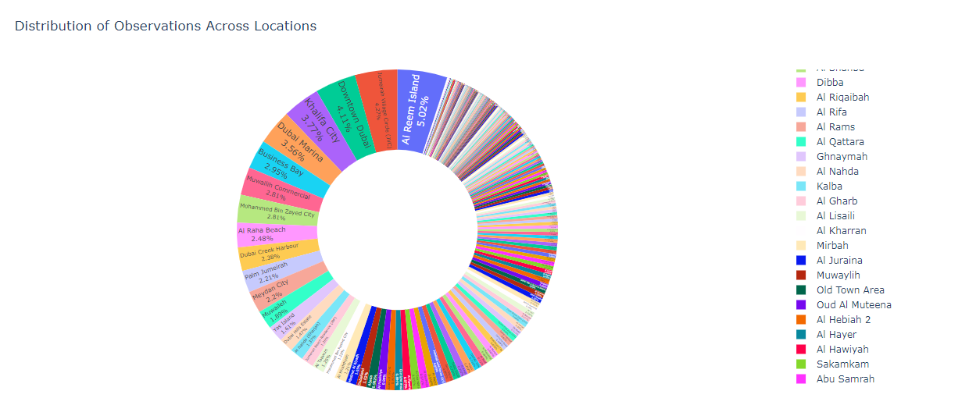

[Figure 27: Donut Chart to Count the occurrence of each Location in the dataset]

4.4.11. Stacked Bar Chart

A stacked bar chart is a kind of bar chart in which each bar is separated into several sub-bars that are stacked one on top of the other to represent various groups or categories. The length of each sub-bar is proportionate to its value, and the length of the bar as a whole represents the sum of all the sub-bars. This method makes it possible to compare the overall value across categories as well as the contribution of each subcategory to the total. According to Few (2019), stacked bar charts are especially useful for showing how categories are composed and how each component works together to form the whole across various categories. They are helpful for visualizing information such as revenue breakdown by department, population distribution by age group over time, or sales by product type across various regions. The ability of stacked bar charts to simultaneously display absolute and relative differences is one of their main advantages. However, when there are a lot of subcategories or when exact comparisons are required, they can get complicated and challenging to understand.
- Creating Donut Chart for Abu Dhabi rental properties Dataset Analyzing and displaying the total rent contributions within various rent categories, grouped by type of property:

The code snippet below uses the Pandas and Matplotlib libraries in Python to prepare data and visualize it as a stacked bar chart. Analyzing and displaying the total rent contributions within various rent categories, grouped by type of property, is the aim.

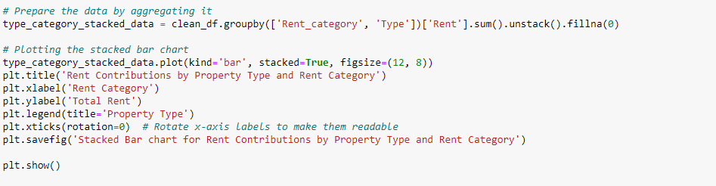
[Figure 28: Figure of code to generate Stacked Bar Chart]

- Code Explanation:
Data Preparation
Grouping and Aggregating Data:
type_category_stacked_data = clean_df.groupby(['Rent_category', 'Type'])['Rent'].sum().unstack().fillna(0)

Creating and Customizing the Stacked Bar Chart:

type_category_stacked_data.plot(kind='bar', stacked=True, figsize=(12, 8))

- plot(kind='bar', stacked=True): starts to create a bar chart with the kind of plot set to 'bar' and the option'stacked=True' to stack the bars on top of one another rather than side by side. Each bar in the stack represents the total sum of the rents stacked by type of property. This stacking is done for each rent category.
- figsize=(12, 8): Sets the size of the resulting plot.
Enhancing the Visualization

plt.title('Rent Contributions by Property Type and Rent Category'): Adds a title to the chart.
plt.xlabel('Rent Category'): Label the x-axis.
plt.ylabel('Total Rent'): Label the y-axis
plt.legend(title='Property Type'): . Adds a legend to the chart
plt.xticks(rotation=0):- Sets the rotation of the x-axis labels to 0 degrees
plt.savefig('Stacked Bar chart for Rent Contributions by Property Type and Rent Category') : Save the chart.
plt.show(): Display the chart

- Explanation of the Generated Stacked Bar Chart

The generated chart shows the total amount of rent received by property type within each rent category. Each rent category is represented by a bar, and the portion of each bar that comes from a particular type of property indicates its contribution to the total rent. This makes it simple for viewers to compare the contributions of various property types to revenues acrossrent categories and to visually analyze which property types are more profitable or common in particular rent ranges. The bar stacking facilitates insights into market trends and property performance by offering a clear visual summary and comparison across categories.

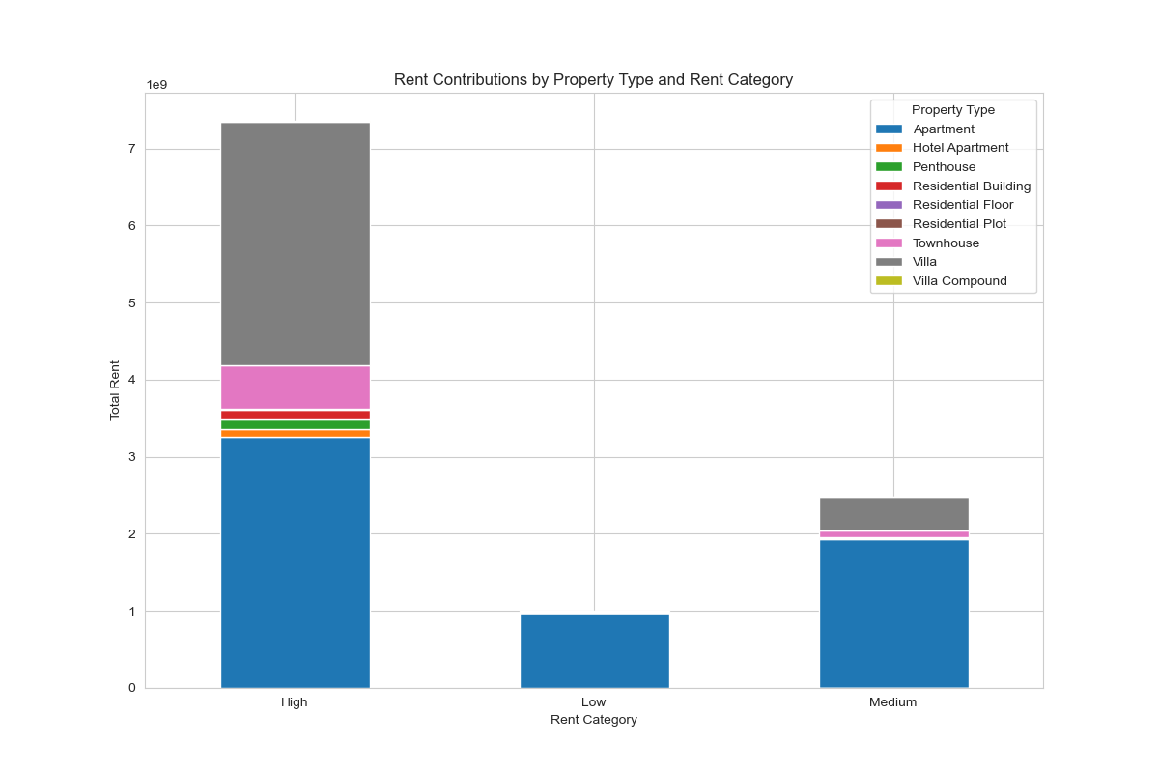
[Figure 29: Stacked Bar Chart]
4.4.12. Violin Plot

An interpretation of a violin plot is a combination of a box plot and a kernel density plot, which is a technique for graphing numerical data. Through the representation of data density at various values, it illustrates the distribution of data across various categories.Vintan plots give a more accurate depiction of the distribution's shape when the density trace is added to the box plot (Hintze, et al., 1998). An enhanced understanding of the distribution is offered by the plot, which is composed of a central box plot encircled by rotated kernel density plots on each side. When comparing various groups or categories, violin plots are especially helpful (Hintze, et al., 1998). They display not only summary statistics that can be seen in a box plot, such as the median, quartiles, and range, but also the density of the data, which sheds light on the form of the data distribution. Because of this, violin plots are perfect for recognizing multi-modal distributions and comprehending the distribution within each category.
- Creating Violin Plot for Abu Dhabi rental properties Dataset for the distribution of rent per square foot among various property types:

Creating a violin plot with the Matplotlib and seaborn libraries to illustrates the distribution of rent per square foot among various property types. When comparing the distribution of a variable across multiple groups, this kind of plot is especially helpful. The following is the way that every code line helps to create this visualization:

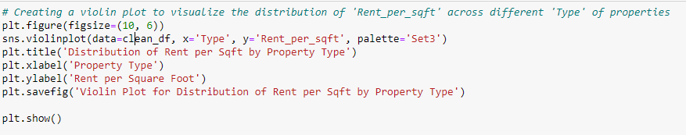
[Figure 30 :Code snippet to create Violin plot ]

- Code Explanation:
- plt.figure(figsize=(10, 6)):- Creates a figure with figure size.
- sns.violinplot(data=clean_df, x='Type', y='Rent_per_sqft', palette='Set3'): Creates a violin plot for ‘clean_df’ with categorical variable ('Type' of property) along the x-axis and 'Rent_per_sqft' as the variable displayed along the y-axis. Uses the 'Set3' color palette for the plot.
- plt.title('Distribution of Rent per Sqft by Property Type'): Adds a title to the chart
plt.xlabel('Property Type') & plt.ylabel('Rent per Square Foot'): Label the x-axis and y-axis respectively
plt.savefig('Violin Plot for Distribution of Rent per Sqft by Property Type'): Saves the plot to a file
plt.show():- Display the Plot

- Explanation of the Generated Violin Plot

The generated violin plot shows the distribution of rent per square foot between various types of properties. With the shape of the violin signifying the density of data points at various rent levels, each 'violin' represents a single property type. While the slimmer sections of the violin represent less common values, the wider sections show where the data is more concentrated, indicating common rent per square foot values.
Understanding a number of aspects of the rental market is made easier by this visualization, including:
- Variability: The degree of variation in rent per square foot for each kind of real estate.
- Density: Indicates typical rent values, as indicated by the concentration of most data points.
- Outliers: When rent prices for particular kinds of properties have extreme values.
In general, violin plots are a great way to give specific insights into a dataset's distribution. This makes them especially helpful in real estate analytics when evaluating property values and market conditions.
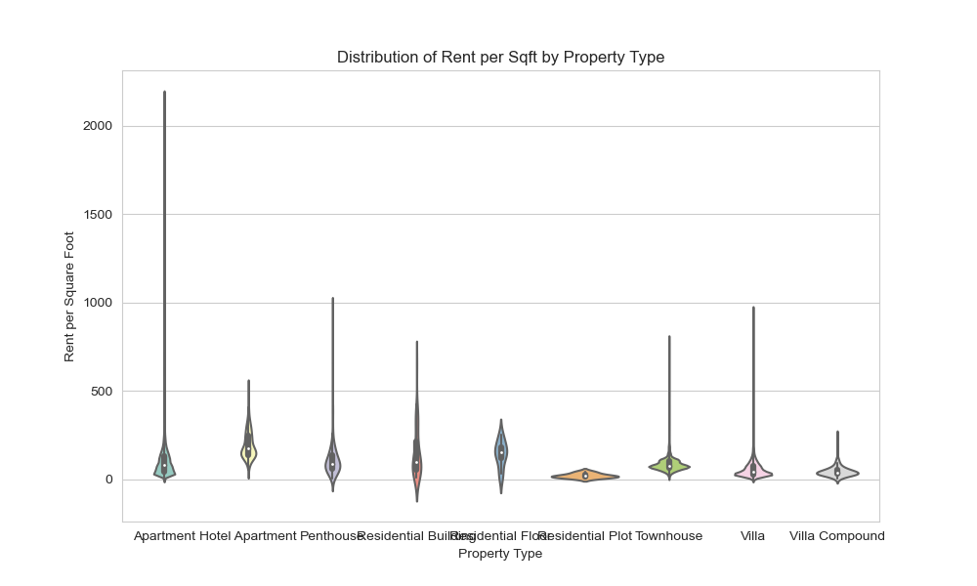
[Figure 31: Violin plot for Distribution of Rent per Sqft by Property Type ]

4.4.13. Rug Plot

One easy visualization method for showing the distribution of a single continuous variable is the rug plot.
- Creating Rug Plot for Abu Dhabi rental properties Dataset for 'Rent_per_sqft' across the different 'Type' of properties

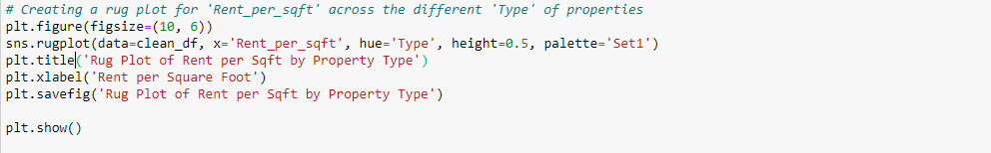

[Figure 32:Code snippet to create Rug plot for Rent per sqft across different type of properties]

- Code Explanation:
The code generate Rug plot using seaborn to show the distribution of 'Rent_per_sqft' for various kinds of properties. A small vertical tick is essentially placed at each data point along an axis in a rug plot. This helps to visualize the distribution and density of data points within a dataset.

Setting Up the Plot
plt.figure(figsize=(10, 6)):- Initializes a new figure for plotting with figure size.
sns.rugplot(data=clean_df, x='Rent_per_sqft', hue='Type', height=0.5, palette='Set1')
- sns.rugplot(): Generates a rug plot.
- data=clean_df`: Specifies the DataFrame from which the data will be drawn.
- x='Rent_per_sqft': Sets the x-axis as 'Rent_per_sqft'.
- hue='Type': Uses the 'Type' column to color-code the ticks, providing visual distinction between different types of properties
- height=0.5: Specifies the height of the ticks in the plot as 0.5
- palette='Set1': Chooses the 'Set1' color palette for the plot

Adding Titles and Labels:
plt.title('Rug Plot of Rent per Sqft by Property Type'): Adds a title to the plot
plt.xlabel('Rent per Square Foot'): Labels the x-axis.
plt.savefig('Rug Plot of Rent per Sqft by Property Type'): Saving the Plot
plt.savefig(): Saves the created plot to a file
plt.show(): Displaying the Plot.

- Explanation of the Generated Rug Plot

The distribution of 'Rent_per_sqft' values among various property types can be quickly and easily visualized with the generated rug plot. With the help of this plot, we can:
- Determine the distribution and clustering of rent prices per square foot for each type of property by using distinct colors for each type of property (as indicated by the 'Type' column).
- Take note of the locations where the data points are sparse, indicating lower common rent prices, and dense, indicating higher common rent values.
- Look for anomalies or strange figures in the rental costs of various kinds of properties.
Analysts can quickly recognize and evaluate patterns or anomalies in the data with the help of this kind of visualization, which is especially helpful for preliminary data exploration.

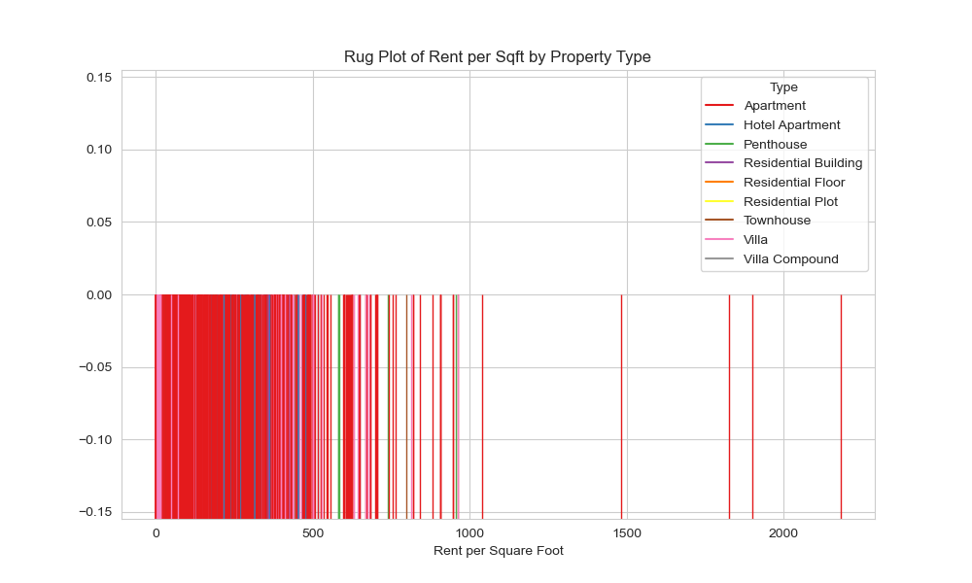
[Figure 33: Rug Plot of Rent per Square by Property Type]
4.4.14. Scatter Plot with a Rug Plot
A common tool in data visualization is the scatter plot, which uses a Cartesian plane to display data points to illustrate the relationship between two continuous variables. The visualization of data distribution along the axes is improved when a scatter plot is combined with a rug plot.
A scatter plot's edges are bordered by tiny ticks, or rugs, to create a rug plot. As well as showing the density and distribution of the data, these ticks represent individual data points. A rug plot can provide viewers with a quicker understanding of the overall structure of the data by assisting them in identifying areas of concentrated and sparse data points, when combined with a scatter plot (Wilke, 2019).

- Creating Scatter Plot with Rug Plot for Abu Dhabi rental properties Dataset to analyze Rent per square fit by property Type:
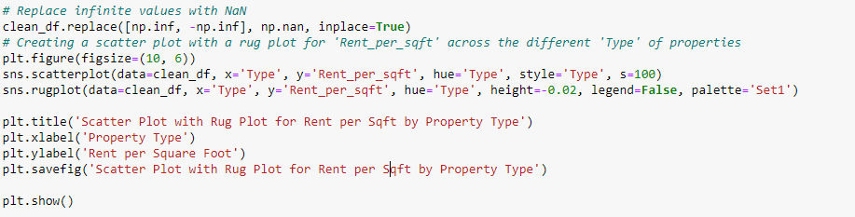
[Figure 34: Code to generate Scatter Plot with Rug Plot for Rent per square fit by property Type]
Code Explanation:
- clean_df.replace([np.inf, -np.inf], np.nan, inplace=True):- This line ensures that any infinite values in the DataFrame are replaced with NaN (Not a Number).
- plt.figure(figsize=(10, 6)):- Initializes a new plotting figure.
Creating Scatter Plot
- sns.scatterplot(data=clean_df, x='Type', y='Rent_per_sqft', hue='Type', style='Type', s=100):- Creates a scatter plot, which is a type of data visualization that uses dots to represent the values obtained for two different variables - one plotted along the x-axis and the other plotted along the y-axis.
Adding a Rug Plot
Rug Plot:
sns.rugplot(data=clean_df, x='Type', y='Rent_per_sqft', hue='Type', height=-0.02, legend=False, palette='Set1'): Adds a rug plot to the scatter plot. Rug plots display a small vertical line for each data point, which is particularly useful for showing the distribution of data along an axis.

- Explanation of the Generated Visualization
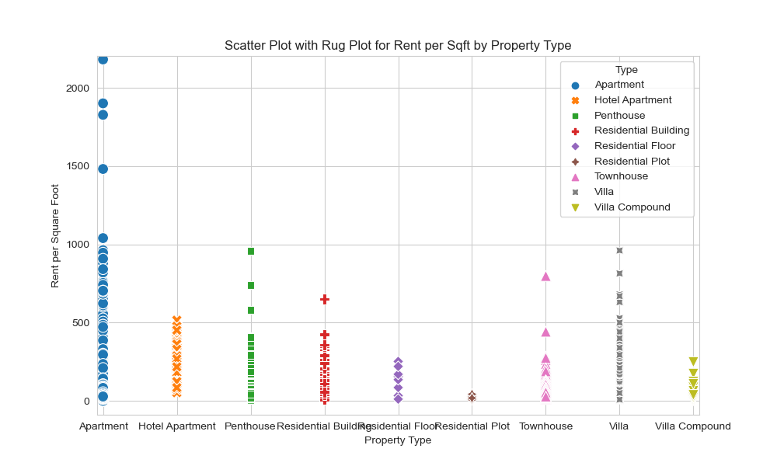
The generated visualization efficiently combines a scatter plot, which provides an additional density indication, with a rug plot, which provides detailed data points. With this hybrid approach, observers can quickly assess the density and distribution of data points across property types (rug plot) in addition to seeing individual data values (scatter plot). This can improve both analytical depth and interpretive clarity by highlighting clusters, outliers, or patterns in the variation of rent per square foot among various property types.
[Figure 35: Scatter Plot with Rug Plot for Rent per square fit by property Type]

4.4.15. Lollipop Chart

A lollipop chart is a type of bar chart that is used to show discrete data points in data visualization. It combines the clarity of a bar chart with the simplicity of a dot plot. A lollipop chart is a useful tool for comparing specific values across categories because each data point is represented by a vertical line (the stick) topped with a circular marker (the lollipop).
To draw attention to differences and emphasize the relative sizes of the data points, lollipop charts are especially helpful. When there are a moderate number of categories, they are frequently utilized because they provide a clear and simple visual representation. When compared to traditional bar charts, the lollipop chart's ability to minimize visual clutter helps viewers concentrate on the actual data values, which contributes to its visual appeal (Kirk, 2019).The ability of lollipop charts to effectively and visually appealingly convey information is one of their main advantages. They work really well for reports and presentations where simplicity and clarity are crucial. Furthermore, the use of lines and markers can help highlight particular data points, which facilitates the identification of trends and outliers (Kirk, 2019).
- Creating Lollipop Chart for Abu Dhabi rental properties Dataset to analyze Rent per square fit by property Type:
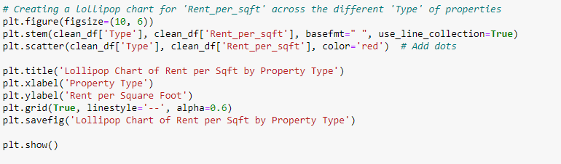
[Figure 36: Code to generate Lollipop Chart for Rent per square fit by property Type ]

- Code Explanation:

By using Matplotlib a lollipop chart is created and shows 'Rent_per_sqft' for various property types. A lollipop chart is a visually appealing and informative data presentation tool that combines elements of a simple stem plot and a scatter plot. Below is an explanation of every part of code and how it fits into the overall structure of the chart:
Setting Up the Plot
plt.figure(figsize=(10, 6)): Initializes a plot with figure size.
plt.stem(clean_df['Type'], clean_df['Rent_per_sqft'], basefmt=" ", use_line_collection=True)
- plt.stem(): Creates the stem portion of the lollipop chart
- basefmt=" ": Removes the baseline along the x-axis
- `use_line_collection=True`: Optimizes the rendering of the stems
- plt.scatter(clean_df['Type'], clean_df['Rent_per_sqft'], color='red') :Add dots
- plt.scatter(): Adds the 'candy' part of the lollipop, which are the dots at the top of each stem
- color='red': Sets the color of the scatter plot markers to red.

- Explanation of the Generated Lollipop Chart

The generated lollipop chart shows 'Rent_per_sqft' for each type of property in an understandable and visually appealing manner. This kind of chart works especially well at showing a dataset's range and distribution while emphasizing specific data points. It is simple to compare different types of properties and spot trends or outliers in the data because each lollipop graphically depicts the rent per square foot for a particular property type. When data needs to be communicated in a clear and eye-catching way, presentations and reports can also benefit from this visual format.

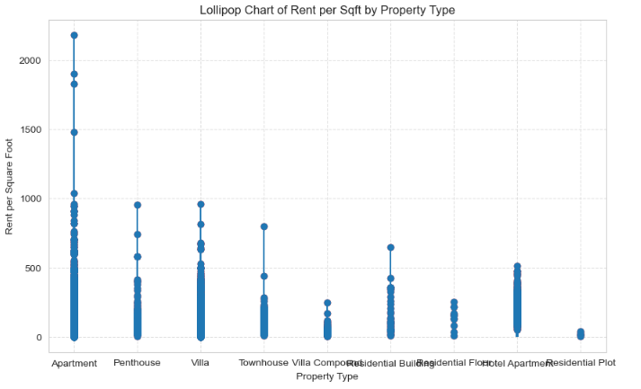

[Figure 37:Lollipop Chart for Rent per square fit by property Type ]
4.4.16. Scatter Map Box Plot

A Scatter Mapbox plot is an advanced data visualization method that makes use of Mapbox's interactive and detailed map-making capabilities by fusing scatter plots with geographic mapping. For the purpose of visualizing spatial data, this method works especially well when individual data points are plotted on a map according to their geographic coordinates.
- Creating Scatter Map Box Plot for Abu Dhabi rental properties Dataset to visualizing spatial data:
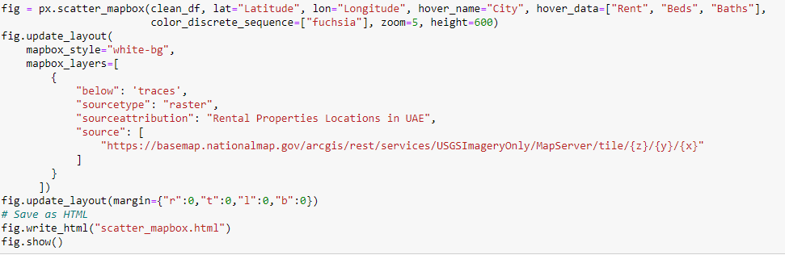
[Figure 38:Code Snippet to generate Scatter Map Box Plot]

- Code Explanation:
1. Color and Zoom Setup:
color_discrete_sequence=["fuchsia"], zoom=5, height=600)
- color_discrete_sequence: This parameter sets the colors of the markers on the map. In this case, all markers will be fuchsia.
- zoom=5: Sets the initial zoom level of the map to 5, which determines how close the map is zoomed in to the coordinates.
- height: Sets the height of the plot to 600 pixels, defining how tall the plot will be on the screen.

2. Map Style and Layers:
fig.update_layout(
mapbox_style="white-bg",
mapbox_layers=[{
"below": 'traces',
"sourcetype": "raster",
"sourceattribution": "Rental Properties Locations in UAE",
"source": [
"https://basemap.nationalmap.gov/arcgis/rest/services/USGSImageryOnly/MapServer/tile/{z}/{y}/{x}"
]
}]
)
3. Adjusting Margins:
fig.update_layout(margin={"r":0,"t":0,"l":0,"b":0})

- Explanation of the Generated Map

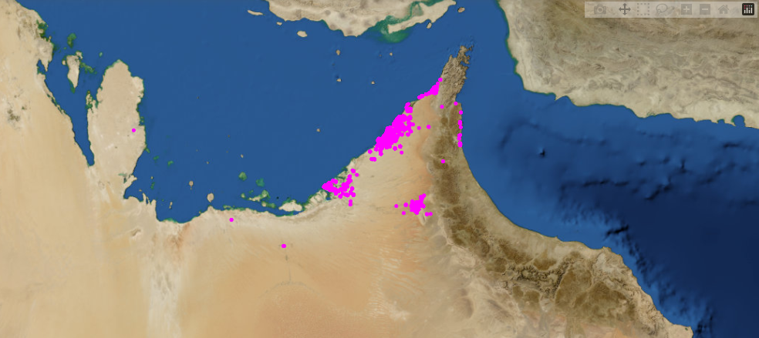
The scatter plot data is displayed geographically based on the coordinates that were supplied in the resulting map-based visualization. The USGS(United States Geological Survey) satellite imagery is superimposed, and points are identified with a distinctive fuchsia color, making spatial data—like the locations of rental properties in the United Arab Emirates—clearly and visually appealingly represented. The map can be customized, has no borders, and can be used in full screen mode, which makes it a useful tool for detailed geographical analysis or presentations in an eye-catching format.

[Figure 39: Scatter Mapbox Plot]

4.4.17. Spark line Plot

A simple and clear way to depict data trends over time is with a spark line plot, one kind of data visualization. Spark lines, which were first introduced by data visualization guru Edward Tufte, are compact, straightforward charts that can be incorporated into text or tables and are perfect for showing trends in a way that uses less space (Tufte, 2006).
- Creating Spark line Plot for Abu Dhabi rental properties Dataset to visualizing spatial data:
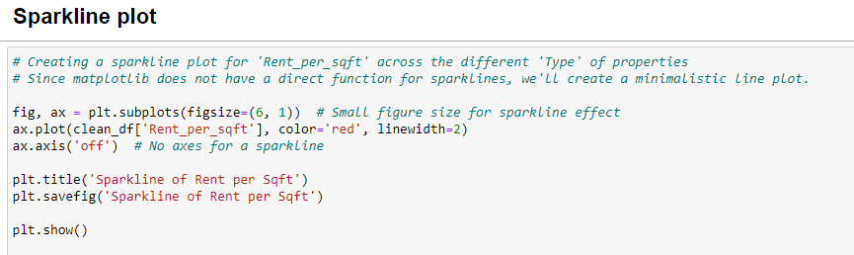
[ Figure 40: Figure of code to generate Spark Line Plot]

- Code Explanation:
The given code explains how to use Matplotlib to create a sparkline plot for 'Rent_per_sqft' across various property types.
- fig, ax = plt.subplots(figsize=(6, 1)) # Small figure size for sparkline effect
- plt.subplots(): Creates a figure and a set of subplots. This method returns a figure and an axes object or array of axes objects.
- figsize=(6, 1): Specifies the size of the figure. The width is 6 inches and the height is 1 inch, creating a very flat, wide appearance typical of sparklines.
- ax.plot(clean_df['Rent_per_sqft'], color='red', linewidth=2)
- ax.plot(): Plots the 'Rent_per_sqft' data on the axes object `ax`.
- color='red': Sets the color of the line to red.
-linewidth =2: Sets the width of the line to 2 points.
- ax.axis('off') : Turns off the axis lines and labels

- Explanation of the Generated Sparkline

An illustration of the rent per square foot trend for different types of properties is produced in the form of a sparkline. When a thorough analysis is not required, this kind of plot works best for rapidly communicating the general movement or trend in the data. When there is a need to display multiple data trends at once or when space is at a premium, it can be particularly helpful to place this clear, concise, and visually appealing summary next to textual content. Viewers are kept focused on the trend rather than the chart's technical aspects by the lack of axes and simple styling.


[Figure 41: Spark Line Plot]

4.4.18. Bubble Chart

Three dimensional data are shown within a two-dimensional plot in a bubble chart, a sort of data visualization. With the third dimension being its size, each bubble represents a data point, whose position is dictated by the first two dimensions (the x and y axes). Few (2009) highlights the utility of this technique in highlighting disparities in magnitude among data points and in illustrating relationships between three variables.
- Creating Bubble Chart for Abu Dhabi rental properties Dataset to analyzing 'Rent_per_sqft' and 'Rent':

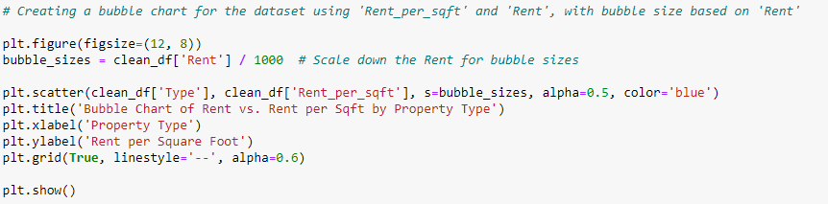
[ Figure 42: Figure of code to generate Bubble chart]

Code Explanation:
plt.figure(figsize=(12, 8)): - Initializes a new plotting figure and sets its size to 12 inches wide by 8 inches tall.

Preparing Bubble Sizes
bubble_sizes = clean_df['Rent'] / 1000 # Scale down the Rent for bubble sizes
- Calculates bubble sizes by scaling down the 'Rent' values, dividing each by 1000.

Scatter Plot for Bubble Chart:
plt.scatter(clean_df['Type'], clean_df['Rent_per_sqft'], s=bubble_sizes, alpha=0.5, color='blue')
- plt.scatter(): Creates a scatter plot which is used here to form the bubble chart.
- clean_df['Type'] and clean_df['Rent_per_sqft']: These specify the x and y coordinates for the bubbles.
- s=bubble_sizes: Sets the size of each bubble using the previously calculated `bubble_sizes`.
- alpha=0.5: Sets the transparency of the bubbles to 50%
- color='blue' Colors all the bubbles blue

- Explanation of the Generated Bubble Chart

The generated bubble chart efficiently illustrates three different aspects of the data: the kind of property, the rent amount indicated by the bubble size, and the rent amount per square foot. This kind of visualization is especially helpful in finding patterns and connections between rent metrics and property type, enabling fast visual evaluations of the interactions between these variables. The distribution along the rent per square foot axis, for instance, can demonstrate how rent value relates to price per square foot across property types, while larger bubbles in a particular area of the plot might indicate areas with higher rents. The chart is made more illuminating and visually appealing by the use of bubble size, which gives the analysis another level of depth.
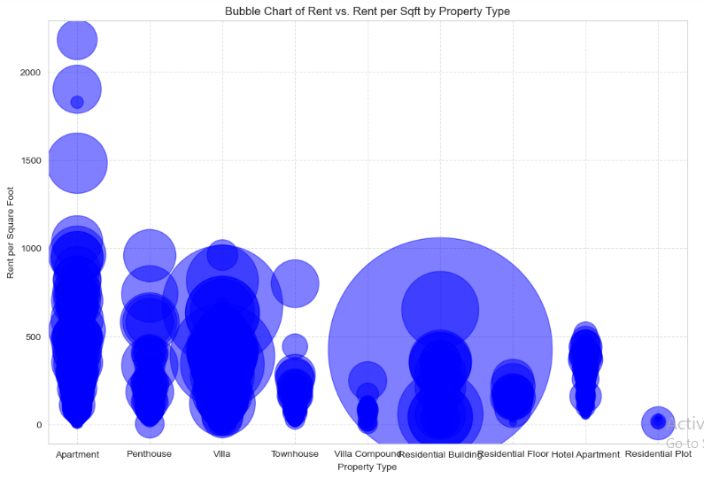
[ Figure 43 : Bubble chart of Rent vs.per Sqft Property Type]

4.4.19. Joint Plot
A joint plot is a flexible method for visualizing data that can be used to examine the relationship between two variables as well as reveal information about each of their respective
distributions.
- Create Joint Plot for Abu Dhabi rental properties Dataset to analyzing 'Rent_per_sqft' and 'Rent':
The given code generates a joint plot using Seaborn's jointplot function, which examines the relationship between two variables in this case, 'Area in sqft' and 'Rent' by combining a scatter plot and histograms.
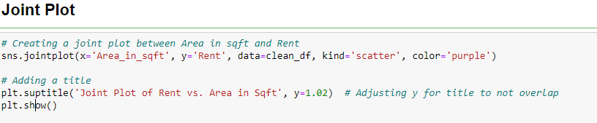
[Figure 44: Code to generate joint plot] between Area in sqft and Rent]
- Code Explanation:
Joint Plot Setup:
sns.jointplot(x='Area_in_sqft', y='Rent', data=clean_df, kind='scatter', color='purple')
- x='Area_in_sqft, y='Rent'`: Specifies the variables to plot on the x-axis and y-axis, respectively.
- data=clean_df`: Indicates the DataFrame source of the data.
- kind='scatter': Defines the type of plot. Here, 'scatter' is chosen to display the relationship between the two variables as a scatter plot.
- color='purple': Sets the color of the points in the scatter plot to purple, making the plot visually distinct.
2. Title Setup:
plt.suptitle('Joint Plot of Rent vs. Area in Sqft', y=1.02) # Adjusting y for title to not overlap
- plt.suptitle(): Adds a title to the overall figure.
- y=1.02: Adjusts the vertical placement of the title to ensure it doesn't overlap with the plot elements.
- plt.show() : Show Plot:
- Explanation of the Generated Joint Plot
The resulting joint plot highlights any possible correlations or patterns and provides a thorough understanding of the relationship between "Area in sqft" and "Rent." For instance, if rents are typically higher in larger areas, the scatter plot would show an upward trend to the right. For market research or real estate planning, it can be helpful to know whether the majority of the properties are grouped around particular area sizes or rent levels, as shown by the histograms.
In exploratory data analysis, this type of plot is particularly useful as it offers insights into the distributions of individual variables as well as their interactions within a cohesive, visual framework.

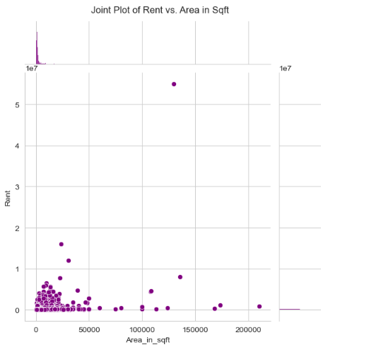
[Figure 45: Joint plot of Rent vs. Area in square fit]
4.4.20. Area Plot
Area charts, also known as area plots, are useful for comparing different data series and displaying cumulative totals over time.
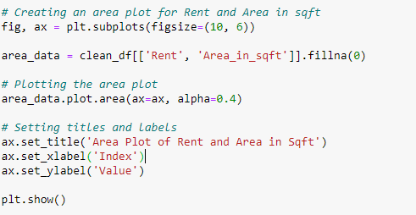
- Create Area Plot for Abu Dhabi rental properties Dataset to analyzing 'Rent_per_sqft' and 'Rent':

[Figure 46: Code snippet to generate Area Plot]
- Code Explanation:

fig, ax = plt.subplots(figsize=(10, 6)): - This initializes a figure object `fig` and an axes object `ax`, with a specified figure size.
area_data = clean_df[['Rent', 'Area_in_sqft']].fillna(0): - A new DataFrame `area_data` is created by selecting only the 'Rent' and 'Area in sqft' columns from `clean_df`. The `fillna(0)` method replaces any missing values in these columns with 0.

Plotting the Area Plot
area_data.plot.area(ax=ax, alpha=0.4)
- area_data.plot.area(): Generates an area plot for the selected data.
- ax=ax: This argument ensures the plot uses the previously created axes object.
- alpha=0.4: Sets the transparency of the fill color in the area plot to 40%.

Customizing the Plot
Setting Titles and Labels:
ax.set_title('Area Plot of Rent and Area in Sqft'): Adds a title to the axes.
ax.set_xlabel('Index'): Label the x-axis.
ax.set_ylabel('Value'): Label y-axis.
plt.show() : Display the Plot.

- Explanation of the Generated Area Plot

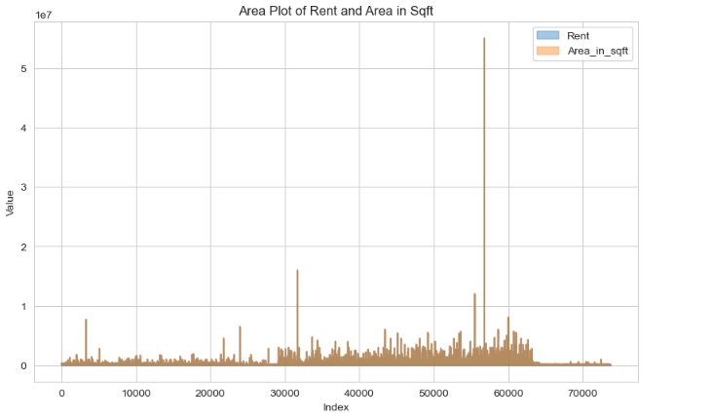

[Figure 47: Area Plot]

The area plot shows trends in "Area in sqft" and "Rent" throughout the index of the DataFrame graphically. The filled area beneath each variable's line represents the variable's variation and relative magnitude over the index. The relationship and trends between the data series, especially how they accumulate over time or another dimension, can be clearly seen visually with this kind of plot, which is helpful for observing how two or more quantities vary together over an index. These kinds of plots can be used in practical settings to detect growth trends, seasonal fluctuations, or disparities between two metrics.
4.4.21. Hexbin

Hexbin plots are a kind of data visualization where hexagonal bins are used to depict the point density in a two-dimensional space.
- Create Hexbin for Abu Dhabi rental properties Dataset to analyzing 'Rent_per_sqft' and 'Rent':

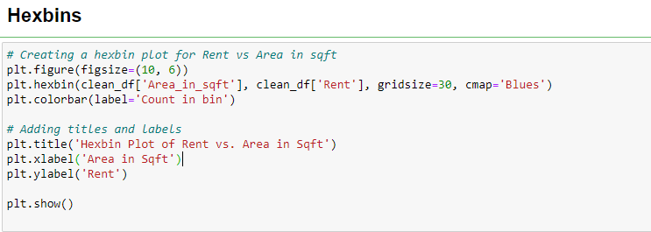
[Figure 48: Code snippet to generate Hexbins]
- Code Explanation:
s
Setting Up the Plot
plt.figure(figsize=(10, 6)): - Initializes a new figure for plotting, with specified dimensions of 10 inches wide by 6 inches tall.
plt.hexbin(clean_df['Area_in_sqft'], clean_df['Rent'], gridsize=30, cmap='Blues'):
- plt.hexbin(): This function creates a hexagonal binning plot.
- clean_df['Area_in_sqft'], clean_df['Rent']: These are the x and y variables.
- gridsize=30: Determines the number of hexagons along the x-axis
- cmap='Blues': Sets the color map to 'Blues', which means areas with higher counts of data points.
- plt.colorbar(label='Count in bin'): - Adds a color bar to the side of the hexbin plot..
- plt.title('Hexbin Plot of Rent vs. Area in Sqft'):- - Adds a title to the plot.
- plt.xlabel('Area in Sqft'):-Labels for the x-axis.
- plt.ylabel('Rent'): Labels for the y-axis.
- plt.show():Display the Plot.
- Explanation of the Generated Hexbin Plot

The concentration of data points at various combinations of "Area in Sqft" and "Rent" is visually represented by the generated hexbin plot. When data points are closely spaced and a scatter plot would cause overplotting, this kind of plot is very helpful. Darker areas in the hexbin plot represent higher densities of properties with particular area sizes and rent values; these patterns and concentrations may not be as clear in other plot types. This can be useful in determining patterns or anomalies in the correlation between a property's size and rental price.
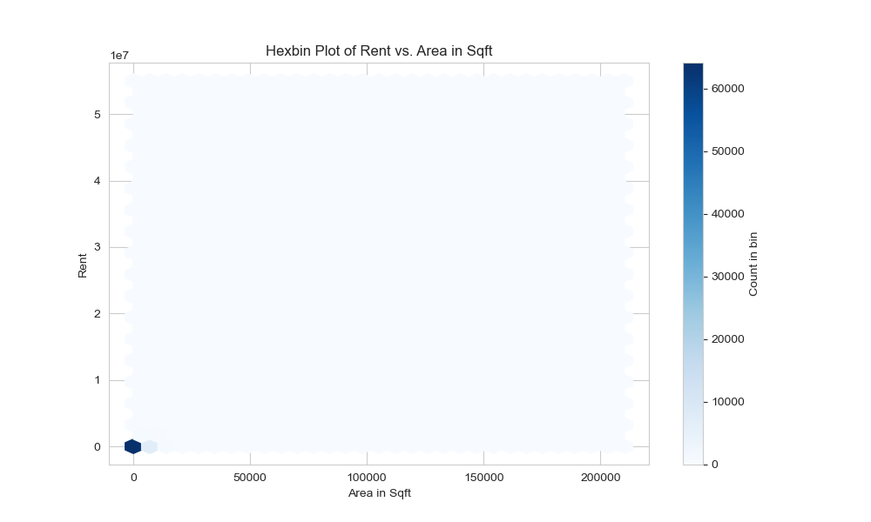
[Figure 49: Hexbins Plot of Rent vs. Area in Sqft]

4.4.22. Pair Plot

A sort of data visualization called a pair plot, sometimes referred to as a scatterplot matrix, is used to examine the connections between several pairs of variables in a dataset. When looking for distributions, correlations, and patterns across several dimensions, they are especially helpful.

- Create Pair Plot for Abu Dhabi rental properties Dataset to analyzing data:
The following Python code create and save a pair plot for housing data using Seaborn.
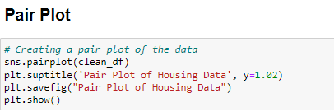

[Figure 50: Code snippet to generate Pair Plot]

- Code Explanation:

sns.pairplot(clean_df):- `sns.pairplot()` generates a pair plot. The DataFrame comprises a grid of plots for every pair of variables. When it comes to numerical variables, the DataFrame displays density plots or histograms on the diagonal to display the distribution of each variable and scatter plots on the off-diagonal cells to investigate correlations between pairs of variables.
plt.suptitle('Pair Plot of Housing Data', y=1.02): Sets a title for the entire figure.
plt.savefig("Pair Plot of Housing Data"):- Saves the current figure to a file.
plt.show():- Displays the plot.

- Explanation of the Generated Pair Plot

A complete analysis of the relationships between every pair of variables in {clean_df} will be provided by the pair plot that is produced. As we can see:

- Correlations: Scatter plots, which show trends in the data points, can be used to determine whether there are any linear correlations between variables.

- Distributions: By displaying the data's distribution for each variable, diagonal plots can be used to detect skewness, multimodality, and other noteworthy characteristics in the data.

- Outliers: In scatter plots, outliers can be seen as points that significantly differ from other points, and in histograms, they can be seen as bars that are separated from the remaining data.
In the early phases of data analysis, this visualization is very helpful in identifying areas that might need more in-depth statistical analysis or transformation.

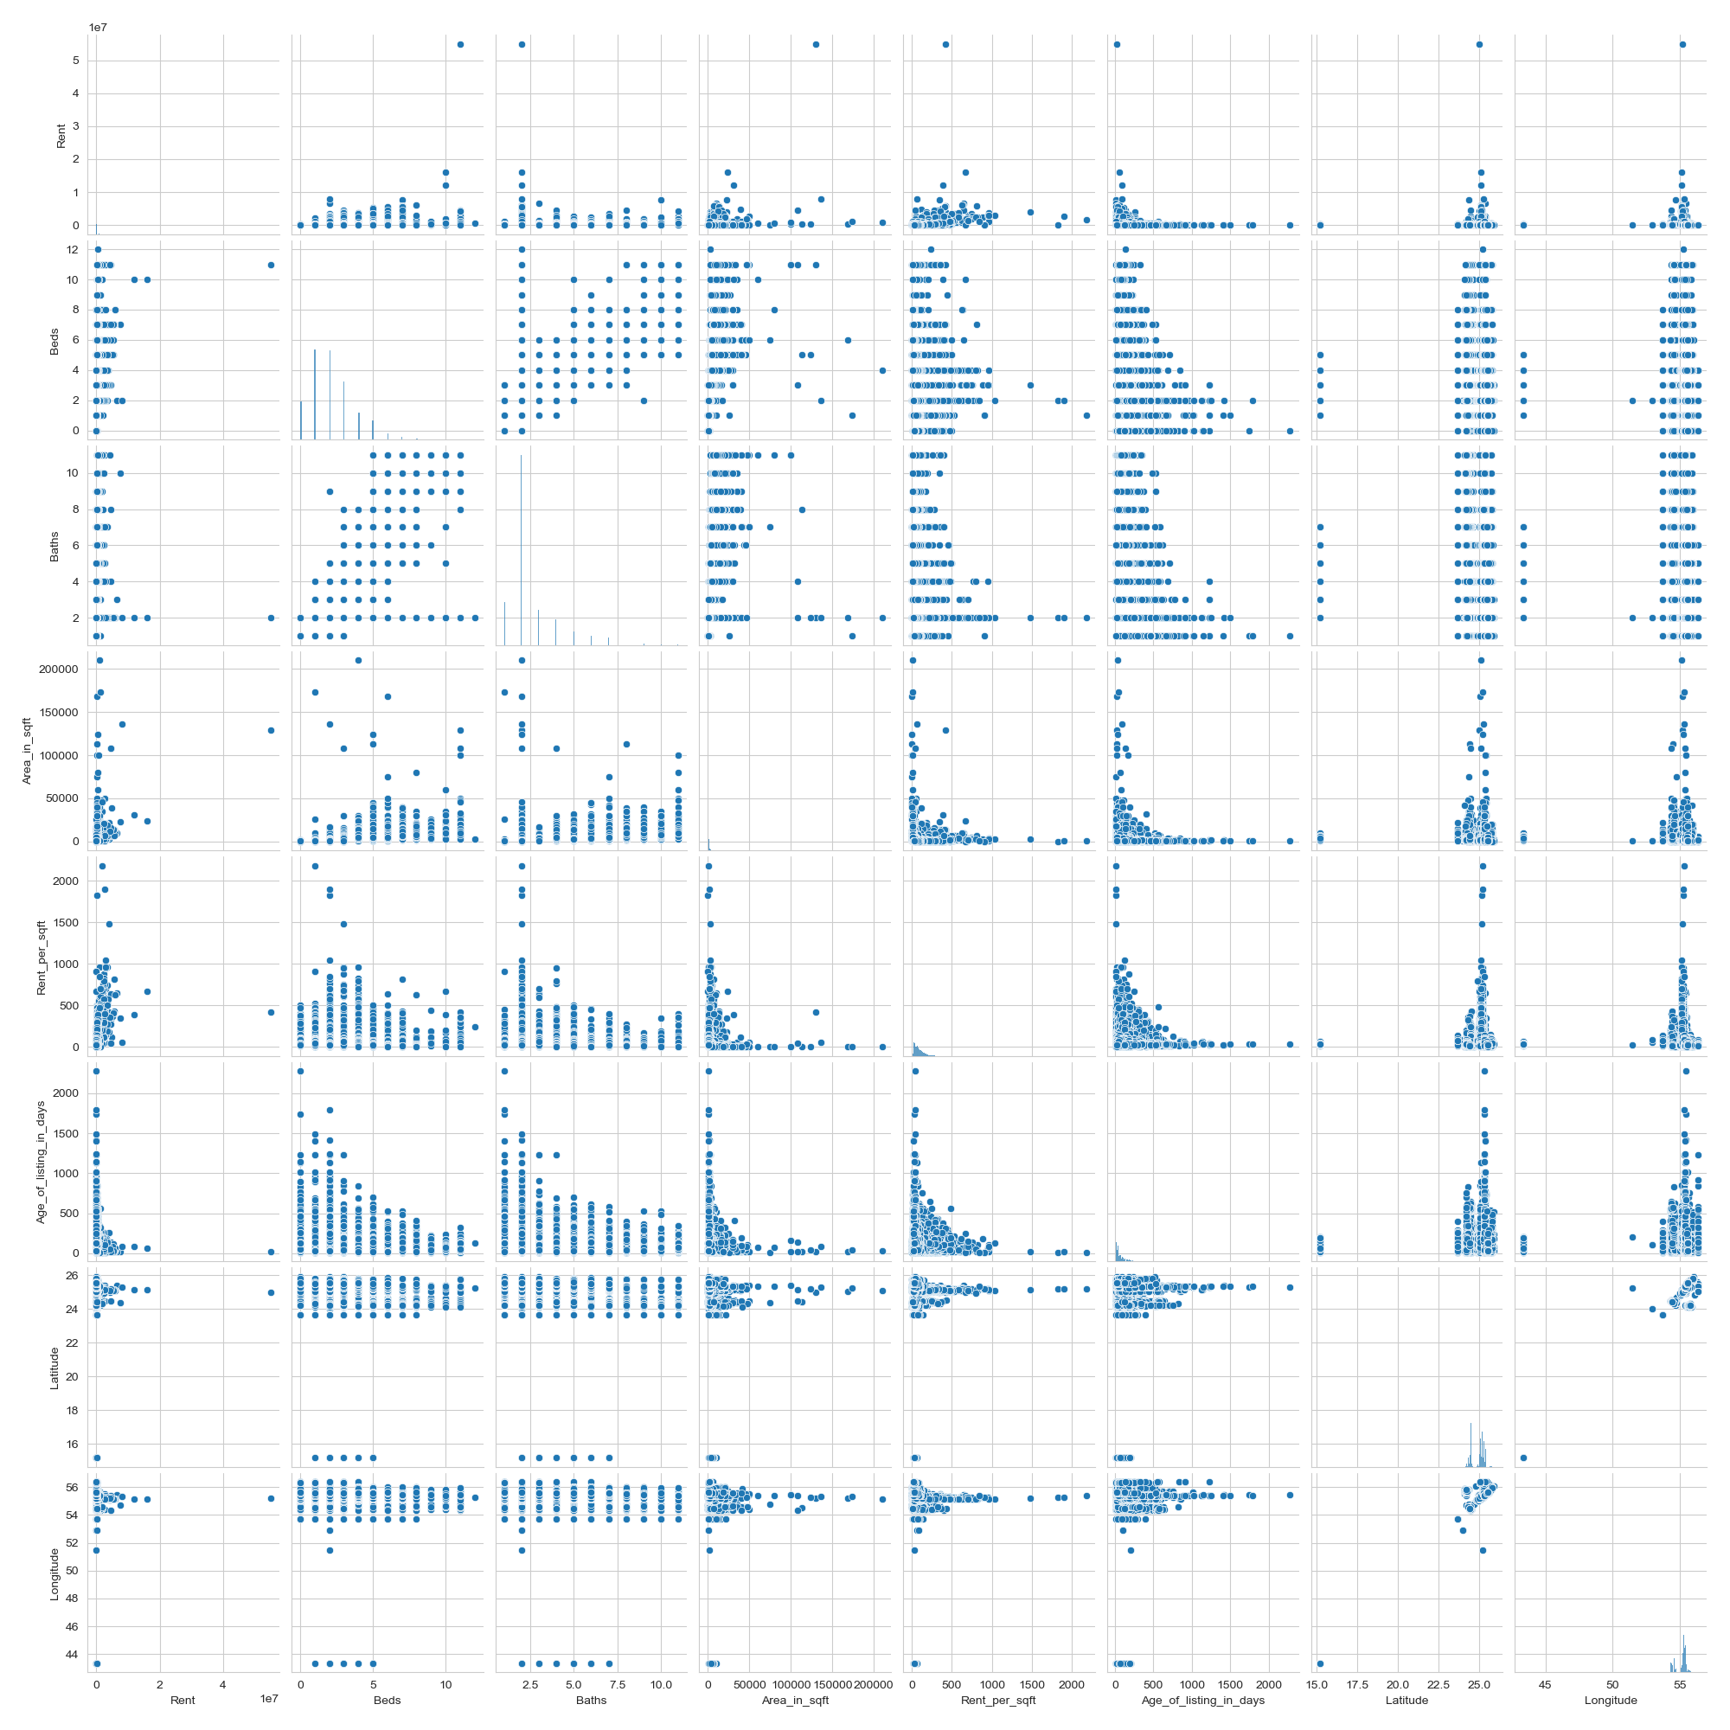
[Figure 51: Pair Plot]

4.4.23. Time Series Plot

Analyzing trends, patterns, and anomalies over time requires the use of time series data visualization. Making educated decisions and comprehending temporal relationships are aided by efficient techniques.

- Create Time Series Plot for Abu Dhabi rental properties Dataset to analyzing Rent Price over Time:

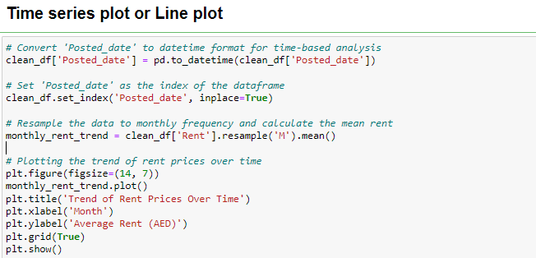

[Figure 52:Code snippet to Generate Time Series Plot]

- Code Explanation:

-clean_df['Posted_date'] = pd.to_datetime(clean_df['Posted_date']):- Converts the 'Posted_date' column from a string or other formats to datetime objects.
- clean_df.set_index('Posted_date', inplace=True) :- Sets the 'Posted_date' column as the index of `clean_df`.
- monthly_rent_trend = clean_df['Rent'].resample('M').mean():Groups the data into monthly bins. The 'M' parameter specifies the frequency as monthly. And Calculates the mean rent for each month.
-plt.figure(figsize=(14, 7)):- Sets up a plotting area of 14 inches by 7 inches
- monthly_rent_trend.plot():Plots the `monthly_rent_trend` Series.
- plt.title('Trend of Rent Prices Over Time'): Adds a title to the plot.
- plt.xlabel('Month'): Label the x- axis.
- plt.ylabel('Average Rent (AED)'): Label the y-axis.
- plt.grid(True) : Enables a grid on the plot.
- plt.show(): Display the plot.

- Explanation of the Generated Plot

The generated plot illustrates the monthly trend of average rent prices over time. Investors can quickly spot any trends, patterns, or seasonal differences in rental rates thanks to this visualization. Indicators of market dynamics, such as seasonal variations in demand or the state of the economy, may be reflected in changes in the average rent. An analysis of this kind is essential for formulating sound policies, managing portfolios, and investing in real estate.
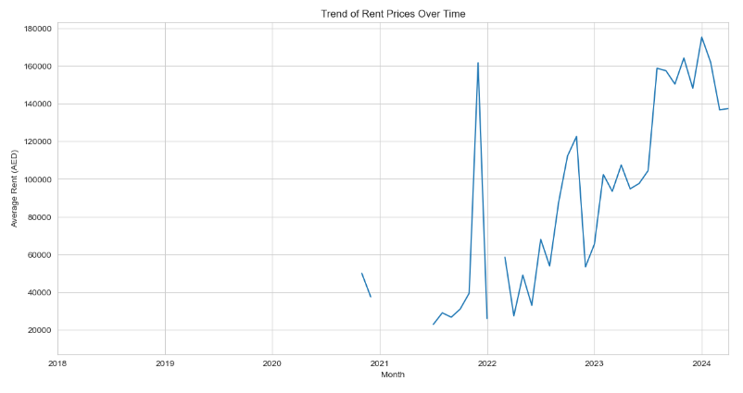

[Figure 53: Time Series Plot Trend of Prices Over Time]

4.4.24. Bokeh Pot

Bokeh is a powerful, flexible, and accessible interactive visualization library for modern web browsers.

- Create Time Bokeh Plot for Abu Dhabi rental properties Dataset:

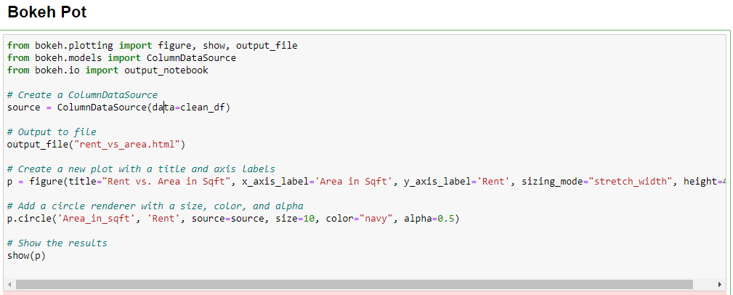

[Figure 54: Code snippet to Generate Bokeh Plot]

- Import Statements

from bokeh.plotting import figure, show, output_file
from bokeh.models import ColumnDataSource
from bokeh.io import output_notebook

- figure, show, output_file are imported from bokeh.plotting. These are essential for creating, configuring, and displaying your plot.
- ColumnDataSource is imported from bokeh.models and is used to hold the data for your plot in a format that Bokeh can efficiently work with.
- output_notebook from bokeh.io is meant to direct the output of the plot to your Jupyter notebook interface, although it's not activated in the code provided.

- Data Source

source = ColumnDataSource(data=clean_df)

- Output Configuration
output_file("rent_vs_area.html") - This function call sets the output of plot to be saved as an HTML file named "rent_vs_area.html".

- Plot Creation

p = figure(title="Rent vs. Area in Sqft", x_axis_label='Area in Sqft', y_axis_label='Rent', sizing_mode="stretch_width", height=400)

- figure() creates a new plot with the specified attributes:
- title: Sets the title of the plot.
- x_axis_label and y_axis_label: Set the labels of the x-axis and y-axis, respectively.
- sizing_mode="stretch_width": Makes the plot width responsive to the container's width, which is useful for web pages.
- height=400: Sets a fixed height for the plot in pixels.

- Adding Glyphs

p.circle('Area_in_sqft', 'Rent', source=source, size=10, color="navy", alpha=0.5)

- p.circle() adds circle glyphs to the plot, where:
- The first two parameters 'Area_in_sqft' and 'Rent' are the names of the columns in `source` that determine the positions of the circles on the x and y axes.
- size=10: Diameter of the circles in pixels.
- color="navy": Color of the circles.
- alpha=0.5: Transparency of the circles; 0.5 means 50% transparent.

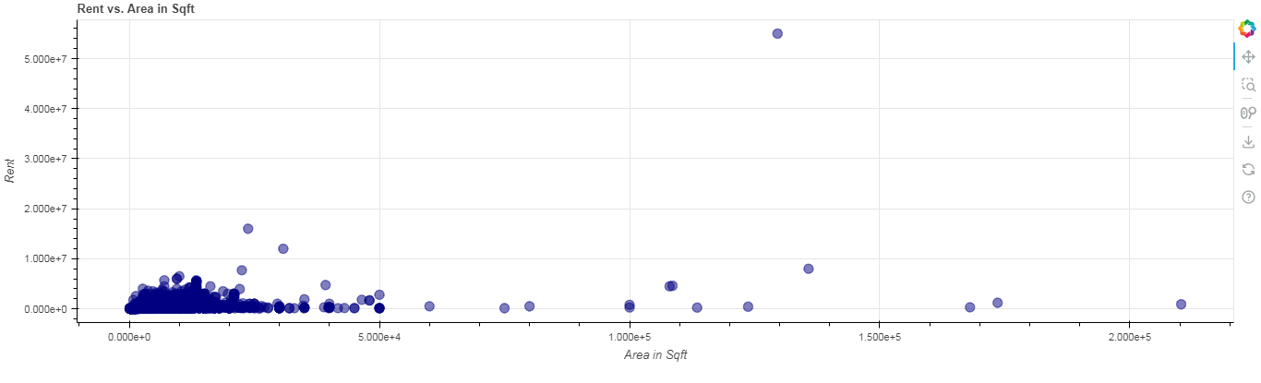
- Display the Plot: show(p)
[Figure 55: Bokeh Plot]

- Explanation of the Bokeh Plot

The relationship between a property's area (measured in square feet) and rental price is represented visually in the Bokeh plot which is generated from the code. With its area plotted on the x-axis and its rent plotted on the y-axis, each data point in this scatter plot represents a single property.
Real estate analysts, landlords, and tenants can all make use of this plot to determine typical rent expectations for a given size of property, assess market conditions, and even identify pricing anomalies. In comparative market analysis, it can also be used as a tool to set rent prices based on the size of the property. All things considered, the plot is a useful visual aid for data analysis and presentation regarding the relationship between rental prices and property size.

5. Conclusion

5.1. Insights and Value Being Presented to the User through the Visualizations

The series of visualizations on the property listing data gave insight into the real estate market relevant to Abu Dhabi. It indicates how rent is distributed in different types of properties for example, how different price strategies are applied to apartments, penthouses, and villas. Mapping of properties also involves showing the geographic trends and categories of the place with rents, which appear to help in visualizing how the rental prices differ within different places and for different types of properties. The scatter plot of rent against area provides a good, clear insight into how the size of property is related to the rent charge, which is very important for prospective tenants and analysts of real estate. Thereby, the timeline of property listings gave a general description of market dynamics over time and pointed out periods with increased or decreased activity.

5.2. Discussion of Limitations or Challenges

A major limitation for this analysis was the fact that, due to connectivity issues, I could not directly display the visualizations interactively. This technical hiccup, unfortunately, disabled any interactive way to engage the data, hence further bringing out insights through the dynamic filtering and drilling down of the data. Additionally, the data set is relatively small and not very representative, so at least some of the larger trends that could arguably come from a larger and more diverse data set might be omitted. Moreover, to a larger extent, the basic nature of the visual tools used would imply that the analytical capability was quite limited, considering the fact that a deeper insight has to be brought out than what shall be achieved with more advanced analysis methods and their corresponding tools.

5.3. Recommendations for Future Work or Next Study

The following might be taken as some measures that would help to increase understanding of the property market in future work:

1. Expand Dataset: Including more properties in different areas and over a longer period would give a richer and broader view of what market trends look like over time and different economic cycles.

2. Advanced Analytics Techniques: Machine-learning models towards predicting trends in rent prices or identifying factors most strongly influencing the price of properties can potentially give out actionable insights to investors and policymakers.

3. Using Additional Data Sources: Including some demographic and economic data would explain the influence of such socio-economic factors on property prices. Information such as median income, population growth, and employment rates would further enrich this analysis.

4. Interactive Dashboard Development: This would mean that stakeholders could go ahead and perform their analysis with real-time data and view any updates as and when market conditions change.

5. Comparative Analysis: Compare these trends to other cities or regions for identifying peculiar opportunities or risks within the Abu Dhabi market.

The resolution of such recommendations through further analysis may thereby provide a more conceptual framework in understanding and predicting the dynamics of real estate, useful to stakeholders ranging from investors to renters for making their decisions.

References
1. Sharma, A.M., 2020. Data visualization. In Data Science and Analytics (pp. 1-22). Emerald Publishing Limited.
2. Unwin, A., 2020. Why is data visualization important? what is important in data visualization?. Harvard Data Science Review, 2(1), p.1.
3. Few, S., 2006. Information dashboard design: The effective visual communication of data. O'Reilly Media, Inc..
4. Anscombe, F.J., 1973. Graphs in statistical analysis. The american statistician, 27(1), pp.17-21.
5. Few, S., 2012. Show Me the Numbers: Designing Tables and Graphs to Enlighten (Analytics, Oakland, CA).
6 Kirk, A., 2019. Data visualisation: A handbook fosr data driven design. Data Visualisation, pp.1-328.
7. Ware, C., 2019. Information visualization: perception for design. Morgan Kaufmann.
8. Evergreen, S.D., 2019. Effective data visualization: The right chart for the right data. SAGE publications.
9. Tufte, E.R., 2001. The visual display of quantitative information (Vol. 2, p. 9). Cheshire, CT: Graphics press.
10. Wickham, H. (2016) ggplot2: Elegant Graphics for Data Analysis. Springer.
11. Healy, K., 2018. Data visualization: a practical introduction. Princeton University Press.
12. Few, S., 2013. Information dashboard design: Displaying data for at-a-glance monitoring (Vol. 5). Burlingame: Analytics Press.
13. Hintze, J.L. and Nelson, R.D., 1998. Violin plots: a box plot-density trace synergism. The American Statistician, 52(2), pp.181-184.
14. Wilke, C.O., 2019. Fundamentals of data visualization: a primer on making informative and compelling figures. O'Reilly Media.
15. Tufte, E.R. and Tufte, E.R., 2006. Beautiful evidence (Vol. 1). Cheshire, CT: Graphics Press.
16. Few, S., 2009. Now you see it: simple visualization techniques for quantitative analysis. Analytics Press.

Appendices

