MINI PROJECT FINAL REPORT

Predicting Rural Water Point Functionality Using Data Mining
Fundamentals of Data Mining (IT3051)
Group Mini Project
WaterPoint Intelligence: Rural Water Point Functionality Decision Support System

Table 1. Submission details
Administrative detail | To be completed
Group / batch | [INSERT GROUP AND BATCH]
Student names and IDs | [INSERT GROUP MEMBER DETAILS]
Specialization | [INSERT SPECIALIZATION]
Lecturer in charge | [INSERT LECTURER]
Submission date | [INSERT SUBMISSION DATE]

Abstract
Rural water-point failure can interrupt access to safe water, while routine inspection resources are limited. This project investigates whether survey and contextual attributes can support the prioritisation of field assessment through three-class functionality prediction. The OpenWashData Rural Water Point Functionality dataset contains 1,793 observations across nine countries and 52 raw variables. The target distinguishes Functional, Partially functional, and Abandoned or not functional water points. Since the Functional class represents 74.3% of records, Macro-F1 and per-class outcomes were prioritised over accuracy alone.
A leakage-safe workflow removed contemporary status indicators and identifiers before a stratified 80/20 split into 1,434 development records and a locked 359-record holdout. Five model families were compared with repeated stratified cross-validation. The three strongest families, HistGradientBoosting, XGBoost and Random Forest, advanced to optimisation. The final Random Forest combines base tree preprocessing, rare-category frequency 10, mutual-information SelectKBest with 60 processed features, and no imbalance treatment. It was selected from development evidence before the holdout was evaluated. Its repeated-CV Macro-F1 was 0.6996 ± 0.0481; one-time holdout Macro-F1 was 0.6699, with accuracy 0.8663 and MCC 0.6466.
The model is exported as a verified serialised inference pipeline. A FastAPI service validates the 32 raw inputs and returns class probabilities; a Next.js dashboard presents predictions and exported analysis evidence. The principal limitation is poor recognition of Partially functional points: holdout recall was 0.1935 and F1 was 0.3000. Post-hoc geographic checks also show weaker transfer across countries. Therefore, the application is presented as decision support for inspection and maintenance planning rather than an automated determination of field condition.
Keywords: rural water points; multiclass classification; Random Forest; class imbalance; data leakage; decision support.

Table of Contents
Abstract 2
Table of Contents 2
List of Figures 6
List of Tables 6
List of Abbreviations 7
1. Introduction 8
1.1 Background 8
1.2 Problem Statement 8
1.3 Aim and Objectives 8
1.4 Scope 8
1.5 Project Contributions 8
1.6 Stakeholders and Decision Support 8
1.7 Report Organisation 8
2. Background and Related Concepts 8
2.1 Rural Water-Point Functionality Monitoring 8
2.2 Water-Point Functionality as a Data-Mining Task 8
2.3 Multiclass Classification and Class Imbalance 8
2.4 Data Leakage 9
2.5 Cross-Validation and Holdout Evaluation 9
2.6 Classification Algorithms Considered 9
2.7 Project Data-Mining Workflow 9
3. Dataset Description and Validation 9
3.1 Source and Licensing 9
3.2 Dataset Profile 9
3.3 Target Variable and Class Meaning 9
3.4 Predictor Categories 9
3.5 Excluded Attributes and Rationale 10
3.6 Dataset Suitability and Instructor Validation 10
3.7 Initial Data-Quality Observations 10
4. Exploratory Data Analysis 10
4.1 EDA Approach 10
4.2 Target Distribution and Class Imbalance 10
4.3 Missing-Value Profile 11
4.4 Duplicate and Invalid-Value Analysis 12
4.5 Numerical Distributions and Outliers 12
4.6 Categorical Patterns 12
4.7 Functionality by Country 12
4.8 Numerical Features vs Target 13
4.9 Correlation Analysis 13
4.10 Leakage Investigation 13
4.11 Summary of EDA Findings and Resulting Design Decisions 13
5. Data Preprocessing 14
5.1 Leakage-Safe Order of Operations 14
5.2 Stratified Development/Holdout Split 14
5.3 Missing-Value Treatment 14
5.4 Sentinel and Invalid-Value Handling 14
5.5 Categorical Encoding and Rare Categories 14
5.6 Ordinal Encoding 14
5.7 Scaling and Log Transform Strategy 14
5.8 Model-Family-Specific Preprocessing 14
5.9 Preprocessing Pipeline and Reproducibility 14
6. Feature Engineering and Feature Selection 15
6.1 Engineered Features Evaluated 15
6.2 Base vs Engineered Feature Sets 15
6.3 Feature-Selection Method 15
6.4 SelectKBest Experiments 15
6.5 Final Production Representation 15
6.6 Final 32-Input Schema 15
7. Modelling Methodology 16
7.1 Experimental Design 16
7.2 Validation Strategy 16
7.3 Evaluation Metrics 16
7.4 Candidate Model Families and Rationale 16
7.5 Baseline Configurations 16
7.6 Hyperparameter Optimization Strategy 16
7.7 Class-Imbalance Strategies 16
7.8 Final Evaluation Protocol 16
8. Results, Optimization and Final Model Selection 16
8.1 Baseline Model Comparison: All Five Families 16
8.2 Base vs Engineered Ablation 17
8.3 Baseline Error and Minority-Class Analysis 17
8.4 Shortlist Selection 17
8.5 Hyperparameter Search Results 17
8.6 Imbalance-Treatment Experiments 17
8.7 Rare-Category Threshold Experiments 17
8.8 Feature-Selection Results 17
8.9 Finalist Repeated-CV Comparison 17
8.10 Final Model Selection and Justification 18
8.11 Historical Holdout Performance 18
8.12 Per-Class Holdout Performance 18
8.13 Confusion Matrix Analysis 18
8.14 Summary of Results 19
9. Model Robustness and Interpretation 19
9.1 Purpose and Post-Hoc Status 19
9.2 Raw Permutation Importance 19
9.3 Selected RF Feature Importance 20
9.4 Coordinate Ablation 20
9.5 Representation Control 20
9.6 Safe SMOTENC Experiment 20
9.7 Learning-Curve Analysis 20
9.8 Cross-Country Robustness 21
9.9 Post-Hoc Decision 21
10. System Design and Implementation 22
10.1 Overall Architecture 22
10.2 Technology Stack 22
10.3 Production Inference Pipeline 22
10.4 Serialization, Metadata and Reproducibility 22
10.5 FastAPI Backend 22
10.6 API Contract and Endpoints 22
10.7 Next.js Frontend 22
10.8 Prediction Workflow 22
10.9 Dashboard, Data Insights and Model Insights 22
10.10 Responsible Prediction Presentation 22
10.11 Running the System 22
11. System Testing 23
11.1 Testing Objectives 23
11.2 Production Pipeline and Serialization Tests 23
11.3 Backend API Tests 23
11.4 Frontend Tests and Build Verification 23
11.5 End-to-End Integration Tests 23
11.6 Invalid, Missing, Null and Unseen-Category Cases 23
11.7 Issues Identified and Refinements 23
12. Discussion 24
12.1 What the Results Say About the Problem 24
12.2 Why Random Forest Was Selected 24
12.3 The Partially Functional Class Challenge 24
12.4 Precision–Recall and Imbalance Trade-offs 24
12.5 Geographic Information vs Cross-Country Transferability 24
12.6 Stakeholder and Operational Value 24
12.7 Methodological Reflection 24
13. Ethical, Legal and Operational Considerations 24
13.1 Decision Support and Human Oversight 24
13.2 Uncertainty and Automation Bias 24
13.3 Geographic Fairness and Transferability 24
13.4 Data Licensing and Privacy 25
13.5 Reproducibility and Auditability 25
14. Limitations 25
15. Future Work 25
16. Conclusion 25
References 25
Appendix A. Repository Structure 26
Appendix B. Complete Production Input Schema 26
Appendix C. Final Model Configuration 27
Appendix D. Group Contributions 27

List of Figures
Figure 1. Target class distribution (Source: project export) 11
Figure 2. Most-missing raw variables (Source: project export) 12
Figure 3. Recorded functionality composition by country (Source: project export) 13
Figure 4. Leakage diagnostic for current-status fields (Source: project export) 13
Figure 5. Base versus engineered feature ablation (Source: project export) 15
Figure 6. Baseline Macro-F1 by model family (Source: project export) 17
Figure 7. Finalist repeated-CV Macro-F1 (Source: project export) 18
Figure 8. Historical holdout confusion matrix (Source: project export) 19
Figure 9. Raw-feature permutation importance (Source: project export) 20
Figure 10. Post-hoc learning curves (Source: project export) 21
Figure 11. Post-hoc country robustness (Source: project export) 21

List of Tables
Table 1. Submission details 1
Table 2. Abbreviations 7
Table 3. Dataset profile 9
Table 4. Feature exclusions 10
Table 5. EDA findings and modelling implications 14
Table 6. Preprocessing by feature type 15
Table 7. Stage-6 baseline family winners 16
Table 8. Finalist repeated-CV results 18
Table 9. Historical holdout per-class performance 18
Table 10. Implemented API routes 23
Table 11. Main limitations and implications 25
Table 12. The 32 raw predictors required by the production pipeline 26
Table 13. Locked production configuration 27
Table 14. Group contribution record to complete before submission 27

List of Abbreviations
Table 2. Abbreviations
Abbreviation | Meaning
API | Application Programming Interface
CV | Cross-validation
EDA | Exploratory Data Analysis
F1 | Harmonic mean of precision and recall
MCC | Matthews correlation coefficient
OOF | Out-of-fold
RF | Random Forest
SMOTENC | Synthetic Minority Over-sampling Technique for nominal and continuous features

1. Introduction

1.1 Background
A water point may appear serviceable in asset inventories even when its present condition has deteriorated. Limited field capacity makes prioritisation important. This project uses historical survey records to estimate functionality status from attributes potentially available before a visit.

1.2 Problem Statement
The three target states have operationally different meanings. A high overall accuracy can conceal missed partially functional sites because that class is small.

1.3 Aim and Objectives
The aim was to build, evaluate and expose a reproducible three-class prediction workflow. Objectives were to understand the dataset; prevent leakage; compare model families; select on development CV; evaluate once on holdout; and deliver an integrated decision-support interface.

1.4 Scope
The system accepts 32 raw attributes and returns a class and three model probabilities. It does not verify the physical state of an individual asset or prescribe repairs.

1.5 Project Contributions
The completed work includes documented EDA, family-specific preprocessing, a locked model-selection protocol, production serialization checks, an API, and a browser dashboard.

1.6 Stakeholders and Decision Support
Potential users include water authorities, NGOs, maintenance teams and researchers. Predictions can help rank inspection candidates alongside local knowledge and field records.

1.7 Report Organisation
Chapters 2–9 explain data, modelling and evidence; Chapters 10–11 describe the implemented system and testing; Chapters 12–16 interpret implications, limitations and future work.

2. Background and Related Concepts

2.1 Rural Water-Point Functionality Monitoring
Functionality is a practical service indicator, but surveys are intermittent and heterogeneous across settings. A prediction can direct attention to uncertain or high-risk assets.

2.2 Water-Point Functionality as a Data-Mining Task
The recorded target is a nominal three-class label. Predictors mix geography, technology, governance, usage, maintenance and environment.

2.3 Multiclass Classification and Class Imbalance
Macro-F1 averages class F1 equally, making the rare Partial class visible. Accuracy remains a supporting measure because the majority class dominates it.

2.4 Data Leakage
Variables describing current water availability or recent breakdown can restate the outcome. Their inclusion would create an unrealistic evaluation for pre-inspection prediction.

2.5 Cross-Validation and Holdout Evaluation
Repeated stratified folds estimate variation during development. A previously untouched holdout gives one final historical check after configuration lock.

2.6 Classification Algorithms Considered
Logistic Regression supplies a linear reference; Random Forest and gradient boosting capture nonlinear mixed-feature relationships. XGBoost and CatBoost add alternative boosted-tree approaches.

2.7 Project Data-Mining Workflow
The sequence was data understanding, EDA, fixed exclusions, split, fold-fitted preprocessing, baseline comparison, development-only optimisation, final lock, holdout evaluation and post-hoc robustness.

3. Dataset Description and Validation

3.1 Source and Licensing
The project repository identifies the Rural Water Point Functionality dataset (rwpfunctionality) from OpenWashData [1]. The dataset is distributed under CC-BY according to project records. The raw workbook was retained as a read-only source during analysis.
Table 3. Dataset profile
Property | Recorded value
Rows | 1793
Raw variables | 52
Countries | 9
Target | functional3
Classes | 3
Columns containing missing values | 40
Fully duplicate rows | 0

3.2 Dataset Profile
The sample spans nine countries but is modest relative to the diversity of water-point technologies and local conditions.

3.3 Target Variable and Class Meaning
Functional denotes serviceable points; Partially functional denotes degraded service; Abandoned or not functional denotes unavailable service. Labels are taken as recorded in the dataset.

3.4 Predictor Categories
The final schema includes location, water-point technology, rehabilitation, management, committee capacity, usage and environment variables.

3.5 Excluded Attributes and Rationale
Seven current-status fields were excluded for leakage. Ten identifiers or high-cardinality administrative fields were excluded. Two pending financial fields were not used. The final retained set contains 32 raw predictors.

3.6 Dataset Suitability and Instructor Validation
The dataset has enough records to support a structured class-comparison exercise and contains a defined target. Documentary evidence of instructor sign-off was not available in the repository materials reviewed.

3.7 Initial Data-Quality Observations
Forty of 52 columns contain some missing values; zero complete duplicate rows were recorded. Missingness has different meanings across survey branches.
Table 4. Feature exclusions
Category | Excluded variables
Current-status leakage | wateravailable; whynowatertoday_wp; whynowatertoday_wp_other; downtime2weeks; minutesfill20l; brokendays_wp; qtymonthsnowater_wp
Identifiers / administration | id; instance_wp; photo_wp; commid_wp; cwid; timepoint_wp; dataorg_wp; subdate_wp; admin2; admin3
Pending / unused | grant_number_wp; balance_any_dollars_wp

4. Exploratory Data Analysis

4.1 EDA Approach
Notebook 02 profiled the unmodified raw dataset before learned preprocessing or model selection.

4.2 Target Distribution and Class Imbalance
Functional accounts for 1,333 records (74.3%), Partially functional 157 (8.8%), and Abandoned or not functional 303 (16.9%). Figure 1 makes the imbalance clear.
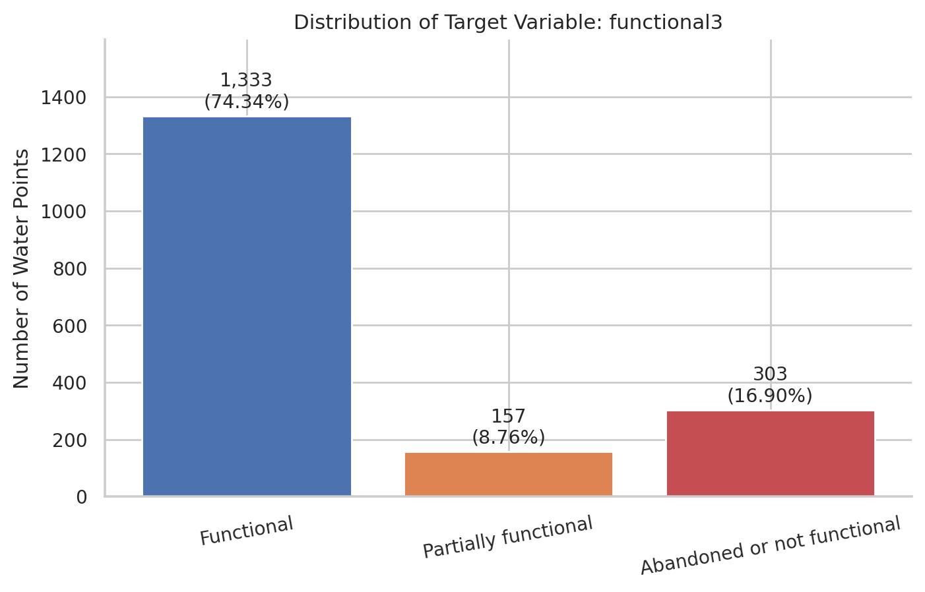
Figure 1. Target class distribution (Source: project export)

4.3 Missing-Value Profile
Several fields are conditionally relevant; others are absent in survey batches. A single blanket fill value would erase this distinction.
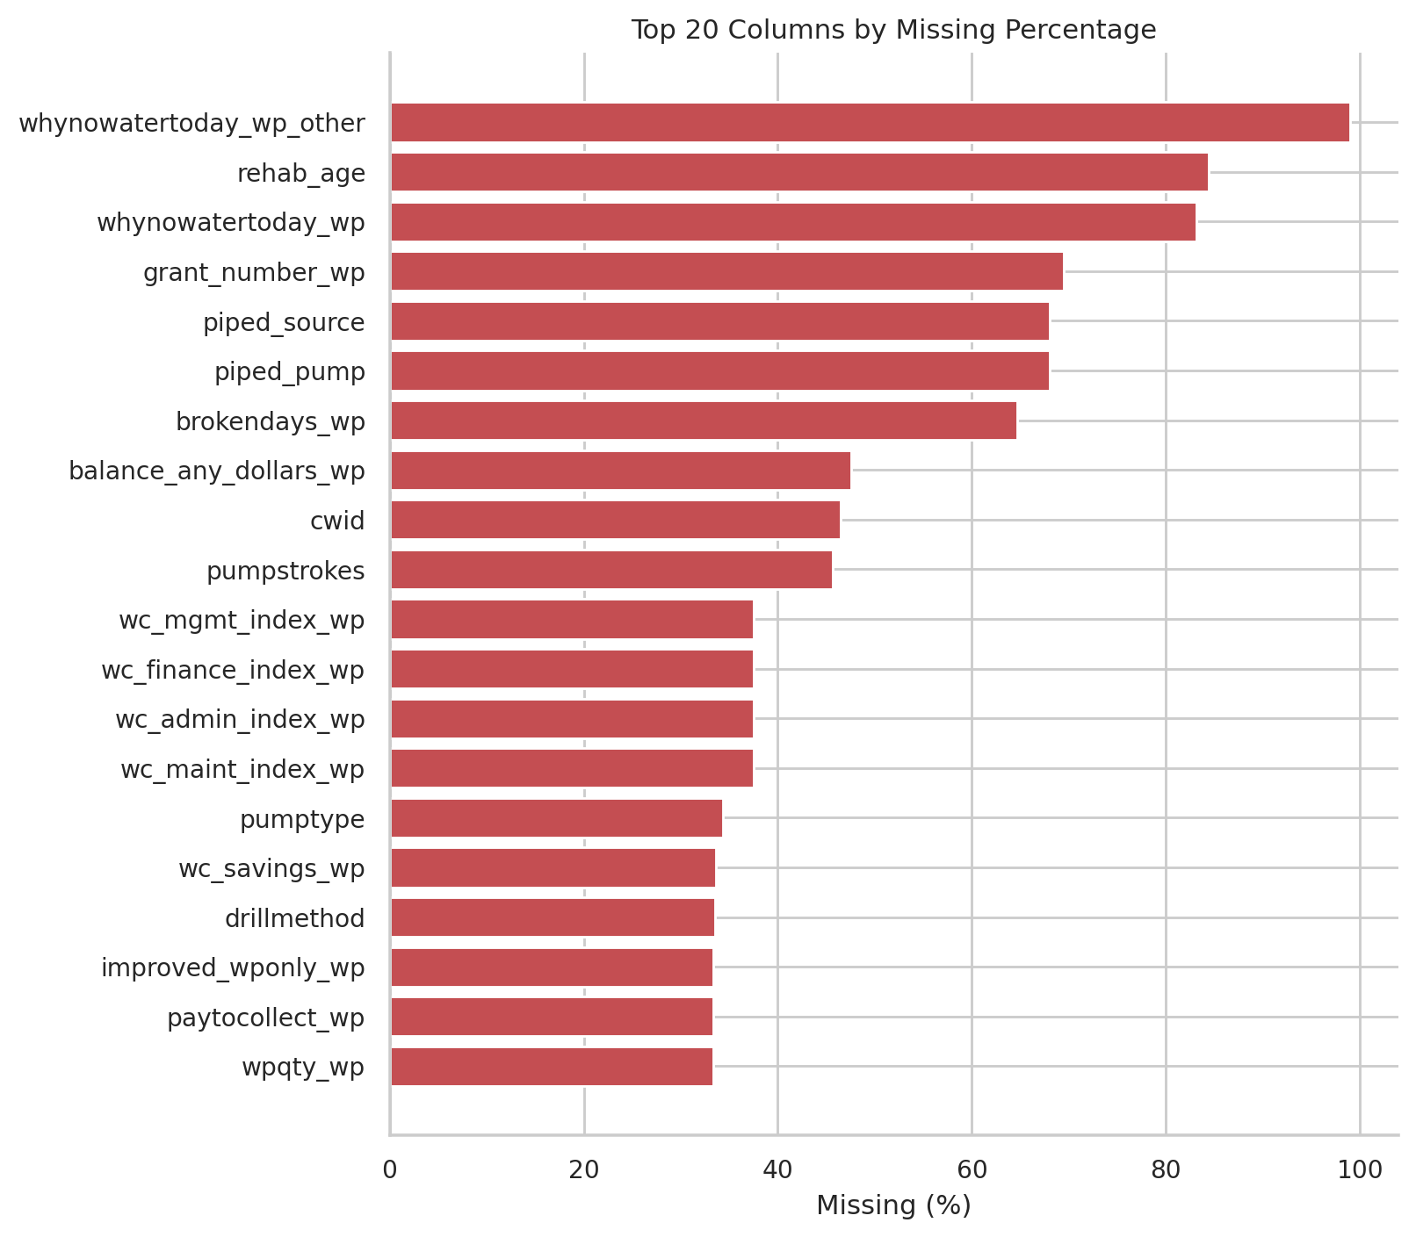
Figure 2. Most-missing raw variables (Source: project export)

4.4 Duplicate and Invalid-Value Analysis
No exact duplicate rows were found. The wc_savings_wp codes 999 and 888 are sentinel values rather than genuine magnitudes.

4.5 Numerical Distributions and Outliers
Usage and age variables are skewed. The 107 recorded negative elevations warrant caution, but observations were not automatically removed or capped.

4.6 Categorical Patterns
Technology, management and geographic categories differ in frequency. Rare categories require a fold-fitted grouping rule.

4.7 Functionality by Country
Figure 3 shows substantial variation in target composition by country; ordinary stratification cannot establish generalisation to an unseen country.
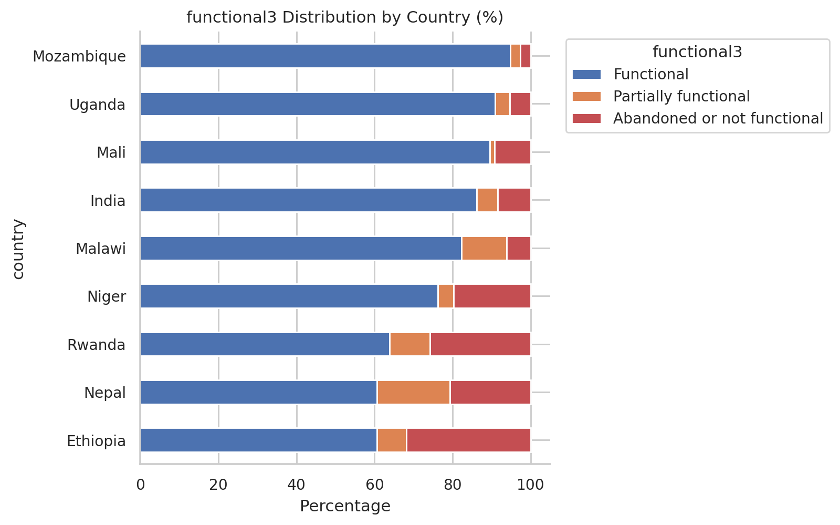
Figure 3. Recorded functionality composition by country (Source: project export)

4.8 Numerical Features vs Target
Numerical distributions overlap across classes. Some current-status variables separate classes sharply, signalling leakage rather than useful prospective information.

4.9 Correlation Analysis
Correlation was used as descriptive evidence, not as a causal test or a stand-alone feature removal rule.

4.10 Leakage Investigation
Water availability, recent downtime and related fields strongly reflect the present target. They were excluded before model comparison.
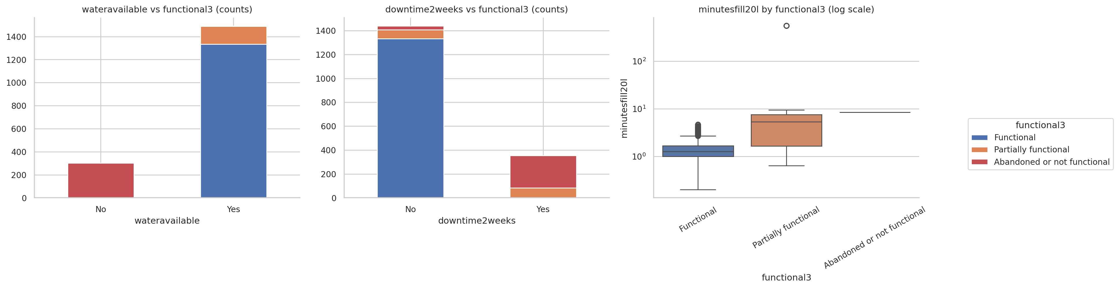
Figure 4. Leakage diagnostic for current-status fields (Source: project export)

4.11 Summary of EDA Findings and Resulting Design Decisions
The EDA directly motivated target-aware metrics, semantic missingness treatment, fixed leakage exclusions and country-level robustness checks.
Table 5. EDA findings and modelling implications
Finding | Design decision
74.3% majority class | Use Macro-F1 and report per-class performance
Structural and survey missingness | Use semantic categories and missing indicators
Current-status variables reveal target | Exclude before modelling
Country composition differs | Assess cross-country robustness after selection

5. Data Preprocessing

5.1 Leakage-Safe Order of Operations
Rule-based exclusions preceded the split. All learned imputation, encoding, rare-category and feature-selection statistics were fitted within development folds.

5.2 Stratified Development/Holdout Split
The fixed random-state-42 split allocated 1,434 records to development and 359 to a historical holdout. The holdout was opened only after final configuration lock.

5.3 Missing-Value Treatment
Conditional fields such as pump or rehabilitation attributes receive explicit Not applicable semantics where appropriate; other nominal unknowns use Unknown. Numeric fields receive fold-fitted imputation and selected missing indicators.

5.4 Sentinel and Invalid-Value Handling
FixedDataCleaner changes wc_savings_wp values 999 and 888 to missing inside the production pipeline.

5.5 Categorical Encoding and Rare Categories
Nominal variables are one-hot encoded, with infrequent levels grouped at the final frequency threshold of 10. Unknown categories are tolerated at inference.

5.6 Ordinal Encoding
Committee indices preserve Inadequate < Minimum < Moderate < Advanced, with missing handled separately.

5.7 Scaling and Log Transform Strategy
Scale-sensitive models received their own numeric representation. Tree models used a base representation without forcing a common scaler across all families.

5.8 Model-Family-Specific Preprocessing
Logistic Regression used scaled variants; tree families used tree-oriented variants, and CatBoost had a native categorical path. This pairing avoids unfair model-family comparisons.

5.9 Preprocessing Pipeline and Reproducibility
The serialized production pipeline retains deterministic cleaning, fitted preprocessing, selection and classification. Its exported metadata records the input schema and feature counts.
Table 6. Preprocessing by feature type
Feature type | Production treatment
Nominal | Semantic missing categories; rare grouping; one-hot encoding
Committee indices | Ordered encoding and separate missing treatment
Skewed numerical | Fold-fitted imputation and tree-oriented base treatment
Sentinel-coded savings | 999/888 to missing before learned transformations

6. Feature Engineering and Feature Selection

6.1 Engineered Features Evaluated
The development workflow assessed additional semantic indicators and derived quantities, including usage or age relationships, without altering the target.

6.2 Base vs Engineered Feature Sets
Figure 5 compares feature representations by family. The selected Random Forest retained the base tree representation because the engineered variant did not justify replacing it.
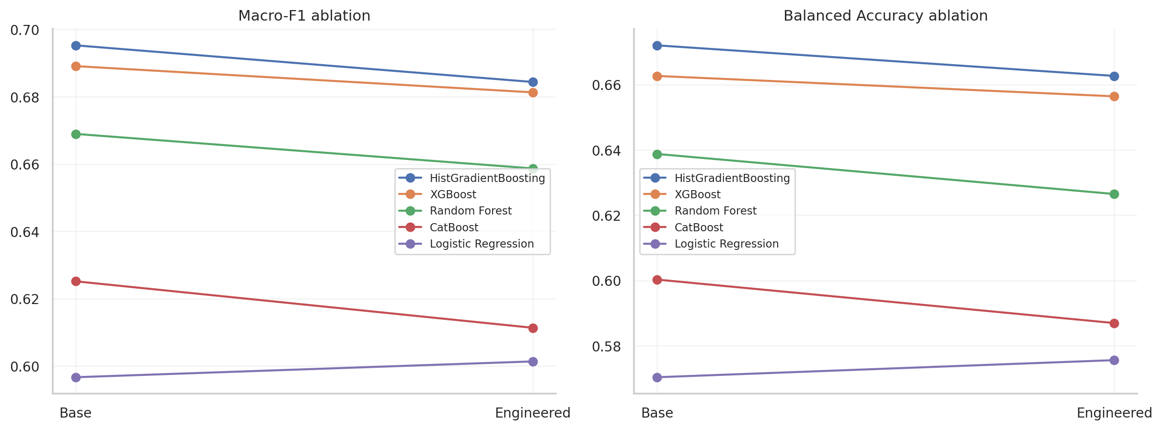
Figure 5. Base versus engineered feature ablation (Source: project export)

6.3 Feature-Selection Method
Mutual-information SelectKBest was fitted inside development CV to rank processed features without using the holdout.

6.4 SelectKBest Experiments
The accepted k=60 experiment gave exploratory five-fold Macro-F1 around 0.7099; final repeated CV was used for selection.

6.5 Final Production Representation
The production preprocessor outputs 102 columns before selection; SelectKBest retains 60. These are processed columns derived from 32 raw inputs.

6.6 Final 32-Input Schema
Appendix B lists the exact schema names from the locked model metadata.

7. Modelling Methodology

7.1 Experimental Design
Stage 6 compared five model families. Stage 7 used development-only optimisation, then selected a final configuration before the one-time holdout evaluation.

7.2 Validation Strategy
The main baseline and finalist comparisons used RepeatedStratifiedKFold with five folds and three repeats. Training and validation results were retained to diagnose overfitting.

7.3 Evaluation Metrics
Macro-F1 was the primary criterion. Balanced accuracy, macro precision, MCC, weighted F1, accuracy, log loss, average precision, class metrics and train–validation gap added context.

7.4 Candidate Model Families and Rationale
Logistic Regression provided a linear reference. Random Forest supplied variance-reduced nonlinear trees; HistGradientBoosting, XGBoost and CatBoost supplied boosted alternatives.

7.5 Baseline Configurations
The baseline family winner for each family was chosen from its own recorded preprocessing/feature-set variants rather than a single shared representation.

7.6 Hyperparameter Optimization Strategy
RandomizedSearchCV searched candidate parameter sets using development data only. Search budgets were 30 HistGB, 35 XGBoost, 30 RF and 12 CatBoost iterations.

7.7 Class-Imbalance Strategies
Class weighting and resampling were explored. SMOTENC required a safe mixed representation and was investigated later as a post-hoc control, not as a reason to rewrite the original lock.

7.8 Final Evaluation Protocol
The final selection record explicitly says holdout_evaluated=false. The 359-record historical holdout was evaluated once afterward; no post-holdout tuning was recorded.

8. Results, Optimization and Final Model Selection

8.1 Baseline Model Comparison: All Five Families
Table 7. Stage-6 baseline family winners
Family | Winning variant | Macro-F1 ± SD | MCC
HistGradientBoosting | HistGB Base | 0.6953 ± 0.0274 | 0.6332
XGBoost | XGBoost Base | 0.6891 ± 0.0283 | 0.6285
Random Forest | RF Base | 0.6689 ± 0.0288 | 0.6128
CatBoost | CatBoost Base | 0.6251 ± 0.0326 | 0.5592
Logistic Regression | LR Engineered | 0.6013 ± 0.0402 | 0.5492

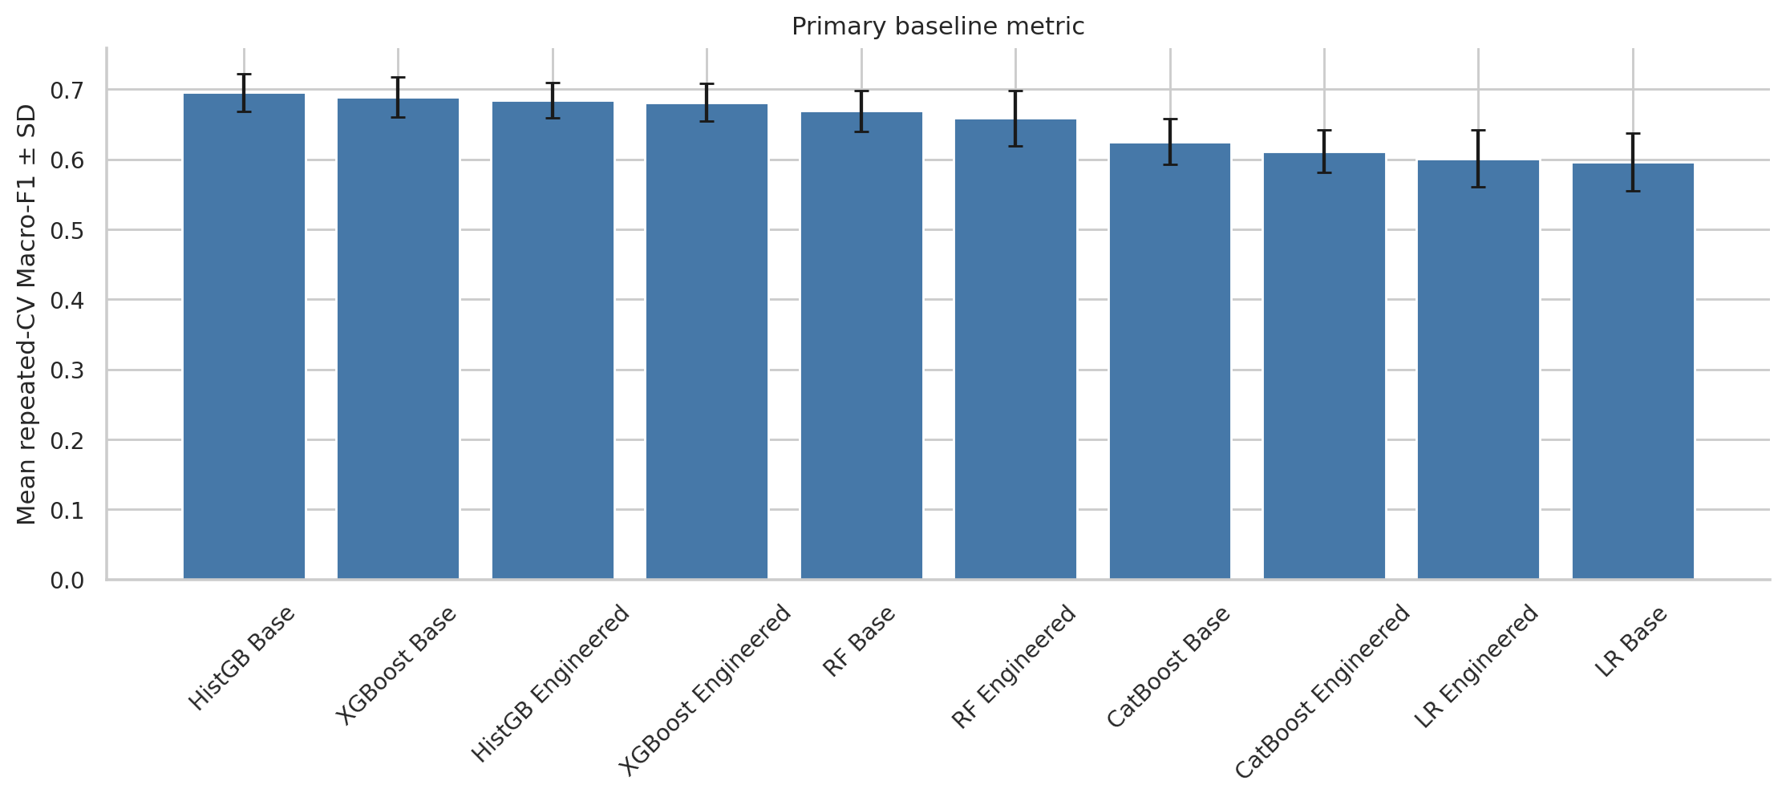
Figure 6. Baseline Macro-F1 by model family (Source: project export)

8.2 Base vs Engineered Ablation
Base tree variants won for the strongest tree families; Logistic Regression preferred the engineered scaled variant.

8.3 Baseline Error and Minority-Class Analysis
Baseline Partial-class recall and F1 were low across families, revealing a persistent minority-class challenge.

8.4 Shortlist Selection
HistGradientBoosting, XGBoost and Random Forest advanced because of their development-only baseline evidence.

8.5 Hyperparameter Search Results
Search best Macro-F1 values were approximately 0.6945 HistGB, 0.6920 XGBoost, 0.6975 RF and 0.6494 CatBoost. The search result alone was not the final selection.

8.6 Imbalance-Treatment Experiments
Alternative weighting and resampling strategies were considered against Macro-F1 and minority-class trade-offs. The selected configuration retained no imbalance treatment.

8.7 Rare-Category Threshold Experiments
A frequency threshold of 10 was accepted for the final tree representation.

8.8 Feature-Selection Results
SelectKBest(k=60) improved the Random Forest development evidence; the final repeated-CV comparison determined the lock.

8.9 Finalist Repeated-CV Comparison
Table 8 compares the three optimisation finalists under repeated CV; the Random Forest led on Macro-F1.
Table 8. Finalist repeated-CV results
Finalist | Macro-F1 ± SD | Balanced accuracy | MCC
Random Forest | 0.6996 ± 0.0481 | 0.6691 | 0.6349
XGBoost | 0.6874 ± 0.0291 | 0.6594 | 0.6264
HistGradientBoosting | 0.6793 ± 0.0221 | 0.6497 | 0.6216

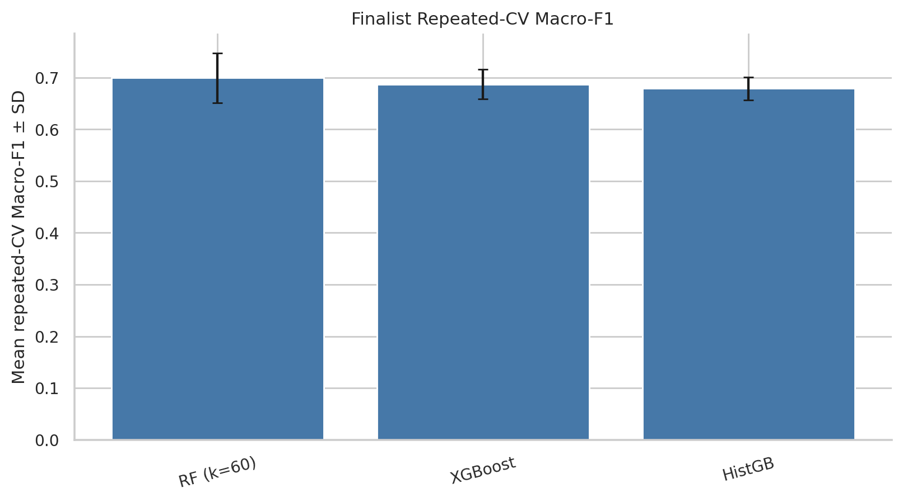
Figure 7. Finalist repeated-CV Macro-F1 (Source: project export)

8.10 Final Model Selection and Justification
The selected RF used 336 trees, max_features=0.5, min_samples_split=8, min_samples_leaf=5, bootstrap=False and no max-depth limit. It was locked before holdout evaluation.

8.11 Historical Holdout Performance
The one-time holdout achieved Macro-F1 0.6699, balanced accuracy 0.6392, MCC 0.6466 and accuracy 0.8663. The accuracy must be read alongside the class imbalance.

8.12 Per-Class Holdout Performance
Functional F1 was 0.9234 and Abandoned F1 was 0.7863. Partial F1 was only 0.3000, with recall 0.1935.
Table 9. Historical holdout per-class performance
Class | Support | Precision | Recall | F1
Functional | 267 | 0.8810 | 0.9700 | 0.9234
Partially functional | 31 | 0.6667 | 0.1935 | 0.3000
Abandoned or not functional | 61 | 0.8214 | 0.7541 | 0.7863

8.13 Confusion Matrix Analysis
Of 31 actual Partial records, six were correctly labelled, 22 were called Functional and three Abandoned. This is the main operational error pattern.
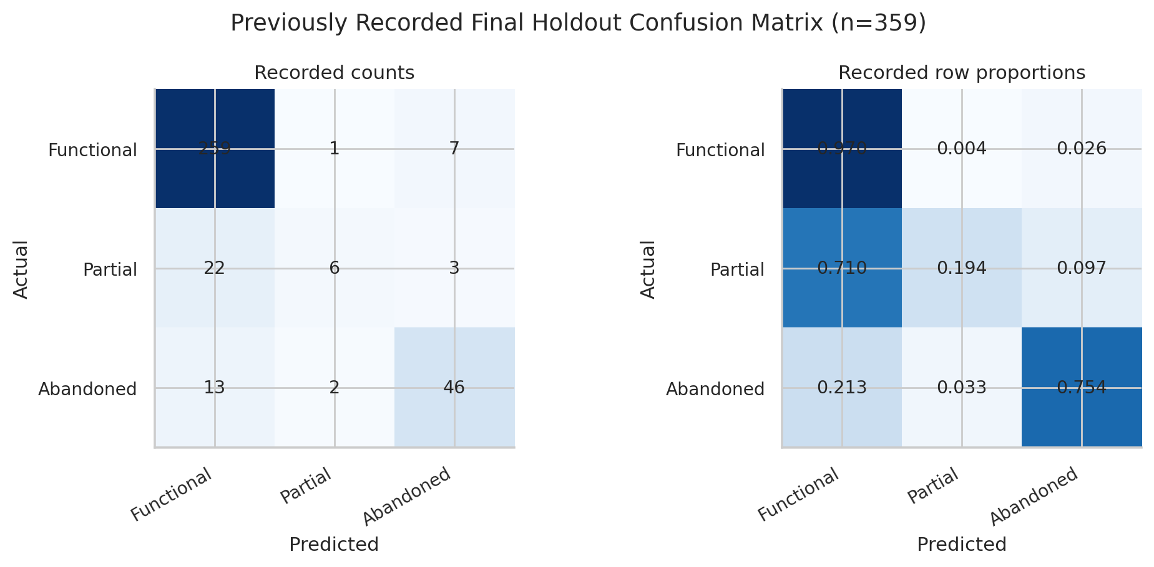
Figure 8. Historical holdout confusion matrix (Source: project export)

8.14 Summary of Results
The final RF led the development comparison and passed the one-time historical check, but Partial recognition and cross-country transfer remain material limits.

9. Model Robustness and Interpretation

9.1 Purpose and Post-Hoc Status
Notebook 06 was completed after the Stage-7 model lock. Its diagnostics probe reliability; they were not used for the original selection.

9.2 Raw Permutation Importance
Permutation results highlighted pumpstrokes and several geographic fields. Importance measures predictive reliance in this dataset, not causal impact.
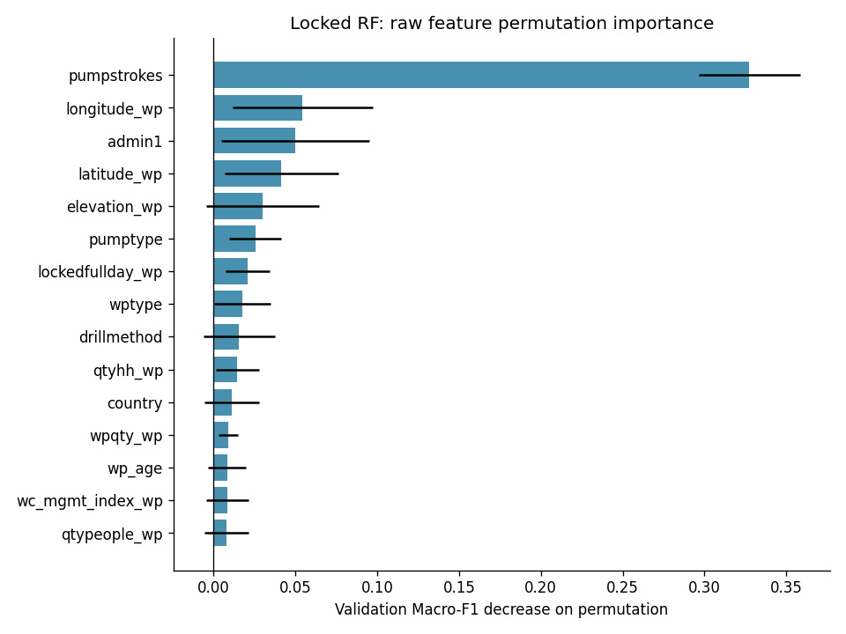
Figure 9. Raw-feature permutation importance (Source: project export)

9.3 Selected RF Feature Importance
The processed-feature view describes how the selected 60 columns contribute inside the RF; correlated variables can share or distort attribution.

9.4 Coordinate Ablation
Removing coordinates reduced repeated-CV Macro-F1 from 0.6996 to 0.6848, indicating useful geographic signal but raising transfer concerns.

9.5 Representation Control
A mixed-representation RF control reached Macro-F1 around 0.6300, below the locked model.

9.6 Safe SMOTENC Experiment
The post-hoc SMOTENC RF improved Partial recall to about 0.4285 while reducing overall Macro-F1 to about 0.6456. It did not justify replacement.

9.7 Learning-Curve Analysis
Learning curves and the 0.1652 train–CV Macro-F1 gap indicate remaining generalisation limits.
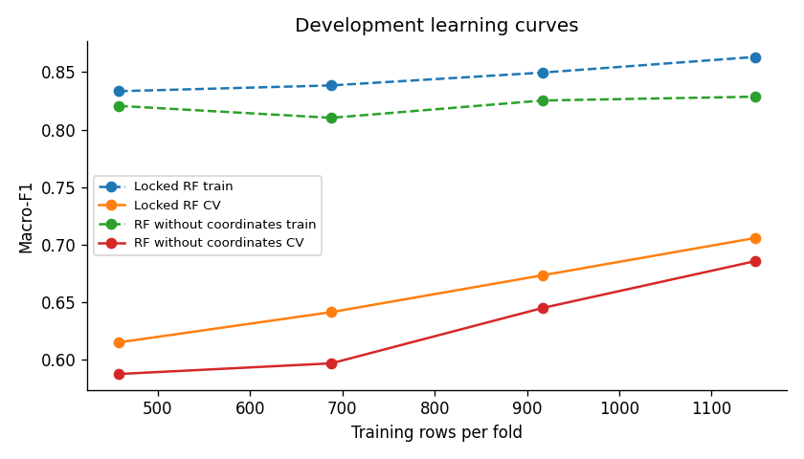
Figure 10. Post-hoc learning curves (Source: project export)

9.8 Cross-Country Robustness
Country-level and leave-one-country-out diagnostics were weaker than ordinary stratified CV, so transfer to unseen countries is uncertain.
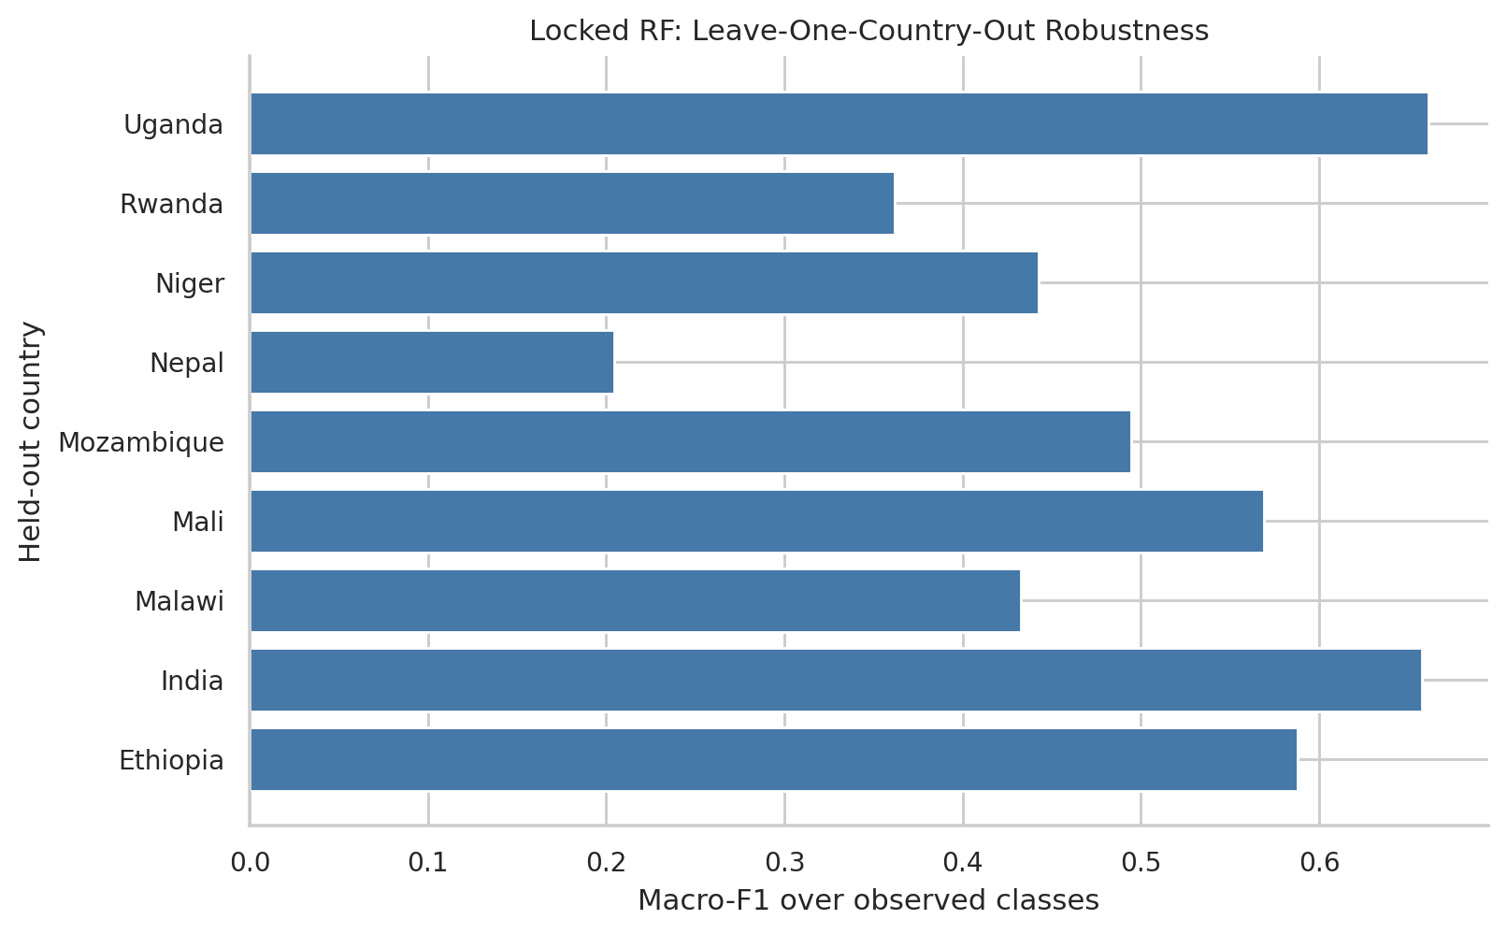
Figure 11. Post-hoc country robustness (Source: project export)

9.9 Post-Hoc Decision
No tested post-hoc candidate supplied enough evidence to replace the locked RF.

10. System Design and Implementation

10.1 Overall Architecture
The Next.js browser client sends HTTP/JSON requests to FastAPI. The API validates one raw record and calls the verified serialized pipeline. Dashboard endpoints serve exported JSON evidence.

10.2 Technology Stack
Python, pandas, scikit-learn, joblib and FastAPI support inference and API delivery. Next.js, TypeScript, React and Recharts support the browser interface.

10.3 Production Inference Pipeline
The exported artifact contains fixed cleaning, fitted preprocessing, SelectKBest(60) and the locked RF. The frontend does not run model preprocessing.

10.4 Serialization, Metadata and Reproducibility
Metadata records 32 raw predictors, 102 preselection processed columns, 60 selected columns, class order and artifact SHA-256. Export verification reports exact preprocessing and reload parity.

10.5 FastAPI Backend
The backend loads and verifies the model once at startup. It validates the 32-field request and returns predicted label, model probability and all three class probabilities.

10.6 API Contract and Endpoints
The prediction route accepts explicit nulls in supported fields and safely handles unseen categories. Separate routes expose model metadata and exported dashboard evidence.

10.7 Next.js Frontend
The implemented routes are Dashboard, Predict, Data Insights, Model Insights and About. The prediction page uses a five-step form populated from the API schema.

10.8 Prediction Workflow
Users enter known fields, review values, submit one JSON record and see the predicted class and probability distribution. Blank entries are sent as null.

10.9 Dashboard, Data Insights and Model Insights
The frontend presents dataset summaries, class patterns, baseline model families, optimisation finalists and robustness evidence from backend data routes.

10.10 Responsible Prediction Presentation
The result warns that a model probability is not a guarantee and that a field inspection remains necessary.

10.11 Running the System
From the repository root, start uvicorn backend.main:app --reload. In frontend/, install dependencies and run npm run dev. The documented default API base is http://127.0.0.1:8000.
Table 10. Implemented API routes
Route | Purpose
GET /health | Readiness
POST /api/v1/predict | Predict one 32-field record
GET /api/v1/model-info | Safe model metadata
GET /api/v1/input-schema | Field contract
GET /api/v1/dashboard/summary | Dataset summary
GET /api/v1/dashboard/eda | EDA evidence
GET /api/v1/dashboard/model-performance | Model evidence
GET /api/v1/dashboard/feature-importance | Importance evidence
GET /api/v1/dashboard/robustness | Robustness evidence

11. System Testing

11.1 Testing Objectives
Tests checked schema and class order, serialized-pipeline parity, API validation, null and unseen-category handling, and frontend interactions.

11.2 Production Pipeline and Serialization Tests
The saved export verification reports preprocessing parity, 102 preselection features, 60 selected features, fresh-process loading and numerical prediction/probability parity.

11.3 Backend API Tests
The repository contains focused FastAPI tests for prediction routes and invalid requests. Test counts should be reported only from an actual local run.

11.4 Frontend Tests and Build Verification
The frontend includes Vitest configuration and component/page tests. The package declares test, lint, typecheck and build scripts.

11.5 End-to-End Integration Tests
The contract connects a schema-driven form to the API and then to the serialized pipeline. No independent live deployment measurement is claimed.

11.6 Invalid, Missing, Null and Unseen-Category Cases
The request schema preserves all 32 names, allows explicit null values where supported and rejects invalid field values; the model encoder tolerates unseen nominal categories.

11.7 Issues Identified and Refinements
Production parity checks addressed training/inference drift. The frontend exposes class distributions and cautions rather than a single unexplained label.

12. Discussion

12.1 What the Results Say About the Problem
Predictors contain meaningful structure, but the small minority class and geographic heterogeneity restrict individual-level reliability.

12.2 Why Random Forest Was Selected
The RF led repeated development CV, had a smaller train–CV gap than the other finalists and used a reproducible, compact selected representation.

12.3 The Partially Functional Class Challenge
Only six of 31 Partial holdout cases were recognised. Most were predicted Functional, making unreviewed operational use particularly risky.

12.4 Precision–Recall and Imbalance Trade-offs
SMOTENC increased Partial recall in a later diagnostic while lowering aggregate quality. The choice depends on inspection capacity and the cost of missed degraded sites.

12.5 Geographic Information vs Cross-Country Transferability
Location helps ordinary CV, yet leave-one-country-out checks are weaker. Geography may capture context that does not transfer unchanged to new locations.

12.6 Stakeholder and Operational Value
A probability display can support triage when combined with records and field judgement. It should not automatically allocate repairs or deny inspection.

12.7 Methodological Reflection
The staged protocol limits leakage and protects the holdout, but a larger external validation set would be needed before operational reliance.

13. Ethical, Legal and Operational Considerations

13.1 Decision Support and Human Oversight
Field teams should review predictions and retain authority over inspection and maintenance decisions.

13.2 Uncertainty and Automation Bias
The maximum predicted probability is a model output, not calibrated certainty. The UI shows all class scores and a caution.

13.3 Geographic Fairness and Transferability
Country-level error differences may distribute missed inspections unevenly. New countries require local validation.

13.4 Data Licensing and Privacy
The dataset source is attributed under the CC-BY terms recorded in the repository. Administrative identifiers and photo fields were excluded from production predictors.

13.5 Reproducibility and Auditability
Locked metadata, artifact checksum, exported evidence and source notebooks support traceability of reported claims.

14. Limitations
Table 11. Main limitations and implications
Limitation | Operational implication
Only 1,793 records | Some country/class combinations are sparse
Partial recall 0.1935 | Many degraded sites may be called Functional
Missing survey fields | Predictions depend on imputation and field availability
Weak cross-country transfer | Unseen-country use requires validation
No established calibration | Probability should not be interpreted as guaranteed risk
No fully independent external set | Historical holdout may not reflect future deployment

15. Future Work
Future work should collect larger and more recent surveys, define an external country-specific evaluation protocol, assess probability calibration, investigate targeted Partial-class data collection and cost-sensitive triage, and monitor error rates after any controlled pilot. Such work should be treated as a new model-development cycle with a fresh locked evaluation set.

16. Conclusion
The project delivered an evidence-based multiclass water-point prediction system with leakage-safe evaluation and a verified FastAPI–Next.js inference path. The selected Random Forest achieved 0.6996 ± 0.0481 repeated-CV Macro-F1 and 0.6699 on the one-time historical holdout. Its weak Partial-class recall and geographic transfer limits make it suitable for cautious decision support and further validation, not autonomous field decisions.

References
[1] M. Götschmann et al., “rwpfunctionality: Water point functionality in sub-Saharan Africa and South Asia,” 2024, doi: 10.5281/zenodo.10878634. Dataset documentation: https://openwashdata.github.io/rwpfunctionality/.
[2] Project repository, notebooks/01_data_understanding.ipynb through notebooks/06_posthoc_robustness.ipynb, executed project analysis, 2026.
[3] Project repository, reports/model_development and reports/model_optimization, exported evaluation results, 2026.
[4] Project repository, models/final_model_metadata.json and reports/model_export/export_verification.json, production artifact metadata, 2026.
[5] Project repository, backend and frontend source and tests, implemented application, 2026.

Appendix A. Repository Structure
Primary directories: data/ (raw and processed records), notebooks/ (six executed analysis stages), reports/ (exported results and figures), src/ (preprocessing and modelling), models/ (serialized artifact and metadata), backend/ (FastAPI), frontend/ (Next.js), scripts/ (export and verification), and tests/.

Appendix B. Complete Production Input Schema
Table 12. The 32 raw predictors required by the production pipeline
No. | Raw predictor
1 | country
2 | admin1
3 | latitude_wp
4 | longitude_wp
5 | elevation_wp
6 | cwfunded_wp
7 | wptype
8 | pumptype
9 | drillmethod
10 | piped_source
11 | piped_pump
12 | rehabyn
13 | qtyhh_wp
14 | whomanage_wp
15 | wp_age
16 | rehab_age
17 | qtypeople_wp
18 | lockedfullday_wp
19 | pumpstrokes
20 | wc_present_wp
21 | paytocollect_wp
22 | improved_wponly_wp
23 | qtyhh_c_wp
24 | wc_admin_index_wp
25 | wc_finance_index_wp
26 | wc_mgmt_index_wp
27 | wc_maint_index_wp
28 | wc_savings_wp
29 | wpqty_wp
30 | pop_1000
31 | annual_rain
32 | season

Appendix C. Final Model Configuration
Table 13. Locked production configuration
Parameter | Value
Preprocessing | tree_base
Rare-category minimum frequency | 10
Processed columns before selection | 102
SelectKBest mutual information | k=60
Imbalance treatment | none
RF trees | 336
Maximum depth | None
Maximum features | 0.5
Minimum split size | 8
Minimum leaf size | 5
Bootstrap | False
Random state | 42
Artifact SHA-256 | e035c403e4bece3ca1cf7202a10439815a0d5f7396748c0696e1e6258fd984de

Appendix D. Group Contributions
Table 14. Group contribution record to complete before submission
Group member | Student ID | Verified contribution
[INSERT NAME] | [INSERT ID] | [INSERT CONTRIBUTION]

