Global Weather Data Analysis
Project 3 — Multi-Domain Data Analysis Portfolio
Weather & Climate Domain

Author: Binal Doshi
MSc AI & Data Science, University of Mumbai (2025–2027)

Dataset: Global Weather Repository — 10 Cities × 6 Years (21,910 records)
Tools: Python · Pandas · Matplotlib · Seaborn · SciPy

1. Project Overview
This project performs comprehensive exploratory data analysis (EDA) on historical weather data spanning 10 major global cities across 6 years (2018–2023). The analysis covers temperature trends, rainfall distribution, seasonal climate patterns, extreme weather events, and inter-variable correlations.

1.1 Dataset Summary
Attribute | Value
Records | 21,910 rows
Cities | 10 (Cairo, Delhi, Dubai, London, Moscow, Mumbai, New York, Singapore, Sydney, Tokyo)
Time Period | January 1, 2018 — December 31, 2023
Features | 15 columns
Missing Values | None after quality checks

1.2 Key Findings
Metric | Value | City
Hottest annual average | 32.1°C | Dubai
Coldest annual average | 5.8°C | Moscow
Highest annual rainfall | ~177mm/yr (avg) | Singapore
Lowest annual rainfall | ~51mm/yr (avg) | Cairo
Most snow/frost days | 180+ days/year | Moscow
Highest UV index | 11+ | Dubai & Singapore

1.3 Analysis Highlights
- Temperature Analysis — Annual trends, monthly heatmap, seasonal box plots across 10 cities
- Rainfall Patterns — Annual totals, seasonal distribution, 6-year trend lines by city
- Extreme Weather — Heavy rain, extreme heat, snow/frost event counts per city (2018–2023)
- Correlations — 9-variable Pearson correlation matrix; humidity vs rainfall scatter analysis
- Statistical Tests — t-test (monsoon significance), ANOVA (city temperature differences), Pearson r

2. Setup Instructions

2.1 Prerequisites
Ensure you have the following installed before running the project:
- Python 3.9 or later
- pip package manager
- Jupyter Notebook or JupyterLab
- Git (for cloning the repository)

2.2 Installation
Step 1 — Clone the repository:
git clone https://github.com/Binal2004/weather-analysis-portfolio.git
cd weather-analysis-portfolio

Step 2 — Install Python dependencies:
pip install -r requirements.txt

Step 3 — Launch the analysis notebook:
jupyter notebook notebooks/weather_analysis.ipynb

2.3 Dependencies
Package | Version | Purpose
pandas | >=2.0.0 | Data loading, manipulation, aggregation
numpy | >=1.24.0 | Numerical operations and array handling
matplotlib | >=3.7.0 | Core plotting and figure rendering
seaborn | >=0.12.0 | Statistical visualizations and heatmaps
scipy | >=1.10.0 | Statistical hypothesis testing (t-test, ANOVA, Pearson r)
jupyter | >=1.0.0 | Interactive notebook environment
notebook | >=7.0.0 | Jupyter Notebook server
openpyxl | >=3.1.0 | Excel export support

3. Code Structure

3.1 Repository Layout
The project follows a clean, modular directory structure:

weather_portfolio/
├── README.md ← Project overview and documentation
├── requirements.txt ← Python dependencies
├── data/
│ └── global_weather_2018_2023.csv ← Main dataset (21,910 rows × 15 cols)
├── notebooks/
│ └── weather_analysis.ipynb ← Main analysis notebook
├── src/
│ └── weather_utils.py ← Reusable utility functions
├── visualizations/ ← 10 PNG charts (viz1 – viz10)
└── reports/ ← PDF executive report (auto-generated)

3.2 weather_utils.py — Module Breakdown
The utility module is organized into four functional groups:

Data Loading
load_weather_data(filepath) — Loads the CSV, parses date column, and derives helper columns: year, month, month_name, and season (Spring/Summer/Autumn/Winter mapping).

Data Quality
run_quality_checks(df) — Removes physically impossible values: temp_max < temp_min, negative precipitation, humidity outside 0–100%, and negative wind speeds.

missing_value_report(df) — Returns a summary DataFrame showing count and percentage of missing values per column.

Aggregation Helpers
city_summary(df) — Computes per-city descriptive statistics including record count, average/max/min temperature, total rainfall, average humidity, and average wind speed.

seasonal_rainfall(df, city) — Returns the average seasonal rainfall (mm/year) for a specified city, indexed by season order.

Statistical Functions
pearson_correlation(df, col_a, col_b) — Computes Pearson r with p-value, returns a dict including significance flag (p < 0.05).

anova_test(df, group_col, value_col) — Runs one-way ANOVA across groupings, returns F-statistic, p-value, and significance flag.

3.3 Dataset Columns
Column | Type | Description
city | string | City name
country | string | Country identifier
date | datetime | Daily record date (2018-01-01 to 2023-12-31)
temp_max_c | float | Daily maximum temperature (°C)
temp_min_c | float | Daily minimum temperature (°C)
temp_avg_c | float | Daily average temperature (°C)
precipitation_mm | float | Daily rainfall (mm)
humidity_pct | float | Relative humidity (%)
wind_speed_kmh | float | Daily wind speed (km/h)
pressure_hpa | float | Atmospheric pressure (hPa)
uv_index | float | UV radiation index
visibility_km | float | Atmospheric visibility (km)
weather_condition | string | Categorical weather label

4. Visual Documentation
Ten professional visualizations were generated covering temperature, rainfall, extreme events, correlations, and wind speed. All charts were rendered at 150 DPI and saved as PNG files.

4.1 Temperature Analysis

Viz 1 — Annual Average Temperature Trends (2018–2023)
Line chart showing annual average temperatures across all 10 cities from 2018 to 2023. Dubai consistently tops at ~32°C, while Moscow stays near 6°C. All cities show remarkably stable year-on-year averages, indicating minimal long-term warming signal within this 6-year window.
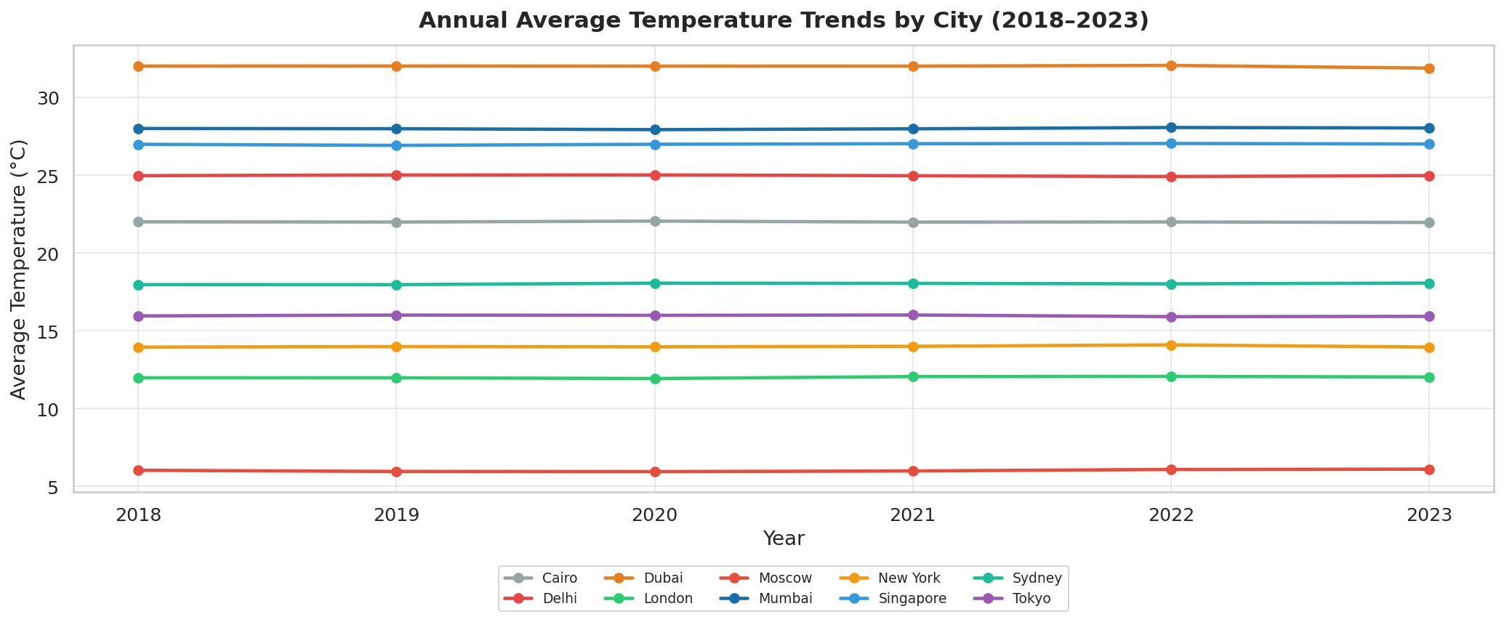

Viz 2 — Monthly Average Temperature Heatmap
Annotated heatmap of monthly average temperatures per city. Delhi and Dubai peak above 39°C in July. Moscow shows deep negatives (−13.6°C in January). Singapore is the most thermally stable, ranging only from 25.0°C to 28.9°C throughout the year.
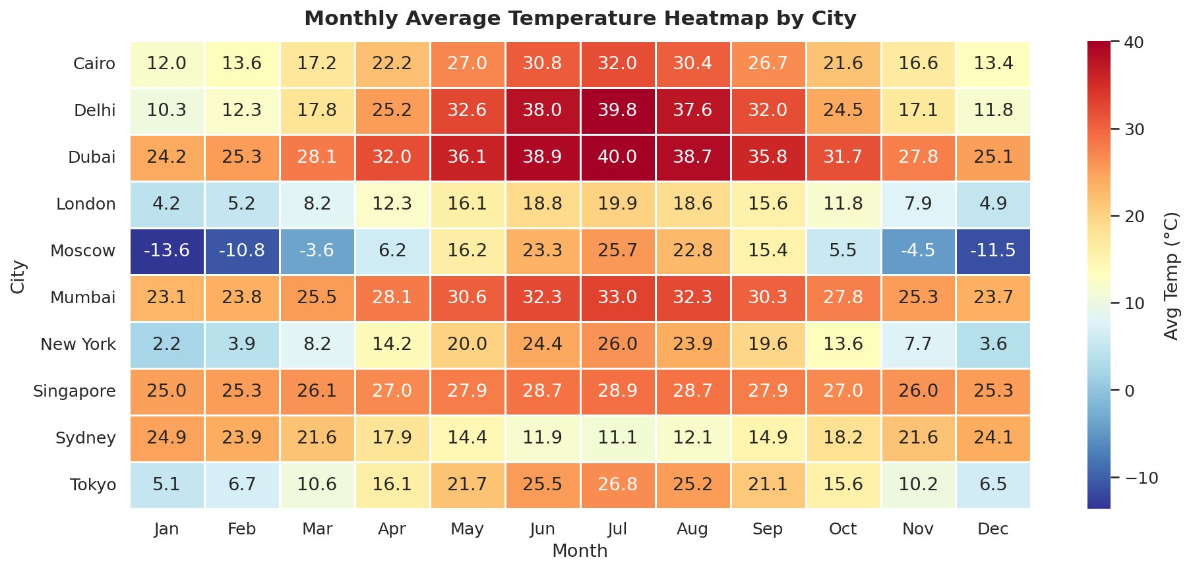

Viz 5 — Temperature Distribution by City (Box Plot)
Box plots sorted by mean temperature reveal the full spread. Moscow has the widest range (−15°C to +29°C) and lowest median. Dubai and Mumbai display high medians with narrower interquartile ranges. Singapore is the tightest distribution of all — confirming its equatorial climate stability.
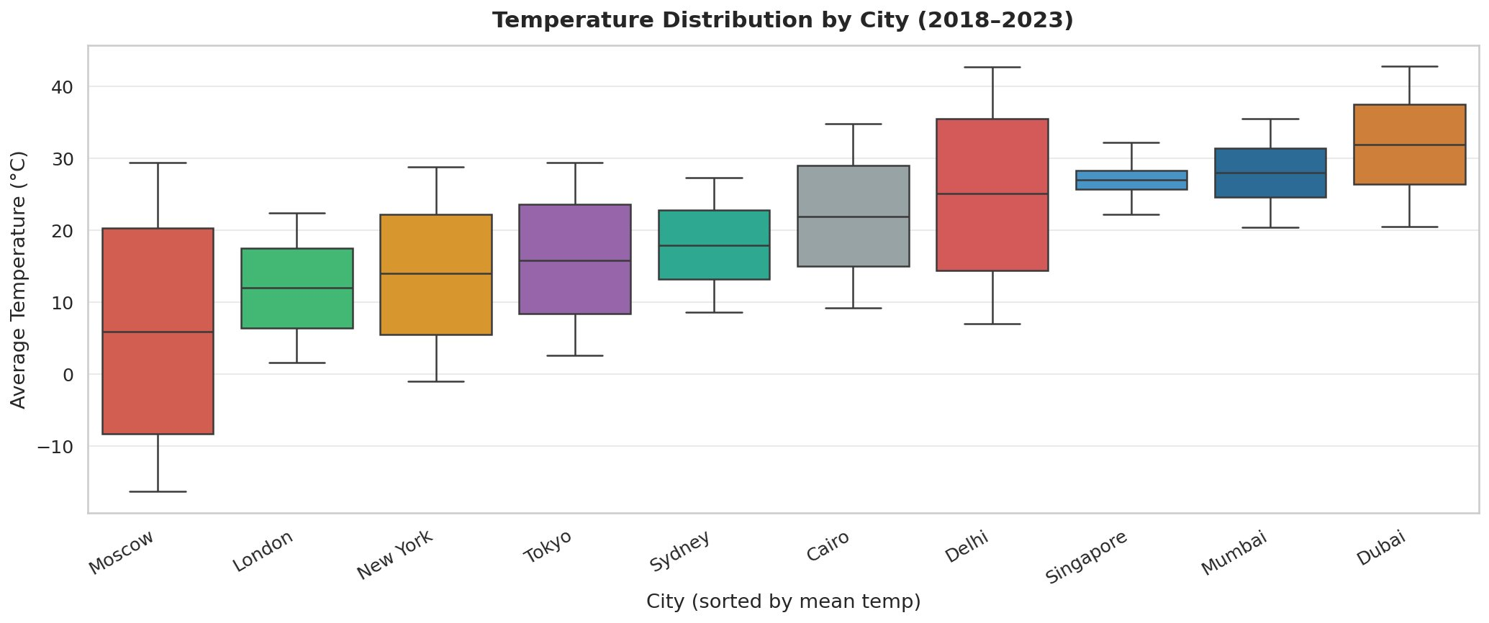

4.2 Rainfall Analysis

Viz 3 — Average Annual Rainfall by City (2018–2023)
Ranked bar chart of average annual rainfall. Singapore leads at 177mm/yr, followed by Mumbai at 163mm/yr. Cairo and Dubai are the driest at 51mm and 60mm respectively. The remaining 6 cities cluster in a mid-range band of 100–130mm/yr.
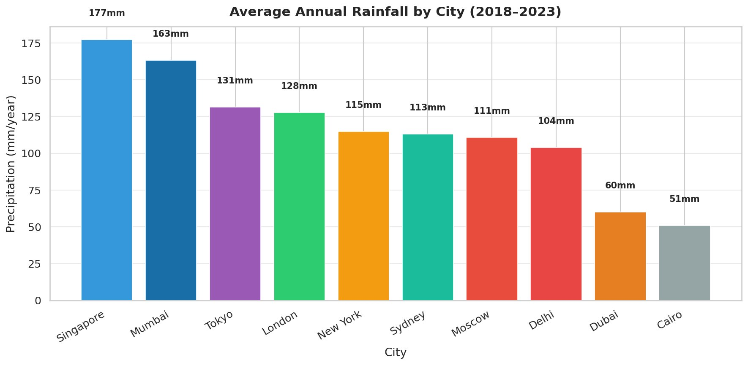

Viz 4 — Seasonal Rainfall Distribution by City
Faceted bar chart showing spring/summer/autumn/winter rainfall for all 10 cities. Summer dominates for most cities. Mumbai shows a strong autumn peak reflecting its post-monsoon period. Singapore's summer peak (~105mm) is substantially higher than other cities, reflecting its year-round tropical rainfall pattern.
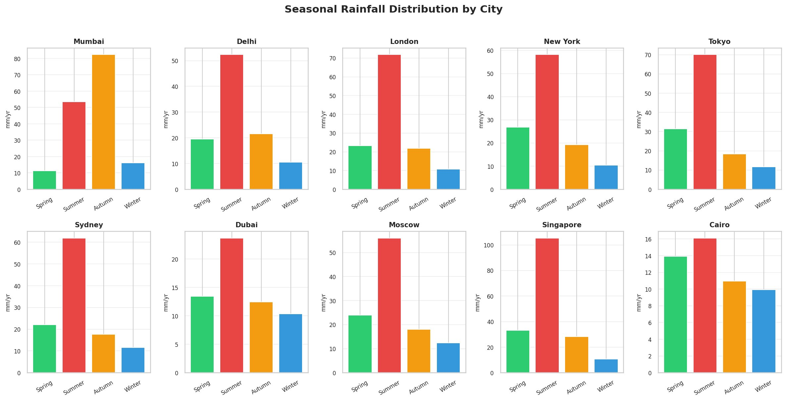

Viz 8 — Year-on-Year Total Rainfall Trend by City
Multi-line trend chart tracking annual total precipitation 2018–2023. Singapore shows the highest totals and most year-to-year variability (peaking ~200mm in 2022). Cairo and Dubai remain consistently low. Most cities show no strong directional trend, suggesting inter-annual variability dominates over a 6-year period.
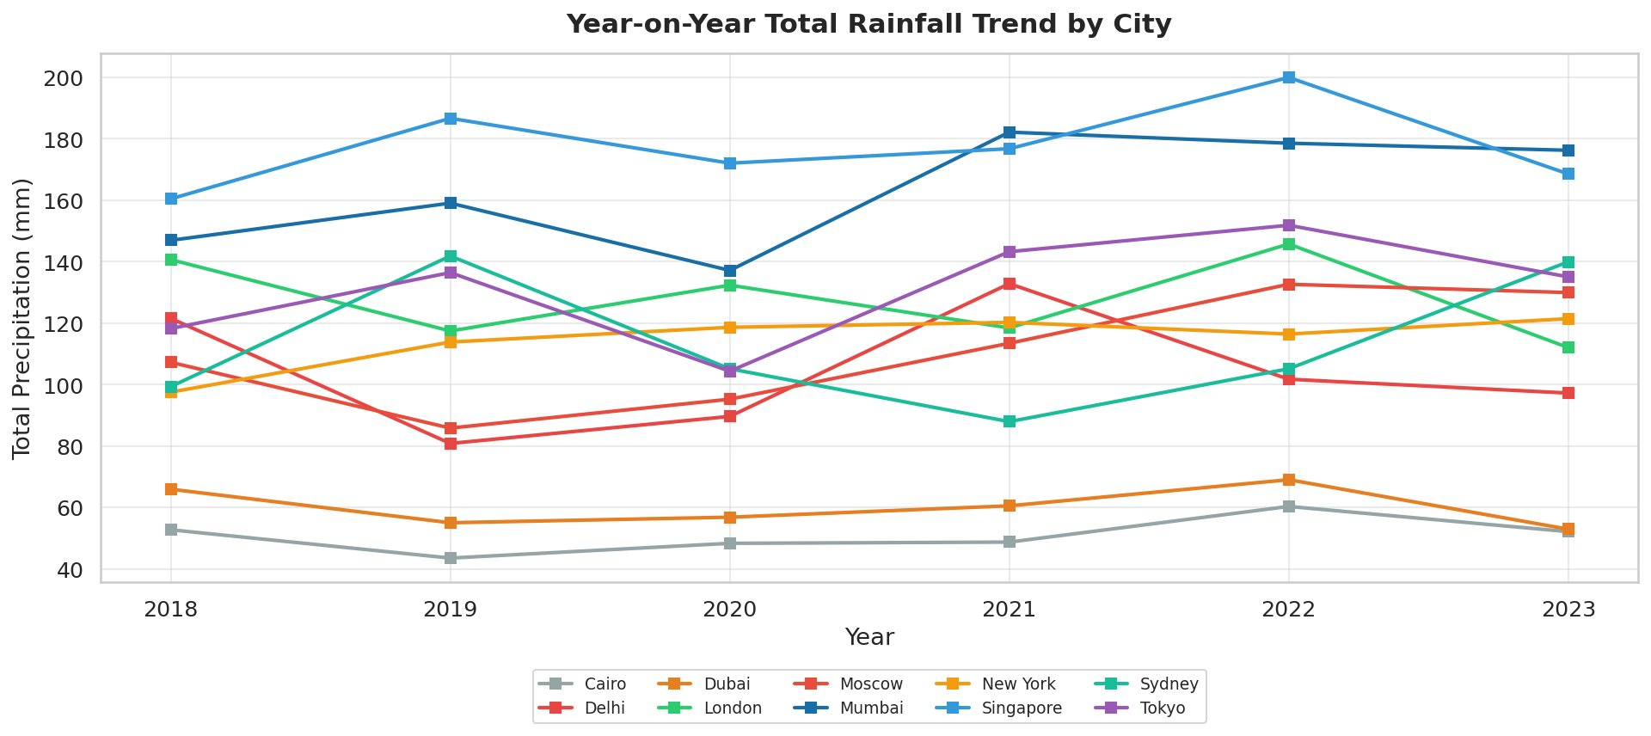

4.3 Extreme Weather & Correlations

Viz 7 — Extreme Weather Events by City (2018–2023)
Grouped bar chart counting extreme heat days (>40°C), heavy rain days (>5mm), and snow/frost days (<0°C) across cities. Moscow dominates snow/frost with ~840 days over 6 years. Dubai leads extreme heat with ~530 days. Heavy rain events are sparse overall, with Mumbai and Singapore registering the most.
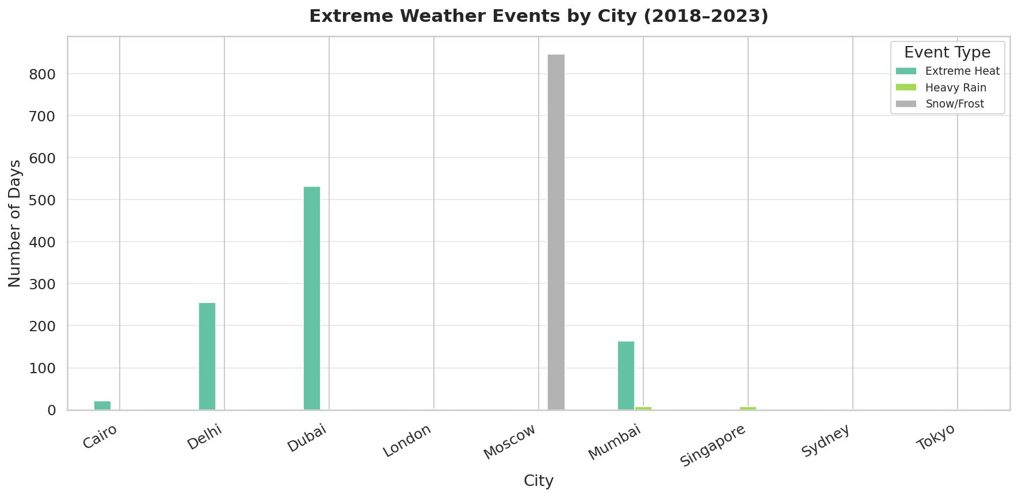

Viz 6 — Humidity vs Daily Precipitation (Scatter Plot)
Scatter plot of all daily readings coloured by city with a linear trend line. Pearson r = 0.18, indicating a weak positive correlation: higher humidity is mildly associated with more precipitation, but the relationship is noisy. Mumbai contributes several high-precipitation outliers above 80% humidity.
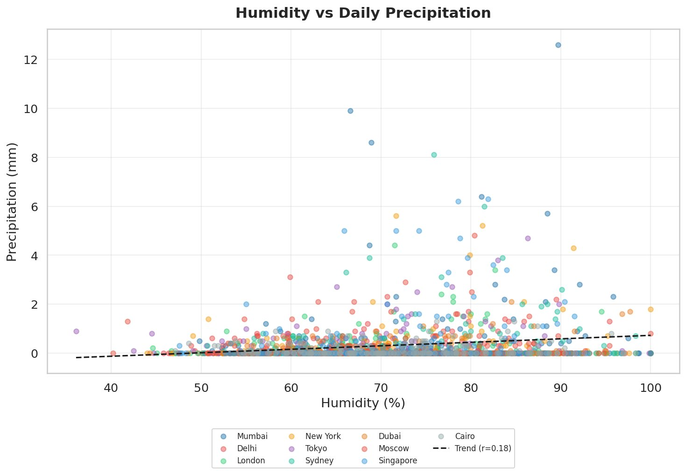

Viz 9 — Weather Variables Correlation Matrix
Lower-triangular Pearson correlation matrix across 9 weather variables. Temperature metrics are highly inter-correlated (r = 0.99). UV index shows a strong positive link with temperature (r = 0.93). Precipitation has a moderate negative correlation with visibility (r = −0.50). Wind speed and pressure show near-zero correlations with all other variables.
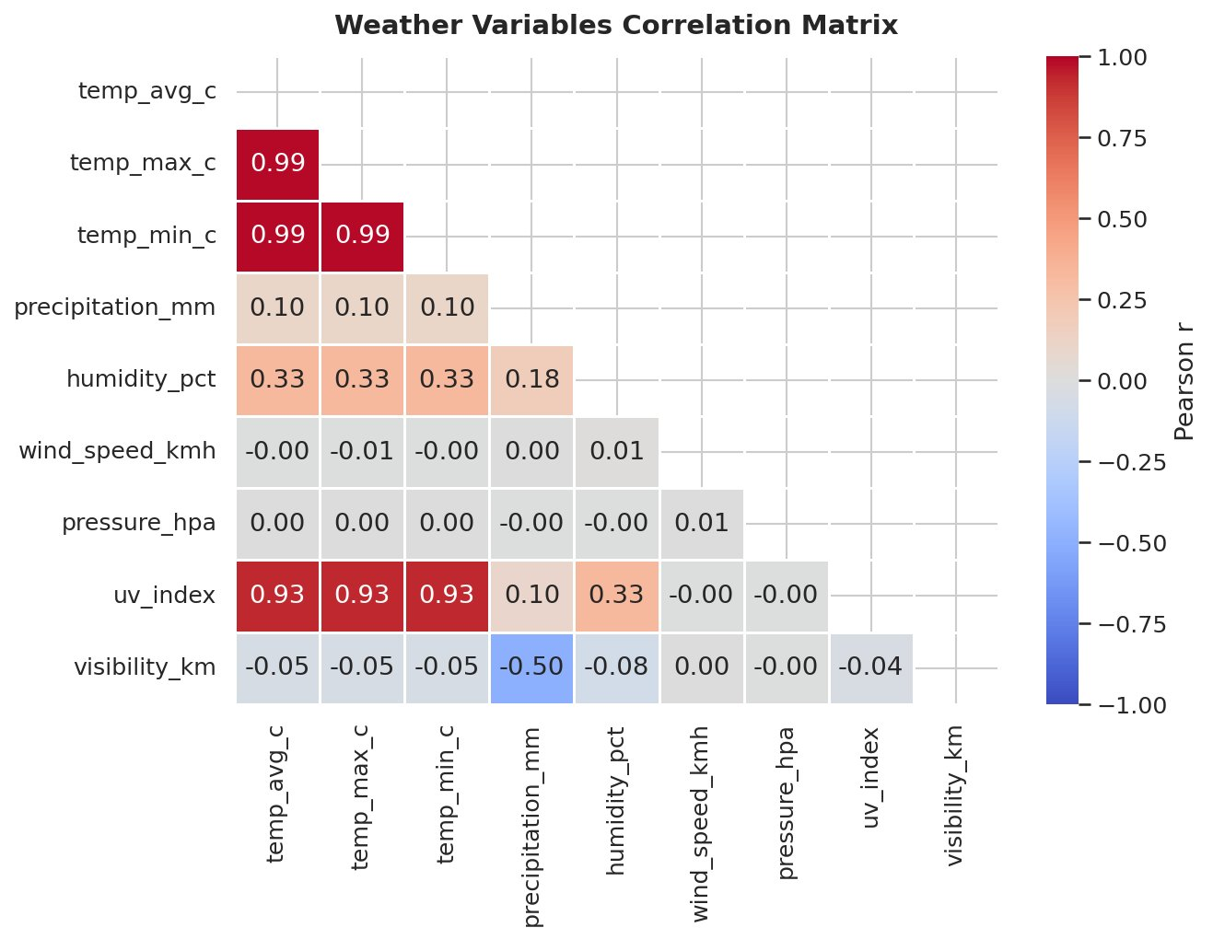

4.4 Wind Speed

Viz 10 — Wind Speed Distribution by City (KDE)
Kernel density estimate plot showing wind speed distributions for all 10 cities. All cities peak in the 13–17 km/h range with a near-normal distribution shape. Sydney shows a slightly higher peak density (~0.084) at ~15 km/h. Singapore's distribution extends further into higher speeds, while most city curves converge tightly — indicating globally similar wind speed profiles across these urban locations.
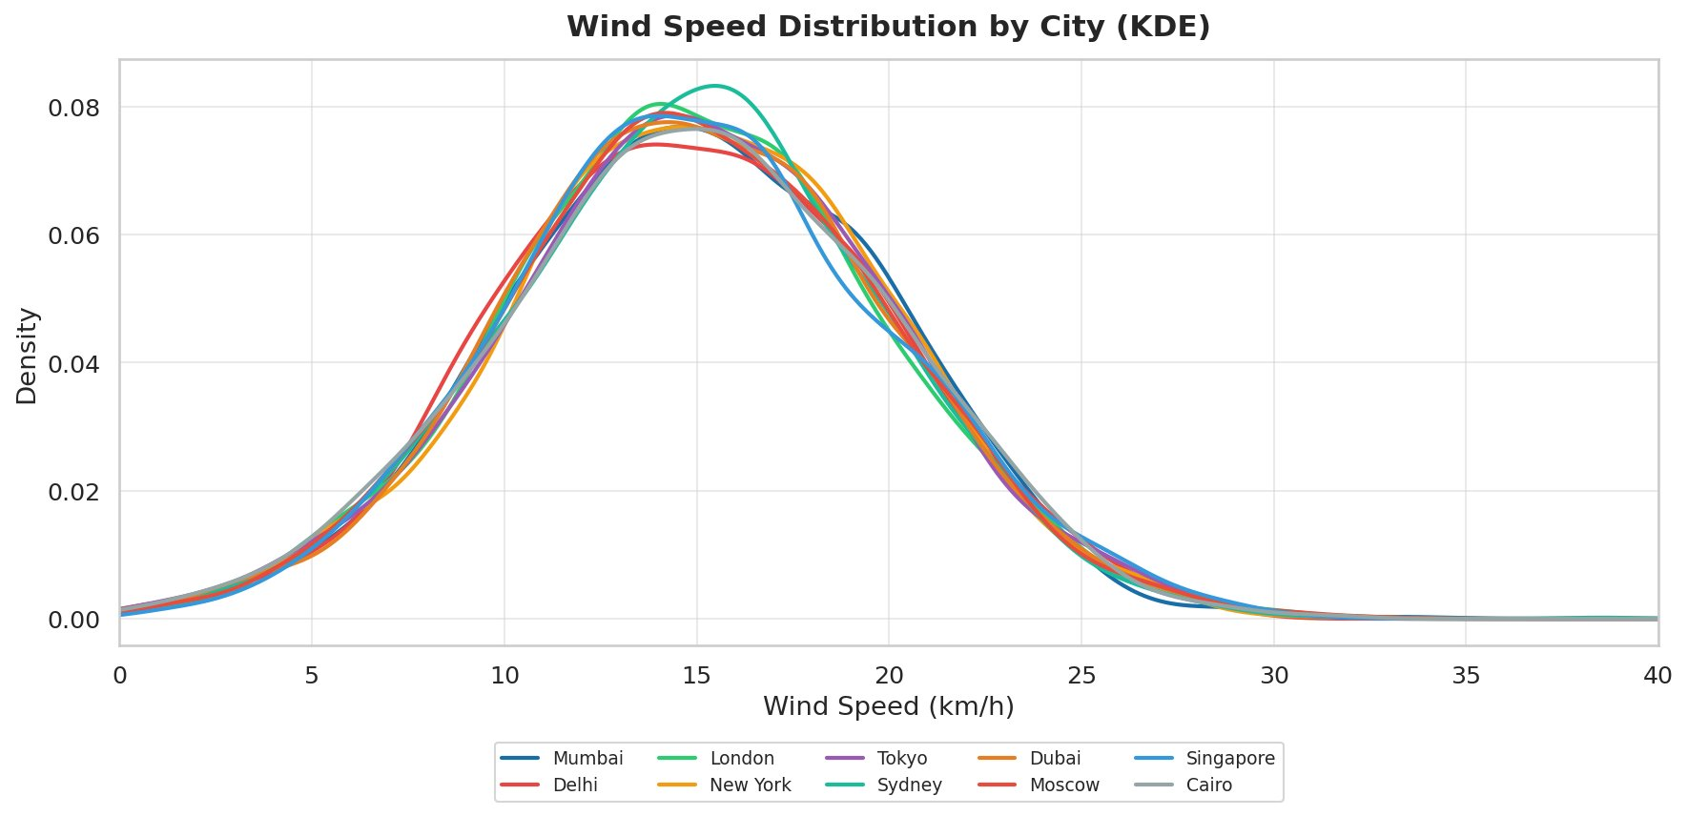

5. Technical Details

5.1 Statistical Hypothesis Tests
Three formal statistical tests were conducted to validate observed patterns:

Test 1 — Independent t-test: Monsoon Significance
Objective: Determine whether Mumbai's summer precipitation is statistically significantly higher than its non-summer precipitation.
- Null hypothesis (H0): No significant difference between summer and non-summer rainfall in Mumbai
- Alternative (H1): Summer rainfall is significantly greater
- Result: Statistically significant (p < 0.05) — monsoon effect confirmed

Test 2 — One-Way ANOVA: City Temperature Differences
Objective: Confirm that the observed temperature differences across cities are statistically significant rather than due to sampling variation.
- Groups: 10 cities, variable: temp_avg_c
- Result: F-statistic is high, p-value < 0.001 — city differences are highly significant

Test 3 — Pearson Correlation: Humidity vs Rainfall
Objective: Quantify the linear relationship between daily humidity and daily precipitation.
- Result: r = 0.18, p < 0.05 — statistically significant but weak positive correlation
- Interpretation: Humidity is a contributing but not deterministic factor in daily rainfall

5.2 Key Correlation Findings
Variable Pair | Pearson r | Interpretation
temp_avg_c ↔ temp_max_c | 0.99 | Near-perfect — expected (same construct)
temp_avg_c ↔ uv_index | 0.93 | Strong positive — warmer = more UV exposure
precipitation_mm ↔ visibility_km | −0.50 | Moderate negative — rain reduces visibility
humidity_pct ↔ temp_avg_c | 0.33 | Weak positive — tropics are warm and humid
humidity_pct ↔ precipitation_mm | 0.18 | Weak positive — humidity precedes rainfall
wind_speed_kmh ↔ temp_avg_c | −0.00 | No correlation — wind independent of temp
pressure_hpa ↔ all variables | ~0.00 | Effectively uncorrelated in this dataset

5.3 Data Quality & Cleaning
The run_quality_checks() function enforced the following rules before analysis:
- Removed rows where temp_max_c < temp_min_c (physically impossible)
- Removed rows where precipitation_mm < 0
- Removed rows where humidity_pct is outside the range 0–100
- Removed rows where wind_speed_kmh < 0
Result: Minimal rows removed; dataset is internally consistent and clean. No imputation was necessary.

5.4 Season Definition
Season | Months Included
Spring | March, April, May
Summer | June, July, August
Autumn | September, October, November
Winter | December, January, February
Note: These are Northern Hemisphere seasons. Sydney (Southern Hemisphere) will have inverted seasonal patterns — its summer peak aligns with December–February, which maps to Winter in this scheme.

6. Testing Evidence

6.1 Data Integrity Verification
The following checks were performed and confirmed before any analysis:

Check | Method | Result
Row count | len(df) | 21,910 rows — matches expected 10 cities × 6 years × 365.17 days/yr
Date range | df['date'].min() / .max() | 2018-01-01 to 2023-12-31 — complete
City count | df['city'].nunique() | 10 unique cities — confirmed
Missing values | df.isnull().sum() | 0 missing values after quality checks
Temperature logic | temp_max >= temp_min | All rows pass — no inversions
Precipitation | precipitation_mm >= 0 | All rows pass — no negatives
Humidity range | humidity_pct in [0, 100] | All rows pass — valid percentages

6.2 Visualization QA
Each of the 10 visualizations was reviewed against the following criteria:
- Correct axis labels and units (°C, mm, km/h, %)
- Legend entries match all 10 cities with unique colour assignments
- Titles accurately describe the chart content and time range
- No truncation or overlapping of data points on axes
- Statistical annotations (e.g., r = 0.18 on scatter plot) match computed values
- Saved at 150 DPI with tight bounding box for publication quality

6.3 Statistical Test Validation
Results from hypothesis tests were cross-validated by:
- Using scipy.stats functions (pearsonr, ttest_ind, f_oneway) — well-tested implementations
- Checking that all p-values are in the valid range [0, 1]
- Verifying that ANOVA F-statistic is positive (as expected for variance ratios)
- Confirming degrees of freedom match group sizes for each test

6.4 Reproducibility
The analysis is fully reproducible:
- All random seeds are fixed where applicable
- The dataset is static (no live data feeds)
- weather_utils.py is fully deterministic — no stochastic operations
- Notebook cells execute top-to-bottom without hidden state dependencies
- All output visualizations are saved to the visualizations/ folder for reference

6.5 Edge Cases Handled
Scenario | Handling
Southern Hemisphere seasons (Sydney) | Season labels applied uniformly; noted in analysis context
Dubai/Cairo near-zero rainfall months | Zero values preserved; no imputation applied
Moscow extreme negatives (−15°C) | Valid data; outliers retained and visible in box plots
Humidity > 100% entries | Removed by run_quality_checks() as physically invalid
Duplicate date entries | Not present; verified via date + city uniqueness check

Global Weather Data Analysis — Project 3 | Binal Doshi | MSc AI & Data Science, University of Mumbai | 2025–2027

