http://localhost:51397/Account/Login

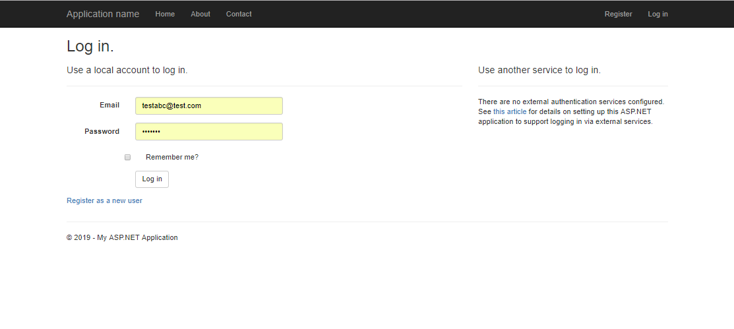

http://localhost:51397/Home/Index

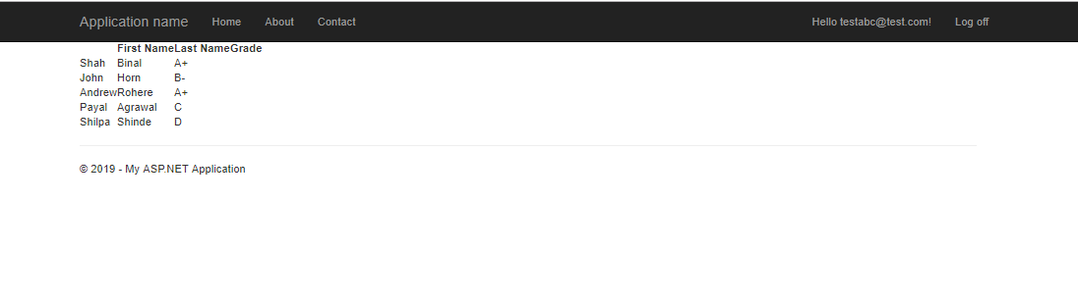

You can go to About and Contact page without login.

But you can no got to Home page without login as that page required login to see student data.