LAB 3: Create a webpage to illustrate the background color property and also add feature to change background color when min width of screen is768 PX.

<! DOCTYPE html>

<html lang="en">

<head>

<meta charset="UTF-8">

<meta name="viewport" content="width=device-width, initial-scale=1.0">

<title>Bg color change</title>

<style>

  @media (min-width: 768px) {

    body {

      background-color:black;

    }

  }

</style>

</head>

<body>

</body>

</html>

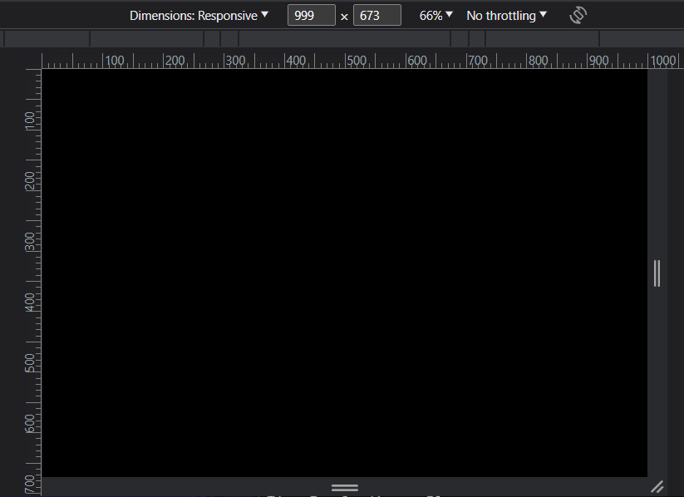 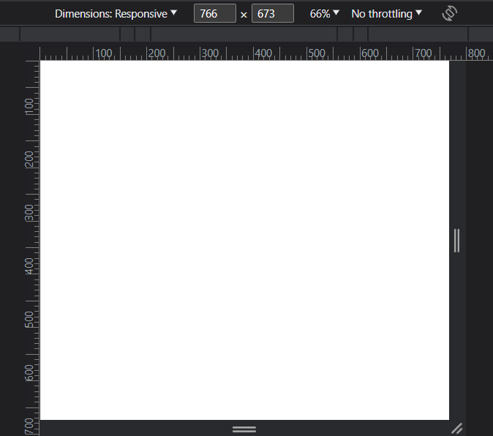

Background color when screen size 768px or less

Normal Background color

Lab2

Qn)Design a single webpage with a <header>, <main>, and <footer>. The header should consist of a navigation bar with links for 'Home', 'About', and 'Services', and apply a hover effect to them. Add a background image to the <main> section, positioning it both horizontally and vertically. In the footer section, include copyright links for social networking sites

<!DOCTYPE html>

<html lang="en">

  <head>

    <meta charset="UTF-8" />

    <meta name="viewport" content="width=device-width, initial-scale=1.0" />

    <title>Single Webpage Example</title>

    <style>

      ::-webkit-scrollbar {

        width: 0%;

      }

      body {

        margin: 0;

        padding: 0;

        font-family: Arial, sans-serif;

      }

      header {

        background-color: #333;

        color: #fff;

        padding: 10px 0;

        text-align: center;

      }

      nav {

        display: flex;

        justify-content: center;

      }

      nav a {

        color: #fff;

        text-decoration: none;

        margin: 0 20px;

        padding: 5px 10px;

      }

      nav a:hover {

        background-color: #555;

      }

      main {

        background-image: url("background.jpg");

        background-size: cover;

        background-position: center center;

        height: 600px;

        display: flex;

        flex-direction: column;

        justify-content: center;

        align-items: center;

        color: #fff;

      }

      footer {

        background-color: #333;

        color: #fff;

        padding: 10px 0;

        text-align: center;

      }

      footer a {

        color: #fff;

        text-decoration: none;

        margin: 0 10px;

      }

    </style>

  </head>

  <body>

    <header>

      <nav>

        <a href="#">Home</a>

        <a href="#">About</a>

        <a href="#">Services</a>

      </nav>

    </header>

    <main>

      <h1>Welcome to Our Website</h1>

      <p>Discover our amazing services and learn more about us.</p>

    </main>

    <footer>

      <p>&copy; 2023 Arzun. All rights reserved.</p>

      <div>

        <a href="#">Facebook</a>

        <a href="#">Twitter</a>

        <a href="#">Instagram</a>

      </div>

    </footer>

  </body>

</html>

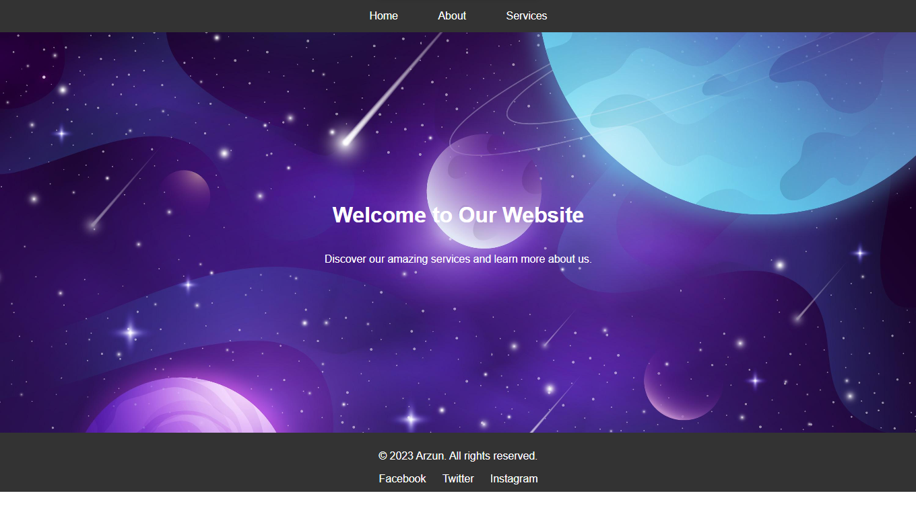

LAB 1: Write HTML code to design a page containing some text in a paragraph by giving suitable heading style and some text formatting tags. Also use semantic markup (citation, abbreviation, quotation, strong & emphasis).

* **<strong>**: Represents strong importance. The text inside this element is typically displayed in bold.
* **<em>**: Represents emphasized text. The text inside this element is typically displayed in italics.
* **<abbr>**: Represents an abbreviation or acronym, and the **title** attribute provides a full explanation of the abbreviation when users hover over it.
* **<q>**: Represents a short quotation. The text inside this element is typically enclosed in quotation marks.
* **<cite>**: Represents the title of a creative work or a citation. In this case, it's used to emphasize a scholarly context.
* **<dfn>**: Represents a definition term. The **data-cite** attribute can be used to provide a source for the definition.
* **<mark>**: Represents highlighted text. The text inside this element is typically highlighted in a distinctive background color.

<!DOCTYPE html>

<html lang="en">

  <head>

    <meta charset="UTF-8" />

    <meta name="viewport" content="width=device-width, initial-scale=1.0" />

    <title>Semantic Markup Example</title>

  </head>

  <body>

    <h1>Welcome to Semantic Markup</h1>

    <p>

      <strong>This is an important paragraph.</strong> It contains

      <em>emphasized</em> text and

      <abbr title="HyperText Markup Language">HTML</abbr> abbreviation. You can

      also use <q>quotation marks</q> to highlight a quote.

    </p>

    <p>

      In a <cite>scholarly context</cite>, it's crucial to provide proper

      <dfn data-cite="https://www.example.com/glossary">definitions</dfn> for

      technical terms.

    </p>

    <p>

      Remember, <mark>highlighting</mark> key points can help readers focus on

      important information.

    </p>

  </body>

</html>

