Installing and Using SASS

Steps

1. Download ruby from: https://rubyinstaller.org/downloads/ (WITHOUT DEVKIT (Ruby 2.6.5-1 (x64))

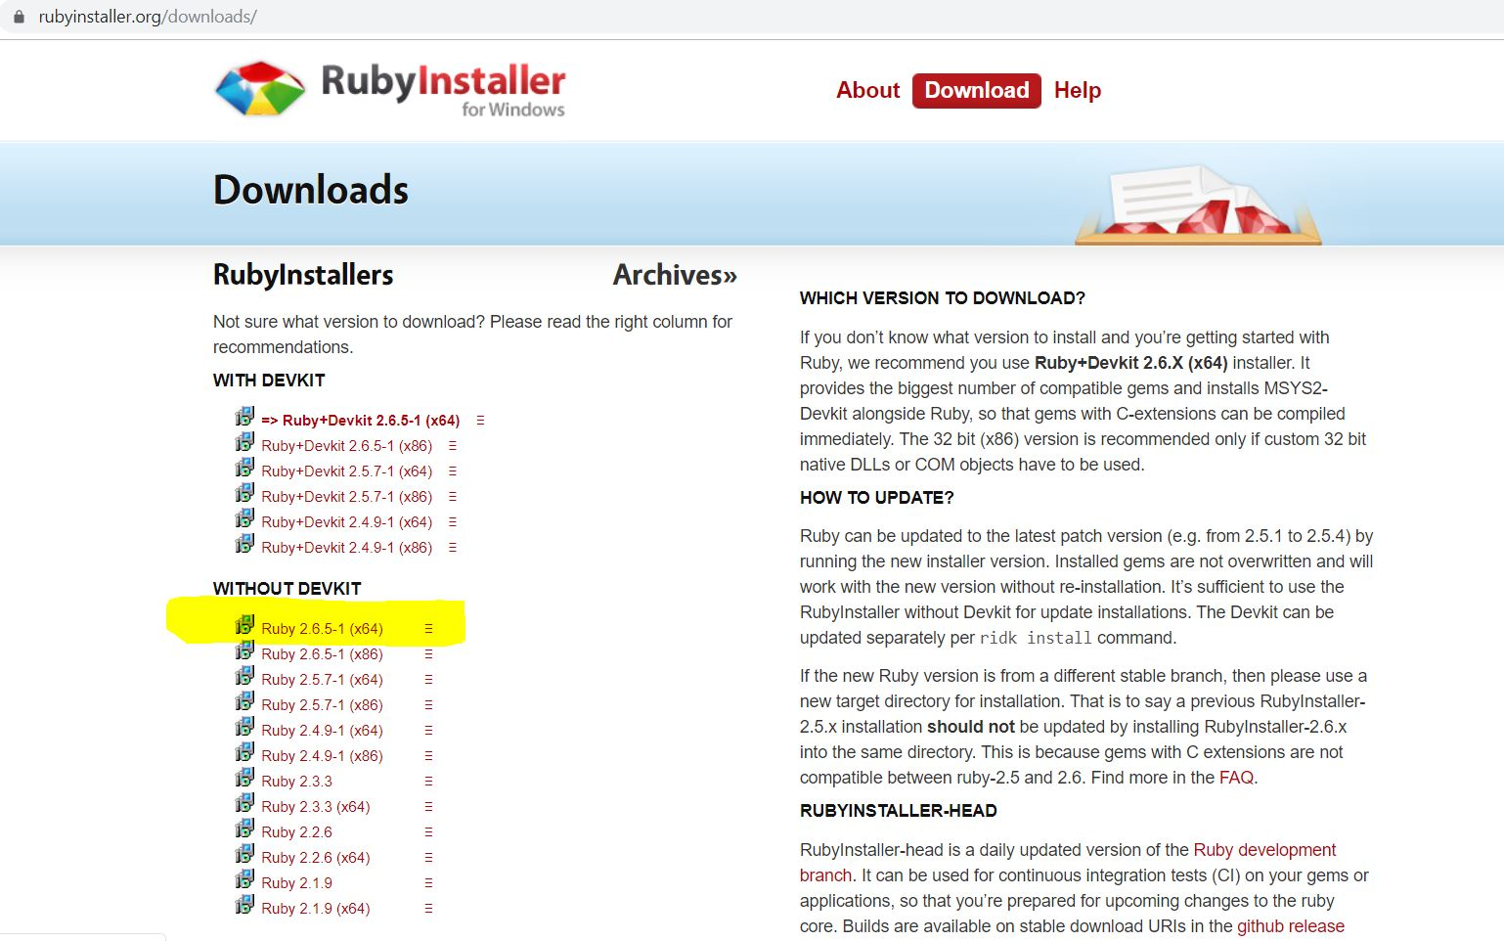
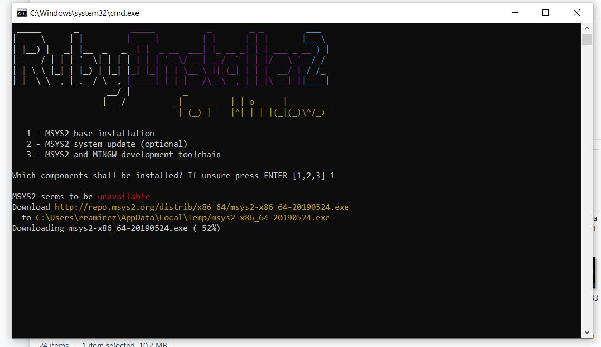
2. Install as admin
3. Download Development Kit from the same website (DevKit-mingw64-64-4.7.2-20130224-1432-sfx.exe)
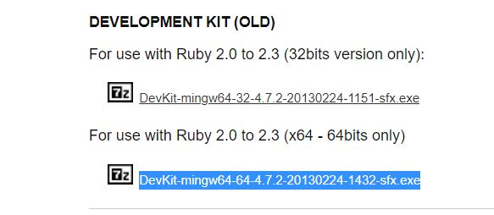

4. Create a new folder in c (C:devKit)

5. Install devkit there
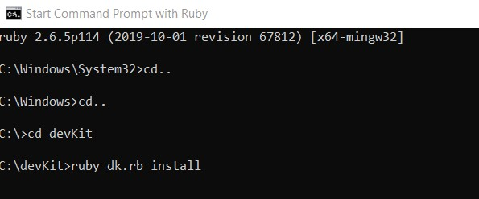

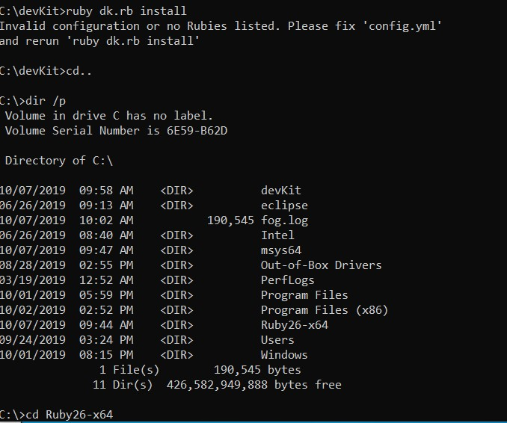
6. If you get this message…

7. Go to the devKit forlder and open config.yml using brackets.

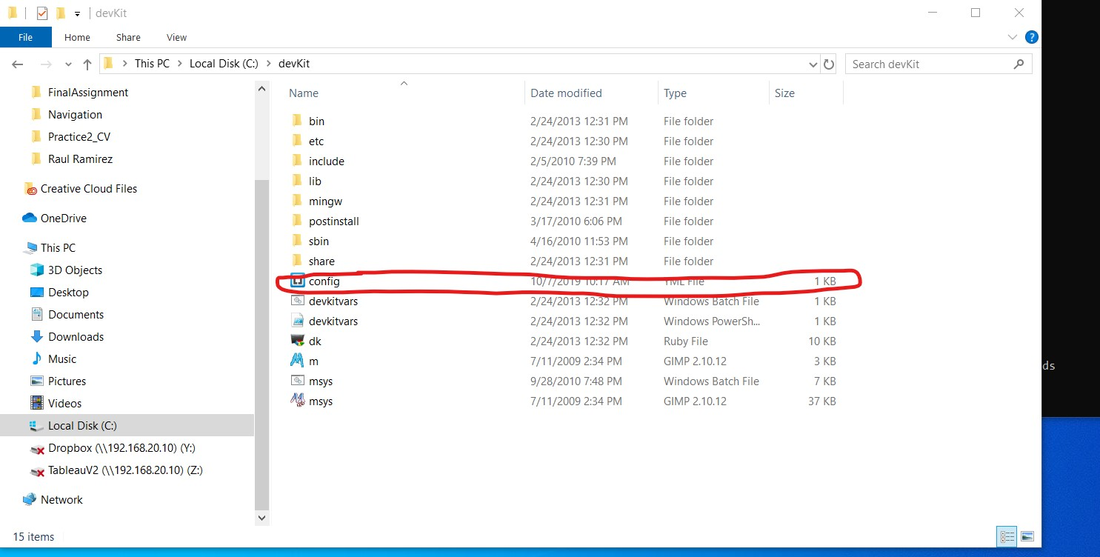
8. Add the following line: -C:/Ruby26x64
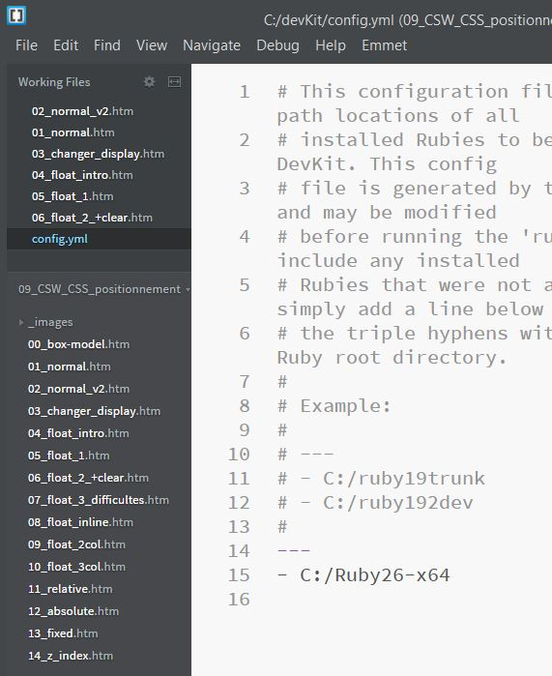

9. go to c:\devKit and use the following commands

c:\devKit>ruby dk.rb init

c:\devKit>ruby dk.rb install

c:\devKit>gem install sass
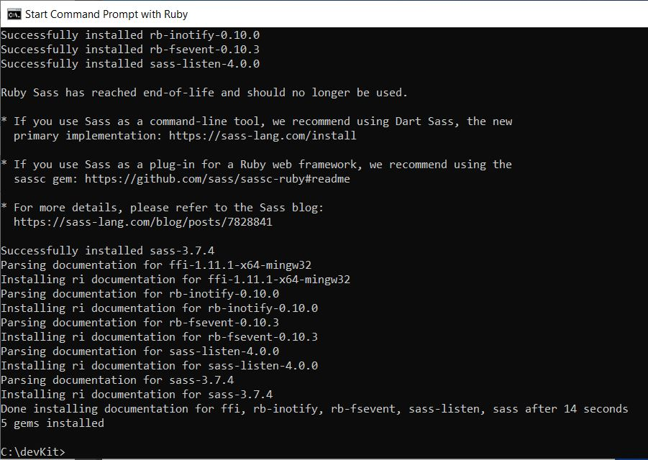
When you get the following, you are ready to use SASS.

10. Use the files provided by your teacher

Find the folder: c:\users\your_user\learning-sass\css\

Once you are there: use the following command to update your css file (SASS will convert scss into css, it will create a new file with the extension .map -DO NOT ERASE IT-).
Sass –update name_of_your_file

