Matrix / Synapse Self-Hosted Stack
A Docker Compose deployment of:
- Matrix Synapse — Matrix homeserver
- MAS — Matrix Authentication Service; native OIDC for Element X (MSC3861)
- coturn — TURN/STUN server for VoIP NAT traversal
- Keycloak — upstream identity provider (user accounts, passwords, OTP)
- PostgreSQL 16 — shared database for Synapse, MAS, and Keycloak
- LiveKit — SFU for MatrixRTC voice/video calls (Element X)
- lk-jwt-service — bridges Matrix OIDC tokens to LiveKit JWT tokens
- ntfy — UnifiedPush server for Android push notifications
- Nginx — HTTPS reverse proxy
- Certbot — automatic Let's Encrypt TLS certificates
All domain names are configured in a single .env file and never hardcoded elsewhere.
────────────────────────────────────────────────────────────

Web interfaces
Interface | URL | Purpose
Keycloak admin | https://<KEYCLOAK_DOMAIN> | User accounts, SSO configuration
MAS account | https://<SYNAPSE_DOMAIN>/account | Session management, password change
Synapse Admin | https://<SYNAPSE_DOMAIN>/admin | Room, user, and server administration
ntfy | https://<SYNAPSE_DOMAIN>:2586 | Push notification dashboard

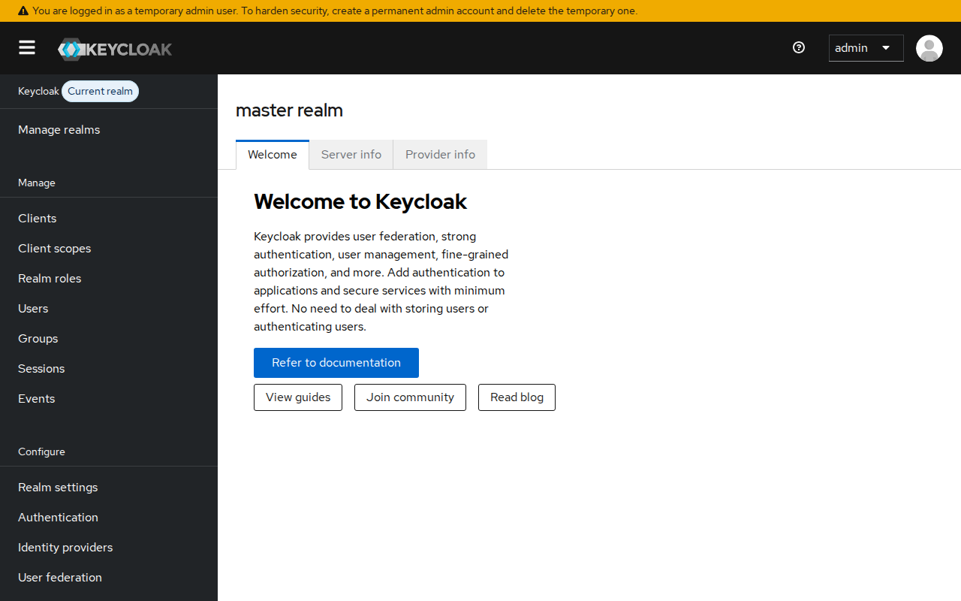 | 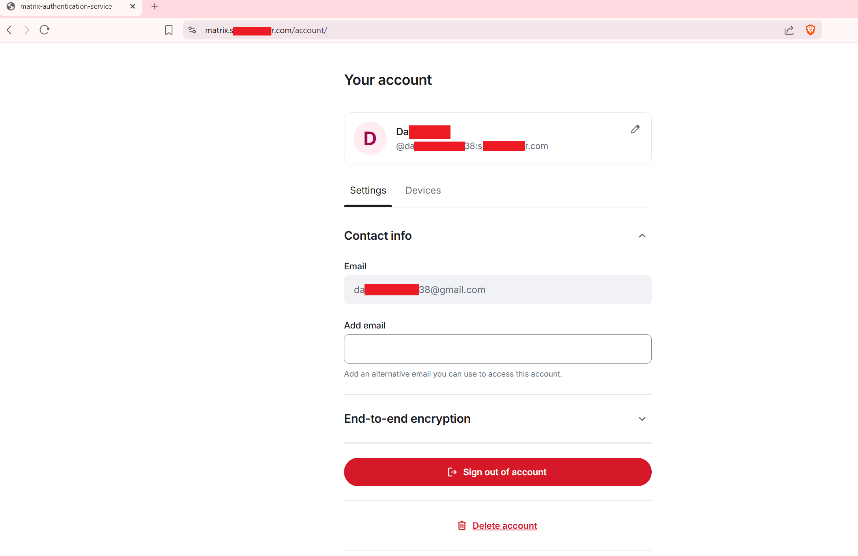
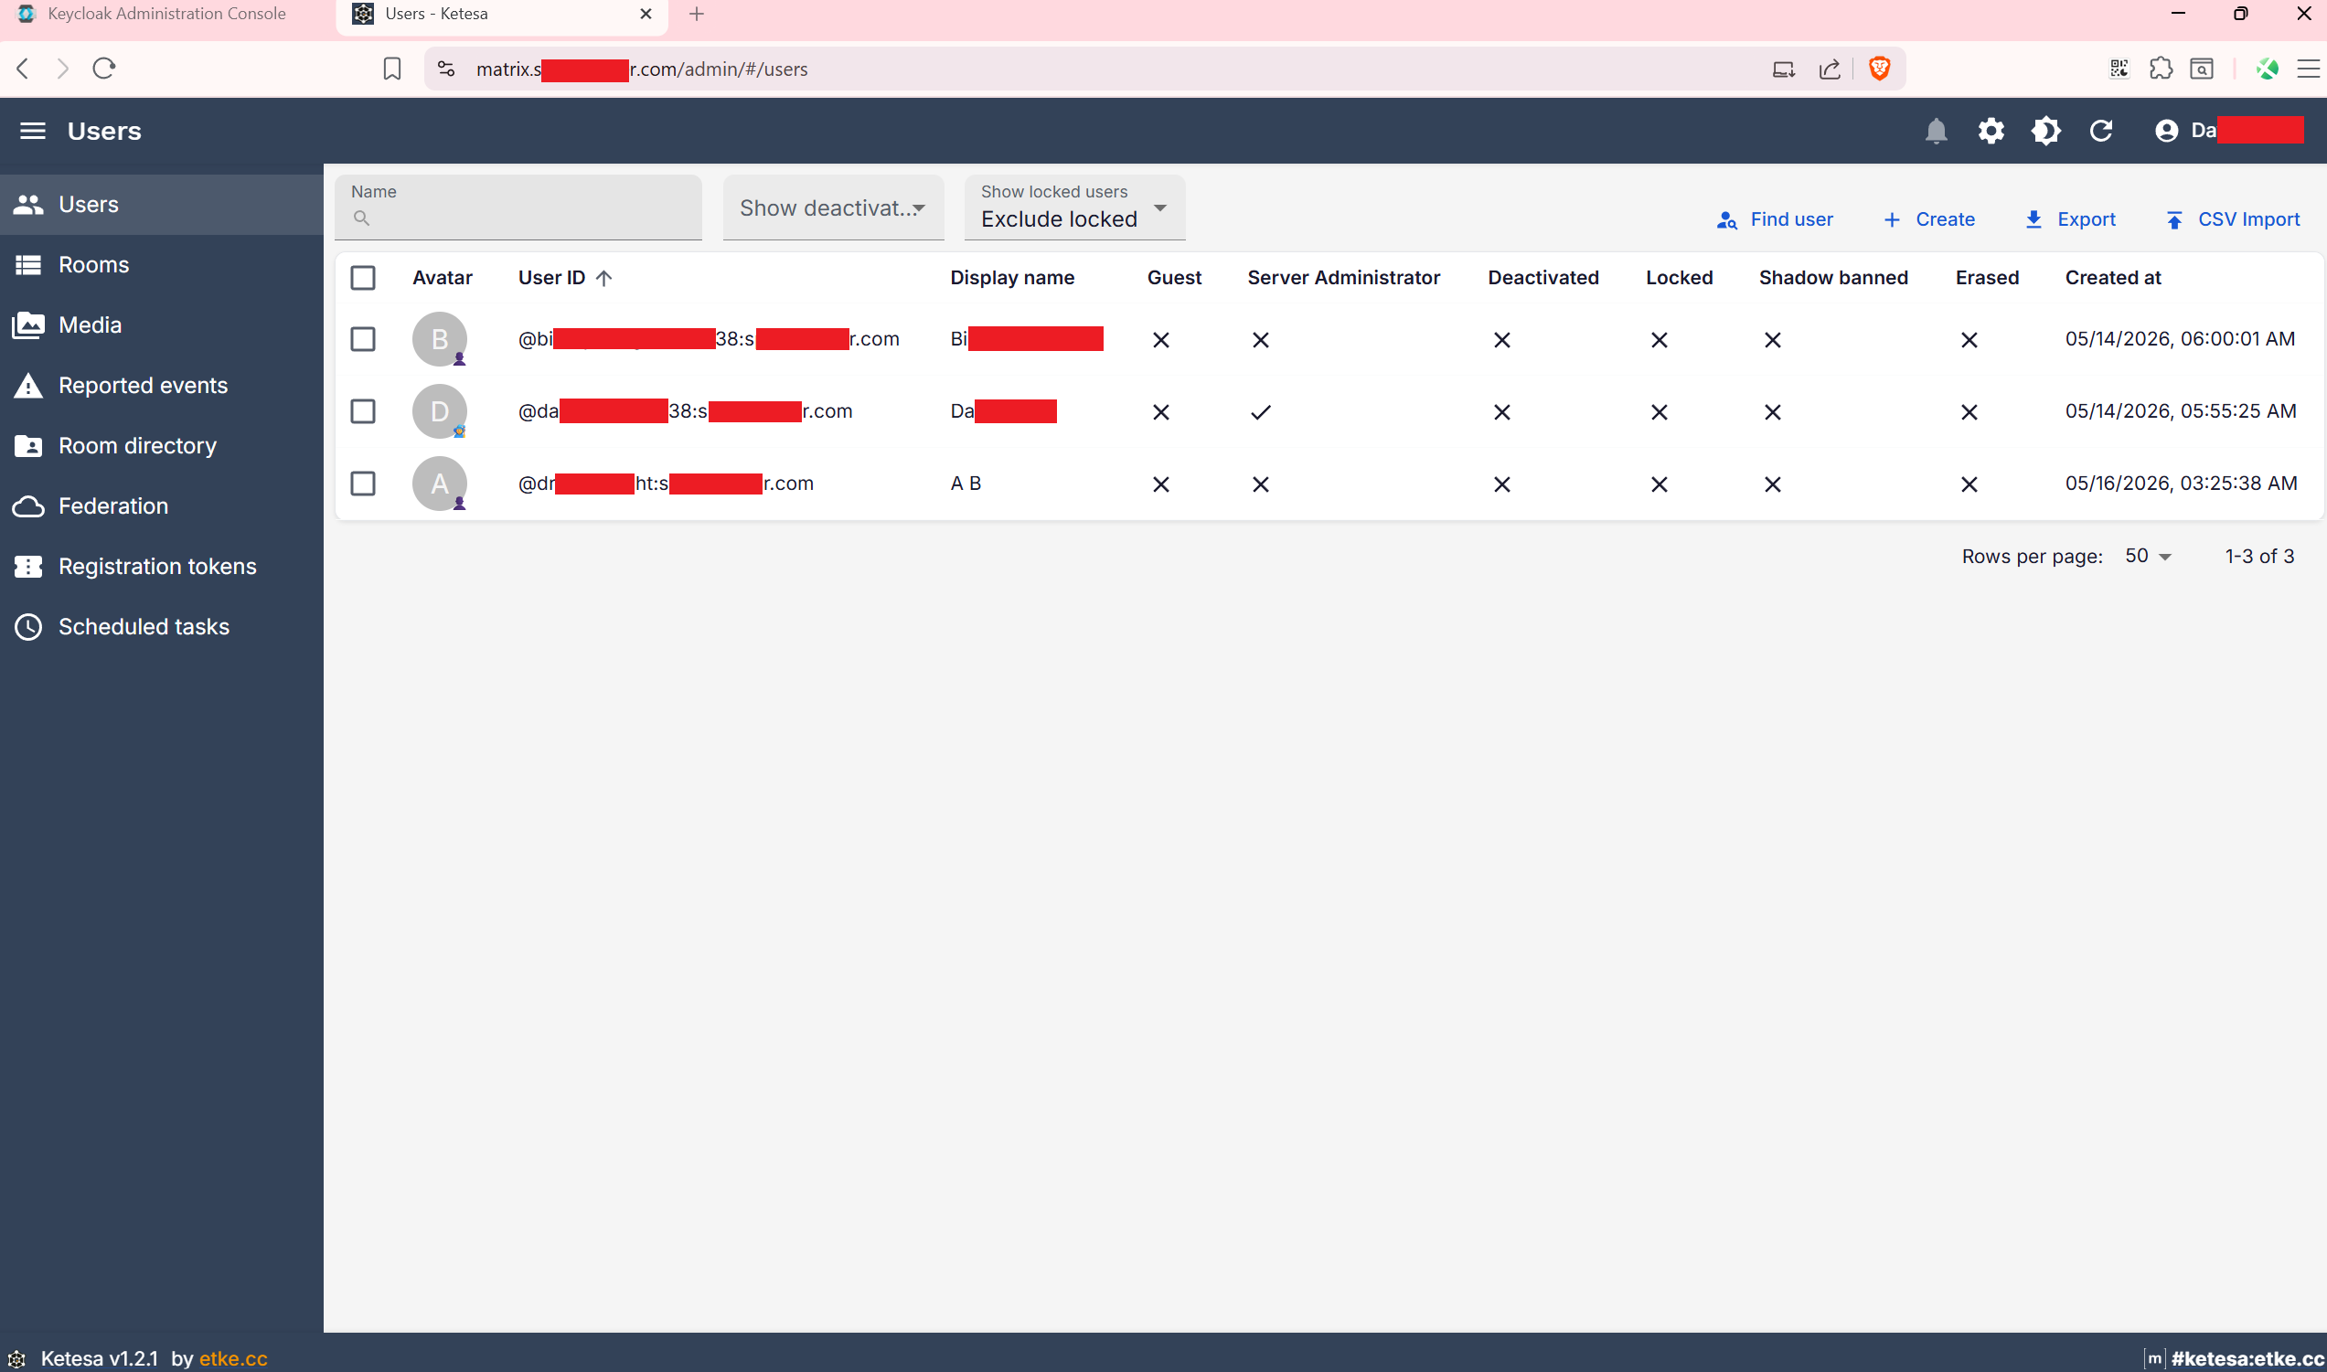 | 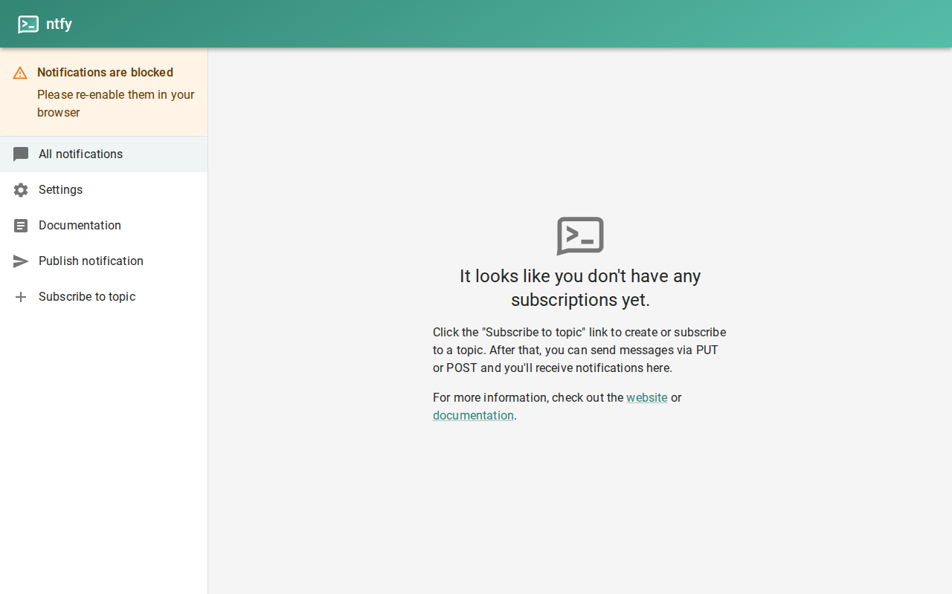

────────────────────────────────────────────────────────────

Prerequisites
- A Linux server with a public IP address running Ubuntu 22.04 or 24.04, with at least 4 GB RAM
- Docker and Docker Compose v2 installed (see below)
- DNS A records pointing all four domains to your server's IP before running init-certs.sh
- Ports 80, 443, 2586, 3478, 5349, 49152–49200/UDP, 7881/TCP, and 50200–50300/UDP open in your firewall
────────────────────────────────────────────────────────────

Installing Docker and Docker Compose on Ubuntu
Skip this section if Docker is already installed. Run docker compose version to check.

1. Remove old versions (if any)
sudo apt remove -y docker docker-engine docker.io containerd runc

2. Add Docker's official apt repository
sudo apt update
sudo apt install -y ca-certificates curl gnupg
sudo install -m 0755 -d /etc/apt/keyrings
curl -fsSL https://download.docker.com/linux/ubuntu/gpg \
| sudo gpg --dearmor -o /etc/apt/keyrings/docker.gpg
sudo chmod a+r /etc/apt/keyrings/docker.gpg
echo \
"deb [arch=$(dpkg --print-architecture) signed-by=/etc/apt/keyrings/docker.gpg] \
https://download.docker.com/linux/ubuntu \
$(. /etc/os-release && echo "$VERSION_CODENAME") stable" \
| sudo tee /etc/apt/sources.list.d/docker.list > /dev/null

3. Install Docker Engine and the Compose plugin
sudo apt update
sudo apt install -y docker-ce docker-ce-cli containerd.io \
docker-buildx-plugin docker-compose-plugin

4. Allow your user to run Docker without sudo
sudo usermod -aG docker $USER
newgrp docker # apply the group change in the current shell

5. Verify the installation
docker version
docker compose version
Both commands should print version information without errors. Docker Compose v2 is
included as a plugin (docker compose) — note there is no hyphen, unlike the older
standalone docker-compose v1.
────────────────────────────────────────────────────────────

Deployment

1. Clone and configure
git clone <this-repo> synapse-docker
cd synapse-docker
cp .env.example .env
Open .env and set every value — this is the only file you need to edit:
Variable | Description
MATRIX_DOMAIN | Base domain for Matrix user IDs (@user:example.com)
SYNAPSE_DOMAIN | Public URL of the Synapse server (matrix.example.com)
KEYCLOAK_DOMAIN | Public URL of Keycloak (auth.example.com)
TURN_DOMAIN | Public URL of the TURN server (turn.example.com)
SERVER_IP | Public IP of this server (required for TURN NAT traversal)
CERTBOT_EMAIL | Email address for Let's Encrypt expiry notifications
POSTGRES_PASSWORD | PostgreSQL superuser password
SYNAPSE_DB_PASSWORD | Password for the synapse database user
KEYCLOAK_DB_PASSWORD | Password for the keycloak database user
SYNAPSE_REGISTRATION_SECRET | Secret for registering users via the admin API
TURN_SECRET | Shared secret between Synapse and coturn
KEYCLOAK_ADMIN | Keycloak admin console username
KEYCLOAK_ADMIN_PASSWORD | Keycloak admin console password
MAS_DB_PASSWORD | Password for the mas database user
MAS_ENCRYPTION_SECRET | 64-character hex string used by MAS to encrypt cookies and tokens
MAS_MATRIX_SECRET | Shared secret between MAS and Synapse for internal API authentication
MAS_SYNAPSE_CLIENT_SECRET | OIDC client secret for Synapse's registration with MAS
MAS_KEYCLOAK_CLIENT_SECRET | OIDC client secret for MAS's registration with Keycloak (generate upfront; paste into Keycloak later)
LIVEKIT_API_KEY | LiveKit API key (any alphanumeric string, used in livekit config and lk-jwt-service)
LIVEKIT_API_SECRET | LiveKit API secret (long random string, must match between livekit and lk-jwt-service)

Password rules: avoid $, ', \, and & in passwords — these characters can break shell-based config substitution.

Generating strong passwords
Use pwgen to generate a secure random password for each secret field:
# Install pwgen if not already present
sudo apt install -y pwgen
# Generate a single 48-character password (no special chars to avoid substitution issues)
pwgen -s 48 1
Run it once per secret variable and paste each output into .env. For example:
POSTGRES_PASSWORD=$(pwgen -s 48 1)
SYNAPSE_DB_PASSWORD=$(pwgen -s 48 1)
KEYCLOAK_DB_PASSWORD=$(pwgen -s 48 1)
MAS_DB_PASSWORD=$(pwgen -s 48 1)
SYNAPSE_REGISTRATION_SECRET=$(pwgen -s 48 1)
TURN_SECRET=$(pwgen -s 48 1)
KEYCLOAK_ADMIN_PASSWORD=$(pwgen -s 48 1)
MAS_ENCRYPTION_SECRET=$(openssl rand -hex 32)
MAS_MATRIX_SECRET=$(pwgen -s 48 1)
MAS_SYNAPSE_CLIENT_SECRET=$(pwgen -s 48 1)
MAS_KEYCLOAK_CLIENT_SECRET=$(pwgen -s 48 1)
LIVEKIT_API_KEY=$(pwgen -s 32 1)
LIVEKIT_API_SECRET=$(openssl rand -hex 32)
# Print them all to copy into .env
echo "POSTGRES_PASSWORD=$POSTGRES_PASSWORD"
echo "SYNAPSE_DB_PASSWORD=$SYNAPSE_DB_PASSWORD"
echo "KEYCLOAK_DB_PASSWORD=$KEYCLOAK_DB_PASSWORD"
echo "MAS_DB_PASSWORD=$MAS_DB_PASSWORD"
echo "SYNAPSE_REGISTRATION_SECRET=$SYNAPSE_REGISTRATION_SECRET"
echo "TURN_SECRET=$TURN_SECRET"
echo "KEYCLOAK_ADMIN_PASSWORD=$KEYCLOAK_ADMIN_PASSWORD"
echo "MAS_ENCRYPTION_SECRET=$MAS_ENCRYPTION_SECRET"
echo "MAS_MATRIX_SECRET=$MAS_MATRIX_SECRET"
echo "MAS_SYNAPSE_CLIENT_SECRET=$MAS_SYNAPSE_CLIENT_SECRET"
echo "MAS_KEYCLOAK_CLIENT_SECRET=$MAS_KEYCLOAK_CLIENT_SECRET"
echo "LIVEKIT_API_KEY=$LIVEKIT_API_KEY"
echo "LIVEKIT_API_SECRET=$LIVEKIT_API_SECRET"

MATRIX_DOMAIN vs SYNAPSE_DOMAIN
Goal | Setting
User IDs like @user:matrix.example.com | Set both to the same value
User IDs like @user:example.com (delegation) | MATRIX_DOMAIN=example.com, SYNAPSE_DOMAIN=matrix.example.com

When they differ, Nginx serves /.well-known/matrix/ on MATRIX_DOMAIN to delegate
federation to SYNAPSE_DOMAIN.
────────────────────────────────────────────────────────────

2. Point DNS
Create an A record for your main domain and CNAME records for the subdomains:
example.com A <SERVER_IP>
matrix.example.com CNAME example.com
auth.example.com CNAME example.com
turn.example.com CNAME example.com
If MATRIX_DOMAIN and SYNAPSE_DOMAIN are the same value, the A record is for that domain and the remaining subdomains point to it via CNAME.
Wait for DNS propagation before continuing.
────────────────────────────────────────────────────────────

3. Obtain TLS certificates (one-time)
This script uses certbot in standalone mode (no Nginx needed yet) to obtain a single
multi-SAN certificate covering all your domains. The certificate is stored in the
certbot-certs Docker volume under live/<MATRIX_DOMAIN>/.
bash scripts/init-certs.sh
Port 80 must be free on the host when this runs.
Note: If you start the stack before running init-certs.sh, Nginx will automatically enter an HTTP-only bootstrap mode and print a waiting message in its logs. It will switch to HTTPS as soon as the certificates appear in the volume.
────────────────────────────────────────────────────────────

4. Start the stack
docker compose up -d
Services start in dependency order. Keycloak and Synapse take ~30–60 seconds on first
boot while initialising their databases.
Check that everything is healthy:
docker compose ps
docker compose logs -f # Ctrl-C to exit

5. Configure Keycloak SSO
See the Keycloak SSO integration section below.
────────────────────────────────────────────────────────────

Keycloak SSO integration with MAS
Keycloak acts as the upstream identity provider. Users authenticate with Keycloak; MAS
handles the native OIDC layer between clients and Synapse.

1. Create the Matrix realm
- Log in to https://<KEYCLOAK_DOMAIN> with your admin credentials.
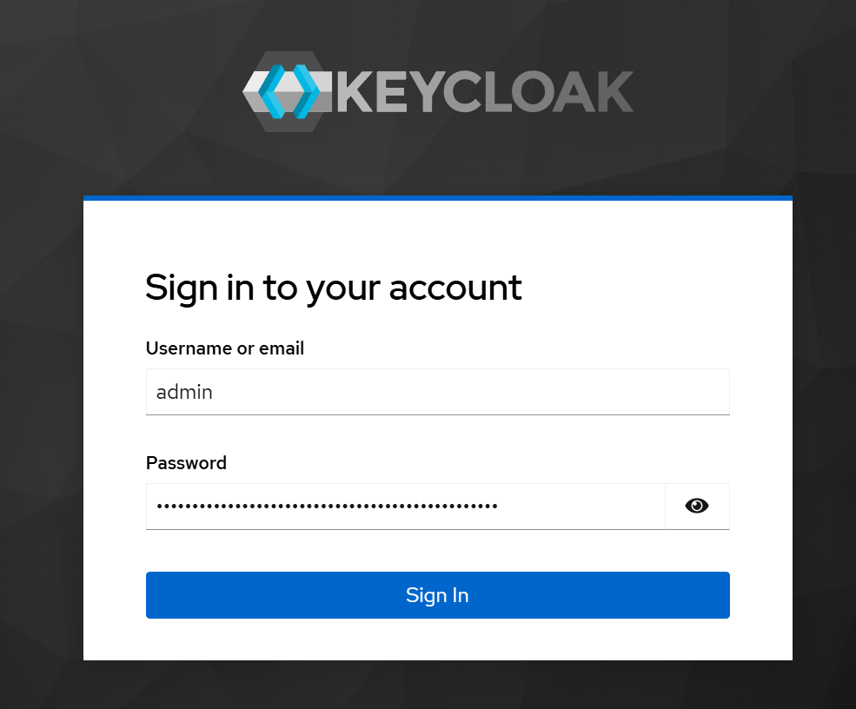
- Click Create realm and set the realm name to matrix.
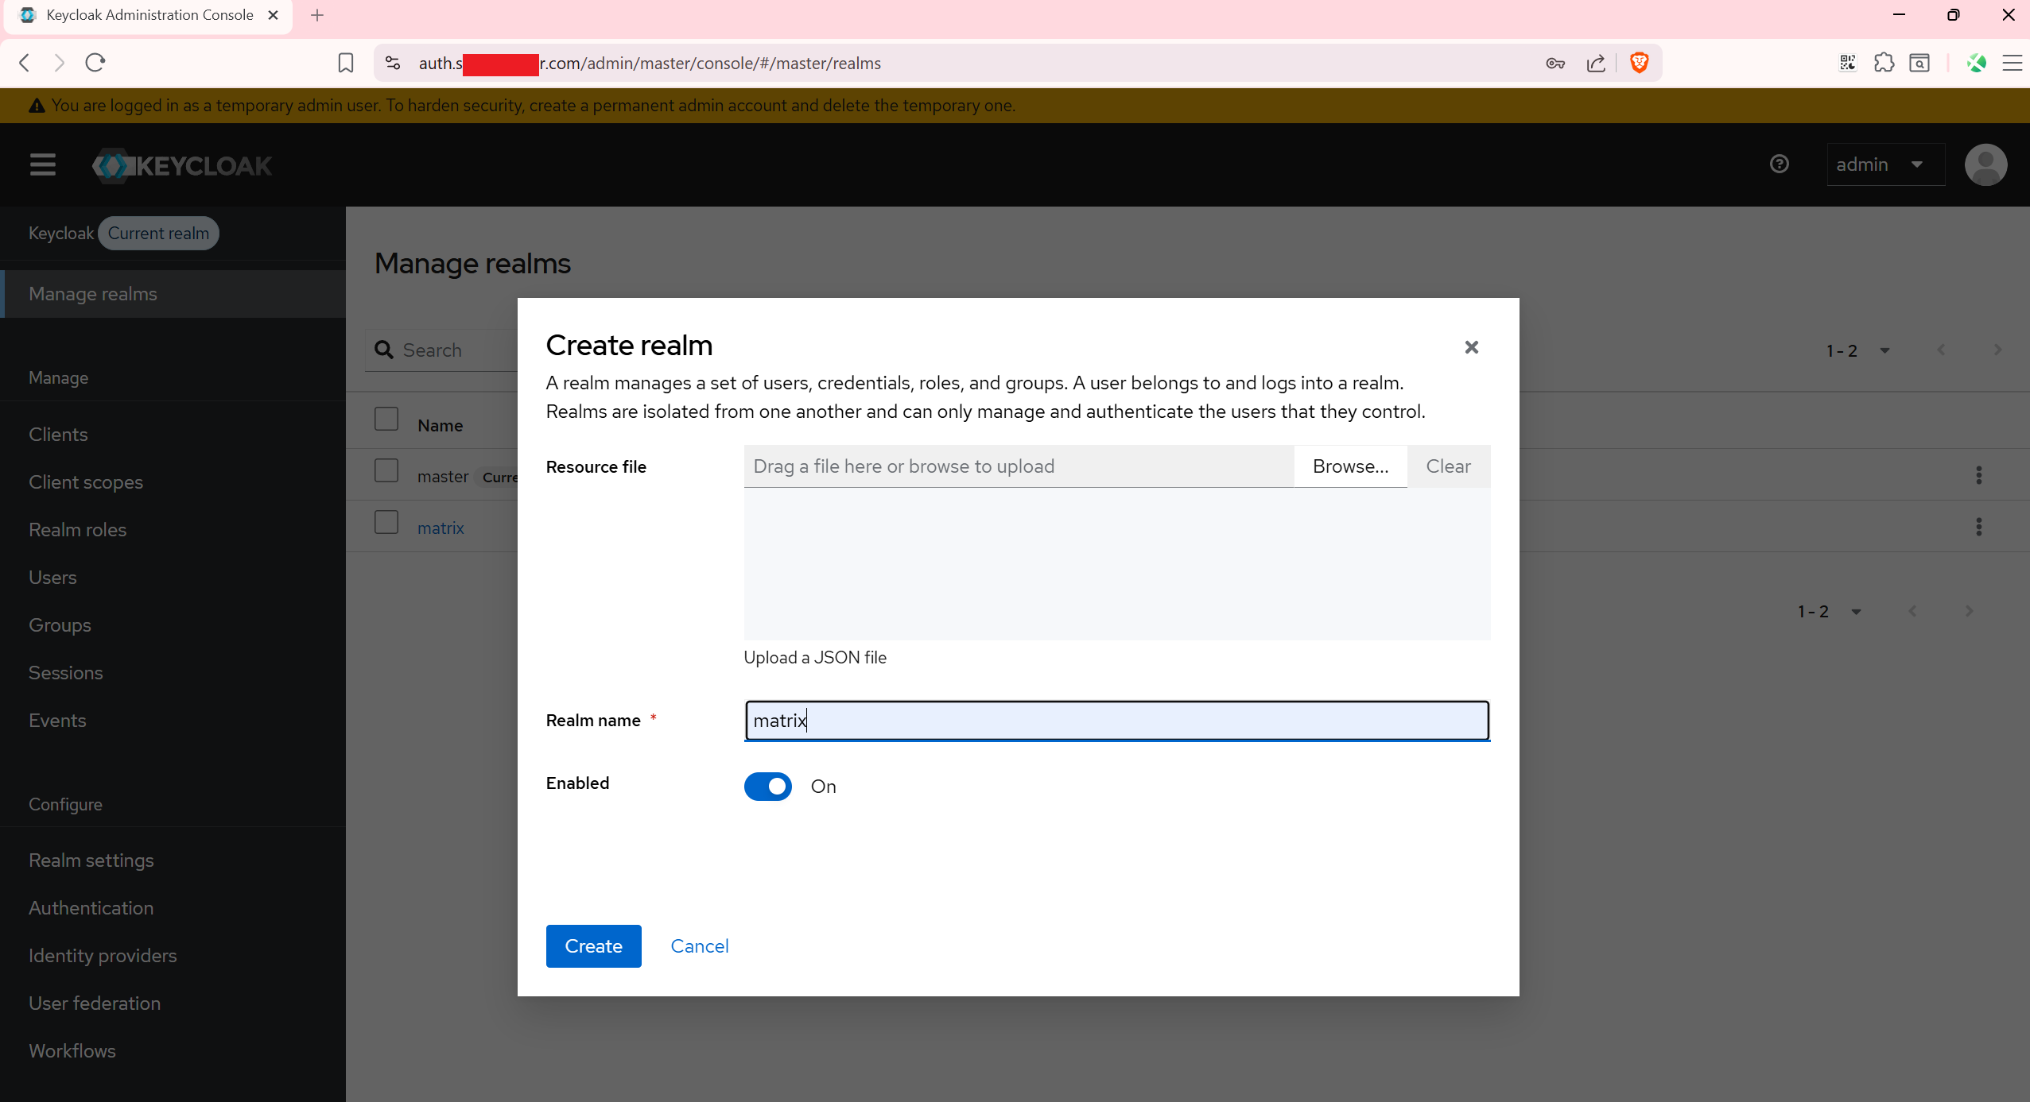

2. Create the MAS OIDC client
Inside the matrix realm, go to Clients → Create client and fill in the following,
then click Save:
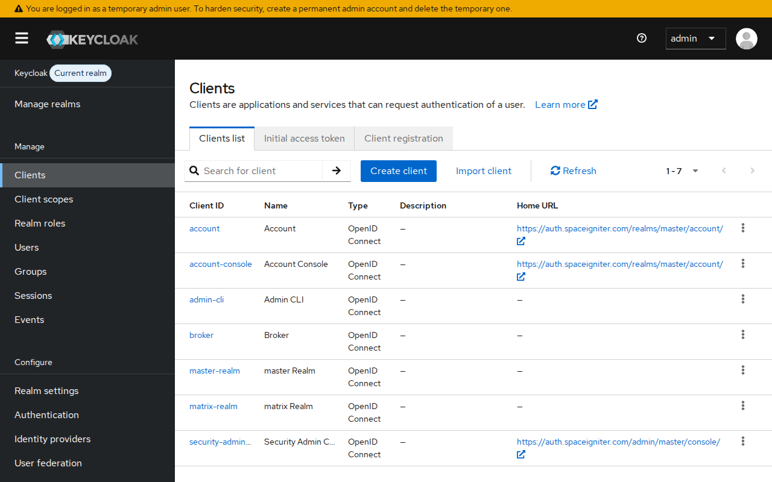
Setting | Value
Client type | OpenID Connect
Client ID | mas
Client authentication | On
Root URL | https://<SYNAPSE_DOMAIN>
Valid Redirect URIs | https://<SYNAPSE_DOMAIN>/upstream/callback/01KEYCAK000000000000000001

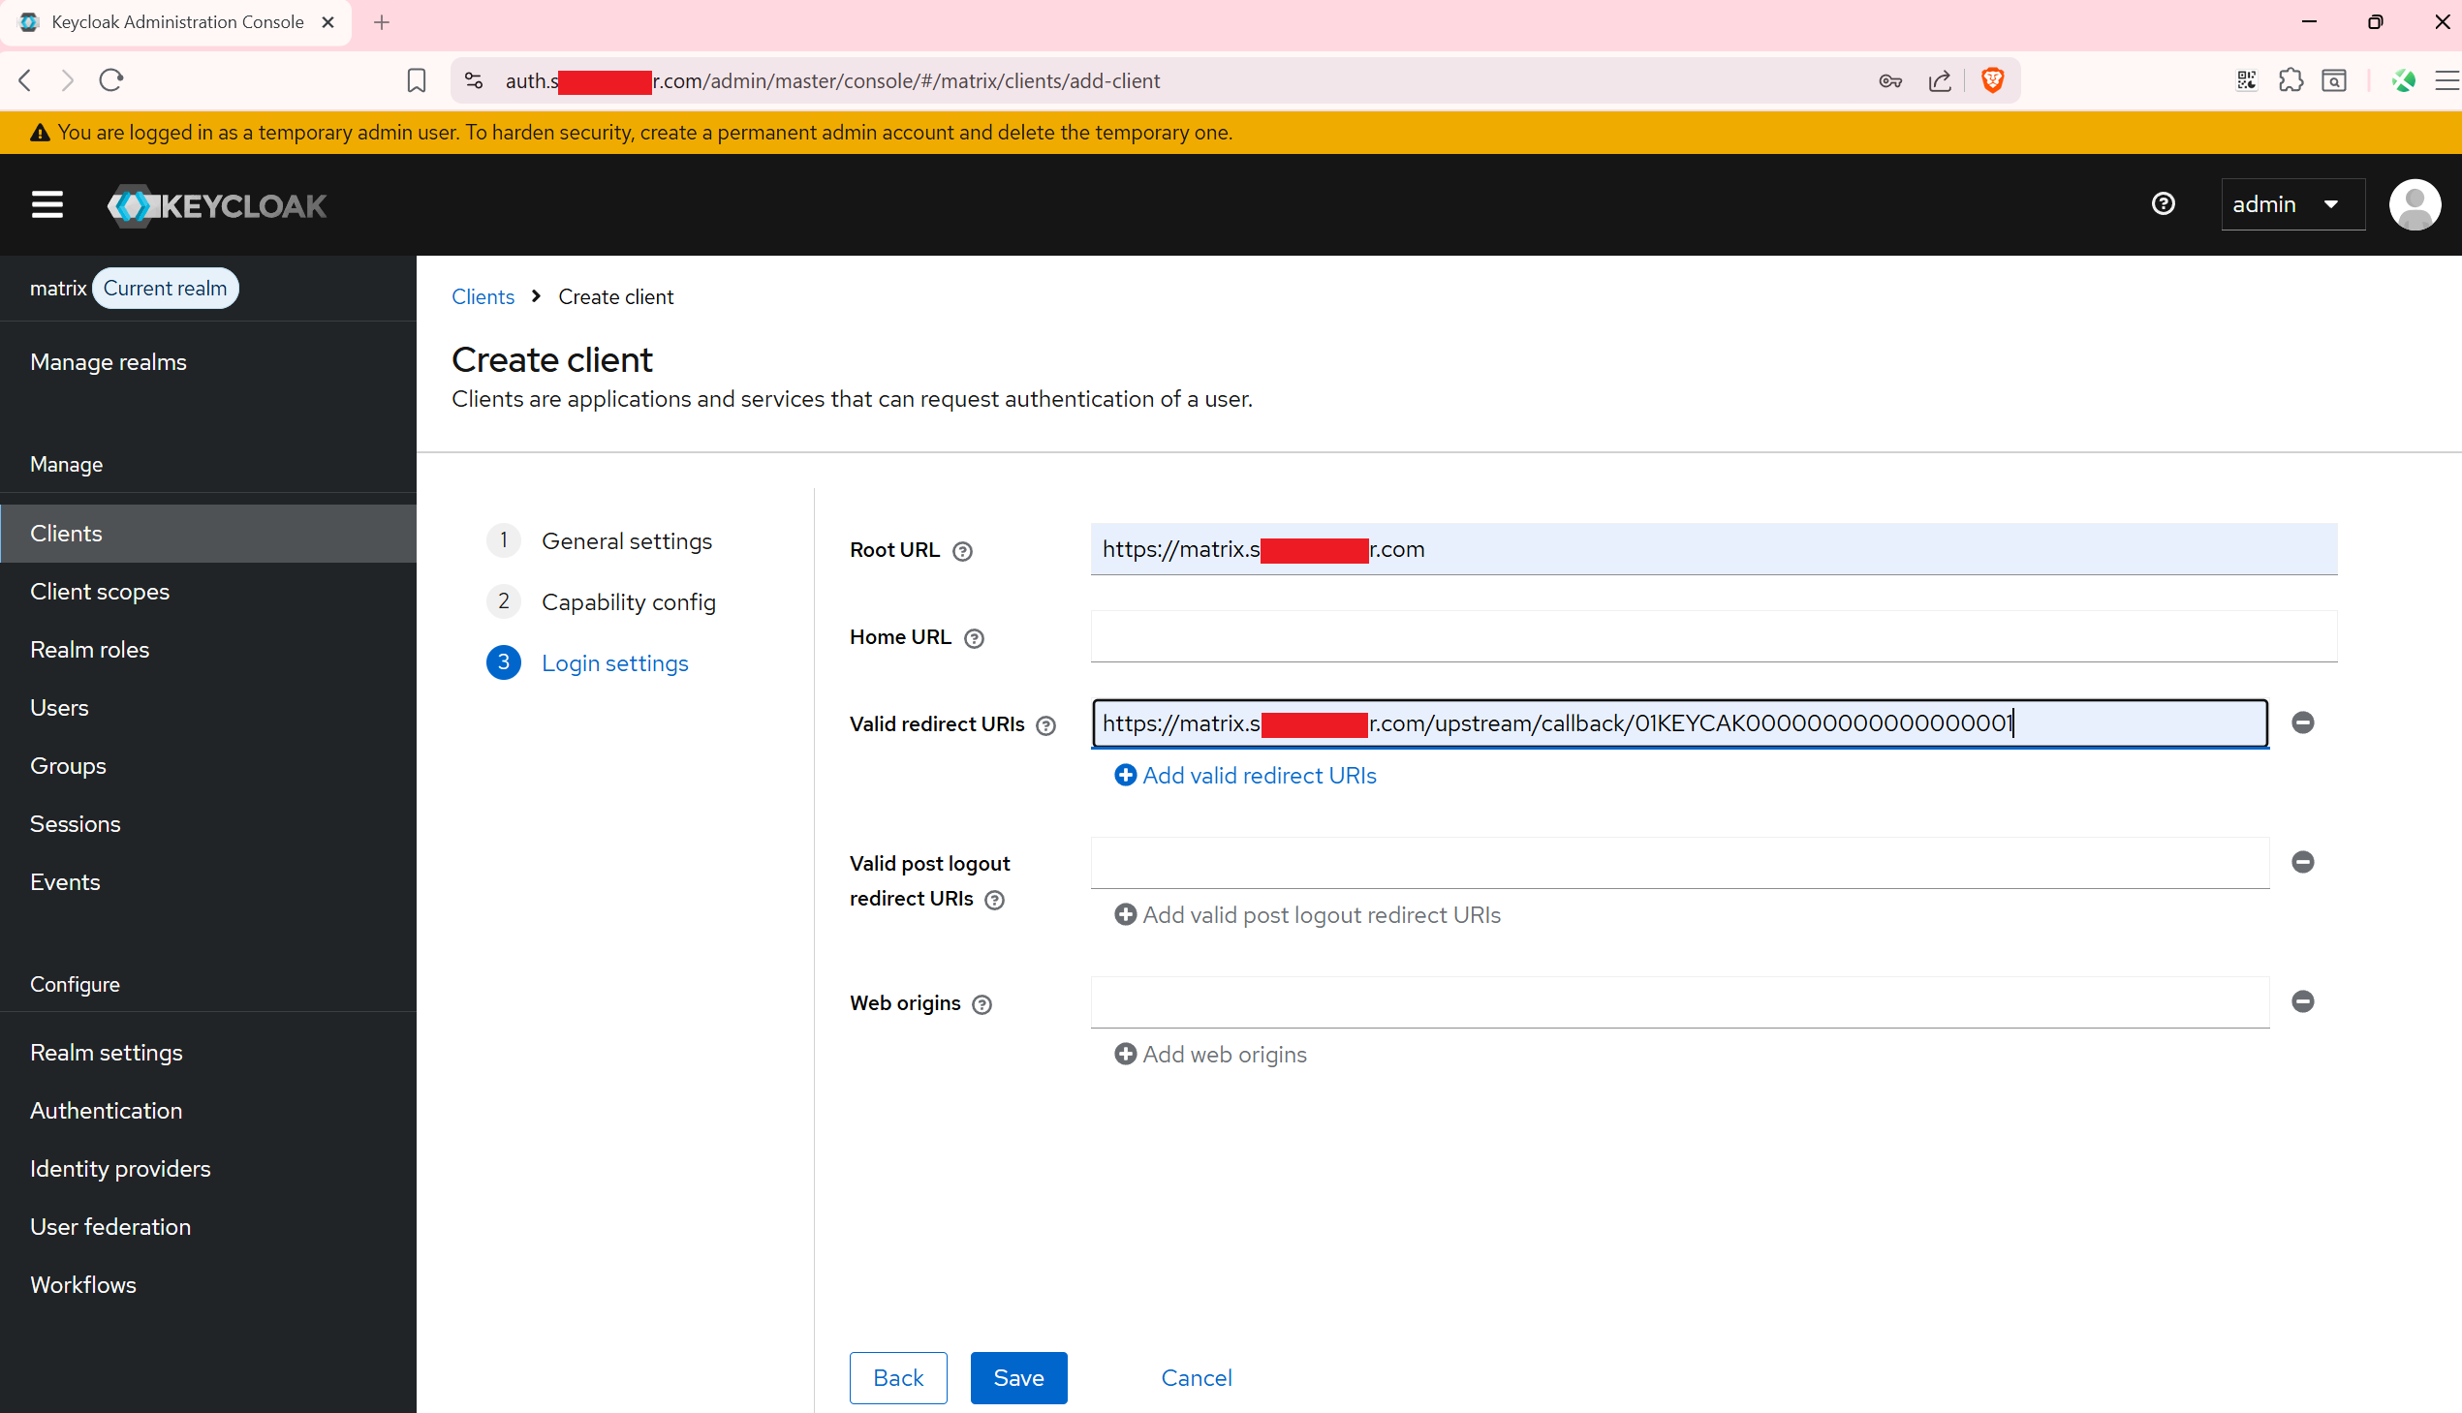
After saving, open the client's Credentials tab and set the Client secret to the
value of MAS_KEYCLOAK_CLIENT_SECRET from your .env file.
Save. No restart is needed — the secret was already baked in at startup.
────────────────────────────────────────────────────────────

Maintenance

Create users
All users authenticate through Keycloak via MAS. There is no self-registration —
accounts must be created by an administrator in the Keycloak admin console.

Normal users
- Log in to https://<KEYCLOAK_DOMAIN> with your admin credentials.
- Select the matrix realm.
- Go to Users → Add user.
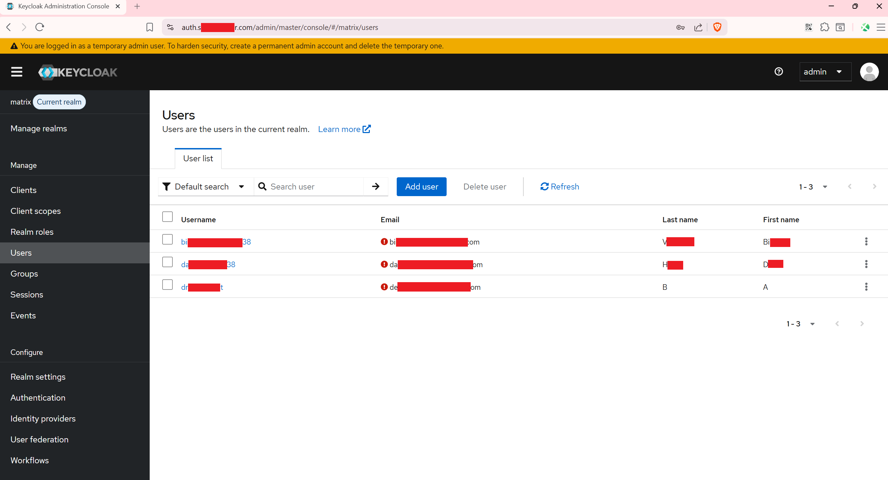
- Add Configure OTP to Required user actions to enforce
two-factor authentication on first login, fill in the username, and click Create.
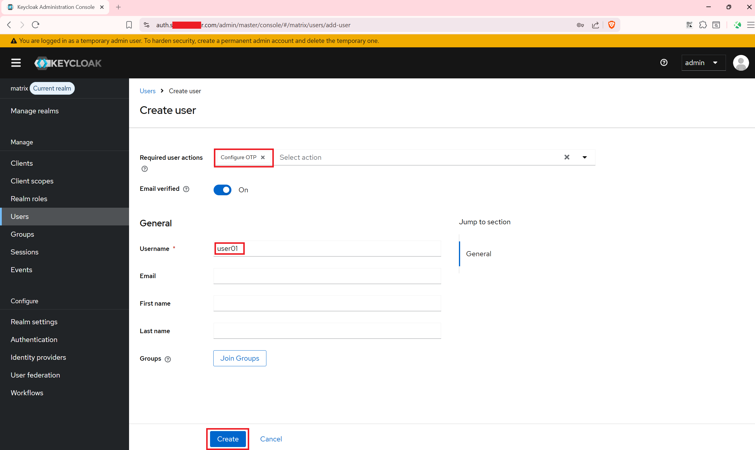
- Open the Credentials tab, set a temporary password, and leave Temporary on so
the user is forced to change it on first login.
That is sufficient — MAS and Synapse auto-provision the account on first login.

Synapse admin (required for the Synapse Admin UI)
The Synapse Admin UI requires a Matrix account with admin privileges.
- Create the user in Keycloak as described above.
- Have that user log in with Element X once so Synapse provisions the account.
- Grant admin rights in both Synapse and MAS — both databases must be updated:
# Grant admin in Synapse
docker compose exec -e PGPASSWORD=<POSTGRES_PASSWORD> postgres \
psql -U postgres -d synapse -c \
"UPDATE users SET admin = 1 WHERE name = '@<username>:<MATRIX_DOMAIN>';"
# Grant admin in MAS (required for the admin UI policy and token claims)
docker compose exec -e PGPASSWORD=<POSTGRES_PASSWORD> postgres \
psql -U postgres -d mas -c \
"UPDATE users SET can_request_admin = true WHERE username = '<username>';"
Why two commands? MAS records each user's admin eligibility in its own can_request_admin column, populated once at first login from Synapse's state at that moment. Updating Synapse's admin flag afterwards does not automatically propagate to MAS. Without can_request_admin = true in MAS, the admin UI login is denied by MAS policy even though the user is an admin in Synapse.
The user can now log in to the Synapse Admin UI at https://<SYNAPSE_DOMAIN>/admin
using their Keycloak credentials.
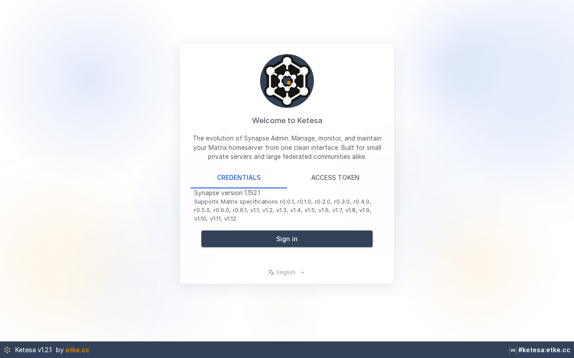

Change password
Passwords are managed by Keycloak — not Synapse, MAS, or Element. Users change their
password via the Keycloak account portal:
https://<KEYCLOAK_DOMAIN>/realms/matrix/account/
After logging in, go to Account Security → Signing in.
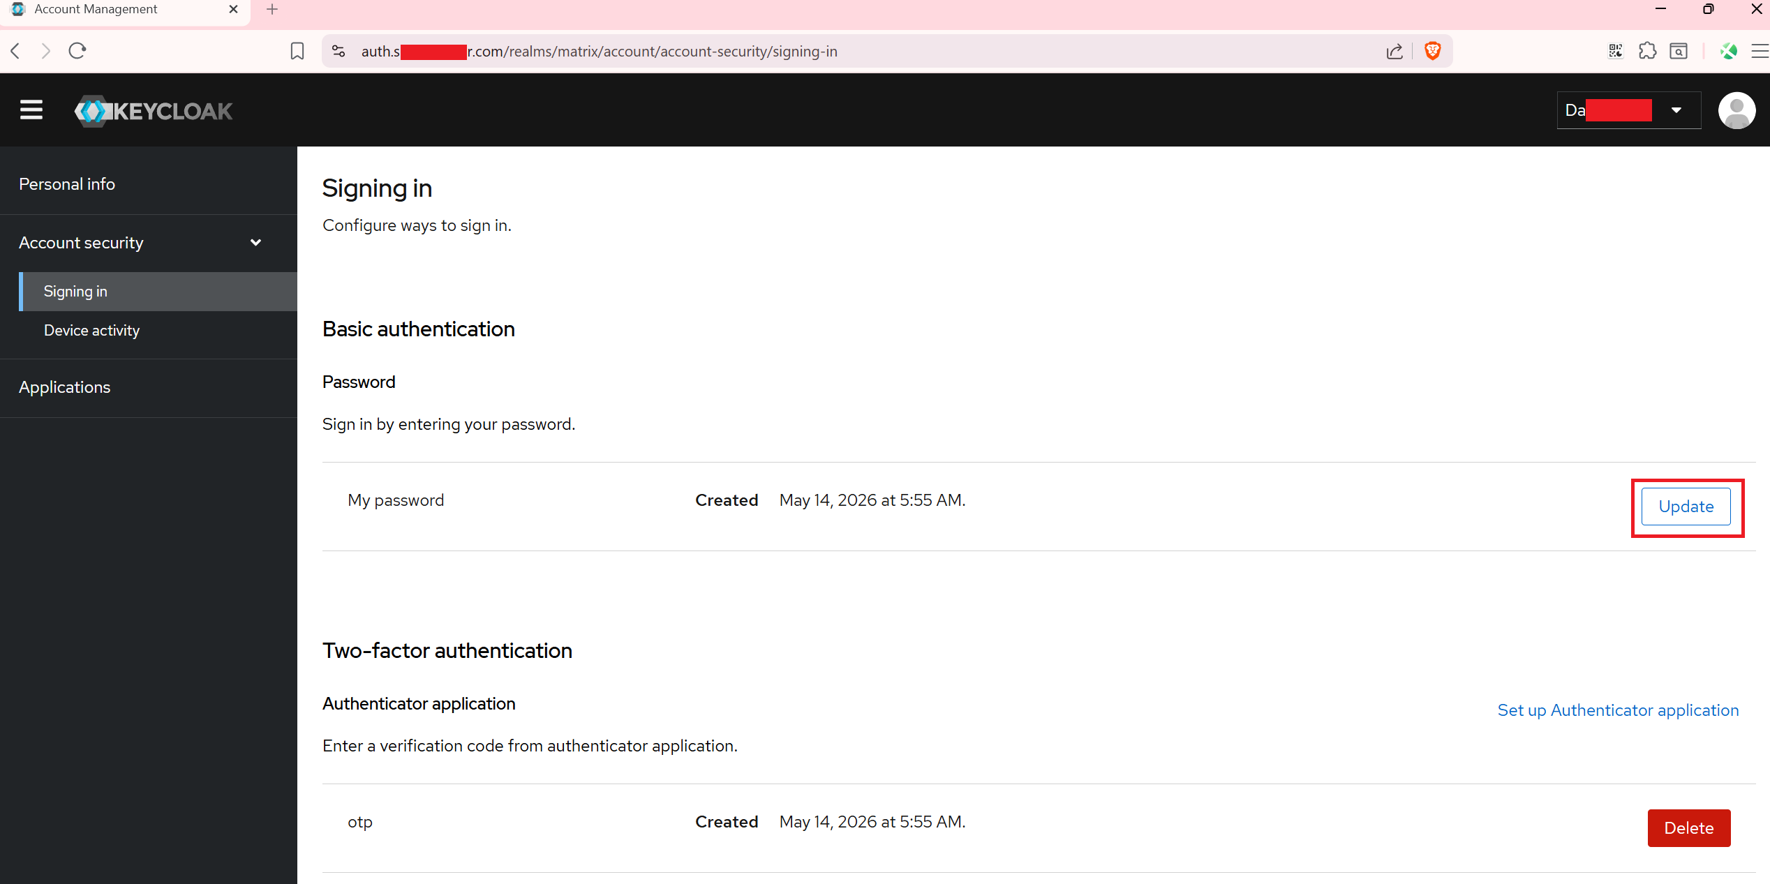
For session management (active devices, sign out remotely), users can use the MAS
account UI at https://<SYNAPSE_DOMAIN>/account.


Certificate renewal
Certbot automatically attempts renewal every 12 hours using the webroot method
(Nginx serves the ACME challenge files). After a successful renewal, reload Nginx to
apply the new certificate:
docker compose exec nginx nginx -s reload
To automate the reload, add a cron job on the host:
0 3 * * * docker compose -f /path/to/synapse-docker/docker-compose.yml exec -T nginx nginx -s reload

Update all images
docker compose pull
docker compose up -d

View logs for a specific service
docker compose logs -f synapse
docker compose logs -f keycloak
docker compose logs -f nginx
docker compose logs -f certbot

Backup
Run the backup script to snapshot all persistent state into a timestamped directory
under ./backups/:
bash scripts/backup.sh
Each backup directory contains:
File | Contents
postgres.sql | Full logical dump of all databases (Synapse + Keycloak)
synapse-data.tar.gz | Synapse signing key and media store
certbot-certs.tar.gz | TLS certificates and account keys
.env | All secrets and domain configuration

The stack must be running when the script is executed (it needs the postgres container
to produce the SQL dump).

Uninstall
To completely remove the stack including all data:
bash scripts/uninstall.sh
This stops all containers and deletes every named volume (databases, media store,
certificates). The action is irreversible — you will be prompted to confirm.
────────────────────────────────────────────────────────────

Architecture overview
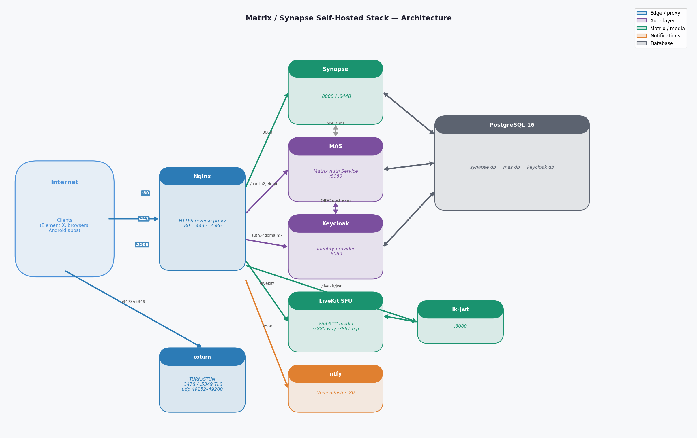
Text diagram
Internet
│
├─ :80 ──► Nginx ──► certbot webroot (ACME challenges)
│ └──► redirect to HTTPS
│
├─ :443 ──► Nginx ──► Synapse :8008 (Matrix client + federation)
│ ├──► MAS :8080 (native OIDC — /oauth2, /login, /account, ...)
│ ├──► Keycloak :8080 (identity provider — auth.example.com)
│ ├──► lk-jwt :8080 (/livekit/jwt — MatrixRTC token bridge)
│ └──► LiveKit :7880 (/livekit/ — WebSocket signaling)
│
├─ :2586 ──► Nginx ──► ntfy :80 (UnifiedPush — Android notifications)
│
├─ :3478 ─► coturn (TURN/STUN plaintext)
├─ :5349 ─► coturn (TURN/STUN TLS)
├─ :7881 ─► LiveKit (TCP fallback for WebRTC media)
└─ :50200–50300/UDP ─► LiveKit (WebRTC media relay)
Internal network (Docker bridge):
Element X ──► MAS (native OIDC login)
Element X ──► lk-jwt (get LiveKit JWT for voice/video call)
Element X ──► LiveKit (WebSocket signaling + WebRTC media)
MAS ──► Keycloak (upstream IdP — user accounts + passwords)
MAS ──► Synapse (MSC3861 token validation)
Synapse ──► MAS (MSC3861 auth delegation)
lk-jwt ──► LiveKit (internal room management)
Synapse ──► PostgreSQL (database: synapse)
MAS ──► PostgreSQL (database: mas)
Keycloak ──► PostgreSQL (database: keycloak)
coturn ──► certbot-certs volume (TLS cert)
Nginx ──► certbot-certs volume (TLS cert)
certbot-webroot volume (ACME challenge files)
TLS is terminated at Nginx for web traffic. coturn handles its own TLS directly using
the shared Let's Encrypt certificate — a multi-SAN cert covering all configured domains,
stored under live/<MATRIX_DOMAIN>/ in the certbot-certs volume.
────────────────────────────────────────────────────────────

Ports reference
Port | Protocol | Service | Purpose
80 | TCP | Nginx | HTTP → HTTPS redirect + ACME challenges
443 | TCP | Nginx | HTTPS (Synapse, MAS, Keycloak, LiveKit signaling)
3478 | UDP/TCP | coturn | TURN/STUN
5349 | UDP/TCP | coturn | TURN/STUN over TLS
49152–49200 | UDP | coturn | TURN relay ports
2586 | TCP | Nginx → ntfy | UnifiedPush (Android push notifications)
7881 | TCP | LiveKit | WebRTC TCP fallback for media
50200–50300 | UDP | LiveKit | WebRTC UDP media relay (MatrixRTC calls)

Firewall rules
All ports in the table above must be reachable from the internet. On Ubuntu with ufw:
sudo ufw allow 80/tcp
sudo ufw allow 443/tcp
sudo ufw allow 2586/tcp
sudo ufw allow 3478
sudo ufw allow 5349
sudo ufw allow 7881/tcp
sudo ufw allow 49152:49200/udp
sudo ufw allow 50200:50300/udp
sudo ufw enable
For other firewall tools (firewalld, iptables, or a cloud security group), open the same ports accordingly.

