|  |
| --- |
|  |
| Introduction To Database |
| Project Report |
| Group 3 :  Joanna Salathé |
| Eliéva Pignat  Sacha Bron |
|  |

|  |
| --- |
| This document contains the 3 deliverables of the introduction to database project. |

Table des matières

Deliverable 3 2

Modification of deliverable 2 2

Query H to S 2

Index performance 14

Importance of indexes based 14

Query Plans 14

Running Time 18

User Interface 19

Choices 19

Server sides 19

Why Java 19

Web server 19

Database Access 19

Client Size 20

How to use the Interface 21

Pre-written Requests 21

Custom Search 21

Clicable Results 21

Insertion 21

Deletion 21

Deliverable 2 22

Importation 22

New ER-Model 22

Changes in Table Creation 22

Search Functionality 25

SQL Queries 26

Queries A to G 27

Interface 33

Deliverable 1 35

ER-Model Choices 35

Constraints Explanation 35

Areas 35

Tracks 35

Recordings 35

Releases 36

Schemas 37

Tables Creation 38

Deliverable 3

# Deliverable 3

## Modification of deliverable 2

After the feedback, the deliverable 2 was modified in the following way :

1. Some queries had to be modified and corrected. For example we add DISTINCT when we count. And we GROUP BY first by ID and after by NAME
2. The foreign key on artist of the artist_track table was removed to be consistant with our database.
3. A short explanation of the queries A to G was added
4. The result of the queries A to G was added

An explanation about the technical part of the graphic interface is added in the deliverable 3 chapter User Interface.

## Query H to S

The queries H, M and N don’t give us any results. They never end (we stop after more than 1 hour). But they work (terminate and give consistant result) when we compute them on our « mini » database (a dummy database with the same schema than the project database but with less entries).

We also try to reduce the number of joins (that was really big). But reducing the multiple join introduced nested loops or/and multiple views and the queries still don’t give us any result.

For the others queries, you can find in this report the SQL codes, an explanation and (a part of) the results.

Query H :

--H :For each area that has more than 30 artists, list the male

--artist, the female artist and the group with the most tracks

--recorded.

-- The query H does not stop

/*We do three different views. One to obtain the male artist, one for the female and the last one for the group by areas.*/

SELECT A.NAME, M.ART_NAME, F.ART_NAME, G.ART_NAME

FROM AREA A,

(SELECT AREA_ID, ART_NAME

FROM

(SELECT AM.ID_AREA AS AREA_ID, AM.NAME AS ART_NAME,

COUNT(DISTINCT ATM.ID_TRACK) AS TCOUNT,

ROW_NUMBER()OVER (PARTITION BY AM.ID_AREA

ORDER BY COUNT(DISTINCT ATM.ID_TRACK)DESC) AS RN

FROM ARTIST AM, ARTIST_TRACK ATM

WHERE AM.GENDER='Male' AND AM.ID_ARTIST=ATM.ID_ARTIST

AND AM.ID_AREA IN (SELECT AR2.ID_AREA

FROM AREA AR2, ARTIST A

WHERE A.ID_AREA= AR2.ID_AREA

GROUP BY AR2.ID_AREA

HAVING COUNT(DISTINCT A.ID_ARTIST)>=30)

GROUP BY AM.ID_AREA, AM.ID_ARTIST, AM.NAME

)WHERE RN<=1) M,

(SELECT AREA_ID, ART_NAME

FROM

(SELECT AM.ID_AREA AS AREA_ID, AM.NAME AS ART_NAME,

COUNT(DISTINCT ATM.ID_TRACK) AS TCOUNT,

ROW_NUMBER()OVER (PARTITION BY AM.ID_AREA

ORDER BY COUNT(DISTINCT ATM.ID_TRACK)DESC) AS RN

FROM ARTIST AM, ARTIST_TRACK ATM

WHERE AM.GENDER='Female' AND AM.ID_ARTIST=ATM.ID_ARTIST

AND AM.ID_AREA IN (SELECT AR2.ID_AREA

FROM AREA AR2, ARTIST A

WHERE A.ID_AREA= AR2.ID_AREA

GROUP BY AR2.ID_AREA

HAVING COUNT(DISTINCT A.ID_ARTIST)>=30)

GROUP BY AM.ID_AREA, AM.ID_ARTIST, AM.NAME

)WHERE RN<=1) F,

(SELECT AREA_ID, ART_NAME

FROM

(SELECT AM.ID_AREA AS AREA_ID, AM.NAME AS ART_NAME,

COUNT(DISTINCT ATM.ID_TRACK) AS TCOUNT,

ROW_NUMBER()OVER (PARTITION BY AM.ID_AREA

ORDER BY COUNT(DISTINCT ATM.ID_TRACK)DESC) AS RN

FROM ARTIST AM, ARTIST_TRACK ATM

WHERE AM.TYPE='Group' AND AM.ID_ARTIST=ATM.ID_ARTIST

AND AM.ID_AREA IN (SELECT AR2.ID_AREA

FROM AREA AR2, ARTIST A

WHERE A.ID_AREA= AR2.ID_AREA

GROUP BY AR2.ID_AREA

HAVING COUNT(DISTINCT A.ID_ARTIST)>=30)

GROUP BY AM.ID_AREA, AM.ID_ARTIST, AM.NAME

)WHERE RN<=1) G

WHERE A.ID_AREA=M.AREA_ID AND A.ID_AREA=G.AREA_ID

AND A.ID_AREA=F.AREA_ID;

Query I :

-- I :American metal group Metallica is asking its fans to choose

-- the setlist for its upcoming concert in Switzerland.

-- Assuming that the Metallica fans will choose the songs that have -- appeared on the highest number of mediums, list the top 25 songs.

/*Order the recordings of Metallica by the count of their mediums apparitions in the track table and select the top 25 of them */

SELECT DISTINCT *

FROM

(SELECT R.NAME, COUNT(DISTINCT T.ID_MEDIUM)

FROM TRACK T, RECORDING R, ARTIST_TRACK AT, ARTIST A

WHERE A.NAME = 'Metallica' AND A.ID_ARTIST = AT.ID_ARTIST

AND AT.ID_TRACK = T.ID_TRACK AND T.ID_RECORDING = R.ID_RECORDING

GROUP BY R.ID_RECORDING, R.NAME

ORDER BY COUNT(DISTINCT T.ID_MEDIUM) DESC)

WHERE ROWNUM <= 25;

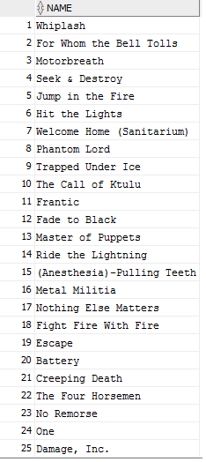

Figure 1 result of query I

Query J :

--J : For each of the 10 genres with the most artists, list the

--female artist that has recorded the highest number of tracks.

/*First we order the genre by the count of their artists and select the top 10 of them. Then for each genre that belongs to this subset

we check if it has female artists in it. If so we order its femals artists by counting the number of track they did with an over partition operator and select the first row for each area.*/

SELECT NAME

FROM(

SELECT AG.ID_GENRE, A.NAME AS NAME, COUNT(DISTINCT AT.ID_TRACK),

ROW_NUMBER()OVER (PARTITION BY AG.ID_GENRE

ORDER BY COUNT(DISTINCT AT.ID_TRACK) DESC) AS RN

FROM ARTIST A, ARTIST_TRACK AT, ARTIST_GENRE AG

WHERE A.ID_ARTIST= AT.ID_ARTIST AND A.GENDER='Female'

AND A.ID_ARTIST=AG.ID_ARTIST

AND AG.ID_GENRE IN (SELECT *

FROM

(SELECT G.ID_GENRE

FROM ARTIST_GENRE G

GROUP BY G.ID_GENRE

ORDER BY COUNT(DISTINCT G.ID_ARTIST) DESC)

WHERE ROWNUM <=10)

GROUP BY AG.ID_GENRE, A.ID_ARTIST, A.NAME

)WHERE RN=1;

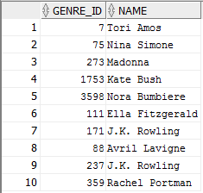

Figure 2 result of query J

Query K :

--K : List all genres that have no female artists, all genres that

--have no male artists and all genres that have no groups.

/*Select the genres that are not present in the result of the selection of genres that have female artist.

Select the genres that are not present in the result of the selection of genres that have male artist.

Select the genres that are not present in the result of the selection of genres that have group artist.

Union the results of each of these subqueries.*/

SELECT G.ID_GENRE

FROM GENRE G

WHERE G.ID_GENRE

NOT IN (SELECT AG.ID_GENRE

FROM ARTIST_GENRE AG, ARTIST A

WHERE AG.ID_ARTIST = A.ID_ARTIST AND A.GENDER = 'Female')

UNION

SELECT G.ID_GENRE

FROM GENRE G

WHERE G.ID_GENRE

NOT IN (SELECT AG.ID_GENRE

FROM ARTIST_GENRE AG, ARTIST A

WHERE AG.ID_ARTIST = A.ID_ARTIST AND A.GENDER = 'Male')

UNION

SELECT G.ID_GENRE

FROM GENRE G

WHERE G.ID_GENRE

NOT IN (SELECT AG.ID_GENRE

FROM ARTIST_GENRE AG, ARTIST A

WHERE AG.ID_ARTIST = A.ID_ARTIST AND A.TYPE = 'Group') ;

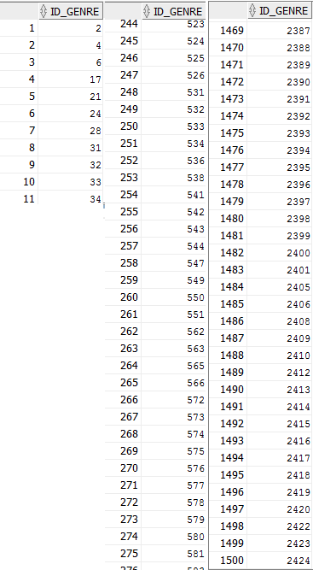

Figure 3 result of query K

Query L :

--L : For each area with more than 10 groups, list the 5 male

--artists that have recorded the highest number of tracks.

/*Select the areas that have more than 10 groups and for each of those areas we order the artist of this area by their count record and select the 5 highest of each area */

SELECT AREA_NAME, ART_NAME

FROM

(SELECT ARE.NAME AS AREA_NAME, A.NAME AS ART_NAME,

COUNT(DISTINCT AT.ID_TRACK) AS TRACKCOUNT,

ROW_NUMBER()OVER(PARTITION BY ARE.ID_AREA, ARE.NAME

ORDER BY COUNT(DISTINCT AT.ID_TRACK) DESC) AS RN

FROM ARTIST A, ARTIST_TRACK AT, AREA ARE

WHERE A.ID_ARTIST = AT.ID_ARTIST AND A.ID_AREA=ARE.ID_AREA

AND ARE.ID_AREA IN

(SELECT AR.ID_AREA

FROM AREA AR, ARTIST A2

WHERE AR.ID_AREA = A2.ID_AREA AND A2.TYPE = 'Group'

GROUP BY AR.ID_AREA

HAVING COUNT(DISTINCT A2.ID_ARTIST) > 10)

GROUP BY ARE.ID_AREA, ARE.NAME, A.ID_ARTIST, A.NAME)

WHERE RN <= 5;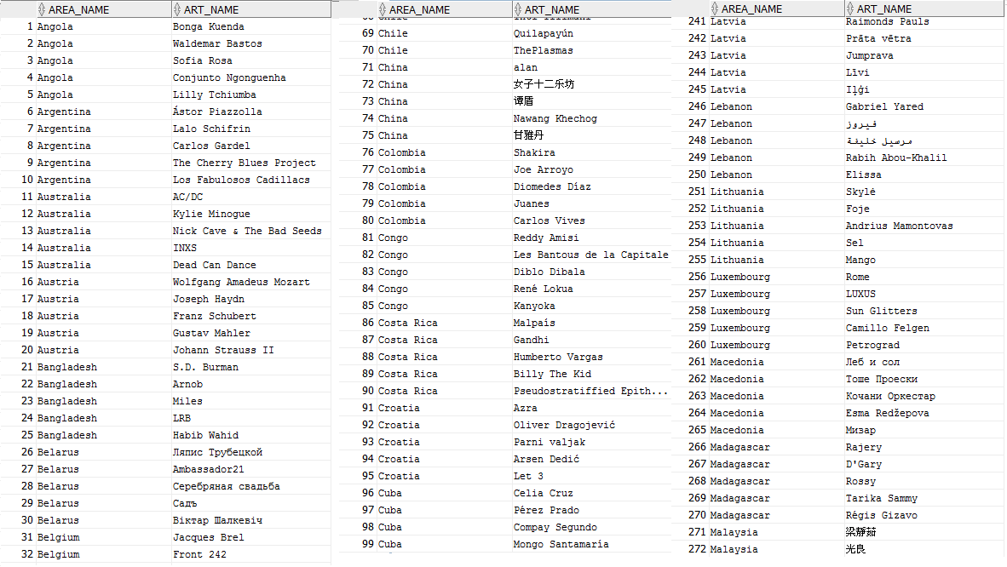

Figure 4 result of query L

Query M :

--M :List the 10 groups with the highest number of tracks that appear

--on compilations. A compilation is a medium that contains tracks

--associated with more than one artist.

--Query M does not stop

/*Count the number of tracks of an artist if the track is on a medium that contains at least an other track create by an other artist. Order the artists by the number of those track and finally select the top 10*/

SELECT *

FROM

(SELECT A.NAME AS NAME, COUNT(DISTINCT T.ID_TRACK)

FROM ARTIST A, ARTIST_TRACK AT, TRACK T

WHERE A.TYPE='Group' AND A.ID_ARTIST=AT.ID_ARTIST

AND AT.ID_TRACK=T.ID_TRACK AND T.ID_MEDIUM

IN (SELECT DISTINCT T2.ID_MEDIUM

FROM ARTIST_TRACK AT2, TRACK T2, ARTIST_TRACK AT3, TRACK T3

WHERE AT2.ID_TRACK=T2.ID_TRACK AND AT3.ID_TRACK =T3.ID_TRACK

AND T2.ID_TRACK <>T3.ID_TRACK AND AT3.ID_ARTIST <>AT2.ID_ARTIST

AND T2.ID_MEDIUM=T3.ID_MEDIUM)

GROUP BY A.ID_ARTIST, A.NAME

ORDER BY COUNT(DISTINCT T.ID_TRACK)DESC

)WHERE ROWNUM<=10;

Query N :

--N :List the top 10 releases with the most collaborations, i.e.,

--releases where one artist is performing all songs and the highest

--number of different guest artists contribute to the album.

--Query N : does not give a result

SELECT *

FROM

(SELECT B.RELEASE_ID, C.COUNT_ART

FROM

--# OF TRACKS PER ARTIST PER RELEASE

(SELECT M.ID_RELEASE AS RELEASE_ID,

COUNT(DISTINCT T.ID_TRACK) AS COUNT_TRACK

FROM ARTIST A, TRACK T, MEDIUM M, ARTIST_TRACK AT

WHERE A.ID_ARTIST=AT.ID_ARTIST AND AT.ID_TRACK=T.ID_TRACK

AND T.ID_MEDIUM=M.ID_MEDIUM

GROUP BY M.ID_RELEASE, A.ID_ARTIST) A,

--# OF TRACK PER RELEASE

(SELECT M.ID_RELEASE AS RELEASE_ID,

COUNT(DISTINCT T.ID_TRACK)AS COUNT_TRACK

FROM MEDIUM M, TRACK T

WHERE T.ID_MEDIUM=M.ID_MEDIUM

GROUP BY M.ID_RELEASE) B,

--# OF DIFFERENT ARTISTS PER RELEASE

(SELECT M.ID_RELEASE AS RELEASE_ID,

COUNT(DISTINCT A.ID_ARTIST)AS COUNT_ART,

COUNT(DISTINCT T.ID_TRACK) AS COUNT_TRACK

FROM ARTIST A, TRACK T, MEDIUM M, ARTIST_TRACK AT

WHERE A.ID_ARTIST=AT.ID_ARTIST

AND AT.ID_TRACK=T.ID_TRACK AND T.ID_MEDIUM=M.ID_MEDIUM

GROUP BY M.ID_RELEASE) C

WHERE B.RELEASE_ID=A.RELEASE_ID

AND A.COUNT_TRACK=B.COUNT_TRACK AND B.RELEASE_ID=C.RELEASE_ID

GROUP BY B.RELEASE_ID, C.COUNT_ART

ORDER BY C.COUNT_ART DESC

)WHERE ROWNUM<=10;

Query O :

--O : List the release which is associated with the most mediums. If

--there are more than one such release, list all such releases.

/*For each release we count the number of medium they are associated to and we order these releases by this count.

Then we inject this result table in a from of another query. In this outer query we check for all releases if the count is equal to the max count of all releases.*/

SELECT RID

FROM

(SELECT R.ID_RELEASE AS RID, COUNT(DISTINCT M.ID_MEDIUM) AS COUNTM

FROM RELEASE R, MEDIUM M

WHERE R.ID_RELEASE = M.ID_RELEASE

GROUP BY R.ID_RELEASE

ORDER BY COUNT(DISTINCT M.ID_MEDIUM) DESC)

WHERE COUNTM = (SELECT MAX(COUNTM)

FROM

(SELECT COUNT(DISTINCT M.ID_MEDIUM) AS COUNTM

FROM RELEASE R, MEDIUM M

WHERE R.ID_RELEASE = M.ID_RELEASE

GROUP BY R.ID_RELEASE

ORDER BY COUNT(DISTINCT M.ID_MEDIUM) DESC));



Figure 5 result of query O

Query P :

--P :List the most popular genre among the groups which are associated with at least 3 genres.

/*We select the groups that are associated with at least 3 genres and count the number of total artist for the genre associated with the previous artists selection .*/

SELECT GNAME

FROM

(SELECT G.NAME AS GNAME

FROM GENRE G, ARTIST_GENRE AG

WHERE G.ID_GENRE=AG.ID_GENRE AND AG.ID_ARTIST IN

(SELECT AG.ID_ARTIST

FROM ARTIST A, ARTIST_GENRE AG

WHERE A.TYPE = 'Group' AND AG.ID_ARTIST = A.ID_ARTIST

GROUP BY AG.ID_ARTIST

HAVING COUNT(DISTINCT AG.ID_GENRE)>=3)

GROUP BY G.ID_GENRE, G.NAME

ORDER BY COUNT(DISTINCT AG.ID_ARTIST) DESC

)WHERE ROWNUM <= 1;



Figure 6 result of query P

-- Q : List the 5 titles that are associated with the most different

--songs (recordings) along with the number of songs that share such

--title.

/*We select the name of the titles and for each of them we count the number of recording that has this name and we

order them by this count. Finally we select the top 5 of them.*/

SELECT *

FROM

(SELECT R.NAME, COUNT(R.ID_RECORDING)

FROM RECORDING R

GROUP BY R.NAME

ORDER BY COUNT(R.ID_RECORDING) DESC)

WHERE ROWNUM <=5;

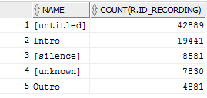

Figure 7 result of query Q

Query R :

--R : List the top 10 artists according to their track-to-release

--ratio. This ratio is computed by dividing the number of tracks an

--artist is associated with by the number of releases this artist

--as contributed a track to.

/*We create 2 views. The first one with the count of tracks of each artist and the second one with the count of releases per artist and then compute the ratio and select the top 10.*/

SELECT *

FROM

(SELECT A.NAME, COUNT_TRACK/COUNT_RELEASE AS RATIO

FROM

(SELECT AT.ID_ARTIST AS ART_ID,

COUNT(DISTINCT AT.ID_TRACK) AS COUNT_TRACK

FROM ARTIST_TRACK AT

GROUP BY AT.ID_ARTIST) TR,

(SELECT AT.ID_ARTIST AS ART_ID,

COUNT(DISTINCT M.ID_RELEASE) AS COUNT_RELEASE

FROM ARTIST_TRACK AT, TRACK T, MEDIUM M

WHERE AT.ID_TRACK=T.ID_TRACK AND T.ID_MEDIUM=M.ID_MEDIUM

GROUP BY AT.ID_ARTIST) ME,

ARTIST A

WHERE A.ID_ARTIST=TR.ART_ID AND A.ID_ARTIST =ME.ART_ID

ORDER BY RATIO DESC

)WHERE ROWNUM <=10;

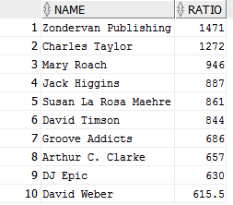

Figure 8 result of query R

Query S :

--S :The concert hit index is a measure of probability that the

--artist can attract enough fans to fill a football stadium.

--We define the “hit artist” as one that has more than 10 songs that

--appear on more than 100 mediums and measure "hit ability" as the

--average number of mediums that a top 10 song appears on.

--List all “hit artists” according to their "hit ability".

/*First we select the recording that are on more than 3 mediums. Then for each artist that contribute to a recording that is in this subset(we have this information by using the precedent table in the

from of this new query) we order them by the count of the medium. Then we choose the 10 first recording with the highest number of medium for each artist.*/

SELECT AID, AVG(COUNTM)

FROM

(SELECT A.ID_ARTIST AS AID, T.ID_RECORDING AS RECORD, COUNTM,

ROW_NUMBER()OVER (PARTITION BY A.ID_ARTIST

ORDER BY COUNTM DESC) AS RN

FROM

(SELECT T2.ID_RECORDING AS IDR,

COUNT(DISTINCT T2.ID_MEDIUM) AS COUNTM

FROM TRACK T2

GROUP BY T2.ID_RECORDING

HAVING COUNT(DISTINCT T2.ID_MEDIUM) >= 100) R3,

ARTIST_TRACK AT, ARTIST A, TRACK T

WHERE A.ID_ARTIST = AT.ID_ARTIST AND AT.ID_TRACK = T.ID_TRACK

AND T.ID_RECORDING = R3.IDR

GROUP BY A.ID_ARTIST, T.ID_RECORDING, COUNTM

)WHERE RN<=10

GROUP BY AID

HAVING COUNT(RECORD) = 10;

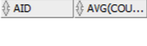

## Index performance

### Importance of indexes based

As seen during the lessons, the indexes can considerably improve the time requested by a query. And it is more important in our case when we come with big data. Indeed, some queries take several minutes to be executed. We can win significant amount of time. The indexes are a trade-off between time and space. More precisely, we use space to stock the indexes but we win time of execution. Thus we cannot add indexes for everything. We have to choose carefully the indexes that we need.

The Oracle Optimizer determines the most efficient query plan. It chooses the plan with the lowest cost. The plan query can help to choose indexes. We can see how the time is distributed and with this information we can see how and where we can win execution time.

### Query Plans

The selected queries are the queries : I, J and O.

Plan for I :

We add an index for the artist name because it must find all Metallica’s tracks.

Here is the plan before the indexes :

|  |  |  |  |  |  |
| --- | --- | --- | --- | --- | --- |
| Id | Operation | Rows | Bytes | Cost (%CPU)| | Time |
| 0 | SELECT STATEMENT | 25 | 525 | 1172 (4) | 00 :00 :15 |
| 1 | HASH UNIQUE | 25 | 525 | 1172 (4) | 00 :00 :15 |
| 2 | COUNT STOPKEY |  |  |  |  |
| 3 | VIEW | 47 | 987 | 1171 (4) | 00 :00 :15 |
| 4 | SORT ORDER BY STOPKEY | 47 | 3572 | 1171 (4) | 00 :00 :15 |
| 5 | HASH GROUP BY | 47 | 3572 | 1171 (4) | 00 :00 :15 |
| 6 | NESTED LOOPS | 47 | 3572 | 1169 (4) | 00 :00 :15 |
| 7 | NESTED LOOPS | 47 | 2303 | 1075 (4) | 00 :00 :13 |
| 8 | NESTED LOOPS | 50 | 1550 | 978 (4) | 00 :00 :12 |
| 9 | TABLE ACCESS FULL | 1 | 21 | 976 (4) | 00 :00 :12 |
| 10 | INDEX RANGE SCAN | 47 | 470 | 2 (0) | 00 :00 :01 |
| 11 | TABLE ACCESS BY INDEX  ROWID | 1 | 18 | 2 (0) | 00 :00 :01 |
| 12 | INDEX UNIQUE SCAN | 1 |  | 1 (0) | 00 :00 :01 |
| 13 | TABLE ACCESS BY INDEX  ROWID | 1 | 27 | 2 (0) | 00 :00 :01 |
| 14 | INDEX UNIQUE SCAN | 1 | 1 | 1 (0) | 00 :00 :01 |

Predicate Information (identified by operation id):

---------------------------------------------------

2 - filter(ROWNUM<=25)

4 - filter(ROWNUM<=25)

9 - filter("A"."NAME"='Metallica')

10 - access("A"."ID_ARTIST"="AT"."ID_ARTIST")

12 - access("AT"."ID_TRACK"="T"."ID_TRACK")

14 - access("T"."ID_RECORDING"="R"."ID_RECORDING")

Here is the plan of the query I after  the indexing:

|  |  |  |  |  |  |
| --- | --- | --- | --- | --- | --- |
| Id | Operation | Rows | Bytes | Cost (%CPU)| | Time |
| 0 | SELECT STATEMENT | 25 | 525 | 201 (2) | 00 :00 :03 |
| 1 | HASH UNIQUE | 25 | 525 | 201 (2) | 00 :00 :03 |
| 2 | COUNT STOPKEY |  |  |  |  |
| 3 | VIEW | 47 | 987 | 200 (1) | 00 :00 :03 |
| 4 | SORT ORDER BY STOPKEY | 47 | 3572 | 200 (1) | 00 :00 :03 |
| 5 | HASH GROUP BY | 47 | 3572 | 200 (1) | 00 :00 :03 |
| 6 | NESTED LOOPS | 47 | 3572 | 198 (0) | 00 :00 :03 |
| 7 | NESTED LOOPS | 47 | 2303 | 104 (0) | 00 :00 :02 |
| 8 | NESTED LOOPS | 50 | 1550 | 7 (0) | 00 :00 :01 |
| 9 | TABLE ACCESS BY INDEX ROWID | 1 | 21 | 5 (0) | 00 :00 :01 |
| 10 | INDEX RANGE SCAN | 1 |  | 3 (0) | 00 :00 :01 |
| 11 | INDEX RANGE SCAN | 47 | 470 | 2 (0) | 00 :00 :01 |
| 12 | TABLE ACCESS BY INDEX  ROWID | 1 | 18 | 2 (0) | 00 :00 :01 |
| 13 | INDEX UNIQUE SCAN | 1 |  | 1 (0) | 00 :00 :01 |
| 14 | TABLE ACCESS BY INDEX  ROWID | 1 | 27 | 2 (0) | 00 :00 :01 |
| 15 | INDEX UNIQUE SCAN | 1 |  | 1 (0) | 00 :00 :01 |

Predicate Information (identified by operation id):

---------------------------------------------------

2 - filter(ROWNUM<=25)

4 - filter(ROWNUM<=25)

10 - access("A"."NAME"='Metallica')

11 - access("A"."ID_ARTIST"="AT"."ID_ARTIST")

13 - access("AT"."ID_TRACK"="T"."ID_TRACK")

15 - access("T"."ID_RECORDING"="R"."ID_RECORDING")

We can observe that the expected time and CPU use is really lower with the indexes.

For the queries O and J the improvement is not significant we cannot see it with the plan because it cannot use the index instead of doing full table scan.

Plan of query J :

|  |  |  |  |  |  |
| --- | --- | --- | --- | --- | --- |
| Id | Operation | Rows | Bytes | Cost (%CPU)| | Time |
| 0 | SELECT STATEMENT | 37800 | 18M | 3809 (4) | 00 :00 :46 |
| 1 | VIEW | 37800 | 18M | 3809 (4) | 00 :00 :46 |
| 2 | WINDOW SORT PUSHED RANK | 37800 | 2030K | 3809 (4) | 00 :00 :46 |
| 3 | SORT GROUP BY | 37800 | 2030K | 3809 (4) | 00 :00 :46 |
| 4 | NESTED LOOP | 37800 | 2030K | 2776 (4) | 00 :00 :34 |
| 5 | HASH JOIN | 797 | 35865 | 1179 (9) | 00 :00 :15 |
| 6 | HASH JOIN | 797 | 9564 | 191 (28) | 00 :00 :03 |
| 7 | VIEW | 10 | 40 | 115 (40) | 00 :00 :02 |
| 8 | COUNT STOPKEY |  |  |  |  |
| 9 | VIEW | 1725 | 6900 | 115 (40) | 00 :00 :02 |
| 10 | SORT ORDER BY STOPKEY | 1725 | 13800 | 115 (40) | 00 :00 :02 |
| 11 | SORT GROUP BY | 1725 | 13800 | 115 (40) | 00 :00 :02 |
| 12 | TABLE ACCESS FULL | 137K | 1074K | 74 (7) | 00 :00 :01 |
| 13 | TABLE ACCESS FULL | 137K | 1074K | 74 (7) | 00 :00 :01 |
| 14 | TABLE ACCESS FULL | 217K | 8759K | 982 (5) | 00 :00 :12 |
| 15 | INDEX RANGE SCAN | 47 | 470 | 2(0) | 00 :00 :01 |

Predicate Information (identified by operation id):

---------------------------------------------------

1 - filter("RN"=1)

2 - filter(ROW_NUMBER() OVER ( PARTITION BY "AG"."ID_GENRE" ORDER BY COUNT(DISTINCT

"AT"."ID_TRACK") DESC )<=1)

5 - access("A"."ID_ARTIST"="AG"."ID_ARTIST")

6 - access("AG"."ID_GENRE"="ID_GENRE")

8 - filter(ROWNUM<=10)

10 - filter(ROWNUM<=10)

14 - filter("A"."GENDER"='Female')

15 - access("A"."ID_ARTIST"="AT"."ID_ARTIST")

The part that we would like to reduce is the full table access that is done on the artist_track and artist tables. There is an index on the artist gender and on the artist_genre for the id_genre.

But the new query plan doesn’t select the new index. It may be that in this case the use of the index cost more. Even the query seems to be slightly slower. It may be because the optimizer must compute more possibilities than without indexes and finally choose the same plan than before.

Plan of query O :

|  |  |  |  |  |  |
| --- | --- | --- | --- | --- | --- |
| Id | Operation | Rows | Bytes | Cost (%CPU)| | Time |
| 0 | SELECT STATEMENT | 923K | 22M | 15844 (4) | 00 :03 :11 |
| 1 | VIEW | 923K | 22M | 7922 (4) | 00 :01 :36 |
| 2 | SORT ORDER BY | 923K | 10M | 7922 (4) | 00 :01 :36 |
| 3 | SORT GROUP BY NOSORT | 923K | 10M | 7922 (4) | 00 :01 :36 |
| 4 | MERGE JOIN | 1047K | 11M | 7922 (4) | 00 :01 :36 |
| 5 | INDEX FULL SCAN | 1236K | 7243K | 3667 (2) | 00 :00 :45 |
| 6 | SORT JOIN | 1044K | 6121K | 4255 (6) | 00 :00 :52 |
| 7 | TABLE ACCESS FULL | 1044K | 6121K | 716 (6) | 00 :00 :09 |
| 8 | SORT AGGREGATE | 1 | 13 |  |  |
| 9 | VIEW | 923K | 11M | 7922 (4) | 00 :01 :36 |
| 10 | SORT GROUP BY | 923K | 10M | 7922 (4) | 00 :01 :36 |
| 11 | MERGE JOIN | 1047K | 11M | 7922 (4) | 00 :01 :36 |
| 12 | INDEX FULL SCAN | 1236K | 7243K | 3667 (2) | 00 :00 :45 |
| 13 | SORT JOIN | 1044K | 6121K | 4255 (6) | 00 :00 :52 |
| 14 | TABLE ACCESS FULL | 1044K | 6121K | 716 (6) | 00 :00 :09 |

Predicate Information (identified by operation id):

---------------------------------------------------

1 - filter("COUNTM"= (SELECT MAX("COUNTM") FROM (SELECT COUNT(*) "COUNTM" FROM

"MEDIUM" "M","RELEASE" "R" WHERE "M"."ID_RELEASE"="R"."ID_RELEASE" GROUP BY

"R"."ID_RELEASE") "from$_subquery$_004"))

6 - access("R"."ID_RELEASE"="M"."ID_RELEASE")

filter("R"."ID_RELEASE"="M"."ID_RELEASE")

13 - access("M"."ID_RELEASE"="R"."ID_RELEASE")

filter("M"."ID_RELEASE"="R"."ID_RELEASE")

We must access the full medium table twice for the id_release. Thus we add an index on the id_release on the medium table but the new plan does not use it. We can suppose that the use of the index cost more.

### Running Time

The running time can depend of random factors like the number of people that use the server at the same time.

A : 5.026 seconds

B : no end

C : 15 seconds

D : 568 seconds

E : 0.567 seconds

F : no end

G : 838 seconds

H : no end

I : 30.157 seconds before added indexes, 0.4 seconds after.

J : 18.64 seconds before added indexes, 19.223 seconds (no better) after.

K : 2.09 seconds

L : 2162.6 seconds

M : no end

N : no end

O : 109.714 seconds before added indexes, 29 seconds after.

P : 2.59 seconds

Q : 249.877 seconds

R : 5175 seconds

S : 563 seconds

## User Interface

The user interface is one of the big part of the project. We had a lot of choices to make during the development of the interface.

This section will explain how the interface work and why we made those choices.

### Choices

First of all, we choose to develop the user interface as Web App because it's an easy way to design the interface we want.

### Server sides

The server is a simple multi-threaded HTTP server that also access the EPFL's Oracle Database.

### Why Java

We choose to code it in Java because it's almost the only language we all know well. Another advantage is that it handles pretty well Oracle's database with the JDBC lib. Plus, Java is powered by Oracle too. It had to be well supported and it is.

### Web server

The web server is pretty simple. It just handles basic HTTP GET requests.

When the server is running, a listener is called. This listener wait for a HTTP request and, when a request is catch, it spawns a worker new thread. Then, it waits for the next request.

The Worker is a little bit more complicated.

First of all, the worker will handle the stream of data comming on the port 80. It will extract the path and GET parameters from the header.

Then, it will try to open the file gave in the path and stream it to the client in the response. The MIME type is automatically detected and sent in the HTTP response headers.

If the requested path is `/do-sql`, the behavior will be different. The worker with try to extarct a SQL query from the GET parameters. Then, it will ask the Database handler to execute the SQL query and to return a JSON with the result (or an error).

### Database Access

The database access is handle by a `Database` class.

It manages the connection and can execute some queries on the Oracle database. To achieve that, we use the JDBC driver.

After executing a query, the response from the Oracle database will be transformed in a JSON.

For instance, if you search an artist called "Flume", the response sent to the client will be:

```

{

"status":"OK",

"data":[

{

"NAME":"Liza Flume",

"GENDER":"Female",

"ID_AREA":0,

"ID_ARTIST":1057910,

"TYPE":"Person"

},

{

"NAME":"Flume",

"GENDER":"Male",

"ID_AREA":13,

"ID_ARTIST":835335,

"TYPE":"Person"

},

{

"NAME":"The Flumes",

"GENDER":"Other",

"ID_AREA":0,

"ID_ARTIST":837196,

"TYPE":"Other"

},

{

"NAME":"DJ Michael Flume",

"GENDER":"Other",

"ID_AREA":0,

"ID_ARTIST":195126,

"TYPE":"Other"

}

]

}

```

### Client Size

### How to use the Interface

### Pre-written Requests

### Custom Search

### Clicable Results

### Insertion

### Deletion

# Deliverable 2

## Importation

We were confronted to some problems during the import part. The « real » data which we have at our disposal are far from the idealized schema that we made for the first part. To reduce those differences, some modifications had to be made.

### New ER-Model

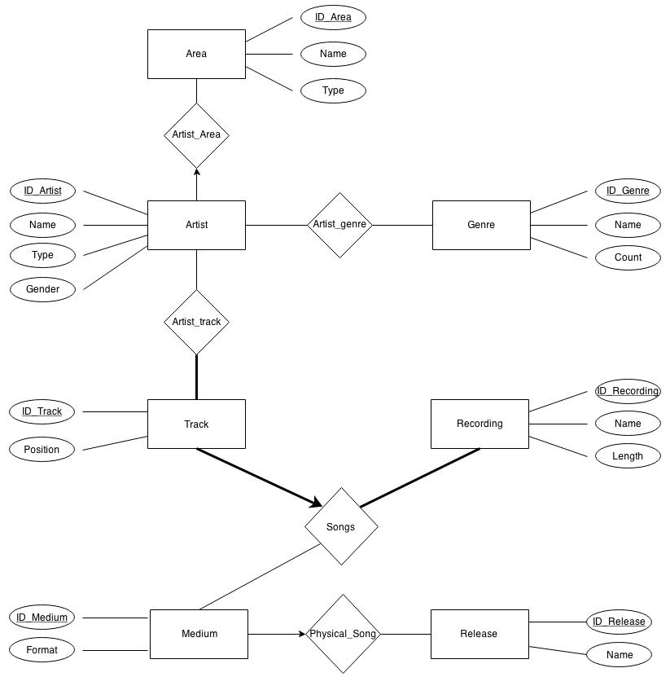Because some data are missing, artist can be associated with one or zero area and release can be associated with one or zero medium.

### Changes in Table Creation

Weaken constraints :

Some constraints had to be weaken by deleting some FOREIGN KEY. Indeed, some constraints that seem natural during the design part of the database, were finally not well adapted to the available data. For example, in the artist table the FOREIGN KEY on the area ID had to be suppressed because some artists are associated with an area ID that does not exist in the area table. For the same reason the FOREIGN KEY on the artist ID in the artist_genre table had to be suppressed, as well as the FOREIGN KEY on the track ID in the artist_track table and the FOREIGN KEY on the Medium ID in the Track table.

Merges for participation constraints :

To capture the constraints that an artist is associated with at most one area, the artist_area table is merged with the artist table. The same is made for the physical_song and the medium.

Fields types more accurate :

We also decided to change every field type for the tables creation (before every fields were just CHAR).

Every field for the creation has to be modified. IDs are only integer, thus use integer instead of CHAR are more suitable. For other fields, VARCHAR are used instead of CHAR because the lengths of the field are really variable thus VARCHAR is more appropriated for the real values of the data.

New table creation sql code :

**CREATE** **TABLE** Area(

ID_Area INT,

Name VARCHAR2(1000),

**Type** VARCHAR2(60),

**PRIMARY** **KEY**(ID_Area)

);

**CREATE** **TABLE** Genre

(ID_Genre INT,

Name VARCHAR2(1000),

**Count** INT,

**PRIMARY** **KEY**(ID_Genre));

**CREATE** **TABLE** Recording

(ID_Recording INT,

Name VARCHAR2(2000),

**Length** INT,

**PRIMARY** **KEY**(ID_Recording));

**CREATE** **TABLE** Release

(ID_Release INT,

Name VARCHAR2(1000),

**PRIMARY** **KEY**(ID_Release));

**CREATE** **TABLE** Artist

(ID_Artist INT,

Name VARCHAR2(1000),

**Type** VARCHAR2(60),

Gender VARCHAR2(20),

ID_Area INT,

**PRIMARY** **KEY**(ID_Artist)

);

**CREATE** **TABLE** Medium

(ID_Medium INT,

Format VARCHAR2(60),

ID_Release INT,

**PRIMARY** **KEY**(ID_Medium)

);

**CREATE** **TABLE** Track

(ID_Track INT,

**Position** INT,

ID_Medium INT,

ID_Recording INT,

**PRIMARY** **KEY**(ID_Track),

**FOREIGN** **KEY**(ID_Recording) **REFERENCES** Recording

);

**CREATE** **TABLE** Artist_Genre

(ID_Artist INT,

ID_Genre INT,

**PRIMARY** **KEY**(ID_Artist, ID_Genre),

**FOREIGN** **KEY**(ID_Genre) **REFERENCES** Genre);

**CREATE** **TABLE** Artist_Track

(ID_Artist INT,

ID_Track INT,

**PRIMARY** **KEY**(ID_Artist, ID_Track),

**FOREIGN** **KEY**(ID_Artist) **REFERENCES** Artist);

## Search Functionality

We decided to implement the search functionality as follow:

1. We chose not to allow the user to search on any column of a table. The reason is we thought all the columns were not really interesting to run queries on. For example in the GENRE table there is a count column, but we believe this is not a useful query to be run for a lambda user. That’s why the only search that can be done on our UI is about the NAME column of the table.
2. We chose to allow the user only to search in table where there is a NAME column. The reason follow from the discussion in the first point previously mentioned. Thus the available tables for search are: AREA, ARTIST, GENRE, RECORDING and RELEASE. In the UI, this table selection can be done through a drop-down list (in order to not let the user write junk as a table name).
3. We construct our queries by using the LIKE operator of SQL using the keyword the user inputted. More formally the query was designed as follow:

"SELECT * FROM "**+**table**+**" WHERE LOWER(name) LIKE lower('%" **+** keyword **+** "%')"

1. The resulting rows of the simple search query are displayed in a HTML table. The HTML columns are the SQL columns of the table that was searched without id related columns. For example if the search was made on the ARTIST table, the HTML columns are NAME, TYPE and GENDER.
2. For the follow up queries we decided that the user can have more infos about a row by clicking on it. We decided to do so since the resulting queries are made upon the id of the row and not about a specific column.
3. The follow up queries are made using the id of the clicked row on chosen tables that seemed logical to be linked to for us.

More precisely the tables are linked like that:

|  |  |
| --- | --- |
| **ID from table** | **Linked with table(s)** |
| AREA | ARTIST |
| ARTIST | AREA, GENRE, RELEASE |
| GENRE | ARTIST |
| RECORDING | ARTIST, RELEASE |
| RELEASE | ARTIST, RECORDING |

These choices were obvious for us since we thought of it as if we were a user of the UI and we talk between us about “What more infos would want the user x if he choose to search a keyword y?”

1. Concerning the displaying we chose to use tabs. We display one of the linked tables and then the user can click on the other tabs to go to the other linked tables. When the user click on one row of one of the linked table the same behaviour occurs as if these row resulted from a simple search query.

## SQL Queries

We have still some problems for the SQL queries. We test all the following queries with a dummy database that is smaller than the music database and the queries give us the expected results. But with the real database some of the queries take a lot of time to be executed (we kill the process after 5 minutes and when we let the execution run the following error can appear…). Those queries are the query B, C, D, F and G. Thus we think that this problem comes from a lack of optimisation of those queries.

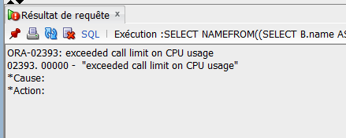

Figure 9: error when the query E is run during a long time

### Queries A to G

--A print the name of artist from switzerland

SELECT A.name

FROM Artist A, Area B

WHERE A.ID_AREA = B.ID_AREA AND B.name= 'Switzerland'

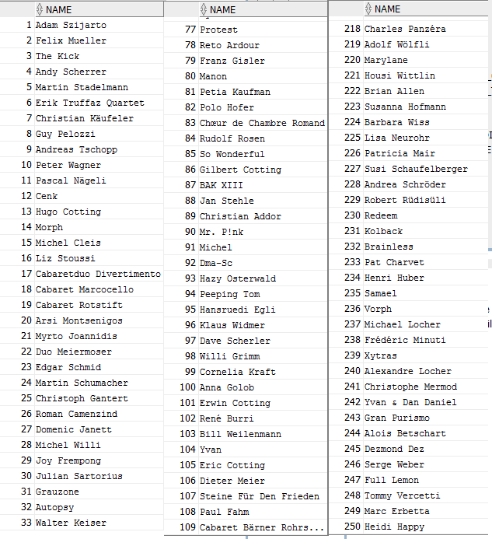

Figure 10 result of query A

--B print the name and the number of female, male and group of the

--area that have the most female, male or group artists.

/*The first part of the query create a table with the following column : AREA| female count| male count| group count and in

SELECT *

FROM

(SELECT B.name AS NAME,

(SELECT COUNT(DISTINCT A.ID_ARTIST)

        FROM ARTIST A

        WHERE A.GENDER='Female' AND B.ID_AREA=A.ID_AREA)

        AS COUNTF,

(SELECT COUNT(DISTINCT A.ID_ARTIST)

        FROM ARTIST A

        WHERE A.GENDER='Male' AND B.ID_AREA=A.ID_AREA)

        AS COUNTM,

(SELECT COUNT(DISTINCT A.ID_ARTIST)

        FROM ARTIST A

        WHERE A.TYPE='Group' AND B.ID_AREA=A.ID_AREA)

        AS COUNTG

FROM AREA B

ORDER BY COUNTF DESC)

WHERE ROWNUM=1

UNION

SELECT *

FROM

(SELECT B.name AS NAME,

(SELECT COUNT(DISTINCT A.ID_ARTIST)

        FROM ARTIST A

        WHERE A.GENDER='Female' AND B.ID_AREA=A.ID_AREA)

        AS COUNTF,

(SELECT COUNT(DISTINCT A.ID_ARTIST)

        FROM ARTIST A

        WHERE A.GENDER='Male' AND B.ID_AREA=A.ID_AREA)

        AS COUNTM,

(SELECT COUNT(DISTINCT A.ID_ARTIST)

        FROM ARTIST A

        WHERE A.TYPE='Group' AND B.ID_AREA=A.ID_AREA)

        AS COUNTG

FROM AREA B

ORDER BY COUNTM DESC)

WHERE ROWNUM=1

UNION

SELECT *

FROM

(SELECT B.name AS NAME,

(SELECT COUNT(DISTINCT A.ID_ARTIST)

        FROM ARTIST A

        WHERE A.GENDER='Female' AND B.ID_AREA=A.ID_AREA)

        AS COUNTF,

(SELECT COUNT(DISTINCT A.ID_ARTIST)

        FROM ARTIST A

        WHERE A.GENDER='Male' AND B.ID_AREA=A.ID_AREA)

        AS COUNTM,

(SELECT COUNT(DISTINCT A.ID_ARTIST)

        FROM ARTIST A

        WHERE A.TYPE='Group' AND B.ID_AREA=A.ID_AREA)

        AS COUNTG

FROM AREA B

ORDER BY COUNTG DESC)

WHERE ROWNUM=1;

--C List the name of 10 groups with the most recorded track

/*order by the number of tracks and select the top 10 for the group*/

SELECT *

FROM(SELECT A.NAME

FROM  Artist A, Artist_Track S

WHERE A.ID_ARTIST=S.ID_ARTIST AND A.TYPE='Group'

GROUP BY A.ID_ARTIST, A.NAME

ORDER BY count(S.ID_TRACK) DESC)

WHERE ROWNUM <=10

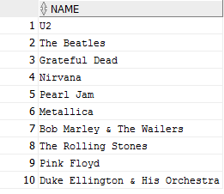

Figure 11 result of query C

--D List the name of 10 groups with the most release

/*Order by the number of releases and select the top 10 for the group*/

SELECT *

FROM(SELECT **A.NAME**

FROM Artist A, Track T, Artist_Track S, Medium M, Release R

WHERE A.ID_ARTIST =S.ID_ARTIST AND T.ID_TRACK=S.ID_TRACK

AND T.ID_MEDIUM=M.ID_MEDIUM AND R.ID_RELEASE = M.ID_RELEASE

AND A.TYPE='Group'

GROUP BY A.ID_ARTIST, **A.NAME**

ORDER BY count(DISTINCT **R.ID_RELEASE**) DESC)

WHERE ROWNUM <=10

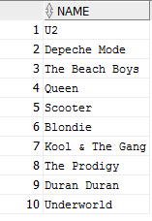

Figure 12 result of query D

--E Print the name of female artist that have the most genres

/*Order by the number of genre of female artist and select the top 1 artist*/

SELECT NAME

FROM (SELECT A.NAME AS NAME,

COUNT(DISTINCT G.ID_GENRE) AS COUNT_GENRE

FROM ARTIST_GENRE G, ARTIST A

WHERE A.ID_ARTIST= G.ID_ARTIST AND A.GENDER='Female'

GROUP BY A.ID_ARTIST, A.NAME

ORDER BY COUNT_GENRE DESC)

WHERE ROWNUM=1



Figure 13 result of query E

--F Print the name of the cities that have more female artist than

--male artist

/*Compare the count of the female artist and the count of male artist for the city. And select the cites that have more female artist than male artist*/

SELECT B.name

FROM Area B

WHERE B.type='City'

AND (SELECT Count(*)

FROM Artist A

WHERE A.gender='Female' AND A.ID_AREA= B.ID_AREA)

     > (SELECT Count(*)

FROM Artist A1

WHERE A1.gender='Male' AND A1.ID_AREA=B.ID_AREA)

--G List the mediums with the most number of tracks

/*Order the mediums by their track count and select the medium that have their track count egal to the max track count.*/

SELECT ID, FORMAT, COUNT_TRACK

FROM

(SELECT M.ID_MEDIUM AS ID, M.FORMAT AS FORMAT,

COUNT(DISTINCT T.ID_TRACK) AS COUNT_TRACK

FROM TRACK T, MEDIUM M

WHERE M.ID_MEDIUM = T.ID_MEDIUM

GROUP BY M.ID_MEDIUM, M.FORMAT)

WHERE COUNT_TRACK = (SELECT MAX(COUNT_TRACK)

FROM

(SELECT M.ID_MEDIUM AS ID, M.FORMAT AS FORMAT,

COUNT(DISTINCT T.ID_TRACK) AS COUNT_TRACK

FROM TRACK T, MEDIUM M

WHERE M.ID_MEDIUM=T.ID_MEDIUM

GROUP BY M.ID_MEDIUM, M.FORMAT)

);



Figure 14 result of query G

## Interface

Figure 15: simple search: the user can choose in which table he wants to do the search

Figure 16 SQL queries: the left table allows the user to select a query and displays the result

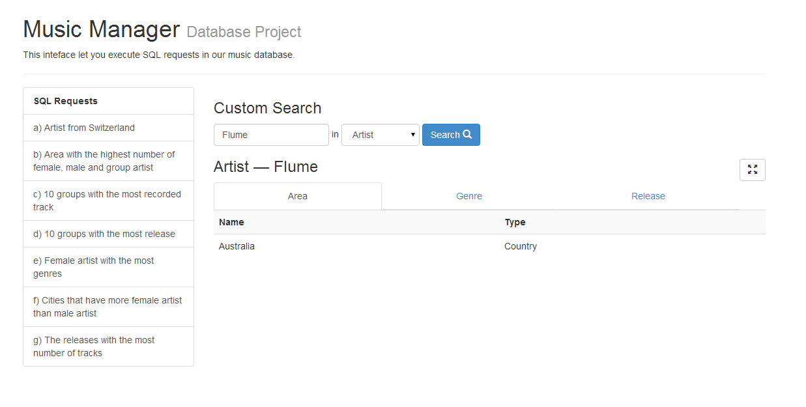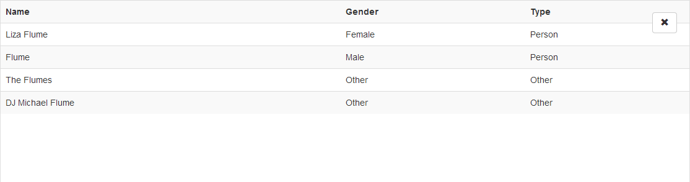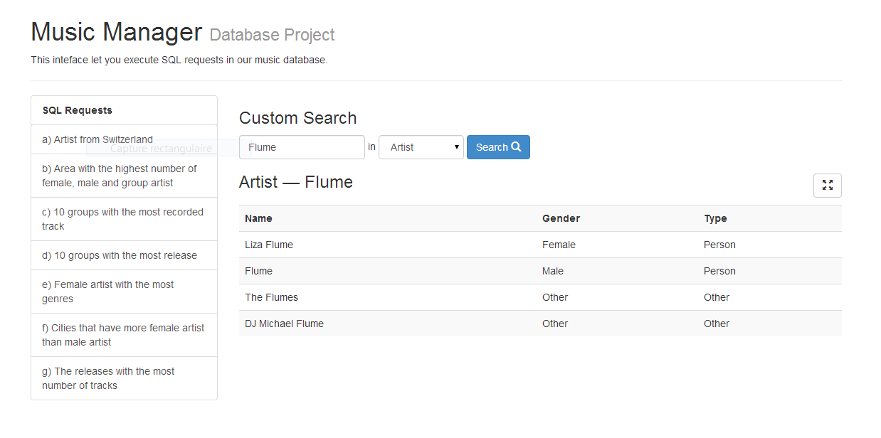

Figure 17: the user clicked on the row of an artist and obtained different complementary information. Different information are available using the tabs

Figure 18: Mode full screen of the results

Figure 19: the user executed a search on an artist

# Deliverable 1

## ER-Model Choices

Every entity contains only its own attributes (*ID*, *name, etc.* but not the *ID* of other entities). We chose to create relations instead of giving the *ID* of an other entities as an attribute of the entity.

This relation design is especially suitable in this case because if several entities share their *ID* this means that a relation exists between them.

The *Song* relation is a ternary relation that represents a song on a support. It relates a support (*Medium*) with the position on this medium (*Track*) and the recording of the song (*Recording*).

*Physical_Song* contains all the pairs of *Release* (album, single…) and on which support it is displayed.

Those choices are made in consideration of the given data. For example, for *Physical_Song* relationship there is an existing relationship between Medium and Release. Medium should contain the ID of Release, so we made a relation of it.

## Constraints Explanation

There is some complex constraints between entities because the musical universe is also complex: collaborations (multiple artists per track), compilations (multiple artists per album), etc.

It is difficult to define more constraints because the available data are often incomplete.

### Areas

An artist can have at most one area. This constraint is given by the available data. Indeed, instinctively we may think that one artist have to come from one or more than one area (for example: New-York (*City*) and America (*Continent*)). But in the given data, the situation is different: an artist can have only one area or no area if the data is missing.

### Tracks

All tracks have to be represented in the relation *Artist_Track* at least once. It means that all tracks were made by at least one artist.

All tracks have to be represented exactly once in the relation *Song*. It means that all tracks (all positions in a CD for example) are related to exactly one music (i.e there is no position without a music) and one support.

### Recordings

All recordings have to be at least once represented in the *Song* relation. Indeed, recording is the logical song. It does not make sense if it does not stand on any support. But the same recording may be on different supports, and be referred by several tracks etc.

### Releases

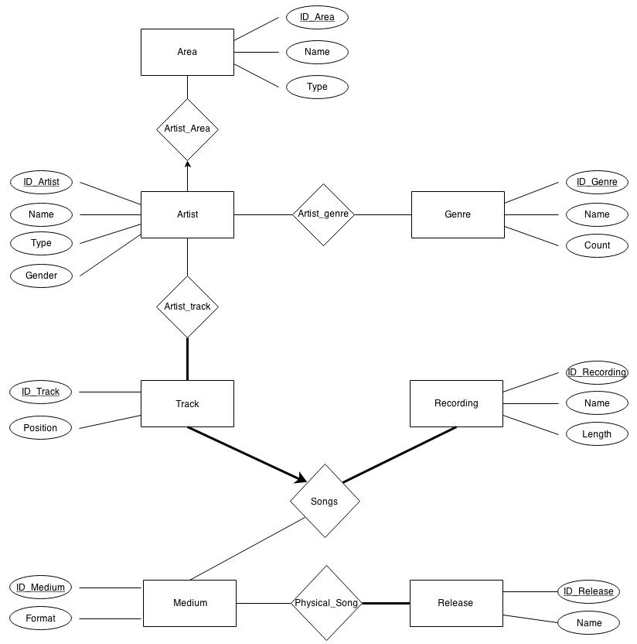All releases must be at least once represented in the *Physical_Song* relation. For the same reason as for recording. It does not make sense that an album, single … does not stand on any support.

### Schemas

**Area** : ID_Area, Name, Type

**Artist** : ID_Artist, Name, Type, Gender

**Genre** : ID_Genre, Name, Count

**Medium** : ID_Medium, Format

**Recording** : ID_Recording, Name, Length

**Release** : ID_Release, Name

**Track** : ID_Track, Position

**Artist_Area** : ID_Artist, ID_Area

**Artist_Genre** : ID_Artist, ID_Genre

**Artist_Track** : ID_Artist, ID_Track

**Physical_Song** : ID_Medium, ID_Recording

**Song** : ID_Track, ID_Medium, ID_Recording

## Tables Creation

-- Area :

CREATE TABLE Area

(ID_Area CHAR(60),

Name CHAR(60),

Type CHAR(60),

PRIMARY KEY(ID_Area))

-- Artist :

CREATE TABLE Artist

(ID_Artist CHAR(60),

Name CHAR(60),

Type CHAR(60),

Gender CHAR(60),

PRIMARY KEY(ID_Artist))

-- Genre :

CREATE TABLE Genre

(ID_Genre CHAR(60),

Name CHAR(60),

Count CHAR(60),

PRIMARY KEY(ID_Genre))

-- Medium :

CREATE TABLE Medium

(ID_Medium CHAR(60),

Format CHAR(60),

PRIMARY KEY(ID_Medium))

-- Recording :

CREATE TABLE Recording

(ID_Recording CHAR(60),

Name CHAR(60),

Length CHAR(60),

PRIMARY KEY(ID_Recording))

-- Release :

CREATE TABLE Release

(ID_Release CHAR(60),

Name CHAR(60),

PRIMARY KEY(ID_Release))

-- Track :

CREATE TABLE Track

(ID_Track CHAR(60),

Position CHAR(60),

PRIMARY KEY(ID_Track))

-- Artist_Area :

CREATE TABLE Artist_Area

(ID_Artist CHAR(60),

ID_Area CHAR(60),

PRIMARY KEY(ID_Artist),

FOREIGN KEY(ID_Artist) REFERENCES Artist,

FOREIGN KEY(ID_Area) REFERENCES Area)

-- Artist_Genre :

CREATE TABLE Artist_Genre

(ID_Artist CHAR(60),

ID_Genre CHAR(60),

PRIMARY KEY(ID_Artist, ID_Genre),

FOREIGN KEY(ID_Artist) REFERENCES Artist,

FOREIGN KEY(ID_Genre) REFERENCES Genre)

-- Artist_Track :

CREATE TABLE Artist_Track

(ID_Artist CHAR(60),

ID_Track CHAR(60),

PRIMARY KEY(ID_Artist, ID_Track),

FOREIGN KEY(ID_Artist) REFERENCES Artist,

FOREIGN KEY(ID_Track) REFERENCES Track)

-- Physical_Song :

CREATE TABLE Physical_Song

(ID_Medium CHAR(60),

ID_Release CHAR(60),

PRIMARY KEY(ID_Medium, ID_Release),

FOREIGN KEY(ID_Medium) REFERENCES Medium,

FOREIGN KEY(ID_Release) REFERENCES Release)

-- Song :

CREATE TABLE Song

(ID_Track CHAR(60),

ID_Recording CHAR(60),

ID_Medium CHAR(60),

PRIMARY KEY(ID_Track),

FOREIGN KEY(ID_Medium) REFERENCES Medium,

FOREIGN KEY(ID_Track) REFERENCES Track,

FOREIGN KEY(ID_Recording) REFERENCES Recording)